FLIGHT BOOKING
Contents
1 Problem Statement 2
2 WIREFRAMES 3
3 Proposed Rest Endpoints to be exposed 5
3.1 Rest APIs: 5
3.2 Code Quality/Optimizations 5

Problem Statement
Build a software system which lets user search for a Flight Ticket and book it & includes Admin related activities. User can also cancel or update the Ticket. Below are the different roles, which need to be supported by above Software System.
- User
- Admin
The scope includes developing the application using tool chain mentioned below.

WIREFRAMES
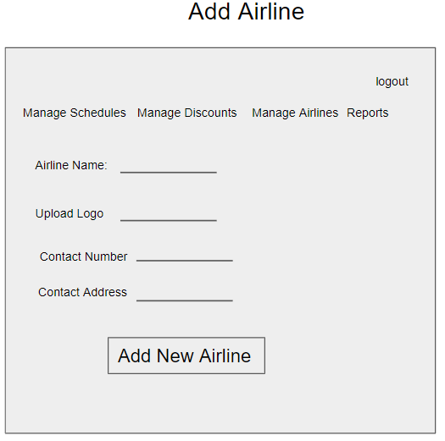
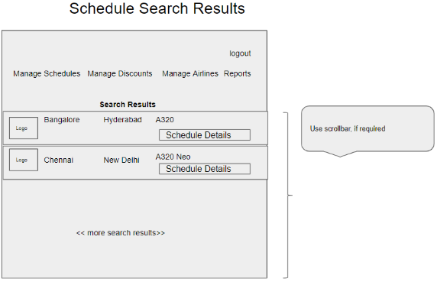
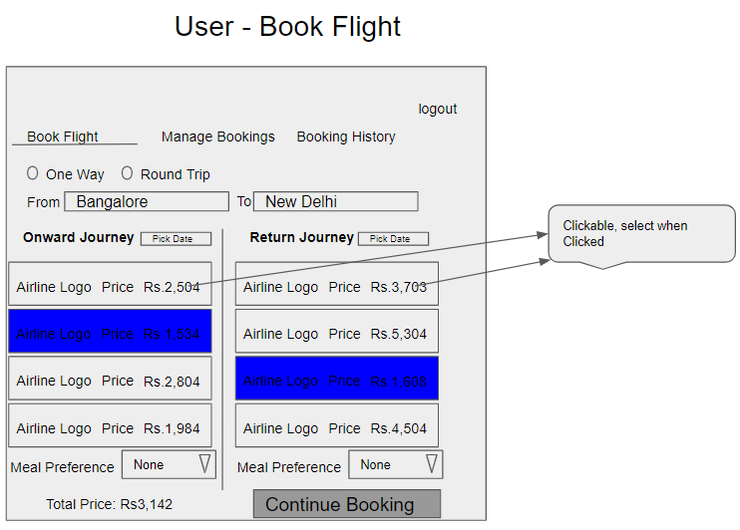
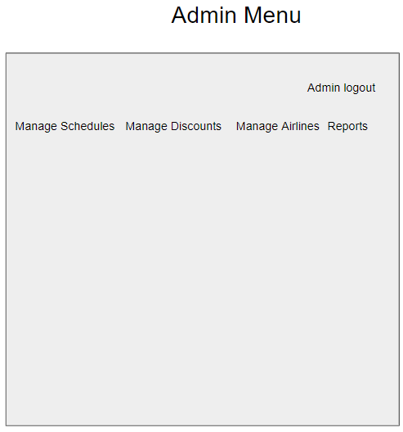
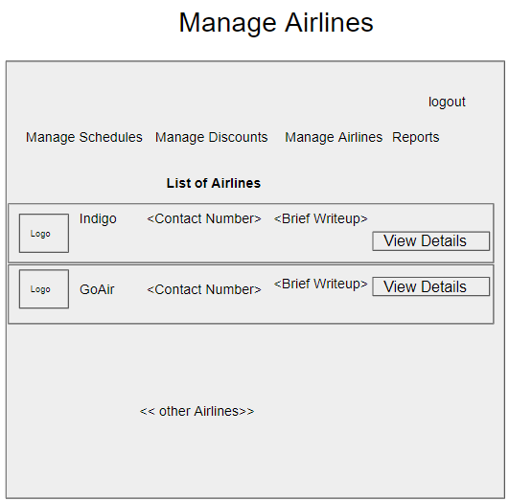
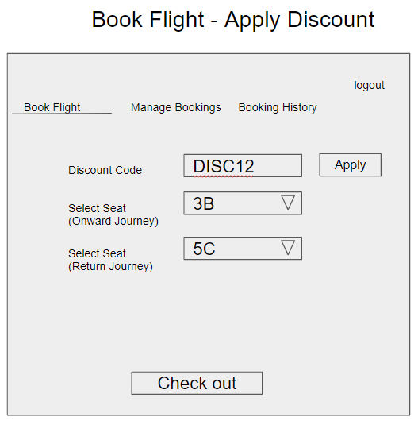
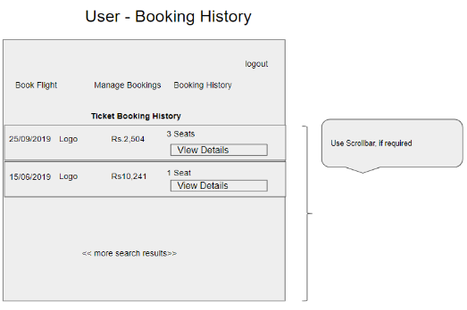
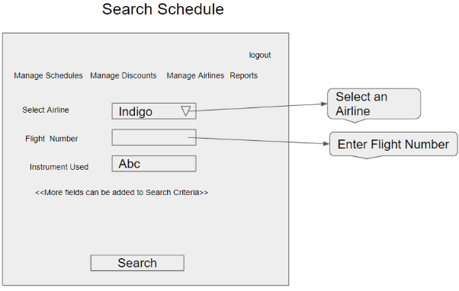
UI needs improvisation and modification as per given use case.
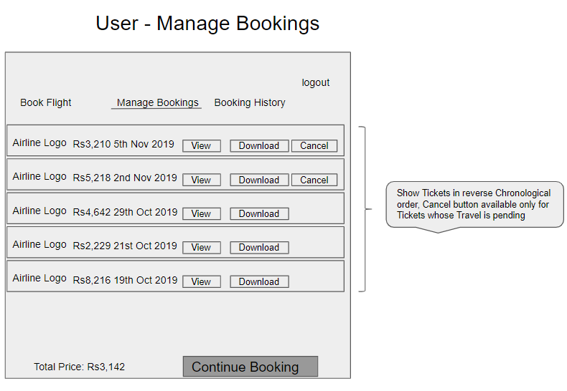
Business Requirements:
As an application developer, develop microservices with below guidelines:
User  Story # | User Story Name | User Story
US_01 | User Mode | - User can search for a Flight based on date/time, from place/to place, one way or round trip  - Each Search result need to display Flight Date/time, Airline Name/Logo, Price(to & round trip – TBD)  - From Search results, User should be able to select a specific Flight and go ahead and complete Ticket Booking by providing below details  - Name and Email ID  - Number of seats to book.  - Details of each passenger (NAME:GENDER:AGE)  - Opt for Meal(Veg/Non veg)  - Select Seat Number(s)  - On successful Ticket Booking, PNR number need to be generated, it should be possible to download TicketBooking can be done a Logged in User only  - With email id user should be able to  - view History of Ticket Bookings,  - Cancel a Ticket only prior to a day(24 hrs) before journey date.  - With PNR number view the booked ticket details
US_02 | Admin Mode | - Admin shall be able to login/logout.  - There can be pre-defined username/password for Admin.  - Admin shall be able to add/block an Airline. When Airline is Blocked, Flights belonging to that Airline will not be shown in Ticket Search results.  - Admin shall be able to add Inventory/Schedule of an existing Airline by specifying below details:  - flight number  - Airline  - From Place  - To Place  - Start date time,  - End date time,  - Scheduled Days(Daily, Week Days, Week Ends, For specific days specify the list of Days like Mon, Wed)  - Instrument used(A320, A320 neo, etc…)  - Total number of business class Seats  - Total number of non-business class Seats  - Ticket cost (consider taxes and other charges),  - number of rows,  - meal(none, veg, non veg)

Proposed Rest Endpoints to be exposed

Rest APIs:
POST | /api/v1.0/flight/airline/register | New airline booking
POST | /api/v1.0/flight/admin/login | Admin login
POST | /api/v1.0/flight/airline/inventory/add | Add Inventory/Schedule of an existing Airline
POST | /api/v1.0/flight/search | Searches for flight
POST | /api/v1.0/flight/booking/{flightid} | Book ticket
GET | /api/v1.0/flight/ticket/{pnr} | Get Booked ticket details based on PNR
GET | /api/v1.0/flight/booking/history/{emailId} | Get Booked tickets history based on Email ID
DELETE | /api/v1.0/flight/booking/cancel/{pnr} | Cancel a booked ticket

Code Quality/Optimizations

- Associates should have written clean code that is readable

