Scoped Certified Application Design

IBM Resilient

**Table of Contents**

1 Overview 3

1.1 References 3

2 Application overview and intended use 3

2.1 Third-party dependencies 3

3 Software architecture overview 3

4 Software design description 4

5 Performance considerations and concerns 4

6 Security considerations and concerns 4

7 Application components 4

7.1 Components created by the application: 5

7.2 Integration components created by the application: 5

8 Future plans 5

9 Service Level Agreement Definition 5

10 Debugging and troubleshooting 6

10.1 Debugging tips: 6

10.2 Failure modes: 6

# Overview

Your Design Document describes the design of your scoped application and will be used throughout the certification process. The document is used internally by ServiceNow only and is not shared with your customers.

To prepare your Design Document, enter a thorough response in each section of this template document. If a section is not applicable, state the reasons clearly.

This document is intended to enable ServiceNow Certification Engineers and Technical Support members to:

* Understand your integration completely
* Identify areas of risk to platform security or platform stability
* Troubleshoot any potential third-party issues

# Application overview and intended use

**The Application:**

* Integrates the Incident Table in ServiceNow with IBM Resilient
* Records from the ServiceNow Incident Table can be used to create Incidents/Tasks in IBM Resilient
* Business Rules allow Work Notes and Additional Comments to be sent to a related IBM Resilient Incident/Task
* The application includes custom REST API Endpoints that allows IBM Resilient to create/update Records in the Incident Table

**The Business Need:**

* Allows a bi-directional integration between ServiceNow Incidents and IBM Resilient Incident/Tasks

**Use Cases:**

* A SOC Analyst needs assistance from another team that uses ServiceNow for their workflow. They can now easily send, synchronize and communicate an Incident/Task from IBM Resilient to a team using ServiceNow
* An Incident is raised in ServiceNow and the customer needs their SOCs assistance to respond to the Incident. They can now easily send, synchronize and communicate a ServiceNow Record in the Incident table to their IBM Resilient team

## Third-party dependencies

None

# Software architecture overview

* A user can create an Incident/Task in IBM Resilient by clicking a ServiceNow UI Action or update an Incident/Task in IBM Resilient or send a Work Note/Additional Comment to IBM Resilient using a ServiceNow Business Rule
* The UI Action/Business Rule starts a ServiceNow Workflow
* The Workflow contains a Run Script that instantiates the ResilientHelper Class
* The ResilientHelper Class reads data from the ServiceNow Record manipulates and maps it, then uses the ResilientAPI Class to make requests to the Resilient Appliance REST API
* If the Resilient Appliance is not publicly accessible (not behind a firewall) a ServiceNow MID Server is needed

# Software design description

**ResilientHelper API**

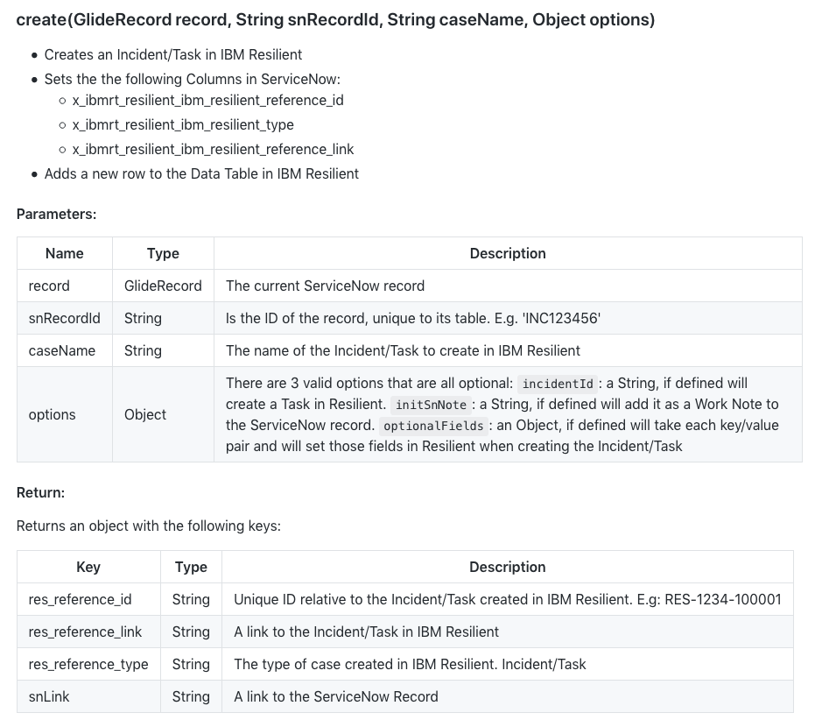

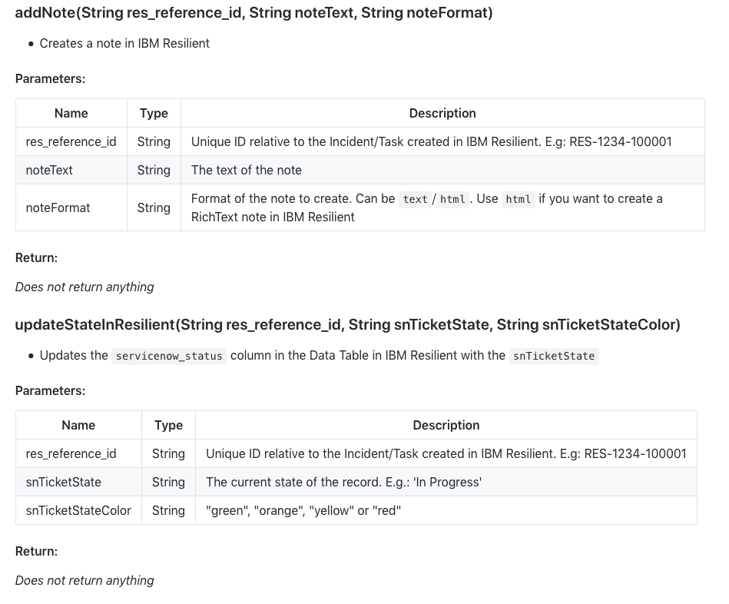

# Performance considerations and concerns

* **High Volume Transactions:**
  + In testing, sending multiple IBM Resilient Incidents/Tasks to ServiceNow did not seem to effect the Platform
* **Inbound Web Services:**
  + One ServiceNow Record is created in the Incident Table when a user chooses to send an IBM Resilient Incident/Task to ServiceNow
* **Outbound Web Services:**
  + One ServiceNow Record is exported each time the user clicks the UI Action to create an Incident/Task in IBM Resilient
* **Error Handling:** all API request exceptions are caught and should be printed in the logs and also a Work Note with the error will be added to the ServiceNow Record
* **Languages**: Currently only supports English
* **Mobile**: not designed to support mobile
* **Browsers**: all that are supported by ServiceNow

# Security considerations and concerns

* **Insecure Protocols:** None
* **Roles:**
  + x_ibmrt_resilient.admin
  + x_ibmrt_resilient.user
  + x_ibmrt_resilient.integrator
* **Users**:
  + User ID: ibmresilient
  + Email: ibm_resilient_integration@example.com
  + First Name: IBM
  + Last Name: Resilient
  + Role: x_ibmrt_resilient.integrator
* **Sensitive Information Handling:**
  + Passwords stored as type password2

# Application components

## Components created by the application:

* **Script Includes:**
  + ResilientAPI (Server)
  + ResilientHelper (Server)
  + CreateTask (Client Callable)
* **Newly Defined Tables:**
  + None
* **Business Rules:**
  + Add Comment to Resilient
  + Add Work Note to Resilient
  + Update State in Resilient
* **Client Scripts (UI Actions):**
  + Create Resilient Incident
  + Create Resilient Task
* **Modules:**
  + Properties (Set settings to connect to IBM Resilient Appliance)
  + Test Connection (Test connection with IBM Resilient Appliance)
  + Support (Gives link to our Community Forum for Support)
* **Properties:**
  + ResilientHost
  + ResilientOrgName
  + ResilientUserEmail
  + ResilientUserPassword
  + ServiceNowUsername
  + UseMidServer
* **Scope Used:**
  + x_ibmrt_resilient
* **User Needed:**
  + User ID: ibmresilient
  + Email: ibm_resilient_integration@example.com
  + First Name: IBM
  + Last Name: Resilient
  + Role: x_ibmrt_resilient.integrator
* **Roles:**
  + x_ibmrt_resilient.admin (Can see UI Actions, Properties Module and Test Connection Module)
  + x_ibmrt_resilient.user (Can see UI Actions)
  + x_ibmrt_resilient.integrator (Has ACL for all custom endpoints)
* **Components modified by the integration:**
  + Incident Table: A new section added with 3 columns

## Integration components created by the application:

* **Inbound web services:**
  + api/add [POST]
    - Add a work note, additional comment or attachment to a Record in the Incident Table
  + api/close_record [POST]
    - Change the state of a Record in the Incident Table to closed/resolved etc.
  + api/create [POST]
    - Create a new Record in the Incident Table
  + api/get_sys_id [GET]
    - Search any table for a records sys_id
  + api/test_connection [GET]
    - Just simply returns a response if authenticated. Allows us to test connection from IBM Resilient
  + api/update [PATCH]
    - Update fields of a ServiceNow Record in the Incident Table

# Future plans

* To have a custom table with all related IBM Resilient Incident/Tasks
* ‘Bindings/references’ between Records in the Incident Table and our custom table will be supported using Reference Fields
* Be able to integrate IBM Resilient with any table in ServiceNow and not just the Incident Table

# Service Level Agreement Definition

In this section, you define the Service Level Agreement (SLA) for your customers.

Customers will be instructed to contact the integration provider (your organization) for technical support.  If a customer first contacts ServiceNow Customer Support, then ServiceNow Customer Support will isolate the problem and instruct the customer to resolve the issue with your organization.

* **Contact Method:** Website
* **Contact Details:** ibm.biz/resilientcommunity

# Debugging and troubleshooting

**Debug the Integration:**

* Logging can be changed to DEBUG mode
  + Go to IBM Resilient > Properties
  + And change the Logging Verbosity to debug:

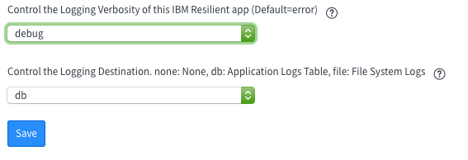

* To debug, change the logging verbosity and try create a Resilient Incident again

**Anticipated issues:**

* If using a MID Server, ensure it is up, running and validated

## Debugging tips:

* Change debugging verbosity and check the logs

## Failure modes:

* Cannot reach IBM Resilient Appliance
* User not authenticated
* When creating a Task, ensure the Incident Number is correct

End of Document