Scoped App Test Plan

IBM Resilient

# Table of Contents

1 Overview 3

2 Design document breakdown 3

3 Performance Test Cases 4

4 Load Test Cases 4

5 Functionality Test cases 5

6 Debugging demonstration 5

# Overview

Your Test Plan document is intended to enable ServiceNow Certification Engineers and Technical Support members to test your application and ascertain its quality. The document is used internally by ServiceNow only and is not shared with your customers.

To prepare your Test Plan, enter a thorough response in each section of this template document. Upload the completed document to your application record on the publisher portal.

ServiceNow performs a full run-through of your completed test plan with the intention of meeting the following high-level objectives:

1. All mitigating factors (processes) that were called out in the Design Document are demonstrated; either spelled out explicitly in this document or outlined for demonstration in the test plan run through.
2. All performance thresholds or constraints that were called out in the Design Document are demonstrated; either spelled out explicitly in this document or outlined for demonstration in the test plan run through.
3. All test cases are written in such a way that anyone, with little to no understanding of the application, can use the Test Plan to execute the full test suite. Any setup and configuration of the instance is outlined, and any dependencies on third-party or standalone software are specified. If customers will receive an installation guide with the application, the guide should be attached to the Design Document.

# Design document breakdown

N/A

# Performance Test Cases

Resource usage, scalability and reliability of the product are validated under this testing. Include all the test cases that were executed when performance testing was done. Also specify the yardstick used for the same. The primary goal of performance testing includes establishing the benchmark behavior of the system.

|  |  |  |  |
| --- | --- | --- | --- |
| *Test Case* | *Setup* | *Expected Result* | *Actual Result* |
| *1* | Go to Incident Table  Open a Record  Click Create Resilient Incident | An Incident should be created in IBM Resilient  The 3 Columns on the ServiceNow Record should contain values | Pass |
| *2* | Repeat Test Case 1 multiple times in succession | An Incident should be created in IBM Resilient for each repeated test  The 3 Columns on the ServiceNow Record should contain values for each repeated test | Pass |

# Load Test Cases

N/A

# Functionality Test cases

|  |  |  |  |
| --- | --- | --- | --- |
| *Test Case* | *Setup* | *Expected Result* | *Actual Result* |
| *1* | Go to Incident Table  Open a Record  Click Create Resilient Incident | An Incident should be created in IBM Resilient  The 3 Columns on the ServiceNow Record should contain values | Pass |
| *2* | Go to Incident Table  Open a Record  Click Create Resilient Task  Enter a valid Resilient Incident ID | A Task should be created in IBM Resilient  The 3 Columns on the ServiceNow Record should contain values | Pass |
| *3* | Open a ServiceNow Record that has a value in its *x_ibmrt_resilient_ibm _resilient_reference_id* column  Add a Work Note | The text of the Work Note should be added to the related IBM Resilient Incident/Task as a Note | Pass |
| *4* | Open a ServiceNow Record that has a value in its *x_ibmrt_resilient_ibm _resilient_reference_id* column  Add an Additional Comment | The text of the Additional Comment should be added to the related IBM Resilient Incident/Task as a Note | Pass |
| *5* | Open a ServiceNow Record that has a value in its *x_ibmrt_resilient_ibm _resilient_reference_id* column  Change the state of the Record | The SNOW Records Data Table should be updated to reference the new state of the Record | Pass |

# Debugging demonstration

* Most errors will be because of connection/authentication issues
* Use the Test Connection module to help debug, it is very intuitive

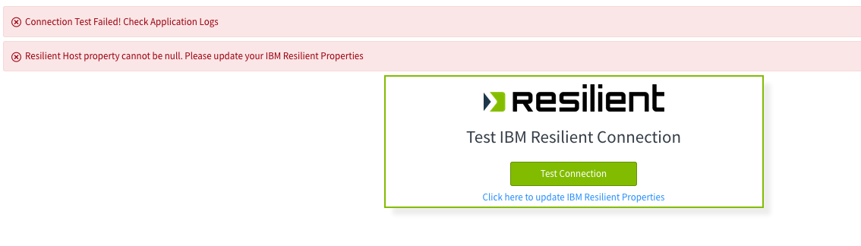

End of Document