**Assignment#2 Report**

**Team 9 (Jun Ma, Zhuojian Zhong, Chang Liu)**

**1. Code Package**

[**https://github.com/jma19/CS244Fall2017.git**](https://github.com/jma19/CS244Fall2017.git)

Our code locates in package Assignment#2 in master and cs244_master branch.

ESP: <https://github.com/jma19/CS244Fall2017/blob/master/Assignment%232/ESPClient/ESPClient.ino>

Server: <https://github.com/jma19/CS244Fall2017/tree/master/Assignment%232/Server>

Plot function: <https://github.com/jma19/CS244Fall2017/blob/master/Assignment%232/plot/plot.ipynb>

**2. Transmitting and Collecting Data**

Based on the work of assignment#1, in this assignment, we need to collect and transmit data generate by MAX30105 particle and pulse Ox sensor. In the Setup phrase of ESP program, we add functionality for MAX30105 module initial setting. In the loop phrase, we read data pair (RED, IR) from MAX30105 module and encapsulate it into a string by using special splitters, and then employee HTTP client to send the string data to server side.

In order to save cost of network transmission, we use batch technique to transmit sensor data. For capturing data with 50 Hz, we transmit a batch of data with 50 pairs within one second, and the batch data format is shown as follows (We use ‘#’ character to separate each data pair (RED, IR)):

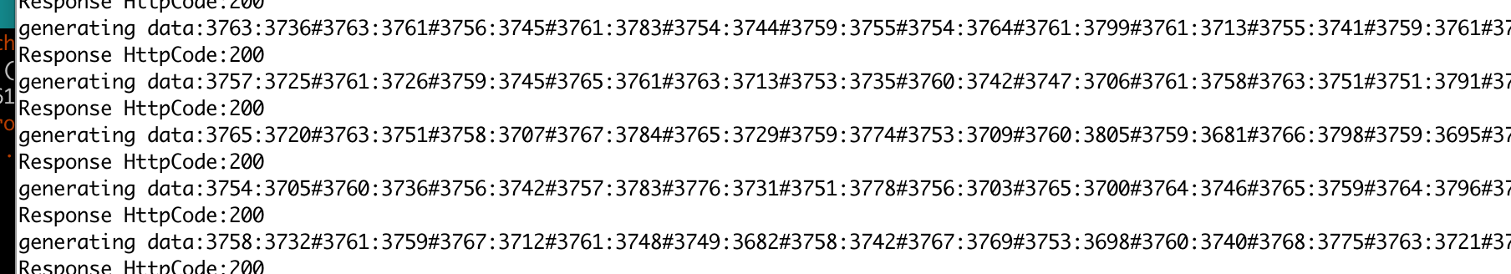

For 2 minutes sampling, we only need to receive 2 * 60 batch of data at sever side for each current setting.

When server receives data, we firstly decode the code, and then save data into memory (considering our samples are small). We record the data into CSV file when finishing recording data.

**3. Result**

The sensor data in csv file is shown as following table, and there are 6000 samples in total.

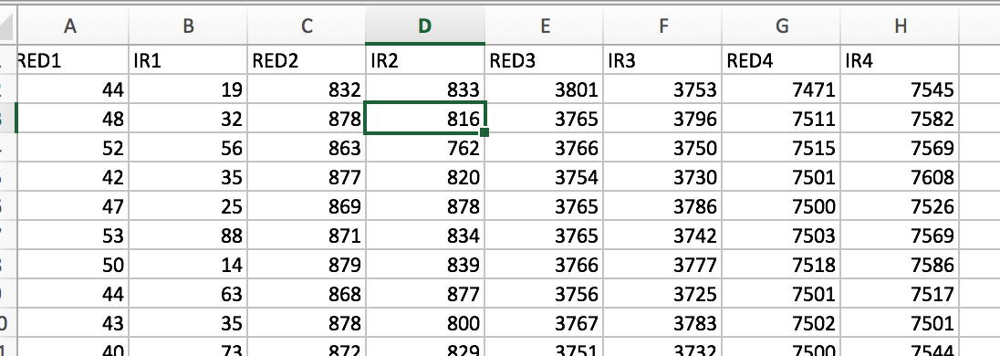

Fig.1, Fig.2, Fig.3, and Fig.4 shows the sensor data diagram for RED and IR with current setting 0.4mA, 6.4mA, 25.4mA, and 50mA respectively. From Fig.1 to Fig.2, the average value of the sensor data for RED and IR is almost proportional to current setting. Fig.5 shows the normalized sensor data diagram for RED and IR variations across different current settings. From Fig.5, we know that the variation value for RED and IR also increases with the increment of current value.

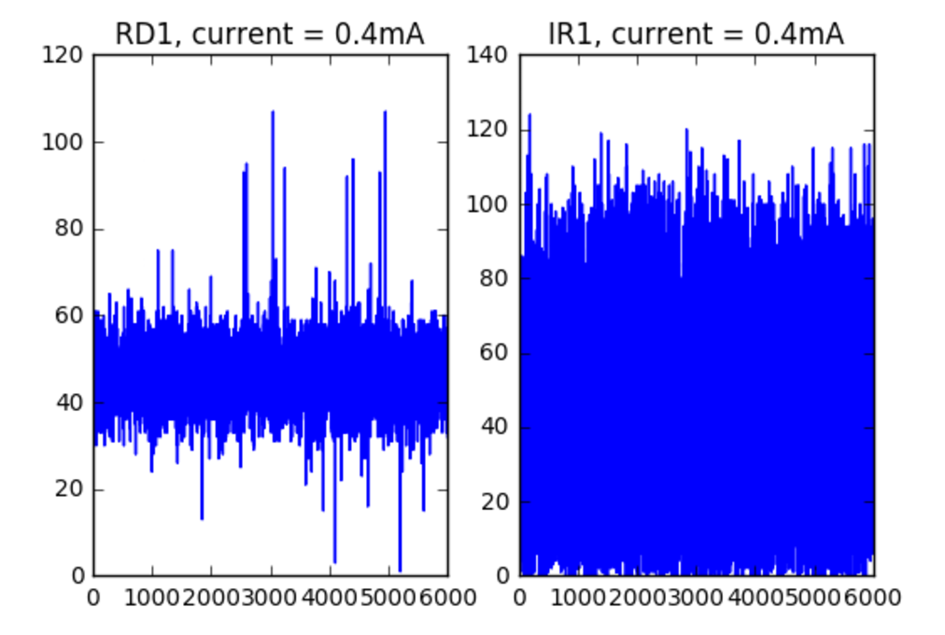

Fig.1 Sensor data diagram for RED and IR under current setting 0.4mA

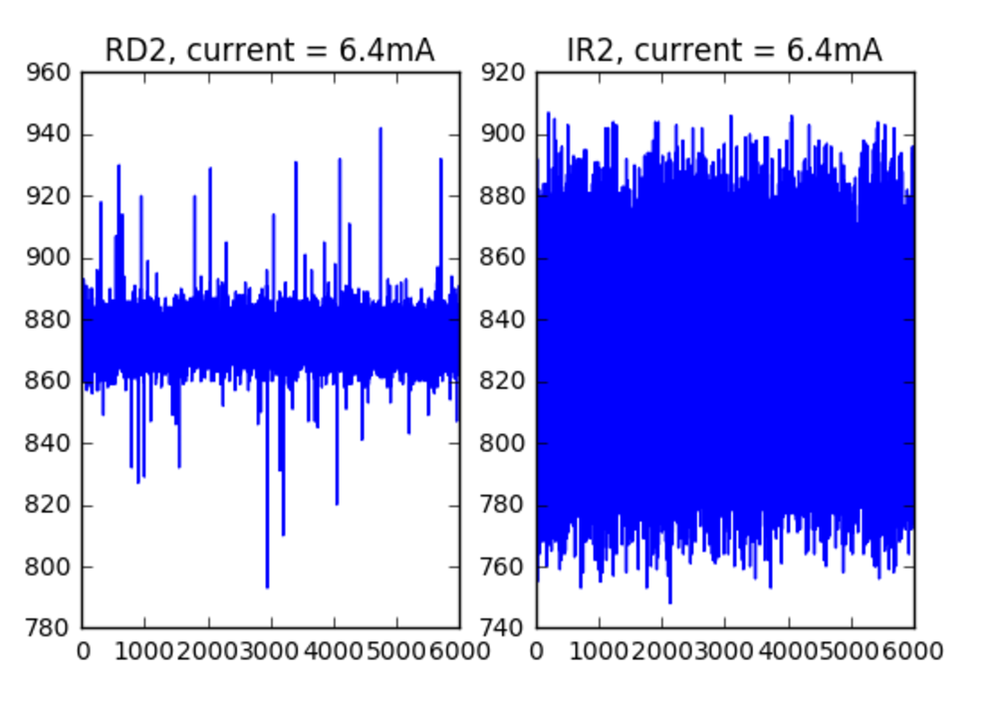

Fig.2 Sensor data diagram for RED and IR under current setting 6.4mA

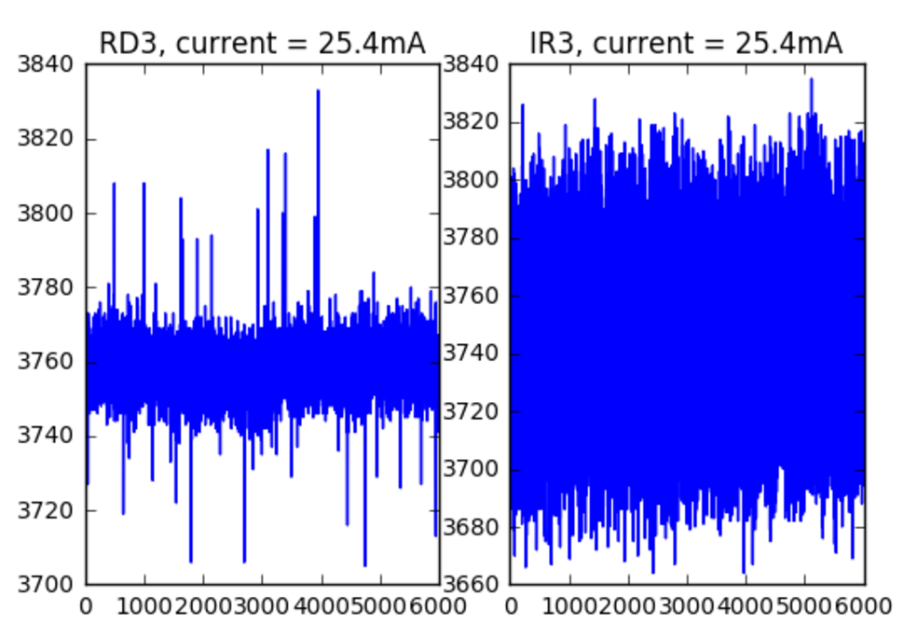

Fig.3 Sensor data diagram for RED and IR under current setting 25.4mA

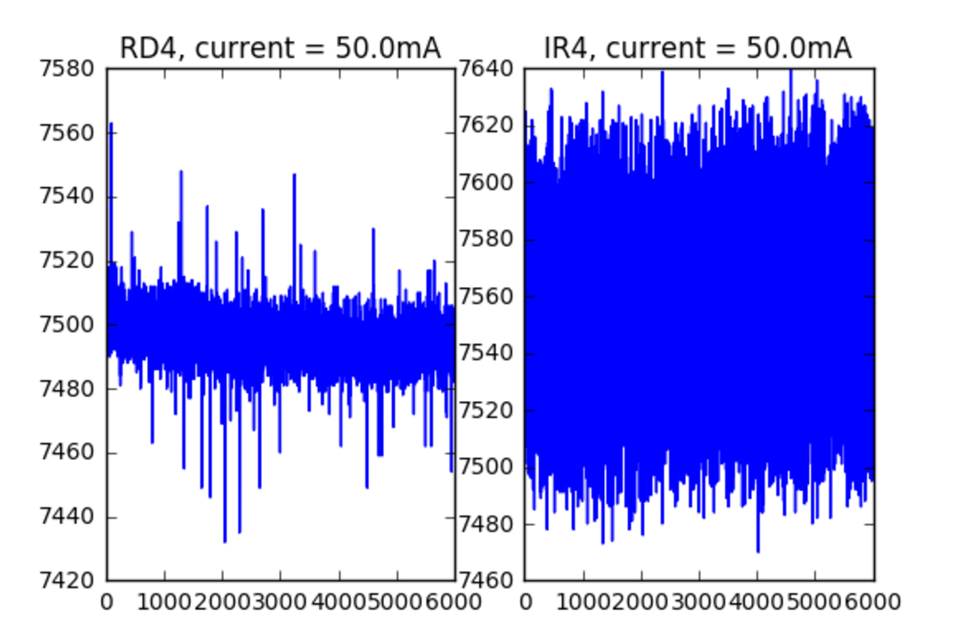

Fig.4 Sensor data diagram for RED and IR under current setting 50mA

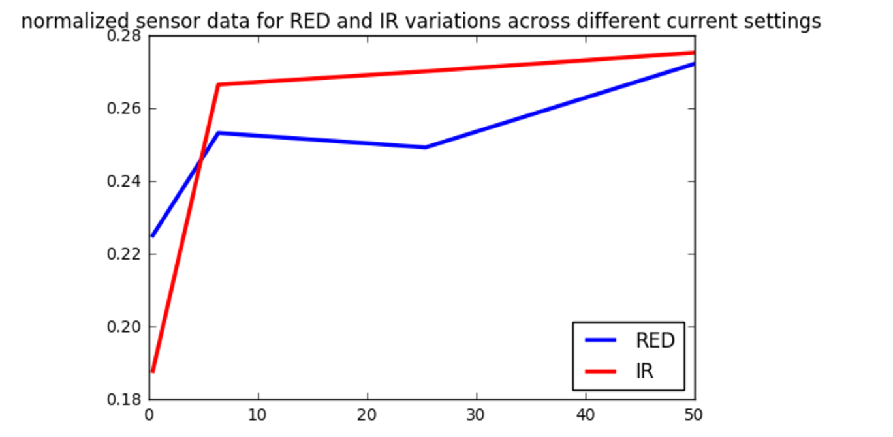

Fig.5 Normalized sensor data diagram for RED and IR variations across different current settings