Digital Collections SPMP

Neal Bhalodia

1.1

Project Overview: The game has the following requirements: it must provide a simple way for users to add items from their physical collections to Digital Collections, must work on mobile and desktop browsers, and must be suitable for people from all ages groups and also for people who aren’t good with technology.

1.2

Project Deliverables: A technical status report must be provided in November. A prototype as well as a plan for how the full version of the application would be finished must be presented in December. A working version of the application.

1.3

Evolution: All issues that take place will be discussed between the client and myself. I will be communicating with the client along the development process to get inputs and correct issues.

1.4

Reference Materials: I currently use a system called ShopKeep to manage inventory for my store but it is meant for a retail brick and mortar business. It has many of the functions I want like being able to search items, being able to track quantity, or other attributes like which supplier you bought it from.

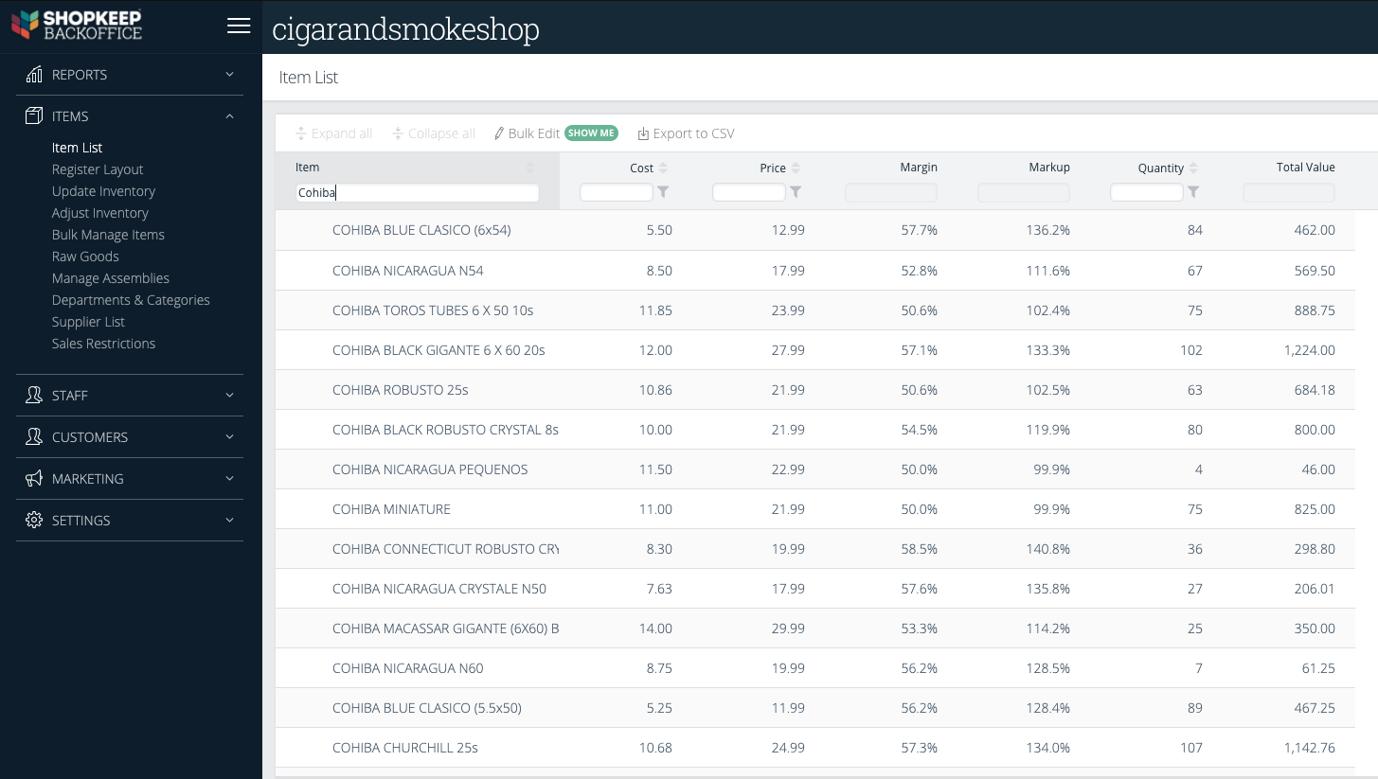

1.5

Definitions and Acronyms:

Collection: any set of similar items.

2.1

Process Model: The application will allow users to create an account where they store digital versions of their physical collection. Once a user signs up they will be able to create a collection with unique attributes. Once the collection is created the user can begin to add items to the collection. Users will be able to add items manually and eventually be able to add items using a CSV that will allow for bulk imports. Once the collections are complete users can show people specific items by searching.

2.2

Organizational Model: All user data will be stored in MongoDB which is a cloud nonrelational database. Each collection will be associated with the user that created the collection.

2.3

Organizational Interfaces: A database must be used to store data and the game must be able to run advertisements.

2.4

Project Responsibilities:

Create a sample UX without functionality to show the client.

Create methods for each piece of function.

Use MongoDB as the database to store user data.

Create a functional version of the application for test users.

Get feedback from test users on major flaws and changes required.

Create a plan to address the issues laid out by test users and fix them.

Continue to fix bugs and updates over the life of Digital Collections

3.1

Management Objective and Priorities: Responsibilities regarding developing the application will be on me. I will also be communicating with the client along the way. The priorities in development are achieving a functional prototype of the application in which all use cases run smoothly by early December and a technical report in November.

3.2

Assumptions, Dependencies and Constraints: The project has deadlines of a technical report being provided in November and a prototype presentation in early December. The cooperation and communication between myself and the client is very important to the completion of this project.

3.3

Risk Management: We will check that all data is properly secured when testing the functionality of the application.

3.4

Monitoring and Controlling Mechanism: There will be a technical status report presentation in November and a prototype presentation in December. Both presentations will be delivered virtually with visual demonstrations and speeches to explain the work.

3.5

Staffing Plan: One developer will handle all aspects of the development process. The client will provide input along the way and ask for any specific changes that they would like to see.

4.1

Methods, Tools, and Techniques

JavaScript, HTML, and CSS will be the languages used to program the application. I will use Webstorm as my IDE. Methods for each function will be created to organize different processes in the application.

4.2

Software Documentation

All lines of code will have comments that explain what the line’s purpose is, so that all future developers can clearly understand the methods and previously written code. There will also be documents with information about what each method does.

4.3

Project Support Functions

To ensure quality assurance all aspects of the application will be tested thoroughly with specific consideration for the user experience.

5

Work Breakdown Structure

