Healthy Adult Lifestyle Game Application

**Aaron Carty,** **Neal Bhalodia, Aayush Kharel, Sudeep Bishwakarma, Adebayo Abayomi**

Preface: A team of five will develop a gaming application to educate adults about healthy lifestyle choices, with a working prototype delivered in early December.

1.1

Project Overview: The game has the following requirements: it must educate adults about healthy living, must have single and multiplayer modes, must be compatible with mobile and desktop devices, game progress must be tracked, companies must be able to display advertisements within the game.

1.2

Project Deliverables:

-Use cases

-Requirements

-Github Repo

-SPMP

-Deployment Plan

-Tech Status Presentation (10/27/2020)

-Final project Presentation (12/08/2020)

1.3

Evolution: The SPMP will evolve to update more deliverables as they are assigned by the client. In addition, deadlines of deliverables will be updated to reflect extensions given.

The software project management plan is under version control. The repository will be updated as the project progresses. Each commit will have information on what was changed during the update.

https://github.com/ibneal/HealthWorld

2.1

Process Model: Software will be designed in an Agile Model process in order to tackle problems and bugs that might arise from production. Github will be implemented for collaboration. The game will allow users to control a character who will be given choices that affect their characters health. Poor choices will affect the health of their character while good choices will improve their character’s health. All characters begin with certain health stats based on vital information that users input in the beginning, so characters can start in good or poor health. In multi-player mode players compete with each other to say who can improve their health score the most.

The waterfall model will be used as the process model for this project.

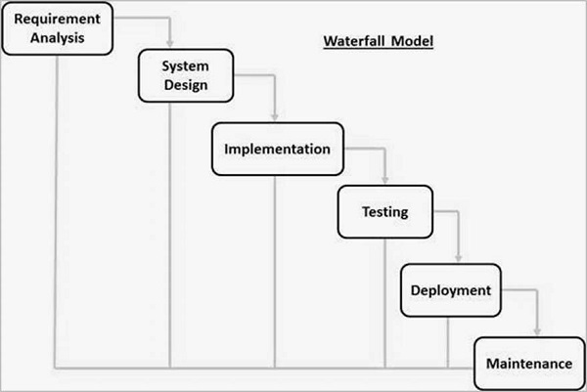

2.2

Organizational Model: Private contract, contractor reports to point of contact (Neal Bhalodia). POC reports to team regarding changes that need to be made.



2.3

Organizational Interfaces:

Organization Liaison Contact Information

Health App Commiteee Neal Bhalodia (Point of contact) nealbhalodia@gmail.com

**Heroku** is a domain and hosting service many multiple features that allow you to deploy updates to the project much more easily. I will also be able to

**Github** will be used to manage the work done on this application and for version control. It will also be connected to Heroku where the project will be deployed.

2.4

Project Responsibilities: We must build an interface for the game to prompt users to enter vital information for their characters. We must display their vital stats and present lifestyle choices. We must calculate the change in vital stats due to lifestyle choices. We must store various data and compare multiple character’s data for multiplayer mode. We must create space for advertisements for companies.

Role Description Person

UI design Handles Frontend Sudeep/Aayush

Code base Database/Backend Neal/Adebayo

3.1

Management Objective and Priorities: Responsibilities regarding developing the game will be delegated to group members and everyone will manage their own respective tasks. The priorities in development are achieving a functional prototype of our game in which all use cases run smoothly by early December and a technical report in November.

3.2

Assumptions, Dependencies and Constraints: The project has deadlines of a technical report being provided in November and a prototype presentation in early December. The cooperation and communication between the team is very important to the completion of this project.

3.3

Risk Management:

-We will check that all data is properly secured when testing the functionality of the game, so that it can’t be manipulated. Client Acceptance (Ask Client what features they would like to see implemented in version 2).

-Project Size (Try to Scale down Project to core functionality).

-Requirements Creep (Implement regression testing to get rid of unnecessary functions).

3.4

Monitoring and Controlling Mechanism: There will be a technical status report presentation in November and a prototype presentation in December. Both presentations will be delivered virtually with visual demonstrations and speeches to explain our work. Client will be given access to GitHub to monitor changes.

3.5

Staffing Plan: A team of five members will work on creating the game interface and functionality, as well as the database management and advertising.

4.1

Methods, Tools, and Techniques

Javascript (Phaser/ Node JS)

HTML/CSS

MySQL

WebStorm IDE

JavaScript, HTML, and CSS will be the primary languages used to program the game.

Most of the individuals working on this project will use Webstorm as their IDE.

4.2

Software Documentation

-All lines of code will have comments that explain what the line’s purpose is, so that all group members can clearly understand.

-APA Format

-SPMP, User cases and Requirements documents uploaded on github.

4.3

Project Support Functions

To ensure quality assurance all aspects of our application will be tested thoroughly with specific consideration for the user experience.

-Configuration Management plan will prevent others from uploading Documents/Editing Source code without Developer permission.

-Versioning will be implemented.

5

Work Breakdown Structure

The gaming interface is the highest priority piece, followed by coding the gameplay, and the advertisement display is the last piece. The gaming interface and gameplay development are co-dependent.

Gantt Chart

Work Breakdown Structure

