brms_reg_school_nesting Diagnostics
Ibrahim Osumanu
2026-05-05
brms_reg_model_production <- readRDS("~/OneDrive/Bayesian Inference/brms_reg_model_production.rds")
summary(brms_reg_model_production)
## Family: bernoulli
## Links: mu = logit
## Formula: is_sped ~ reg + (1 | Schl)
## Data: df_reg_clean (Number of observations: 139601)
## Draws: 4 chains, each with iter = 5000; warmup = 2500; thin = 1;
## total post-warmup draws = 10000
##
## Multilevel Hyperparameters:
## ~Schl (Number of levels: 222)
## Estimate Est.Error l-95% CI u-95% CI Rhat Bulk_ESS Tail_ESS
## sd(Intercept) 0.72 0.04 0.65 0.81 1.01 865 1861
##
## Regression Coefficients:
## Estimate Est.Error l-95% CI u-95% CI Rhat Bulk_ESS
## Intercept -1.87 0.05 -1.96 -1.77 1.01 385
## regAfricanAmerican_Female 0.16 0.03 0.10 0.21 1.00 4177
## regAfricanAmerican_Male 0.78 0.03 0.73 0.83 1.00 3775
## regAmericanIndian_Female 0.01 0.18 -0.36 0.36 1.00 11559
## regAmericanIndian_Male 0.65 0.15 0.35 0.94 1.00 12132
## regAsian_Female -1.21 0.10 -1.41 -1.03 1.00 11211
## regAsian_Male -0.25 0.06 -0.37 -0.12 1.00 9054
## regHawaiian_Female 0.12 0.31 -0.53 0.69 1.00 11967
## regHawaiian_Male 0.14 0.31 -0.49 0.70 1.00 13402
## regHispanicDLatino_Female -0.14 0.03 -0.21 -0.08 1.00 5521
## regHispanicDLatino_Male 0.44 0.03 0.38 0.50 1.00 4968
## regMultiMRacial_Female -0.05 0.05 -0.16 0.05 1.00 8515
## regMultiMRacial_Male 0.64 0.04 0.55 0.73 1.00 7660
## regWhite_Male 0.56 0.02 0.51 0.61 1.00 4033
## Tail_ESS
## Intercept 812
## regAfricanAmerican_Female 6441
## regAfricanAmerican_Male 6527
## regAmericanIndian_Female 7493
## regAmericanIndian_Male 7769
## regAsian_Female 7591
## regAsian_Male 7346
## regHawaiian_Female 6807
## regHawaiian_Male 7018
## regHispanicDLatino_Female 6813
## regHispanicDLatino_Male 6961
## regMultiMRacial_Female 7345
## regMultiMRacial_Male 7148
## regWhite_Male 5954
##
## Draws were sampled using sampling(NUTS). For each parameter, Bulk_ESS
## and Tail_ESS are effective sample size measures, and Rhat is the potential
## scale reduction factor on split chains (at convergence, Rhat = 1).
library(performance)
## Warning: package 'performance' was built under R version 4.4.3
icc_results<-icc(brms_reg_model_production)
print(icc_results)
## # Intraclass Correlation Coefficient
##
## Adjusted ICC: 0.137
## Unadjusted ICC: 0.132
library(bayesplot)
## Warning: package 'bayesplot' was built under R version 4.4.3
## This is bayesplot version 1.11.1
## - Online documentation and vignettes at mc-stan.org/bayesplot
## - bayesplot theme set to bayesplot::theme_default()
## * Does _not_ affect other ggplot2 plots
## * See ?bayesplot_theme_set for details on theme setting
library(ggplot2)
## Warning: package 'ggplot2' was built under R version 4.4.3
# Select your main parameters (Global Intercept and Variances)
# 'sd_Group__Intercept' is the typical brms name for random intercept SD
params <- c("Intercept","b_Intercept", "sd_Schl__Intercept")
params_1<-c("Intercept","b_Intercept", "sd_Schl__Intercept","b_regAfricanAmerican_Female", "b_regAfricanAmerican_Male", "b_regAmericanIndian_Female","b_regAmericanIndian_Male","b_regAsian_Female","b_regAsian_Male","b_regHawaiian_Female","b_regHawaiian_Male","b_regHispanicDLatino_Female","b_regHispanicDLatino_Male","b_regMultiMRacial_Female","b_regMultiMRacial_Male","b_regWhite_Male")
# Generate the side-by-side plot
mcmc_combo(brms_reg_model_production,
pars = params,
combo = c("dens_overlay", "trace"))
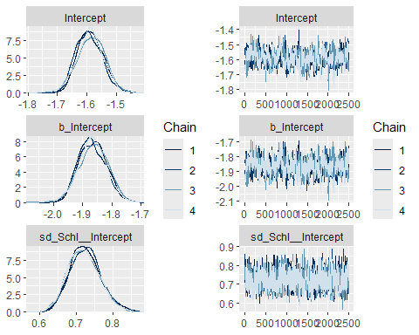
# This shows the 50% (thick line) and 95% (thin line) credible intervals
mcmc_intervals(brms_reg_model_production,
pars = params_1) +
vline_0() # Adds a vertical line at zero for significance testing
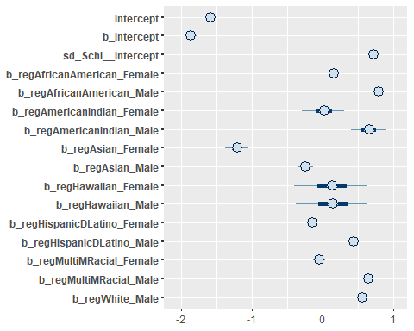

Posterior Predictive Checks
library(bayesplot)
pp_check(brms_reg_model_production, nsamples = 50)
## Warning: Argument 'nsamples' is deprecated. Please use argument 'ndraws'
## instead.
