**Assignment #1**

*(LO 1)*

Name: **Muhammad Syazwan bin Azman** Matric No: **1822127**

**Questions:**

1. By using google colab code to access your webcam, capture three different facial expressions of yourself.
   1. Apply both Canny Edge Detection and Sobel Edge Detection to only the face area of the image using a suitable threshold value. (5 Marks)
   2. Perform blurring of only faces in those images. (5 Marks)
   3. Calculating the number of coins in an image using contours. (5 Marks)

**Answers:**

All the three different facial expression was captured using the “FaceCapture.ipynb” file:

**Photo1.jpg** **Photo2.jpg**



**Photo3.jpg**



1. All the photos need to be stored in the same folder as working folder.

1- The photos need to be converted to gray and undergo Gaussian Blur process. And then, using canny function in OpenCV to get the canny output. To display the Canny output only at the face, masking technique needed to mask the images. Here are the output images for Canny Edge Detection:

**Photo1.jpg** **Photo2.jpg**

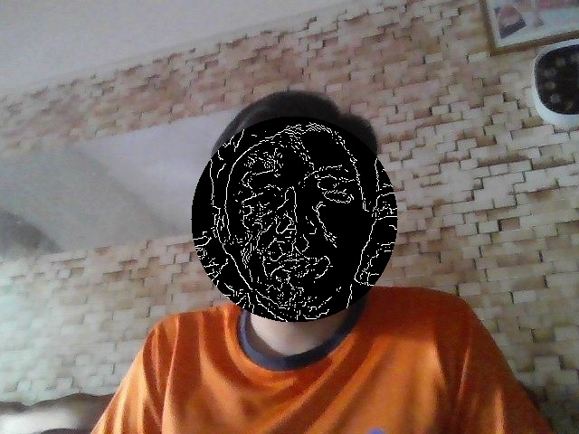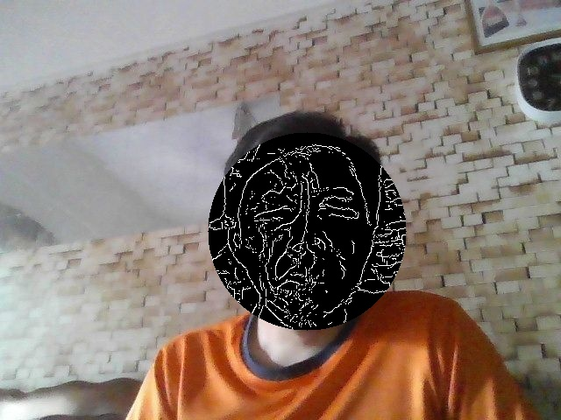

**Photo3.jpg**

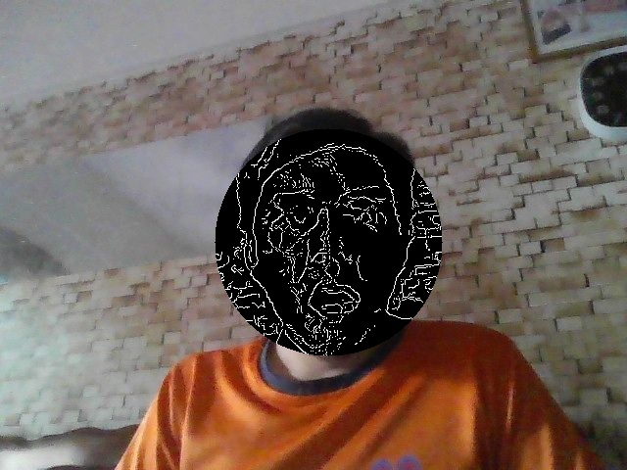

2- The photos need to be converted to gray and undergo Gaussian Blur process. And then, using Sobel function in OpenCV to get the Sobel output. To display the Sobel output only at the face, masking technique needed to mask the images. Here are the output images for Sobel Edge Detection:

**Photo1.jpg** **Photo2.jpg**

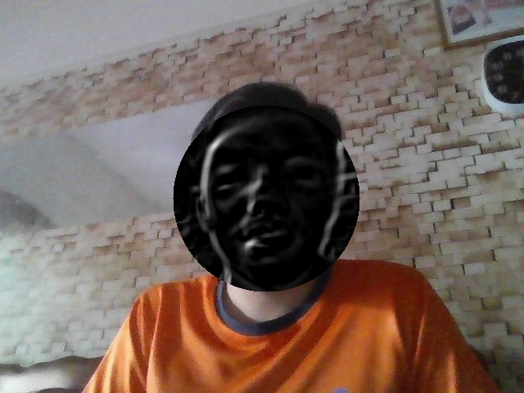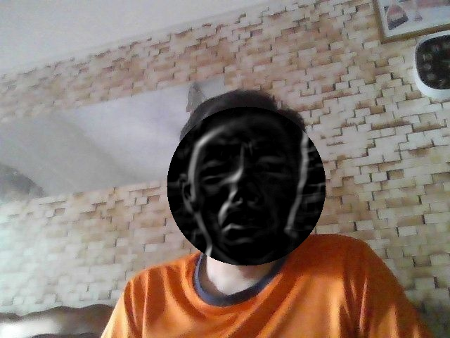

**Photo3.jpg**

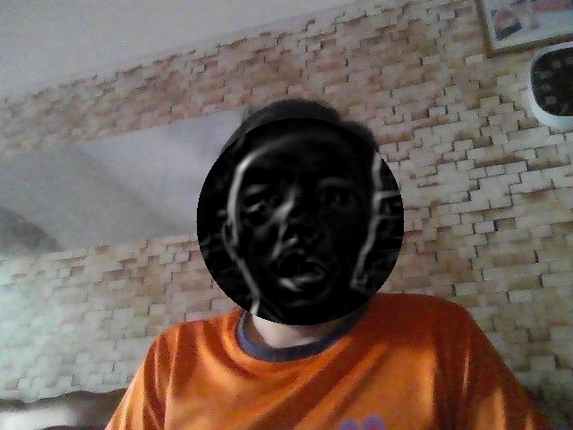

1. The original images will be blurred using Gaussian Blur function in OpenCV. A mask image referring to the blur image will be produced. Then, original image and blurry image will be masked by the blurry mask image output. Here are the Blurry face on the images:

**Photo1.jpg** **Photo2.jpg**

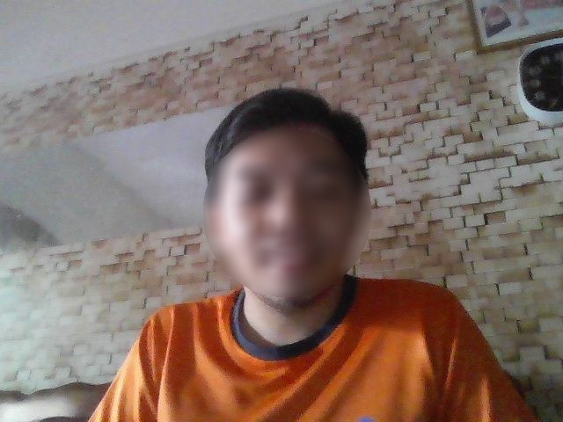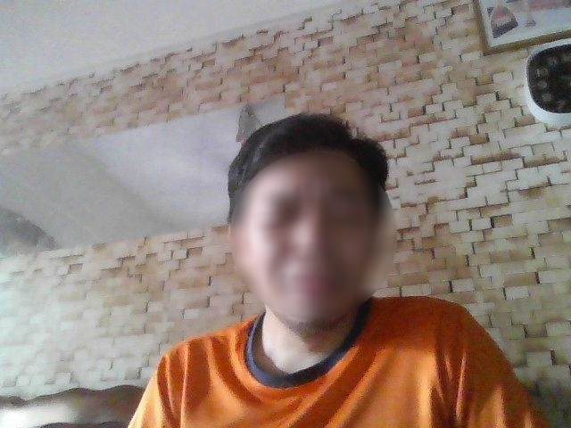

**Photo3.jpg**

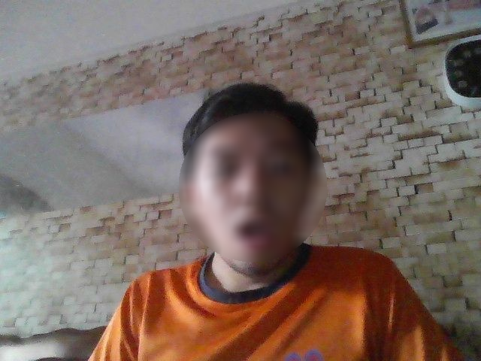

1. The images will be converted to gray and then blurry imagers. After that, the images will undergo dilation process after been converted to canny images. Using “findContours” function in OpenCV, the program can count specific shape in the images. Here are the output images for calculating number of coins:

**coins1.jpg**

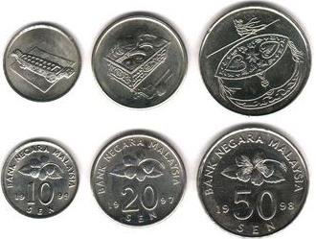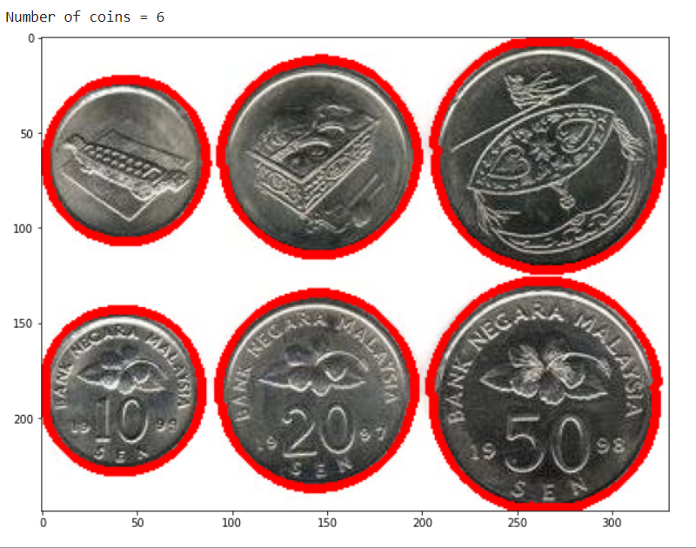

**coins2.jpg**

