Review of Utility Networks

Table of Contents

1 Introduction 2

1.1 Urban Simulation 2

1.2 3D Data in Urban Simulation 2

2 Semantic City Models 2

2.1 CityGML 2

2.2 Application Domain Extension (ADE) 3

2.3 3DCityDB 3

3 Utility Networks 3

3.1 Visualizing Utility Networks 4

3.1.1 Augmented Reality 4

3.2 Modeling with Utility Networks 4

3.2.1 Eco-Industrial Parks 4

3.2.2 Distributed Power Generation in Hierarchical Networks 5

3.2.3 Energy Reclamation using Another Network's Existing Infrastructure 5

4 The UtilityNetwork ADE 6

4.1 Overview 6

4.2 Functional Modeling 8

4.3 UtilityNetwork ADE for 3DCityDB 8

4.4 Applications & Examples 9

4.4.1 Cascading Failures with SIMKAS-3D 9

4.4.2 Dual Representation with the Nanaimo Water Network 9

4.4.3 3DCityDB Implementation and Topological Routing Analysis with the Rotterdam Electric Network 10

5 Conclusion 11

6 Bibliography 12

# 1 Introduction

## 1.1 Urban Simulation

The modern urban citizen's expected standard of living, together with the trend of populations shifting to urban centres has made clear the necessity of careful planning and distribution of limited resources. These resources are in many cases delivered to the urban population via utility networks. When a person turns on the tap, water is expected to flow. When they turn on the light switch, electric current is expected to illuminate the light bulb. It is easy to take these systems for granted, but the truth is that these conveniences are merely the end result of a carefully-planned system, spanning entire networks at differing scales, constantly balancing network load while anticipating future demand, twenty-four hours a day, seven days a week. (Waddell & Ulfarsson, 2004) provide a history of so-called "Urban Simulations", which are broadly defined as *"operational models that attempt to represent dynamic processes and interactions of urban development and transportation"*.'

## 1.2 3D Data in Urban Simulation

While Waddel & Ulfarsson primarily emphasized the policy & stakeholder considerations, urban simulations can be designed to analyze any aspect of the urban environment. With the recent increases in computational capacity and availability of 3D spatial data, it has become feasible to perform simulations on urban environments that take into account physical & geoemtrical properties of the urban structures themselves. A popular area of research in this regard has been to use 3D building models to calculate energy losses and gains due to solar irradiance (Simons, 2014), (Quan et al., 2015), (Pili, Desogus & Melis, 2018).

# 2 Semantic City Models

A semantic city model is one which stores not only the physical and geometrical properties of the objects, but also information that is not inherently spatial, such as the age of a building, the species of tree, the number of doors or windows in a building, etc. Such semantical properties are important - useful assumptions can be made from the age of a building regarding its heat loss, for instance.

## 2.1 CityGML

CityGML is a standardized storage and exchange format for 3D city models based on Geographic Markup Language (GML) and developed by the Open Geospatial Consortium (OGC). It is designed to provide a common framework for geometric and semantic information about objects found in cities at multiple levels of detail (OGC 2012). It has become a popular choice for base data intended to be used in urban simulations. This is because its standardized definitions allow for simulation models to be designed to be reusable and reproducible, while maintaining enough flexibility to suit most needs in creating customized 3D city models.

## 2.2 Application Domain Extension (ADE)

An application domain extension is an expansion of the existing CityGML schema to enable a similarly-standardized model for a specific theme (CityGML, 2018). By using the abstract *"CityObject"* class, from which all CityGML classes derive themselves from, an entirely new family of classes can be defined via an XML schema definition file (.xsd). Each ADE has its own namespace to separate them from core CityGML classes, as well as other ADE classes. In this way, multiple ADEs can be added to a single CityGML file without interfering with each other. Figure 1 depicts the modular expansion-like relationship between ADEs and CityGML.

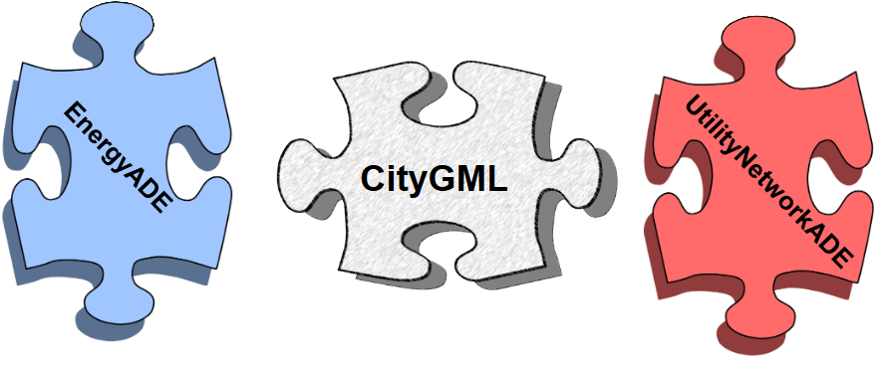  
Figure 1: ADEs connect to CityGML to expand their ability to model specific thematic properties of city objects. From (Nichersu, 2017)

## 2.3 3DCityDB

The 3D City Database (3DCityDB) is a pre-defined relational database schema that provides a near 1:1 mapping of the CityGML data structure specification in a relational database context (TU Berlin, 2011). It is available for (PostGIS enabled) PostgreSQL and Oracle Spatial databases. Using 3DCityDB as the basis for an urban simulation model leverages the speed and transactional integrity of a relational database management system (RDBMS) while maintaining the familiar standardized CityGML specification. It has enjoyed many implementations in the domain of urban modeling and simulation, including development of a 3D city model for Berlin (Stadtler et al., 2009), cloud-based storage & distribution of 3D city models (Herreruela, Nagel & Kolbe, 2012) and development of a 3D city model for New York and subsequent rendering using the Cesium web-based rendering engine (Kolbe, Burger & Cantzler, 2015). Figure 2 depicts the relationship between CityGML and 3DCityDB.

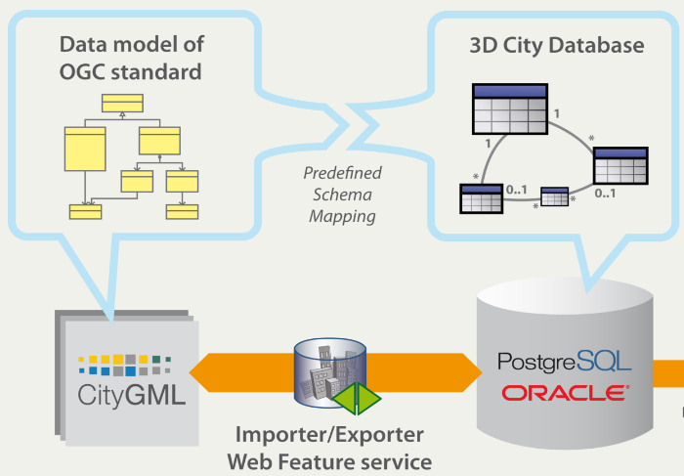  
Figure 2: Relationship between the CityGML data model and the table schema in the 3DCityDB. From (Kunde, 2014)

# 3 Utility Networks

Similar to how the physical & geometrical properties of urban buildings play an important role in determining resource demand & distribution, the physical & geometrical properties of the utility network structures are also important considerations, in addition to the functional connectivity. Further to this, the increasing complexity of modern utility networks introduces interdependencies. For instance, a water processing facility requires electricity to function. In the event of an electrical network component breakdown upstream of the water processing facility, the water network downstream of the facility will cease to have water flowing through it. These kinds of interdependencies are difficult to model, given the differences in network type-specific modeling systems.

## 3.1 Visualizing Utility Networks

* 1. Given that quite often the majority of the components that comprise a utility network are underground or otherwise hidden, visualizing them becomes a top priority. In modern GIS, visualizing geometrical features that represent utility networks is quite trivial. The real complications arise when the source data for different networks are only available in different formats, often tailoured for use in a specific GIS, relevant to its network type. A preferable solution would be a utility network data model that uses the same core fundamentals to model all types of utility networks at all scales. This would allow for any arbitrary GIS to easily render the network features, no matter the semantic differences between them.

### 3.1.1 Augmented Reality

The recent advances in augmented reality (AR) technology bring exciting possibilities in the context of visualization of hidden utility network features. Devices such as tablets and AR/VR goggles are coming into the realm of affordability for industry and even personal use. It was found during a survey of people who routinely work with utility networks by (Gustafsson & Berg, 2017) that 88.9% of respondents believed that 3D visualizations of utility network data (including AR visualizations) would improve their field work. (Blut, Blut & Blankenbach 2017) have explored in great detail the feasibility and best practices of visualizing large-scale CityGML datasets for rendering on portable computers and indeed in AR applications. Given other recent successes in the field visualization of CityGML / 3DCityDB & urban simulations (Wendel, Nuñez & Simons, 2017), (Heuveline, Ritterbusch & Ronnås, 2011), a standardized, CityGML-based model for utility networks would be a valuable asset for facilitating visualization of hidden utility network components themselves, as well as the results of urban simulations thereupon.

## 3.2 Modeling with Utility Networks

* + 1. Utility network modeling is a broad topic with varying levels of informational requirement. Some models may consider only the connectivity of network elements, requiring no semantic information about the physical components that comprise the network. Others may factor in semantic properties such as the material, flow capacity, age of the component etc., and some may also factor in the topographical properties, such as the length & width of components, even the elevation may be important when considering height differentials.

### 3.2.1 Eco-Industrial Parks

Maximization of efficiency in industrial parks has been married to ecological responsibility by means of the concept of the "eco-industrial park". By using network infrastructure to connect different industrial facilities together, the by- or waste-products of one facility can be used directly as the input to another. (Boix et al., 2015) promotes the development of eco-industrial parks, as they are efficient to the industries themselves, as opposed to punitive "end-of-pipe" solutions, which are often expensive and mandated by a political decree. The authors provide a comprehensive review of optimization methods used to design eco-industrial parks with maximum efficiency. However, most of the methods described are theoretically-defined, offering very little or no information about the model that could manage such complex network datasets. In order to facilitate the development of accurate and precise eco-industrial park network models, a data format is required that can model physical network component properties, their semantic properties, their functional topological connectivity. Networks for different transported media must be able to be stored together and indeed be able to interact with each other. Such a data format would allow for concrete definition of optimization algorithms that could be quickly adapted for new network datasets and / or up- or down-scaling.

### 3.2.2 Distributed Power Generation in Hierarchical Networks

In (Georgilakis & Hatziargyriou, 2015), it is observed that distributed power generation is a hallmark of modern power distribution planning. The reductions in cost of power generation on the individual level, such as from photovoltaic cells and wind turbines is significant and must be accounted for when planning electric network load balancing. A data format is therefore required that is able to model sources and sinks of electricity on low, medium and high voltage networks simultaneously. Algorithms designed to use such a data format as input would therefore be re-usable for different networks, and would facilitate simulation of network modifications & expansions.

### 3.2.3 Energy Reclamation using Another Network's Existing Infrastructure

With the increase in prevalence of district heating networks (DHNs) in Europe, it is not unexpected that some of them are beginning to integrate "waste heat" produced by commercial and/or industrial equipment (Sayegh et al., 2017). Such a coupling between individual networks further reiterates the usefulness of a standardized data format that can model the interdependencies between networks, where the output of an element in one network can serve as the input to another.

Another case of network coupling with existing infrastructure is that of (City of Nanaimo (1), 2018), wherein water flowing through pipes down a slope gains kinetic energy, which is recovered by turbines and converted to electricity for the local electric grid before being deposited into the nearby reservoir. It is clear that in order for accurate models and simulations to be performed, a uniform data model is required for utility network modeling and simulation that can model topographical, topological and semantical properties, as well as the ability to store different networks and their interdependencies.

# 4 The UtilityNetwork ADE

## 4.1 Overview

An ADE of particular interest for the development of urban simulations involving utility networks is the UtilityNetwork ADE. It extends the CityGML schema to enable storage of features related to utility networks, including their geometry, semantic properties and topological connectivity. (Becker, Nagel & Kolbe, 2012) describe the genesis of the ADE as a response to a lack of definition precision capability in three major network modeling frameworks.

The first model, the ArcGIS Network Model, was found only to be able to represent 2D topography and connectivity information. Any 3D representation would be therefore decoupled from the model. Additionally, it was limited to only water, electricity and gas networks, with no common model shared between them.

The second model, the Industry Foundation Classes (IFC) Utility Model, was found to be restricted to a local engineering reference frame, making it only relevant to individual buildings, and not feasibly able to scale up to urban scale.

The final model, the INSPIRE Network Package, was found to lack the capability to decompose features into smaller features in a hierarchical way, as well as explicit 3D topographic representations of network features. It was also found that the functionality of network features was not obvious, and that the emphasis of the model was on describing topography and not on modeling functionalities of individual features.

Consequently, the UtilityNetwork ADE was designed so as to model any kind of network, at any or indeed multiple hierarchical scales (see Figure 3) with explicit definitions of the function of network components. A topographical and topological structure of networks and their constituent components allows for a simultaneous dual-representation of topography and topology. The functional linkages between network components are also modeled explicitly (see Figure 4). Network components can be aggregated into hierarchical complex features (see Figure 5). The goal was to have a data model which could store any information from the three previously mentioned data models with no information loss (Becker, Nagel & Kolbe, 2012).

The concept of recursively defining network component feature hierarchies, as well as the "dual representation concept is further elaborated on in (Becker, Nagel & Kolbe 2011). Furthermore, the need for further research into the nature of how exactly to model dependencies between networks is expressed.

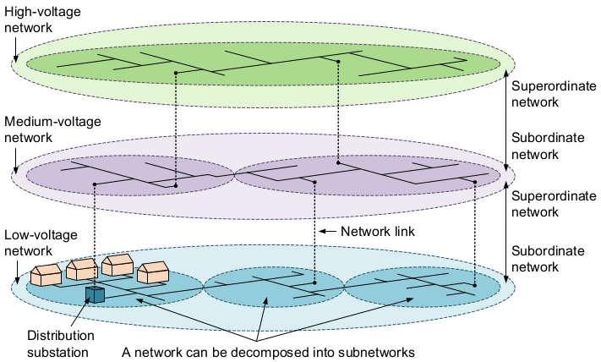  
Figure 3: Multiple networks modeled in a hierarchy. From (Kutzner & Kolbe, 2016).

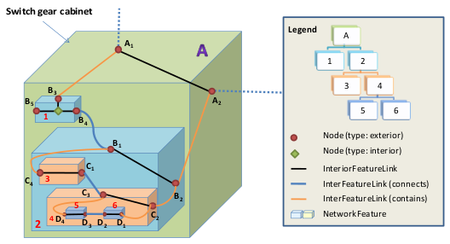  
Figure 4: Multiple network components modeled in a hierarchy. From (Becker, Nagel & Kolbe, 2011).

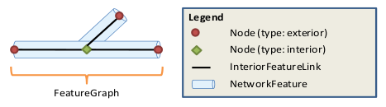  
Figure 5: Dual representation (topographical & topological) of network components with explicitly modeled linkages. From (Becker, Nagel & Kolbe, 2011)

## 4.2 Functional Modeling

In (Kutzner & Kolbe, 2016), attention is given to exploring the capability of defining the functionality of components in a network that would be useful in a simulation context. Firstly, the concept of the "Supply Area" is introduced, which provides an alternative for connecting consumption elements in the network. It is a geographical region, which is a property of the network, and it is considered an extent inside of which all consumption elements are inherently connected to that network's production element(s) (see Figure 6). It provides an alternative for creating functional models when little or no information is available regarding the actual layout of the network.

The concepts of "Suppliability" and "Suppliedness" are also introduced, which are intended to be measures of how much of the network's transported medium can be consumed by a consumption element, and what is at the current moment being consumed by the consumption element. These concepts are valuable in developing functional simulation models to evaluate the changes in the flow of the network's transported medium.

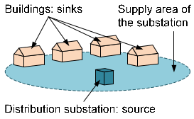  
Figure 6: Distribution area for a network, connection a source network feature (production) to its sink features (consumption). From (Kutzner & Kolbe, 2016).

## 4.3 UtilityNetwork ADE for 3DCityDB

Similarly to how the CityGML schema has been mapped to a relational database schema via the 3DCityDB (see section 2.3), there are also efforts to map the UtilityNetwork ADE schema as an extension to the 3DCityDB default schema. Following recent successes in doing so for the Energy ADE (Agugiaro & Holcik, 2017), there is such a schema mapping that has been recently completed and is undergoing testing (Agugiaro, 2018). A specific point of interest is the inclusion of so-called "smart insert functions". Relational databases often rely on complex relationships to minimize data storage requirements and increase computational efficiency, which come at the cost of ease of viewing and understanding. These "smart insert" functions allow a developer to insert individual network elements with a simple and human-readable PostgreSQL function, which takes care of the complex data relation mapping automatically to maintain database integrity. These functions make it quite simple to convert CityGML files with the UtilityNetwork ADE extension to a standardized relational database format, based on the already-familiar 3DCityDB schema.

## 4.4 Applications & Examples

### 4.4.1 Cascading Failures with SIMKAS-3D

The Simulationen von intersektoriellen Kaskadeneffekten bei Ausfallen von Versorgungsinfrastrukturen (SIMKAS-3D) project was the first use of the UtilityNetwork ADE in practice. Its goal was to model the cascading effects & failures due to an initial failure in a different, but dependent utility network. A multi-utility network complete with internetwork dependencies was developed for the city of Berlin (Bundesministerium für Bildung und Forschung, 2012). Unfortunately, the data was not made publicly available.

### 4.4.2 Dual Representation with the Nanaimo Water Network

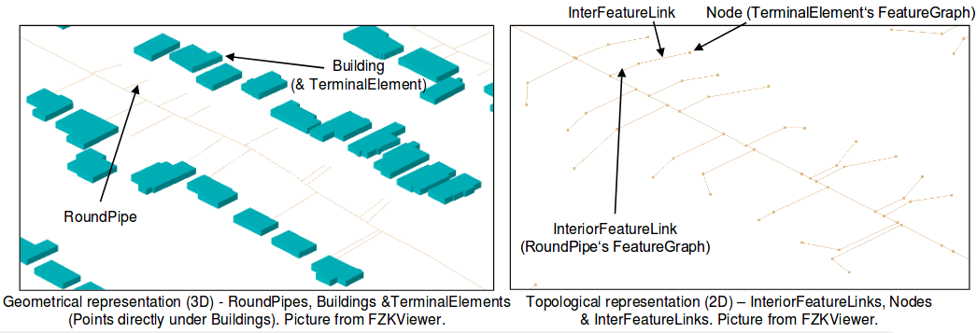  
Figure 7: Leveraging the "dual representation" principle to only model what is known about the physical network components (left), while adding abstract links to complete the functional connection to the buildings (right). From (Boates, 2017).

The city of Nanaimo in Canada has released various utility network data to their Open Data Catalogue (City of Nanaimo (2), 2018). (Boates, 2017) converted parts of the water network into a network dataset with functional connectivity in the UtilityNetwork ADE. Attention was given specifically to the ability to model differences between the topographical and topological representations, in accordance with the "dual representation" principle outlined in (Becker, Nagel & Kolbe, 2011). A lack of specific information about how the water pipes connected into the houses themselves led to a solution in which only the known pipes are modeled, but an abstract link is added to the topological structure to complete the functional connection (see Figure 7).

### 4.4.3 3DCityDB Implementation and Topological Routing Analysis with the Rotterdam Electric Network

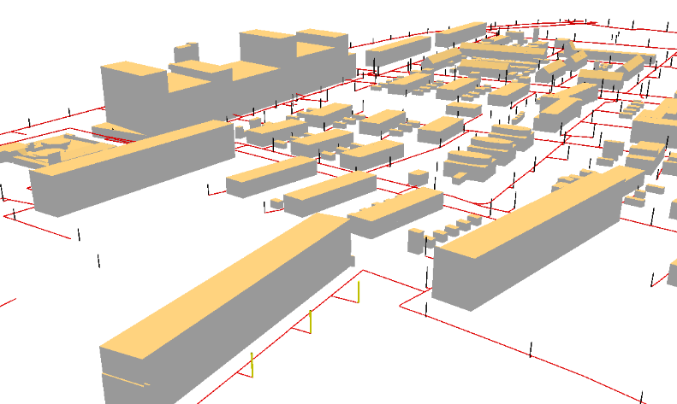  
Figure 8: The electrical network in Rotterdam modeled in the UtilityNetwork ADE. The three yellow features are streetlights that have been identified as being effected by a network break, by using the pgRouting topological routing algorithms.

The city of Rotterdam in the Netherlands has recently released their sewer and electrical network as part of an open data initiative. (den Juin, 2017) translates this data into a functional utility network model in the UtilityNetwork ADE. Of particular interest was the subsequent conversion of the CityGML dataset to the associated 3DCityDB schema in a PostgreSQL (+PostGIS) database. In doing so, capability for the use of the pgRouting library (pgRouting, 2018) was enabled, which allowed for topological routing algorithms to be used to identify streetlights that were downstream from a certain point (see Figure 8). This proves that it is feasible to perform topological network connectivity modeling using the UtilityNetwork ADE 3DCityDB schema.

# 5 Conclusion

Utility networks remain a surprisingly underdeveloped topic of research. They are absolutely in supplying urban areas with the necessities of life and luxuries that the modern citizen has come to expect. They are also becoming more complex, and the interdependencies between them are constantly increasing. A unified data model is needed that is able to model utility networks physically, semantically and functionally, as well as on arbitrary scales. Such a data model would be of great value for visualization of and developing simulation models for extremely complex utility networks.

The UtilityNetwork ADE offers these capabilities. As an extension of the CityGML data model, it will be able to interface well with existing semantic city models. The mapping of its schema to an extension for the 3DCityDB also allows for the leveraging of the speed and transactional integrity of an RDBMS. The work conducted so far in building models with it is promising and offers exciting possibilities in visualizing, developing urban simulations on and modeling interdependencies between utility networks.

# 6 Bibliography

**Waddell & Ulfarsson, 2004:** *"Introduction to Urban Simulation: Design and Development of Operational Models"*. In "Handbook of Transport Geography and Spatial Systems (Handbooks in Transport, Volume 5)", pp. 203 - 236

**Simons, 2014:***"Development of a CityGML infrastructure for the implementation of an energy demand method with different data sources"*. Master Thesis at Hochschule Karlsruhe Technik und Wirtschaft.

**Quan et al., 2015:** *"A GIS-based Energy Balance Modeling System for Urban Solar Buildings"*. Energy Procedia (75). Elsevier.

**Pili, Desogus & Melis, 2018:** *"A GIS tool for the calculation of solar irradiation on buildings at the urban scale, based on Italian standards"*. Energy and Buildings 158. Elsevier.

**OGC 2012:** *"OGC City Geography Markup Language (CityGML) Encoding Standard"*. Accessed 2018-03-04. <https://www.citygml.org/>

**TU Berlin, 2011:** *"CityGML DBMS storage 3DCityDB Implementation"*. Powerpoint Presentation. Accessed 2018-03-04. <https://www.3dcitydb.org/3dcitydb/fileadmin/downloaddata/Delft_3DCityDB.pdf>

**Stadler et al., 2009:** *"Making interoperability persistent: A 3D geo databased based on CityGML"*. Proceedings of the 3rd International Workshop on 3d Geo-Information, Lecture Notes in Geoinformation & Cartography. Springer.

**Herreruela, Nagel & Kolbe, 2012:** *"Value-added services for 3D City Models using Cloud Computing"*. Geoinformatik 2012 "Mobilität und Umwelt", Konferenzband zur Tagung Geoinformatik. Shaker.

**Kolbe, Burger & Cantzler, 2015:** *"CityGML goes to Broadway"*. Photogrammetric Week '15. Wichmann.

**CityGML, 2018:** *"Application Domain Extensions (ADE)"*. Website. Accessed 2018-03-04. <https://www.citygml.org/ade/>

**Nichersu, 2017:** *"Common Workshop of the Utility Network ADE and the Energy ADE"*. Agenda and Results of the CityGML UtilityNetwork ADE workshop 2017 December - Karlsruhe, Germany. Powerpoint Presentation. Accessed 2018-03-27 <https://en.wiki.utilitynetworks.sig3d.org/index.php/Agenda_and_results_of_the_CityGML_Utility_Network_ADE_workshop_2017_December_-_Karlsruhe,_Germany>

**Kunde, 2014:** *"3DCityDB V3.0"*. VirtualCitySystems. Powerpoint Presentation. Accessed 2018-03-27. <http://slides.com/fxku/3d-city-database#/>

**Gustafsson & Berg, 2017:** *"2D and 3D Visualization to Support Fieldwork in the Area of Utility Networks"*. Degree Project in Civil Engineering and Urban Management. KTH Royal Institute of Technology School of Atchitecture and the Built Envrionment.

**Blut, Blut & Blankenbach 2017:** *"CityGML goes mobile: application of large 3D CityGML models on smartphones"*. International Journal of Digital Earth. Taylor & Francis.

**Wendel, Nuñez & Simons, 2017:** *"Urban Energy Modeling - Semantic 3D City Data as Virtual and Augmented Reality"*. GIM International. Online. Accessed 2018-03-05. <https://www.gim-international.com/content/article/urban-energy-modelling>

**Heuveline, Ritterbusch & Ronnås, 2011:** *"Augmented Reality for Urban Simulation Visualization"*. The First International Conference on Advanced Communications and Computation.

**City of Nanaimo (1), 2018:** *"Reservoir No. 1 and Energy Recovery Facility"*. Website. Accessed 2018-03-05. <https://www.nanaimo.ca/your-government/projects/projects-detail/reservoir-no-1>

**Boix et al., 2015**: *"Optimization methods applied to the design of eco-industrial parks: a literature review"*, Journal of Cleaner Production (87). Elsevier.

**Georgilakis & Hatziargyriou, 2015:** *"A review of power distribution planning in the modern power systems era: Models, methods and future research"*. Electric Power Systems Research (121). Elsevier.

**Sayegh et al., 2017:** *"Trends of European research and development in district heating technologies"*. Renewable and Sustainable Energy Reviews (68). Elsevier.

**Becker, Nagel & Kolbe, 2012:** *"Semantic 3D modeling of multi-utility networks in cities for analysis and 3D visualization"*. Selected papers from the 3D GeoInfo Conference 2012 in Quebec City. Springer.

**Becker, Nagel & Kolbe, 2011:** *"Integrated 3D modeling of multi-utility networks and their interdependencies for critical infrastructure analysis"*. Advances in 3D Geo-Information Sciences, Lecture Notes in Geoinformation in Cartography, Springer.

**Kutzner & Kolbe, 2016:** *"Extending Semantic 3D City Models by Supply and Disposal Networking for Analyzing the Urban Supply Situation"*. Dreiländertagung der DGPF, der OVG under der SGPF in Bern, Schweiz (25). DGPF.

**Agugiaro & Holcik, 2017:** *"3D City Database extension for the CityGML Energy ADE 0.8 PostgreSQL Version Documentation"*. Online. Accessed 2018-03-05. <https://github.com/gioagu/3dcitydb_ade/raw/master/02_energy_ade/manual/3DCityDB_Energy_ADE_0.8_Documentation.pdf>

**Agugiaro, 2018:** *"3D City Database extension for th CityGML Utility Network ADE"*. Github repository. Online. Accessed 2018-03-05. <https://github.com/gioagu/3dcitydb_ade/tree/master/03_utility_network_ade>

**Bundesministerium für Bilding und Forschung:** *"Simulationen von Kaskadeneffekten bei Ausfällen von Versorgungsinfrastrukturen"*. Online. Accessed 2018-03-05. <https://www.sifo.de/de/simkas-3d-simulation-von-intersektoriellen-kaskadeneffekten-bei-ausfaellen-von-1820.html>

**City of Nanaimo (2), 2018:** Open Data Catalogue. Online. Accessed 2018-03-05. <https://www.nanaimo.ca/open-data-catalogue>

**Boates, 2017:** Nanaimo Water Pipes Utility Network ADE Sample. PowerPoint Presentation. Online Accessed 2018-03-05. <https://en.wiki.utilitynetworks.sig3d.org/images/upload/2017-12-08_UtiltyNetworkADE_Karlsruhe.pdf>

**den Juin, 2017:** *"A 3D modeling approach for integrated management of below and above ground utility network features"*. PowerPoint Presentation. Online. Accessed 2018-03-05. <https://en.wiki.utilitynetworks.sig3d.org/images/upload/UtilityNetworkADE_Karlsruhe_XanderdenDuijn.pdf>

**pgRouting, 2018:** *"pgRouting Project"*. Online. Accessed 2018-03-05. <http://pgrouting.org/>