Load Forecast

Ian Bledsoe

August 09, 2021

#Setup

#Source setup

#Loaddata setup

#Temp setup

#Rescomsplit model

#EEdata setup

#outagedata setup

## [1] Dy Load_hour month nonWaunaSystem   
## [5] Wauna Biorefinery Halsey Camas   
## [9] NumHrs timeseq revtimeseq nonWaunaSystem.n1  
## [13] nonWaunaSystem.n2 Wauna.n1 Wauna.n2 Biorefinery.n1   
## [17] Biorefinery.n2 Halsey.n1 Halsey.n2 Camas.n1   
## [21] Camas.n2 ResRatio WaunaRatio HalseyRatio   
## [25] BioRatio CamasRatio Jan Feb   
## [29] Mar Apr May Jun   
## [33] Jul Aug Sep Oct   
## [37] Nov Dec HDD CDD   
## [41] N_HDD N_CDD cumResidential cumWauna   
## [45] cumBiorefinery cumHalsey TotHrs ResOut   
## [49] WaunaOut BioOut HalseyOut CamasOut   
## [53] CogenOut   
## <0 rows> (or 0-length row.names)

#Remove EE

#Detrend Historic

## llh.restrend: 0.01346895

## hlh.restrend: 0.0107091

## llh.halseytrend: -0.01721077

## hlh.halseytrend: -0.01348218

## llh.waunatrend: 0.0003006184

## hlh.waunatrend: 0.0004932791

#Setup forecast

#Forecast

#Model Summaries

##   
## Call:  
## lm(formula = nonWaunaSystem.n2 ~ HDD + CDD, data = loaddata[loaddata$Load_hour ==   
## "HLH", ])  
##   
## Residuals:  
## Min 1Q Median 3Q Max   
## -3.1378 -0.7219 0.0643 0.7964 3.1645   
##   
## Coefficients:  
## Estimate Std. Error t value Pr(>|t|)   
## (Intercept) 4.517422 0.496065 9.107 < 0.0000000000000002 ***  
## HDD 0.025636 0.001305 19.645 < 0.0000000000000002 ***  
## CDD 0.006453 0.001647 3.919 0.000122 ***  
## ---  
## Signif. codes: 0 '***' 0.001 '**' 0.01 '*' 0.05 '.' 0.1 ' ' 1  
##   
## Residual standard error: 1.186 on 201 degrees of freedom  
## Multiple R-squared: 0.8689, Adjusted R-squared: 0.8676   
## F-statistic: 666.3 on 2 and 201 DF, p-value: < 0.00000000000000022

##   
## Call:  
## lm(formula = nonWaunaSystem.n2 ~ HDD + CDD, data = loaddata[loaddata$Load_hour ==   
## "LLH", ])  
##   
## Residuals:  
## Min 1Q Median 3Q Max   
## -2.93360 -0.59265 0.02554 0.64101 2.71864   
##   
## Coefficients:  
## Estimate Std. Error t value Pr(>|t|)   
## (Intercept) 2.833160 0.352843 8.030 0.0000000000000809 ***  
## HDD 0.031096 0.001170 26.567 < 0.0000000000000002 ***  
## CDD 0.011066 0.002844 3.891 0.000136 ***  
## ---  
## Signif. codes: 0 '***' 0.001 '**' 0.01 '*' 0.05 '.' 0.1 ' ' 1  
##   
## Residual standard error: 1.037 on 201 degrees of freedom  
## Multiple R-squared: 0.8918, Adjusted R-squared: 0.8907   
## F-statistic: 828.2 on 2 and 201 DF, p-value: < 0.00000000000000022

##   
## Call:  
## lm(formula = Wauna.n2 ~ Jan + Feb + Mar + Apr + Jun + Jul + Aug +   
## Sep + Oct + Nov + Dec + WaunaOut, data = loaddata[loaddata$Load_hour ==   
## "HLH" & loaddata$Dy >= "2009-01-01", ])  
##   
## Residuals:  
## Min 1Q Median 3Q Max   
## -10.2182 -1.2920 0.3353 1.6169 9.4276   
##   
## Coefficients:  
## Estimate Std. Error t value Pr(>|t|)   
## (Intercept) 67.68810 1.02020 66.348 < 0.0000000000000002 ***  
## Jan 5.76048 1.31644 4.376 0.000024486437412 ***  
## Feb 7.38933 1.29568 5.703 0.000000074541932 ***  
## Mar 7.24358 1.32432 5.470 0.000000220447670 ***  
## Apr 6.05501 1.27665 4.743 0.000005423129181 ***  
## Jun 5.86455 1.31471 4.461 0.000017401580878 ***  
## Jul 5.13819 1.30051 3.951 0.000127 ***  
## Aug 4.87903 1.30214 3.747 0.000267 ***  
## Sep 5.28850 1.28556 4.114 0.000068356167802 ***  
## Oct 5.60886 1.28031 4.381 0.000023997304435 ***  
## Nov 4.33925 1.32432 3.277 0.001345 **   
## Dec 6.47596 1.31300 4.932 0.000002419129070 ***  
## WaunaOut -0.20212 0.02463 -8.208 0.000000000000185 ***  
## ---  
## Signif. codes: 0 '***' 0.001 '**' 0.01 '*' 0.05 '.' 0.1 ' ' 1  
##   
## Residual standard error: 2.925 on 131 degrees of freedom  
## Multiple R-squared: 0.6188, Adjusted R-squared: 0.5839   
## F-statistic: 17.72 on 12 and 131 DF, p-value: < 0.00000000000000022

##   
## Call:  
## lm(formula = Wauna.n2 ~ Jan + Feb + Mar + Apr + Jun + Jul + Aug +   
## Sep + Oct + Nov + Dec + WaunaOut + HDD, data = loaddata[loaddata$Load_hour ==   
## "LLH" & loaddata$Dy >= "2009-01-01", ])  
##   
## Residuals:  
## Min 1Q Median 3Q Max   
## -10.8677 -1.2286 0.4534 1.6009 7.7059   
##   
## Coefficients:  
## Estimate Std. Error t value Pr(>|t|)   
## (Intercept) 67.013650 1.823073 36.759 < 0.0000000000000002 ***  
## Jan 4.338376 1.746681 2.484 0.014272 *   
## Feb 6.135741 1.562594 3.927 0.000139 ***  
## Mar 5.936947 1.583730 3.749 0.000266 ***  
## Apr 5.141744 1.395311 3.685 0.000334 ***  
## Jun 5.952998 1.486431 4.005 0.000104 ***  
## Jul 5.803474 1.592213 3.645 0.000385 ***  
## Aug 5.626220 1.659029 3.391 0.000922 ***  
## Sep 5.173589 1.481529 3.492 0.000655 ***  
## Oct 4.708419 1.346653 3.496 0.000646 ***  
## Nov 3.214120 1.528031 2.103 0.037354 *   
## Dec 4.436366 1.773341 2.502 0.013601 *   
## WaunaOut -0.246813 0.038907 -6.344 0.00000000342 ***  
## HDD 0.008930 0.007186 1.243 0.216196   
## ---  
## Signif. codes: 0 '***' 0.001 '**' 0.01 '*' 0.05 '.' 0.1 ' ' 1  
##   
## Residual standard error: 3.002 on 130 degrees of freedom  
## Multiple R-squared: 0.5464, Adjusted R-squared: 0.501   
## F-statistic: 12.05 on 13 and 130 DF, p-value: < 0.00000000000000022

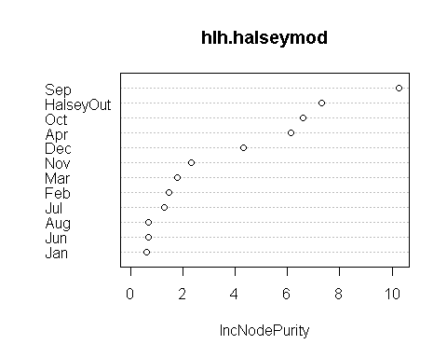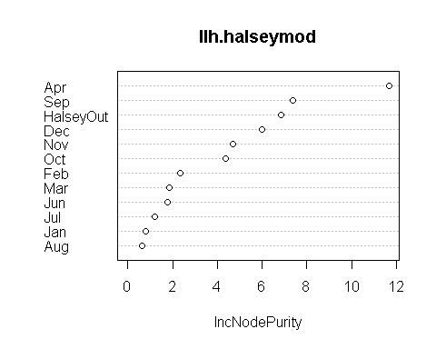

#Add Trend

#Subtract EE

#Finger on Scale

## Error in `$<-.data.frame`(`*tmp*`, Wauna.ff, value = 67) :   
## replacement has 1 row, data has 0

#Summary tables

#Output

#Summary stats

## MAPE RES: 0.1073421 MAE RES: 1.346021

## MAPE Wauna: 0.05534305 MAE Wauna: 3.930187

## MAPE Halsey: 0.063557 MAE Halsey: 0.9464212

#Annual aMW Plots 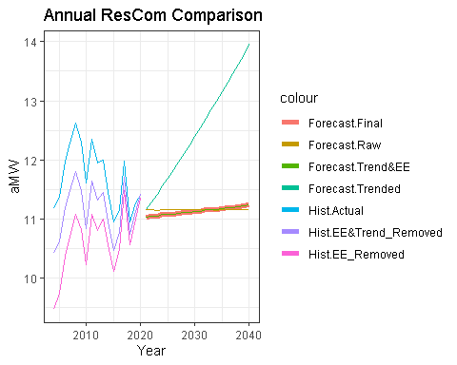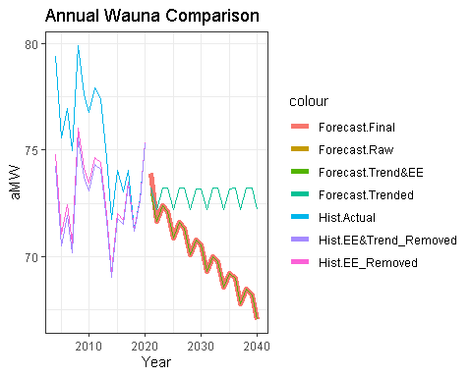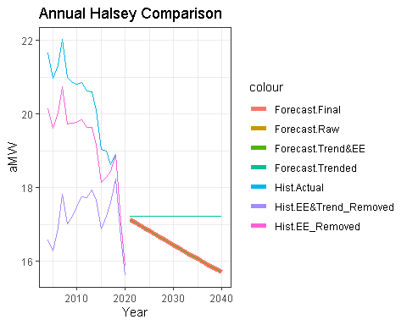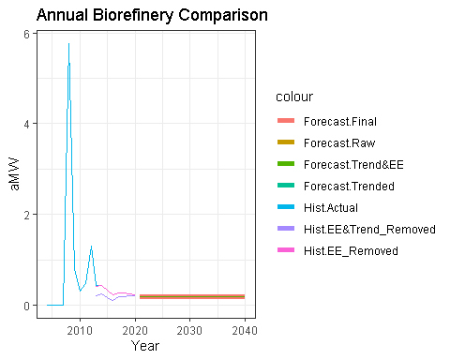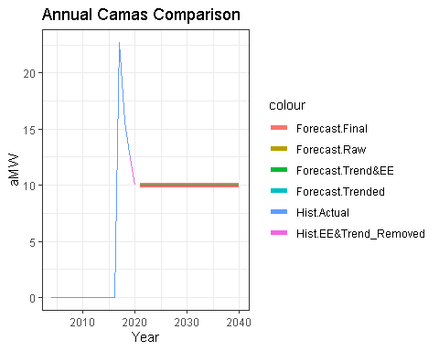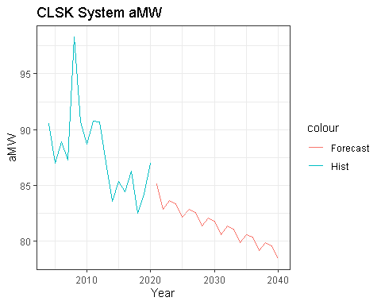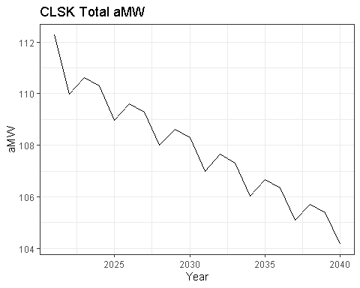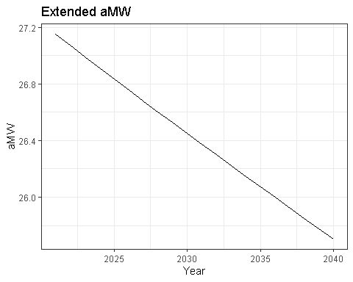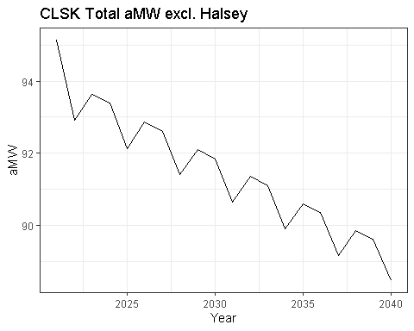

#Monthly aMW Plots 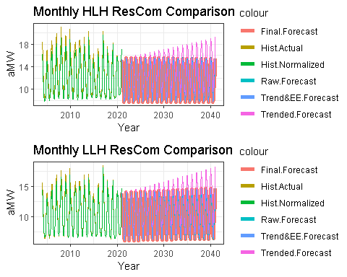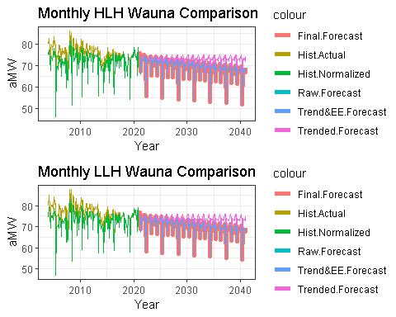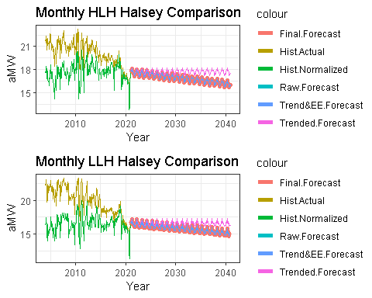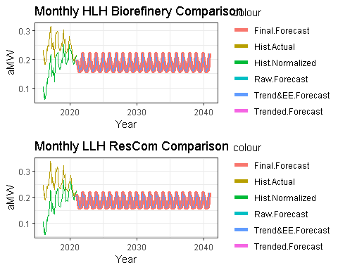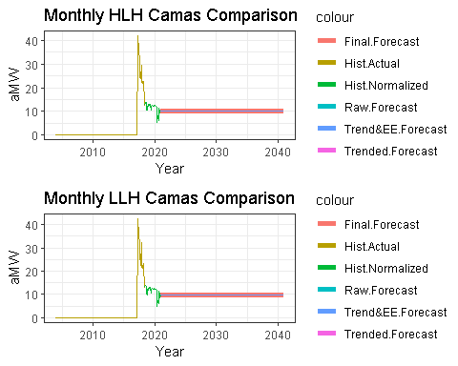 #Monthly aMW Plots2 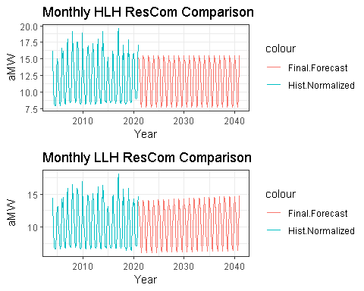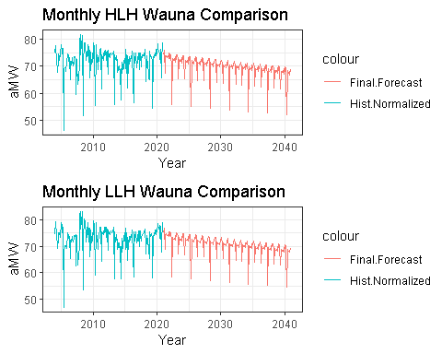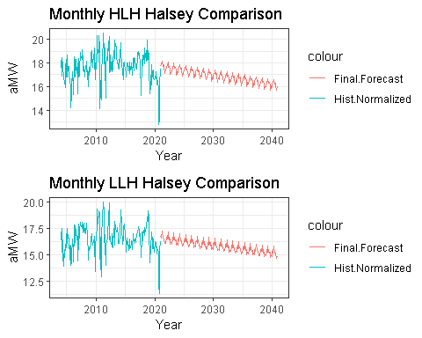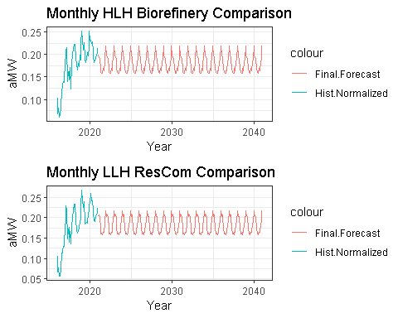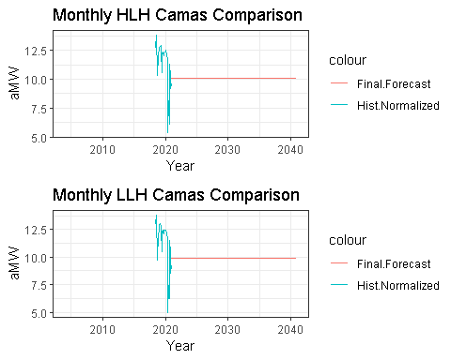

#Monthly Peak Forecast vs. Actual 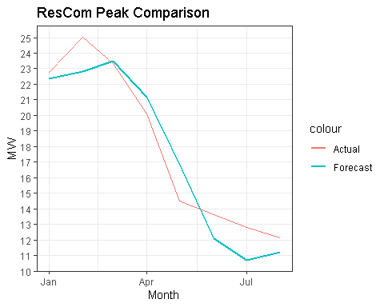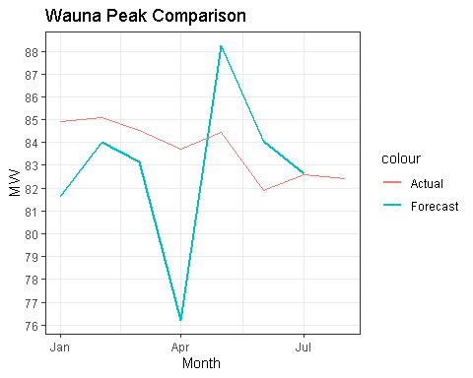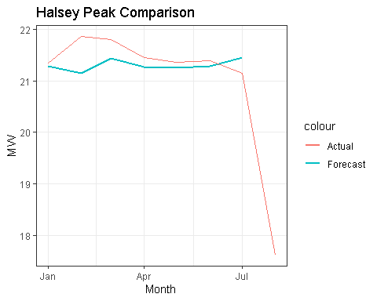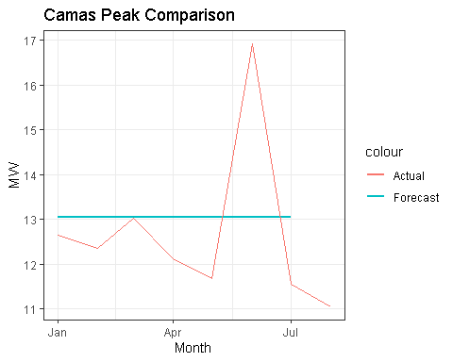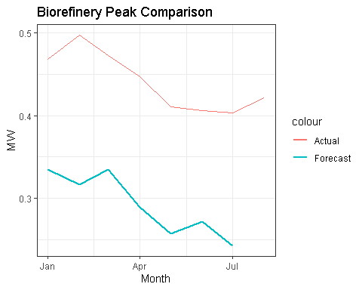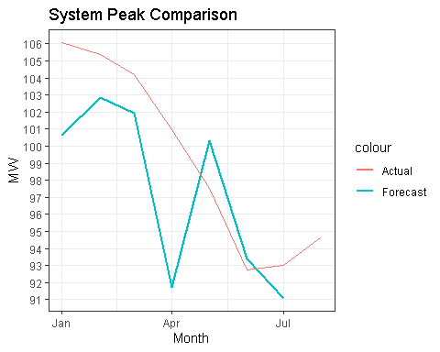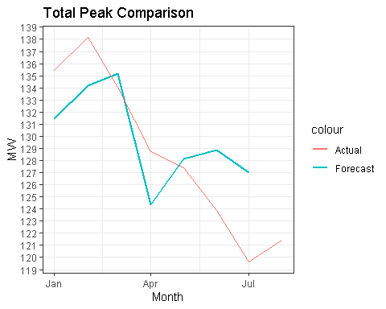

#Monthly Energy Forecast vs. Actual 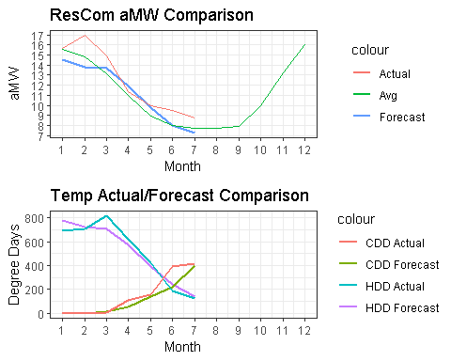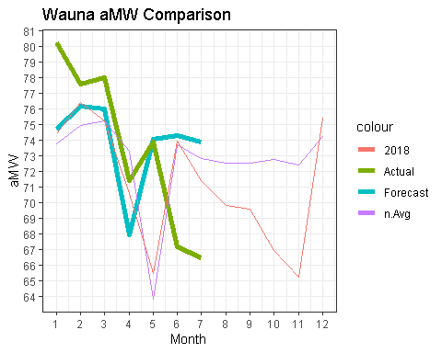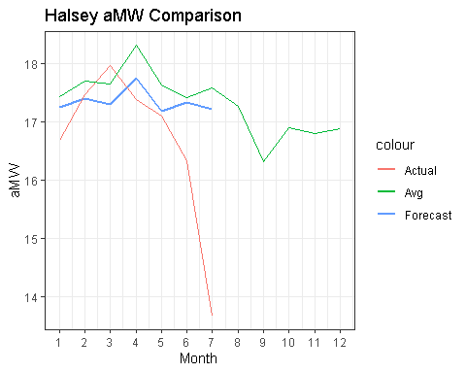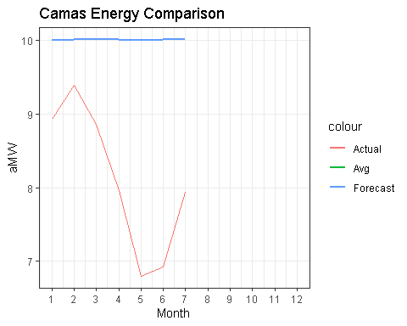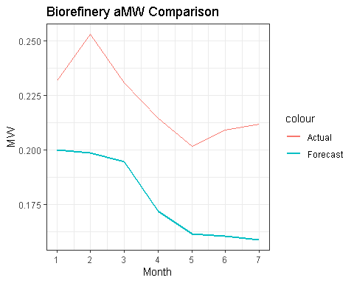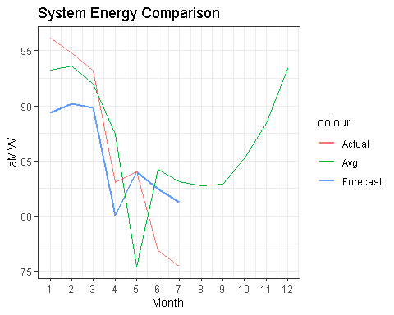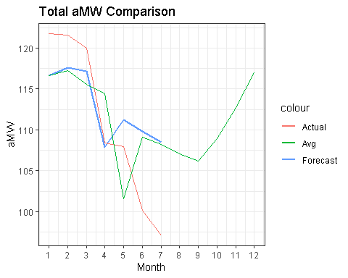

#Monthly EE Forecast 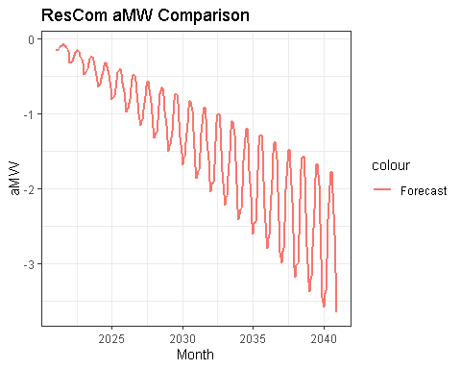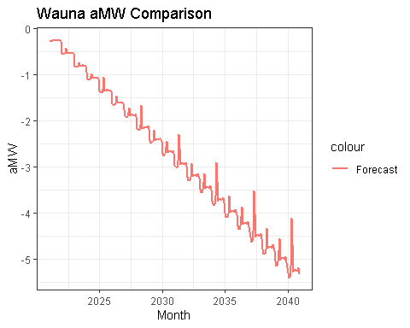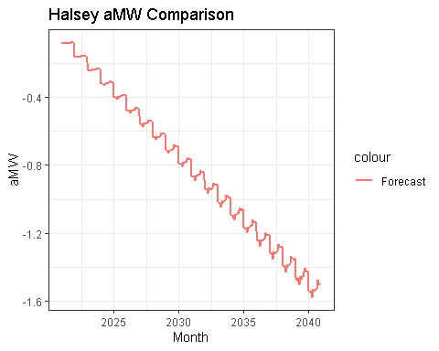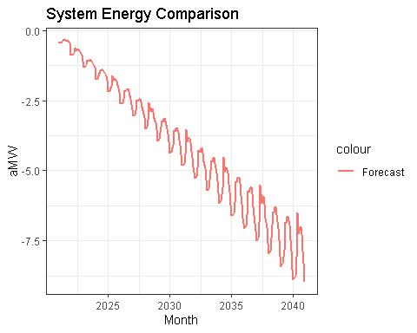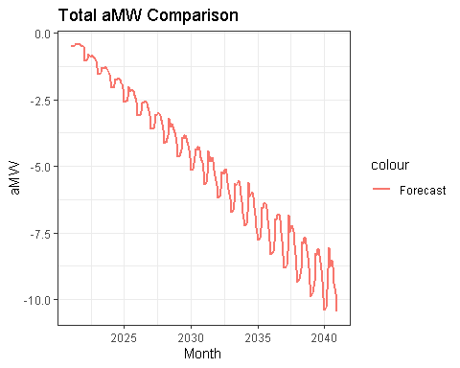 #Monthly EE Diff 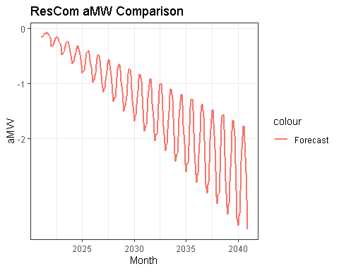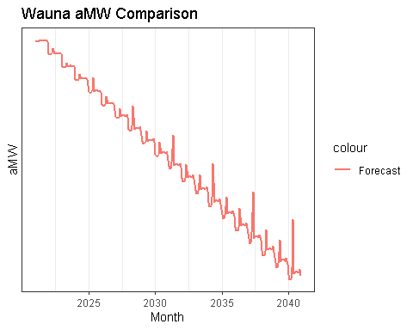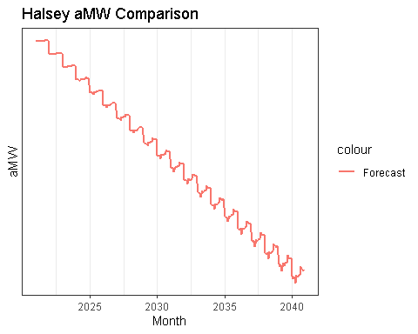

#Wauna Load_Factor Debug

## png   
## 2

#Temperature Plots 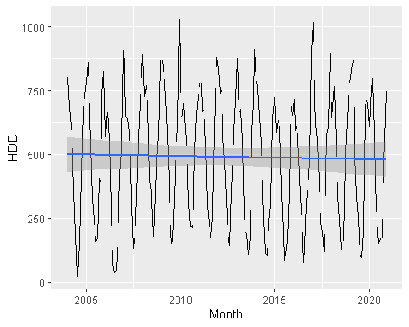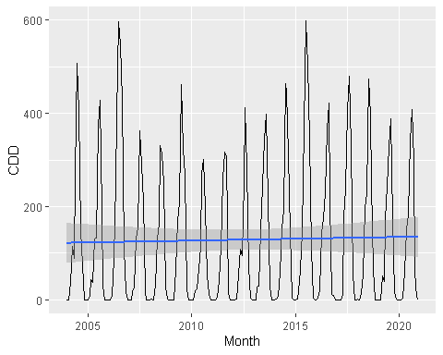

## [1] 10.25951

## [1] NaN

#Other Testing

#LOad Hour Plots 

