ShelterCare Satisfaction Report: 2020

# Introduction/Background:

In doing background research, I came upon different views of employee satisfaction surveys. However, after scouring a variety of sources I found an approach that I think well suits the format of your iteration.

Professor Armin Trost teaches human resources at Furtwangen University in Schwarzwald, Germany. As a consultant for a myriad of large corporations such as Lufthansa, Deutsche Telekom, and Audi, he has established himself as a brilliant mind in talent acquisition and HR. In a video ironically called ‘Employee Surveys don’t Work’, Professor Trost lays out how he believes employee surveys should be used to affect worker sentiment in your organization.

To begin, Trost starts by describing how he sees employee surveys mismanaged, so as to distinguish what makes these questionnaires effective. From his experience, organizations generally start by using a survey to attempt analyzing a potential improvement in the environment. In other words, they use the survey to tell them where issues in employee sentiment exist. When this issue is seen and interpreted by management, they enact policies or actions to raise employee sentiment for the next iteration of the survey.

|  |  |  |  |  |
| --- | --- | --- | --- | --- |
| Survey Employees  (Looking for problems) |  | Identify potential improvements  (Plan to fix problems) |  | Attempt to achieve targets (Fix problems) |

Figure 1: A misguided decision flow process involving employee satisfaction surveys, according to Professor Trost[1]

However, this involves a flaw. The format above assumes that you know what questions to ask in the first place. The most important part of designing a survey comes from understanding what you want to ask your employees and presenting that question clearly.

Trying to use surveys to accurately understand the intricacies of your ground level operations is a misuse of what the tool is used for. In a description of the traditional survey process, Professor Trost denotes a step of the system as ‘prestudy’. This is a reconnaissance period, in which the leadership tries to question their understanding of the workplace. Understanding individual sentiment throughout your organization allows you as a leadership team to understand why people might feel satisfied or dissatisfied with the organization.

Once a potential improvement is identified, use the employee survey to measure an indicator associated with the causal factor. Use the current year’s survey to get a baseline for the question, then compare with data as it is gathered over the next few periods. The ideal scenario involves some sort of action on the part of leadership at an executive or local level to improve that indicator, which would thereby improve employee satisfaction with the organization.

In order to find an appropriate indicator, I would reference an important statement by Professor Trost; “Whenever you prepare questions in an employee survey… people will not understand your questions…”[2]. The important lesson is that individuals will answer what they think the question asks, not what the wording specifies. As such, it is important to understand how the grassroots community of your organization will interpret the question. This can be done by testing how individuals react and interpret various terms in focus group settings.

Once the wording of the question accurately references the general workforce’s sentiment towards a particular issue, the responses can be used as a quantifiable metric to measure the success of your organization in dealing with the issue.

Now that we have a variable we want to affect, use changes to the workplace to change the environment as you wish. Then, use the indicators to mark your progress. Set targets and do the best to achieve them, then look to the same prestudy methods of gaining intelligence on how employees feel towards the issue after the workplace changes.

|  |  |  |  |  |  |  |  |  |
| --- | --- | --- | --- | --- | --- | --- | --- | --- |
| Prestudy  (Looking for problems) |  | Determine indicators |  | Survey for indicators (Baseline or Control Values) |  | Enact Workplace Changes (Try to fix problems) |  | Resurvey (Compare against Control, try to reach targets) |

Figure 1: A suggested decision flow process for improving the workplace utilizing employee satisfaction surveys

|  |
| --- |
| To clarify, I’ll use a hypothetical scenario using our survey as a template (Please note that this scenario is not indictive of the actual results):  Take as given that we conduct a prestudy, speaking to individuals at a variety of different levels throughout the organization. In this portion, we seem to see an aggregate feeling that communication between the various levels of the hierarchy is inefficient in some way. We will treat communication as purely the information exchanged between the various levels of the hierarchy, NOT the effectiveness of leadership to act on that information.  Now that we’ve identified an issue, we find a way to measure how individuals feel about communication among different levels of the system. I would argue that there are several key questions to pay attention to within the survey that may act as indicators.  “My voice is heard in my department or program” (Meaningful work) – The question is good, but the wording is vague. If the terms of department and program are left to an individuals discretion, they may answer with the entire organization in mind or just their immediate environment.  Narrowing this question to analyze one particular relationship will tell you more than asking about the general systems ability to accept grassroots input. An example of the reworded question might be: “My immediate supervisors hear what I have to say.” Or “Executive management understands my departments needs.”  “Supervision effectively communicated with all team members” (Supervision) – This is a well worded question that analyzes the relationship between middle management and grassroots employees.  Now that we have 2 indicators for the communication between various levels of the organization, we survey the population to get an accurate baseline response set. Now that we have our original data, we create a program or change within the workplace aimed at helping communication between the different layers of the organization, and use future surveys as a way to measure the effectiveness of various solutions.  Now that we have 2 indicator questions, we will enact a workplace change to address the issue. As time goes on, we will use future survey results to measure the impact of our environmental revisions. |

# Methodology:

This year will be about creating baseline statistics of the various questions. I will create various analysis useful for comparing our current data with that of future surveys to determine the changes in the workplace environment.

Visuals will be included in an appendix for use at your discretion. I will point out questions that had poor response scores, and pose questions for the next survey iteration’s prestudy. Use these questions as a motivator to ask members of your workforce what they think might be causing the low responses.

For numeric metrics, I will be using the top 2 box score method. Commonly used to assess the effectiveness of products to meet consumer demands, it is a great way to sum up how many individuals believe that the organization is at the very least fulfilling the minimum responsibilities it should towards them and their peers.

|  |  |
| --- | --- |
| Top 2 box Score Calculation:  To alter for the meaningful work (work culture) category, I replaced excellent with strongly agree and sufficient with somewhat agree. | $$Score=\frac{Excellent responses+Sufficient responses}{Total Responses}$$ |

# Results:

There are several observations we can make from the raw data, but keep in mind that the most important and relevant data will be relative to historical data.

The strongest questions in terms of top 2 box scores were the following:

* (Meaningful work/Work Culture)My work at ShelterCare helps meet an important need in the community. (96%)
* (Supervision) Sufficiently meets requirements for audits, contracts, and/or billings with outside agencies. (93%)

The percentage box scores represent the portion of responses that were positive: Excellent, Sufficient, Strongly Agree, Somewhat Agree.

The score for executive handling for audits, contracts, etc. is also higher for the executive management when compared with the rest of the questions. This may point towards well managed interactions with outside entities.

There seems to be a consistent gap in the scores between the executive and immediate supervisor categories of questioning, with immediate supervisors scoring higher on average. However, I would not assume this implies an accurate representation of feelings towards each level, because it may be that executive leadership will always score lower due to the amount of distance between the centralized power of the organization and the average worker.

Some of the questions that scored lower using the top 2 box score method when compared to the rest of their category included the following:

* (Supervision) Encourages career development
* (Management/Executive leadership) Encourages career development

However, I would repeat that just because they had a lower score, does not mean these questions indicate a weakness of the organization, just a clue as to where to start investigating.

# Conclusion:

The majority of this report has been focused on how to utilize this data effectively. I argue that just interpreting one data set in a vacuum is useless, scores relative to other periods are a way to measure change in employee sentiment, which a leadership team can use to their benefit. Therefore I would intend for this set of responses to be taken as a baseline, used to quantify the effectiveness of different workplace policies meant to improve working standards and culture.

There are several changes that I argue would help increase the effectiveness of the employee survey from its current format. To begin, I would group questions, but I wouldn’t consider all of them to aggregate to some value. The information here specifies where there might be problems, not an accurate overview of how influential the factors are.

While I do agree in the effectiveness of having categories of questions aimed at middle management and executive leadership, I would change the questions in the ‘Meaningful work’ category to serve some other purpose. What do you mean by Meaningful work? Is it the pride with which individuals take in their job? Or is it the ability of the organization to fulfill the goal set to them?

The meaningful work category seems to be a measure of various aspects of the organizational culture. Between asking its internal reward and input tendencies via the questions “I feel appreciated for the work that I do” and “My voice is heard in my department/program”. So in the interest of clarifying presentations, I would change the meaningful work category to work culture.

Next, and most importantly, I would ensure consistent archiving of each period’s surveys. Having the raw information will leave open lines of questioning for future analysts.

Another thought to consider is that of introducing more optional categorical identifiers in the surveys. Have an option for people to identify themselves as members of various parts of your organization, so as to better understand the source of the issues. However, I am not familiar with the legality of anonymity in employee satisfaction surveys, so I would first consult any legal counsel you have before pursuing this course of action. Ensure that individuals can remain anonymous to protect them against repercussions of middle or executive leadership, while retaining enough information to accurately predict where the source of workplace inefficiencies are.

Keep in mind that employee sentiment may change over the course of a year, possibly with seasonal effects. I would recommend that analysts observe the workplace for clues on how volatile the opinions of individuals are. Then try to measure those fluctuations in a timeframe that gives you information about how the opinions of employees change over time.

Finally, I would try to do pronounced reconnaissance on your workplace environment before the next survey. Understand how people feel and think about your organization, and the sources of strife that can be analyzed with good survey questioning. Think about questions you can ask to your employees that result in the same categorical responses (Poor-Excellent) that give you specific information about how employees feel about your various institutions.

Then, after quantifying the issue with these questions, enact workplace policies to affect the metric positively. This process describes a methodical system for analyzing issues in the workplace, and effectively analyzing responses to the issues.

If your organization is interested in more materials for research regarding interpreting and executing employee satisfaction surveys, I highly recommend using Armin Trost’s lecture on them. It is free on youtube here (<https://www.youtube.com/watch?v=yi0HPEleL8Q>). Also, I would advise checking out Gallup’s Q12 poll, a distinguished and often used method for getting a comprehensive look at employee opinions. You can find more information about it here (<https://q12.gallup.com/public/en-us/Features>).

Appendix: Complete individual question analysis

# Meaningful Work (Work Culture) Category

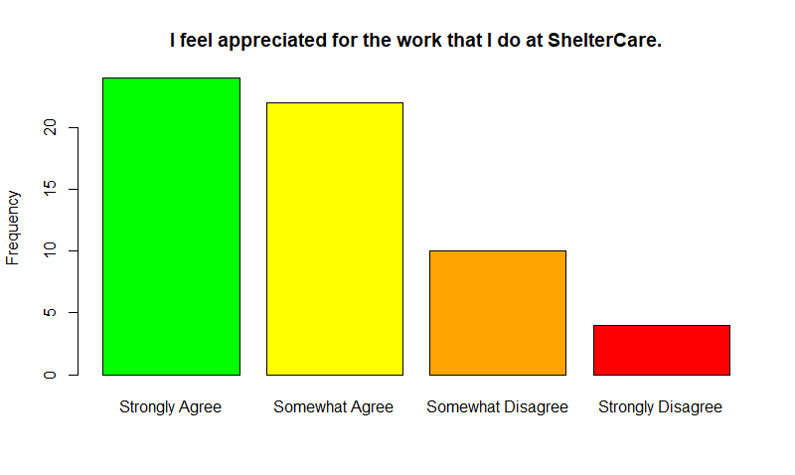

Top 2 Box score (as a percentage): 46/60= 77%

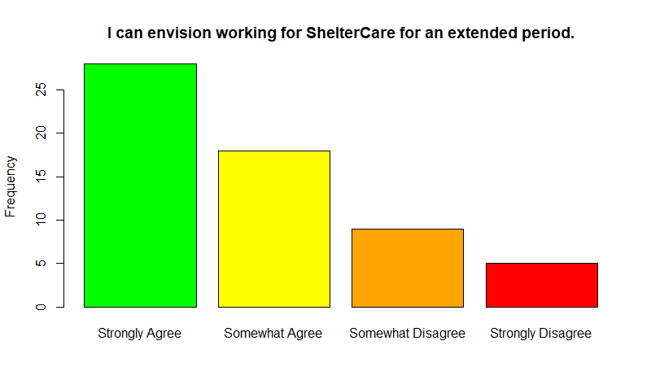

Top 2 box score: 46/60= 77%

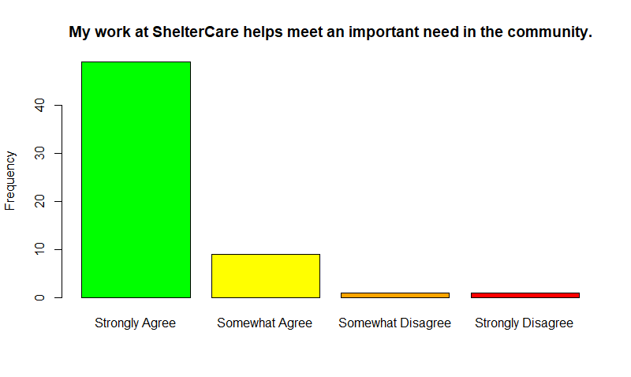

Top 2 box score: 58/60= 97%

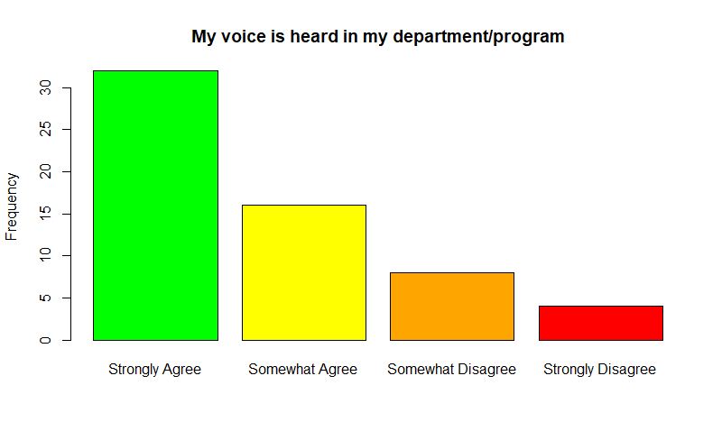

Top 2 box score: 48/60= 80%

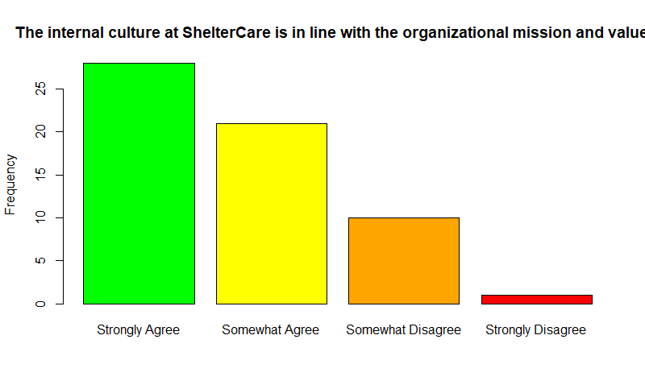

Top 2 box score: 49/60= 82%

# Emotional Safety

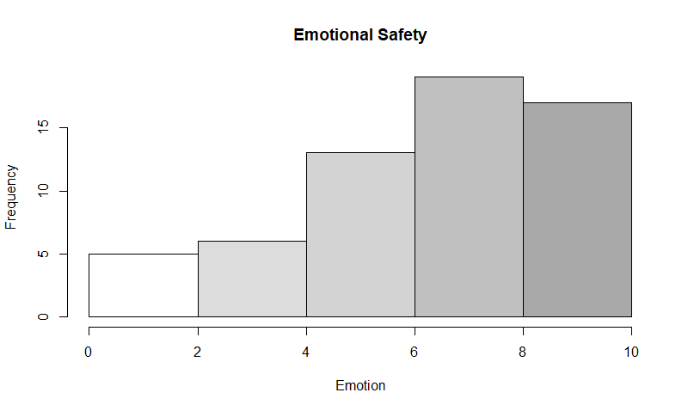

# Physical Safety

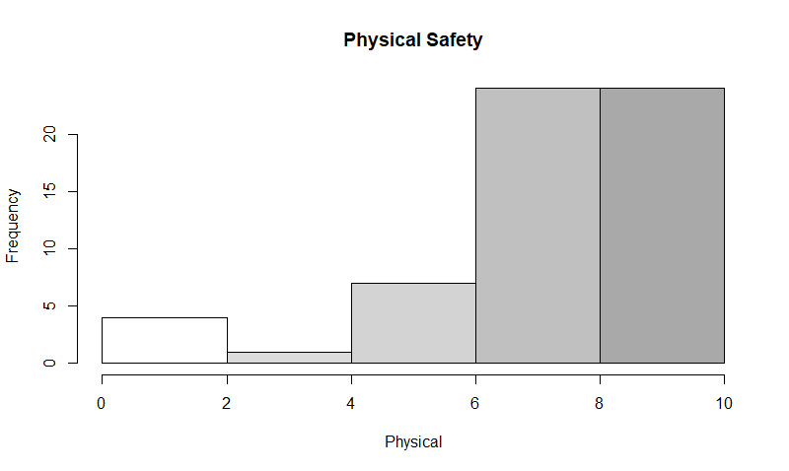

# Supervision

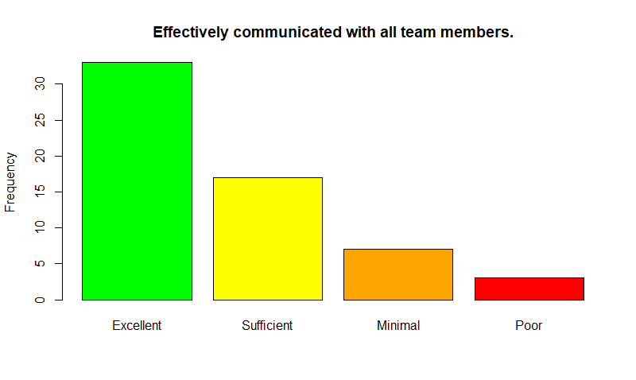

Top 2 box score: 49/60= 82%

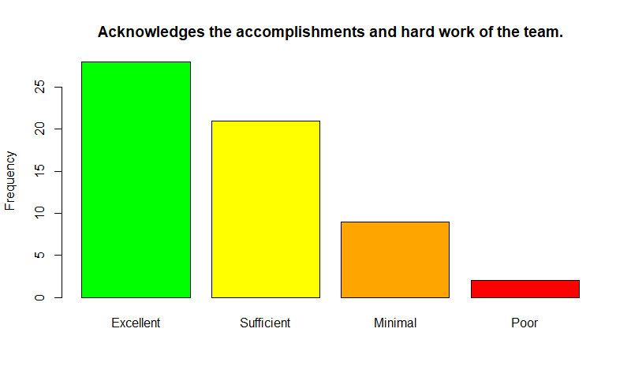

Top 2 box score: 51/60= 85%

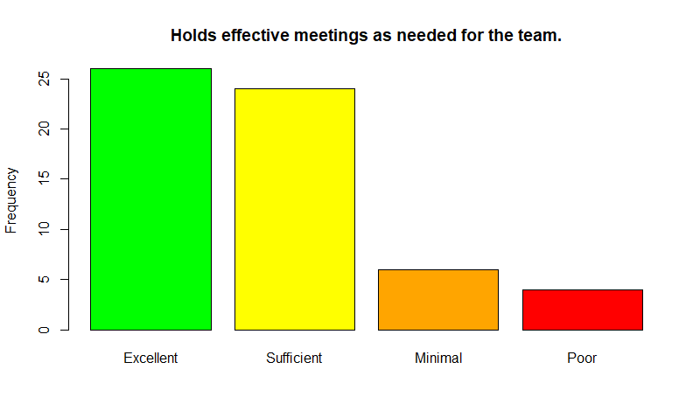

Top 2 box score: 47/60= 78%

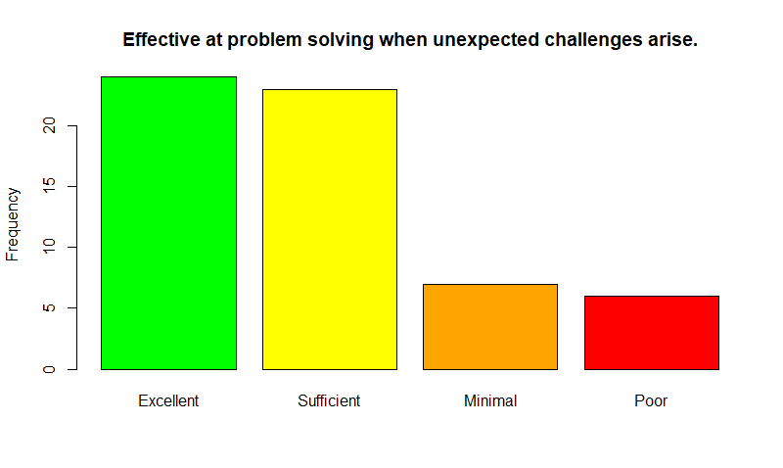

Top 2 box score: 50/60= 83%

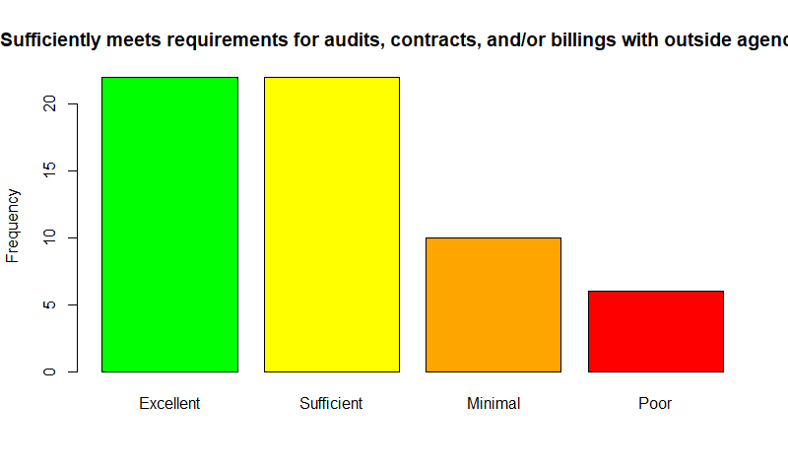

Top 2 box score: 56/60= 93%

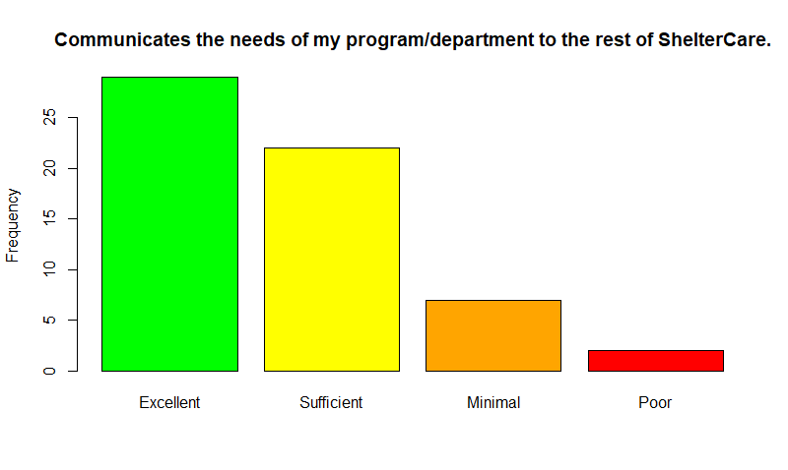

Top 2 box score: 50/60= 83%

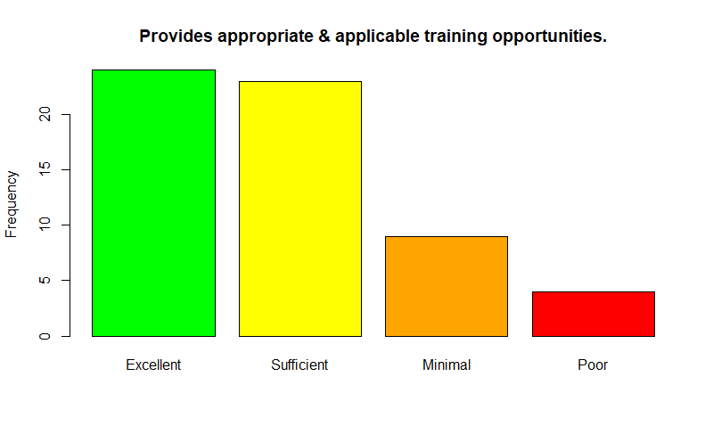

Top 2 box score: 47/60= 78%

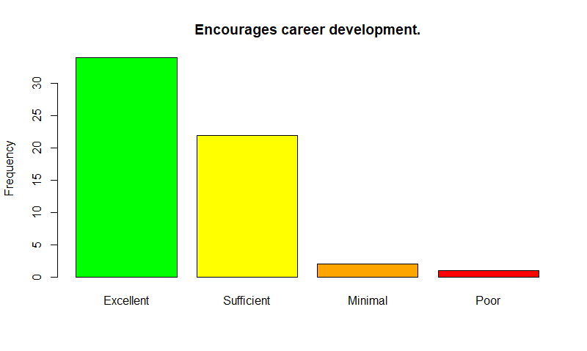

Top 2 box score: 44/60= 73%

# Management/Executive Leadership

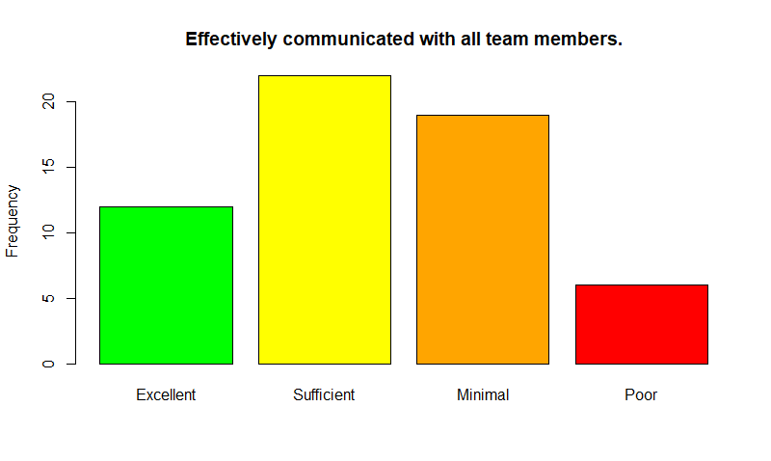

Top 2 box score: 34/60= 56%

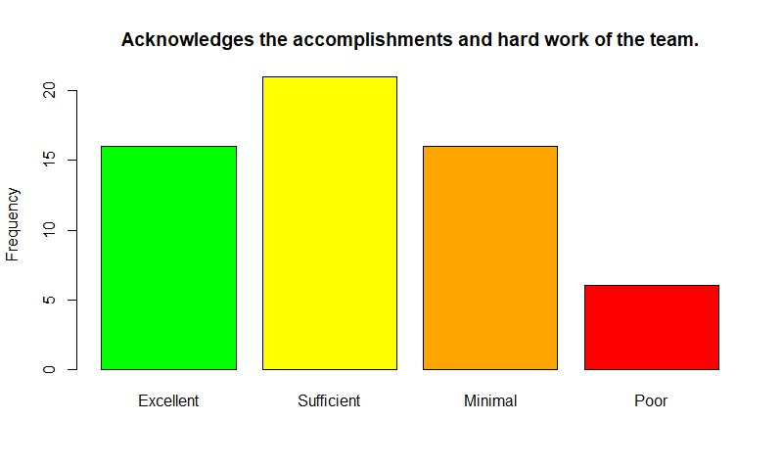

Top 2 box score: 37/60= 62%

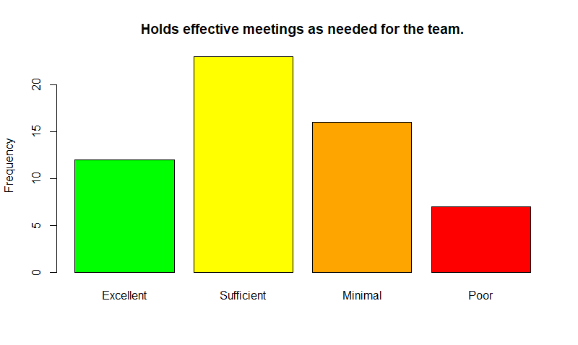

Top 2 box score: 35/60= 58%

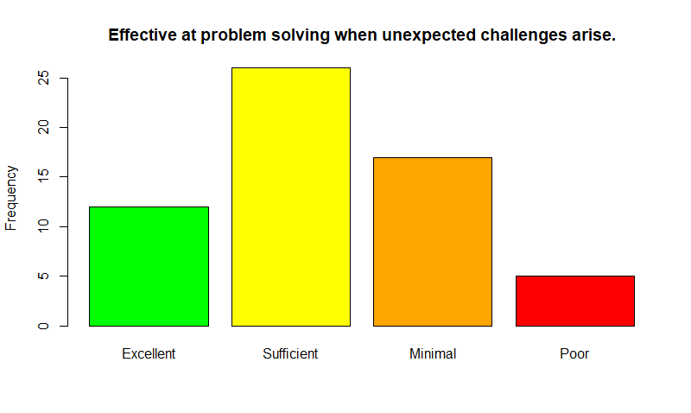

Top 2 box score: 38/60= 63%

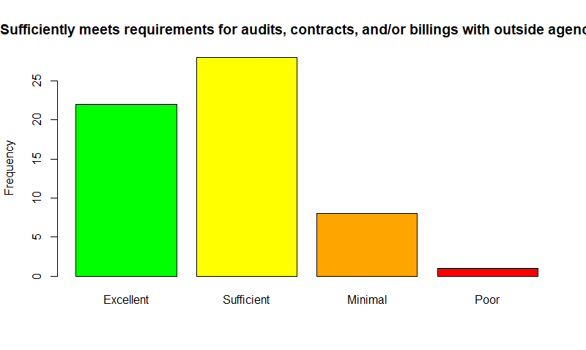

Top 2 box score: 50/60= 83%

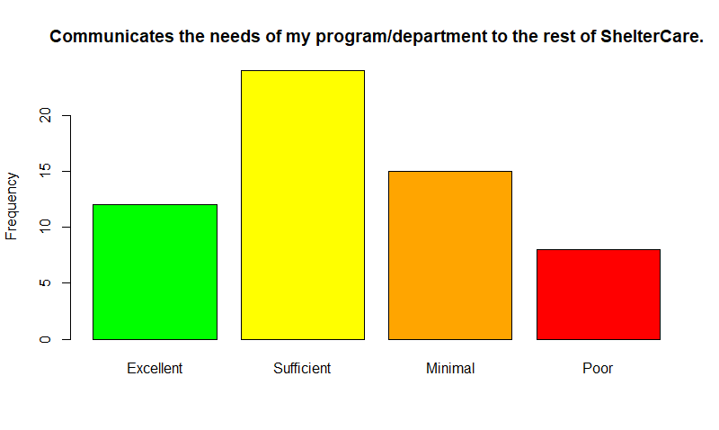

Top 2 box score: 36/60= 60%

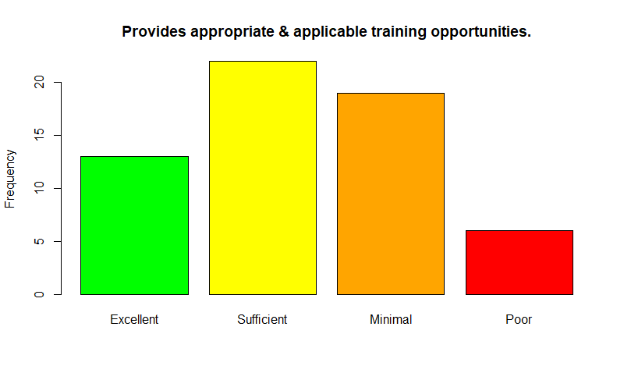

Top 2 box score: 35/60= 58%

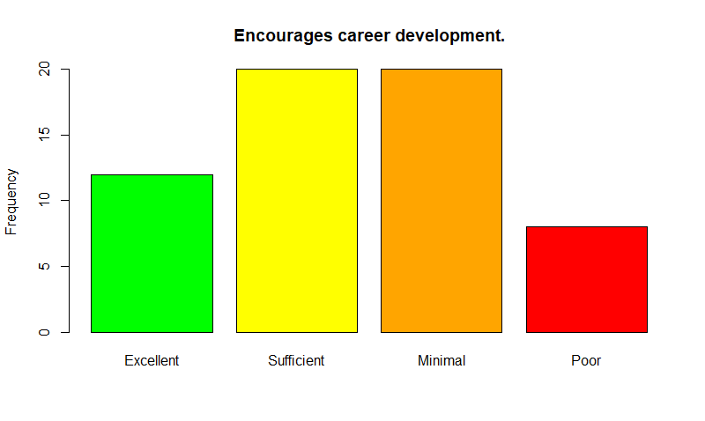

Top 2 box score: 32/60= 53%

1. <https://www.youtube.com/watch?v=ttp71J-CoX0>, Armin Trost, Employee Surveys don’t Work, 3:50
2. <https://www.youtube.com/watch?v=yi0HPEleL8Q>, Armin Trost, HR Management Lecture Part 09 – Employee Survey, 12:10