|  |  |
| --- | --- |
| **Beirut Arab University**  **Faculty of Science**  **Computer Science Department** | **Course:**  CMPS441-Fundamentals of Algorithm  **Semester:** Fall 2024-2025  **Lab2** |

**Part I: Sorting**

Sorting algorithms are fundamental to computer science and have various applications, including searching, data structures, and optimization problems.

Common sorting algorithms include:

1. **Selection Sort:**

The idea behind selection sort is that we put a list in order by placing each item in turn. In other words, we put the smallest item at the start of the list, then the next smallest item at the second position in the list, and so on until the list is in order.

An example of the selection sort is given in the figure below.

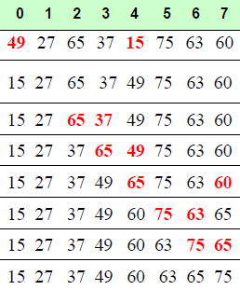

Pseudocode:

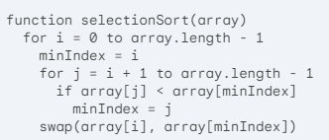

1. **insertion Sort:**

The idea of insertion sort is that; we start from the second element as we assume that the first element is always sorted. Then from the second element to the last element, we compare each element to all of its previous elements and the put that element in the proper position.

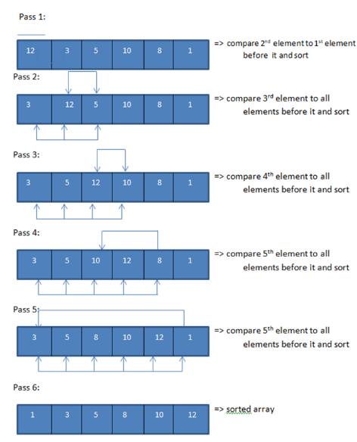

**Your task is to implemets all the above sorting algorithms**

**Part II: A Problem on Sorting**

**Challenge:** Solve the Codeforces problem titled Sale using insertion sort. Aim to achieve an "Accepted" verdict on your submission.

Problem link: https://codeforces.com/problemset/problem/1312/B

Sale

Once Bob got to a sale of old TV sets. There were *n* TV sets at that sale. TV set with index *i* costs *ai* bellars. Some TV sets have a negative price — their owners are ready to pay Bob if he buys their useless apparatus. Bob can «buy» any TV sets he wants. Though he's very strong, Bob can carry at most *m* TV sets, and he has no desire to go to the sale for the second time. Please, help Bob find out the maximum sum of money that he can earn.

**Input**

The first line contains two space-separated integers *n* and *m* (1 ≤ *m* ≤ *n* ≤ 100) — amount of TV sets at the sale, and amount of TV sets that Bob can carry. The following line contains *n* space-separated integers

*ai* ( - 1000 ≤ *ai* ≤ 1000) — prices of the TV sets.

**Output**

Output the only number — the maximum sum of money that Bob can earn, given that he can carry at most *m* TV sets

**Input**

5 3

-6 0 35 -2 4

**Output**

8

**Input**

4 2

7 0 0 -7

**Output**

7