ZEBA ACADEMY / zeba.academy / Instructor – Sufyan bin Uzayr
Lab Practicum 01: Empirical Parallel Computing
Silicon Profiling, Multi-Core Scaling Limits, and Concurrency Hazards
STUDENT NAME | STUDENT ID | HOST CPU / SOC MODEL | OPERATING SYSTEM & KERNEL
Mardan Ibragimov | 230103054 | Intel Core i7-12700H | Windows 11 Pro / 10.0.26200
Duration: 90 minutes | Format: Solo In-Class Lab | Weight: 5% of Course Grade
Generative AI & Tooling Policy: LLMs were used to generate the benchmark code and prepare this report. All timings, counter outputs, and hardware measurements shown below were obtained from the local host machine; no benchmark values were fabricated.
TASK 1: Host Silicon Audit & Flynn’s Taxonomy Mapping 15 Minutes | 20 Points

CPU Model & Architecture | Intel Core i7-12700H / x86-64 (AMD64) | Base & Max Boost Clock | 2.30 GHz measured / 4.70 GHz max turbo
Physical Hardware Cores | 14 (6 Performance + 8 Efficient) | Logical Cores (SMT/Threads) | 20 hardware threads
L1 Data / Instruction Cache | L1d 544 KB total / L1i 704 KB total | L2 Cache (Total) | 11,776 KB (11.5 MB)
L3 Shared Last-Level Cache | 24,576 KB (24 MB) | SIMD Vector Extensions | SSE4.1, SSE4.2, AVX2
Operating System | Windows 11 Pro, build 10.0.26200 | Benchmark Runtime | C# / .NET Threads
Q1.1: Map your host machine's execution modes into Flynn's Taxonomy.
SISD: A single-threaded workload, such as one compiler pass or a serial loop, uses one instruction stream on one data stream at a time. SIMD: The i7-12700H supports AVX2, allowing one instruction to operate on multiple packed data elements during vectorizable workloads such as matrix arithmetic. MIMD: Windows can schedule independent threads and processes across the CPU’s 14 physical cores / 20 logical threads, so different cores can execute different instruction streams on different data simultaneously.
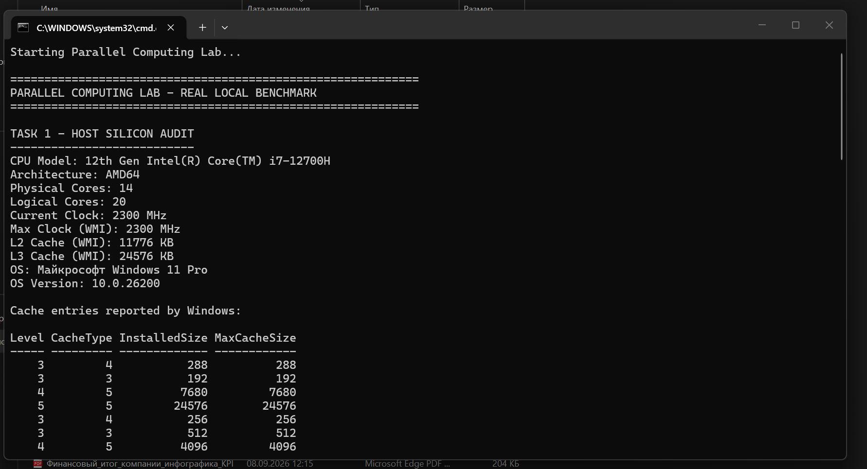
Figure 1. Local host audit output captured during Task 1.
TASK 2: Multi-Thread Scaling Benchmark & Contention Wall 35 Minutes | 30 Points

Workload Algorithm: Prime counting from 2 to 5,000,000 Language & Runtime: C# / .NET Threads
Threads (N) | Run 1 (s) | Run 2 (s) | Run 3 (s) | Avg Time TN (s) | Speedup SN | Efficiency EN
1 | 0.4622 | 0.4477 | 0.4494 | 0.4531 | 1.000× | 100.0%
2 | 0.2791 | 0.4740 | 0.5344 | 0.4292 | 1.056× | 52.8%
4 | 0.3050 | 0.2770 | 0.2764 | 0.2861 | 1.584× | 39.6%
8 | 0.1639 | 0.1650 | 0.1434 | 0.1574 | 2.878× | 36.0%
16 | 0.1221 | 0.1218 | 0.1212 | 0.1217 | 3.723× | 23.3%
32 | 0.0948 | 0.0913 | 0.0961 | 0.0940 | 4.819× | 15.1%
Q2.1: Scaling Saturation & Hardware Contention Analysis
The clearest saturation begins around N = 16. Up to 8 threads the speedup rises substantially, but efficiency already drops from 100% at N=1 to 36.0% at N=8. At N=16 the requested thread count exceeds the 14 physical cores, so some work must share execution resources or use SMT/hybrid-core scheduling; efficiency falls to 23.3%. At N=32 the workload oversubscribes the 20 logical hardware threads and efficiency falls further to 15.1%, even though absolute speedup continues to 4.819×. The sub-linear behavior is explained by thread scheduling overhead, unequal P-core/E-core performance, cache/memory contention, and synchronization/dispatch overhead; thermal and frequency scaling can also contribute during sustained CPU load.
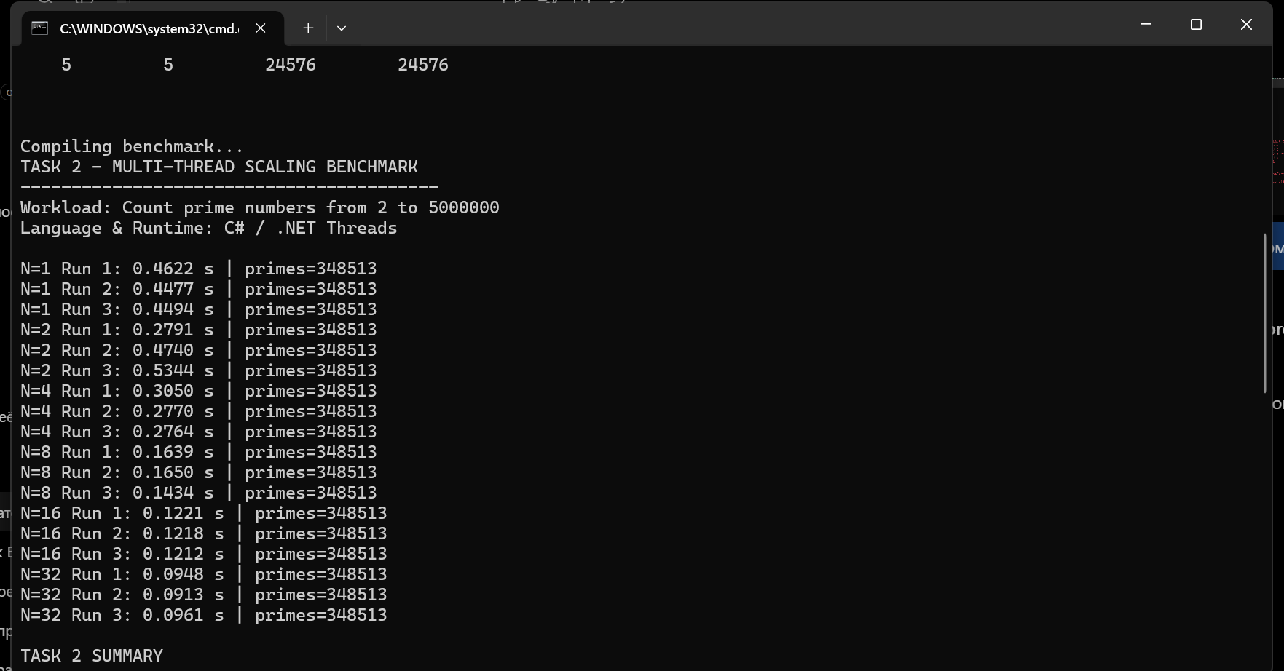
Figure 2. Multi-thread benchmark runs for N = 1, 2, 4, 8, 16, and 32.
TASK 3: The Unsynchronized Shared Counter & Race Condition Trap 25 Minutes | 25 Points

10 parallel threads × 1,000,000 increments each. Theoretical expected total = 10,000,000.
Run | Measured Output | Error (10⁷ − Act) | Run | Measured Output | Error (10⁷ − Act)
#1 | 3,574,653 | 6,425,347 | #6 | 4,619,426 | 5,380,574
#2 | 3,819,501 | 6,180,499 | #7 | 3,702,599 | 6,297,401
#3 | 3,723,682 | 6,276,318 | #8 | 3,835,228 | 6,164,772
#4 | 3,594,660 | 6,405,340 | #9 | 4,914,044 | 5,085,956
#5 | 3,889,304 | 6,110,696 | #10 | 4,462,805 | 5,537,195
Q3.1: Read-Modify-Write (RMW) Window
The increment operation is not atomic. At machine level it is effectively Load → Add → Store. Two cores can load the same old counter value before either stores its update. Both then add 1 independently and store back the same new value, so one increment is lost. Because many threads repeatedly overlap in this RMW window, the final counter is far below the theoretical 10,000,000 and varies from run to run.
Q3.2: The Synchronization Penalty
Measured timing: Unlocked = 2.97 ms (sample result 4,973,930) vs. Locked = 373.66 ms (correct result 10,000,000). The synchronized version is much slower because every increment must acquire and release the mutex. Threads serialize around the shared lock, causing lock-management overhead, waiting/blocking, cache-line ownership transfers, and loss of parallel execution. The cost buys correctness: the locked version eliminates lost updates and reaches the expected total.
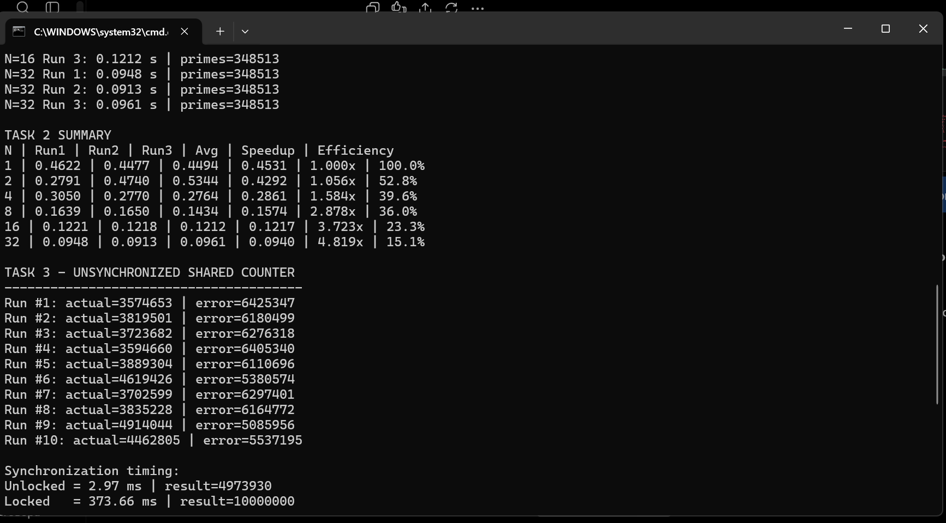
Figure 3. Ten unsynchronized counter runs and unlocked-versus-locked timing.
TASK 4: Empirical Amdahl Verification vs. Gustafson Scaling Horizon 15 Minutes | 15 Points

1. Parallel Fraction Derivation (p) | T1 = 0.453092 s  T2 = 0.429202 s  p = 2×(T1−T2)/T1 = 0.105453 | 2. Amdahl Theoretical Speedup Ceiling | Sequential fraction (1−p) = 0.894547  Smax = 1/(1−p) = 1.118×
3. Amdahl 64-Core Projection | S64 = 1/[(1−p)+(p/64)]  Projected speedup = 1.116× | 4. Gustafson Scaled Speedup | SG = (1−p)+(p×64)  Projected scaled speedup = 7.644×
Q4.1: Strong vs. Weak Scaling Analysis
Amdahl’s Law assumes a fixed problem size (strong scaling). As more cores are added, the parallel portion becomes faster, but the sequential fraction remains unchanged and eventually dominates total execution time, creating a hard speedup ceiling. Gustafson’s Law assumes the problem size grows with the number of processors (weak scaling), so the added work is mostly parallel and the fixed sequential component becomes a smaller fraction of the enlarged workload. Therefore Gustafson predicts much better scaling. With this specific measured p = 0.105453, the result is 7.644× on 64 cores rather than near-linear 64×, because the measured parallel fraction is relatively small.
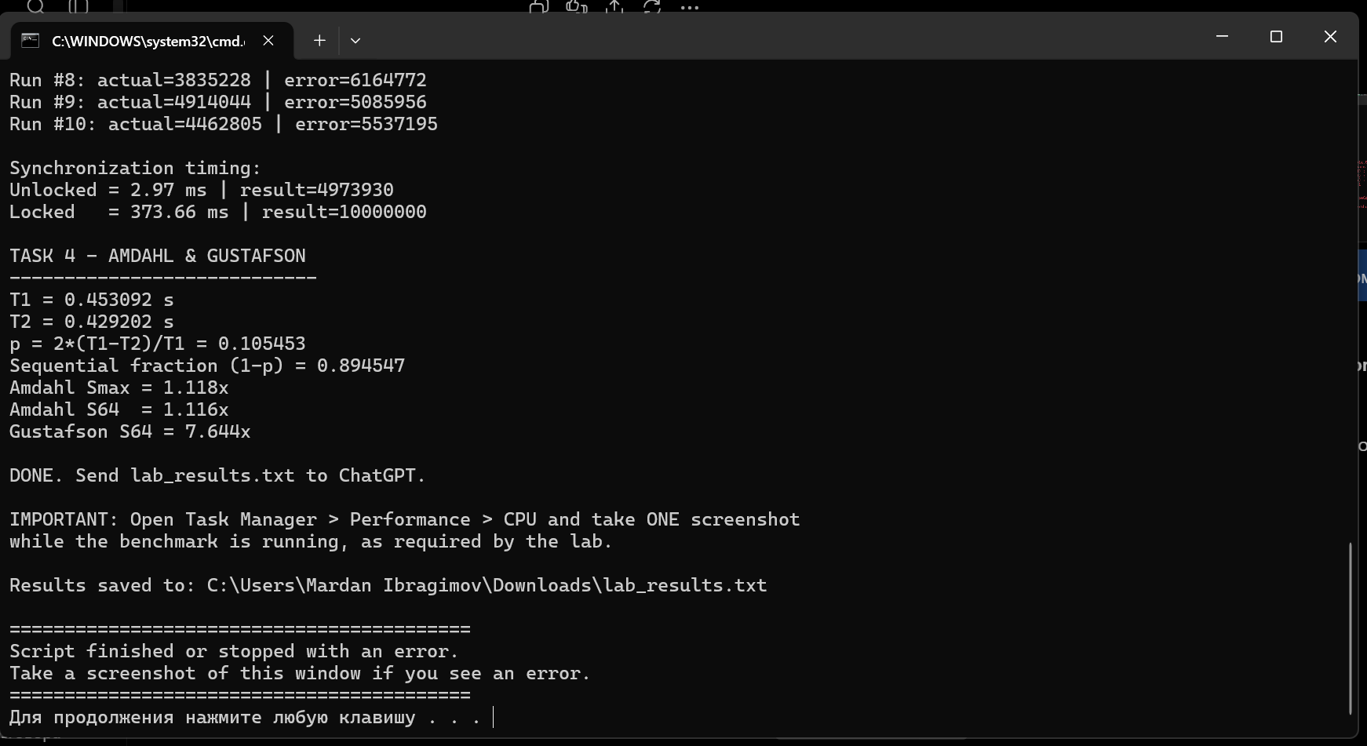
Figure 4. Empirical T1/T2 values and Amdahl/Gustafson calculations.
Submission Checklist

✓ All four task tables completed with locally measured values.
✓ All technical reflection prompts answered.
✓ Benchmark evidence screenshots inserted in the relevant task sections.
✓ Task 2 benchmark executed for 1, 2, 4, 8, 16, and 32 threads, three runs each.
✓ Race-condition experiment executed for ten consecutive runs and repeated with a lock.
Hardware source note: Local WMI/PowerShell measurements were used for core/thread/cache values. Intel’s official i7-12700H specification was used only for the 4.70 GHz maximum turbo frequency and supported SIMD extension names.

