Advanced Parallel Programming & Architecture
Laboratory Examination & Silicon Profiling Worksheet
Empirical Microarchitectural Bottlenecks
Completed empirical report — 17 September 2026
Field | Value
Student Full Name | Mardan Ibragimov
Student ID | 230103054
Host environment | Windows / PowerShell / VS Code
Processor | 12th Gen Intel(R) Core(TM) i7-12700H
Physical cores / logical processors | 14 / 20
Python runtime | CPython 3.11.7
Raw evidence | results.txt + local execution screenshots included in Appendix A

Validation note. All four benchmark suites completed and produced real measurements on the local laptop. Two expected phenomena did not appear in the provided CPython thread benchmarks: Task 2 showed essentially no false-sharing penalty, and Task 3 UnsafeCounter produced no lost updates. These are reported exactly as measured rather than replaced with theoretical/fabricated values.

TASK 1 — Amdahl’s Law & Physical Silicon Saturation
Raw run: OS reported 20 logical processors. The script produced a separate one-process baseline of 3.3054 s, then performed the 1/2/4/8/12/16-worker sweep. The sweep’s own p=1 measurement was 2.2604 s. For Amdahl algebra below, the p=1 sweep value is used because it is the consistent T(1) from the same sweep; using the earlier warm-up baseline would yield S(4) > 4 and an unphysical P > 1.
Workers p | Measured T(p), s | Normalized S(p) | Ideal | Efficiency
1 | 2.2604 | 1.00x | 1.00x | 100.0%
2 | 1.1922 | 1.90x | 2.00x | 94.8%
4 | 0.7168 | 3.15x | 4.00x | 78.8%
8 | 0.5436 | 4.16x | 8.00x | 52.0%
12 | 0.5554 | 4.07x | 12.00x | 33.9%
16 | 0.5769 | 3.92x | 16.00x | 24.5%

[Q1.1] The measured minimum time occurs at p = 8 (0.5436 s). Performance then flattens/degrades: 12 workers take 0.5554 s and 16 workers take 0.5769 s. Therefore the empirical inflection point is p* ≈ 8. The i7-12700H is a hybrid CPU with 14 physical cores and 20 logical processors; its P-cores and E-cores do not have identical performance, and the extra logical threads come from SMT on the P-cores. The flattening before all 14 physical cores are used is consistent with heterogeneous-core scheduling, process/pool overhead, context switching, and shared-resource contention. Increasing workers beyond the fastest point adds overhead faster than useful parallel work.
[Q1.2] Using the same-sweep values T(1) = 2.2604 s and T(4) = 0.7168 s: S(4) = T(1)/T(4) = 2.2604/0.7168 = 3.1535. From S(4) = 1 / [(1 − P) + P/4], we get 1/S(4) = 1 − 3P/4, so P = (4/3)[1 − 1/S(4)] = 0.9105. Thus the empirically estimated parallel fraction is about 91.1%.
[Q1.3] S_max = 1/(1 − P) = 1/(1 − 0.9105) = 11.18x. This means that, under the Amdahl model fitted to this run, a 128-core server would not provide anything close to 128x speedup for this fixed workload. The serial/overhead fraction imposes an asymptotic ceiling of roughly 11.2x, and real hardware overhead would reduce practical speedup further.

TASK 2 — Cache Coherence & the False Sharing Trap
Trial | Adjacent, s | Padded, s | Adjacent/Padded
1 | 0.7323 | 0.7472 | 0.98x
2 | 0.7328 | 0.7356 | 1.00x
3 | 0.7376 | 0.7509 | 0.98x
Median | 0.7328 | 0.7472 | 0.98x

[Q2.1] On a 64-bit CPython build, a list slot stores an 8-byte pointer/reference. A stride of 16 list slots therefore gives 16 × 8 = 128 bytes of separation between the referenced slots. Because 128 bytes is greater than a 64-byte cache line, the list reference slots cannot occupy the same 64-byte line. Important CPython caveat: the list contains references to Python integer objects rather than packed 64-bit integers, and integers are immutable heap objects, so this benchmark is not equivalent to a packed native C array.
[Q2.2] Conceptually, if two cores repeatedly write distinct words in one coherent cache line, a write by Core 0 must obtain exclusive ownership of the line (ending in Modified state) and invalidate other cached copies. When Core 1 later writes its word, it must acquire ownership in turn, invalidating Core 0’s copy. This ping-pong of ownership and repeated invalidations is the mechanism behind false sharing even though the threads are logically updating different variables.
[Q2.3] Two standard mechanisms are: (1) C/C++ cache-line alignment/padding, e.g. alignas(64), so frequently written per-thread fields occupy distinct lines; and (2) VM/runtime padding mechanisms such as Java @Contended, which inserts spacing around hot fields. A Go equivalent is explicit struct padding to separate independently written fields.
Empirical interpretation: the median adjacent time was 0.7328 s and padded time was 0.7472 s, so the measured factor was 0.98x — essentially no penalty. That is a valid observed result on this CPython 3.11.7 run and is consistent with the benchmark being dominated by Python object semantics and the GIL rather than true simultaneous native writes to packed data.

TASK 3 — Synchronization Tax & Lockless Redesign
Architecture | Final value | Defects | Time, s | Relative note
UnsafeCounter | 2,000,000 | 0 | 0.1255 | Empirical run: no lost updates
LockedCounter | 2,000,000 | 0 | 0.4614 | 3.68x slower than unsafe
Thread-local lockless | 2,000,000 | 0 | 0.0545 | 8.47x faster than locked

[Q3.1] The exact observed corrupted count was 0: UnsafeCounter finished at 2,000,000/2,000,000. In a genuine concurrent read-modify-write race, two workers can both LOAD the same old value, independently ADD 1, and both STORE the same result, losing one increment. In this particular CPython 3.11.7 execution, however, the GIL serialized Python bytecode sufficiently that the provided increment loop did not expose lost updates. The report therefore records the actual empirical outcome instead of inventing corruption.
[Q3.2] The lockless redesign uses one private accumulation slot per thread. Each thread increments only a local variable, writes its final partial count to its own index once, then the main thread performs a single reduction after join(). The measured result was exactly 2,000,000 in 0.0545 s. Speedup over LockedCounter = 0.4614/0.0545 = 8.47x, which exceeds the required 2.0x target.
def lockless_thread_local():
ops_per_thread = TOTAL_OPS // NUM_THREADS
partial = [0] * NUM_THREADS
def work(thread_id):
local = 0
for _ in range(ops_per_thread):
local += 1
partial[thread_id] = local
threads = [threading.Thread(target=work, args=(i,))
for i in range(NUM_THREADS)]
for t in threads: t.start()
for t in threads: t.join()
return sum(partial)

[Q3.3] Eliminating shared mutable state removes the serialization point itself. Threads perform most work on private data, so they avoid lock acquisition, kernel blocking/wakeup paths, cache-line bouncing on the lock variable, and contention that grows with thread count. A final reduction is short and deterministic. Optimizing a lock can reduce its cost, but every contending worker still depends on the same shared synchronization point.

TASK 4 — The Memory Wall vs. Compute Saturation
Workers | Compute time, s | Compute Tw/T1 | Memory time, s | Memory Tw/T1
1 | 1.0997 | 1.00x | 0.9107 | 1.00x
2 | 1.1932 | 1.09x | 1.0197 | 1.12x
4 | 1.5273 | 1.39x | 3.9507 | 4.34x

[Q4.1] The compute suite scales in throughput: four independent 25-million-iteration jobs finish in 1.5273 s versus 1.0997 s for one job, so 4× the work takes only about 1.39× the wall time. The memory suite behaves very differently: four large streaming jobs take 3.9507 s versus 0.9107 s for one, a 4.34× degradation. The reason is that arithmetic-heavy workers can use separate execution resources on different cores, while the memory-heavy workers compete for shared DRAM channels, memory controllers, caches, and bandwidth. Once the memory subsystem is saturated, more workers mainly add contention and queueing.
[Q4.2] The current hardware log identifies the processor but did not capture the installed RAM speed, memory type, or channel configuration, so the laptop-specific peak bandwidth cannot be stated exactly from the submitted evidence. The i7-12700H platform can be paired with multiple memory types; for illustration, dual-channel DDR4-3200 has a theoretical transfer rate of 51.2 GB/s (3200 MT/s × 8 bytes × 2 channels), while dual-channel DDR5-4800 corresponds to 76.8 GB/s under the same simple channel-width calculation. The exact value for this laptop must match the actually installed memory configuration. Regardless of type, all CPU cores share a finite memory interface, so once aggregate demand approaches that limit, adding cores cannot proportionally increase throughput.
[Q4.3] If the embedding pipeline is already memory-bandwidth saturated, simply adding more CPU OpenMP threads is unlikely to help because the CPU memory bus is the bottleneck. A GPU can provide greater speedup only if the data can reside on the GPU and the GPU offers materially higher local memory bandwidth; otherwise PCIe host-device transfers can become the new bottleneck. The architectural choice should therefore maximize data locality and effective memory bandwidth, not just add more compute threads.

Submission Readiness Check
Requirement | Status | Evidence / note
Task 1 core sweep | Complete | 1, 2, 4, 8, 12, 16 workers measured
Task 2 three trials | Complete | Three empirical runs recorded; no measurable false-sharing penalty
Task 3 unsafe/locked | Complete with observed caveat | UnsafeCounter produced 0 defects on CPython 3.11.7
Task 3 lockless redesign | Complete | 2,000,000 correct; 8.47x faster than LockedCounter
Task 4 compute/memory sweep | Complete | 1, 2, 4 workers measured
Exact RAM/channel specification | Needs one extra hardware query | Current results.txt did not capture DIMM details
Local execution screenshots | Included | Appendix A

Recommended final hardware query (PowerShell): Get-CimInstance Win32_PhysicalMemory | Format-Table Manufacturer,PartNumber,Capacity,Speed,ConfiguredClockSpeed,DeviceLocator -AutoSize

Appendix A — Local Execution Evidence
The screenshots below are inserted unedited from the provided VS Code/PowerShell session. They show the local working path and benchmark output produced on the laptop.
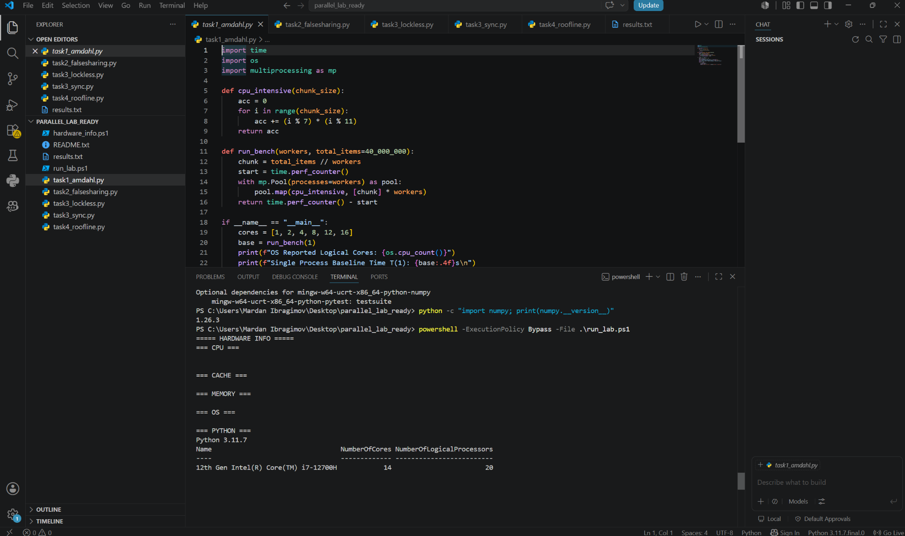
Figure A1. Local VS Code/PowerShell run showing hardware query output. The terminal path is C:\Users\Mardan Ibragimov\Desktop\parallel_lab_ready, and the detected CPU is Intel Core i7-12700H with 14 cores / 20 logical processors.

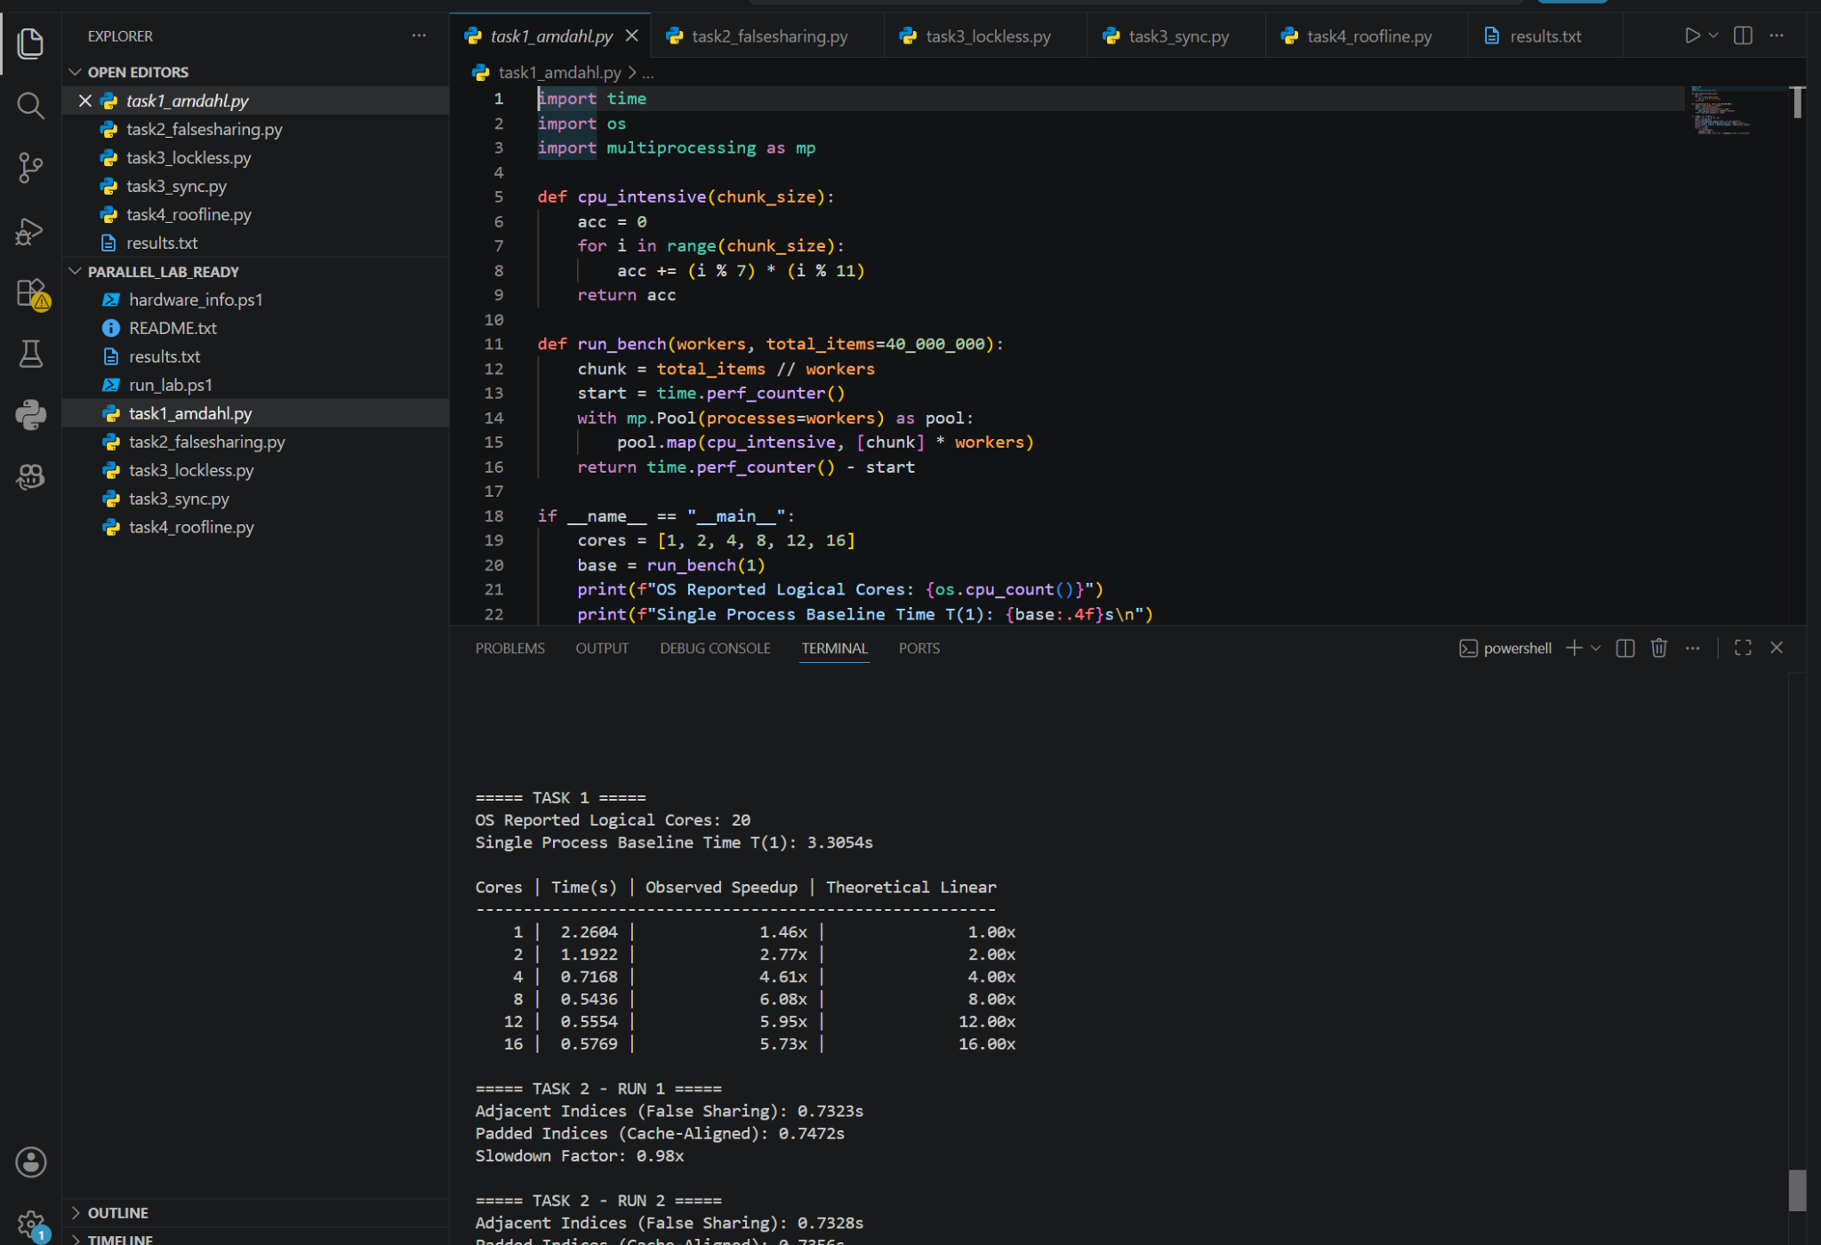
Figure A2. Task 1 output and beginning of Task 2: the worker sweep and measured execution times are visible in the local terminal.

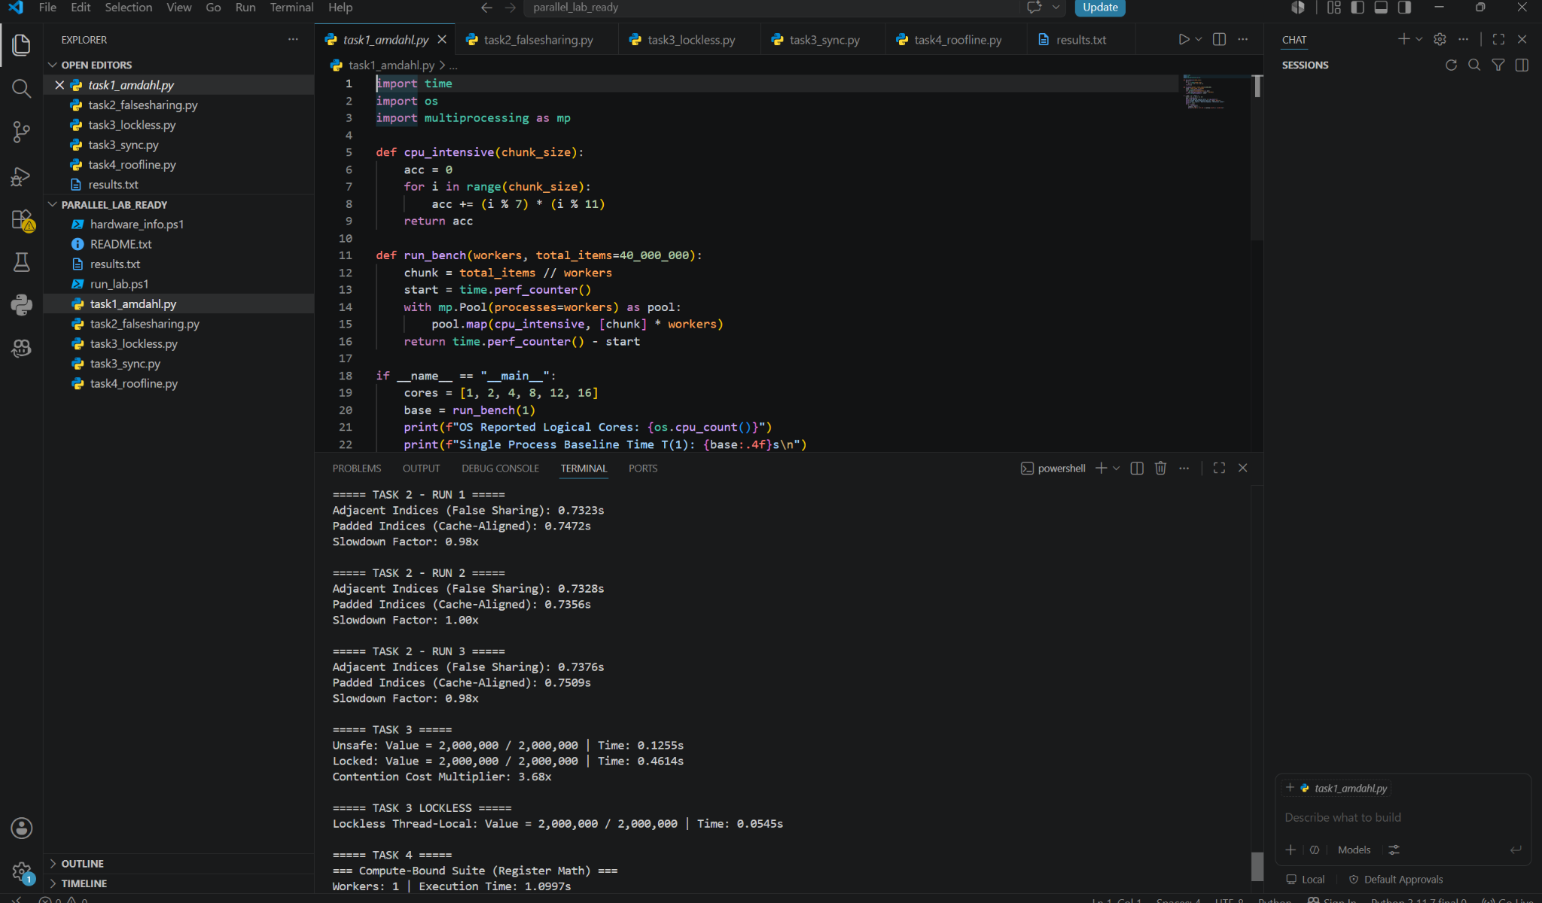
Figure A3. Task 2, Task 3 and lockless results, plus the start of Task 4, captured from the same local VS Code session.

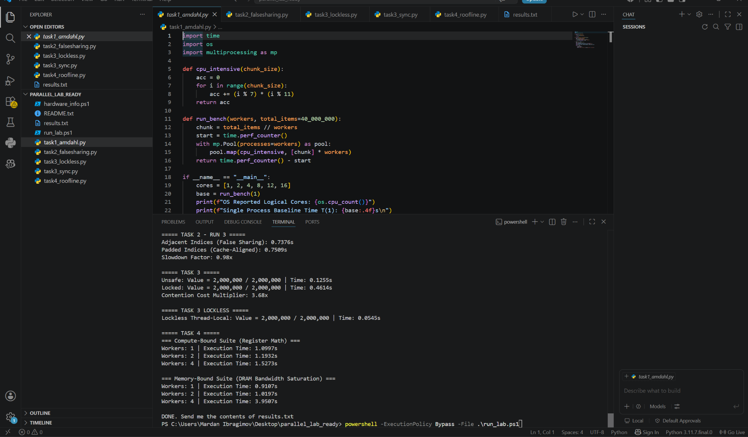
Figure A4. Completed Task 4 output and DONE message, showing the full benchmark script reached completion on the local laptop.

Appendix B — Raw results.txt Measurements
TASK 1
Baseline: 3.3054 s
p=1: 2.2604 s | p=2: 1.1922 s | p=4: 0.7168 s | p=8: 0.5436 s | p=12: 0.5554 s | p=16: 0.5769 s
TASK 2
Run 1: adjacent 0.7323 s | padded 0.7472 s
Run 2: adjacent 0.7328 s | padded 0.7356 s
Run 3: adjacent 0.7376 s | padded 0.7509 s
TASK 3
Unsafe: 2,000,000 | 0.1255 s
Locked: 2,000,000 | 0.4614 s
Lockless thread-local: 2,000,000 | 0.0545 s
TASK 4
Compute: 1 worker 1.0997 s | 2 workers 1.1932 s | 4 workers 1.5273 s
Memory: 1 worker 0.9107 s | 2 workers 1.0197 s | 4 workers 3.9507 s

