Table of Contents

Antioch University
Faculty of Informatics Engineering — Department of Software Engineering
Draw-to-Web
A Desktop Visual Authoring Tool for Generating Semantic, Responsive, Accessible Web Pages
Graduation Project Report
Prepared by:
Ibrahim Haski (221116)
Yousef Deeb (112004)
Abd Alrazak Qahwaji ([ID])
Supervised by: [Supervisor Name]
Academic Year 2025–2026

Abstract
Authoring a web page that is at once semantic, responsive, and accessible still demands specialist skill, and the visual “no-code” builders that promise to remove that barrier typically do so at the expense of output quality: heavy proprietary runtimes, non-semantic markup, absolute positioning, and pages that are difficult to audit for accessibility. Draw-to-Web is a desktop application that resolves this tension. A single Document Model is the only source of truth: the canvas is a rendering of that model, and a deterministic generator walks the same model to emit semantic HTML5, tokens-driven CSS, and opt-in, independently toggleable JavaScript. When no runtime behaviour is enabled, the output contains no <script> at all. Accessibility is enforced as a build-time hard gate — axe-core runs on the generated HTML and blocks export on any critical or serious violation — rather than left to manual review. The system was built as a strict-TypeScript Electron + React application with a Zustand/immer state layer, a Zod-validated process boundary, and a nine-stage export pipeline. Version 1.0.0 adds three authoring surfaces that reuse the same operations and export path: draw-to-create (draw a rectangle to place an element), match-layout (adopt a professional design from a rough draft), and a headless Model Context Protocol (MCP) server. The v1.0.0 release is green across all automated gates: 1042 automated tests across 110 files pass, linting and strict type-checking are clean, the accessibility gate is enforced on every export path, and the data-layer and export performance budgets are met with wide margins (for example a full nine-stage export of a portfolio page completes in roughly 0.2–0.3 s against a 10 s budget). The work shows that visual, no-code authoring and hand-written-quality output need not be opposites.
Keywords: visual web authoring; no-code; semantic HTML5; web accessibility (WCAG); design tokens; deterministic code generation; Electron; Model Context Protocol.

Introduction

Field of Work
The modern web is built from three languages — HTML for structure, CSS for presentation, and JavaScript for behaviour — yet authoring a page that is simultaneously semantic, responsive, and accessible remains a specialised skill. Over the last decade a class of visual web builders — tools such as Webflow, Framer, and Wix — has lowered the barrier to entry by letting users compose pages on a canvas rather than in a text editor [1], [2], [3]. These tools trade code for direct manipulation, which is a genuine advance in accessibility of authoring; but they frequently do so at the cost of the output: heavy client-side runtimes, non-semantic “div soup”, absolute positioning that breaks on unexpected viewports, and markup that is difficult to audit against accessibility standards.
Two forces sharpen the problem. First, the no-code / low-code movement has brought a large, non-technical audience to web authoring, so the quality of what a builder emits is now the quality that most sites inherit. Second, accessibility has moved from a courtesy to a requirement: the Web Content Accessibility Guidelines (WCAG) [4] are referenced by legislation in many jurisdictions, and semantic HTML [5] is the foundation on which assistive technology depends. In parallel, professional front-end practice has converged on design tokens — named, themeable primitives for colour, spacing, and typography — as the disciplined way to keep a design system consistent. A tool built today should treat semantics, accessibility, and tokens as first-class concerns rather than as afterthoughts to be patched on later.

Problem Statement
The core tension this project addresses is that visual authoring and high-quality output are usually treated as opposites. A user who cannot write code is typically forced to accept whatever markup a builder emits, with no guarantee of semantic structure, accessibility compliance, or portability, and often with a hard dependency on the vendor’s hosting and runtime. The question the project sets out to answer is therefore concrete and testable:
Can a canvas-based visual editor produce hand-written-quality output — semantic, deterministic, accessibility-gated HTML and CSS with only opt-in JavaScript — without requiring the author to write or read code, and without locking the result to a proprietary platform?

Proposed Solution
Draw-to-Web is a desktop application that answers this question by making a single Document Model the only source of truth. The canvas is a rendering of that model; a deterministic generator walks the same model to emit semantic HTML5, tokens-driven CSS, and opt-in vetted JavaScript. Every visual property is token-bindable and per-breakpoint, so theming and responsiveness fall out of the data model rather than being bolted on. Accessibility is enforced by a hard gate (axe-core) that blocks export on any critical or serious violation, and the output is formatted with prettier so that it reads as though a human wrote it. Because the tool is a local desktop application, the exported bundle is a plain folder of files with no build step and no mandatory runtime — fully portable, with no vendor lock-in.
Version 1.0.0 extends this foundation with three authoring surfaces that make the tool faster to use without weakening any of its guarantees, because each reuses the same document operations and export pipeline: draw-to-create (draw a rectangle and the system proposes the element to place), match-layout (sketch a rough structure and adopt a bundled professional design that matches it), and a headless Model Context Protocol (MCP) server that drives the whole pipeline programmatically [6], so the builder can be scripted by an agent or a client with no graphical interface.

Report Organisation
The remainder of this report is organised as follows. Chapter 2 states the primary and specific objectives and the project scope. Chapter 3 describes the work methodology: the task-driven, milestone-gated process, the ownership model, and the quality gates. Chapter 4 presents the implementation plan and the deviations from it. Chapter 5 gathers the functional and non-functional requirements and the primary use cases. Chapter 6 reviews similar projects and positions Draw-to-Web against them. Chapter 7 gives the system analysis, including the UML class, use-case, and sequence diagrams. Chapter 8 lists the technologies used and justifies each choice. Chapter 9 details the implementation. Chapter 10 covers testing and evaluation against the defined budgets, and Chapter 11 reports the results against the objectives, states the limitations honestly, and concludes.

Project Objective

Primary Objective
The primary objective is to design and build a desktop application that lets non-developers author modern, semantic, responsive, and accessible web pages by direct manipulation on a canvas, and that exports a portable, human-readable HTML/CSS bundle with opt-in, independently toggleable JavaScript behaviours. The guiding principle throughout is that output quality is a first-class requirement: the tool must never force the author to choose between the convenience of visual editing and the quality of the result.

Specific Objectives
The primary objective decomposes into six specific, measurable sub-objectives. Each is written so that Chapters 10 and 11 can report on it directly.
- Single source of truth. Represent every page as one Document Model. The canvas renders it and the generator walks it; no component owns page state independently. Measurable by: a one-directional data-flow architecture in which the store is the only mutable state.
- Semantic, deterministic output. Emit semantic HTML5 chosen by role (<header>, <nav>, <main>, <section>, <article>, <footer>, <button>, <a>) and guarantee byte-identical output for identical input — no timestamps and no random identifiers. Measurable by: a determinism test and a no-position:absolute invariant test.
- Accessibility by construction. Enforce a hard gate that blocks export on any critical or serious accessibility violation, and honour a single <h1>, unbroken heading order, alt text on every image, ARIA labels on icon-only controls, visible focus indicators, and the prefers-reduced-motion preference. Measurable by: the axe-core gate and the validation rule suite.
- Tokens-driven, responsive styling. Drive all styling through design tokens with light/dark theming and per-breakpoint values (desktop, tablet, mobile, small). Measurable by: var() references in output, a :root token block, and emitted media queries.
- Opt-in, vetted runtime. Ship only the JavaScript the author enables; with all behaviours disabled, produce JavaScript-free output. Measurable by: the all-flags-off “no <script>” test.
- Accessible authoring surfaces (v1.0.0). Provide draw-to-create, match-layout, and a headless MCP server, each reusing the same document operations and export pipeline so they inherit the same guarantees. Measurable by: their dedicated test suites and the fact that headless exports pass the same accessibility gate.

Scope
The project deliberately bounds its scope into three tiers. Tier 1 — the target output-capability set specified in draft/Features/features.md — is fully in scope and is what the builder must be able to produce: semantic, tokens-driven, accessible, responsive pages with opt-in runtime behaviour. Tier 2 is the broader editor-experience “nice to have” set, and Tier 3 is the long-horizon product concern (cloud, accounts, billing, and real-time collaboration); both are out of scope for this sprint. The one conscious exception is that three Tier 2 authoring surfaces — draw-to-create, match-layout, and the MCP server — were brought forward into v1.0.0 because they proved to be the most demonstrable capabilities in the product and, crucially, because their cores are pure and headless and reuse the existing operations, so they added capability without adding architectural risk (this decision, and the scope-line move it entails, is recorded in the project decision log as D-03 and discussed in Section 4.3).

Work Methodology
This chapter describes how the team worked — the development model, ownership structure, interface contracts, and quality gates — rather than what was built. The process was unusually well documented for a student project, and that discipline is itself one of the project’s results.

Development Model: Task-Driven Milestones
Development followed a task-driven, milestone-gated model rather than a fixed time-box. Progress was unlocked by completing the tasks that gate each milestone, not by the calendar: a milestone was “done” only when its gating tasks were complete and every quality gate was green. Five milestones carried the work from M1 (Foundation) through M5 (Polish + Demo), followed by the v1.0.0 demo cut (the milestone table is reproduced in Chapter 4, Table 4.1). Every task carried a single owner, a priority (P0 blocks the demo, P1 is a Tier-1 feature, P2 is polish), and explicit depends:/blocks: links, so the critical path was always visible and the Document Model — which blocks every other area — was scheduled to land first.

Team Structure and Ownership
Three engineers owned disjoint areas of the codebase, which kept merge contention low and made every file traceable to a responsible owner:
- Ibrahim Haski — the Document Model (types, schemas, operations, tokens, validation, migrations, presets), the output pipeline (generator, runtime, seo, export), the Electron shell and IPC, and the build/CI configuration.
- Yousef Deeb — the state layer: the Zustand stores, undo/redo history implemented as immer patches, persistence (the .dtw file format), autosave and crash recovery, and external-change reload; and, in v1.0.0, the draw / match / MCP surfaces.
- Abd Alrazak Qahwaji — the user interface: the canvas, the properties, layers, and tokens panels, the sidebar, the topbar, and the semantic-inference hints the generator consumes.

Cross-Owner Contracts
Because three people worked in parallel against a shared model, the interfaces between owners were fixed as twelve numbered contracts (C1–C12). These include the shared types (C1), the Zod schemas kept in lockstep with them (C2), the operation set (C3), the typed IPC surface (C4), the store hooks (C5), the generator entry point (C6), the presets registry (C7), the validation function (C8), the token resolver (C9), the semantic-inference hint (C10), the image-upload IPC contract (C11), and the export orchestrator (C12). Any breaking change to a contract required a pull request labelled contract-change and a review from the named downstream consumer; this single rule is what allowed the three lanes to move quickly without silently diverging.

Quality Gates and Tooling
Every push had to pass three gates: linting (ESLint + Prettier), strict type-checking (TypeScript in strict mode across the main, preload, and renderer tsconfigs), and the full automated test suite. These were enforced twice — locally by a husky pre-push hook and again in continuous integration — so a red build could not reach main. On top of the three gates, specialised automated review passes checked properties that unit tests do not naturally cover: output determinism, the no-position:absolute invariant, accessibility of generated output, and correctness of any contract change. A weekly integration ritual merged all open feature branches, ran the full matrix, and held a short debrief with no new commits, which caught cross-lane integration problems early rather than at release. As a matter of academic integrity, the project also enforced a “no AI attribution” policy on all commits, pull requests, and reviews; the work and its authorship are the students’ own.

Version Control and Release Workflow
Work used conventional commits (for example feat(generator): emit skip-to-content link) on short-lived feature branches that were squash-merged into main; the main branch was never force-pushed. Releases were tag-driven: pushing a v* tag triggered a per-operating-system build matrix that produced native installers (Windows NSIS, Linux AppImage/deb, macOS dmg/zip) and published a single GitHub Release. Versions progressed v0.1.0 $→$ v0.2.0 $→$ v0.3.0 $→$ v1.0.0, with each tag corresponding to a completed milestone.

Project Implementation Plan

Milestone Breakdown
The work was divided into five gated milestones plus the v1.0.0 demo cut (Table 4.1). The ordering encodes the technical dependencies of the system: the Document Model and the store had to exist before anything could be rendered or generated (M1); themable output required the token system (M2); composition and responsiveness required presets and per-breakpoint style (M3); the runtime, SEO, and the accessibility gate hardened the output (M4); and polish plus a released artifact completed the sprint (M5). Each milestone was “done” only when its gating tasks were complete and all quality gates were green.
Milestone plan and definition of done.
Milestone | Theme | Definition of done (summary)
M1 | Foundation | Types + store + recursive canvas + undo/redo + persistence + basic generator + export shell.
M2 | Tokens + Themes | Token registry + theme toggle + auto-layout + :root block + var() refs.
M3 | Composition + Resp. | 6+ presets + hover/focus states + breakpoint switcher + multi-select + image upload.
M4 | Runtime + Hardening | Full runtime snippets + SEO + validation console + axe-core gate + templates.
M5 | Polish + Demo | Polish + performance budgets + release artifact + rehearsed demo.
v1.0.0 | Demo cut | draw-to-create + match-layout + headless MCP server; released with native installers.

Task Allocation and the Critical Path
Tasks were identified by owner and area — for example I-DOC-* for the Document Model, I-GEN-* for the generator, I-RUN-* for runtime snippets, Y-* for the store, and L-* for the user interface — each with a priority and explicit dependency links. The critical path ran through the Document Model: because the types (C1), schemas (C2), and operations (C3) are consumed by every other lane, the I-DOC tasks were front-loaded and had to land before the store, canvas, and generator could be written against a stable shape. Table 4.2 summarises the allocation of areas to owners.
Allocation of work areas to owners.
Owner | Areas (task prefixes)
Ibrahim Haski | Document Model (I-DOC), Electron shell (I-ELE), generator (I-GEN), runtime (I-RUN), SEO (I-SEO), export (I-EXP), templates (I-TPL), build/CI (I-BLD).
Yousef Deeb | Zustand stores, history via immer patches, persistence, autosave/crash recovery, external-change reload (Y-*); draw / match / MCP surfaces (v1.0.0).
Abd Alrazak Qahwaji | Canvas, properties/layers/tokens panels, sidebar, topbar, live validation console, semantic-inference hints (L-*).

Deviations from the Plan
A plan is only credible if its deviations are recorded honestly. Four decisions in the project’s append-only decision log changed the plan, and each is summarised here.
- D-01 — Code signing cancelled permanently. Windows Authenticode signing and macOS notarization (task I-BLD-05) were cut from scope, not merely deferred: the team has no code-signing certificate and no Apple Developer ID and decided the cost was not justified. Builds therefore ship unsigned, and the README documents how users bypass the resulting one-time operating-system trust prompt.
- D-02 / D-04 — Releases shipped ahead of the manual demo rehearsal and the render-layer performance sign-off. The v0.3.0 and v1.0.0 tags were cut while two manual items remained open: the rehearsed demo on the packaged build, and the empirical render-layer performance capture (drag FPS, theme-toggle latency, and similar). These are not code defects — the automated suite is green — but a conscious, documented waiver, tracked as the top post-release item (issue #95).
- D-03 — Three Tier-2 authoring surfaces brought forward into v1.0.0. Draw-to-create, match-layout, and the MCP server were originally Tier-2 (out of scope), but were merged and shipped as the headline of the demo cut because they are the most demonstrable features in the product and, being pure and headless at their core and reusing the existing operations, added capability without adding architectural risk.
Recording these deviations, with their rationale and accepted consequences, is part of the methodology (Chapter 3): the decision log is the mechanism that keeps “what we planned” and “what we shipped” reconcilable.

Requirements Gathering
Requirements were elicited from the Tier-1 feature specification (draft/Features/features.md) and the architecture and constraints in the execution plan. They are presented here as functional requirements, non-functional requirements, and the primary use cases; the use-case diagram that accompanies these descriptions appears in Chapter 7, Figure 7.6.

Functional Requirements
- The system shall let a user insert, select, move, reorder, group, and delete elements on a canvas, with full undo and redo.
- The system shall support the primitive element types — container, text, image, button, link, icon, list, and divider — and presets that compose those primitives into larger structures (hero, cards grid, navigation, footer, and so on) without introducing new element types.
- The system shall let a user define design tokens (colour, spacing, font size, font family, line height, radius, shadow) and bind element styles to them, with coordinated light and dark theme values.
- The system shall support per-breakpoint style values (desktop, tablet, mobile, small) and per-state overrides (hover, focus-visible, active) on every element.
- The system shall create an element from a rectangle the user draws on the canvas, proposing the most likely element kind with a confidence hint (draw-to-create).
- The system shall match a rough drawn layout against bundled professional designs and let the user adopt the best match as a full document (match-layout).
- The system shall validate the document and export a portable HTML/CSS/JS bundle as a ZIP archive, together with SEO assets (sitemap, robots).
- The system shall expose the document, generation, and export pipeline over a headless Model Context Protocol (MCP) server, so the builder can be driven without its graphical interface.
- The system shall save and open projects as versioned .dtw files, with autosave, crash recovery, and reload on external change.

Non-Functional Requirements
- Accessibility. Export shall be blocked on any critical or serious axe-core violation, and the output shall satisfy the project’s WCAG-aligned rules (single <h1>, no heading skips, alt text, ARIA labels on icon-only controls, visible focus, reduced-motion support) [4].
- Determinism. Identical input shall yield byte-identical output (no timestamps, no random identifiers), so exports are reproducible and diff-able.
- Performance. Data-layer operations (save, open, undo/redo) and the export pipeline shall meet defined budgets (see Chapter 10).
- Security. The Electron application shall run with context isolation, no Node integration, and sandboxing; a strict Content Security Policy in production; and Zod-validated IPC boundaries with path sanitisation and size caps.
- Portability. The exported output shall have no build step and no mandatory runtime dependency, so it can be hosted anywhere as static files.
- Maintainability. The codebase shall be strict TypeScript with no any, named exports, and JSDoc on every exported function in the core modules.

Primary Use Cases
Each use case below is given as a short structured description (actor, precondition, main flow, postcondition). Together they define the actors and system boundary drawn in Figure 7.6.

UC-1: Author and export a page
Actor: Author. Precondition: the application is open. Main flow: the author opens a template or a blank page; inserts and edits elements on the canvas; adjusts tokens, theme, and per-breakpoint values; runs the live validation console to resolve any issues; and requests an export. Postcondition: a valid, accessibility-gated ZIP bundle is written to disk.

UC-2: Draw to create an element
Actor: Author. Precondition: a container is selected. Main flow: the author drags a rectangle; the system normalises the box, ranks the likely element kind with a confidence hint, and offers alternatives; the author accepts a kind; the element is placed through an ordinary insert operation. Postcondition: a new element exists in the document at a grid-snapped position; the drawn pixels never enter the store.

UC-3: Match my layout
Actor: Author. Precondition: a rough layout has been sketched. Main flow: the author opens Match; the system computes a structural fingerprint of the current tree and ranks the bundled professional designs with a per-dimension breakdown; the author adopts one. Postcondition: the chosen design is hydrated as an ordinary document through the same path a project load uses.

UC-4: Drive the builder headlessly (MCP)
Actor: MCP client / agent. Precondition: the MCP server is running. Main flow: the client calls create_document, then inserts presets, sets tokens, theme, runtime flags, and SEO, then calls run_a11y_check and export_site — all without the graphical interface. Postcondition: an exported bundle that has passed the same accessibility gate as an interactive export.

UC-5: Save, open, and recover a project
Actor: Author. Precondition: a project exists in memory or on disk. Main flow: the author saves the project as a versioned .dtw file, or opens one; on load, the file passes through Zod validation, version migration, and validation again; autosave protects unsaved work and crash recovery restores it after an abnormal exit. Postcondition: the document in memory matches the persisted state (or the most recent recoverable state).

Reference Study
This chapter surveys the most relevant existing visual web builders, notes the advantages and shortcomings of each with respect to output quality, and then positions Draw-to-Web against them. The dimensions chosen for comparison are the ones that motivated this project: whether the tool is a local desktop application, whether it produces semantic and portable output, whether it enforces accessibility, whether styling is tokens-first, whether JavaScript-free output is possible, and whether the pipeline is scriptable. Because commercial products change frequently, specific feature claims should be re-verified at submission.

Survey of Similar Projects

Webflow
Webflow is a browser-based visual builder aimed at professional designers, with fine-grained control over the CSS box model and a large template ecosystem [1]. Advantages: strong style-level control; markup that is more semantic than most drag-and-drop builders; mature hosting and content management. Shortcomings: it is a hosted, subscription platform rather than a local tool; clean code export is gated behind paid tiers; and it offers no built-in accessibility gate that blocks publishing on violations.

Framer
Framer is a design-first site builder known for rich interactions and motion [2]. Advantages: excellent prototyping and animation; very fast to a polished, hosted result. Shortcomings: the published site leans on a proprietary runtime, so the output is not a portable, dependency-free bundle; the author has limited control over the raw semantic structure of the HTML; and it is oriented around Framer’s own hosting.

Wix
Wix is a mass-market, all-in-one website builder [3]. Advantages: the lowest barrier to entry of the tools surveyed; hosting, templates, and domain management are integrated. Shortcomings: historically heavy and non-portable output; limited semantic and accessibility guarantees; and strong platform lock-in — the site cannot meaningfully be exported and self-hosted.

Elementor (WordPress)
Elementor is a visual page builder that runs inside WordPress [7]. Advantages: an enormous plugin and theme ecosystem; visual editing on top of the world’s most common CMS. Shortcomings: it requires a full WordPress (PHP + database) stack; the generated DOM is typically heavy and nested; and output quality depends heavily on the surrounding theme and plugins.

Bootstrap Studio and Pinegrow
These are desktop visual editors that emit real HTML and CSS, and are therefore the closest in spirit to Draw-to-Web [8], [9]. Advantages: local applications; the code is visible and export-friendly; no mandatory hosting. Shortcomings: both are framework-coupled (Bootstrap Studio is built around Bootstrap; Pinegrow around Bootstrap/Tailwind/foundation frameworks); the learning curve is closer to a code editor than to a canvas; and neither ships a tokens-first theming model or an accessibility export gate that blocks on violations.

Comparative Analysis
Table 6.1 compares the tools on the dimensions that distinguish Draw-to-Web. A tick () means the property holds; a dash () means it does not; a tilde (~) means partial or configuration dependent.
Comparison of visual web builders on output-quality dimensions.
Dimension | Draw-to-Web | Webflow | Framer | Wix | Elementor
Local desktop app
Semantic HTML output |  | ~ | ~ |  | ~
Accessibility hard gate
Tokens-first theming |  | ~ | ~
JS-free output option
Portable / no lock-in |  | ~ |  |  | ~
Headless / scriptable (MCP)

Positioning of Draw-to-Web
The survey shows a consistent gap: the established builders optimise for the authoring experience and for hosting, and treat output quality as a secondary concern that the author cannot fully control. Even the desktop tools that do emit real code couple it to a CSS framework and provide no built-in accessibility gate. Against this landscape, Draw-to-Web’s distinguishing bets are deliberate responses to the shortcomings above: it is a local desktop tool whose exported bundle is portable and free of vendor lock-in; it treats output quality as a first-class, enforced requirement (semantic, deterministic, and accessibility-gated); it uses a tokens-first styling model rather than framework classes; it makes the runtime opt-in down to fully JavaScript-free output; and it exposes the same pipeline through a headless MCP interface for scripting and automation. In short, where the incumbents ask the author to trust the platform, Draw-to-Web makes the quality of the output a checkable, reproducible property of every export.

System Analysis
This chapter analyses the system: first the layered architecture and data flow, then the three formal UML views required for the design — a class diagram of the Document Model, a use-case diagram of the actors and their goals, and sequence diagrams of the two most characteristic interactions (draw-to-create and export).

Architectural Overview
Draw-to-Web is organised into layers with a strictly one-directional data flow: the user interface writes to the store through operations, the Document Model is the single source of truth, and the output layer reads the document to generate and export. Nothing flows the other way — the canvas is a rendering of the document, never the model itself. Figure 7.1 shows the layered architecture across the Electron main, preload, and renderer processes, and Figure 7.2 shows the one-directional data flow that this layering enforces.
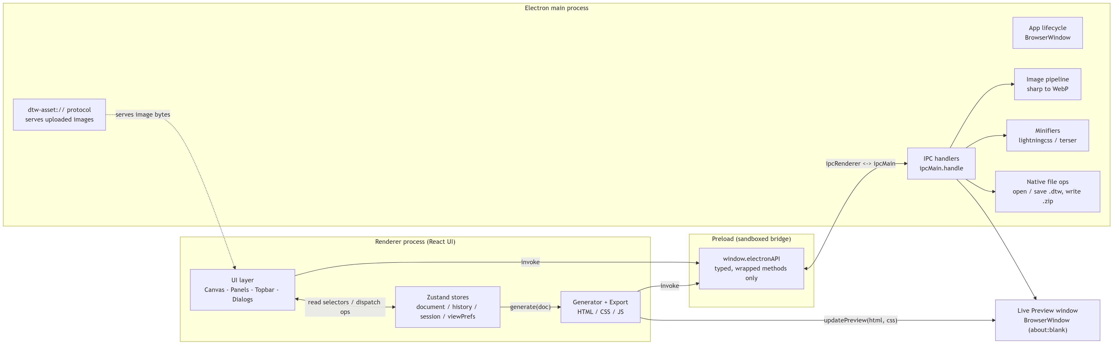
Layered architecture: renderer (UI $→$ store $→$ generator) over a sandboxed preload bridge and an Electron main process.
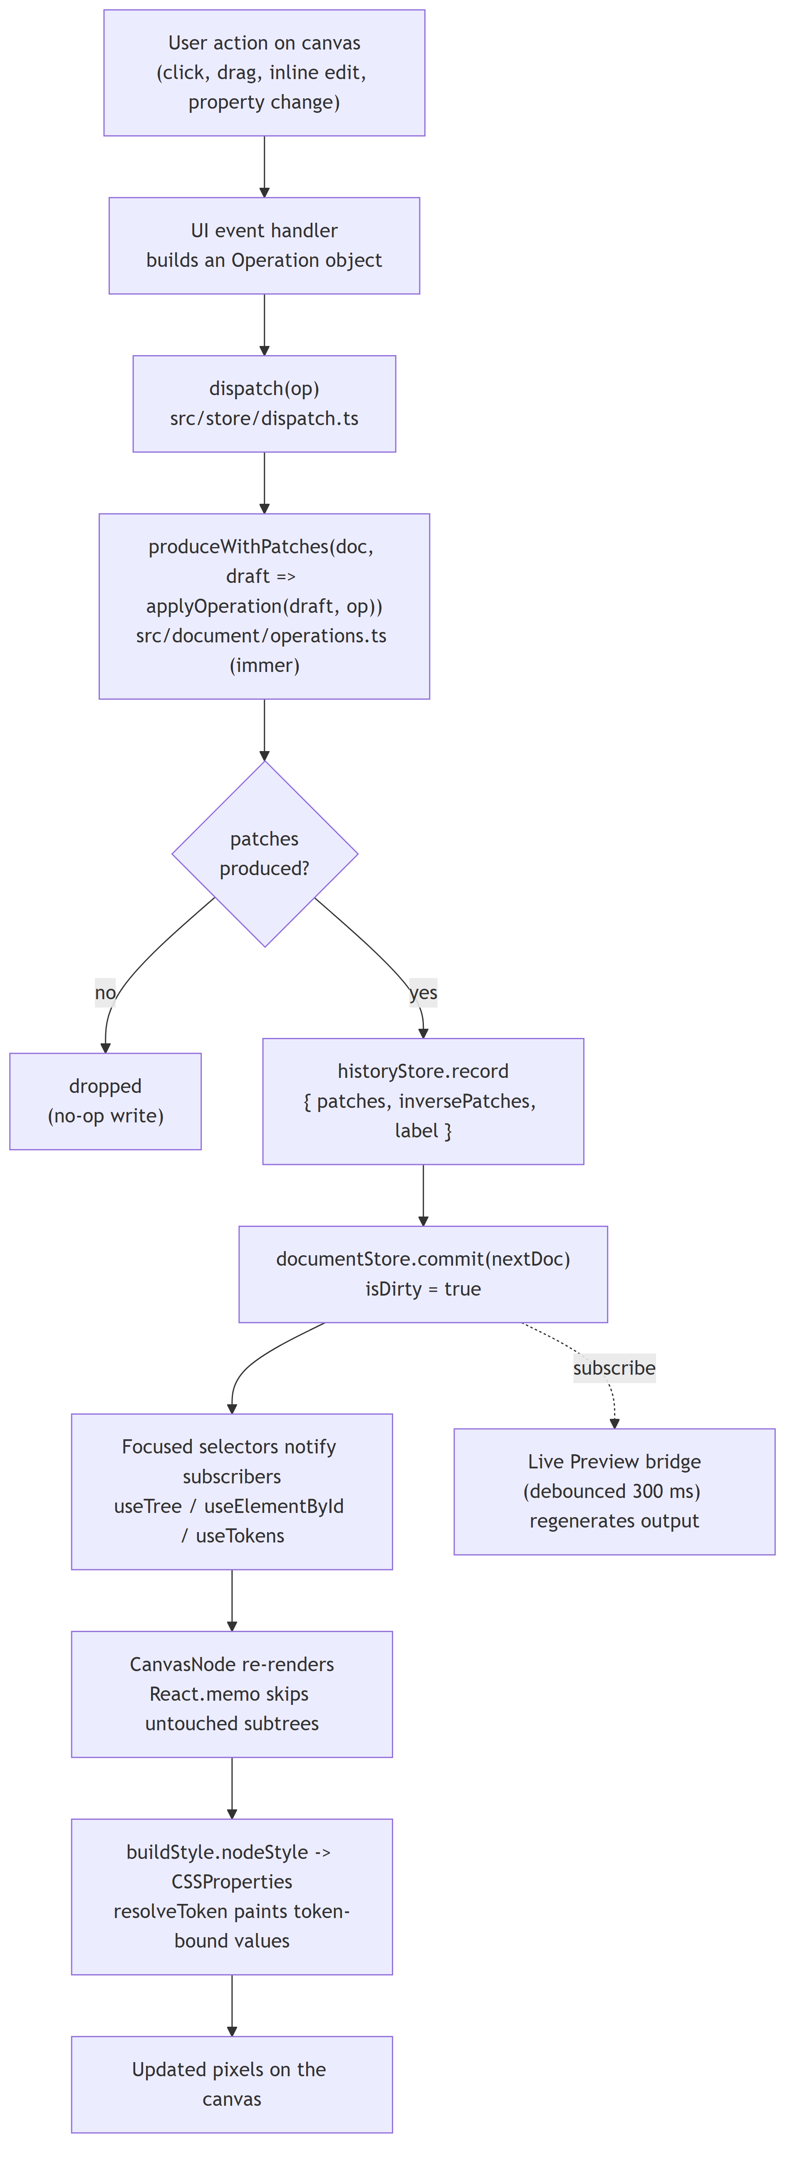
One-directional data flow. The UI dispatches operations to the store; the generator and export pipeline read the resulting document.
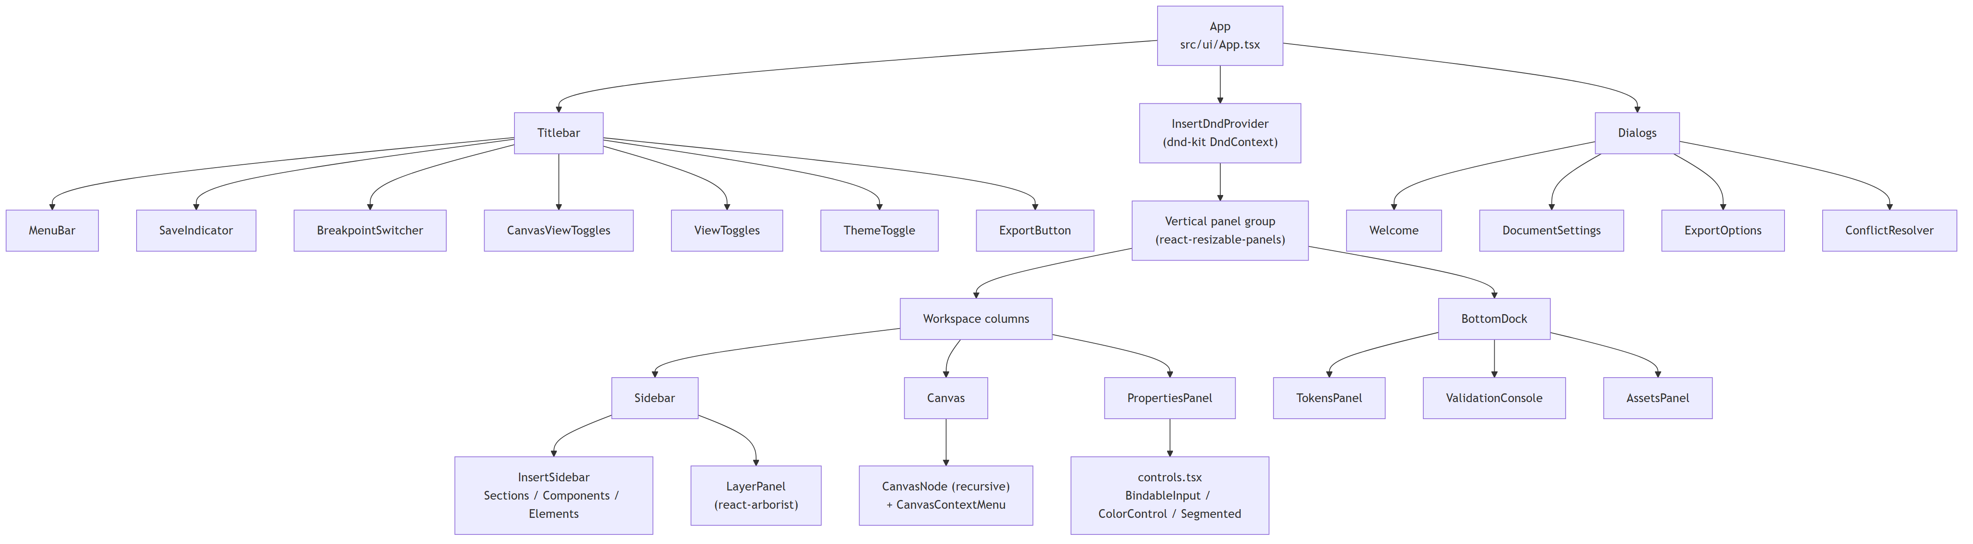
Renderer component hierarchy.
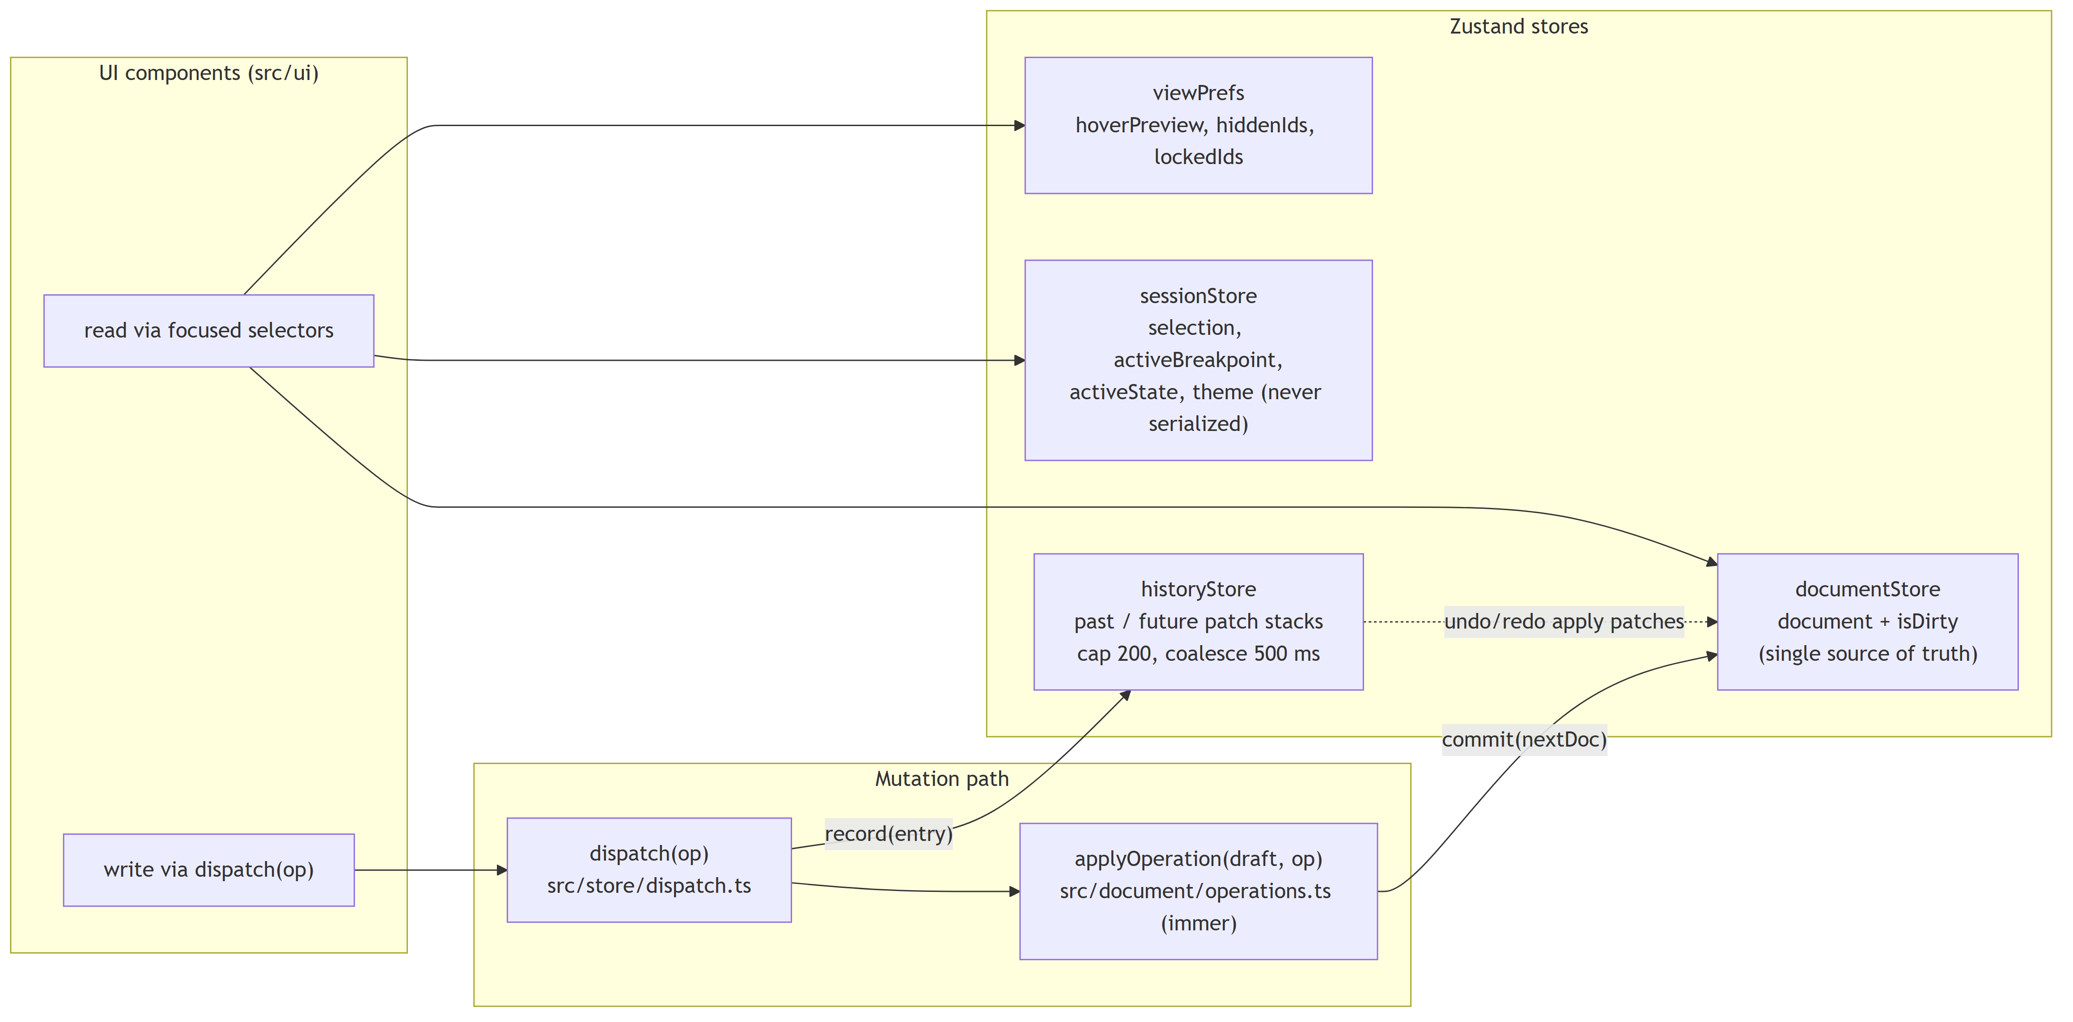
State stores (document, history, session) and their relationships.

Class Diagram (Document Model)
The Document Model is the heart of the system and therefore its class model. A single Document aggregates the design tokens, the SEO configuration, the runtime flags, the author settings, the variables, and the asset manifest, plus one element tree. Every renderable element is an ElementNode — an abstract base (all elements share an identity, a per-breakpoint style, a states map, and an optional animation) specialised into eight concrete primitive types. Only ContainerNode owns children, and its children are themselves ElementNodes, which is the recursive composition that makes the document a tree. Complex shapes (hero, cards grid, navigation) are not new classes: they are presets that compose these same primitives. Figure 7.5 shows the model, generated from src/document/types.ts.
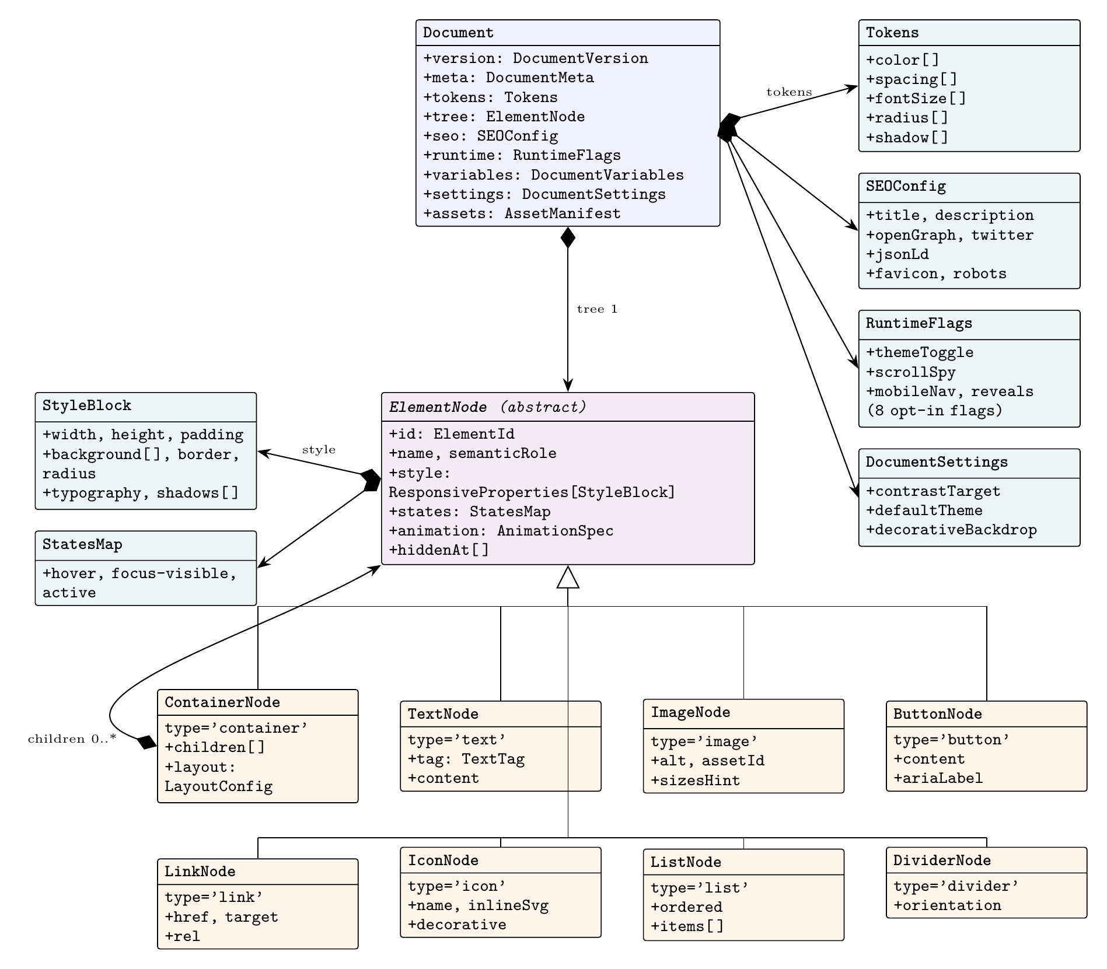
Class diagram of the Document Model. Filled diamonds denote composition; the hollow triangle denotes generalisation. ContainerNode composes further ElementNodes, making the document a recursive tree.

Use-Case Diagram
The system has two actors: the Author, a human working in the graphical editor, and the MCP Client, a program or agent driving the same pipeline headlessly. Figure 7.6 shows their goals. Note that both Author & export a page and Drive builder headlessly include the shared Validate document and Export ZIP bundle use cases — the same generation, accessibility gate, and packaging serve both the interactive and the headless path.
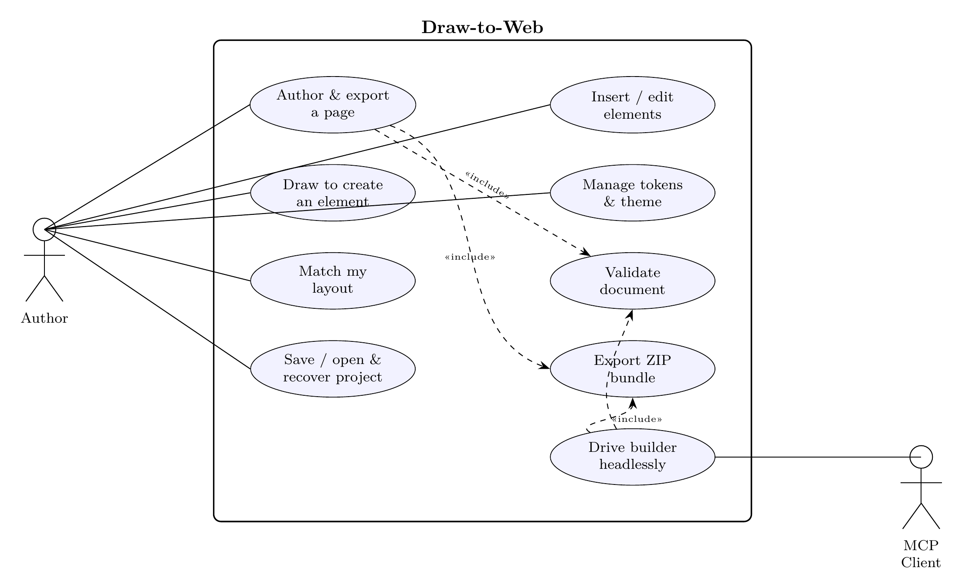
Use-case diagram. The Author drives the graphical goals; the MCP Client drives the headless goal. Both the interactive and headless export paths «include» the same validation and packaging.

Sequence Diagrams
Two interactions best characterise the system. The first, Figure 7.7, is draw-to-create: how a rectangle drawn on the canvas becomes a real element through an ordinary operation, so that the drawn pixels themselves never enter the store. The second, Figure 7.8, is the export pipeline: how a document is validated, generated, gated for accessibility, optimised across the IPC boundary, and packaged. The nine-stage pipeline is also shown as a flow in Figure 7.9.
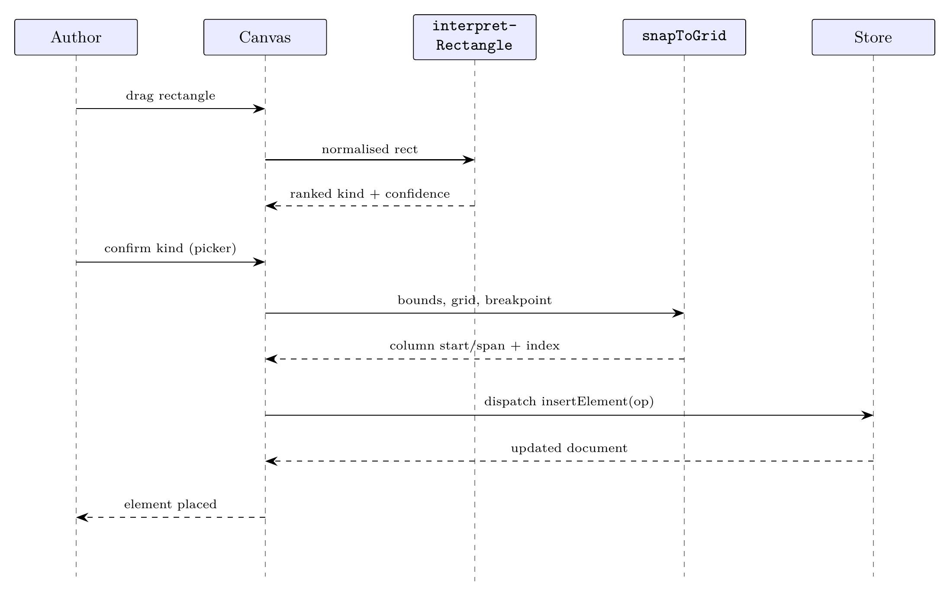
Sequence diagram: draw-to-create. The canvas interprets the rectangle and snaps it to a grid placement (pure functions), then dispatches a normal insertElement operation; the drawn pixels never enter the store.
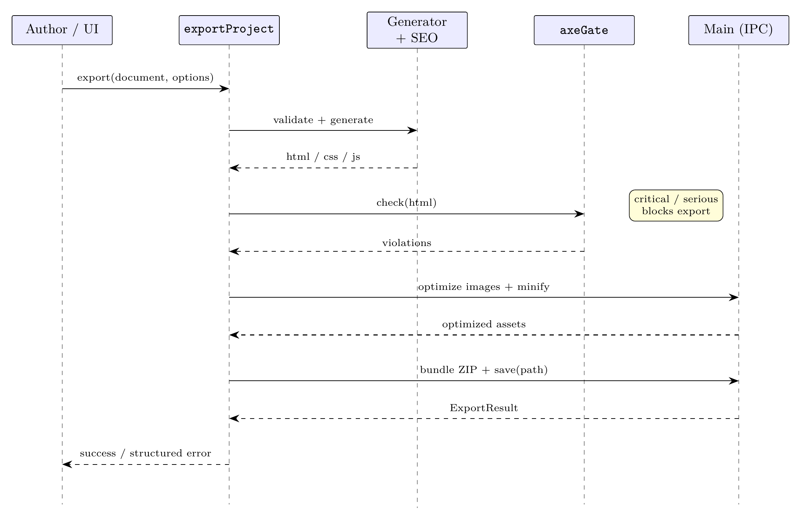
Sequence diagram: the export pipeline. The accessibility gate runs before any asset crosses the IPC boundary; a critical or serious violation aborts the export with a structured error.
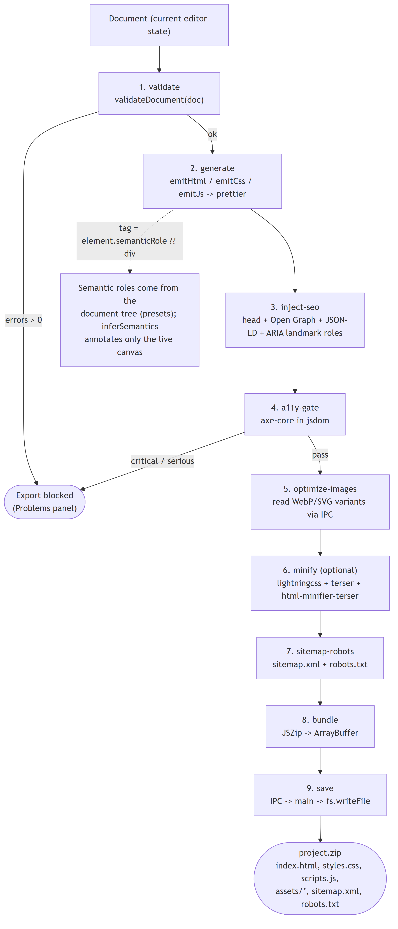
The nine-stage export pipeline as a flow: validate $→$ generate $→$ inject-SEO $→$ a11y-gate $→$ optimize-images $→$ minify $→$ sitemap/robots $→$ bundle $→$ save.

Technologies Used

Overview
The application is a single TypeScript codebase spanning three runtime contexts: an Electron main process (privileged, native OS access), a preload security bridge, and a React renderer (the editor UI). It is built and packaged with Vite and electron-builder. Every technology was chosen against a specific requirement rather than by default; Table 8.1 lists the principal choices and the reason for each, and the sections that follow expand on the choices that best show the engineering rationale.
Principal technologies and justification.
Technology | Role | Justification
Electron [10] | Desktop shell | Cross-platform desktop with native file access; local-first, no server required.
React 18 [11] | UI | Declarative rendering of the document tree; mature ecosystem and tooling.
TypeScript 5 [12] | Language | Strict typing across three processes; the cross-owner contracts are enforced at compile time.
Zustand + immer [13], [14] | State + history | Minimal store with no boilerplate; immer patches yield undo/redo almost for free.
Zod [15] | Validation | Schema validation at the IPC and file-load boundaries; types are derived via z.infer to keep schema and type in lockstep.
axe-core [16] | A11y gate | Industry-standard accessibility engine; blocks export on any critical or serious issue.
prettier [17] | Output format | Formats generated HTML/CSS so it reads as hand-written before minification.
Lightning CSS [18] | CSS minify | Fast, correct CSS transform and minification in the export pipeline.
sharp [19] | Images | Generates WebP and srcset variants in the main process.
Vite [20] | Build / dev | Fast hot-module-reload dev server and production bundling.
MCP SDK [6] | Headless API | Exposes the pipeline as tools to agents and clients over stdio.
Beyond the principals, the editor uses @dnd-kit for canvas drag-and-drop and react-arborist for the layers tree; Radix UI primitives for accessible tabs, dialogs, and popovers; react-colorful and chroma-js for the colour picker and contrast checks; and jszip plus html-minifier-terser in the export pipeline. Each of these maps to a specific Tier-1 feature in the execution plan’s library-to-feature justification.

Selected Justifications in Depth

Why a single Document Model backed by immer
Making one immutable Document the source of truth means that undo/redo, persistence, and generation all reduce to functions of one value. immer is what makes this ergonomic: each operation is written as if it were mutating a draft, while produceWithPatches captures the forward and inverse patches that the history store replays for undo and redo. The operations therefore never need to know anything about history — reversibility is a property of the patch round-trip, not of the operation code.

Why an accessibility hard gate rather than a linter
Accessibility is treated as a build error, not a warning. The axe-core engine runs on the generated HTML inside a jsdom document, and any critical or serious violation aborts the export. This guarantees a compliance floor that no manual review process could match consistently, and — crucially — it applies to every export path, including the headless MCP server, so the guarantee cannot be bypassed by scripting the tool.

Why prettier plus stable identifiers gives deterministic output
A recurring requirement is that identical input must yield byte-identical output. Two decisions make this hold: element identifiers are generated once and are stable across save/load (they are never regenerated), and the generator emits no timestamps or random values. Running the emitted HTML and CSS through prettier then produces a canonical, human-readable form, so two exports of the same document are not merely equivalent but textually identical — which makes the output diff-able and the pipeline testable by exact comparison.

Implementation
This chapter describes how the system was built, following the data as it flows from the Document Model through the generator to the export pipeline, and then the three v1.0.0 authoring surfaces and the security boundary.

The Document Model
Every page is one Document: a tree of ElementNodes together with the design tokens, SEO configuration, runtime flags, variables, settings, and asset manifest (the class model in Figure 7.5). The primitive types — container, text, image, button, link, icon, list, and divider — are the only node kinds; complex shapes such as a hero or a cards grid are presets that compose primitives, not new classes. This “composition over enumeration” rule keeps the model small and the generator simple.
All mutation flows through a single discriminated Operation union. Each operation is a pure function over an immer draft — signature (draft: Document, op: Op) => void — applying exactly one logical change, and each carries a kind discriminator so the store can capture patches for undo/redo. Listing [lst:ops] shows two representative operations; note that style writes are targeted at a named breakpoint slot, so an edit to the tablet value never silently overwrites the desktop base.
[language=,caption={Two operations from the discriminated union (\texttt{src/document/operations.ts}).},label=lst:ops]
/** Insert an element under an existing container. */
export interface InsertElementOp {
readonly kind: 'insertElement'
readonly parentId: ElementId
readonly node: ElementNode
/** Position among parent.children; appended when omitted. */
readonly index?: number
}
/**
* Write a value into node.style[breakpoint][...path]. The named
* breakpoint slot is created if absent; siblings are left untouched.
*/
export interface UpdateNodeStyleOp {
readonly kind: 'updateNodeStyle'
readonly id: ElementId
readonly breakpoint: BreakpointKey
readonly path: PropertyPath
readonly value: unknown
}
Files load through a strict boundary: a .dtw file is parsed, validated with Zod, run through any version migrations, and validated again, so an old or corrupt file can never reach the internal types unchecked.

The Generator
The generator is a compiler, not an inferer: it walks the document and emits HTML, CSS, and JS deterministically, so identical input yields byte-identical output. Tag selection is driven by each node’s semantic role (with a sensible default per type), which is how the output earns its semantic structure. The CSS is tokens-driven — a :root block defines every token, dark-theme overrides and a prefers-color-scheme block follow, and element rules reference var(--token) rather than raw values. Layout is expressed with CSS Grid, Flexbox, and clamp(), and never with absolute positioning; this invariant is enforced by a test that scans the generated CSS.

Runtime Snippets
JavaScript is opt-in per behaviour: theme toggle, scroll-spy, smooth scroll, mobile navigation, nav-on-scroll, reveals, animation gating, and terminal typing are each gated by a flag that defaults to off. The JS emitter concatenates only the enabled snippets into a single IIFE; if every flag is off, no <script> is emitted at all. Every snippet is written to the same discipline — passive event listeners, work deferred with requestAnimationFrame or debounced, a no-operation when its feature is disabled, and full respect for prefers-reduced-motion — so enabling a behaviour never degrades the page’s performance or accessibility.

The Export Pipeline
Export (Figures 7.8 and 7.9) chains nine stages — validate, generate, inject-SEO, a11y-gate, optimize-images, minify, sitemap/robots, bundle, save — each emitting a structured progress event so the UI can show exactly where the pipeline is. The result is a discriminated union, so a failure reports precisely which stage failed and why. The accessibility gate runs before any asset crosses the IPC boundary to the main process, so a failing document never reaches image optimisation or packaging.

v1.0.0 Authoring Surfaces

Draw-to-create
A drawn rectangle is normalised, classified by interpretRectangle (a ranked kind with a confidence score and a short explainer), and resolved to a grid placement by snapToGrid (pure math over column start/span and an insertion index — never pixels). The canvas then builds an ordinary node with the existing primitive factory and dispatches a normal insertElement operation, so the drawn pixels never enter the store (Figure 7.7).

Match-layout
extractSignature builds a deterministic structural fingerprint of a document tree (again, never pixels); matchLayout ranks that fingerprint against six bundled professional pages — each shipping a build-time precomputed signature — with a per-dimension breakdown; and the chosen page is hydrated through the very same entry point that a project load uses. Adopting a design is therefore indistinguishable, downstream, from opening a file.

Headless MCP server
A stdio Model Context Protocol server exposes roughly twenty tools over the same pipeline (create_document, insert_preset, apply_template, set_tokens, match_layout, run_a11y_check, export_site, and so on). Each tool is a thin adapter over the existing operations and entry points — no logic is reimplemented — and it runs without Electron by using a filesystem-backed export shim. Because it reuses the same pipeline, a headless export passes the same accessibility gate as an interactive one.

Process Boundaries and Security
The main process runs with context isolation, no Node integration, and sandboxing; the preload exposes only a typed electronAPI bridge, so the renderer can never reach raw ipcRenderer or Node built-ins. Every IPC handler validates its input — path sanitisation, size caps, and MIME sniffing on uploads — and a strict Content Security Policy is applied in production (relaxed only for hot-module reload in development). Validation happens at the edges; the internal types are trusted in between.

Testing and Evaluation

Testing Strategy
Testing is automated and layered, mirroring the source tree so that every module is exercised close to where it is defined. As of v1.0.0 the suite comprises 1042 tests across 110 files, covering the Document Model, the generator, the runtime snippets, SEO, the export pipeline, the templates, the stores, the user interface, and the three v1.0.0 surfaces. Table 10.1 summarises the suites and what each covers.
Test suites and their coverage.
Suite | Coverage
tests/document/ | Types, schemas, operations, tokens, validation, presets, migrations
tests/generator/ | HTML/CSS/JS emitters, determinism, prettier formatting, invariants
tests/runtime/ | Runtime snippet behaviour in jsdom
tests/seo/ | head / Open Graph / JSON-LD / sitemap / robots and the axe gate
tests/export/ | Full pipeline including minify, dry-run, and self-host fonts
tests/templates/ | Blank / portfolio / landing / resume round-trips and axe-cleanliness
tests/store/, tests/main/, tests/ui/ | Stores, IPC handlers, renderer components
tests/a11y/ | End-to-end axe-core on rendered output
tests/draw/, tests/match/, tests/mcp/ | The v1.0.0 authoring surfaces

Quality Gates
Three gates run on every push and again in continuous integration: linting (ESLint + Prettier), strict type-checking (the main/preload and the renderer tsconfigs), and the full test suite. Beyond the three, additional automated checks enforce properties that ordinary unit tests do not naturally capture: output determinism (the same document must serialise to identical bytes), the no-position:absolute invariant, and the axe-core accessibility gate, which blocks export on any critical or serious violation. Because these gates are enforced both locally (a pre-push hook) and in CI, a red build cannot reach main.

Performance Evaluation
Performance budgets fall into two categories, and the project reports them separately and honestly. Data-layer and export budgets are measured headlessly in a dedicated performance lane and pass with wide margins (Table 10.2). Render-layer budgets — drag frame rate, theme toggle latency, breakpoint switch, layers-tree scroll, and cold-start — require the running application and an interactive profiler; at the time of writing these are not yet captured, and are tracked as a post-release task (issue #95). They are deliberately not reported here as measured, because doing so would misrepresent an empirical result that has not been taken; capturing them on the demo hardware is the top outstanding item (Chapter 11).
Headless performance results (v1.0.0 performance lane). Re-run and confirm on the target machine before final submission.
Metric | Budget | Measured | Pass
Project save (.dtw serialise, 500 elements) | $<$ 500 ms | $≈$ 0.1 ms
Project open (parse + migrate + validate) | $<$ 1500 ms | $≈$ 1.3 ms
Undo/redo round-trip (500 elements) | $<$ 16 ms | $≈$ 0.1 ms
Dry-run / code preview | $<$ 500 ms | $≈$ 72 ms
Full export (9 stages incl. axe + minify) | $<$ 10 s | $≈$ 0.2–0.3 s

Accessibility and Output-Quality Evaluation
Output quality is evaluated by the project’s export-verification harness rather than by inspection. The exported templates are reported to score a Lighthouse SEO of 1.00 with valid JSON-LD, and the accessibility gate holds critical and serious violations at zero across every export path (the same gate runs for the interactive editor and for the headless MCP server). As with the render-layer numbers, the exact Lighthouse Performance and byte-size figures should be re-captured on the target machine and recorded before final submission; the harness and the performance-capture checklist automate that measurement.

Results and Conclusion

Results Against Objectives
The six specific objectives from Chapter 2 were all met, and each is backed by an automated check rather than by assertion:
- O1 (single source of truth) — achieved. One Document Model holds all page state; the canvas renders it and the generator walks it, with a strictly one-directional data flow.
- O2 (semantic, deterministic output) — achieved and test-guarded by the determinism check and the no-position:absolute invariant.
- O3 (accessibility by construction) — achieved. The axe-core hard gate blocks export on any critical or serious issue, on every export path.
- O4 (tokens-driven, responsive) — achieved through the :root token block, theme overrides, var() references, and per-breakpoint media queries.
- O5 (opt-in runtime) — achieved. With all runtime flags off the output contains no <script> element.
- O6 (authoring surfaces) — achieved in v1.0.0. Draw-to-create, match-layout, and the headless MCP server each ship with their own test suite and reuse the same operations and export pipeline.

Summary of Results
The v1.0.0 release is green across all automated gates: 1042 tests pass, linting and strict type-checking are clean, the accessibility gate is enforced, and the data-layer and export performance budgets are met with wide margins (Chapter 10). The application is packaged and released with native installers for Windows, macOS, and Linux, driven by a tag-triggered build matrix. The central claim of the project — that visual, no-code authoring and hand-written-quality output are not in tension — is therefore supported by a working, tested, and released artifact.

Limitations
Honesty about limitations is part of the result, and the project records them explicitly:
- Render-layer performance is not yet empirically signed off. The six in-application render metrics (drag frame rate, theme toggle, breakpoint switch, layers scroll, and cold-start) were consciously waived at release and remain to be captured on the demo hardware (issue #95, decision D-04).
- The demo has not been formally rehearsed on the packaged build — the same waiver.
- Builds are unsigned, as code signing was cut from scope permanently (decision D-01), so users pass a one-time operating-system trust prompt documented in the README.
- Scope is Tier 1 plus three Tier 2 surfaces; the broader editor-experience features and all Tier 3 product concerns (cloud, accounts, collaboration) remain out of scope.

Future Work
Future work follows the project’s own scope tiers. In the near term, the outstanding items above should be closed: capture the render-layer numbers and rehearse the demo (issue #95), and consider bringing the MCP tool surface under a formal, versioned contract like the other C1–C12 interfaces. In the medium term, the remainder of the Tier 2 editor experience (future-authoring.md) would round out the tool; in the long term, the Tier 3 product concerns (future-product.md) — hosting, accounts, and real-time collaboration — would turn it from a local tool into a platform. Adding code signing, revisited from decision D-01, is a small, self-contained task whenever certificates become available.

Conclusion
Draw-to-Web demonstrates that visual, no-code authoring and high-quality output need not be opposites. By making a single Document Model the source of truth and treating semantics, determinism, and accessibility as build-time guarantees rather than manual afterthoughts, the tool produces portable, hand-written-quality HTML and CSS with only the JavaScript the author opts into. Version 1.0.0 extends this foundation with faster authoring (draw-to-create and match-layout) and a headless, scriptable interface (MCP), while keeping the same accessibility gate on every path. The result is a builder whose output quality is not a matter of trust but a checkable, reproducible property of every export — which is precisely the gap the reference study identified in the existing tools.

References
[1] Webflow, Inc., “Webflow: Visual web development platform.” Accessed: Jul. 01, 2026. [Online]. Available: https://webflow.com/
[2] Framer B.V., “Framer.” Accessed: Jul. 01, 2026. [Online]. Available: https://www.framer.com/
[3] Wix.com Ltd., “Wix Website Builder.” Accessed: Jul. 01, 2026. [Online]. Available: https://www.wix.com/
[4] W3C, “Web Content Accessibility Guidelines (WCAG) 2.1.” Accessed: Jul. 01, 2026. [Online]. Available: https://www.w3.org/TR/WCAG21/
[5] WHATWG, “HTML Living Standard.” Accessed: Jul. 01, 2026. [Online]. Available: https://html.spec.whatwg.org/
[6] Anthropic, “Model Context Protocol Specification.” Accessed: Jul. 01, 2026. [Online]. Available: https://modelcontextprotocol.io/
[7] Elementor Ltd., “Elementor: WordPress Website Builder.” Accessed: Jul. 01, 2026. [Online]. Available: https://elementor.com/
[8] Zine EOOD, “Bootstrap Studio.” Accessed: Jul. 01, 2026. [Online]. Available: https://bootstrapstudio.io/
[9] Pinegrow d.o.o., “Pinegrow Web Editor.” Accessed: Jul. 01, 2026. [Online]. Available: https://pinegrow.com/
[10] OpenJS Foundation, “Electron.” Accessed: Jul. 01, 2026. [Online]. Available: https://www.electronjs.org/
[11] Meta, “React.” Accessed: Jul. 01, 2026. [Online]. Available: https://react.dev/
[12] Microsoft, “TypeScript.” Accessed: Jul. 01, 2026. [Online]. Available: https://www.typescriptlang.org/
[13] pmndrs, “Zustand: bear necessities for state management.” Accessed: Jul. 01, 2026. [Online]. Available: https://github.com/pmndrs/zustand
[14] Michel Weststrate, “Immer.” Accessed: Jul. 01, 2026. [Online]. Available: https://immerjs.github.io/immer/
[15] Colin McDonnell, “Zod: TypeScript-first schema validation.” Accessed: Jul. 01, 2026. [Online]. Available: https://zod.dev/
[16] Deque Systems, “axe-core: accessibility engine.” Accessed: Jul. 01, 2026. [Online]. Available: https://github.com/dequelabs/axe-core
[17] Prettier, “Prettier: an opinionated code formatter.” Accessed: Jul. 01, 2026. [Online]. Available: https://prettier.io/
[18] Devon Govett, “Lightning CSS.” Accessed: Jul. 01, 2026. [Online]. Available: https://lightningcss.dev/
[19] Lovell Fuller, “sharp: high performance Node.js image processing.” Accessed: Jul. 01, 2026. [Online]. Available: https://sharp.pixelplumbing.com/
[20] Evan You and Vite contributors, “Vite.” Accessed: Jul. 01, 2026. [Online]. Available: https://vitejs.dev/

