Name : ibraheem

Sap id : 42896

Section : Bscs 5

**Lab task 4**

**Q1:**

**Code :**

**Package file code :**

package mathoperation;  
public class MathOperation {  
 public static double add(double a, double b) {  
 return a + b;  
 }  
 public static double subtract(double a, double b) {  
 return a - b;  
 }  
  
 public static double multiply(double a, double b) {  
 return a * b;  
 }  
  
 public static double divide(double a, double b) {  
 if (b == 0) {  
 System.*out*.println("Error: Division by zero is not allowed.");  
  
 }  
 return a / b;  
 }  
}

**main test class file :**

import mathoperation.MathOperation;  
  
public class Main {  
 public static void main(String[] args) {  
 double num1 = 10, num2 = 5, num3 = 0;  
  
 System.*out*.println("Addition: " + MathOperation.*add*(num1, num2));  
 System.*out*.println("Subtraction: " + MathOperation.*subtract*(num1, num2));  
 System.*out*.println("Multiplication: " + MathOperation.*multiply*(num1, num2));  
 System.*out*.println("Division (valid case): " + MathOperation.*divide*(num1, num2));  
 System.*out*.println("Division (divide by zero): " + MathOperation.*divide*(num1, num3));  
 }  
}

**output :**

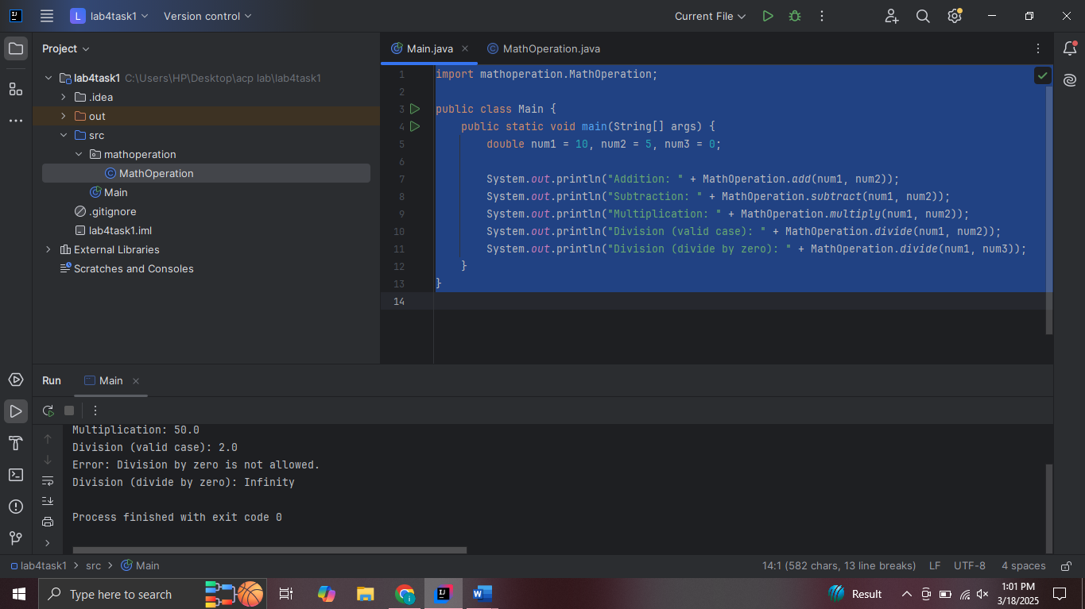

**Q2 :**

**Package code :**

package greetings;  
import java.time.LocalTime;  
public class Greetings {  
 public static String getGreeting(String name) {  
 LocalTime currentTime = LocalTime.*now*();  
 int hour = currentTime.getHour();  
 String greetingMessage;  
  
 if (hour < 12) {  
 greetingMessage = "Good morning";  
 } else if (hour < 18) {  
 greetingMessage = "Good afternoon";  
 } else {  
 greetingMessage = "Good evening";  
 }  
  
 return greetingMessage + ", " + name + "!";  
 }  
}

**main class code :**

import greetings.Greetings;  
public class Main {  
 public static void main(String[] args) {  
 String name = "ibraheem";  
 String greetingMessage = Greetings.*getGreeting*(name);  
 System.*out*.println(greetingMessage);  
 }  
}

**output :**

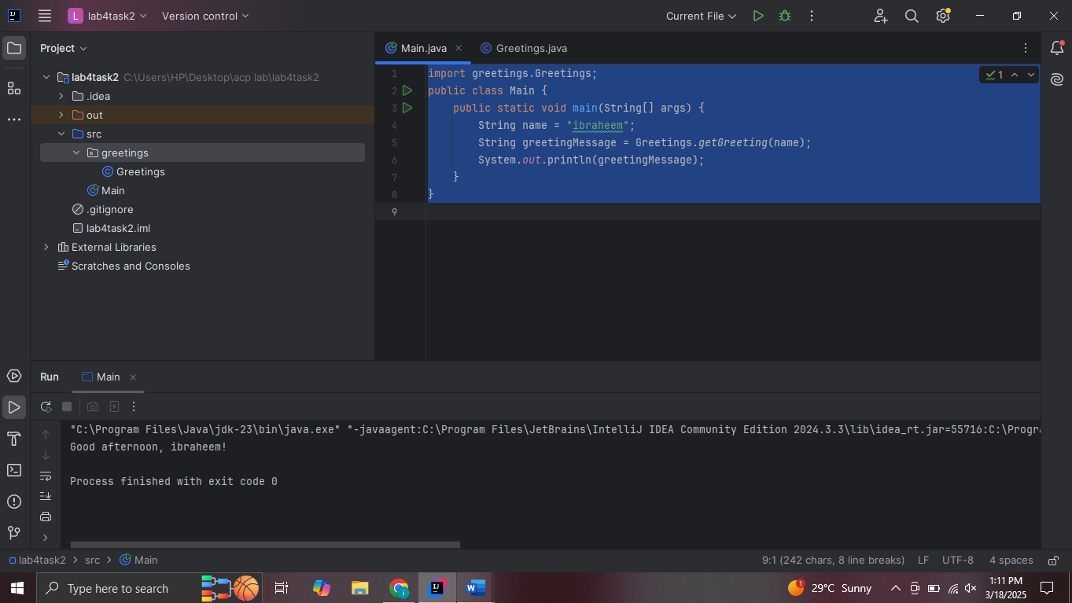

**Q3 :**

**Package screenshot and code :**

**Circle code :**

package shapes;  
public class circle {  
 public double radius;  
   
 public circle(double radius) {  
 this.radius = radius;  
 }  
 public double getArea() {  
 return 3.14 * radius * radius;  
 }  
}

**rectangle code :**

package shapes;  
public class rectangle {  
 public double length;  
 public double width;  
 public rectangle(double length, double width) {  
 this.length = length;  
 this.width = width;  
 }  
 public double getArea() {  
 return length * width;  
 }  
}

**main class :**

import shapes.circle;  
import shapes.rectangle;  
  
public class Main {  
 public static void main(String[] args) {  
 circle circle = new circle(5.0);  
 System.*out*.println("Area of Circle: " + circle.getArea());  
 rectangle rectangle = new rectangle(4.0, 6.0);  
 System.*out*.println("Area of Rectangle: " + rectangle.getArea());  
 }  
}

**output:**

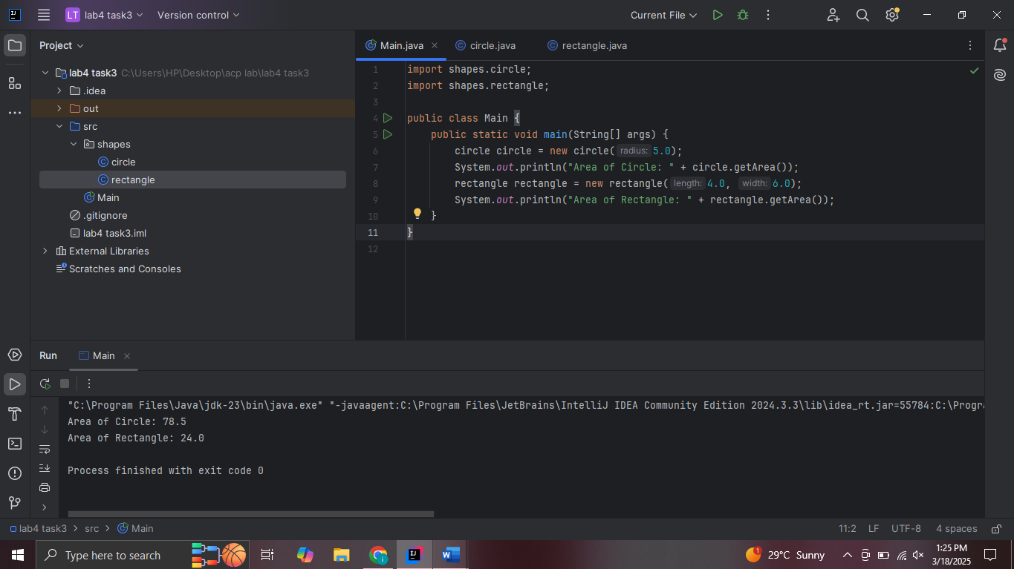

**Q4 :**

**Package code :**

package randomgame;  
import java.util.Random;  
import java.util.Scanner;  
public class numbergame {  
 private int randomNumber;  
  
 public numbergame() {  
 Random random = new Random();  
 this.randomNumber = random.nextInt(10) + 1;  
 }  
  
 public void play() {  
 Scanner scanner = new Scanner(System.*in*);  
 System.*out*.println("Guess a number between 1 and 10:");  
 int userGuess = scanner.nextInt();  
 if (userGuess == randomNumber) {  
 System.*out*.println("Congratulations! You guessed the correct number.");  
 } else {  
 System.*out*.println("Sorry, the correct number was " + randomNumber + ". Try again!");  
 }  
 scanner.close();  
 }  
}

**main code :**

import randomgame.numbergame;  
public class Main {  
 public static void main(String[] args) {  
 numbergame game = new numbergame();  
 game.play();  
 }  
}

**output :**

