Name : ibraheem

Sap id : 42896

Section : bscs 5

**Labtask 2**

**Q1**

**Code :**

class Car {  
 String make="toyota";  
 String model="corrolla";  
 int year=16;  
 public void displayDetails() {  
 System.out.println("Make: " + make);  
 System.out.println("Model: " + model);  
 System.out.println("Year: " + year);  
 }  
}  
  
public class Main {  
 public static void main(String[] args) {  
 Car myCar = new Car();  
  
 myCar.displayDetails();  
 }  
}

**output :   
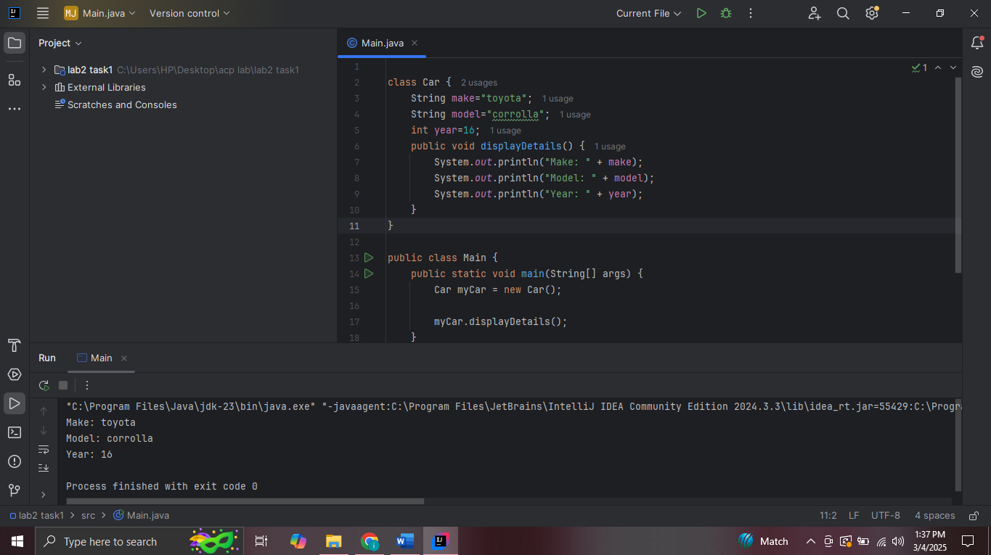**

**Q2**

**Code :**

class Shape {  
 public double calculateArea() {  
 return 0.0;  
 }  
}  
  
  
class Circle extends Shape {  
 double radius;  
  
 public double calculateArea() {  
 return 3.14 * radius * radius;  
 }  
}  
  
  
class Rectangle extends Shape {  
 private double width;  
 private double height;  
 public double calculateArea() {  
 return width * height;  
 }  
}  
  
public class Main {  
 public static void main(String[] args) {  
 Circle circle = new Circle();  
 System.*out*.println("Area of Circle: " + circle.calculateArea());  
 Rectangle rectangle = new Rectangle();  
 System.*out*.println("Area of Rectangle: " + rectangle.calculateArea());  
 Shape shape = new Shape();  
 System.*out*.println("Area of Generic Shape: " + shape.calculateArea());  
 }  
}

**output :**

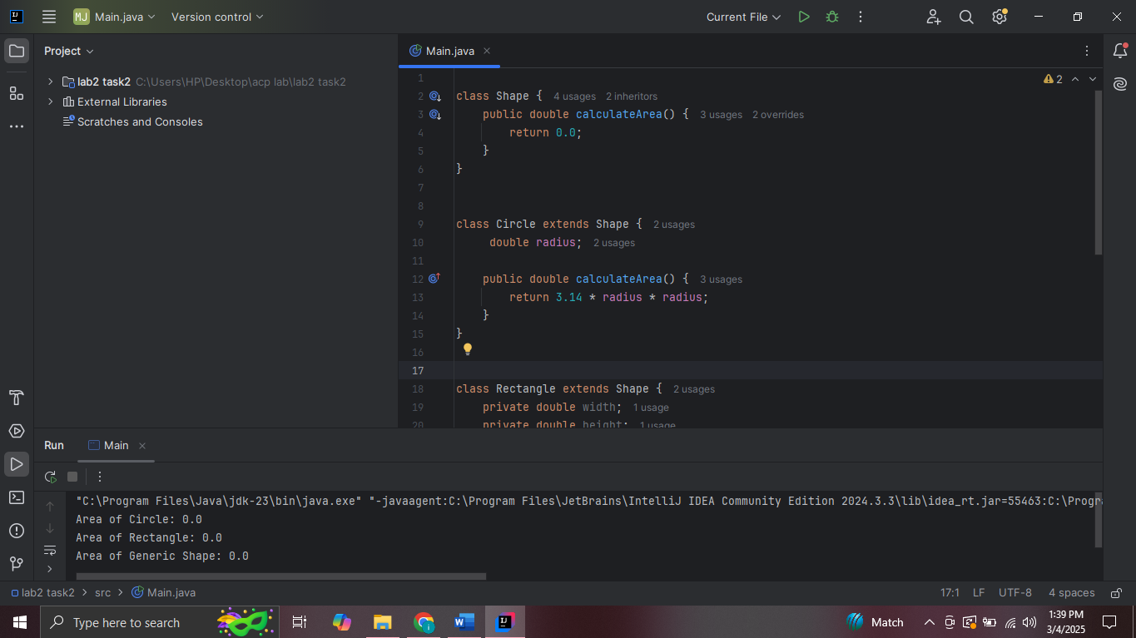

**Q3**

**Code :**

class Room {  
 private double area;  
 private String color;  
  
  
 public void setArea(double area) {  
  
 this.area = area;  
 }  
  
 public double getArea() {  
  
 return area;  
 }  
  
  
 public void setColor(String color) {  
  
 this.color = color;  
 }  
  
  
 public String getColor() {  
  
 return color;  
 }  
  
  
 public void displayRoomInfo() {  
 System.*out*.println("Room Area: " + area + " sq. meters");  
 System.*out*.println("Room Color: " + color);  
 }  
}  
  
  
class House {  
 private Room livingRoom;  
 private Room bedroom;  
  
  
 public void setLivingRoom(Room livingRoom) {  
 this.livingRoom = livingRoom;  
 }  
  
  
 public void setBedroom(Room bedroom) {  
 this.bedroom = bedroom;  
 }  
  
  
 public void displayHouseInfo() {  
 System.*out*.println("House Details:");  
 System.*out*.println("Living Room:");  
 livingRoom.displayRoomInfo();  
 System.*out*.println("\nBedroom:");  
 bedroom.displayRoomInfo();  
 }  
}  
  
  
 class HouseDemo {  
 public static void main(String[] args) {  
  
 Room livingRoom = new Room();  
 livingRoom.setArea(25.5);  
 livingRoom.setColor("Blue");  
  
 Room bedroom = new Room();  
 bedroom.setArea(15.0);  
 bedroom.setColor("White");  
  
  
 House myHouse = new House();  
 myHouse.setLivingRoom(livingRoom);  
 myHouse.setBedroom(bedroom);  
  
   
 myHouse.displayHouseInfo();  
 }  
}

**output :**

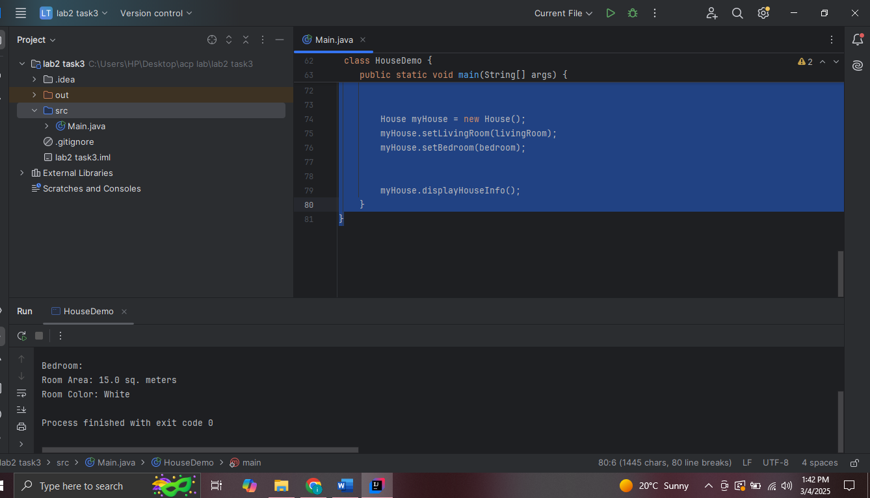

**Q4 :**

**Code :**

class Room {  
 private double area;  
 private String color;  
  
  
 public void setArea(double area) {  
  
 this.area = area;  
 }  
  
 public double getArea() {  
  
 return area;  
 }  
  
  
 public void setColor(String color) {  
  
 this.color = color;  
 }  
  
  
 public String getColor() {  
  
 return color;  
 }  
  
  
 public void displayRoomInfo() {  
 System.*out*.println("Room Area: " + area + " sq. meters");  
 System.*out*.println("Room Color: " + color);  
 }  
}  
  
  
class House {  
 private Room livingRoom;  
 private Room bedroom;  
  
  
 public void setLivingRoom(Room livingRoom) {  
 this.livingRoom = livingRoom;  
 }  
  
  
 public void setBedroom(Room bedroom) {  
 this.bedroom = bedroom;  
 }  
  
  
 public void displayHouseInfo() {  
 System.*out*.println("House Details:");  
 System.*out*.println("Living Room:");  
 livingRoom.displayRoomInfo();  
 System.*out*.println("\nBedroom:");  
 bedroom.displayRoomInfo();  
 }  
}  
  
  
 class HouseDemo {  
 public static void main(String[] args) {  
  
 Room livingRoom = new Room();  
 livingRoom.setArea(25.5);  
 livingRoom.setColor("Blue");  
  
 Room bedroom = new Room();  
 bedroom.setArea(15.0);  
 bedroom.setColor("White");  
  
  
 House myHouse = new House();  
 myHouse.setLivingRoom(livingRoom);  
 myHouse.setBedroom(bedroom);  
  
   
 myHouse.displayHouseInfo();  
 }  
}