HW1—Exact motion planning
Q2
Prove A⊕(B∪C) = (A⊕B)∪(A⊕C):
s ∈A⊕(B∪C) $∃ q_{1},q_{2} :s=q_{1}+q_{2}$ , $q_{1}$∈A $∧q_{2}$∈ B∪C
$∃ q_{1},q_{2} :s=q_{1}+q_{2}$ , $q_{1}$∈A $∧(q_{2}$∈ B or $q_{2}$∈ C)
$∃ q_{1},q_{2} :s=q_{1}+q_{2}$ ,( $q_{1}$∈A $∧q_{2}$∈ B) or ( $q_{1}$∈A $∧q_{2}$∈ C)
s∈ A⊕B or s∈ A⊕C
s∈ (A⊕B)∪(A⊕C)

What is the Minkowski sum of:
- Two points : a single point , Let the points be $p$and $q$ then {p}⊕{q}={p+q}.
- A point and a line: Let the point be $p$, and let $L$be a line,
{p}⊕L={p+ℓ:ℓ∈L}. meaning we got the same line shifted by vector $p$.
Two line segments:
Case 1: Segments are parallel:
we will get line segment whose length is the sum of the two segment lengths.
Case 2 : Segments are not parallel: we will get parallelogram.
- Two Disks:
A disk whose center is the sum of the centers and whose radius is the sum of the radii.
Prove "E ≤3V −6" (V ≥ 3)
if E=0,1,2 then the statement is true because we assume V>=3 (E<=2<3<=3V −6)
else( E>=3 ):
We will define face-degree=d(f)=number of edges that form f boundary
- Each face is bounded by at least 3 edges(that is true for the external face because E>=3) so:
d(f)≥3 for every face f $⇒$ $\sum_{f}{d(f)}$≥3F.
- Every edge contributes exactly 2 to the total face-degree count (one per adjacent face), so:
$\sum_{f}{d(f)}$=2E
- From the previous points we get : 2E≥3F.
- We saw in the class Euler’s formula V-E+F=2.
$$⇒F=2+E-V ⇒3F=6+3E-3V$$combining with the last point:
$$6+3E-3V≤2E ⇒E≤3V-6$$

Q3
3.2
Result of the given input :
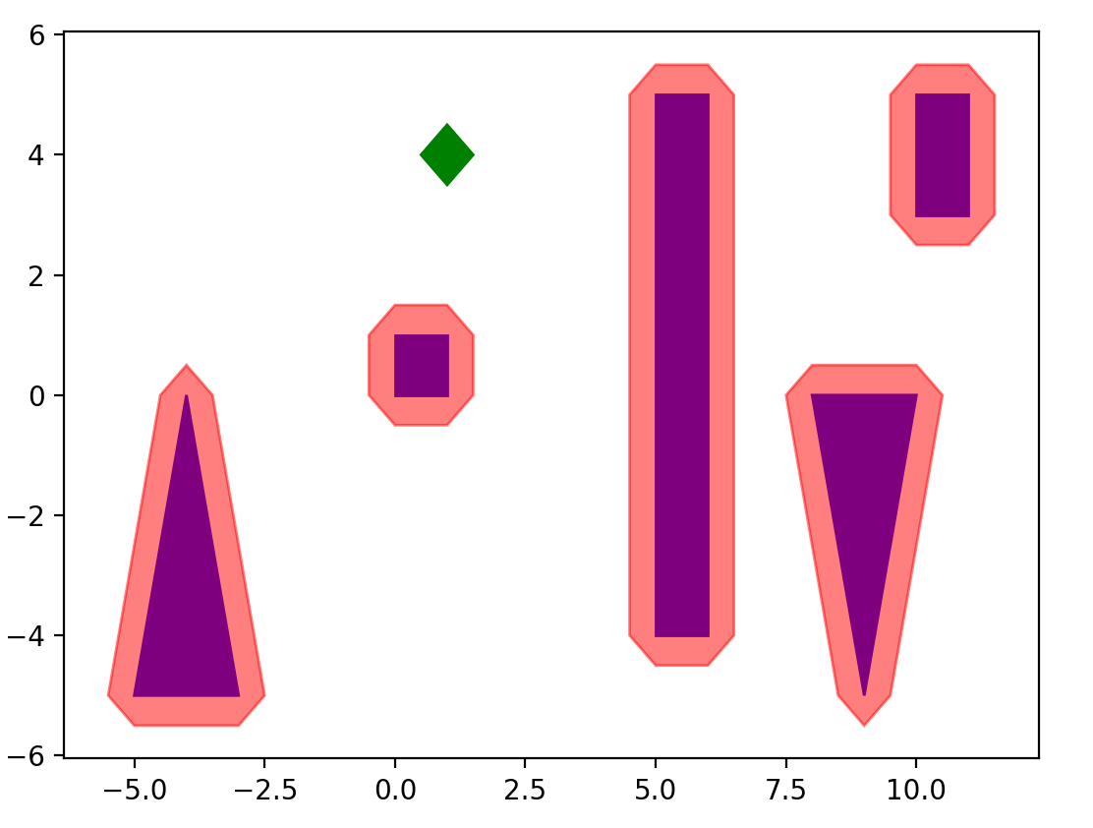
Result of new input :
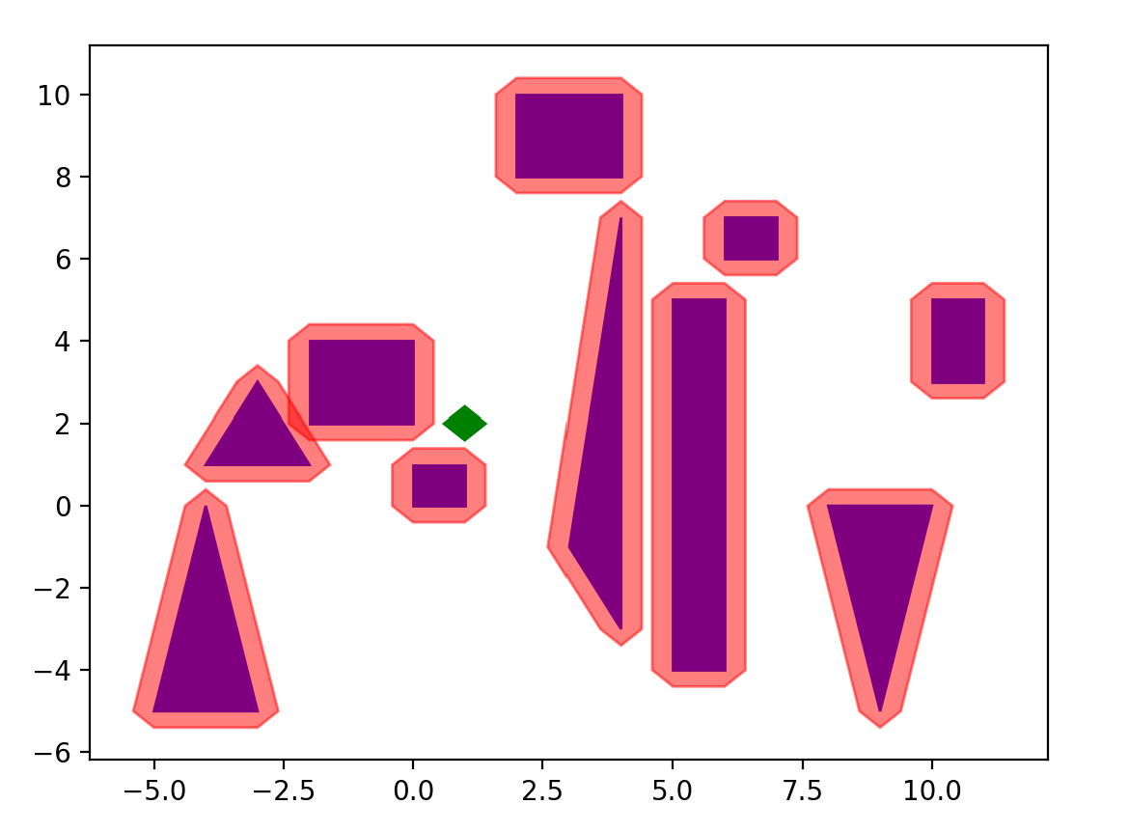

Computational Complexity of the Implementation:
Let $n$ be the number of vertices of the workspace obstacle $P$,
and let $m$be the number of vertices of the robot polygon $R$.
Our Minkowski sum implementation is based on the convex-hull method, which consists of two main steps:
1-Generating all pairwise point sums
for (px, py) in P:
for (qx, qy) in R:
sums.append((px + qx, py + qy))
Since we generate exactly $n×m$points, the time cost is: $O(nm)$
2- Computing the convex hull of S,
Using Shapely computing a convex hull for N=nm points takes:
$O(Nlog(N))$=O (nm log ($nm$))

In total, time complexity is O(nm)+O(nm log(nm))=O(nm log(nm))

How can non-convex obstacles affect the results?
it does not work for non-convex polygons because it removes the concavities of the actual Minkowski sum, resulting in a shape that is the convex hull of the true sum, not the sum itself. The algorithm only identifies the outermost boundary points and misses internal geometric features critical for non-convex shapes. So Using the convex hull algorithm for non-convex polygons produces an approximation that is larger than the actual sum .
non-convex obstacle example : 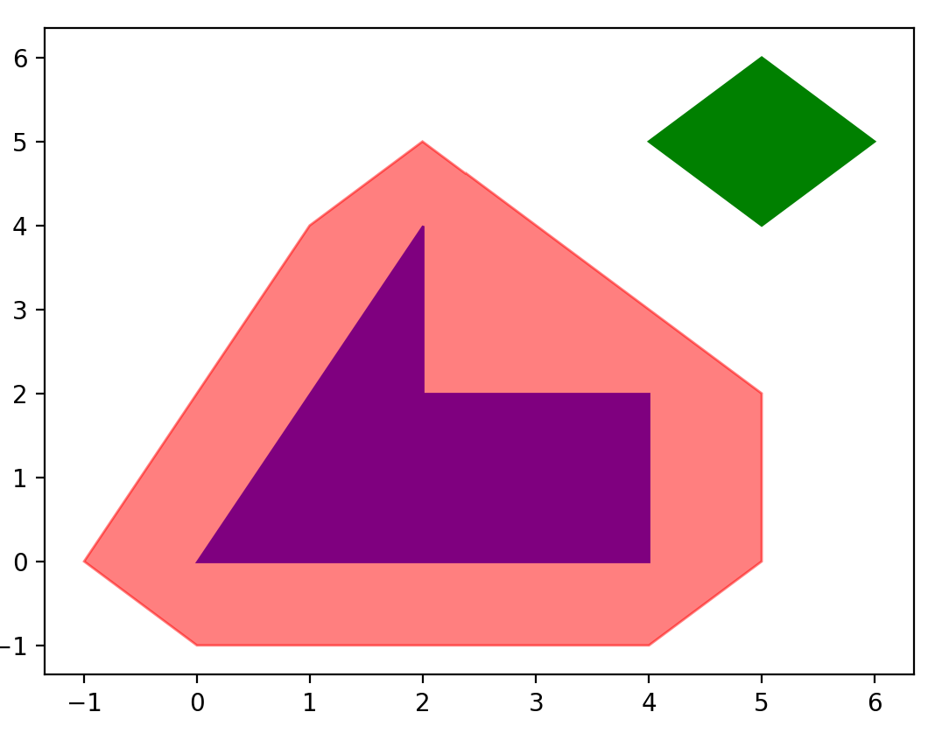
The figure demonstrates that when using the convex-hull Minkowski sum algorithm on a non-convex obstacle, the concave portion of the obstacle is removed, producing a convex and larger c-space obstacle. This over-approximates the true Minkowski sum, preventing some valid paths.

