Final Project Report
Predicting Road Accident Severity

Course: Project in Artificial Intelligence (02360502)
Semester: Spring 2026
Student 1: Ibraheem Akaree | ID: 212930846 | ibraheema@campus.technion.ac.il
Student 2: Sewar Abahry | ID: 325345734 | sewar.abahry@campus.technion.ac.il
Advisor: Yotam Gavish

Table of Contents
Right-click and choose “Update Field” to generate the table of contents.

1. Introduction

1.1 Problem Statement
Road traffic accidents impose a significant burden on emergency services, healthcare systems, and public safety infrastructure. In Great Britain alone, tens of thousands of personal-injury accidents are recorded annually by the police. When an accident is reported to emergency services, dispatchers must decide within seconds, and with incomplete information, what level of response to send: a single patrol car, an ambulance, or a full emergency response team.
This project addresses the question: given only the information available in the first moments after a 999 call — location, time, road type, and whatever the caller can report — can accident severity be predicted accurately enough to be useful for dispatch? A reliable severity predictor at dispatch centres could help optimise emergency resource allocation, reduce response times for the most serious accidents, and ultimately save lives.

1.2 Approach
The problem is cast as supervised classification over the STATS19 collision_severity label (Fatal / Serious / Slight, and a binary Slight-vs-Severe collapse). Rather than relying on STATS19 alone, every accident record is enriched with three external, non-trivially-joined data sources — OpenStreetMap road infrastructure, DfT AADF traffic volume, and Open-Meteo historical weather — each of which may or may not be available, or worth the latency, at dispatch time. STATS19 fields themselves are acquirable too, grouped with the three external sources into ten dispatch-time acquisition bundles (Section 5.1); 1,024 classifiers are trained, one per bundle subset, so that whichever combination happens to be available at inference time, a matching model exists. The long-term goal (Section 5) is a reinforcement-learning agent that decides at runtime which bundles are worth acquiring before invoking the matching classifier. That agent is now implemented (Section 5.6), but its current learned policy is degenerate — it acquires the same single bundle for every collision rather than adapting per case — so the classifiers described in this report remain, for now, the environment it sits on top of rather than a deployed acquisition policy.

2. Data Pipeline & Dataset Construction
The predictive features are drawn from four sources: STATS19, the UK Department for Transport's official road-accident database, which supplies the primary records and the severity label; DfT AADF, annual traffic-volume counts joined to each accident by nearest count point; OpenStreetMap, road-infrastructure detail (speed cameras, lane count, medians) ; and Open-Meteo, objective historical weather at the accident's exact location and hour, replacing STATS19's subjective officer-recorded weather field. The pipeline below folds all four into a single feature table stage by stage.
The full pipeline is a strict linear chain of CSV-in/CSV-out R stages, orchestrated by CODE/run_pipeline.R and documented in detail in docs/data_pipeline.md. Each stage is named after the sources folded in so far: stats19 → stats19+aadf → stats19+aadf+osm → stats19+aadf+osm+meteo, after which the table is split into train/valid/test, and normalized.

2.1 Severity-Aware Sampling
STATS19 is heavily imbalanced toward Slight-injury collisions in the real population. stats19_download.R downloads accident years 2016–2025 and applies a deliberate, disclosed sampling policy: every Fatal collision is kept, while Serious and Slight collisions are capped per year (1,400 / 2,800).

2.2 Feature Engineering
Starting from the STATS19 fields available at call time, the pipeline successively adds the AADF/OSM/Open-Meteo external features, spatial risk-density features, arriving at a 61-column combined table (89,779 rows in the reference pipeline run).
Stage | Adds | Notes
STATS19 realtime (collisions) | 14 features (road type, junction, speed limit, time, …) | Only fields available before post-collision investigation
STATS19 realtime (vehicles) | 7 vehicle-type flags (has_hgv, has_car,) | Aggregated from one-row-per-vehicle via multi-hot flags
STATS19 realtime (casualties) | n_casualties, n_pedestrian_casualties, youngest/oldest_casualty_age | not always volunteered up front, so given a higher acquisition cost in the planned RL reward
AADF join | aadf_traffic_volume, aadf_distance_m, aadf_match_type | Nearest count point on the same road, falling back to nearest overall
OSM join | has_speed_camera, has_traffic_calming, has_traffic_signals, lane_count, has_median | Two-stage ref-then-nearest road matching.
Open-Meteo join | temperature_2m_c, precipitation_mm, wind_speed_10m_kmh, weather_code, snowfall_cm, snow_depth_m | objective replacement for the subjective STATS19 weather field
Risk-density | hist_acc_rate_500m, hist_severe_frac_500m, hist_fatal_rate_500m, dist_to_nearest_hist_acc_m | Computed only from strictly prior-year accidents — no leakage.

2.3 Data Split
After feature engineering, the combined table is split into train / validation / test sets at 70% / 15% / 15%, stratified by collision_year × collision_severity — rows are grouped into year-and-severity strata, shuffled, and cut at those fractions within each stratum — so every split gets a proportional mix of years and severities, not just a matching overall ratio.

2.4 Normalization
Three transformations are applied to the combined feature table before the train/valid/test splits are used for training, with all statistics computed from the train split only and applied identically to valid and test — no leakage.
Cyclic encoding: day_of_week (1–7) and the hour extracted from time (0–23) are periodic — day 7 and day 1 are adjacent, hour 23 and hour 0 are adjacent — so a linear scale or z-score would break that adjacency. Both are replaced by a sin/cos pair (day_of_week_sin/cos, hour_sin/cos), and the original day_of_week and time columns are dropped.
log1p for skewed columns : Before z-scoring, log1p(x) is applied to any column that is right-skewed in the train split and non-negative. 12 columns met this threshold (e.g aadf_traffic_volume, aadf_distance_m, precipitation_mm, snowfall_cm, hist_acc_rate_500m, n_casualties) — compressing heavy right tails so the z-score isn't dominated by rare extreme values.
Z-score : 21 numeric columns are standardized using x_norm = (x − mean) / SD, with mean and SD computed from the train split only and applied identically to valid and test.
(e.g `number_of_vehicles`, `speed_limit`, `aadf_traffic_volume`,`dist_to_speed_camera_m`, `lane_count’)

3. Training

3.1 Hyperparameter Tuning
Hyperparameters are tuned with Optuna. The search maximises macro F1 over 60 trials using a TPE sampler tuning nine XGBoost parameters. Each trial is scored by 4-fold GroupKFold cross-validation on the pooled training and validation sets.
The final classifier is retrained on the full training set with the selected configuration. Tuning raises test macro F1 from 0.7291 to 0.7369 (+0.0078) over XGBoost's defaults, with balanced accuracy rising from 0.7294 to 0.7372 and ROC-AUC from 0.8072 to 0.8117.

3.2 Choice of Model Family
We tried multiple model families before settling on an architecture. Seventeen families were compared on identical data: full acquisition of the three external sources (aadf+osm+meteo, 52 features), the same train/valid/test split, 3 seeds, scored on test.
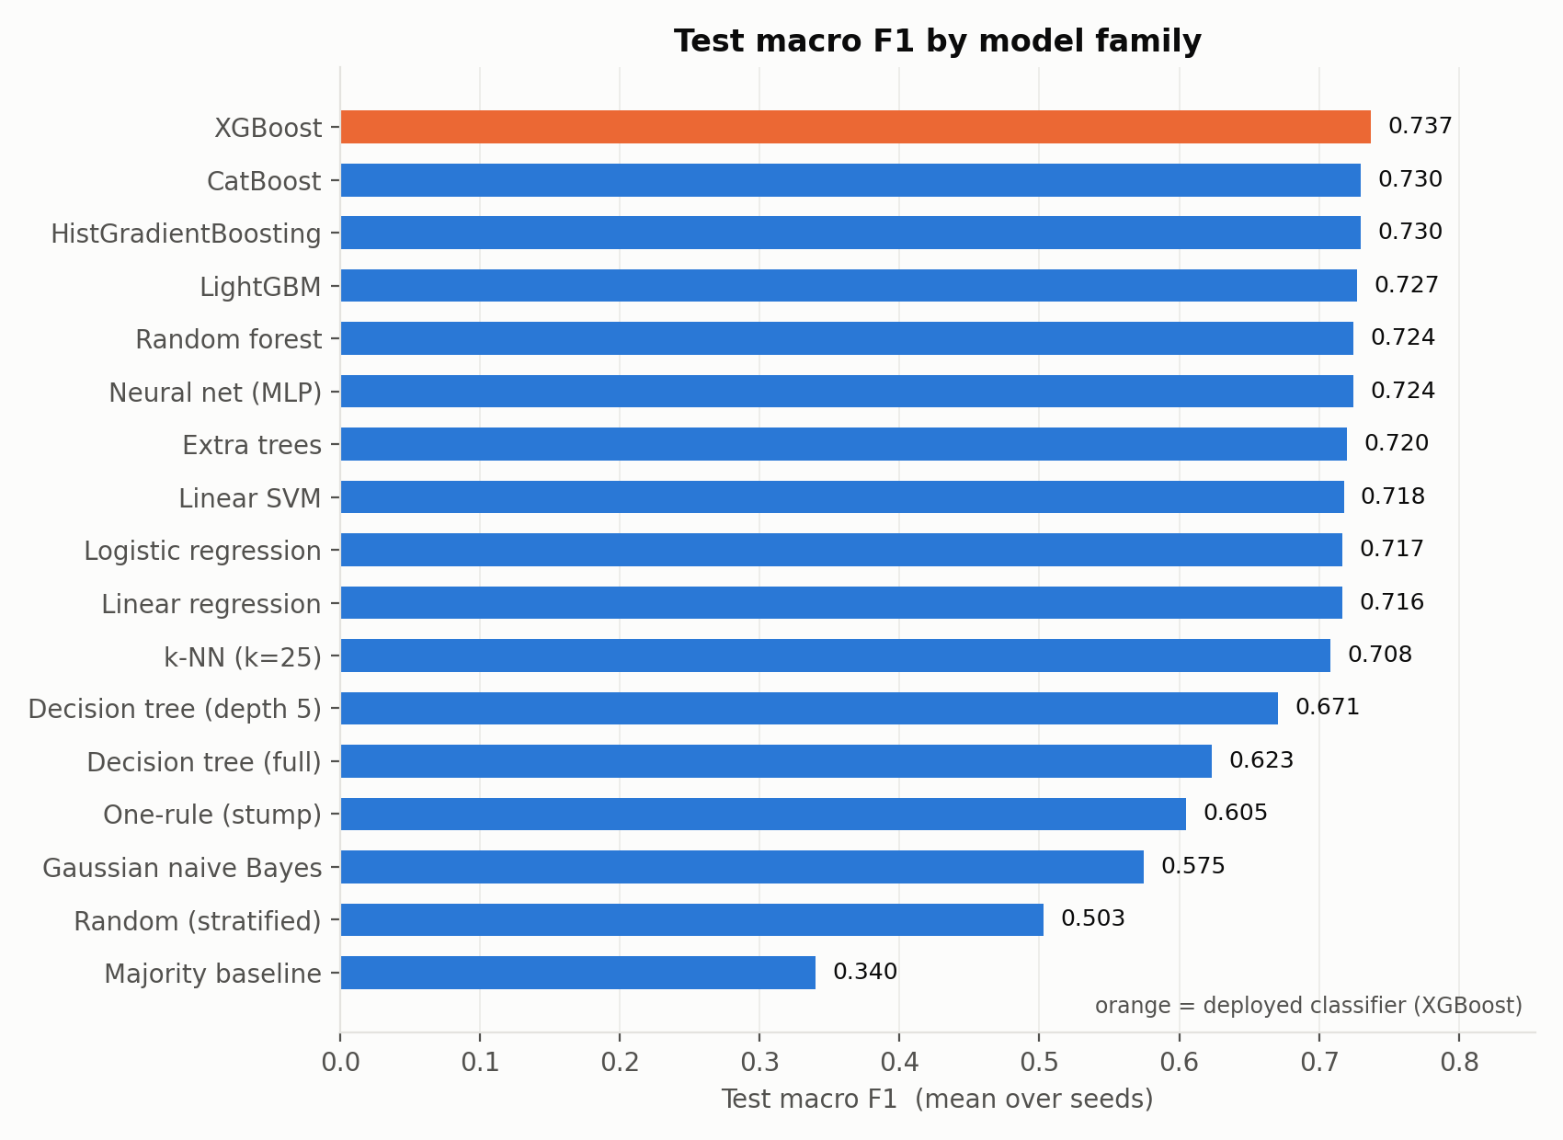
Figure 1
Test macro F1 for all seventeen model families, averaged over 3 seeds; XGBoost (orange) is the family used for every classifier in this project. The shape of the comparison is visible at a glance: a tight cluster of tree ensembles and the neural net between 0.72 and 0.74, a second tier of linear/simple models around 0.71–0.72, then a sharp drop to the decision-tree and non-learned baselines below 0.68 — the real gap in this project is between “a reasonable model” and “no model”, not between individual top algorithms.
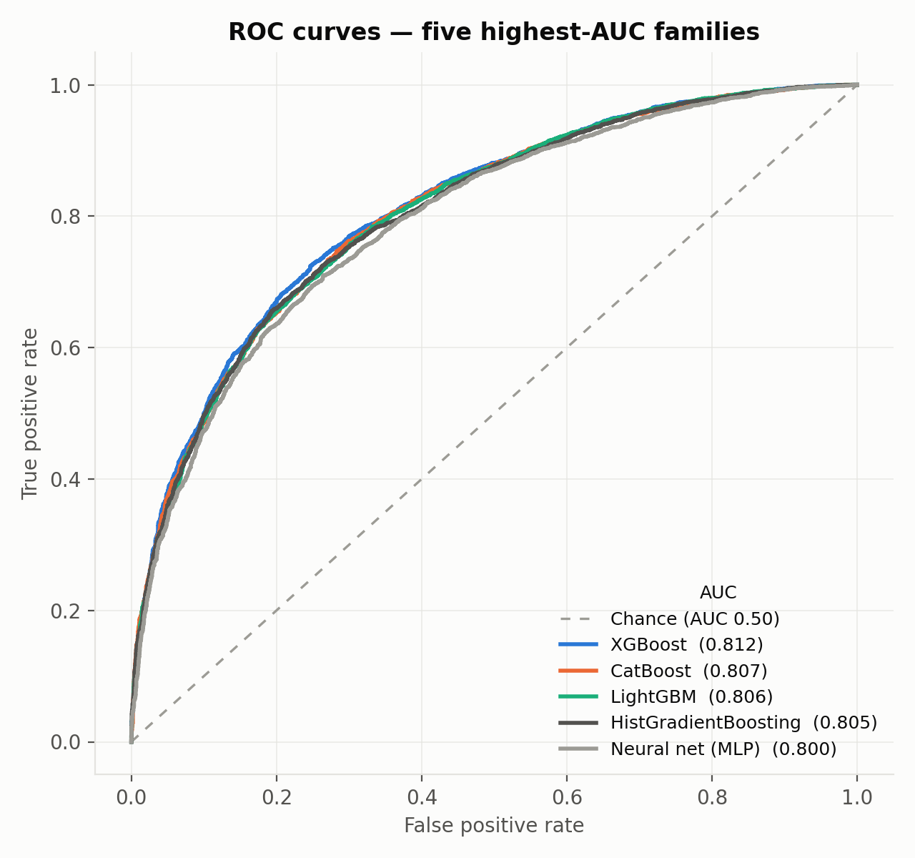
Figure 2
ROC curves for the five highest-AUC families (true positive rate vs. false positive rate across every possible decision threshold). The five lines are visually almost indistinguishable across the full range, and their AUC values sit within 0.012 of each other (0.800–0.812) — evidence that these models aren't just similar at one threshold (as Figure 1's single macro-F1 number might suggest) but rank collisions by predicted risk in essentially the same way at every threshold.
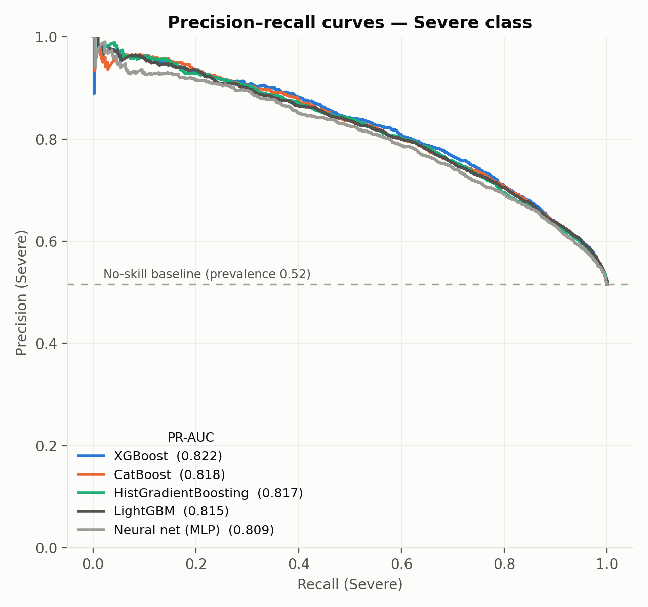
Figure 3
Precision–recall curves for the Severe class specifically, the class this project cares about most (missing a Severe collision is costlier than a false alarm). The dashed line marks the no-skill baseline — the precision a model with no predictive skill would get, equal to Severe's 52% prevalence in this dataset. All five curves sit well above that baseline and again overlap closely, so model-family choice doesn't meaningfully trade precision against recall on Severe class.
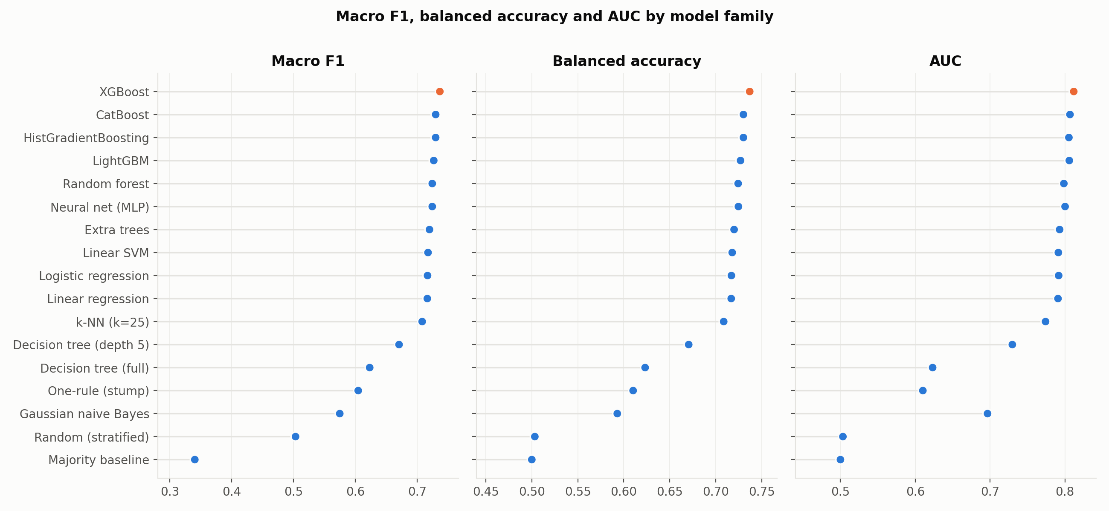
Figure 4
The same seventeen families ranked separately by macro F1, balanced accuracy, and AUC. All three panels produce the same ordering — tree ensembles and the neural net at the top, linear/simple models in the middle, non-learned baselines at the bottom — so the conclusion doesn't depend on which single metric is used to judge “best”.

3.3 XGBoost Results in Detail
Since the comparison above shows XGBoost is the best-performing family, the rest of this project continues with XGBoost alone.
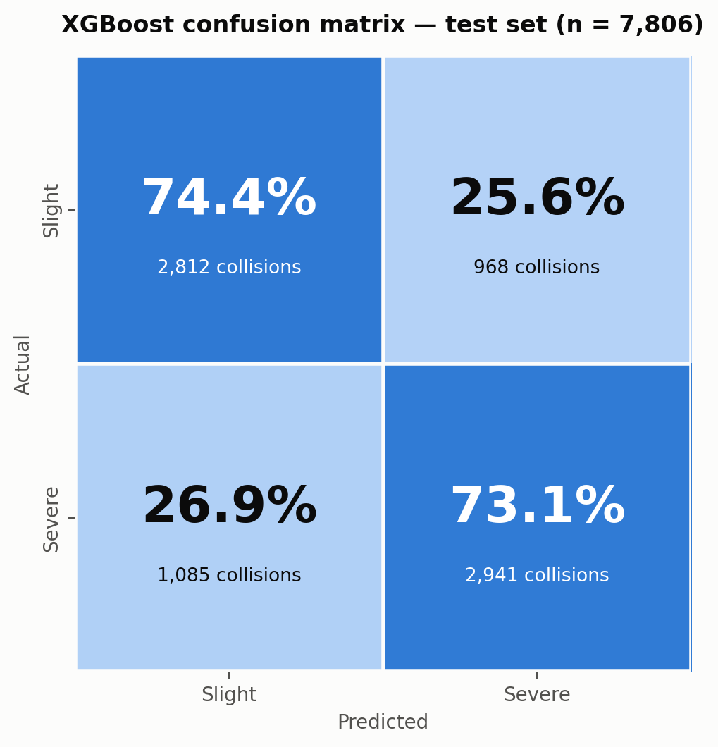
Figure 5
XGBoost's confusion matrix on the test set (n = 7,806), row-normalised (each row — the true class — sums to 100%). Of actual Slight collisions, 74.4% are correctly predicted Slight and 25.6% are wrongly predicted Severe; of actual Severe collisions, 73.1% are correctly predicted Severe and 26.9% are wrongly predicted Slight. The two error rates are close to each other, which is the sign of a model making genuine, balanced mistakes on both classes rather than one that's quietly defaulting to whichever class is easier or more common.

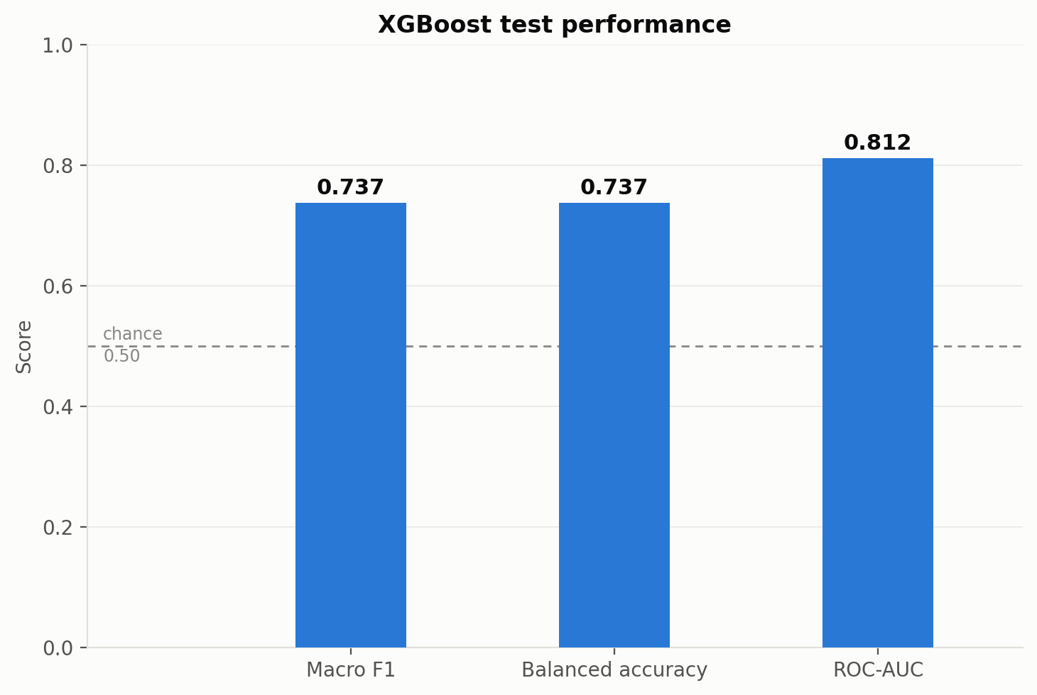
Figure 6
The same test run summarised as three headline metrics against the 0.50 chance line: macro F1 0.737, balanced accuracy 0.737, and ROC-AUC 0.812 . AUC sitting noticeably above the other two reflects that XGBoost's raw ranking of collisions by predicted risk is stronger than what a single fixed threshold (0.5) captures.

4. Experiments

4.1 Leakage Audit: What the Dispatch-Time Constraint Gives Up
The leakage audit experiment measures the accuracy cost of restricting the classifier to dispatch-time information, by comparing it against a reference model trained on all STATS19 fields — including forensic and officer-recorded detail no dispatcher could possibly have at call time (vehicle skid patterns, driver demographics, whether police attended, and more). The full-STATS19 model is explicitly not a deployment candidate — it exists only to measure this gap.
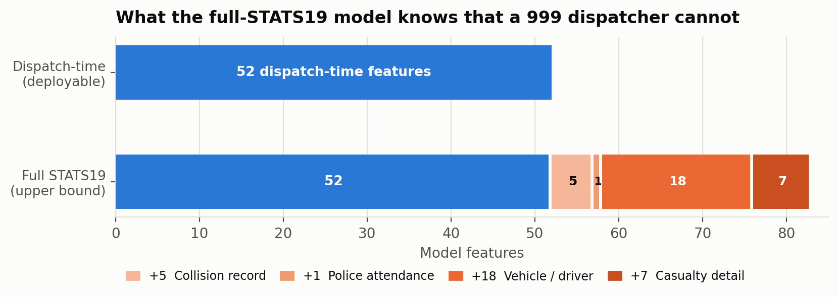
Figure 7
This chart sizes the two feature sets side by side. The dispatch-time (deployable) model uses 52 features — shown as a single bar. The full-STATS19 (upper bound) model uses those same 52 features plus 31 more, broken out by category: +5 collision-record fields, +1 police-attendance flag, +18 vehicle/driver fields, and +7 casualty-detail fields, for 83 features total. The point of the chart is scale: the full model isn't a small tweak on top of the deployable one, it's 60% more features — and every one of them is something only knowable after the fact.
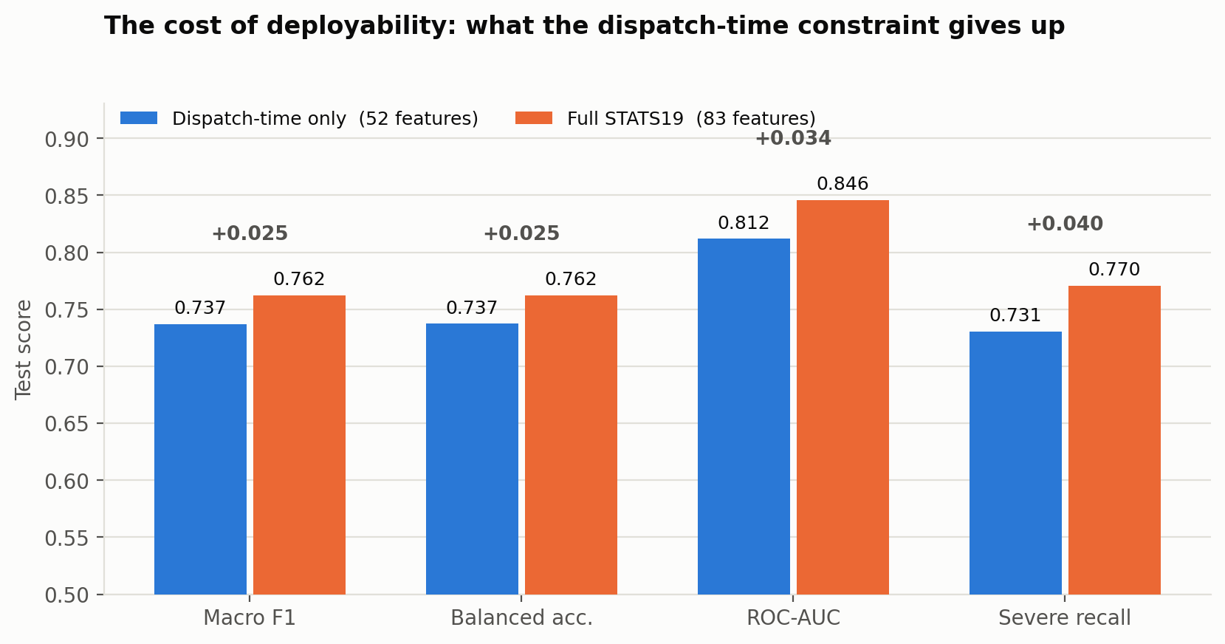
Figure 8
This is the audit's actual result: the dispatch-time-only model against the full-STATS19 model across four test-set metrics — macro F1 (0.737 → 0.762, +0.025), balanced accuracy (0.737 → 0.762, +0.025), ROC-AUC (0.812 → 0.846, +0.034), and Severe recall (0.731 → 0.770, +0.040). The takeaway: The gap is real but modest, the dispatch-time constraint has a knowable, bounded cost, even with 60% more features (none of which a real dispatcher can ever have) the ceiling only rises by a few points. That bounded cost is what justifies shipping the dispatch-time-only model rather than chasing full-STATS19 numbers that wouldn't be achievable in a real deployment.

4.2 Officer vs. Data: Does Objective Weather Beat the Officer's Guess?
STATS19 records a single subjective weather category (weather_conditions), filled in by the attending officer. Open-Meteo instead provides an objective, hourly reconstruction of the weather at the accident's exact coordinate and hour — temperature, precipitation, wind speed, a WMO weather code, snowfall, snow depth. This experiment asks two separate questions: do the two sources even agree about what the weather was, and does swapping the subjective field for the objective one — or using both together — actually improve severity prediction once the model already has the rest of the dispatch-time feature set?
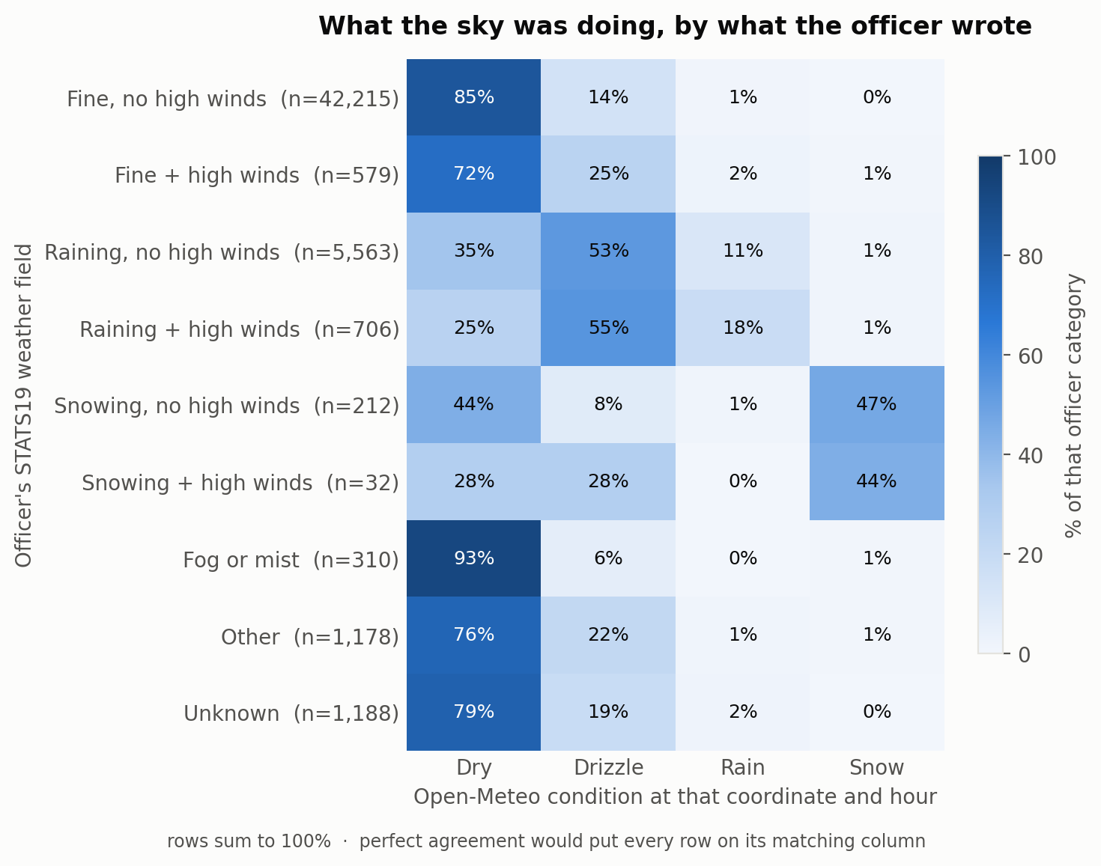

Figure 9
This heatmap cross-tabulates what the officer wrote (rows, each summed to 100%) against Open-Meteo's actual conditions at that coordinate and hour (columns).
On the common case, the two sources agree well: when the officer logged plain "Fine, no high winds," Open-Meteo recorded Dry conditions 85% of the time (72% for "Fine + high winds").
The disagreement is specifically about precipitation and fog, When an officer logged "Raining, no high winds," Open-Meteo detected some precipitation (Drizzle or Rain) 64% of the time (53% Drizzle + 11% Rain) and Dry only 35% — so on "did it rain at all," the two sources actually agree about two-thirds of the time- STATS19's officer field has no drizzle/rain distinction of its own, so a single officer "Raining" entry gets split by the sensor into two different intensities the officer never separated in the first place.
Fog/mist is the real structural gap: Open-Meteo has no fog or mist category at all — Dry/Drizzle/Rain/Snow are all precipitation-intensity buckets, and mist is a visibility condition, not a precipitation one — so 93% of officer-logged fog collisions simply come back "Dry".

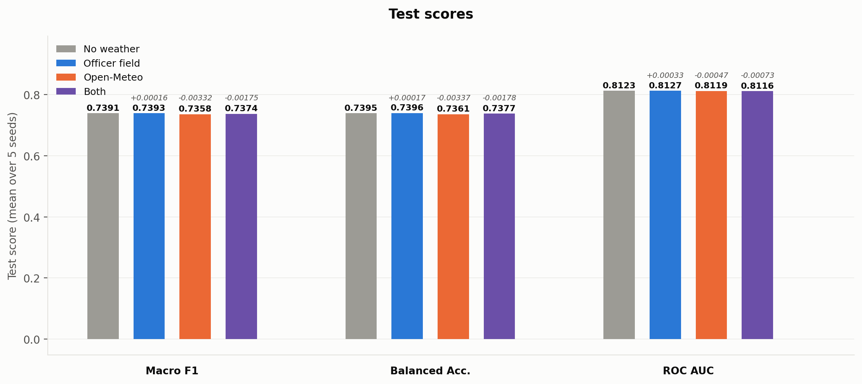
Figure 10
This bar chart adds each weather source — the officer's field alone, Open-Meteo alone, and both together — on top of the full dispatch feature set, and compares test macro F1, balanced accuracy, and ROC-AUC against a no-weather baseline, averaged over 5 seeds. Every variant lands within about ±0.003 of the no-weather baseline.
Conclusion:
The officer's field beats Open-Meteo, but neither is doing much. The officer's field nudges test scores very slightly positive; Open-Meteo is consistently negative on all . So between the two, the officer's subjective field is the better choice — but "better than a source that's actively negative" isn't the same as "helpful": Neither source moves the needle once the rest of the dispatch feature set is already in the model.
We expect this to show up directly in the RL agent's behaviour - we predict the trained agent will learn to rarely, if ever, acquire the meteo bundle.

4.3 Temporal Drift: Does the Model Stay Useful as Years Pass?
does accident severity prediction degrade as time passes between training and deployment? A classifier is trained only on 2016–2017 data, then evaluated across every test year from 2016 through 2024, against a control model trained on all years and evaluated the same way.
Because 2024 is the largest gap from the 2016–2017 training window, it's used as the headline comparison point in the summary table, but the full by-year chart is what actually shows whether performance decays smoothly with distance from training or does something else
Metric | Drift model (2016–17 → 2024) | Control (all years → 2024) | Delta
Macro F1 | 0.7283 | 0.7440 | −0.0157
Balanced accuracy | 0.7301 | 0.7449 | -0.0148
ROC-AUC | 0.8018 | 0.8160 | −0.0142
Severe recall | 0.6674 | 0.7041 | −0.0367
Slight recall | 0.7929 | 0.7857 | +0.0071
A model trained only on 2016–2017 and never updated loses about 1.4–1.6 points of macro F1/balanced accuracy/AUC by 2024 — a real but modest decline.
The more operationally relevant number is Severe recall, which drops nearly 3.7 points: a stale model doesn't just get slightly less accurate overall, it specifically gets worse at flagging the collisions that matter most. Slight recall actually improves slightly.

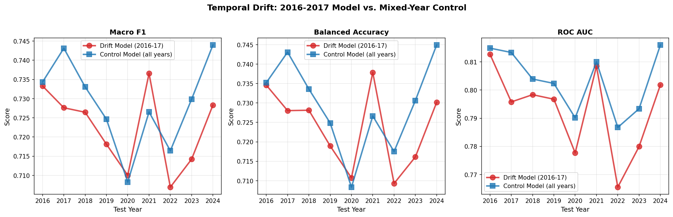
Figure 11
This three-panel line chart plots both models' Macro F1, Balanced Accuracy, and ROC-AUC across every test year from 2016 to 2024. Two things stand out. First, the drift model sits below the control model in almost every year . Second, and more interesting: both lines move together, tracing the same shape — both dip sharply in 2020 and again in 2022, and both recover by 2024. That shared shape means a good chunk of the year-to-year swing isn't really about model staleness at all — it's that some years are just intrinsically harder or easier to predict (2020 plausibly reflects COVID-disrupted traffic), and both models feel that difficulty equally regardless of which years they were trained on. The genuine drift signal is the consistent vertical gap between the two lines, not the shape of either curve on its own.

5. Active Feature Acquisition
To address the real-world constraints of a 999 dispatch centre— acquisition cost and latency —we extend our system from a static classifier to an Active Feature Acquisition (AFA) framework. We formulate this process as a Markov Decision Process (MDP) and solve it using Reinforcement Learning, where an agent sequentially decides which additional piece of information to acquire next — or whether the current level of certainty is already sufficient to make a prediction

5.1 The Ten Acquisition Bundles
An action is not a single feature column but one real-world acquisition act: one question put to the caller, one lookup against the collision coordinate, or one external API call. Every acquirable feature — the STATS19 fields and the three external sources alike — is grouped into one of ten such bundles.
Kind | Bundle | Features
Ask the caller | vehicles | number_of_vehicles + 7 vehicle-type flags
 | casualties | How many hurt, and who: pedestrian / driver / passenger / motorcyclist / cyclist counts
 | casualty_demographics | Youngest & oldest age, child / elderly / female counts
Map lookup | road_class | Road class & number (1st + 2nd), road type, trunk-road flag
 | road_environment | Speed limit, urban/rural, light conditions, weather conditions, pedestrian crossing
 | junction | Junction detail & control
 | crash_history | Prior-year accident rate, severe fraction, fatal rate, and distance to nearest prior accident, all within 500 m
External API | aadf | Annual Average Daily Flow, distance to count point
 | osm | Traffic calming, signals, lane count, median, speed camera
 | meteo | Temperature, precipitation, wind, weather code, snowfall, snow depth

The only free information — available with no acquisition action at all — is the call timestamp (day-of-week and hour, cyclically encoded). Every bundle is strictly additive: acquiring one can only add information, never remove it. “Kind” is a descriptive label for analysis only; it does not bundle actions into one step, and bundles of the same kind are not required to cost the same.

5.2 1,024 Acquisition-Subset Classifiers
Because any of the ten bundles may or may not be acquired at each state, a dedicated classifier is trained for every subset — 2^10 = 1,024 classifiers, from the free-information-only model (timestamp alone) up to full acquisition (all ten bundles). All 1,024 models are pre-trained and cached in advance.

5.3 MDP Formulation
The State Space
The state at each decision step is defined as $s_{t}$= ($x_{free}$, $x_{acquired}$, $m_{t}$, $p_{t}$), representing all available
information about a specific accident at a given moment in the episode, where:

- $x_{free}$: The call timestamp — the only information available with no acquisition action at all
- $x_{acquired}$ : The bundles obtained so far during the episode
- $m_{t}$ : 10-bit mask of which bundles have been obtained (also the cache key into the 1,024-model bank of Section 5.2)
- $p_{t}$ : is the matching classifier's current predicted probability distribution over severity classes given what has been acquired so far. Every bundle is strictly additive, so mₜ alone determines which frozen classifier is queried for pₜ, and pₜ is recomputed at every state as the mask changes.
The initial state $s_{0}$ begins each episode with only $x_{free}$ populated, an empty $x_{acquired}$,, mask $m_{0}$ = 0 (all zeros), and p₀ is calculated based on $x_{free}$ alone. reflecting the real-world scenario where only the call timestamp is known at the moment of the 999 call, and no additional features have yet been acquired.

The Action Space
At each step, the RL agent evaluates the currently available information and chooses from the
following discrete set of actions:
- $A_{0}$: Predict & Terminate, returning the current pₜ.
- $A_{1}$…$A_{10}$ : one per acquisition bundle (Section 5.1), each incurring that bundle's own acquisition cost.

The Transition Function
The transition function defines how the state evolves in response to the agent’s actions, the transitions are as follows:
- If the agent takes an acquisition action $A_{i}$ : Acquiring bundle i deterministically sets bit i of mₜ and reveals that bundle's feature values for the current accident, moving the episode from mₜ to mₜ ∪ {i}; the matching classifier from the 1,024-model bank is then queried to produce the next pₜ.
- If the agent takes the terminal action A0 (Predict & Terminate): The agent outputs the predicted severity and terminates.

The Reward Function
The composite reward is formulated as follows:
$Reward=R_{terminal }$ + Σₜ $R_{step }\left(t\right)$
$$R_{step }\left(t\right)= α·ΔConfidenceₜ - Cᵢ \\ R_{terminal }= β·Accuracy(ŷ, y)$$
Where:
- $ΔConfidenceₜ$ : The improvement in prediction confidence after acquiring bundle i at step t ( how much did the highest class probability increase?) - Rewards acquisitions that meaningfully reduce uncertainty.

- $Accuracy(ŷ, y)$: Represents the evaluation metric of the final severity prediction (Macro F1-score) compared against the true ground-truth label (y) from STATS19. This reward component is only delivered at the terminal step ($A_{0}$).

- α, β : Weighting parameters controlling the trade-off between step-level guidance and terminal accuracy. α is kept small relative to β, so that guides exploration without overshadowing the final prediction objective. These are treated as design parameters to be tuned empirically.

- Cᵢ : Per-bundle acquisition costs, now set (Section 5.6, bundle_costs.py) from estimated real-world latencies rather than from the value-of-information sweep of Section 5.4 as originally planned — each of the ten bundles gets its own independently chosen cost rather than one shared per tier, since e.g. asking about casualty ages is slower and less reliable than asking what vehicles were involved even though both are ask-the-caller bundles.

5.4 Value-of-Information Sweep (1,024 Acquisition Subsets)
Training and caching all 2^10 = 1,024 acquisition-subset classifiers (binary Slight-vs-Severe, normalized variant, ≈29 minutes, resumable) is both how the RL environment's model cache (Section 5.2) gets built and, on its own, a full ablation of the ten acquisition bundles.
Timestamp-only (the free-information floor) reaches 0.5487 valid / 0.5408 test macro F1; full acquisition (all ten bundles) reaches 0.7406 valid / 0.7377 test — a small further gain over the 0.7367 full-acquisition figure from the original 3-external-source space (Section 4.1), and the whole action space is worth +0.19 macro F1 over the free floor. Mean marginal value of each bundle, averaged over all 512 subsets that lack it:
Bundle | Kind | Mean marginal | Alone | Helps in
casualties | ask caller | +0.0402 | +0.106 | 100%
vehicles | ask caller | +0.0351 | +0.093 | 100%
casualty_demographics | ask caller | +0.0319 | +0.088 | 100%
road_environment | map lookup | +0.0097 | +0.070 | 98%
crash_history | map lookup | +0.0079 | +0.067 | 96%
junction | map lookup | +0.0061 | +0.052 | 95%
road_class | map lookup | +0.0056 | +0.057 | 88%
osm | external API | +0.0032 | +0.046 | 81%
aadf | external API | +0.0015 | +0.035 | 68%
meteo | external API | −0.0008 | +0.002 | 36%

- What the caller tells you dominates. The three ask-the-caller bundles are worth 4–25× any lookup or API bundle, and they are the only ones that help in every context (100% of the 512 subsets that lack each one). The three external sources — the entire original action space — contribute comparatively little, which is what motivated widening the action space to the STATS19 fields in the first place.
- Value saturates at about five bundles. The three caller bundles plus road_class and road_environment reach 0.7364 test — statistically indistinguishable from acquiring all ten (0.7377). Past that point, every further bundle is worth ≤+0.004, and the ranking among top subsets is within noise.
- meteo has negative mean marginal value: averaged across the 512 subsets lacking it, adding weather makes performance very slightly worse rather than better, though it still helps a minority of subsets (36%). Consistent with the model-family comparison's finding (Section 3.2) that most of the project's signal comes from the engineered feature set rather than any one external source.
These are population-average values, describing the best fixed policy at each subset size — not necessarily the best per-collision policy. Whether that distinction matters is exactly the open question Section 5.5 identifies as the gate on the RL work.

5.5 Planned Baselines
- No-acquisition — the classifier on the free timestamp only; zero cost, lower-bound accuracy.
- Full-acquisition — always acquires all ten bundles; maximum cost, upper-bound accuracy (0.7406 valid / 0.7377 test macro F1, Section 5.4; see also Section 4.2 for the closely related full-STATS19 ceiling).
- Best Fixed Subset — the single best-scoring subset at the RL agent's average budget, chosen offline from the 1,024-subset sweep (Section 5.4), since every subset is already trained. This is the baseline that actually matters: because it is directly computable, the RL agent only earns its added complexity if it beats it — i.e. only if the right subset genuinely differs from one collision to the next, rather than being roughly the same for everyone.
- Static feature priority — a fixed acquisition order applied up to the same average cost budget as the learned agent, unable to adapt per accident.
Before any of this is built, the project's own next step is a per-instance headroom check: scoring every test collision under all 1,024 cached models and comparing a per-instance oracle — for each collision, whichever cached subset predicts best — against the single Best Fixed Subset. If the two are close, the best subset barely varies across collisions and an adaptive policy has no room to beat a hardcoded acquisition order; if the oracle meaningfully outperforms the best fixed subset, that gap is the ceiling the RL agent is trying to reach. The check needs no new training — it only needs the sweep already run — and it gates whether the RL work is worth building at all. In practice the MDP/Q-learning implementation (Section 5.6) was built before this check was run, so it remains outstanding — see Section 8.

5.6 Implementation & Preliminary Results
The design in Sections 5.3–5.5 has since been implemented in CODE/training/agent/. mdp_environment.py wraps one collision's features and the 1,024-classifier cache from Section 5.2 into the 11-action state machine specified above (action 0 = Predict & Terminate, actions 1–10 = acquire bundle i−1); ql_solver.py is a tabular Q-learner over the resulting 1,024-state space, trained epsilon-greedy with the standard update rule Q[s][a] ← Q[s][a] + α⋅(r + γ⋅max Q[s'][a'] − Q[s][a]) and evaluated by its greedy policy. train_rl_agent.py, analyze_policy.py, analyze_voi.py, tune_rewards.py and visualize_voi.py form an evaluation pipeline (full_evaluation.sh runs all five, ≈10 minutes), documented in CODE/training/agent/README.md and EVALUATION.md.
Bundle acquisition costs. The per-bundle costs C_{i} left open in Section 5.3 are now set in bundle_costs.py from estimated real-world latencies rather than a placeholder: the three ask-the-caller bundles cost 1–3 seconds of phone time (vehicles 1.0 s, casualties 2.0 s, casualty_demographics 3.0 s), the four map-lookup bundles cost 40–60 ms (junction 40, road_class/road_environment 50, crash_history 60), and the three external-API bundles cost 10–30 ms (osm 10, aadf 20, meteo 30) — acquiring all ten costs 6.26 s in total. This inverts the value-of-information ranking from Section 5.4, where the ask-the-caller bundles are worth the most information: they are also, by a wide margin, the most expensive to acquire, which is exactly the trade-off the agent is meant to learn (Figure 12).
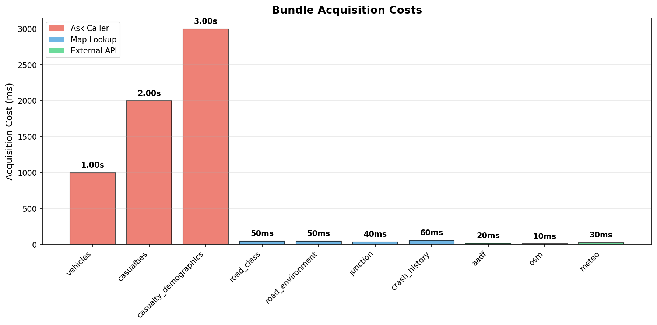
Figure 12
Calibrated acquisition costs by bundle and tier (bundle_costs.py). External-API calls (10–30 ms) and map lookups (40–60 ms) are two to three orders of magnitude cheaper than asking the caller a question (1–3 s), even though Section 5.4's static sweep found the ask-the-caller bundles carry most of the predictive value.
Preliminary results. analyze_voi.py compares the trained agent (default hyperparameters: 1,000 training episodes, α=0.1 learning rate, γ=0.99, ε=0.1, step-weight α=1.0, terminal-weight β=1.0) against three baselines on 300 held-out test collisions:
Strategy | Accuracy | Mean steps | Mean confidence
predict_immediate (0 acquisitions) | 53.7% | 0.0 | 0.550
learned_policy (RL agent) | 57.7% | 1.0 | 0.604
greedy_confidence (stop at conf>0.8) | 68.0% | 5.3 | 0.750
full_acquisition (all 10 bundles) | 69.7% | 10.0 | 0.698
Source: docs/figures/voi/strategy_summary.csv. These are plain 0/1 accuracy, not the macro F1 used elsewhere in this report — the current MDP's terminal reward is defined directly on accuracy, so this table is not directly comparable to the macro-F1 figures in Sections 3–5.4 (the two are close but not identical on this near-balanced task).
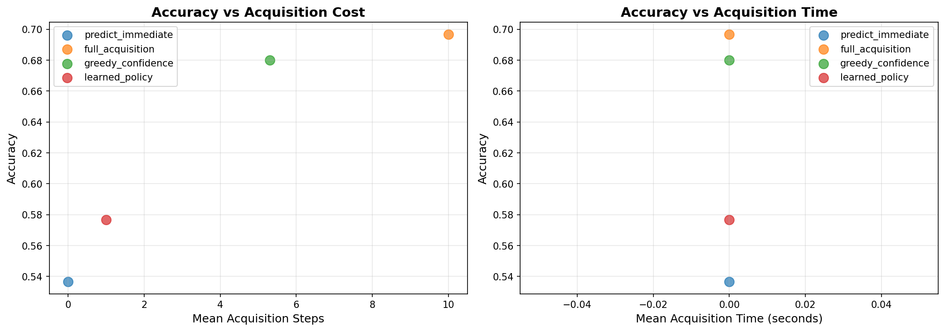
Figure 13
Accuracy vs. mean acquisition steps (left) and vs. mean acquisition time (right) for the four strategies in the table above. The learned_policy (red) sits well below greedy_confidence and full_acquisition and only narrowly above predict_immediate. The right-hand panel is currently uninformative: strategy_summary.csv does not yet record wall-clock acquisition cost per episode, only step count, so every strategy plots near zero seconds regardless of the bundle costs defined in bundle_costs.png — a known gap in the evaluation pipeline, not a result.
The learned policy's shortfall is not just a lower number in the table above — analyze_policy.py's output (docs/figures/policy_analysis/policy_analysis.json and acquisition_sequences.json, 500 episodes) shows it is degenerate rather than adaptive: every single evaluated episode takes the identical action sequence — acquire crash_history (the 60 ms map-lookup bundle), then predict & terminate — regardless of the collision's features. Figure 14 makes this visible directly: the value-of-information chart has exactly one bar, because crash_history is the only bundle the trained policy ever acquires. The current Q-learning run has converged on a fixed one-bundle heuristic, not on the per-instance adaptive policy that is the point of the RL formulation; behaviourally it is closer to the Static feature priority baseline of Section 5.5 than to an agent that "decides at runtime which information is worth acquiring." EVALUATION.md's own troubleshooting section anticipates this failure mode (“Accuracy worse than baselines”) and prescribes the fix — more training episodes, a lower learning rate, and re-tuning the α/β reward weights with tune_rewards.py — none of which had been run yet at the time of this report (Section 8).
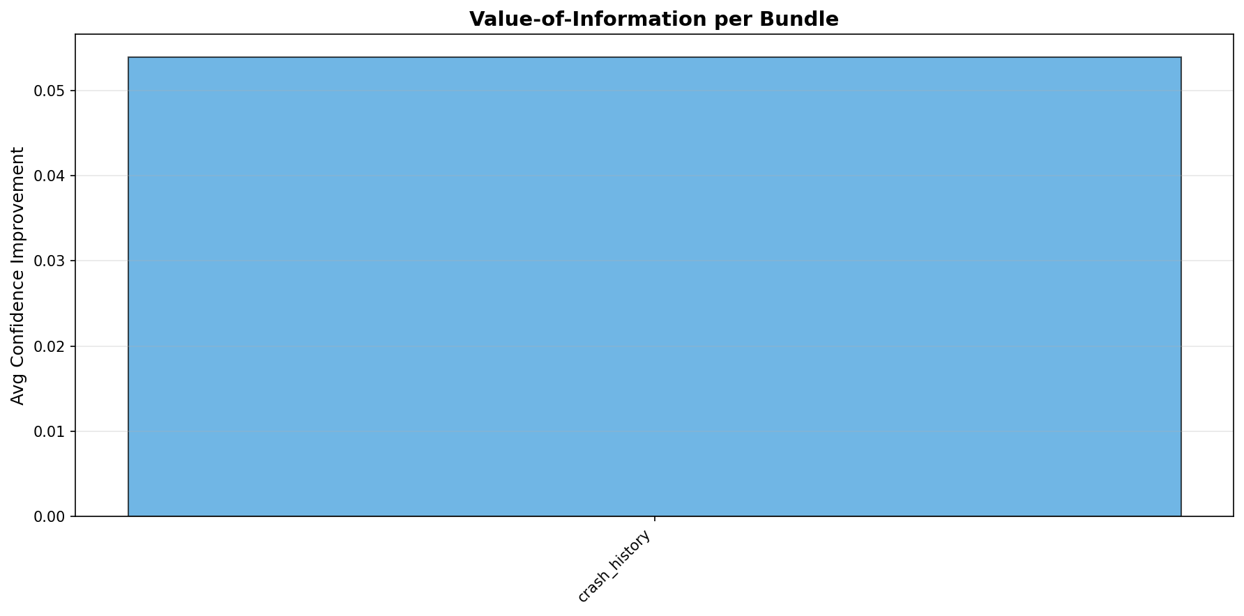
Figure 14
Value-of-information per bundle for the current learned policy (analyze_policy.py, 500 episodes). A single bar: crash_history is the only bundle the policy ever chooses to acquire, confirming the degenerate, non-adaptive behaviour described above rather than a genuine ranking over the ten bundles.
None of this invalidates the MDP formulation itself — the environment, action space, and reward wiring all run end-to-end against the real 1,024-model cache, and the evaluation pipeline correctly detects and reports the failure rather than hiding it. What is missing is a policy that has actually learned to trade cost against confidence per collision; Section 8 lists the concrete next steps toward that.

7. Discussion & Limitations
- Class balance is deliberately non-natural. Every headline metric in this report is measured on a Fatal-enriched benchmark chosen to make the classification problem tractable and comparable across experiments; it is not an estimate of real-world dispatch accuracy. Section 6.6 gives the reconstruction path back to a population-realistic estimate.
- OSM is a present-day snapshot. Road-infrastructure features reflect the network as it exists today, not as it was at each historical accident's date, since Geofabrik does not publish historical extracts at this granularity.
- Open-Meteo weather is paid at production volume. The free archive endpoint's rate limits (600 calls/min, 5,000/hour, 10,000/day) are workable for offline training-data construction but would need a paid plan for real-time dispatch-time acquisition at scale.
- Model-family choice barely matters once the feature pipeline is fixed. Section 4 shows the gap between the deployed XGBoost model and a plain thresholded linear regression is only 0.020 macro F1 — most of this project's measurable contribution is in the feature engineering, not the learning algorithm.
- The Active Feature Acquisition agent is implemented but not yet working. Section 5.6 documents a working, end-to-end Q-learning implementation — an MDP environment, a tabular solver, and a five-tool evaluation pipeline — but the current learned policy is degenerate: across every evaluated collision it acquires the same single bundle (crash_history) and then terminates, rather than adapting per collision, and it underperforms both the greedy-confidence and full-acquisition baselines. Diagnosing and fixing that collapse is now the primary open item in the project plan.

8. Conclusion & Future Work
This project has built and validated a complete, reproducible pipeline for predicting road-accident severity from dispatch-time-available information, enriched with three external data sources joined through non-trivial spatial and temporal logic. 1,024 frozen XGBoost classifiers cover every combination of the ten dispatch-time acquisition bundles (Sections 5.1–5.2), and the flagship full-acquisition binary classifier reaches test macro F1 ≈ 0.74 on the current, disclosed, Fatal-enriched benchmark — +0.132 macro F1 over a non-learned one-rule baseline, with the dispatch-time restriction itself costing only ≈+0.026 macro F1 relative to a model given every pre-label STATS19 field. Model-family comparisons show this gap is set almost entirely by the engineered feature set rather than by the choice of learning algorithm.
The immediate next steps are: (1) diagnose and fix the learned policy's collapse onto a single fixed bundle (Section 5.6) — via longer training, a lower learning rate, and a systematic α/β sweep with tune_rewards.py — so the agent adapts its acquisitions per collision instead of reproducing a static rule; (2) run the per-instance oracle headroom check from Section 5.5, still outstanding, to establish whether an adaptive policy has any room to beat the single Best Fixed Subset; (3) once the agent is genuinely adaptive, evaluate it against the no-acquisition, full-acquisition, greedy-confidence, and static-priority baselines on macro F1 rather than plain accuracy, and add wall-clock acquisition time to the evaluation pipeline, which does not yet track it; and (4) extend the population-realistic reconstruction (Section 6.6) into a standard reporting step alongside every future macro-F1 result, so headline numbers and field-deployment expectations are never conflated.

Appendix A: Repository & Reproducibility
The full codebase, all raw and processed data (where not gitignored for size), and the exact commands to reproduce every result in this report are in the project repository. Key commands (run from the repo root, with the project's .venv activated):
Task | Command
Run the full R data pipeline | Rscript CODE/run_pipeline.R
Train the flagship binary classifier | python CODE/training/train/train_classifier.py --sources aadf osm meteo --binary --data-variant normalized --use-best-params
Tune hyperparameters | python CODE/training/tune/tune_full_acquisition_classifier.py --n-trials 60 --binary --data-variant normalized
Calibrate decision thresholds | python CODE/training/train/calibrate_thresholds.py --sources aadf osm meteo --binary --data-variant normalized
Model-family comparison | python CODE/experiments/compare_model_families.py --seeds 42 43 44
Population-accuracy reconstruction | python CODE/experiments/evaluate_population.py
Train & evaluate the RL agent | python CODE/training/agent/train_rl_agent.py --n-train 1000 --n-eval 500
Full RL evaluation pipeline | bash CODE/training/agent/full_evaluation.sh

There is no automated test suite, linter, or CI configuration in this repository; correctness is validated experimentally, via the ablations and comparisons summarised in Section 6.

Appendix B: References
- STATS19 (UK Department for Transport), via github.com/ropensci/stats19.
- DfT Annual Average Daily Flow traffic counts, roadtraffic.dft.gov.uk/downloads.
- OpenStreetMap, via the Overpass API (overpass-api.de) and Geofabrik Great Britain extracts (download.geofabrik.de).
- Open-Meteo Historical Weather API, open-meteo.com/en/docs/historical-weather-api.
- XGBoost: Chen & Guestrin, “XGBoost: A Scalable Tree Boosting System,” KDD 2016.
- Optuna: Akiba et al., “Optuna: A Next-generation Hyperparameter Optimization Framework,” KDD 2019.

