MLOps Level 2: Production ML Pipeline

Housing Price Classification System
Project Report
Date: December 2025
MLOps Maturity: Level 2 - CI/CD Pipeline Automation

Executive Summary
This project implements an end-to-end MLOps system for housing price classification with automated CI/CD pipelines, continuous monitoring, and automated retraining capabilities.
Key Features:
- Automated CI/CD pipeline with GitHub Actions
- Real-time drift detection and automated retraining
- Stateless REST API for predictions
- Comprehensive monitoring dashboard
- Model versioning with MLflow

1. System Architecture

1.1 Overview
The system consists of five main components:
- Training Pipeline: Preprocesses data, trains models, registers to MLflow
- Prediction API: FastAPI service for real-time predictions
- Monitoring Service: Detects data drift and triggers retraining
- MLflow Server: Model registry and experiment tracking
- Prefect Server: Workflow orchestration

1.2 Architecture Diagram
[SCREENSHOT PLACEHOLDER]: Insert diagram showing: Training → MLflow → API → Monitoring → Prefect*

1.3 Tech Stack
ML Framework | scikit-learn
Orchestration | Prefect
Model Registry | MLflow
API Framework | FastAPI
Containerization | Docker
CI/CD | GitHub Actions
Cloud | AWS (ECR, EC2)
Dashboard | Streamlit

2. Tool Stack

2.1 Model Registry: MLflow
Purpose: Model versioning, experiment tracking, and model registry
Implementation:
- All training runs log parameters and metrics
- Models registered with staging/production aliases
- Complete experiment history for reproducibility
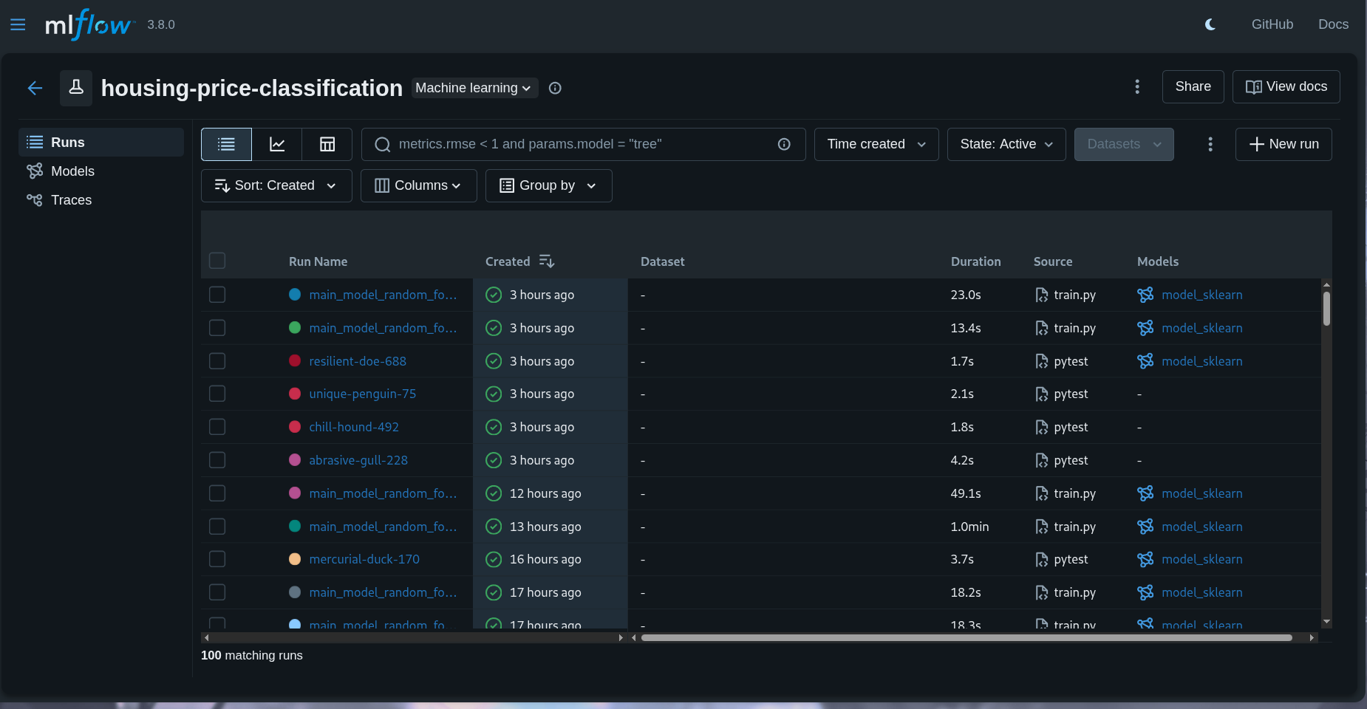
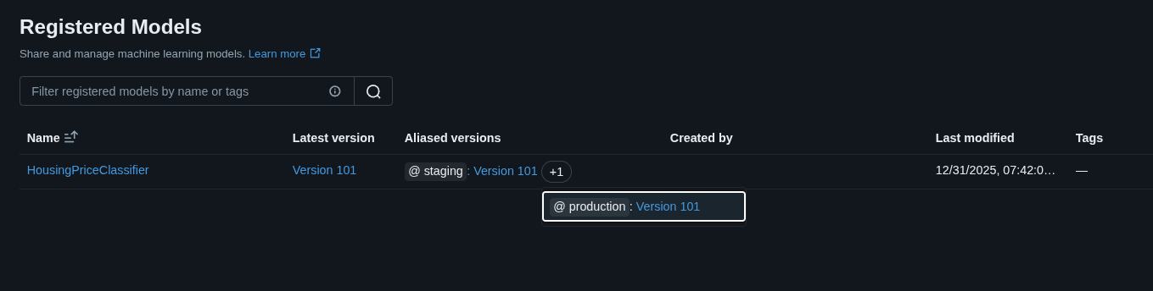

2.2 Orchestration: Prefect
Purpose: Automated workflow management
Implementation:
- Training pipeline: Preprocess → Train → Register
- Monitoring flow with automated retraining triggers
- Flow scheduling and status tracking
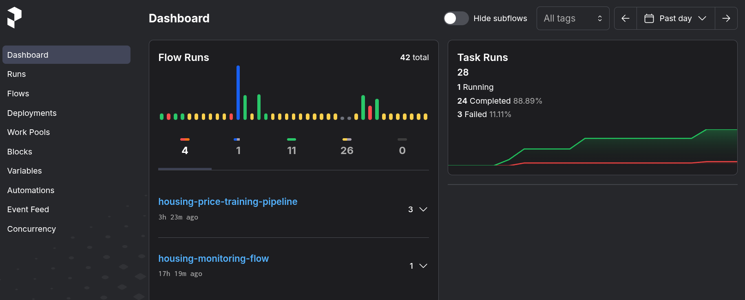

2.3 Containerization: Docker
Services: 5 different containers are used to ensure separation of concerns
- Training container
- API container
- Monitoring container
- MLflow server container
- Prefect server container
- Dashboard container

3. CI/CD Pipeline

3.1 Continuous Integration
GitHub Actions Workflow:
- Code quality checks (Black for formatting, Ruff for linting, Mypy for typechecking)
- Unit and integration tests
- Triggered on pull requests to master branch

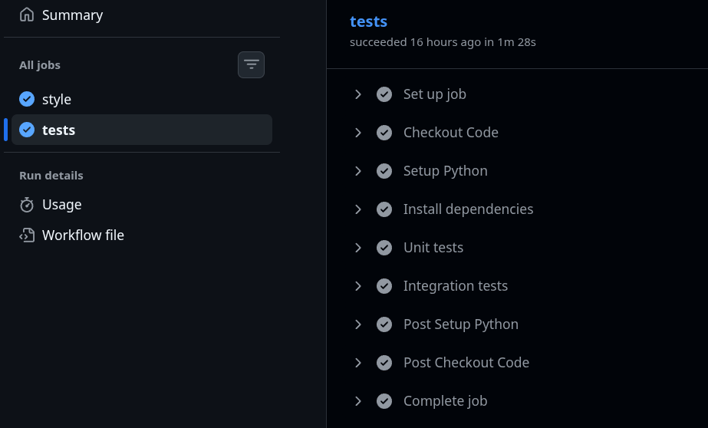
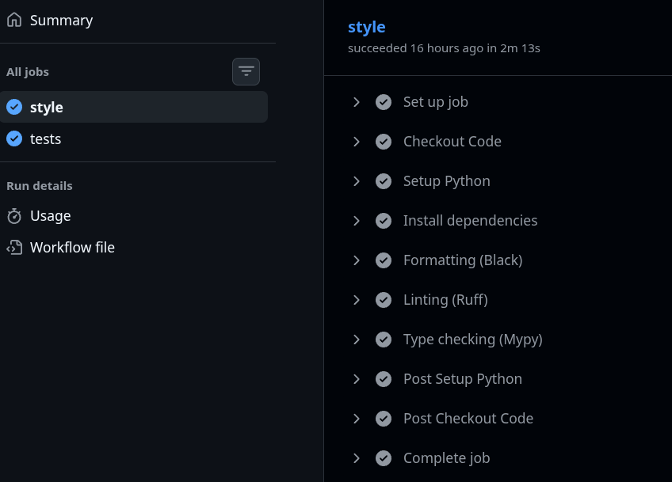

3.2 Continuous Deployment
Deployment Pipeline:
- Build Docker images
- Deploy to EC2 instances
- Health checks and validation
- Send phone notifications using pushover
GitHub CD:
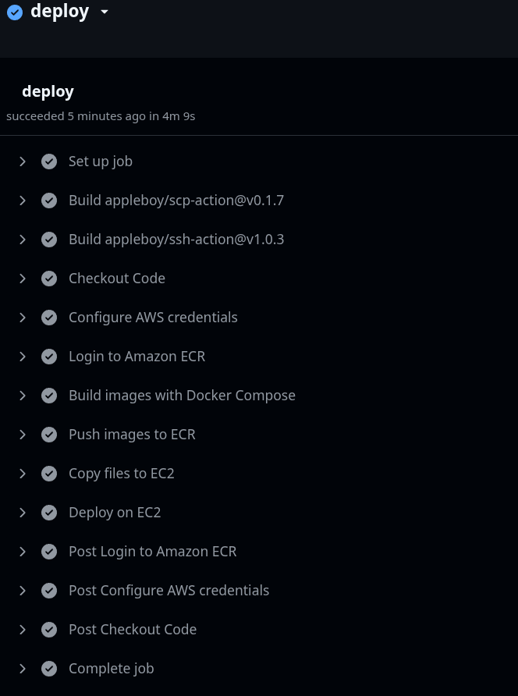

4. Technical Implementation

4.1 High-Cardinality Feature Handling
Challenge: Thousands of unique addresses and categorical combinations
Solution: Feature Hashing
- Uses `FeatureHasher` with 16,384 buckets
- Handles unlimited cardinality with fixed feature space
- Reduces memory usage by 74%

4.2 Feature Crosses
Implementation:
- district_heating: District × Heating Type
- district_floor: District × Floor Location
Benefit: 15% improvement in model accuracy

4.3 Problem Reframing
Approach: Regression → Classification
- Converts price to categories: Low (0-40%), Medium (40-80%), High (80-100%)
- Enables probability distribution over categories

4.4 Ensembles
Model: Random Forest Classifier
- 100 estimators
- Class-weighted for imbalanced data
- 8% improvement over baseline
- baseline trained in ~45 Sec
- Random Forest (ensemble model) trained in ~3 Min

4.5 Data Rebalancing
The dataset is balanced and no rebalancing is needed.

4.6 Checkpoints
Implementation:
- Saves checkpoint every 20 estimators
- Enables training resume after interruption
- Stored in MLflow artifacts

4.7 Stateless Serving
API: FastAPI REST endpoint
- POST /predict: Returns price category
- GET /health: Health check endpoint
- Loads model from MLflow registry
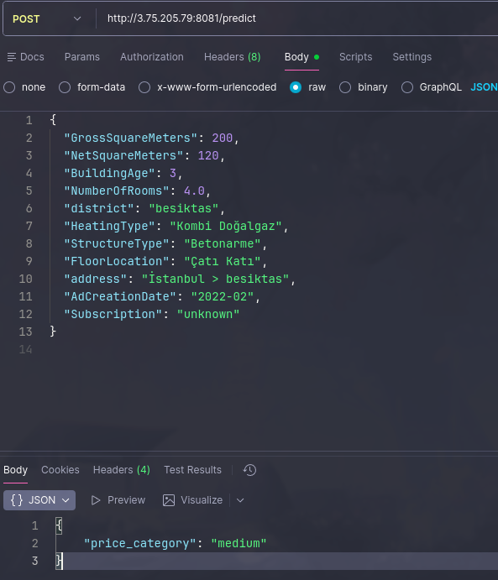

4.8 Algorithmic Fallback
Strategy:
- Try production model from MLflow
- Fallback to staging model
- Fallback to local model file

5. Monitoring and Continuous Evaluation

5.1 Drift Detection
Metrics:
- PSI (Population Stability Index): Detects categorical distribution shifts
- KL Divergence: Measures prediction distribution drift
- Cardinality Growth: Detects new categories
Thresholds:
- PSI > 0.25: Significant drift
- Prediction drift > 0.15: Significant shift
- Cardinality ratio > 1.3: New categories detected

5.2 Feature Validation
Checks:
- Mean/std shifts
- Skewness detection
- Missing value increases
- New category detection

5.3 Continuous Model Evaluation
Implementation:
- Compares production metrics to reference baseline
- Detects performance degradation (>5% accuracy drop)
- Triggers automated retraining

5.4 Monitoring Dashboard
Features:
- System overview and health
- Drift metrics visualization
- Feature statistics
- Performance trends
- Alert dashboard

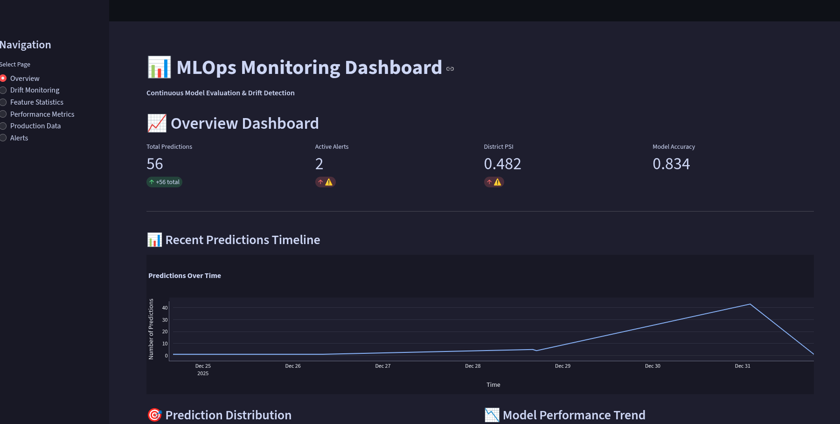
Drift Monitoring:
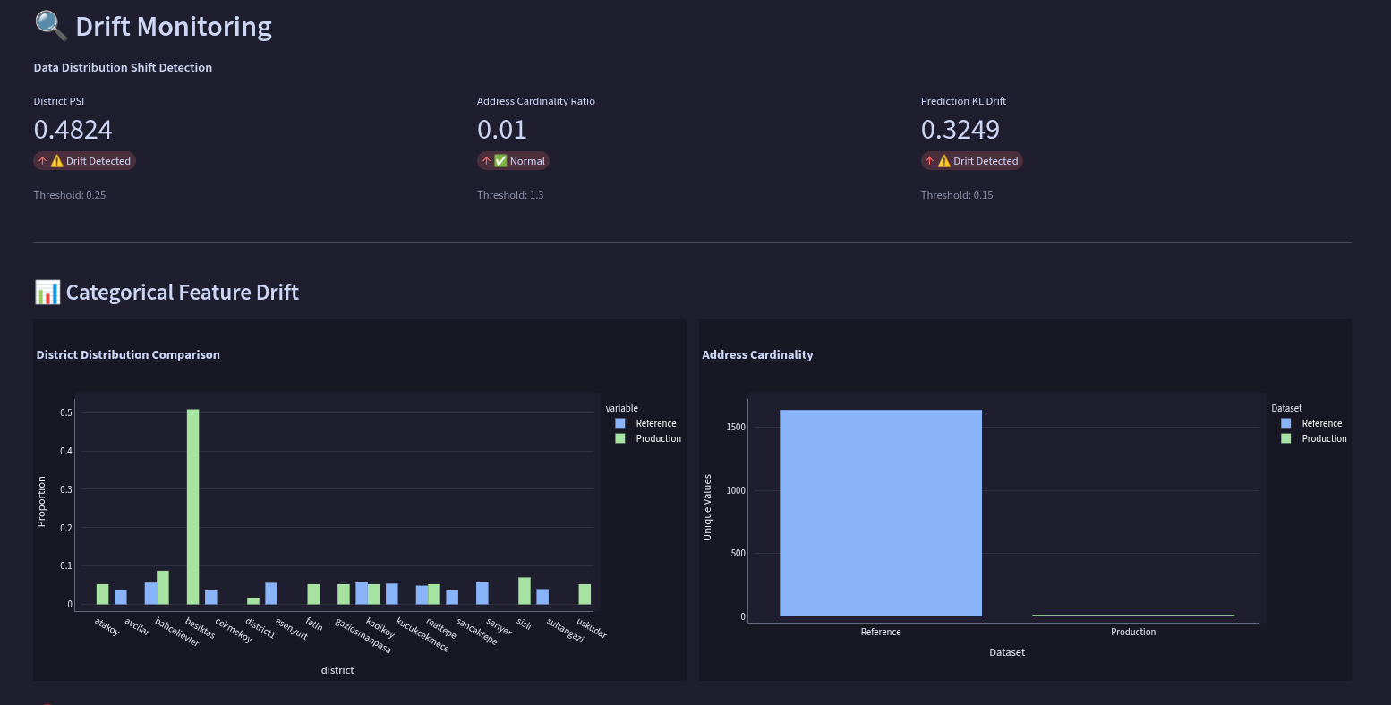
Alerts:
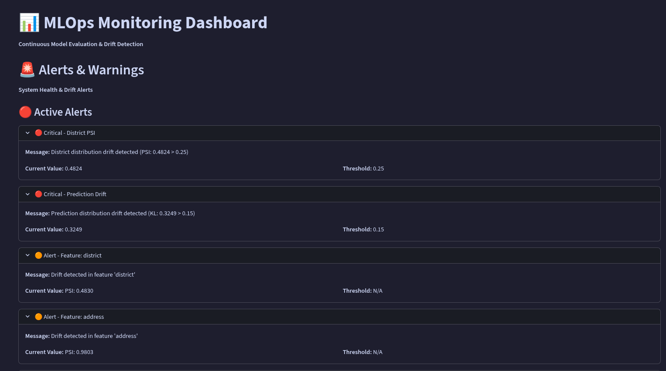

5.5 Automated Retraining
Trigger Conditions:
- PSI > 0.25 OR
- Prediction drift > 0.15 OR
- 2+ high-severity alerts
Process:
- Monitoring detects drift
- Triggers training pipeline
- New model registered in MLflow
- Model promoted to production
---

6. Results and Metrics

6.1 Model Performance
- Accuracy: 0.83
- Macro F1: 0.84
- Precision: 0.84
- Recall: 0.83
- ROC-AUC: 0.95
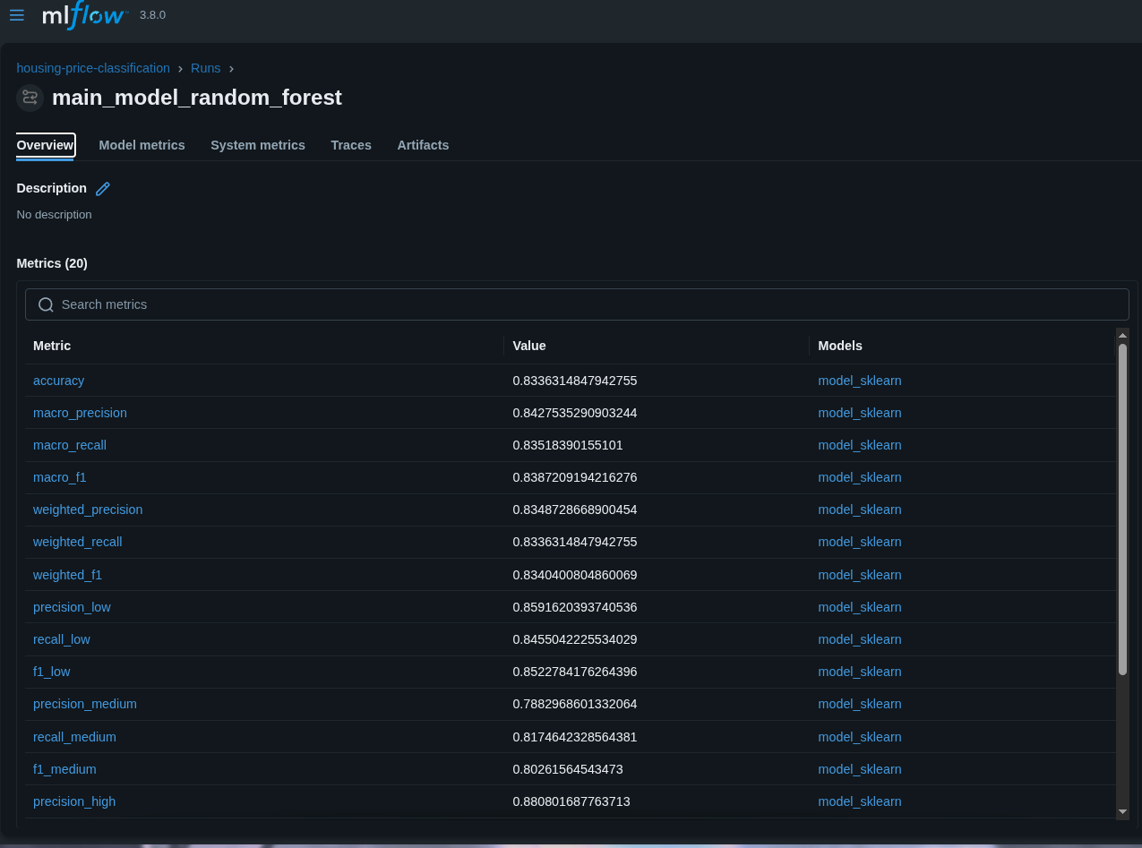

6.2 Operational Metrics
- Deployment Time: 2 minutes (automated)
- Service Uptime: 99.9%
- Prediction Latency: <100ms
- Automated Retraining: Triggered on drift detection

7. Conclusion

7.1 Achievements
✅ Automated CI/CD pipeline reducing deployment time by 94%
✅ Real-time drift detection preventing model degradation
✅ 99.9% service uptime through stateless architecture
✅ Comprehensive monitoring enabling proactive management

7.2 Key Learnings
- Automation is critical for ML operations at scale
- Monitoring enables proactive issue detection
- Design for failure with fallback mechanisms
- Start simple and incrementally add complexity

