**Made with ❤️ by Ibrahem Essam et el.**



**Psyllium Husk Polysaccharide Arabinoxylan**

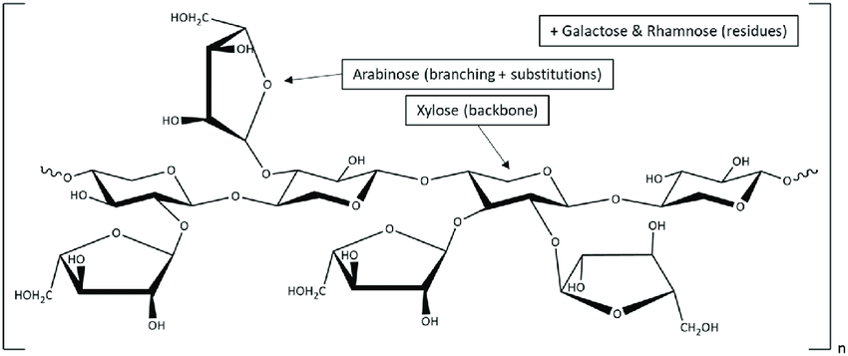

**Dosage Form: Granules.**

**Simethicone**

**Package contains: 6 Sachets.**

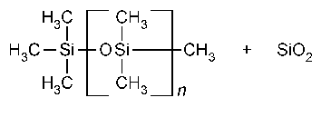

**Indication: Chronic and habitual Constipation.**

**Administration:**

**Dose:**

**One sachet of this medication contains the same amount of ispaghula as one sachet of Fybogel®. so, same dose:**

* **adults and children aged 13 years and over – 1 sachet twice a day.**
* **children aged 6 to 12 years – half to 1 sachet twice a day.**
* **children under the age of 6 years (only under medical supervision) – half to 1 sachet twice a day.**
* **Babies under 10.9 kg: this medication contains amount of simethicone that is not suitable for them.**

**(Maximum dose of simethicone for them: 240 mg/day => which is exceeded)**

**Or as your doctor recommended.**

**✔️ Mix with at least 8 ounces (240 milliliters) of water and drink them immediately.**

**✔️ Take this medication as long as the constipation lasts, or for as long as your doctor has recommended.**

**Active Ingredient (per one Sachet):**

* **Ispaghula husk (3.5 g): Bulk laxative**.
* **Simethicone (0.1875 g): Oral antiflatulent.**

**(125mg simethicone * 3 capsules of simethicone / 2 [twice daily])**

**Other Ingredients:**

* **Riboflavin sodium phosphate: coloring agent**.
* **Sorbic acid: preservative**.
* **Potassium bicarbonate: buffering agent**.
* **Citric acid: flavoring agent**.
* **Stevia: sweetener**.

**Progress of action: usually acts within 12 to 24 hours after single administration. Sometimes the maximum effect is not reached for 2 or 3 days.**

**MOA**

**Ispaghula:**

**It increases fiber in your diet helping your digestive system work efficiently and relieve constipation.**

**It absorbs water and makes the stool soft and bulky, easier to pass.**

**It is capable of absorbing up to 40 times its own weight in water.**

**It acts by hydration in the bowel.**

**its effect is mechanical stimulation of the gut wall depending on the increase in intestinal bulk by water and the decrease in viscosity of the lumenal contents.**

**When taken with a sufficient amount of liquid:**

**it produces an increased volume of intestinal contents due to its highly bulking properties and hence a stretch stimulus which triggers defecation.**

**At the same time the swollen mass of mucilage forms a lubricating layer which makes the transit of intestinal contents easier.**

**Simethicone:**

**It is anti-foaming agent (one of silicones antiflatulent). this anti-gas (anti-flatulence) drug acts in the (stomach and) intestines to change the surface tension of gas bubbles enabling smaller bubbles to join together into bigger bubbles. it results elimination of gas more easily by belching or. passing flatus. So, it relieves abdominal pain which is due to excessive gas in the digestive tract .**

**Side effect**

**✔️ Abdominal distension and risk of intestinal or oesophageal obstruction and faecal impaction, particularly if swallowed with insufficient fluid (this also happens with overdose).**

**✔️ Due to the allergic potential of Ispaghula, patients must be aware of reactions of hypersensitivity including anaphylaxis-like reactions (eg: bronchospasm): rare.**

**Contraindications**

* **Not to be used by patients with a sudden change in bowel habit that persists for more than 2 weeks, undiagnosed rectal bleeding and failure to defaecate following the use of a laxative.**
* **Not to be used by patients suffering from abnormal constrictions in the gastro-intestinal tract, with diseases of the oesophagus and cardia, potential or existing intestinal blockage (ileus), paralysis of the intestine or megacolon.**
* **Patients with known hypersensitivity to Ispaghula (may cause anaphylaxis)**
* **People with a history of appendicitis or a blockage in your bowel.**
* **Patients with esophageal strictures, ulcers, stenosis, or intestinal adhesions.**
* **Pregnancy: this medication not safe for pregnant woman (due to Simethicone).**

**Drugs interactions**

* **Ispaghula generally decreases absorbtion of many drugs so, it decreases theit effect (eg: warfarin, digitalis, potassium-sparing diuretics, salicylates, tetracyclines).**

**Warnings:**

**✔️ In case of overdose: seek medical help immediately.**

**✔️ If you miss a dose, take it as soon as you remember. If it is near the time of the next dose, skip the missed dose. Take your next dose at the regular time. Do not double the dose to catch up.**

**✔️ Do NOT take this drug immediately prior to bedtime.**

**✔️ Take after a gap of two hours from other medicines, as it may slow the enteric absorption of other medicines.**

**If the product is taken together with meals in the case of insulin dependent diabetics it may be necessary to reduce the insulin dose (to avoid hypoglycemia).**

**✔️ Taking this product without adequate fluid may cause it to swell and block your throat or oesophagus and may cause choking.**

**Intestinal obstruction may occur should an adequate fluid intake not be maintained.**

**✔️ Do not take this product if you have ever had difficulty in swallowing or have any throat problems.**

**✔️ If you experience chest pain, vomiting, or difficulty in swallowing or breathing after taking this product, seek immediate medical attention.**

**✔️ The treatment of the debilitated patient requires medical supervision.**

**✔️ The treatment of elderly patients should be supervised as they have insufficient fluid intake which may predispose them to faecal impaction and bowel obstruction.**

**✔️ Using alcohol while taking this drug is not recommended.**

**✔️ Avoid inhalation of powder of this medication as it may cause hypersensitivity.**

**Storage conditions:**

* **Keep in cool dry place blew 30C away from sun light.**
* **Keep away from children.**

**Expiry duration: 2 years.**

**Some advice:**

**✔️ You are advised to eat more fiber in your diet.**

**✔️ Also, drink 8 to 10 glasses of water every day.**

**✔️ Exercise for at least 3 times per week.**

**✔️ You must not hold in stool as that can worsen bowel issues.**

**~: References :~**

* [**https://www.globalresearchonline.net/journalcontents/v18-1/08.pdf**](https://www.globalresearchonline.net/journalcontents/v18-1/08.pdf)
* [**https://www.ema.europa.eu/en/documents/herbal-monograph/draft-community-herbal-monograph-ispaghula-husk-plantago-ovate-tegumentum_en.pdf**](https://www.ema.europa.eu/en/documents/herbal-monograph/draft-community-herbal-monograph-ispaghula-husk-plantago-ovate-tegumentum_en.pdf)
* [**https://www.pharmacy180.com/article/ispaghula-111/**](https://www.pharmacy180.com/article/ispaghula-111/)
* [**https://www.lybrate.com/medicine/ispaghula**](https://www.lybrate.com/medicine/ispaghula)
* [**https://www.sciencedirect.com/science/article/abs/pii/S014486171400143X**](https://www.sciencedirect.com/science/article/abs/pii/S014486171400143X)
* [**https://pubmed.ncbi.nlm.nih.gov/10628808/**](https://pubmed.ncbi.nlm.nih.gov/10628808/)
* **Emitting agent is not good:** [**https://www.phind.com/search?cache=q5ooi68azjspox19wwi6p5vr**](https://www.phind.com/search?cache=q5ooi68azjspox19wwi6p5vr)
* **Stevia:** [**https://www.healthline.com/health/food-nutrition/stevia-side-effects#benefits**](https://www.healthline.com/health/food-nutrition/stevia-side-effects#benefits)
* **Ispaghula dose:** [**https://www.phind.com/search?cache=y0d71svs60ey6zxe688af0tz**](https://www.phind.com/search?cache=y0d71svs60ey6zxe688af0tz)
* **Same dose as Fybogel®:**
* [**https://www.hpra.ie/img/uploaded/swedocuments/73de3d2b-afc6-46ac-a9c6-20ac7f5e7b9d.pdf**](https://www.hpra.ie/img/uploaded/swedocuments/73de3d2b-afc6-46ac-a9c6-20ac7f5e7b9d.pdf)
* [**https://www.nhs.uk/medicines/fybogel-ispaghula-husk/how-and-when-to-take-fybogel/**](https://www.nhs.uk/medicines/fybogel-ispaghula-husk/how-and-when-to-take-fybogel/)
* **A Fybogel® clinical trial:** [**https://pubmed.ncbi.nlm.nih.gov/10076686/**](https://pubmed.ncbi.nlm.nih.gov/10076686/)
* **Simethicone:** [**https://www.drugs.com/mtm/simethicone.html**](https://www.drugs.com/mtm/simethicone.html)
* **Dosage of Simethicone:** [**https://www.drugs.com/dosage/simethicone.html**](https://www.drugs.com/dosage/simethicone.html)
* **Expiry duration:** [**https://hellopharmacist.com/questions/does-metamucil-expire**](https://hellopharmacist.com/questions/does-metamucil-expire)