

**Faculty of engineering - Shoubra**

**Benha University**

**Research Article / Research Project / Literature Review**

in fulfillment of the requirements of

|  |  |
| --- | --- |
| **Department** | **Engineering Mathematics and Physic** |
| **Division** | **------** |
| **Academic Year** | **2019-2020 Preparatory** |
| **Course name** | **Computer** |
| **Course code** | **Ece001** |

**Title: -**

**Programming languages**

By:

|  |  |  |  |
| --- | --- | --- | --- |
|  | Name | Edu mail | B.N |
| 1 | Ibrahim Yasser Ibrahim | Ebrahim195016@feng.bu.edu.eg | 16 |

**Approved by:**

|  |  |
| --- | --- |
| Examiners committee | Signature |
| Dr.Ahmed Bayoumi |  |
| Dr.Shady Elmashad |  |
| Dr. Abdelhamid Attaby |  |

GitHub-link: <https://github.com/ibrahemyasser/ece001>

GitHub-page: <https://ibrahemyasser.github.io/ece001/>

**Application brief**

I have chosen this subject to talk about it because programming languages and computer coding have simplified our lives. Every part of our lives depends on codes, whether it's cars, banks, home appliances or hospitals. No wonder, coding is one of the core competencies needed by today's most well-paid workers. In particular, coding skills are of interest in the segments IT, data analytics, science, web design, and engineering. The ever-growing list of programming languages and protocols will make it difficult for programmers and developers to select any language that is best suited to their work or project at hand. Ideally, every programmer should know a language close to the framework (C, Go, or C++), an object oriented language (Java or Python), a functional programming language (Scala), and a powerful scripting language (Python and JavaScript.

**Screenshots**

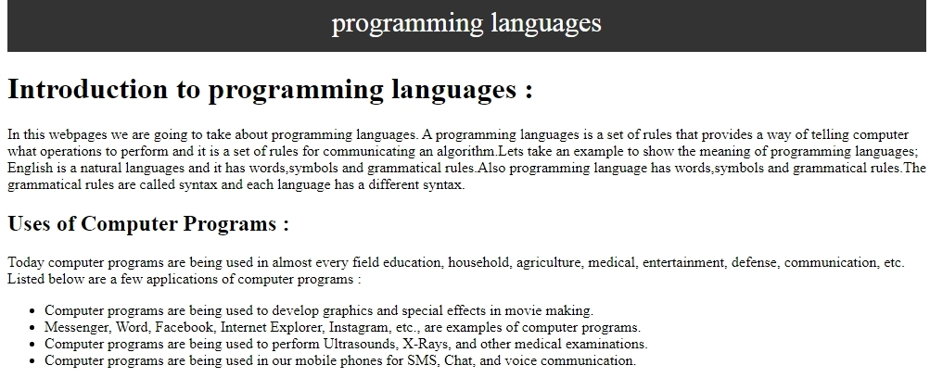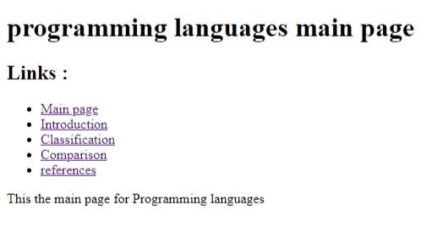

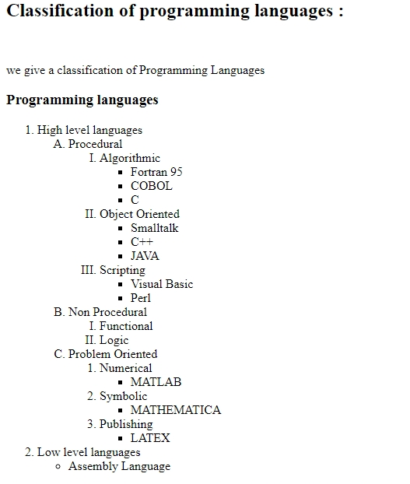

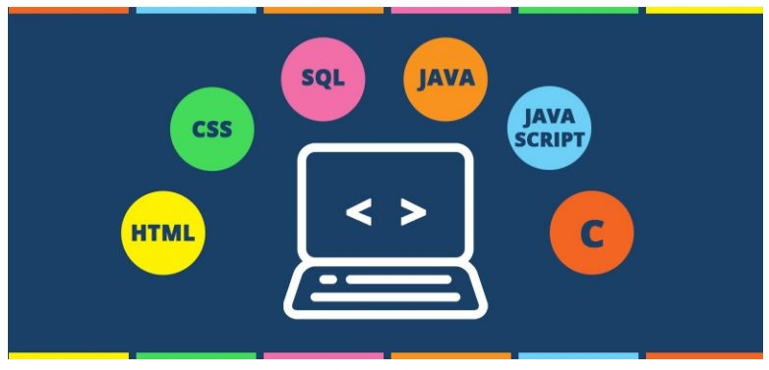

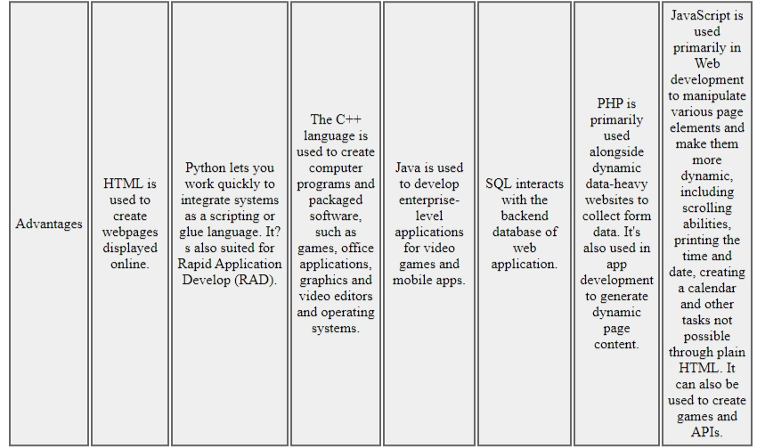

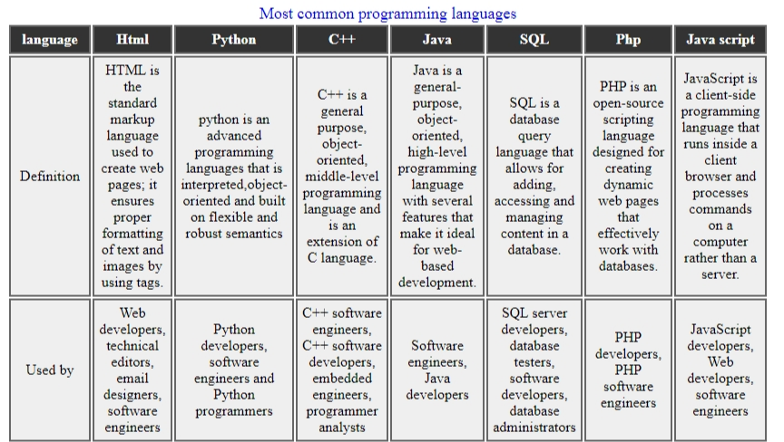

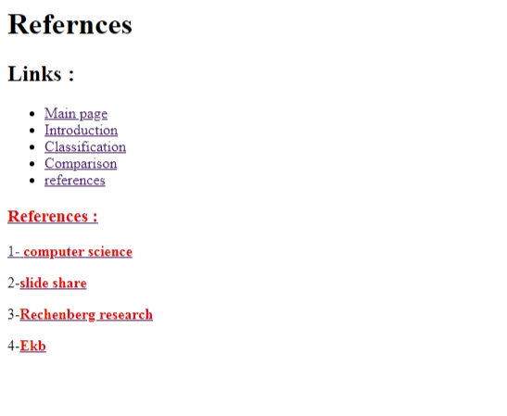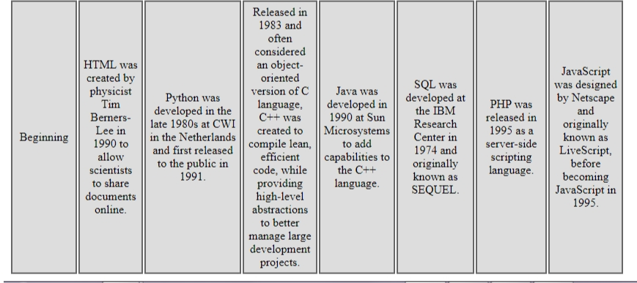

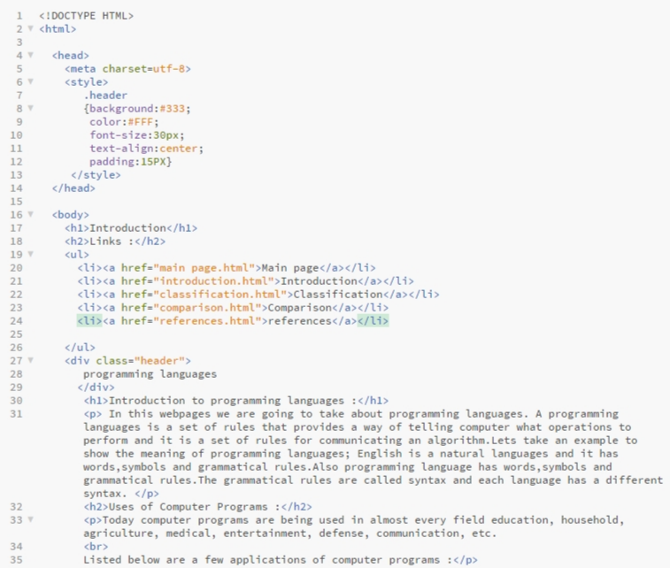  **Source code**

