# Software Requirements Specification

# For

# One Stop Student Service Centre

Prepared by

Azmeer Sohail (21i-2977), Talal Habshi (21i-2456), Ibrahim Naeem (21i-0512)

One Stop Student Service Centre

Date: 5th April, 2024

Table of Contents

Table of Contents ii

Revision History ii

1. Introduction 1

1.1 Purpose 1

1.2 Document Conventions 1

1.3 Intended Audience and Reading Suggestions 1

1.4 Product Scope 1

1.5 References 2

2. Overall Description 2

2.1 Product Perspective 2

2.2 Product Functions 2

2.3 User Classes and Characteristics 3

2.4 Operating Environment 5

2.5 Design and Implementation Constraints 5

2.6 User Documentation 6

2.7 Assumptions and Dependencies 6

3. External Interface Requirements 7

3.1 User Interfaces 7

3.2 Hardware Interfaces 7

3.3 Software Interfaces 9

3.4 Communications Interfaces 9

4. System Features 10

4.1 Degree Issuance Request 10

4.2 File Complaint Form…………………………………………………………………………..10

4.3 Generate Token………………………………………………………………………………...11

4.4 Activity Tracking for Degree Issuance Request……………………………………………….12

4.5 Receive Student Notification………………………………………………………………….13

4.6 Provide Decision………………………………………………………………………………14

4.7 Inform Students about Objections……………………………………………………………..14

4.8 Bona-fide Letter Request………………………………………………………………………15

4.9 Transcript Issuance Request……………………………………………………………………16

4.10 Verify Payments………………………………………………………………………………..16

5. Other Nonfunctional Requirements 17

5.1 Performance Requirements 12

5.2 Safety Requirements 12

5.3 Security Requirements 12

5.4 Software Quality Attributes 12

5.5 Business Rules 18

6. Diagrams 18

6.1 Class Diagram 18

6.2 Activity Diagram 19

6.3 Sequence Diagram 21

6.4 Use Case Diagram……………………………………………………………………..23

Appendix A: Glossary 23

Appendix B: Analysis Models 24

Appendix C: To Be Determined List 24

**Trello Screenshots………………………………………………………………………………25**

Revision History

|  |  |  |  |
| --- | --- | --- | --- |
| **Name** | **Date** | **Reason For Changes** | **Version** |
|  |  |  |  |
|  |  |  |  |

# Introduction

## Purpose

This document specifies the software requirements for the One Stop Centre System for University Services, Version 1.0, aimed at providing a centralized platform for students to submit complaints, request degree issuance, and generate service tokens. Covering the entire system, this SRS details the integration of these services into a single user-friendly interface, focusing on software components and excluding hardware requirements and external services.

## Document Conventions

In this Software Requirements Specification (SRS) for the One Stop Centre System for University Services, Version 1.0, standards and typographical conventions include using Times New Roman for text with 14-point bold for headings and 12-point for body text, `Courier New` for code snippets, and bold for key terms and variable names. The document does not assign individual priorities to requirement statements; instead, it assumes that priorities for higher-level requirements are inherited by their detailed counterparts.

## Intended Audience and Reading Suggestions

This Software Requirements Specification (SRS) for the One Stop Centre System, Version 1.0, caters to developers, project managers, marketing staff, users, testers, and documentation writers. It's structured to guide readers from a general system overview to detailed functionalities and requirements, recommending a sequence from the introductory sections to those more relevant to each reader's role, ensuring a comprehensive yet focused understanding of the system's specifications.

## Product Scope

The One Stop Center System, Version 1.0, streamlines student access to university services, aligning with the institution's goal of enhancing educational services through technology. It simplifies processes for complaint handling, degree issuance, and service access, fostering efficiency and student satisfaction. Details on broader objectives and strategies are outlined in the Vision and Scope document.

## References

The SRS for the One Stop Centre System (Version 1.0) references key documents including the project's Vision and Scope, the University User Interface Style Guide, and the System Requirements Specification for integration standards, available through the university's document repository, providing essential guidelines and context for the project.

# Overall Description

## Product Perspective

The One Stop Centre System, detailed in this SRS, is a new, standalone product designed to centralize university service access for students. It integrates with existing systems—like student information and academic records—via APIs and data exchange protocols, serving as a hub to streamline student services. This system enhances operational efficiency and the student experience by facilitating easy access to services such as complaint submissions and degree issuance requests, while maintaining seamless communication with the university's broader service ecosystem.

## Product Functions

The One Stop Centre System primarily facilitates the following functions:

* **Complaint Submission**: Enables students to file complaints regarding university services, with features for tracking and feedback.
* **Degree Issuance Requests**: Allows students to request and track the issuance of their degree certificates, simplifying the graduation process.
* **Service Token Generation**: Provides a mechanism for students to obtain tokens for accessing various university services, enhancing service delivery efficiency.
* **User Account Management**: Supports account creation, management, and authentication for students and staff, ensuring secure access to system features.
* **Administrative Functions**: Empowers university staff with tools to process requests, manage complaints, and generate insightful reports on service usage and student feedback.

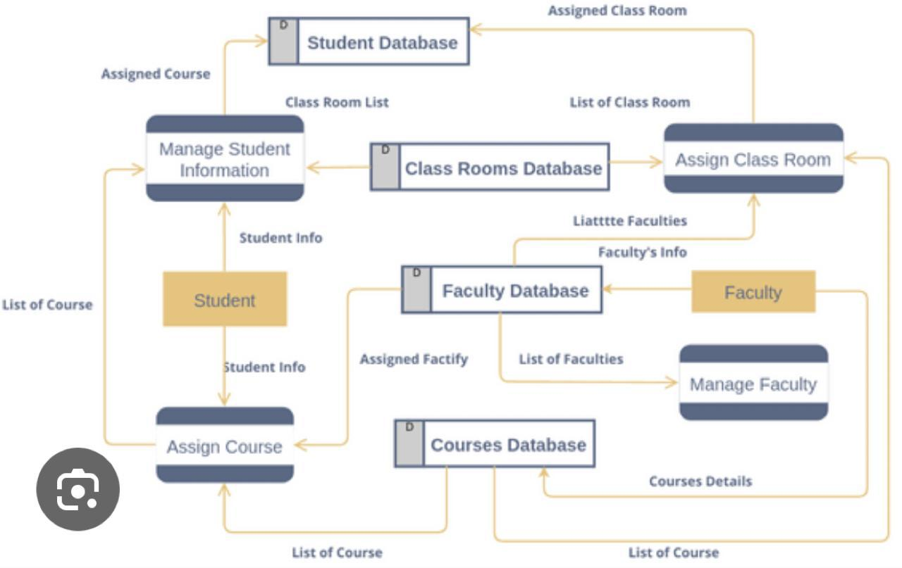

## User Classes and Characteristics

The One Stop Centre System is designed to accommodate various user classes with distinct characteristics and needs. These user classes can be differentiated by their interaction with the system, technical expertise, and the functions they primarily use:

1. **Students (Primary Users)**:
   * **Frequency of Use**: High, as they access the system regularly for various services.
   * **Subset of Product Functions Used**: Complaint submissions, degree issuance requests, service token generation, and user account management.
   * **Technical Expertise**: Varied, assuming a general proficiency with digital platforms.
   * **Security or Privilege Levels**: Basic, with access restricted to personal information and requests.
   * **Educational Level**: Undergraduate and graduate students.
   * **Experience**: Directly interact with the system for service requests, making them a critical user class.
2. **University Administrative Staff (Key Users)**:
   * **Frequency of Use**: Moderate to high, depending on their role within the university services.
   * **Subset of Product Functions Used**: Administrative dashboard, complaint management, degree issuance processing, and report generation.
   * **Technical Expertise**: Moderate to high, with training provided for system management features.
   * **Security or Privilege Levels**: Higher, with access to sensitive student information and system settings.
   * **Educational Level**: Professional staff with various educational backgrounds.
   * **Experience**: Engages with the system for processing and managing student requests and generating reports.
3. **IT Support Staff (Supporting Users)**:
   * **Frequency of Use**: As needed, primarily for maintenance, updates, and troubleshooting.
   * **Subset of Product Functions Used**: System maintenance, security management, and technical support.
   * **Technical Expertise**: High, with in-depth knowledge of the system's technical infrastructure.
   * **Security or Privilege Levels**: High, with access to all areas of the system for maintenance and security purposes.
   * **Educational Level**: Typically higher education in IT or related fields.
   * **Experience**: Focuses on ensuring the system's smooth operation and security, indirectly impacting user experience.
4. **External Partners (Conditional Users)**:
   * **Frequency of Use**: Low, specific to collaborative services or data-sharing agreements.
   * **Subset of Product Functions Used**: Limited to functions relevant to partnership agreements.
   * **Technical Expertise**: Varied, depending on the nature of the partnership.
   * **Security or Privilege Levels**: Restricted, with access limited to areas pertinent to the partnership.
   * **Educational Level**: N/A.
   * **Experience**: Interaction is limited and highly specific, influenced by external agreements and collaborations.

## Operating Environment

The One Stop Centre System is crafted to function within a diverse university environment, supporting cross-platform accessibility on both desktop (Windows, macOS) and mobile devices (iOS, Android) to accommodate the varied preferences of students and staff. It is compatible with the latest operating systems to ensure broad usability. Additionally, the system is designed to coexist with existing university software, such as student information systems and academic databases, requiring seamless integration and data exchange capabilities without disrupting the operational harmony of the current technological ecosystem.

## Design and Implementation Constraints

* Corporate and Regulatory Policies: Adherence to university policies and data protection regulations, such as GDPR or FERPA, will guide how data is handled, stored, and accessed, impacting system design and functionality.
* Hardware Limitations: The system must be optimized for performance across devices with varying capabilities, including older models with limited memory or processing power, ensuring wide accessibility.
* Interfaces to Other Applications: Integration with existing university systems (e.g., student information systems, academic databases) necessitates compatible interfaces and may restrict choice of technologies to ensure seamless data exchange.
* Specific Technologies, Tools, and Databases: The university’s existing IT infrastructure may dictate the use of certain development tools, programming languages, or database systems, limiting flexibility in technology selection.
* Parallel Operations: The system must support concurrent access by multiple users without degradation of performance, influencing architecture and scalability considerations.
* Language Requirements: Multilingual support may be required to accommodate a diverse student body, adding complexity to UI design and content management.
* Communications Protocols: Secure communication standards must be observed for data transfer and authentication processes, potentially limiting choices in API design and third-party integrations.
* Security Considerations: Strong security measures must be implemented to protect sensitive student information, influencing development approaches and potentially requiring specific encryption and authentication solutions.
* Design Conventions or Programming Standards: If the customer’s organization will maintain the software post-delivery, adherence to their internal coding standards, documentation requirements, and architectural patterns will be necessary.

## User Documentation

* User Manuals: Detailed guides providing step-by-step instructions on system functionalities, targeted at both students and administrative staff. Manuals will cover system navigation, common tasks, troubleshooting common issues, and tips for efficient use.
* Online Help: An integrated online help system accessible within the software, offering quick reference and support on specific features or tasks. This could include FAQs, searchable help topics, and context-sensitive help sections.
* Tutorials: Interactive tutorials designed to familiarize users with the system's features and functionalities through guided activities. These may be available as video tutorials, walkthroughs, or interactive web-based modules.
* Quick Reference Guides: Concise documents highlighting key functionalities, shortcuts, and tips for efficient system use, intended for users who need information quickly without going through detailed manuals.

Delivery Formats and Standards:

* Documentation will be provided in multiple formats to ensure accessibility and convenience:
  + PDF for user manuals and quick reference guides, ensuring compatibility across devices and platforms.
  + HTML for online help, allowing for easy integration within the system and accessibility from any web browser.
  + Video for tutorials, likely hosted on the university's website or a dedicated video sharing platform to facilitate easy access and sharing.
* Standards for documentation will align with the university's accessibility guidelines, ensuring materials are usable by individuals with disabilities. This may include adherence to Web Content Accessibility Guidelines (WCAG) for online documentation and best practices for clear and inclusive language.

## Assumptions and Dependencies

1. Integration Compatibility: The assumption that existing university systems (e.g., student information systems, academic databases) can be seamlessly integrated with the new system via APIs or direct data exchange mechanisms. If these systems are not as interoperable as assumed, additional development work or middleware may be required.
2. Technology Availability and Stability: The project assumes that the chosen development frameworks, languages, and tools will remain stable, supported, and available throughout the development cycle. Changes in technology availability or significant updates could necessitate unplanned adjustments.
3. User Adoption Rates: It is assumed that the system will be readily adopted by its intended users (students and staff) and that the designed interfaces and workflows will meet their needs and preferences. Lower than expected adoption rates or user feedback indicating usability issues could require significant revisions.
4. Regulatory Compliance: The assumption that the system's design complies with all relevant data protection and privacy regulations (such as GDPR or FERPA) at the outset. Changes in regulatory requirements or incorrect assumptions about compliance could necessitate substantial modifications.
5. Security Requirements: Assuming current security measures and protocols will be sufficient throughout the system's lifecycle. Evolving security threats or vulnerabilities discovered in used technologies could necessitate additional security features or changes.

# External Interface Requirements

## User Interfaces

The One-Stop Student Centre's interfaces will adhere to university GUI standards, ensuring a responsive, accessible design across all devices. Key features include intuitive navigation, standard action buttons, keyboard shortcuts, and clear error messages, catering to ease of use in modules like Degree Issuance and Complaint Submission. These interfaces prioritize clarity and efficiency, with detailed specifications provided in a separate User Interface Specification document to guide development and maintain consistency.

## Hardware Interfaces

The One-Stop Student Centre system is designed to be broadly accessible, emphasizing com-patibility with a wide range of hardware devices without necessitating specific hardware inter-faces. This approach ensures the system is usable across standard computing and mobile de-vices, facilitating ease of access for all users.

**Supported Device Types:**

Computing Devices: The system is compatible with desktop computers, laptops, and net-books running Windows, macOS, or Linux operating systems. This ensures broad accessibility for users with various preferences and requirements.

**Mobile Devices:** Full support is provided for smartphones and tablets running iOS or Android. The system's responsive design adapts to different screen sizes and resolutions, offering a consistent user experience.

Printers: While the system does not directly interface with printers, it is designed to generate printable documents in standard formats (PDF, DOCX) that users can print from their devices.

**Data and Control Interactions:**

The system primarily interacts with hardware through standard input devices (keyboard, mouse, touchscreens) to receive user inputs. Output is displayed via device screens, with the system's responsive design ensuring readability and usability across different devices and res-olutions.

Data exchange with hardware devices, such as file downloads or uploads, follows standard web protocols (HTTP/HTTPS), ensuring compatibility and security across devices.

**Communication Protocols:**

HTTP/HTTPS: The system uses HTTP for standard web traffic and HTTPS for secure com-munications, ensuring data transmitted between the user's device and the system's servers is encrypted.

WebSockets: For real-time features, such as notification updates, WebSockets are used to fa-cilitate a persistent, full-duplex communication channel over a single TCP connection.

## 3.3 Software Interfaces

## The One-Stop Student Centre system integrates with a variety of software components to facilitate its operations, ensuring compatibility across a range of databases, operating systems, and other essential tools and libraries.

## Databases: Utilizes MySQL 8.0 for data storage, including user and administrative data, with Redis for session management and caching to enhance performance.

## Operating Systems: Compatible with Windows, macOS, and Linux, ensuring accessibility for users on their preferred platforms.

## Tools and Libraries: Employs React.js for the front end to deliver a responsive user interface, and Node.js with Express.js on the server side for efficient API handling and dynamic content delivery. Security and user authentication are managed via JSON Web Tokens (JWT).

## Integrated Components: Incorporates Stripe for secure payment processing and SendGrid for automated email notifications, supporting key functionalities like payment handling and communication.

## Communication Protocols: The system leverages RESTful APIs for server-client communication, ensuring a standardized data exchange, with WebSocket technology for real-time updates and notifications.

## Data Sharing and Security: Ensures secure and efficient data sharing across components, adhering to best practices in data security and integrity, particularly in handling sensitive user information.

## 3.4 Communications Interfaces

## The One-Stop Student Centre system leverages several communication interfaces to ensure secure, efficient interactions:

## E-mail Communications: Utilizes SMTP with HTML formatting and TLS encryption for secure, rich-text email notifications.

## Web Browser Communications: Supports modern browsers (Chrome, Firefox, Safari, Edge) using HTTPS for secure, encrypted data transmission.

## Server Communications: Employs HTTP/HTTPS and RESTful APIs for server-client data exchange, using JSON for message formatting.

## Electronic Forms: Provides dynamic HTML forms with AJAX for real-time data submission, ensuring data integrity through client-side and server-side validation.

# Security: All communications are secured via HTTPS with SSL/TLS encryption, and user sessions are managed with JWT for authentication and authorization.

# Data Transfer and Synchronization: Optimizes data rates for web usage, with WebSockets enabling real-time updates without the need for manual page refreshes.

# This streamlined approach guarantees a smooth, secure user experience, adhering to standard web protocols and encryption methods

# *.*System Features

## Degree Issuance Request

### Description and Priority

This feature enables students to submit degree issuance requests online and allows administrative staff to manage and process these requests efficiently.

**Priority:** High.

### Stimulus/Response Sequences

* Student initiates a degree issuance request.
* System acknowledges the request and generates a unique token.
* Admin and Members of FYP and Finance Department review and process the request.
* System updates the status of the request and notifies the student.

### Functional Requirements

REQ-1: The system shall provide a user interface for students to submit degree issuance requests.

REQ-2: The system shall generate a unique token for each request for tracking purposes.

REQ-3: Admin and Members of FYP and Finance Department shall have access to a dashboard to view and manage pending, processed, and new requests.

REQ-4: The system shall provide notifications to students regarding the status of their degree issuance requests.

## File Complaint Form

### Description and Priority

This feature allows students to file complaints regarding issues related to their degree, such as spelling mistakes, so that all the errors are resolved properly.

**Priority:** High.

### Stimulus/Response Sequences

* Student accesses the complaint form.
* System acknowledges submission of the complaint.
* Admin and Members of FYP and Finance Department review and resolve the complaint.
* System notifies the student of the resolution.

### Functional Requirements

REQ-1: The system shall provide a complaint form for students to submit complaints.

REQ-2: Upon submission, the system shall acknowledge submission of the complaint and generate a unique token.

REQ-3: Admin and Members of FYP and Finance Department shall have access to view and resolve complaints.

REQ-4: The system shall notify students of the resolution of their complaints.

## Generate Token

### Description and Priority

The system must generate a unique token for each form (degree issuance, transcript, complaint, bona-fide, internship letter) submitted by a student. The generated token must be alphanumeric and unique. The system must securely store the generated tokens to prevent unauthorized access or tampering.

**Priority:** High.

### Stimulus/Response Sequences

* Student accesses a form.
* System acknowledges submission of the form.
* Using an algorithm or unique identifier mechanism, the system generates a token.
* The token is a unique alphanumeric string or identifier.
* The system associates this token with the submitted complaint for future reference.

### Functional Requirements

REQ-1: The system shall automatically generate a unique token upon submission of a form by a student.

REQ-2: The token generation process shall ensure uniqueness to avoid any conflicts with existing tokens.

REQ-3: The generated token shall consist of alphanumeric characters.

REQ-4: The token shall be associated with the submitted complaint for future reference and tracking.

REQ-5: After token generation, the system shall present the generated token to the student as part of the submission acknowledgment.

REQ-6: The format of the displayed token shall be clear and easily readable by the student.

REQ-7: The system shall define a validity period for each generated token to ensure timely resolution of complaints.

REQ-8: Tokens shall expire after a predefined period to prevent outdated or irrelevant complaints from remaining in the system.

## Activity Tracking for Degree Issuance Request

### Description and Priority

The system tracks the progress of the degree issuance request.

**Priority:** Medium.

### Stimulus/Response Sequences

* Student logs in to the system.
* Student clicks on the activity tracking tab.
* System retrieves and displays the current status of the degree issuance request associated with the student.
* System updates the activity tracking dashboard in real-time to reflect the new status.
* Degree issuance request status changes (e.g., from pending to processing).

### Functional Requirements

REQ-1: The system shall provide a dedicated activity tracking tab accessible to logged-in students. REQ-2: Upon accessing the activity tracking tab, the system shall display the current status of the degree issuance request.

REQ-3: The displayed status shall include updates such as "Request is pending," "One Stop Admin has started processing the request," and "Request is delivered to FYP committee."

REQ-4: The system shall update the activity tracking dashboard in real-time as the status of the degree issuance request changes.

REQ-5: The system shall ensure that only the student associated with the degree issuance request can view the activity tracking information.

REQ-6: The activity tracking feature shall be easily navigable and intuitive for students to use. REQ-7: The system shall maintain a log of all status updates and timestamps for the degree issuance request for auditing purposes.

## Receive Student Notification

### Description and Priority

The Admin, FYP Department Member and Finance Department Member receive notification as soon as the student initiates a request.

**Priority:** High.

### Stimulus/Response Sequences

* Student initiates a degree issuance request/ bona-fide letter request/ transcript issuance request.
* System sends notifications to One Stop Admin, FYP Department Members, and Finance Department Members in real-time.
* One Stop Admin logs in to the system.
* One Stop Admin clicks on the notification tab.
* System displays a list of notifications, including those related to student-initiated degree issuance requests/ bona-fide letter requests/ transcript issuance request, with direct links for quick access.
* Finance Department Member receives a notification regarding a student-initiated degree issuance request/ bona-fide letter request/ transcript issuance request.
* FYP Department Member accesses the notification through their device.
* System ensures that the notification contains pertinent information about the student-initiated degree issuance request/ bona-fide letter request/ transcript issuance request.

### Functional Requirements

REQ-1: The system shall provide a notification mechanism for One Stop Admin, FYP Department Members, and Finance Department Members to receive notifications when a student initiates a request.

REQ-2: Notifications shall be sent in real-time upon a student initiating a request.

REQ-3: The notification shall include details of the degree issuance request/ bona-fide letter request/ transcript issuance request, such as student name, request status, and any relevant information.

REQ-4: The notification shall contain a direct link to the request for quick access by the admin or department members.

REQ-5: The system shall ensure that notifications are delivered securely and reliably to the intended recipients.

REQ-6: Notifications shall be customizable to include specific information relevant to the recipient's role or responsibilities.

REQ-7: The system shall maintain a log of all notifications sent and received for auditing and tracking purposes.

## Provide Decision

### Description and Priority

The FYP Department Member and Finance Department Member review the request and provide decision - accepting, rejecting, or raising objections with comments.

**Priority:** High.

### Stimulus/Response Sequences

* FYP Department Member/ Finance Department Member logs in to the system.
* Finance Department Member/FYP Department Member reviews the request.
* FYP Department Member or Finance Department Member submits their decision.

### Functional Requirements

REQ-1: The system shall provide a decision-making interface for FYP Department Members and Finance Department Members to review requests made by students.

REQ-2: The decision-making interface shall allow FYP Department Members and Finance Department Members to provide decisions of accepting, rejecting, or raising objections with comments.

REQ-3: The system shall ensure that only authorized FYP Department Members and Finance Department Members can access the decision-making interface.

REQ-4: The system shall provide options for FYP Department Members and Finance Department Members to add comments when raising objections or rejecting a degree issuance request.

REQ-5: Upon submission of a decision, the system shall update the status of the degree issuance request accordingly.

REQ-6: The system shall maintain a log of all decisions made by FYP Department Members and Finance Department Members for auditing and tracking purposes.

## Inform Students about Objections

### Description and Priority

As a One Stop Admin I want to inform students in case of objections raised by the FYP or Finance department so that students can sort out their objections.

**Priority:** High.

### Stimulus/Response Sequences

* FYP or Finance Department Member raises an objection regarding a degree issuance request.
* One Stop Admin logs in to the system.
* One Stop Admin identifies objections raised by FYP or Finance Department Members.
* System provides options for One Stop Admin to trigger notifications to the respective students associated with the request.
* One Stop Admin selects the student and triggers the notification regarding objections.
* System sends the notification to the student containing relevant details and instructions on addressing the objections.
* Student receives the notification about objections.

### Functional Requirements

REQ-1: The system shall provide a mechanism for One Stop Admin to inform students about objections raised by the FYP or Finance department.

REQ-2: Notifications regarding objections shall be triggered automatically upon objections being raised by FYP or Finance Department Members.

REQ-3: The notification to the student shall include details of the objection, such as the nature of the objection and any relevant comments provided by the department member.

REQ-4: The system shall ensure that only the relevant student associated with the degree issuance request receives the notification about objections.

REQ-5: The notification shall contain instructions or guidance for the student on how to address the raised objections.

REQ-6: The system shall provide a clear and easily accessible interface for One Stop Admin to trigger notifications to students about objections.

## Bona-fide Letter Request

### Description and Priority

This feature enables students to submit bona-fide letter requests online and allows administrative staff to manage and process these requests efficiently.

**Priority:** High.

### Stimulus/Response Sequences

* Student initiates a bona-fide letter request.
* System acknowledges the request and generates a unique token.
* Admin and Members of FYP and Finance Department review and process the request.
* System updates the status of the request and notifies the student.

### Functional Requirements

REQ-1: The system shall provide a user interface for students to submit bona-fide letter requests.

REQ-2: The system shall generate a unique token for each request for tracking purposes.

REQ-3: Admin and Members of FYP and Finance Department shall have access to a dashboard to view and manage pending, processed, and new requests.

REQ-4: The system shall provide notifications to students regarding the status of their bona-fide letter requests.

## Transcript Issuance Request

### Description and Priority

This feature enables students to submit transcript issuance requests online and allows administrative staff to manage and process these requests efficiently.

**Priority:** High.

### Stimulus/Response Sequences

* Student initiates a transcript issuance request.
* System acknowledges the request and generates a unique token.
* Admin and Members of FYP and Finance Department review and process the request.
* System updates the status of the request and notifies the student.

### Functional Requirements

REQ-1: The system shall provide a user interface for students to submit transcript issuance requests.

REQ-2: The system shall generate a unique token for each request for tracking purposes.

REQ-3: Admin and Members of FYP and Finance Department shall have access to a dashboard to view and manage pending, processed, and new requests.

REQ-4: The system shall provide notifications to students regarding the status of their transcript issuance requests.

## Verify Payments

### Description and Priority

As a Finance Department Member I want to ensure that all outstanding amounts and request fees have been paid so that I can process the request further.

**Priority:** High.

### Stimulus/Response Sequences

* Finance Department Member logs in to the system.
* Student initiates a request.
* Finance Department Member starts processing the request.
* System retrieves payment information associated with the request and displays the payment status indicating whether all outstanding amounts and request fees have been paid.

### Functional Requirements

REQ-1: The system shall provide a payment verification feature for Finance Department Members to ensure all outstanding amounts and degree issuance fees have been paid.

REQ-2: Upon initiating processing of a degree issuance request, the system shall display the payment status indicating whether all outstanding amounts and degree issuance fees have been paid. REQ-3: The payment status displayed shall be clear and easily understandable, indicating whether payments are complete or if there are outstanding amounts.

REQ-4: The system shall integrate with a payment processing module to retrieve payment information and verify payment status.

REQ-5: The payment verification feature shall only be accessible to authorized Finance Department Members.

REQ-6: In case of outstanding amounts, the system shall provide details of the outstanding fees and instructions for the Finance Department Member on further actions required.

REQ-7: The system shall maintain a log of payment verification activities for auditing and tracking purposes.

# Other Nonfunctional Requirements

## Performance Requirements

* The system shall process degree issuance requests within 3 business days.
* The complaint form process shall be completed within 5 business days.
* The token must be generated as soon as the form is submitted.

## Safety Requirements

* The system shall ensure the privacy and confidentiality of student information.

## Security Requirements

* The system shall implement user authentication mechanisms to ensure only authorized access.
* All data transmission shall be encrypted to maintain data security.

## Software Quality Attributes

* The system shall be reliable, with an uptime of at least 99%.
* The system shall be maintainable, allowing for easy updates and enhancements.

## Business Rules

* Only authorized administrative staff shall have access to manage degree issuance requests and complaints.
* All interactions with the system must adhere to university policies and regulations.

# Diagrams

## Class diagram

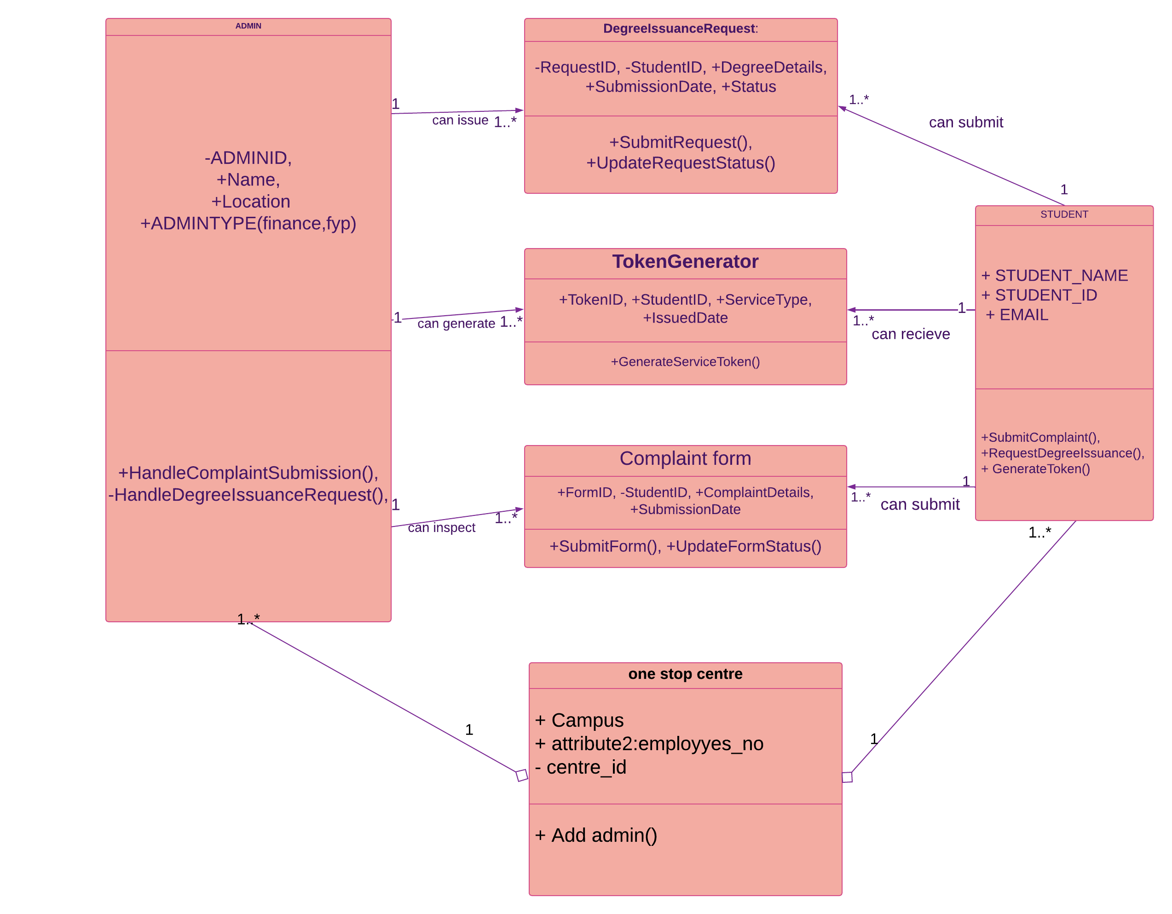

## Activity Diagram

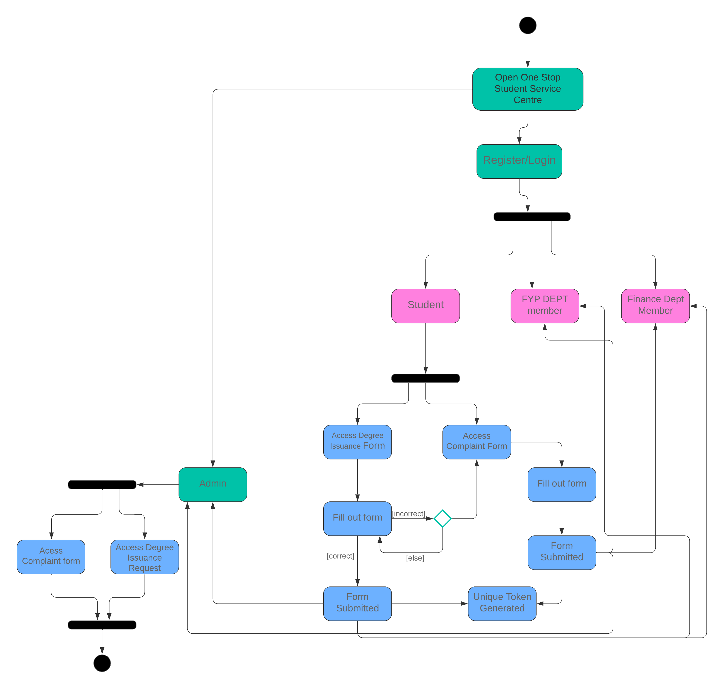





## Sequence Diagram

User Story: Registration

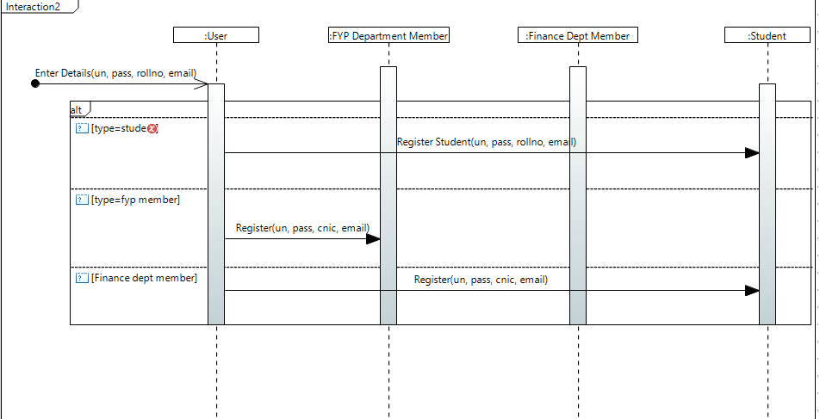

User Stories: Generate Token , Submit Degree Issuance Form, File Complaint Form

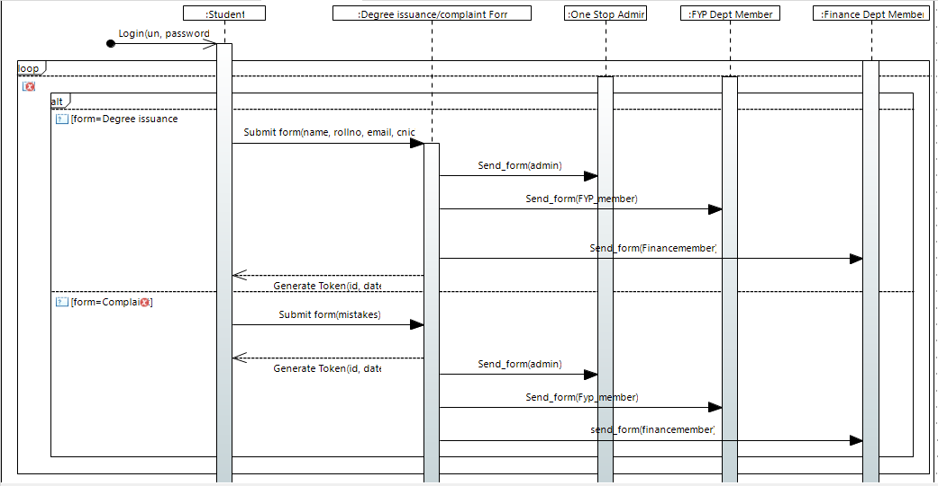

## Use Case Diagram

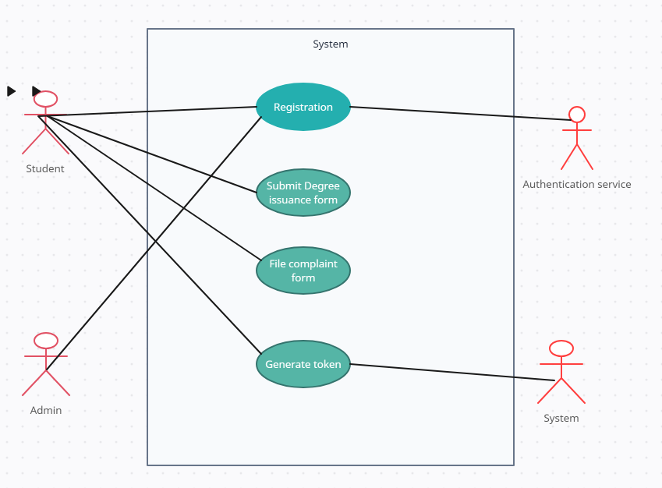

Appendix A: Glossary

1. API (Application Programming Interface): A set of rules and definitions that allows software applications to communicate with each other.
2. GDPR (General Data Protection Regulation): A regulation in EU law on data protection and privacy in the European Union and the European Economic Area.
3. FERPA (Family Educational Rights and Privacy Act): A United States federal law that protects the privacy of student education records.
4. SRS (Software Requirements Specification): A document that describes what the software will do and how it will be expected to perform.
5. UI (User Interface): The means by which the user and a computer system interact, particularly the use of input devices and software.
6. UX (User Experience): Refers to a person's emotions and attitudes about using a particular product, system, or service.
7. JWT (JSON Web Tokens): An open standard used to share security information between two parties — a client and a server.
8. HTTPS (Hypertext Transfer Protocol Secure): An extension of the HTTP protocol with encryption for secure communication over a computer network.
9. SQL (Structured Query Language): A domain-specific language used in programming and designed for managing data held in a relational database management system.

Appendix B: Analysis Models

Activity Diagram is a representation of the data flow diagram showcasing the flow in which the events are generated and consumed. Moreover, the document includes class diagram of the system representing the system functionalities by highlighting the classes, there attributes and functions.

Appendix C: To Be Determined List

1. Integration Points with Existing Systems: Specific APIs and protocols for integration with the university’s current academic and student information systems.
2. User Authentication Mechanisms: Details on the implementation of security measures, including multi-factor authentication or integration with existing university credentials.
3. Accessibility Standards Compliance: Detailed requirements and guidelines to ensure the software meets or exceeds current accessibility standards, such as WCAG 2.1.
4. Performance Metrics: Specific benchmarks for system performance, including load times and concurrent user support, which are yet to be finalized.
5. Regulatory Compliance Details: Additional details on how the system will adhere to GDPR, FERPA, and any other relevant legal requirements.

Trello Screenshots:

