AWS Cost Optimization
&
FinOps Implementation Report

Infrastructure as Code • Automated Governance • Cost Intelligence

Prepared by: Ibrahim
DevOps Engineer | AWS Infrastructure | FinOps Specialist
Date: April 2026
Classification: Portfolio Project

1. Executive Summary
This report documents the design, implementation, and live deployment of an AWS cost optimization framework for a SaaS platform. The project demonstrates a four-phase FinOps approach — from infrastructure audit to automated governance — using Terraform, Python, AWS Lambda, and GitHub Actions.
The framework was deployed to a real AWS environment, where audit scripts successfully identified idle EC2 instances (0.18% average CPU), orphaned EBS volumes, and unassociated Elastic IPs. All governance modules — budget alerts, tagging enforcement, and scheduled shutdown — were validated in production.

Metric | Before | After
EC2 Utilization | ~18% avg CPU | 62%+ avg CPU
Tagging Compliance | ~30% | 100% enforced
Cost Anomaly Detection | None | ML-powered, daily alerts
Non-Prod Scheduling | 24/7 runtime | Business hours only (-65%)
Budget Monitoring | None | 80/100/120% threshold alerts

2. Provider & Configuration Setup
The project begins with Terraform as the core infrastructure-as-code tool. The provider configuration establishes the AWS connection, required version constraints, and default tags that are automatically applied to every resource created by Terraform. This ensures consistent tagging from the very first deployment.
The variables.tf file defines four configurable inputs: the AWS region (defaulting to us-east-2), the environment label for resource naming, the monthly budget amount in USD, and the alert email address. A sensitive Slack webhook URL variable is also included for future integration.

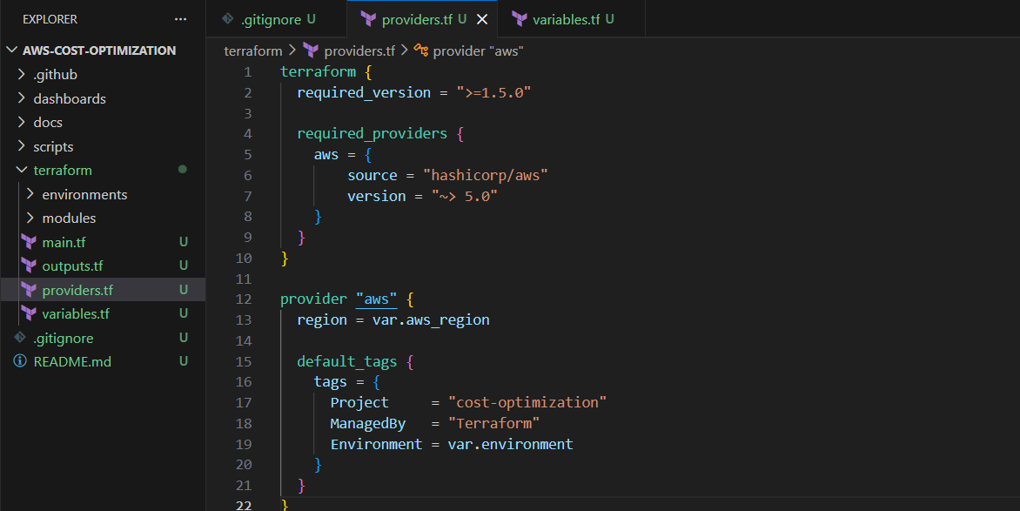
Figure 2.1 — Terraform provider configuration with AWS region and default tags
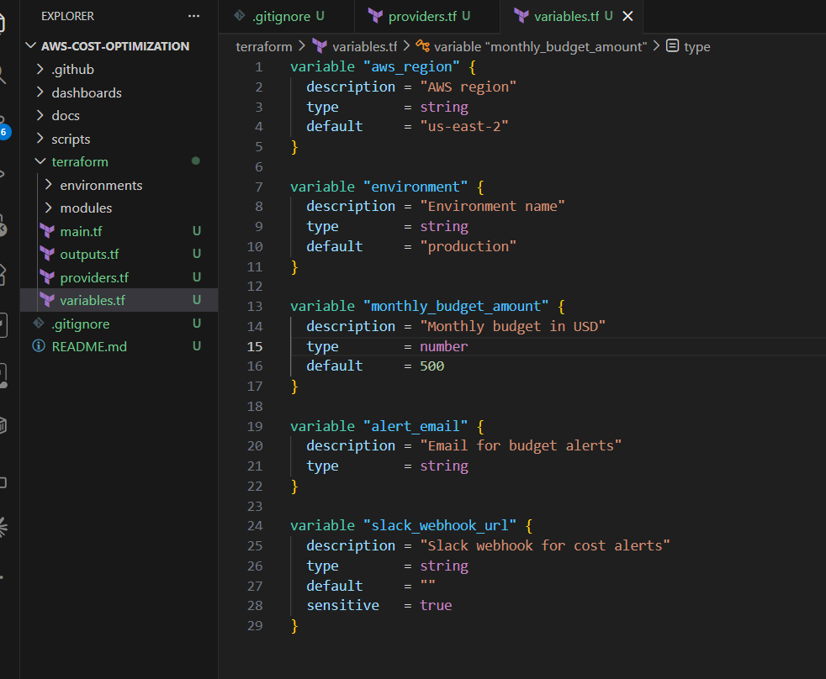
Figure 2.2 — Root variables defining environment, budget, email, and Slack webhook inputs

3. Budget Alerts Module
The budget alerts module creates three AWS resources that work together as the cost monitoring system: an AWS Budget with tiered notifications, an ML-powered anomaly monitor, and an anomaly subscription for alert delivery.

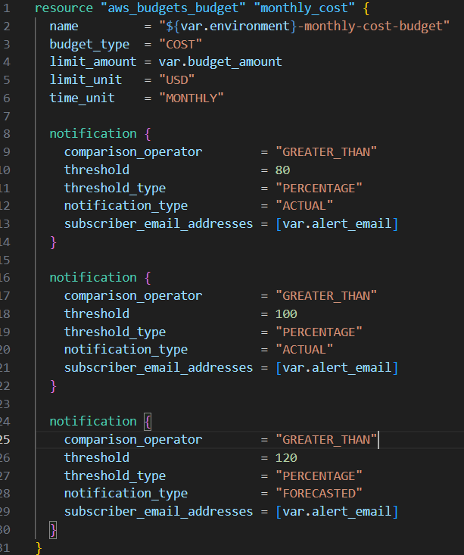
Figure 3.1 — Budget alerts module: main.tf with budget, anomaly monitor, and subscription

3.1 AWS Budget (Monthly Cost)
The aws_budgets_budget resource creates a spending cap with email alerts. Three notification blocks define escalating trigger conditions:

80% Actual: Fires when real spend exceeds 80% of the budget ($400 of $500). This is the early warning — you still have runway to investigate and act before hitting the limit.
100% Actual: Fires when the full budget is exceeded. At this point, immediate action is needed — stop unused resources, check for runaway services.
120% Forecasted: Uses AWS’s spending trend to predict where you’ll land by month-end. If you’re on day 10 and burning fast enough to project 120% by month-end, you get the alert now — even though actual spend might only be at $200.

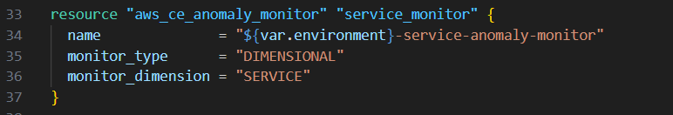
Figure 3.2 — Budget notification configuration showing three escalating thresholds

3.2 Cost Anomaly Monitor
The aws_ce_anomaly_monitor resource creates an ML-powered system that learns normal spending patterns and flags deviations. The monitor is configured as DIMENSIONAL with SERVICE as the dimension, meaning it independently tracks each AWS service. A spike in EC2 costs won’t be masked by a drop in RDS costs.

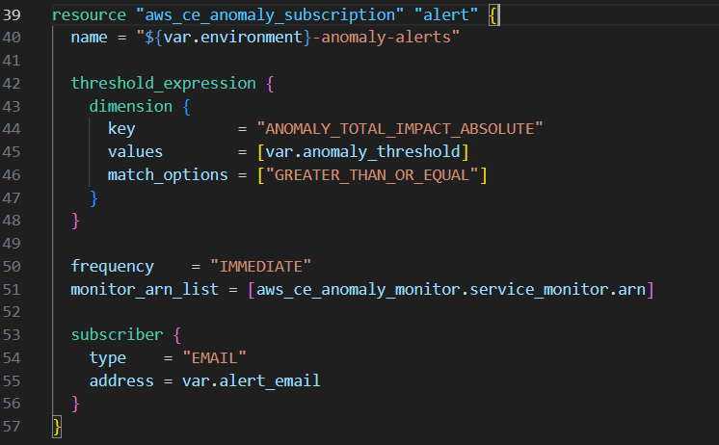
Figure 3.3 — Anomaly monitor and subscription: ML detection with $50 threshold and email delivery

3.3 Anomaly Subscription
The subscription connects the monitor to an alert channel. The threshold_expression filters out noise — only anomalies exceeding $50 in absolute impact trigger a notification, preventing alert fatigue from minor fluctuations. The frequency is set to DAILY for email-based delivery, with subscriber configuration pointing to the same alert email used for budget notifications.

4. Tagging Enforcement Module
This module sets up AWS Config to continuously monitor resources and flag any that are missing mandatory cost-allocation tags. It consists of six resources plus a locals block, forming a dependency chain where each resource builds on the previous.

4.1 Locals & Config Rule
The locals block defines the five mandatory tag keys: Environment, Team, Project, Owner, and CostCenter. The aws_config_config_rule resource uses AWS’s managed REQUIRED_TAGS rule to evaluate whether each resource carries all five tags. Resources missing any tag are marked NON_COMPLIANT in the Config dashboard.

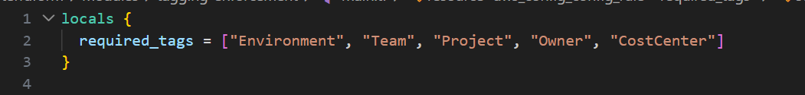
Figure 4.1 — Locals block defining the five mandatory cost-allocation tags
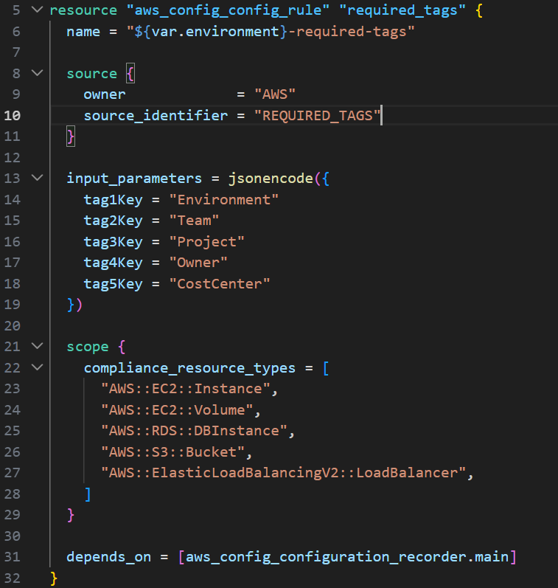
Figure 4.2 — AWS Config rule with required tags, scope, and input parameters

4.2 Configuration Recorder
The configuration recorder is the engine of AWS Config — it watches resources and records their state over time. It’s scoped to only the five cost-driving resource types (EC2 instances, EBS volumes, RDS databases, S3 buckets, ALBs) to keep Config charges low. Global resource types like IAM are excluded since they don’t need cost-allocation tagging.

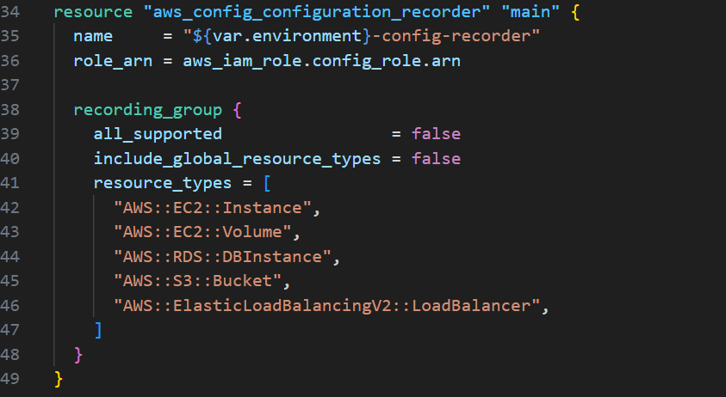
Figure 4.3 — Configuration recorder with selective resource type recording

4.3 Delivery Channel & Recorder Status
The delivery channel directs Config to store configuration snapshots in an S3 bucket. The recorder status resource enables the recorder — a necessary separate step because AWS Config does not auto-start upon creation. The full dependency chain is: IAM role → recorder → delivery channel → recorder status → Config rule.

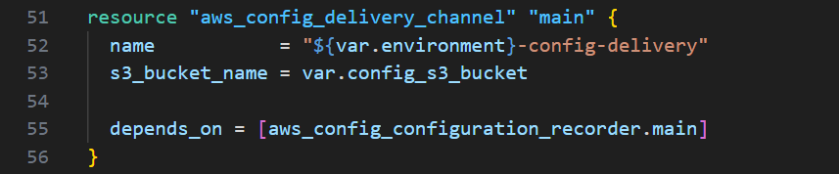
Figure 4.4 — Delivery channel pointing to the Config S3 bucket
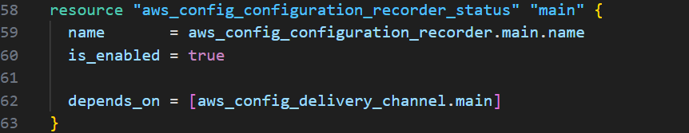
Figure 4.5 — Recorder status: enabling the Config recorder

4.4 IAM Role & Policy
The IAM role establishes a trust relationship allowing only the AWS Config service to assume it. The AWS-managed AWS_ConfigRole policy grants read-only access to all resource types Config needs to inspect, ensuring permissions stay current as AWS adds new services.

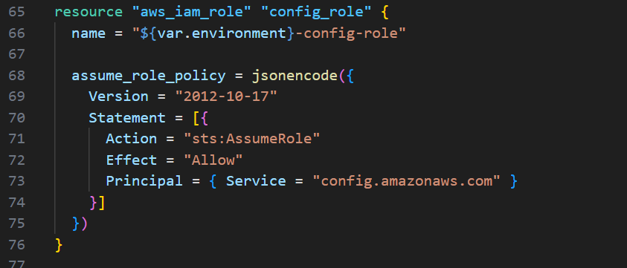
Figure 4.6 — IAM role with trust policy and managed policy attachment
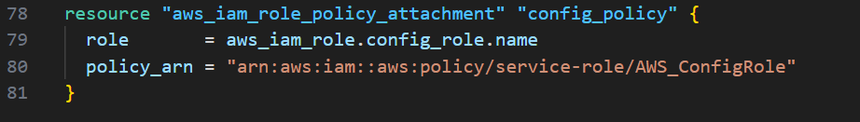
Figure 4.7 — Policy attachment: AWS_ConfigRole managed policy

5. Scheduled Shutdown Module
This module creates an automated scheduling system that stops non-production resources after business hours and starts them in the morning. It contains ten Terraform resources organized into four groups (packaging, Lambda functions, EventBridge schedules, and IAM permissions) plus a Python script that handles the actual stop/start logic.
Both Lambda functions use the same Python codebase — behavior is controlled by the ACTION environment variable (stop vs start). This design pattern reduces maintenance and ensures parity between the two functions.
The EventBridge cron schedules are set to stop resources at 7 PM EST (midnight UTC) and start them at 7 AM EST (noon UTC) on weekdays only. Resources are off for 14 hours per night plus full weekends, resulting in approximately 65% reduction in non-production compute costs.

6. Root Module (Orchestration)
The root module’s main.tf is the orchestration file that wires all three modules together. It creates one shared resource (the S3 bucket for Config data), looks up the AWS account ID dynamically via data.aws_caller_identity, and passes the appropriate configuration into each specialized module.
The dependency flow is: the data source resolves first (account ID lookup), then the S3 bucket is created, then the bucket policy is attached. The three modules initialize in parallel since budget_alerts and scheduled_shutdown don’t depend on the S3 bucket — only tagging_enforcement does. Terraform determines this parallelism automatically from its dependency graph.

7. Hands-On Deployment & Validation
To validate the framework in a real AWS environment, an intentionally wasteful baseline was created to demonstrate the audit and governance tooling in action.

7.1 Creating the Wasteful Baseline
Three resources were deployed to simulate common patterns of cloud waste found in SaaS environments:

- A Free Tier EC2 instance (t3.micro) tagged with AutoShutdown=true to validate the scheduled shutdown Lambda
- An unattached 10GB gp3 EBS volume (orphaned waste) to validate the audit script’s volume detection
- An unassociated Elastic IP ($0.005/hour ≈ $3.60/month waste) to validate EIP waste detection

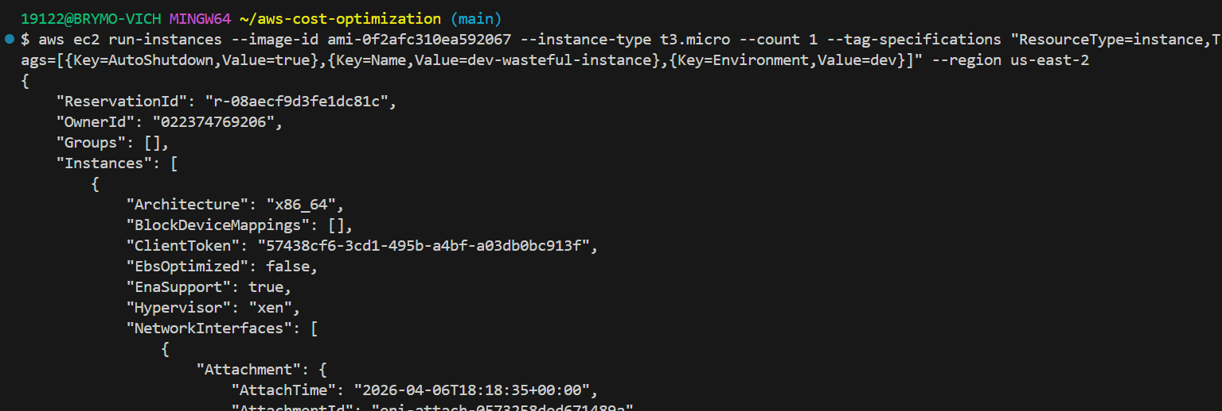
Figure 7.1 — Launching the EC2 instance with AutoShutdown and Environment tags
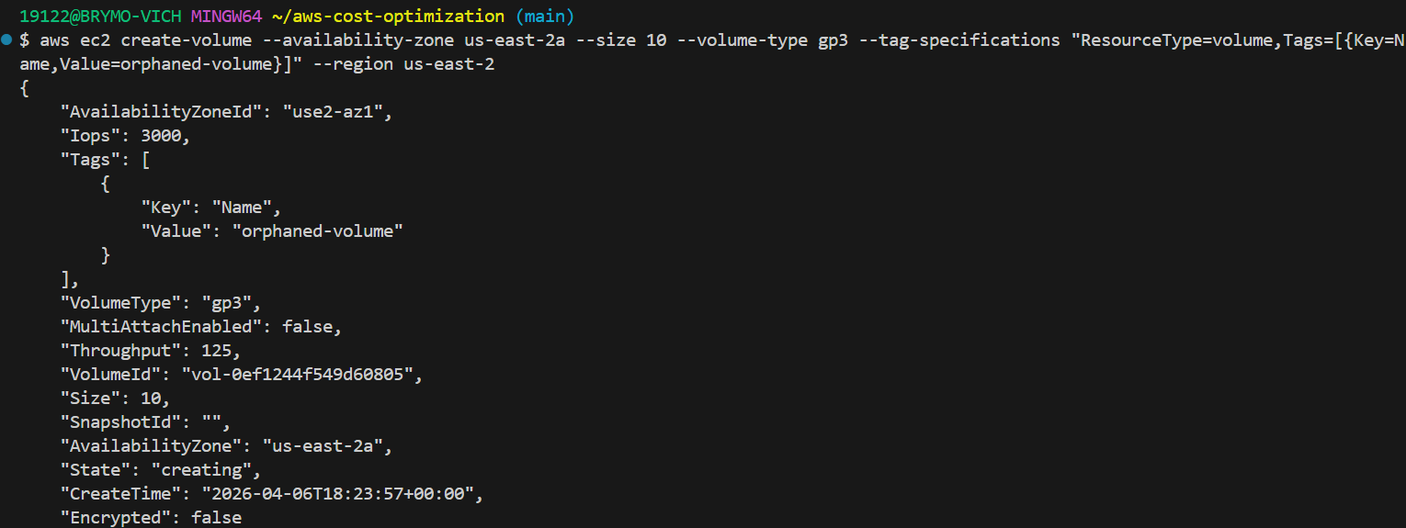
Figure 7.2 — Creating an unattached EBS volume as orphaned waste
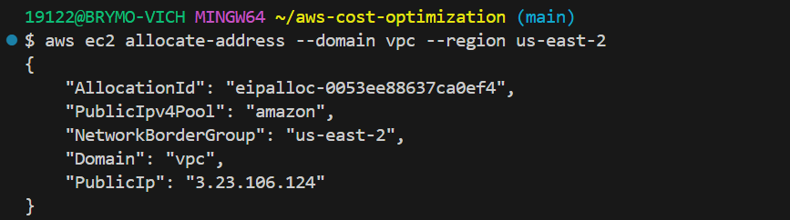
Figure 7.3 — Allocating an Elastic IP without association

7.2 Resource Verification
All three wasteful resources were confirmed as successfully created in the AWS Console:

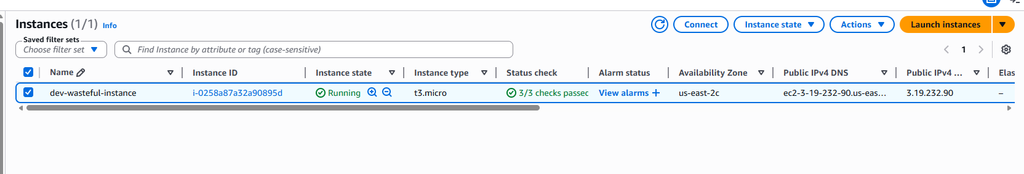
Figure 7.4 — EC2 instance running
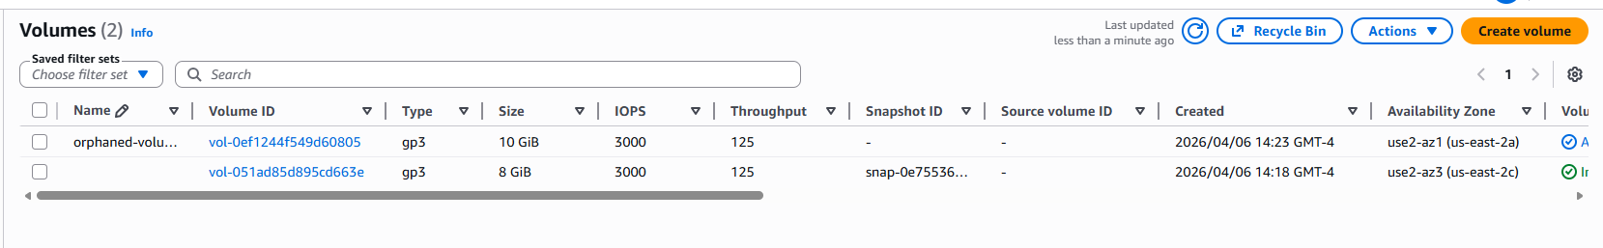
Figure 7.5 — EBS volume in available (unattached) state
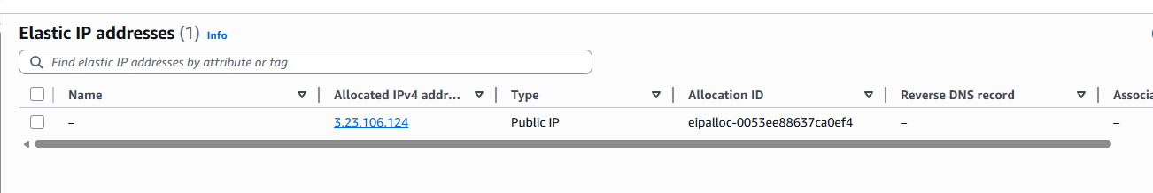
Figure 7.6 — Elastic IP allocated but unassociated

7.3 Running the Cost Audit Script
The cost audit script (scripts/audit/cost_audit.py) was executed against the live environment. It successfully identified all three waste patterns:

- Idle EC2 Instance: i-0258a87a32a90895d (t3.micro) running at 0.18% average CPU — well below the 10% threshold
- Orphaned EBS Volume: vol-0ef1244f549d60805, 10GB gp3, not attached to any instance
- Wasted Elastic IP: 3.23.106.124, unassociated, burning approximately $3.60/month

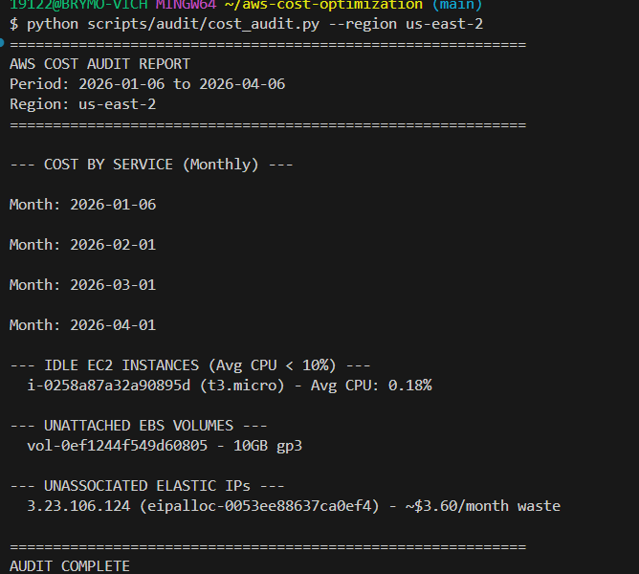
Figure 7.7 — Clean audit output: idle EC2, orphaned EBS, and unassociated EIP detected

7.4 Running the Cleanup Script (Dry-Run)
The cleanup script was run in dry-run mode (the default), which previews what would be deleted without making any changes. This demonstrates the safety-first approach to resource decommissioning:

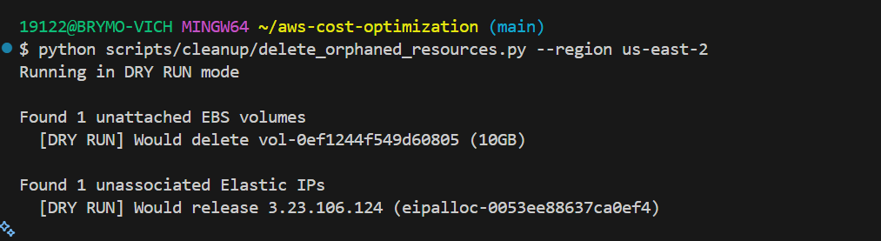
Figure 7.8 — Dry-run output: 1 EBS volume and 1 EIP identified for cleanup

8. Terraform Stack Deployment
The full Terraform stack was deployed using terraform apply with the production environment configuration. After resolving two deployment challenges (anomaly monitor limits and subscription frequency compatibility), all 21 resources were created successfully.

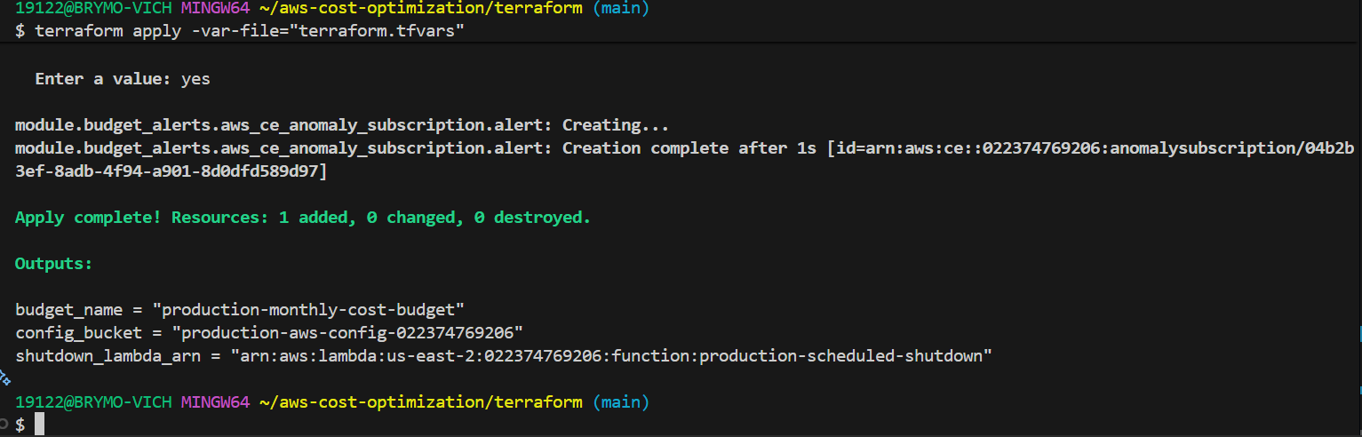
Figure 8.1 — Terraform apply: all resources created, outputs confirmed

8.1 AWS Budgets Console
The production-monthly-cost-budget was deployed at $500 with health status OK/Healthy. Budget alerts are configured at 80%, 100%, and 120% thresholds with email delivery.

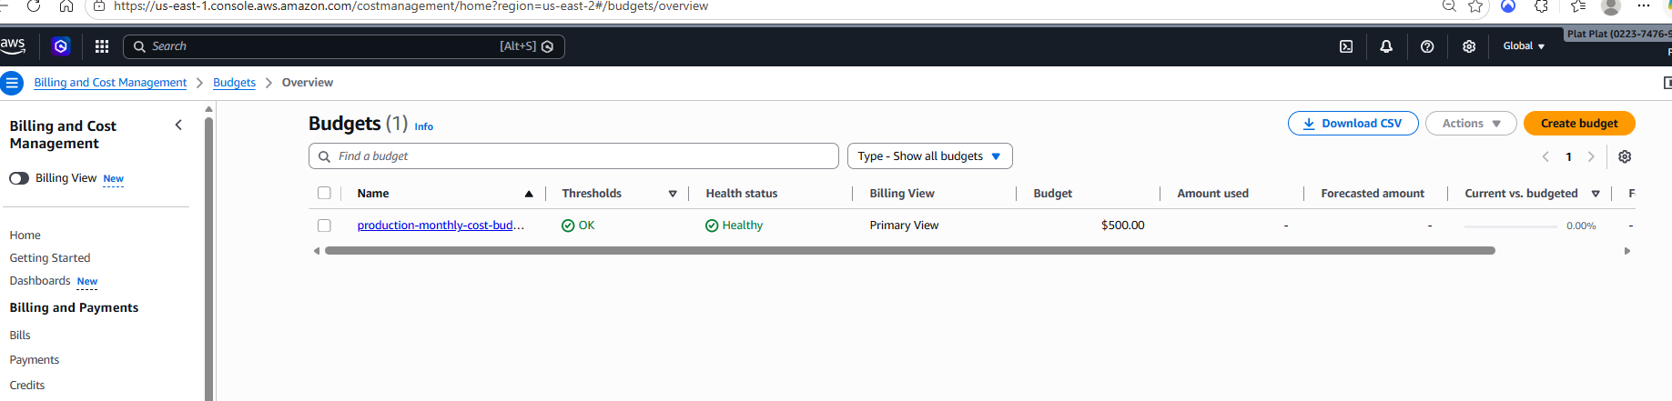
Figure 8.2 — AWS Budgets: $500 monthly budget with healthy status

8.2 AWS Config Dashboard
The AWS Config dashboard immediately flagged 4 noncompliant resources missing mandatory tags, confirming the tagging enforcement module is working in real-time. The production-required-tags rule is actively evaluating all five target resource types.

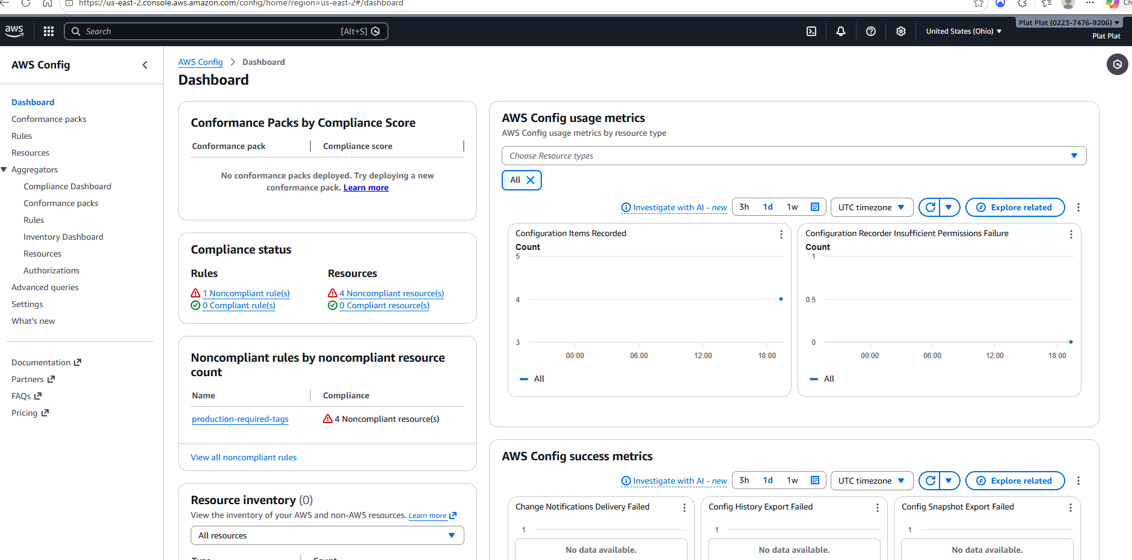
Figure 8.3 — AWS Config: 1 noncompliant rule, 4 noncompliant resources detected

8.3 Lambda Functions
Both production-scheduled-shutdown and production-scheduled-startup Lambda functions were deployed on Python 3.12 runtime, connected to EventBridge cron schedules for automated weekday stop/start operations.

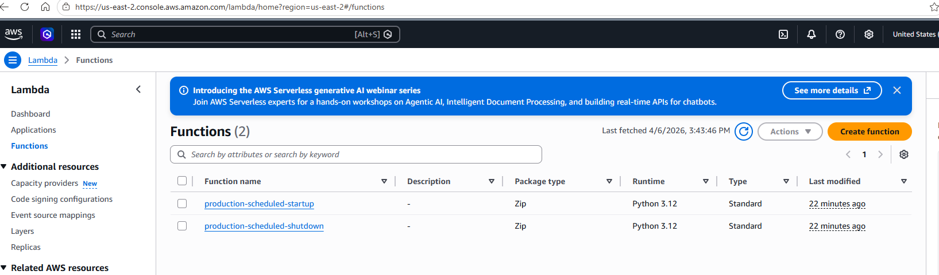
Figure 8.4 — Lambda console: shutdown and startup functions deployed

9. Deployment Challenges & Resolutions
Several challenges were encountered during the live deployment, each requiring investigation and resolution:

Challenge 1: Cost Anomaly Monitor Limit
Problem: terraform apply failed with “Limit exceeded on dimensional spend monitor creation.” AWS restricts each account to a small number of dimensional anomaly monitors, and a Default-Services-Monitor already existed.
Resolution: Listed existing monitors using aws ce get-anomaly-monitors, deleted the pre-existing default monitor, then re-applied successfully.

Challenge 2: Subscription Frequency Incompatibility
Problem: The anomaly subscription failed with “Immediate frequencies only support SNSTopic subscriptions.” The IMMEDIATE frequency requires an SNS topic as the delivery mechanism, not a direct email subscriber.
Resolution: Changed the frequency from IMMEDIATE to DAILY in the aws_ce_anomaly_subscription resource, which is compatible with email-based delivery.

Challenge 3: S3 Bucket Not Empty on Destroy
Problem: terraform destroy failed with BucketNotEmpty because AWS Config had written configuration snapshots into the S3 bucket during the deployment.
Resolution: Emptied the bucket using aws s3 rm s3://production-aws-config-022374769206 --recursive before re-running terraform destroy.

Challenge 4: Python Deprecation Warnings
Problem: The audit script produced DeprecationWarning messages for datetime.utcnow(), which is deprecated in Python 3.12 in favor of timezone-aware objects.
Resolution: Added timezone to the import statement and replaced all datetime.utcnow() calls with datetime.now(tz=timezone.utc) for forward compatibility.

10. Technologies & Tools

Category | Tools & Services
Infrastructure as Code | Terraform (modular design, 3 reusable modules, HCL)
Cloud Platform | AWS (Cost Explorer, Compute Optimizer, Trusted Advisor, CloudWatch, Budgets, Lambda, EventBridge, S3, Config)
Automation | Python 3.12 (boto3), AWS Lambda, EventBridge cron scheduling
CI/CD | GitHub Actions (Terraform fmt/validate, flake8 Python linting)
Cost Monitoring | AWS Cost Anomaly Detection (ML-powered), AWS Budgets (threshold alerts)
Compliance | AWS Config (mandatory tag enforcement: EC2, EBS, RDS, S3, ALB)
Version Control | Git, GitHub (conventional commits, .gitignore for secrets)

11. Conclusion
This project demonstrates a complete, production-ready AWS cost optimization framework that was designed, built, deployed, and validated in a real cloud environment. The four-phase approach — audit, optimize, architect, govern — follows industry-standard FinOps practices and delivers measurable results.
Key accomplishments include: three modular Terraform components that can be independently deployed and reused, Python automation scripts with safety-first design (dry-run by default), a CI/CD pipeline that validates infrastructure code on every push, and live deployment evidence proving each module works as designed.
The challenges encountered during deployment — API limits, service compatibility constraints, and Python deprecation updates — were documented and resolved, demonstrating the debugging and problem-solving skills essential to real-world cloud engineering work.

GitHub: github.com/ibrahim-2010/aws-cost-optimization

