

**Faculty of engineering - Shoubra**

**Benha University**

**Research Article / Research Project / Literature Review**

in fulfillment of the requirements of

|  |  |
| --- | --- |
| **Department** | **Engineering Mathematics and Physics** |
| **Division** | **-----------------** |
| **Academic Year** | **2019-2020 Preparatory** |
| **Course name** | **Computer** |
| **Course code** | **ECE001** |

**Title: -**

**Artificial Intelligence**

By:

|  |  |  |  |
| --- | --- | --- | --- |
|  | Name | Edu mail | B.N |
| 1 | Ibrahim Ali Ibrahim Elsherbiny Hegab | ebrahim195014@feng.bu.edu.eg | 14 |

**Approved by:**

|  |  |
| --- | --- |
| Examiners committee | Signature |
| Dr Ahmed Bayoumi |  |
| Dr Shady Elmashad |  |
| Dr Abdelhamid Attaby |  |

**Table of contents**

|  |  |
| --- | --- |
| **Subject / section** | **Page** |
| **Introduction** | **3** |
| **History Of Artificial Intelligence** | **4** |
| **The Importance Of Artificial Intelligence** | **5** |
| **Capabilities Of Artificial Intelligence** | **6** |
| **Areas Of Artificial Intelligence** | **6** |
| **Benefits Of Artificial Intelligence** | **7** |
| **Applications Of Artificial Intelligence** | **7** |
| **Components Of Artificial Intelligence** | **9** |

**Introduction**

We need something that helps us understand some things quickly, maybe we got them from another side but for a much longer period, so we find that artificial intelligence is what helps us in this thing, from the beginning we need to define intelligence and define what it means in human intelligence. Artificial intelligence is a type of modern science that has spread widely in recent times, so it has entered into many industrial and research fields, led by robots and smart services for governments and companies. The stage of intelligence applies to any situation that seeks to solve complex problems. According to the Oxford dictionary definition, intelligence is the ability to understand, learn and think. From this definition it can be concluded that if you are on the device a kind of intelligence, then we must have created three capabilities in understanding, learning and thinking. Thus, the new way of trying to simulate human intelligence has created an emergency of new science called artificial intelligence. Artificial Intelligence (AI) is an informatics field that emphasizes creating smart machines that work and respond like humans. Many tasks include AI computers designed to include: speech recognition, training, planning, and problem solving. Deep learning allowed for many real-life machine learning applications, thus extending the AI ​​sector as a whole. Deep learning separates activities in ways that make them look all kinds of computer aid possible such as driverless cars, better preventative health care, artificial intelligence is the future and present. Machine learning is the art of studying algorithms in the simplest way to learn from results, learn from them, then make a decision or expect about something What in the world. Therefore, instead of manual codec actions with a specific set of instructions for performing a specific task, the computer is "trained" with large amounts of data and algorithms that give it the ability to learn how to perform the task.

**History of artificial intelligence:** There was talk about the work of the artificial intelligence project in the past, but the first references to artificial intelligence are due to the theory of computing by Alan Turing, who contributed to the development of modern theory and how to develop smart machines. John McCarthy MIT University in addition to Allen Newell, Herbert Simon and Claude Shannon as founding fathers of this field and this area received great attention and support during the fifties and sixties of the last century, but due to some difficulties, support was largely stopped during the seventies known as the Artificial Intelligence Winter but soon This interest did not return at the beginning of the eighties thanks to the emergence of many modern technologies such as the concept of expert systems and the emergence of new technologies in the field of semiconductor manufacturing such as integration at a high level VLSI and from the nineties began to develop in this area until IBM managed to manufacture the Deep Blue computer in 1997 Who managed to defeat the world chess champion at the time and the development continued until Google managed its pioneering program Alpha Go which managed in 2016 to The defeat of the South Korean Lee will be called the world champion in the game of Joe, which requires very complicated analysis and processing capabilities that exceed the possibilities of the game. A thousand Joe is the first application of artificial intelligence in general, the orientation is able to learn to solve problems, whatever their nature.

**Literature Review**

**Artificial intelligence**: it is the field of study that simulates the processes of human intelligence on computer systems.it is one of the branches of computer science, which is that behavior and the characteristics that different computer programs depend on, and is in line with human mental capabilities in various works. Among the most important of these capabilities is the ability of the machine to teach and make the right decisions.

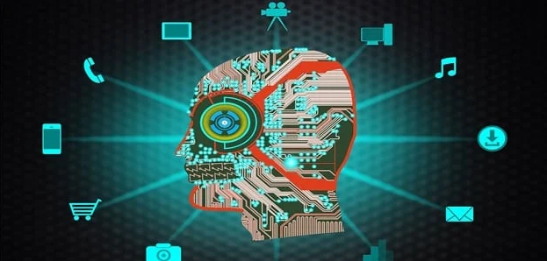 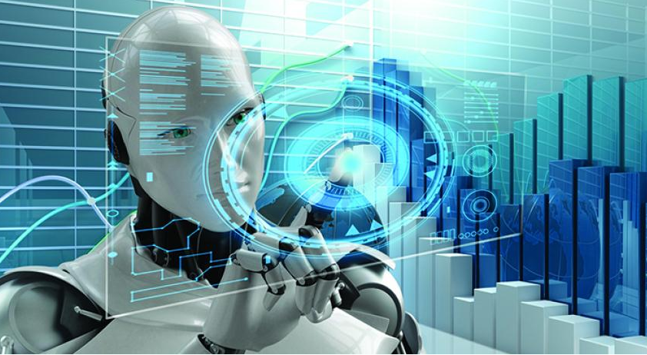

**The importance of artificial intelligence in this world**: There are many advantages that artificial intelligence possesses, and the use of this intelligence on machines and devices makes solving any problem easier, through which the problem can be known and solved using the logical method. Nowadays, the voices can be known and spoken by some. Very useful in learning greatly, it can provide the solutions you want without any human intervention, and this is the biggest achievement at any time. It handles any information anyone can use. It has great ability to understand data and analyze it well. This artificial intelligence finds any solution to any problem that humans cannot solve and know, and it has advanced and modern importance in homes, where there are

many devices in the house that we can control such as lighting, closing doors and many other devices that we control recently from far and also very important in Education, so that it helps the student to know the level he has, and also get any program he requests, and this helps the student a lot and he cannot surrender in light of his education to reach the required success for him, and understand the most difficult things in education, , so we find that these things have evolved in every period To reach unparalleled progress, we cannot now abandon a computer or any device that uses artificial intelligence.

**Artificial intelligence capabilities:** Artificial intelligence acquires information through practical practices, and is able to accurately distinguish between multiple issues. One of the most important capabilities of artificial intelligence is its response to variables, and is characterized by flexibility and speed of reaction in all situations. Artificial intelligence has its ability to perceive, and thus make decisions properly, depending on studying all the possibilities and mastering its results, and then choosing the best decisions that lead to the desired results. Quickly be able to detect and correct errors, and make better improvements in the future. Artificial intelligence began with the development of some different computer programs, chief among them chess games, when the scientist Claude Shannon drew up an algorithm that qualified the computer to play chess and anticipated all the possibilities of the other player's move.

**Artificial intelligence areas:** Artificial intelligence introduces all the technical fields that need logical thinking, knowledge, planning, and virtual perception based on applying theories and choosing the right solutions. In air transport such as the participation of artificial intelligence where the machine is involved in road planning, along with landing and takeoff plans, And also in the banks in the accounting, And one of the most prominent areas in which simulation programs and applications are

distinguished. Industry through robots It is capable of performing the tasks of the human race. Development of computer programs and applications in various fields, including medicine, engineering, trade and investment, among others. Developing cognitive simulation through testing theories, face recognition, memory activation, and other functions. Development of engines with smart capabilities, such as driverless cars and drones.

**Benefits of artificial intelligence:** such in agriculture and medicine we find that artificial intelligence is important on the part of agriculture in knowing the appropriate weather for cultivation, as well as good soil in agriculture, and how we can make good crops and increase production, as we find it important in medicine in terms of knowing the necessary diagnosis for each disease, as well as knowing the appropriate treatment for it, To treat it, we find that there is always a noticeable development, and as for medicine we find that the development has become more than before with the treatment used for the patient, so it is possible to monitor our patients to know the doses they do not take through advanced devices from afar, and also we find in the field of agriculture, there are machines used In agriculture it is more advanced than before, and it cannot delay like previous machines, but we also find it fast and good to handle. And it has a great importance from the recruitment side, so we find that the number of applicants for any job is badly needed, and we also find that the knowledge of the CV needs a computer equipped for this purpose, and we find that it is important for customer service, until we find that in order to communicate with the largest possible number Customer, a computer is required to help with this.

**Applications used by artificial intelligence:** There are important applications used by artificial intelligence, Artificial Creativity, Social Media, Chatbots, Autonomous Vehicles, Space Exploration, Health Care, Finance, Marketing, intelligent robots

which can perform tasks with their own experiences without pre-programmed. and Home security that through the facial recognition algorithm, the AI-powered home creates an index of the individuals who live in it, as well as those known through your social media connections and home visits, which helps it to distinguish between family members, guests and visitors, through this technology there will be a decrease Great in attempts to steal and enter the home, and with these security systems in addition to motion detectors, sensors and security cameras, it will be easy to assess the potential breach and even to request an emergency service, And in Data Security which is crucial for every company and cyber-attacks are growing very rapidly in the digital world. AI can be used to make your data more safe and secure. Some examples such as AEG bot, AI2 Platform, are used to determine software bug and cyber-attacks in a better way. And in games so that we find that their composition and choosing between the right is not easy, so we find that the games here use all the possibilities that enable people with ease knowing what to speak, the computer has the ability to listen to people so that they know what they are talking and want, then they implement it. There is a system of vision also through the use of two-dimensional images. And has many application in other fields.

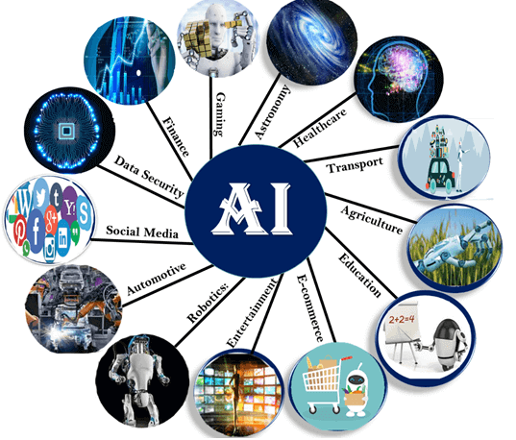

**Fears of using artificial intelligence:** When we use artificial intelligence in many areas around us, we fear at the time not caring about any human race and not needing it in any work, as there is an alternative capable of making everything that the human race does. Fear also of the ability of any device with artificial intelligence to repair itself, that is, it does not need human hands in order to be seen and repaired, and this is one of the most dangerous things, so this intelligence should not negatively affect society, and we find that the lack of development of these devices is in The interest of humans, so that there are no fears that make us feel anxious about it, will do a lot, but it will cause big problems as well. Also, we cannot imagine our life without the use of artificial intelligence, because it is so general in life, so whatever it comes to it, we cannot control many things without it, so we should not make it equal to humans. But it has the importance necessary to help people only, it should not be equal or better, and it should not be completely destroyed so you will not regret it.

**Components of artificial intelligence**: it essentially requires specialized hardware and software to write and train algorithms for machine learning. Not a single programming language is synonymous with AI, but few are common, including Python , R, and Java.**1- It is consists of**: **The data system**, which is how to represent data or a problem in a computer where it can process it and produce the appropriate results. **2-Research**, which is thinking in itself as the computer searches and evaluates the options available to it according to established criteria, or he deduces them and then decides the best solution. **3-Algorithms,** which they are needed to map out how to use this information. **4-A programming language,** that is used to represent both information and algorithms and has features that are appropriate for the nature of artificial intelligence systems such as programming in logic and list of processing.

**References**

**1-Bayesian Artificial Intelligence, Second Edition, Kevin B. Korb, Ann E. Nicholson.**

**2-Artificial Intelligence, Nils J. Nilsson, Stanford University, Morgan Kaufmann, publishers, INC.**

**3-**<https://www.sas.com/en_us/insights/analytics/what-is-artificial-intelligence.html>**.**

**4-**<https://www.thaqfya.com/search-artificial-intelligence-applications/>.

5- <https://www.edureka.co/blog/artificial-intelligence-applications/>

6**-**<https://searchenterpriseai.techtarget.com/definition/AI-Artificial-Intelligence>.

**7-**<https://arabcio.org/%D9%85%D8%AC%D8%A7%D9%84%D8%A7%D8%AA%D8%A7%D9%84%D8%B0%D9%83%D8%A7%D8%A1%D8%A7%D9%84%D8%A7%D8%B5%D8%B7%D9%86%D8%A7%D8%B9%D9%8A%D9%88%D8%A7%D8%B3%D8%AA%D8%AE%D8%AF%D8%A7%D9%85%D8%A7%D8%AA%D9%87/>**.**

**8-** <https://www.britannica.com/technology/artificial-intelligence>**.**

**9-**<https://golden.com/list-of-artificial-intelligence-companies>**.**