Title: Multi-sector impact-based forecasting of cyclone damages across lead times in Bangladesh
Author Names and Affiliations:
Raihanul Haque Khan¹, Asif Uddin Bin Noor¹, MD Ibrahim Abdullah¹, Raisa Binthe Ahmed¹

Abstract: Anticipatory action against tropical cyclones requires reliable impact forecasts to guide pre-landfall resource mobilisation across vulnerable locations. This study develops a multi-sector impact-forecasting framework integrating forecasted hazards (wind gust, rainfall, storm surge), baseline vulnerability (INFORM 2022), and sector-specific exposure (building footprints, Fraction of Absorbed Photosynthetically Active Radiation) into housing and agricultural impact scores across Bangladesh. Pre-landfall predictions at 24-hour, 48-hour, and 72-hour lead times were validated against Department of Disaster Management observed damage records for Cyclones Remal, Midhili, and Sitrang. Results showed housing discrimination was reliable under severe cyclonic forcing but degraded substantially for lower-intensity events, while agricultural predictions provided more consistent separation across all event types. Percentile-based threshold optimization resolved systemic over-forecasting across all events, and Quadratic-Weighted Kappa calibration bounded off-category severity errors below 9 percent. Real-world application during Cyclone Remal demonstrated that calibrated Upazila-level predictions, embedded in a co-designed anticipatory action system, can meaningfully reduce pre-landfall damage incidence.

Keywords: Impact-based forecasting; Impact Forecasting; Tropical cyclones; Anticipatory action; Disaster risk management; Multi-sector impact assessment; Vulnerability; Exposure; Forecasted Hazard.
Introduction: The rapid progression of climate change is intensifying the escalation and frequency of extreme weather phenomena. The previous decade has been defined by a convergence of unprecedented environmental phenomena, including record-breaking ocean temperatures, accelerated sea-level rise, frequent cyclones, catastrophic flooding, unpredictable droughts, and extensive glacial retreat¹. The increasing global frequency and magnitude of these events pose substantial risks to both ecological systems and human societies². This trend, primarily propelled by intensified anthropogenic greenhouse gas emissions, is projected to worsen as global warming persists^{2,3}. This escalation has facilitated the emergence of compound extremes; climate projections suggest a future characterized by increasingly overlapping hazards, which amplify adverse impacts and place significant strain on already scarce socioeconomic resources. For Bangladesh, this paradigm shift is especially urgent, as conventional weather forecasting has historically prioritized broadcasting the ‘state of the weather’ over projecting the specific ‘socioeconomic impact’ associated with these events⁴.
Hydrometeorological hazards, specifically tropical cyclones, represent persistent threats to the safety, livelihoods, and economic stability of vulnerable populations globally. Characterized by high-velocity wind gusts, intense precipitation, and storm surges, these forecasted hazards frequently cause significant human casualties, extensive structural and agricultural damage, and the disruption of critical communication infrastructure⁵. Approximately 90 tropical cyclones occur annually worldwide, with
deleterious impacts disproportionately affecting coastal regions in developing nations, such as Bangladesh⁶. In this context of unprecedented climate instability, disaster risk management assumes a critical role in facilitating evidence-based decision-making and bolstering community resilience. Bangladesh has achieved substantial progress in reducing cyclone-related mortality through targeted investments in forecasting capabilities, early warning systems, cyclone shelters, evacuation protocols, embankment construction, and the mobilization of volunteer networks^{7,8}. Consequently, cyclone-induced fatalities have declined from approximately 500,000 in 1970 to 4,234 during Cyclone Sidr in 2007⁸.
Despite these significant advancements in reducing mortality, recent cyclones continue to cause severe humanitarian and infrastructural consequences. For instance, while Cyclone Amphan resulted in fewer than 30 fatalities, it displaced 2.5 million individuals and damaged over 400,000 hectares of land and residential properties^{9,10}. Subsequent events have further demonstrated this persistent vulnerability: Cyclone Yaas affected approximately 1.3 million people and damaged 26,000 houses across nine coastal districts, including Bhola, Patuakhali, Satkhira, Bagerhat, and Barguna¹¹. Similarly, Cyclone Sitrang resulted in 18 deaths, affected 1.92 million people, and damaged approximately 10,000 houses⁹. Cyclone Mocha necessitated the evacuation of over 750,000 individuals from coastal areas¹². Most recently, Cyclone Remal affected 4.6 million people, causing 16 fatalities, the forced displacement of 807,023 residents, and economic losses exceeding BDT 10,595 million, primarily in the agricultural sector¹³.
Collectively, these historical data highlight that while Bangladesh has achieved notable success in reducing cyclone-related fatalities, disaster risk assessment methodologies must evolve beyond static hazard mapping toward more integrative frameworks that incorporate exposure, vulnerability, and forecasted hazard dynamics. While humanitarian organizations, including the Bangladesh Red Crescent and UN OCHA, have already operationalized Anticipatory Action protocols in the region using predefined trigger-based systems¹⁴, effectively implementing these measures requires stakeholders to possess granular knowledge of when, where, and how a hazard event will manifest. The present framework needs to advance this operational landscape by moving beyond established threshold-based triggers to provide a more spatially explicit layer of impact information, enabling the estimation of cyclone impacts across all upazilas to support targeted disaster response. Impact forecasting (IF) serves as a critical analytical mechanism to facilitate this proactive approach. According to World Meteorological Organization (WMO) guidelines, Impact forecasting (IF) or, to a certain extent, Impact-based forecasting (IBF) is a forecasting approach that moves beyond the basic characterization of an anticipated hazard by estimating its potential consequences for exposed populations, assets, and economic sectors. By integrating forecast hazard information with spatially explicit exposure and vulnerability data, IF enables the prediction of localized impacts on multiple sectors such as infrastructure, agriculture, livestock, livelihoods, and essential services. This supports more precise, area-specific, and anticipatory disaster-response strategies¹⁵.
The global integration of Impact-based Forecasting for diverse hydrometeorological hazards marks a paradigm shift in disaster risk management, moving away from hazard-centric methodologies toward location-specific, impact-oriented frameworks^{16,17}. International studies have demonstrated the application of IBF to tropical cyclones, floods, severe winds, and other hazards by combining forecast information with exposure and vulnerability indicators to estimate impact on housing damage, displacement, infrastructure disruption, and affected populations^{18,19}. Forecast-based financing and anticipatory-action frameworks have further linked predefined forecast thresholds with early interventions, allowing protective measures to be implemented before the full impacts of a hazard occur¹⁴.
In the context of Bangladesh, the adoption of IBF is increasingly critical, as tropical cyclones converge with compounding vulnerability drivers such as high population density, precarious housing, and climate-sensitive livelihoods, which amplify hazard impacts and restrict access to essential services, thereby lowering the adaptive capacity of the community^{20,21}. Scholarly efforts are shifting toward high-resolution spatial assessments that underscore the complex relationships among forecasted hazards, exposure, and vulnerabilities, highlighting the challenges of managing disaster risk in Bangladesh²². Moreover, multidisciplinary modeling, such as the deployment of the Weather Research and Forecasting model to simulate the impact of Cyclone Remal, exemplifies the use of high-resolution numerical weather prediction combined with geospatial risk analytics²³. Additionally, advancements in storm surge and coastal inundation models for the Bengal Delta provide the spatial hazard footprints necessary to identify at-risk settlements, critical infrastructure, agricultural zones, and coastal populations^{24,25}.
Existing studies have also assessed cyclone and coastal-flood vulnerability through geographic information systems, composite indices, hydrodynamic modeling, and multi-criteria analysis^{20,21,26}. These studies demonstrate that similar cyclone conditions may produce substantially different consequences across locations because of variations in housing quality, poverty, livelihood dependence, population characteristics, access to cyclone shelters, infrastructure, and coping capacity^{20,21}. Research on floods and lightning has similarly examined relationships among hazard occurrence, exposure, vulnerability, warning access, and resulting social or economic impact^{27,28,29}. However, these applications generally remain hazard-specific, event-specific, or geographically limited. Consequently, the existing evidence base has primarily focused on isolated components of risk. While real-time, coupled hydrodynamic modeling systems, such as those demonstrated by Uddin Khan et al. during Cyclone Amphan, have significantly enhanced operational hazard forecasting, these efforts typically prioritize meteorological and hydrodynamic parameters²⁵. Parallel research has independently advanced spatial assessments of exposure, susceptibility, and socioeconomic vulnerability^{20,21,26}. Despite these contributions, a critical gap persists in integrating real-time forecast hazard information with upazila-level exposure and vulnerability indicators within a nationally consistent operational framework that can estimate event- and sector-specific impacts. Furthermore, while existing studies provide valuable static assessments^{20,21,26}, they lack the capacity to project the consequences of specific forecast events, which is a challenge compounded by inherent meteorological uncertainty, thereby limiting their utility for real-time decision-making regarding priority assistance.
To address this gap, the present study proposes a standardized, spatially explicit methodology to estimate cyclone impacts across all upazilas of Bangladesh. The framework build upon the INFORM Risk Index and integrates forecast hazard intensity and spatial extent with upazila-level exposure and vulnerability information to calculate comparative impact. Exposure data are disaggregated by relevant sectors, such as agriculture and households, allowing the potential consequences of a cyclone to be assessed separately for different sectors. The principal contribution of the methodology is its ability to translate cyclone forecasts into location-specific and sector-specific impact estimates within a nationally consistent framework. Although the methodological structure may also be adapted to other hazards, its primary application is cyclone impact forecasting. By identifying the upazilas and sectors most likely to experience severe impact, the proposed approach can support impact-based warnings, anticipatory action, resource prioritization, and targeted emergency response in Bangladesh.

Results
To evaluate the predictive skill and temporal stability of the impact-forecasting framework, pre-landfall forecast scores for three selected cyclones (Cyclone Remal, Midhili and Sitrang) were validated against ground-damage data collected by the Department of Disaster Management (DDM). The validation evaluated three distinct forecast lead times targeting landfall on 26 May 2024, 17 November 2023, and 24 October 2022. For all three cyclones, forecasts issued at 00:00 UTC with 72-hour, 48-hour, and 24-hour lead times were considered. All evaluations were performed on log-transformed (log(X+1)) datasets across Sub-National administrative units to assess various statistical analyses.
Preliminary Verification using Mann–Whitney U Test
To verify the presence of a valid predictive signal prior to continuous modelling, a non-parametric, one-sided Mann-Whitney U test assessed group separation between damaged (DDM > 0) and undamaged (DDM = 0) Upazilas across all three lead times (Tables S1a, S2a, S3a). Because the test partitions on the presence or absence of reported loss, physical count and monetary expenditure variables that share an identical damage partition yield identical statistics and are reported jointly per typology. Where a building category recorded no positive damage observations for a given event, the test was undefined and is reported as not evaluable rather than as a null result.
Initial testing on Cyclone Remal demonstrated statistically significant group separation between damaged and undamaged locations across the dominant structural typologies and their associated monetary repair metrics at all three forecast lead times (p < 0.05), with affected Upazilas consistently recording higher median forecast scores than unaffected ones. Disaggregation by building typology showed that separation scaled inversely with structural resilience: kacha and half brick-built structures maintained consistent, significant separation throughout (p < 0.001), while brick-built dwellings followed a more nuanced lead-time profile. Separation for this typology was absent at 24 h (p = 0.167), when recorded damage was limited to fewer than one in ten evaluated Upazilas; became significant at 48 h (p = 0.028) as the forecast field narrowed toward the landfall zone; and fell away again at 72 h (p = 0.310). This same pattern, initial absence, 48-h peak, and subsequent loss of significance, was shared by partially damaged cropland, and points to 48 h as the horizon at which detectable group separation was most comprehensive across both structural and agricultural categories for this event. In the agricultural sector, total damaged cropland and fully damaged cropland maintained significant separation over unaffected Upazilas at all three lead times (p < 0.05), while partially damaged cropland held significance only at 48 h. Full statistics are provided in Tables S1a, Table S2a, and Table S3a.
Preliminary verification for Cyclones Midhili and Sitrang revealed strong sector-specific contrasts. For Midhili, no brick-built dwelling damage was recorded and that typology is not evaluable; structural housing predictions failed to achieve significant group separation across all remaining evaluable typologies at any lead time (p >= 0.08). For Sitrang, housing predictions not only failed to achieve significance at any lead time but exhibited a consistent directional inversion across all four typologies (p > 0.48 throughout), with damaged Upazilas recording median forecast scores at or below those of undamaged ones. The inversion held across all three independent forecast horizons and across all typologies in a pattern that scaled with structural class, pointing to a systematic spatial mismatch between the predicted housing impact field and the recorded distribution of damage for this event rather than to sampling variability at a single lead time.
In contrast, the agricultural sector maintained significant group separation for headline cropland indicators at shorter lead times for both events. For Midhili, partially damaged cropland showed the strongest agricultural separation of the three events, remaining significant at all three lead times (p < 0.0001 at 24 h and 48 h; p = 0.017 at 72 h), while total damaged cropland held significance at 24 h and 48 h before falling below the threshold at 72 h (p = 0.059). Unlike Remal, agricultural separation for Midhili was strongest at 24 h and weakened steadily thereafter, with no 48-h advantage, which reflects the faster translation and lower intensity of this system. Fully damaged cropland showed a weak directional inversion across all Midhili lead times, consistent with the rarity of total crop loss under moderate forcing and with the broad-scale vegetation exposure signal that the fAPAR indicator captures. For Sitrang, partially damaged cropland and total damaged cropland both separated significantly at 24 h (p = 0.006 and p = 0.012, respectively); partial cropland extended this to 48 h (p = 0.021), but all agricultural categories lost significance by 72 h.
Across the three events, partially damaged cropland proved to be the most consistently separating agricultural indicator, reaching significance across more cyclones and lead times than any other category. The total-damaged-cropland aggregate provided comparable operational reliability and is the more robust single indicator given its stability across event intensities. Fully damaged cropland performed well only under the severe, sustained forcing of Remal and should be interpreted with caution in lower-intensity contexts.
Threshold-Independent Detection Skill: Receiver Operating Characteristic (ROC) and Area Under the Curve (AUC)
Receiver Operating Characteristic (ROC) curves and Area Under the Curve (AUC) statistics evaluated the intrinsic discrimination skill of raw forecast impact signals independently of any specific decision threshold cutoff across all pre-landfall horizons (Figure S1-S3).
Cross-event comparison revealed clear sector-specific discrimination patterns between structural housing and agricultural cropland exposure. Structural housing forecasts demonstrated good to excellent discrimination for Cyclone Remal, with AUC values of 0.827 at 24h and and 0.813 at 48h lead times, declining to 0.742 at 72h. The ROC curves for this event rose steeply toward the upper-left corner at shorter lead times, indicating a high rate of true positive detection with comparatively few false alarms, consistent with the strong group separation identified in the preliminary verification. Pre-landfall housing discrimination for Cyclone Midhili sat notably lower, ranging from 0.531 to 0.582 across the three horizons, with the 24h forecast achieving marginally higher skill (AUC = 0.580) than the 48h forecast (AUC = 0.582) and the 72h forecast producing the weakest result (AUC = 0.531). For Cyclone Sitrang, housing AUC values remained at or below the no-skill baseline throughout all three lead times (0.495 to 0.503), consistent with the directional inversion identified in the Mann-Whitney screening and confirming that the housing impact field for this event carried no usable discrimination signal prior to landfall. Across the two weaker events, signal dilution from localised building resilience and the complex track characteristics of both storms limited the structural forecast's ability to separate affected from unaffected Upazilas, reinforcing the need for post-forecast percentile calibration to define operationally meaningful impact boundaries.
Agricultural exposure signals derived from fAPAR vegetation stress demonstrated more consistent discrimination across all three events. For Cyclone Midhili, agricultural forecasts achieved good discrimination skill at 24h (AUC = 0.730) and 48h (AUC = 0.725) before attenuating at 72h (AUC = 0.603), reflecting the faster decay of agricultural detection identified in the preliminary screening. For Cyclone Remal, agricultural AUC values ranged from 0.649 at 24h to 0.683 at 48h and 0.634 at 72h, placing all three horizons in the fair-to-moderate discrimination range. Cyclone Sitrang produced the weakest agricultural discrimination of the three events, with AUC values of 0.617, 0.582, and 0.519 at 24h, 48h, and 72h respectively, each progressively approaching the no-skill line. Across all events, agricultural AUC values showed a general tendency to attenuate with increasing lead time, consistent with the growing forecast uncertainty at longer horizons. The fAPAR-based signal nonetheless provided meaningful separation between affected and unaffected cropland areas in the two more impactful events at shorter lead times, supporting its continued use as a standardised pre-landfall agricultural exposure indicator, while the Sitrang results point to the limits of that signal under lower-intensity, geographically diffuse conditions.
Statistical Validation and Regression Analysis
Continuous regression and rank correlation analyses were performed on log-transformed datasets across complete positive pairs containing both non-zero forecast scores (X > 0) and non-zero ground observations (Y > 0), characterising the gradation of severity among affected Upazilas rather than the ability to separate affected from unaffected areas, which the categorical verification assesses separately.
Continuous predictions for Cyclone Remal exhibited statistically significant predictive skill across both built-environment and agricultural indicators (Table S1b). For the housing sector, forecast skill was weakest at 24h (total damaged houses: r = 0.392, R² = 0.154, rho = 0.382), peaked at 48h (r = 0.498, R² = 0.248, rho = 0.429), and attenuated at 72h (r = 0.340, R² = 0.116, rho = 0.256), consistent with the 48h optimum identified in the group-separation screening. Typology disaggregation confirmed that less resilient kacha and semi-pucca structures drove the housing signal at all three horizons, while brick-built dwellings returned weak, non-significant associations throughout (p > 0.36). In the agricultural sector, predictions for Remal maintained strong and stable continuous skill across all three lead times, with total damaged cropland area recording r values of 0.511, 0.567, and 0.568 at 24h, 48h, and 72h respectively. The near-identical performance at 48h and 72h indicates that agricultural severity gradation was reliably captured well before landfall and remained robust as the forecast horizon extended, in contrast to the group-separation results where agricultural AUC declined at 72h.
Continuous housing predictions for Cyclone Midhili showed no significant skill across any lead time or typology (p > 0.15 throughout; Table S2b), consistent with the absence of group separation for this event. Agricultural forecasts for Midhili told a more favourable story: physical cropland damage achieved significant explanatory power and rank monotonicity at all three lead times for total damaged cropland area (r = 0.565 at 24h, 0.411 at 48h, 0.446 at 72h), with the 24h forecast producing the strongest continuous signal of the three horizons. Monetary agricultural loss predictions were significant at 24h (r = 0.322) but weaker than the corresponding land-area metric, reflecting greater variability in reported financial loss relative to physical extent.
Forecast performance for Cyclone Sitrang was more limited overall (Table S3b). Housing forecasts produced near-zero or slightly negative continuous associations at all lead times across all typologies, with no significant skill detected (p > 0.11 throughout). Agricultural indicators for Sitrang achieved modest but significant predictive skill at 24h and 48h for both total damaged cropland area (r = 0.208 at 24h, r = 0.232 at 48h) and total agricultural monetary loss (r = 0.216 at 24h, r = 0.244 at 48h), before losing significance at 72h (p > 0.35). The continuous skill for Sitrang, while statistically present at the shorter lead times, was markedly lower than for the other two events, reflecting the more diffuse spatial distribution of cropland damage associated with this storm's wider but less intense impact footprint.
Exploratory Ordinal Discretization and No-Impact Threshold Optimization
Evaluating normalized forecast impact scores using static, equal-interval cutoffs (No Impact: <= 0.15, Low: 0.15-0.30, Moderate: 0.30-0.70, High: > 0.70) revealed a critical methodological limitation: uncalibrated boundaries assigned non-zero ground damage to the No Impact class, creating boundary ambiguity and classifying damaged Upazilas as unaffected false negatives. To resolve boundary overlap, candidate No-Impact decision thresholds were evaluated across percentiles P5 through P50 using a custom objective function balancing event detection skill against false alarms and frequency bias (Decision Score = CSI - FAR - |Bias - 1|). Threshold optimization across all evaluated forecast lead times for Cyclone Remal, Cyclone Midhili, and Cyclone Sitrang demonstrated high operational stability, successfully eliminating false-negative overlap and correcting baseline model over-prediction across events (Tables 1-3).
Applying threshold optimization to Cyclone Remal consistently selected the 15th percentile as the optimal cutoff for housing across all forecast lead times (P15 = 0.0326 to 0.0608) (Figure 1, Table 1). This threshold normalized Frequency Bias from an uncalibrated 1.181 to an exact unity value of 1.000, maintaining Critical Success Index values of 0.684 to 0.832 and establishing a forecasted No-Impact coverage rate that matched ground-observed non-impact conditions. For agricultural exposure during Remal, optimization selected the 30th percentile across all three lead times (P30 = 0.1039 to 0.2194), bringing uncalibrated Frequency Bias (1.393) down to a consistent 0.991 and aligning No-Impact coverage with ground truth (29%).
A similar percentile calibration across lead times resolved baseline over-prediction during Cyclone Midhili (Figure 2, Table 2). Housing threshold optimization consistently converged at the 40th percentile across all forecast lead times (P40 = 0.0977 to 0.1874), correcting uncalibrated Frequency Bias from 1.698 toward near-unity and matching the forecasted No-Impact rate (40%) with ground-observed non-impact conditions (41%). Agricultural threshold optimization selected the 30th percentile at 24h (P30 = 0.2700) and the 25th percentile at 48h and 72h (P25 = 0.1598 and 0.1977), adjusting Frequency Bias to near-unity (1.028 across all calibrated agricultural horizons) and aligning forecasted No-Impact coverage with ground observations (26% to 31%).
In the case of Cyclone Sitrang, percentile calibration across all three forecast lead times effectively normalized both sector calculations against ground observations (Figure 3, Table 3). Housing threshold optimization converged at the 20th percentile at 24h (P20 = 0.0766), the 25th percentile at 48h (P25 = 0.0580), and the 15th percentile at 72h (P15 = 0.0570), reducing Frequency Bias from an uncalibrated 1.254 toward near-unity (1.000 to 1.176) and maintaining CSI values of 0.642 to 0.684 across lead times. The variation in optimal percentile across lead times reflects the more spatially inconsistent housing impact field identified for this event in the preliminary verification. Agricultural threshold optimization selected the 30th percentile at 24h (P30 = 0.2324) and the 25th percentile at 48h and 72h (P25 = 0.1763 and 0.1765), reducing uncalibrated Frequency Bias from 1.396 down to 0.977 to 1.028 and aligning the forecasted No-Impact coverage rate with observed ground conditions (29%).
Across all three cyclone events and all evaluated lead times, percentile-based threshold optimization successfully reallocated misclassified Upazilas out of the No Impact class into the Low impact tier, removing false negatives and establishing standardized baseline boundaries for multi-tier damage assessment.
Table 1. Categorical Verification, Decision Threshold Optimization, and Verification Metrics for Cyclone Remal (24h, 48h, 72h Lead Times)
Parameter | Housing  Uncal. | Housing  24h | Housing  48h | Housing  72h | Agri  Uncal. | Agri  24h | Agri  48h | Agri  72h
Cutoff Value | X > 0 | P15=0.0326 | P15=0.0497 | P15=0.0608 | X > 0 | P30=0.1039 | P30=0.1487 | P30=0.2194
Optimal Cutoff | X > 0 | P15 | P15 | P15 | X > 0 | P30 | P30 | P30
Threshold Value | -- | 0.0326 | 0.0497 | 0.0608 | -- | 0.1039 | 0.1487 | 0.2194
Hits (H) | 105 | 96 | 95 | 93 | 88 | 63 | 63 | 66
False Alarms (FA) | 19 | 10 | 11 | 13 | 36 | 24 | 24 | 27
Misses (M) | 0 | 9 | 10 | 12 | 1 | 26 | 26 | 23
True Negatives (TN) | 1 | 10 | 9 | 7 | 0 | 12 | 12 | 9
POD | 1 | 0.908 | 0.907 | 0.893 | 0.989 | 0.752 | 0.752 | 0.725
FAR | 0.153 | 0.095 | 0.107 | 0.133 | 0.29 | 0.241 | 0.241 | 0.24
CSI | 0.847 | 0.832 | 0.807 | 0.684 | 0.704 | 0.607 | 0.607 | 0.57
Frequency Bias | 1.181 | 1 | 1 | 1 | 1.393 | 0.991 | 0.991 | 0.991
Overall Accuracy (%) | 84.8 | 84.8 | 83.2 | 80 | 70.4 | 60 | 60 | 60
Peak Decision Score | -- | 0.741 | 0.7 | 0.68 | -- | 0.357 | 0.357 | 0.295
Table 2. Categorical Verification, Decision Threshold Optimization, and Verification Metrics for Cyclone Midhili (24h, 48h, 72h Lead Times)
Parameter | Housing  Uncal. | Housing  24h | Housing  48h | Housing  72h | Agri  Uncal. | Agri  24h | Agri  48h | Agri  72h
Cutoff Value | X > 0 | P40=0.1874 | P40=0.0977 | P40=0.1225 | X > 0 | P30=0.2700 | P25=0.1598 | P25=0.1977
Optimal Cutoff | X > 0 | P40 | P40 | P40 | X > 0 | P30 | P25 | P25
Threshold Value | -- | 0.1874 | 0.0977 | 0.1225 | -- | 0.2700 | 0.1598 | 0.1977
Hits (H) | 53 | 34 | 34 | 32 | 65 | 54 | 51 | 49
False Alarms (FA) | 37 | 20 | 20 | 22 | 25 | 9 | 12 | 18
Misses (M) | 0 | 19 | 19 | 21 | 0 | 11 | 14 | 16
True Negatives (TN) | 0 | 17 | 17 | 15 | 0 | 16 | 13 | 7
POD | 1 | 0.536 | 0.638 | 0.017 | 1 | 0.831 | 0.831 | 0.793
FAR | 0.411 | 0.318 | 0.373 | 0.012 | 0.278 | 0.132 | 0.192 | 0.24
CSI | 0.589 | 0.5 | 0.603 | 0.603 | 0.722 | 0.738 | 0.691 | 0.6
Frequency Bias | 1.698 | 1.176 | 1.017 | 1.017 | 1.385 | 1.028 | 1.028 | 1.028
Overall Accuracy (%) | 58.9 | 56.7 | 56.7 | 52.2 | 72.2 | 77.8 | 71.1 | 62.2
Peak Decision Score | -- | 0.144 | 0.072 | 0.003 | -- | 0.563 | 0.474 | 0.312
Table 3. Categorical Verification, Decision Threshold Optimization, and Verification Metrics for Cyclone Sitrang (24h, 48h, 72h Lead Times)
Parameter | Housing  Uncal. | Housing  24h | Housing  48h | Housing  72h | Agri  Uncal. | Agri  24h | Agri  48h | Agri  72h
Cutoff Value | X > 0 | P20=0.0766 | P25=0.0580 | P15=0.0570 | X > 0 | P30=0.2324 | P25=0.1763 | P25=0.1765
Optimal Cutoff | X > 0 | P20 | P25 | P15 | X > 0 | P30 | P25 | P25
Threshold Value | -- | 0.0766 | 0.0580 | 0.0570 | -- | 0.2324 | 0.1763 | 0.1765
Hits (H) | 117 | 92 | 91 | 92 | 105 | 76 | 73 | 78
False Alarms (FA) | 31 | 27 | 28 | 27 | 43 | 28 | 31 | 33
Misses (M) | 1 | 26 | 27 | 26 | 1 | 30 | 33 | 28
True Negatives (TN) | 0 | 4 | 3 | 4 | 0 | 15 | 12 | 10
POD | 0.991 | 0.78 | 0.831 | 0.893 | 0.991 | 0.717 | 0.831 | 0.715
FAR | 0.21 | 0.218 | 0.373 | 0.133 | 0.291 | 0.269 | 0.192 | 0.24
CSI | 0.785 | 0.642 | 0.673 | 0.684 | 0.705 | 0.567 | 0.691 | 0.568
Frequency Bias | 1.254 | 1.176 | 1.005 | 1 | 1.396 | 0.977 | 1.028 | 1.028
Overall Accuracy (%) | 78.5 | 64.4 | 63.1 | 64.4 | 70.5 | 61.1 | 57 | 59.1
Peak Decision Score | -- | 0.479 | 0.389 | 0.408 | -- | 0.275 | 0.474 | 0.233

Figure 1. No-Impact Threshold Optimization for Cyclone Remal Across Pre-Landfall Forecast Lead Times (24h, 48h, and 72h). Multi-panel trade-off analysis evaluating optimal percentile cutoffs for defining the "No Impact" threshold across agricultural land damage (left column: a, c, e) and housing damage (right column: b, d, f) at 24-hour (a, b), 48-hour (c, d), and 72-hour (e, f) lead times prior to landfall.
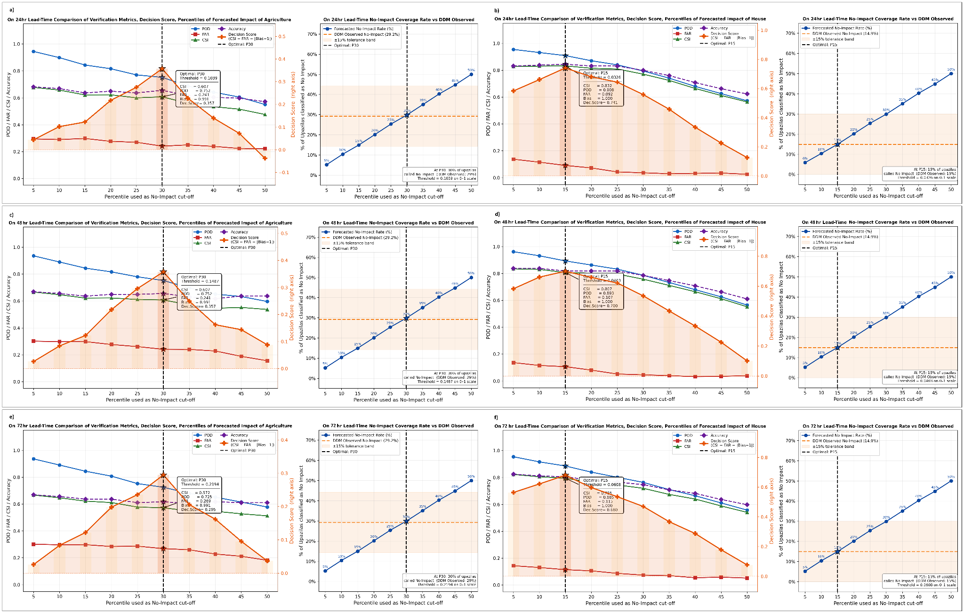
Figure 2. No-Impact Threshold Optimization for Cyclone Midhili Across Pre-Landfall Forecast Lead Times (24h, 48h, and 72h). Multi-panel trade-off analysis evaluating optimal percentile cutoffs for defining the "No Impact" threshold across agricultural land damage (left column: a, c, e) and housing damage (right column: b, d, f) at 24-hour (a, b), 48-hour (c, d), and 72-hour (e, f) lead times prior to landfall.
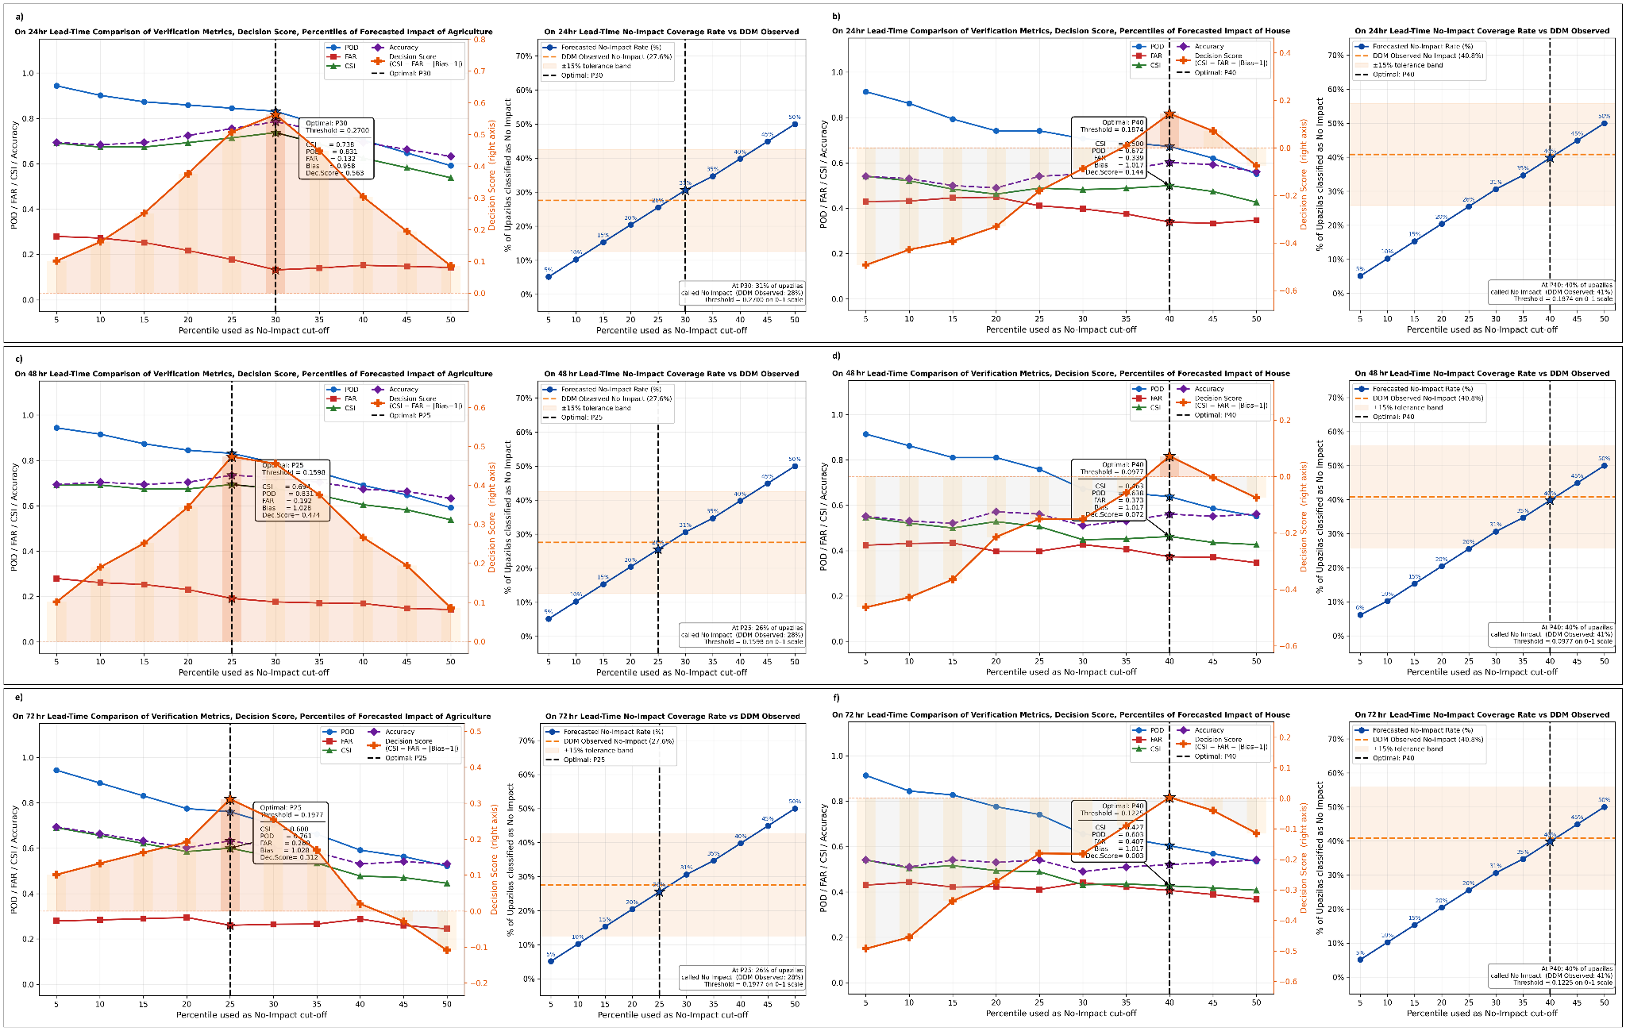
Figure 3. No-Impact Threshold Optimization for Cyclone Sitrang Across Pre-Landfall Forecast Lead Times (24h, 48h, and 72h). Multi-panel trade-off analysis evaluating optimal percentile cutoffs for defining the "No Impact" threshold across agricultural land damage (left column: a, c, e) and housing damage (right column: b, d, f) at 24-hour (a, b), 48-hour (c, d), and 72-hour (e, f) lead times prior to landfall.
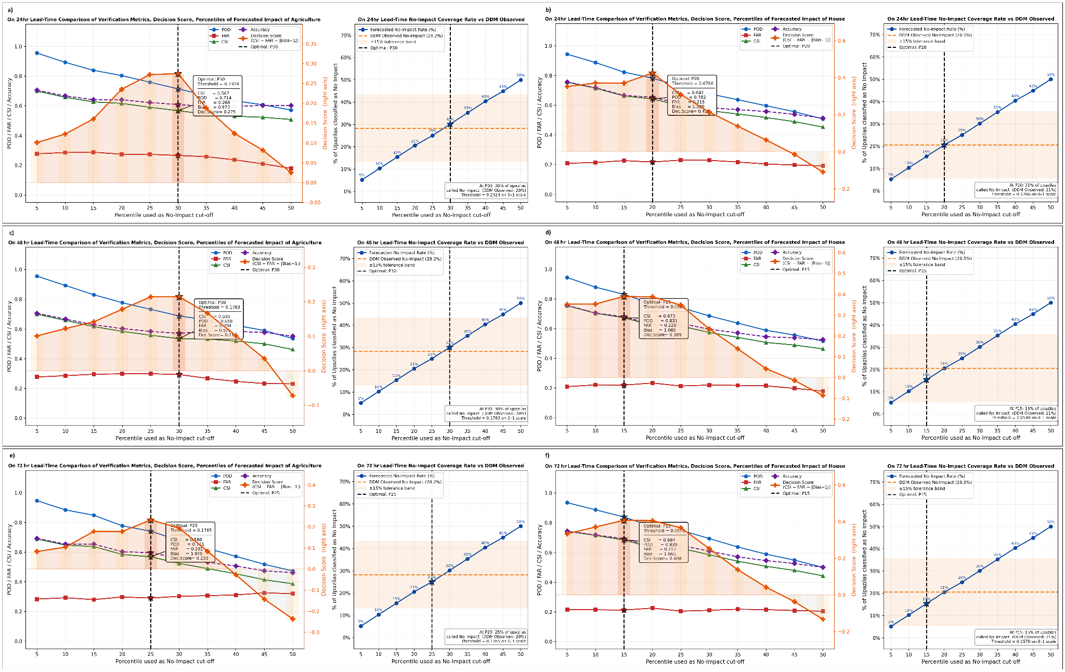
Spatial Distribution of Forecasted Hazards and Synthesized Multi-Sector Impacts
To evaluate the geographic translation of physical hazard intensity into localised sector damage, normalised impact scores were generated by combining forecasted hazard layers comprising wind gust and rainfall with spatial exposure and vulnerability matrices. Storm surge was incorporated into the impact computation where applicable but is not displayed as a standalone spatial layer in the figures that follow. Because storm surge inundation is inherently confined to low-lying coastal Upazilas and its spatial extent is heavily dependent on the precise landfall track, showing a country-wide surge map would misrepresent its geographic scope; the surge contribution is instead embedded within the composite impact score and is most evident in the coastal clustering of high-impact values visible in the housing and agricultural panels. Individual wind gust and rainfall hazard layers were therefore mapped alongside normalised composite impact distributions (ranging from 0.0 for minimum impact to 1.0 for maximum severe impact) across 72-hour, 48-hour, and 24-hour pre-landfall forecast lead times for both housing and agricultural cropland at the Upazila administrative level.
The spatial hazard field for Cyclone Remal reflected a powerful cyclonic storm advancing northward across the central Bay of Bengal (Figure 4). At the 72-hour and 48-hour lead times, forecasted coastal wind gusts predominantly fell in the 120–150 km/h range, peaking at 125.2 km/h and 135.1 km/h, respectively. Only as the system approached landfall at the 24-hour lead time did peak forecast gusts exceed 150 km/h, reaching up to 161.0 km/h across localized southwestern coastal upazilas, with surrounding coastal areas experiencing widespread 120–150 km/h winds (Figure 4). The high-intensity wind gust remained spatially consistent across all horizons, with the landfall corridor becoming more tightly defined by 24 hours as synoptic track uncertainty resolved. Rainfall was very heavy across a broad north-south corridor from the southern coast through central Bangladesh, with the heaviest accumulations concentrated along the landfall axis at all lead times. Integrating these forcing layers with exposure and vulnerability data produced high composite impact scores across southwestern and south-central coastal Upazilas for both sectors. For the housing sector, impact values above 0.60 formed a spatially continuous cluster along the southwestern coastal belt at 72 hours, with this cluster sharpening and intensifying toward the Khulna-Barguna- Patuakhali corridor by 24 hours as the track stabilised. Agricultural impact followed a broadly similar spatial pattern, with elevated scores accumulating across the same coastal farming belt, reflecting the combined effect of strong wind forcing and high pre-event crop biomass captured by the fAPAR exposure indicator.
During Cyclone Midhili, physical hazard maps reflected a faster-moving, lower-intensity cyclonic storm that crossed the central coast with wind gusts of 80 to 120 km/h along a narrow coastal corridor, intensifying to 120 to 150 km/h in localised patches only at 24 hours (Figure 5). Rainfall coverage was moderate-to-heavy across south-central and eastern coastal Upazilas, narrowing in spatial extent as the storm approached and completed landfall. Synthesised housing impact scores identified isolated moderate-to-high impact pockets (0.60 to 0.80) along central coastal Upazilas, most clearly defined at 48 and 24 hours as the forecast track became more certain. The spatial footprint of elevated housing impact was noticeably smaller than that observed for Remal, consistent with the weaker and more localised wind field. Agricultural impact showed a somewhat broader coastal distribution of moderate scores relative to housing, reflecting the regional sensitivity of fAPAR-based crop exposure to even moderate wind and inundation forcing across central estuarine Upazilas. The relatively compact and asymmetric spatial impact pattern for Midhili demonstrates how rapid storm translation and northeastern recurvature limited the time available for wind and surge forcing to accumulate across any single Upazila, producing more localised impact concentrations than the slower system of Remal.
In the case of Cyclone Sitrang, forecasted hazard maps revealed an extensive rainfall field covering central and eastern Bangladesh at all three lead times, with very heavy accumulations over a wide inland swath (Figure 6). Wind gusts of 80 to 120 km/h were forecast along south-central and southeastern coastal Upazilas, with 120 to 150 km/h confined to a narrow zone only at 24 hours. The housing impact distribution highlighted a moderate-risk corridor along the southeastern and south-central coast, most clearly resolved at 24 hours, where building exposure density overlapped with the strongest predicted wind and surge forcing. The spatial concentration of high-impact housing values was noticeably less cohesive than for Remal, which is consistent with the directional inversion and low AUC values identified for Sitrang housing across all three lead times in the preliminary and discrimination analyses. Agricultural impact remained tightly constrained to low-lying coastal Upazilas at 72 and 48 hours, with the high-impact zone sharpening and shifting southward at 24 hours as the forecast track resolved toward the Barisal sector. The wide inland rainfall footprint did not translate into elevated agricultural impact scores for interior Upazilas because those areas lack the high pre-event fAPAR values that drive agricultural exposure in this framework, accurately reflecting the reality that standing crop loss under Sitrang was primarily a coastal inundation rather than a broad inland wind-damage event.
Across all three storm events, mapping individual hazard drivers alongside composite multi-sector impact scores confirms that integrating physical forcing with spatially explicit exposure and vulnerability captures the principal damage gradients at the Upazila level. The contrasting spatial configurations of the three events also illustrate why event-specific percentile calibration, rather than fixed universal thresholds, is necessary for meaningful impact classification: a score of 0.40 carries different operational significance in a severe, slow-moving system like Remal than in a fast-moving moderate system like Midhili or a rainfall-dominated event like Sitrang.
Figure 4. Spatial distribution of forecasted physical hazards and synthesized multi-sector impact scores for Cyclone Remal across pre-landfall lead times. a) 72-hour forecast lead time. b) 48-hour forecast lead time. c) 24-hour forecast lead time. Rows display (from left to right): daily maximum 10-m wind gust (km/h), daily accumulated rainfall (mm), normalized agricultural impact score, and normalized housing impact score aggregated at the Upazila administrative level. Hazard legends depict wind gust speed ranges (up to >150 km/h) and rainfall accumulation classes (light to very heavy, >88 mm). Synthesized impact scores are normalized per event onto a continuous scale from 0.0 (minimum impact, green) to 1.0 (maximum impact, red).
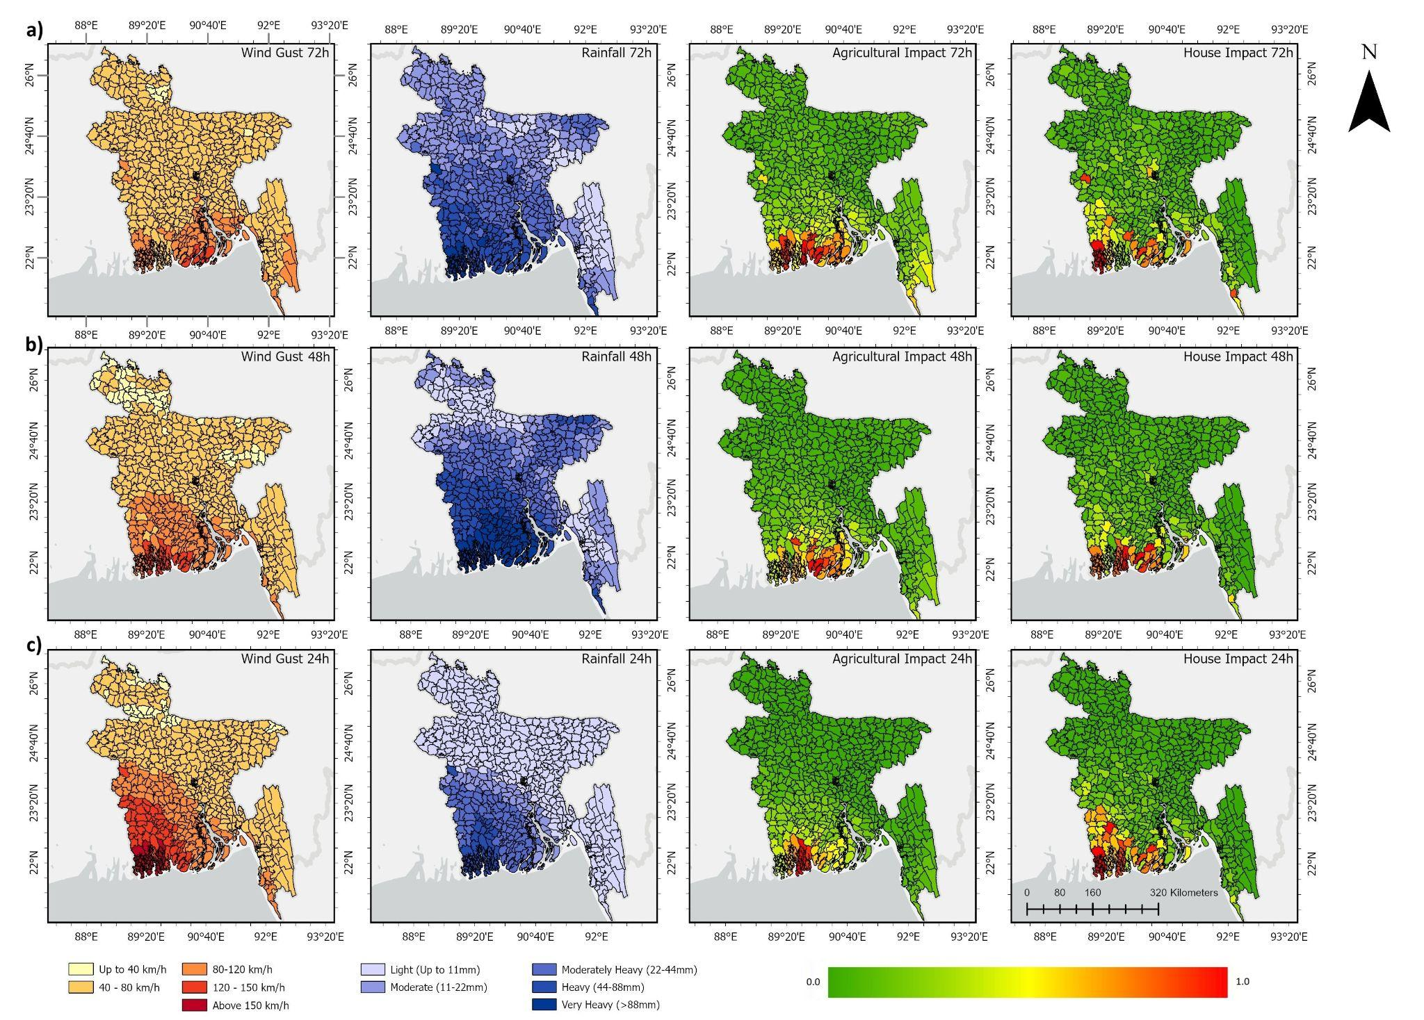
Figure 5. Spatial distribution of forecasted physical hazards and synthesized multi-sector impact scores for Cyclone Midhili across pre-landfall lead times. a) 72-hour forecast lead time. b) 48-hour forecast lead time. c) 24-hour forecast lead time. Rows display (from left to right): daily maximum 10-m wind gust (km/h), daily accumulated rainfall (mm), normalized agricultural impact score, and normalized housing impact score aggregated at the Upazila administrative level. Hazard legends depict wind gust speed ranges (up to >150 km/h) and rainfall accumulation classes (light to very heavy, >88 mm). Synthesized impact scores are normalized per event onto a continuous scale from 0.0 (minimum impact, green) to 1.0 (maximum impact, red).
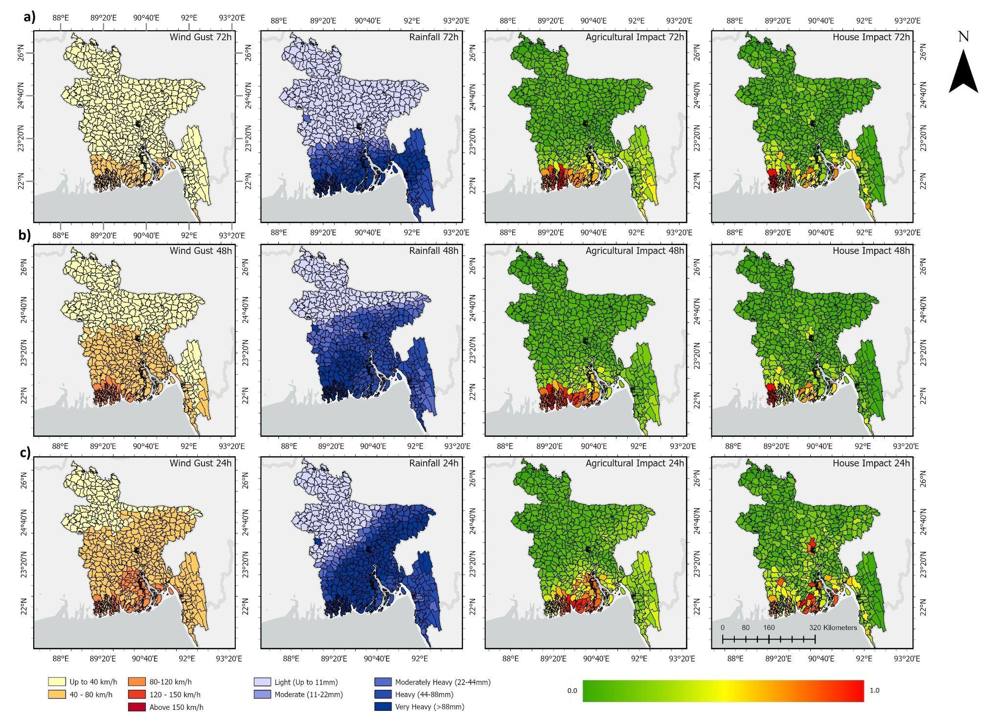
Figure 6. Spatial distribution of forecasted physical hazards and synthesized multi-sector impact scores for Cyclone Sitrang across pre-landfall lead times. a) 72-hour forecast lead time. b) 48-hour forecast lead time. c) 24-hour forecast lead time. Rows display (from left to right): daily maximum 10-m wind gust (km/h), daily accumulated rainfall (mm), normalized agricultural impact score, and normalized housing impact score aggregated at the Upazila administrative level. Hazard legends depict wind gust speed ranges (up to >150 km/h) and rainfall accumulation classes (light to very heavy, >88 mm). Synthesized impact scores are normalized per event onto a continuous scale from 0.0 (minimum impact, green) to 1.0 (maximum impact, red).
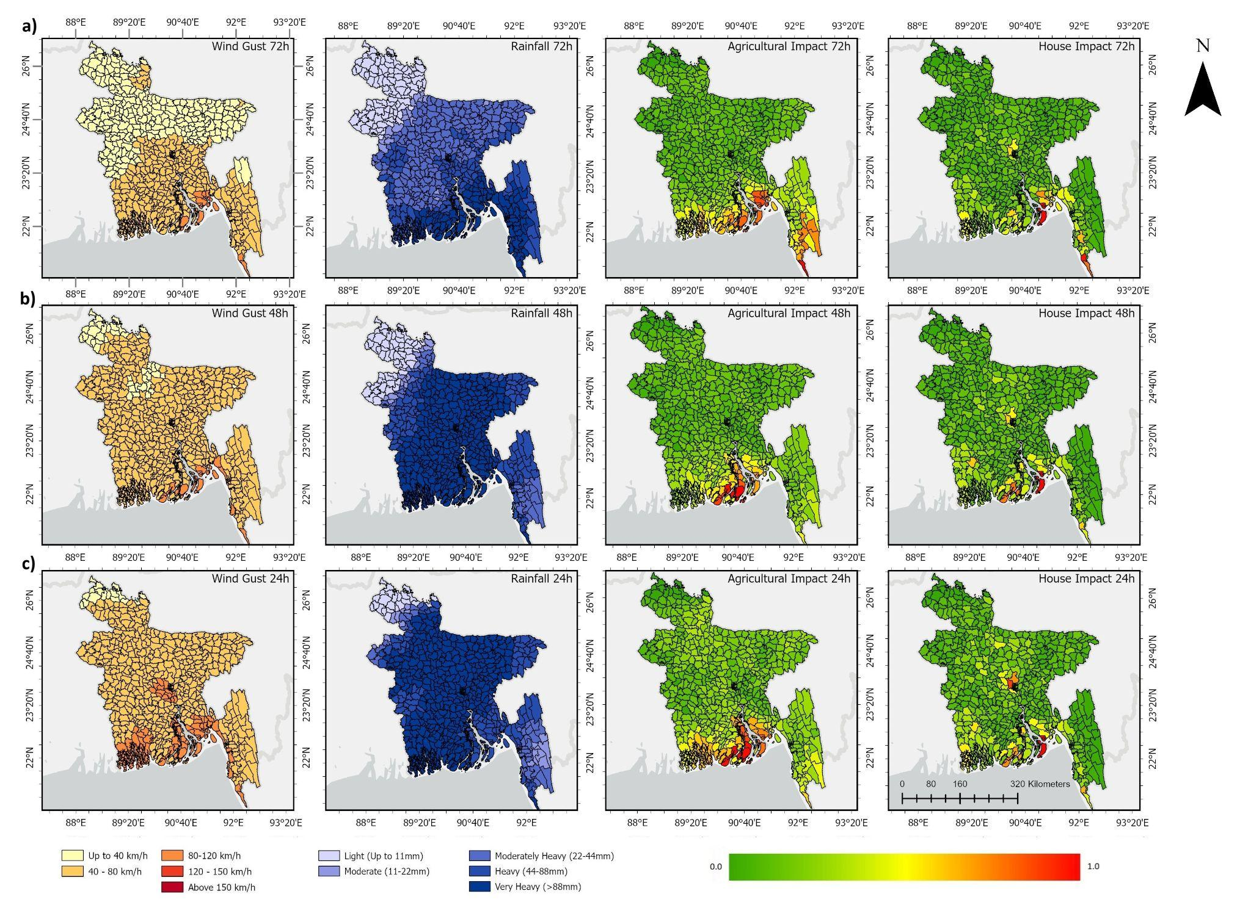
Binary Categorical Verification and Event Matching
Evaluating calibrated decision thresholds within standard 2 x 2 contingency tables significantly improved categorical event classification across all evaluated coastal Upazilas compared to uncalibrated baselines (X > 0) across 24-hour, 48-hour, and 72-hour forecast horizons (Tables 1, 2, and 3).
Across all three cyclone events, uncalibrated baselines suffered from severe over-forecasting, generating high false alarm counts and inflated Frequency Bias values ranging from 1.181 to 1.698 because small baseline impact scores produced across minimally affected areas by the multiplicative combination of exposure and vulnerability were misclassified as meaningful ground impact. Percentile threshold optimization successfully eliminated this systemic over-forecasting by raising the No-Impact boundary above zero. This reclassified unaffected administrative units from False Alarms into True Negatives, stabilizing Frequency Bias toward the optimal unity target across all pre-landfall lead times. While converting border cases into True Negatives introduced a minor trade-off in missed detections, it maximized the overall Decision Score and established realistic No-Impact boundaries matching ground-observed coverage rates.
Focusing on Cyclone Remal, housing threshold optimization at the 15th percentile reduced False Alarms from 19 down to 10 to 13, corrected Frequency Bias to exactly 1.000, and maintained CSI values of 0.832, 0.807, and 0.684 at 24h, 48h, and 72h respectively, with peak Decision Scores reaching 0.741 (Table 1). Agricultural threshold optimization at the 30th percentile across all lead times successfully brought uncalibrated Frequency Bias (1.393) down to a consistent 0.991 while isolating 63 to 66 confirmed Hits across the calibrated agricultural horizons.
For Cyclone Midhili, threshold optimization consistently converged at P40 for housing and P30/P25 for agriculture. Housing calibration corrected an extreme baseline Frequency Bias of 1.698 toward near-unity, cutting False Alarms from 37 to 20. The agricultural model achieved its strongest detection skill under calibration at 24 hours (P30 = 0.2700), where the calibrated boundary drove CSI up to 0.738, Frequency Bias to 1.028, and overall Accuracy to 77.8%, with a peak Decision Score of 0.563 (Table 2).
Evaluating Cyclone Sitrang, percentile calibration across all three lead times effectively corrected the uncalibrated agricultural Frequency Bias from 1.396 down to 0.977 to 1.028, while CSI values of 0.567 to 0.691 confirmed meaningful detection skill in the agricultural sector. Housing calibration produced CSI values of 0.642 to 0.684 across lead times, with peak Decision Scores of 0.389 to 0.479 and Frequency Bias values of 1.000 to 1.176, reflecting the partial but incomplete correction of the housing impact field's spatial mismatch for this event (Table 3).
Spatial Event Matching and Categorical Detection Verification against Observed Damage Data
To evaluate the geographic alignment between forecasted impact patterns and actual post-disaster damage records, spatial event matching was conducted against ground observations compiled by the Department of Disaster Management (DDM) across all coastal Upazilas. Administrative units were categorised into Hits (green, where forecasted impact coincided with reported DDM ground damage) and False Alarms (red, where forecasted impact occurred in locations with zero reported ground loss in DDM records). Upazilas for which DDM submitted no damage report are shown in grey and excluded from verification; the verification therefore covers only the subset of Upazilas for which DDM records exist. This reporting boundary varies across events and damage variables, reflecting differences in the spatial extent of field surveys conducted after each cyclone. Spatial distributions were mapped across 12 distinct panels evaluating total damaged house counts, total monetary housing repair losses, total agricultural cropland area loss, and total agricultural monetary loss for Cyclones Remal, Midhili, and Sitrang (Figure 7).
Spatial comparison for Cyclone Remal demonstrated the strongest overall geographic alignment of the three events, with a dense, spatially continuous green cluster of confirmed Hits across the southwestern and south-central coastal belt. DDM reporting for Remal covered the widest geographic footprint of the three events, encompassing a large share of the coastal Upazila network. Housing Hits were concentrated in districts along the direct landfall corridor, including Khulna, Bagerhat, Satkhira, Patuakhali, Barguna, and Bhola, where DDM recorded the most severe physical destruction. False Alarms appeared as a scattered fringe across the eastern peripheral districts, primarily in the Comilla and Noakhali corridors, where low-level forecast values exceeded the detection threshold without corresponding DDM damage entries. In the agricultural sector, the spatial Hit pattern extended somewhat further inland than for housing, reflecting the broader spatial sensitivity of the fAPAR-based crop exposure indicator. False Alarms were distributed across the peripheral eastern, southeastern, and western margins, where forecast agricultural scores remained above the detection threshold despite limited reported cropland loss in DDM records.
During Cyclone Midhili, spatial event matching reflected the narrower field survey footprint and the more compact impact swath of this event. The DDM reporting coverage for Midhili was substantially more limited than for Remal, particularly for agricultural variables, where a large proportion of inland Upazilas carry no DDM record and appear grey in the figure. Within the assessed coastal zone, housing Hits formed a compact band across the central coastal belt encompassing Barishal, Bhola, and Patuakhali, while False Alarms were distributed across the Chattogram belt to the east, the Khulna belt to the west, and the central southern coast, where outer-band forecast signals exceeded the threshold without corresponding structural damage in the DDM record. Agricultural Hits formed a coherent green cluster across south-central estuarine Upazilas within the DDM-reported area, with False Alarms concentrated along both the eastern and western coastal margins. The agricultural sector achieved noticeably stronger spatial alignment than the housing sector within the reported footprint, consistent with the stronger group separation observed for agricultural indicators across all Midhili lead times in the Mann-Whitney screening.
Spatial matching for Cyclone Sitrang revealed a more mixed pattern than for the other two events, particularly in the housing sector. For house counts and monetary repair loss, red False Alarms were prominent across northern inland districts and the eastern coastal margin, with green Hits distributed unevenly across the central and southeastern coast rather than forming a spatially continuous cluster. This fragmented pattern is consistent with the directional inversion identified in the preliminary verification, where forecast housing scores showed no capacity to separate damaged from undamaged Upazilas, and with AUC values at or below the no-skill baseline across all three lead times, ranging from 0.495 to 0.503. In the agricultural sector, a substantially larger and more coherent green cluster spanned the southeastern and south-central coastal belt, with False Alarms concentrated along the eastern coastal and inland peripheral districts outside the core inundation zone. The markedly better agricultural spatial alignment relative to housing for Sitrang reflects the physical reality that crop damage under this event was driven by coastal inundation rather than wind intensity, a mechanism that the fAPAR-based exposure indicator captures more reliably than the building-footprint exposure used for the housing sector.
Overall, mapping spatial hit distributions across all three events confirms that forecasted agricultural impact patterns consistently achieved broader and more spatially coherent alignment with DDM ground records than housing patterns for the two lower-intensity events. For Remal, both sectors performed well, reflecting the sufficient intensity and spatial extent of that storm to generate detectable signals across both exposure indicators. The sector-specific divergence in spatial detection skill for Midhili and Sitrang reinforces the interpretation established throughout the validation: the framework's housing signal is most reliable under major cyclonic forcing, while the agricultural signal provides a more robust spatial baseline across a wider range of storm intensities.
Figure 7. Spatial distribution of categorical event matching (Hits vs. False Alarms) across coastal Upazilas comparing forecasted impacts against DDM observed damage data for Cyclones Remal, Midhili, and Sitrang. Sub-panels correspond to individual tropical cyclone events evaluated against post-disaster Department of Disaster Management (DDM) ground records: a) Cyclone Remal, b) Cyclone Midhili, and c) Cyclone Sitrang. Columns within each row display spatial performance across four post-disaster damage variables (from left to right): total number of damaged houses, total monetary repair loss for houses (BDT), total agricultural cropland area damaged (ha), and total agricultural monetary loss (BDT). Green shading indicates Hits (forecasted impact coincided with confirmed DDM ground damage), red shading indicates False Alarms (forecasted impact occurred without reported DDM ground loss), and grey administrative units represent Upazilas with no submitted DDM survey report, which are excluded from the verification domain.
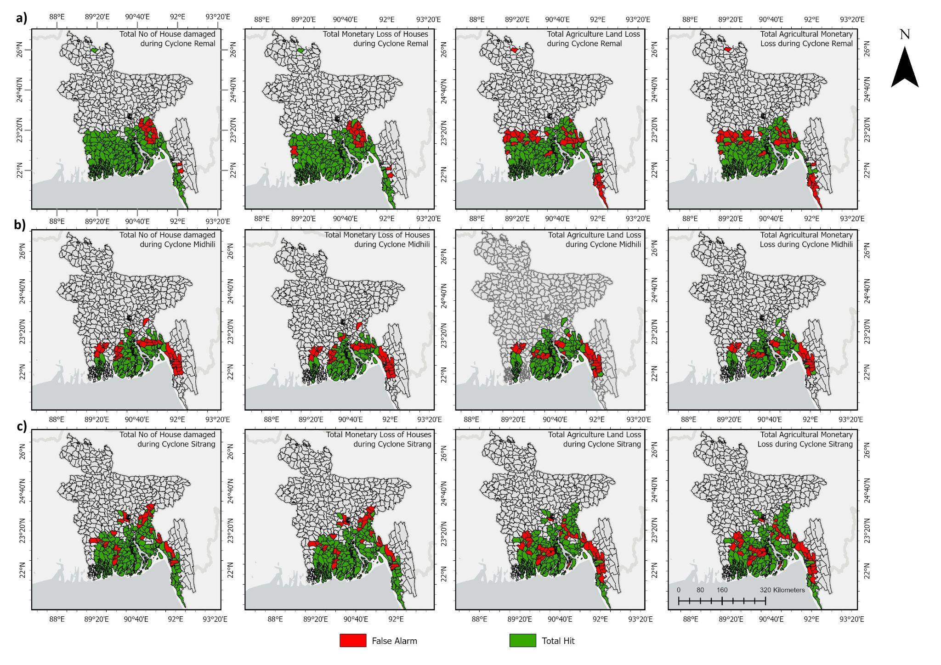
Multi-Class Ordinal Severity Calibration and Confusion Matrix Analysis
To evaluate how accurately predicted impact scores translated into discrete severity levels, framework calculations were compared against ground-truth damage observations across four ordinal classes consisting of No Impact, Low, Moderate, and High. Ground observations were initially discretized using a standard uncalibrated tertile baseline (P33/P67), which produced modest or negative Quadratic-Weighted Cohen's Kappa scores against fixed forecast classes. Systematically calibrating severity boundaries on ground-truth loss data by maximizing Quadratic-Weighted Cohen's Kappa resolved this distributional misalignment, yielding positive performance gains across all three storm events and pre-landfall lead times (24h, 48h, and 72h).
Initial evaluation of Cyclone Remal achieved the strongest overall ordinal performance among all analyzed events. For structural housing metrics, a single cyclone-wide DDM cut-point pair was fixed at 3,360 and 4,277 damaged households (P82/P88) for counts and at BDT 203.7M and 236.3M (P83/P86) for repair loss, maximizing mean Kappa across all three lead times. Under these fixed boundaries, housing Kappa values of +0.527 at 24h, +0.591 at 48h, and +0.443 at 72h were achieved for household counts, with exact matches reaching 52.6%, 57.8%, and 51.9% respectively and within-one-class agreement of 73.4%, 72.7%, and 70.8% across lead times. Performance peaked at 48 hours, consistent with the 48-hour optimum identified in the group-separation and continuous regression analyses. In the agricultural sector during Remal, fixed cut-points of 27 ha and 480 ha (P30/P68) for land area and BDT 4.0M and 95.3M (P36/P84) for monetary loss produced calibrated Kappa values of +0.473 to +0.567 for cropland area and +0.483 to +0.537 for monetary loss across lead times, maintaining off-category errors below 7.8% for all four evaluated variables across all three forecast horizons (Figure 8, Table 4a and 4b).
Figure 8. Four-by-four confusion matrices comparing impact forecasts against ground-truth DDM observed losses for Cyclone Remal across four ordinal severity categories (No Impact, Low, Moderate, and High) for coastal Upazilas (n = 154). Rows display the temporal forecast horizons prior to landfall: a) 1 Day (24h, top row), b) 2 Day (48h, middle row), and c) 3 Day (72h, bottom row). Within each lead time, four matrices evaluate: (left) Number of Damaged Households, (centre-left) Monetary Damage for Houses (BDT), (centre-right) Total Agricultural Land Area Damaged (ha), and (right) Monetary Damage for Agricultural Land (BDT). Cell shading represents classification accuracy: green denotes exact category matches on the diagonal, yellow highlights single-class adjacent displacements, and red indicates severe off-category misclassifications spanning two or more severity levels. Summary statistics above each matrix report total Upazilas (n), exact matches, adjacent matches, and off-category errors.
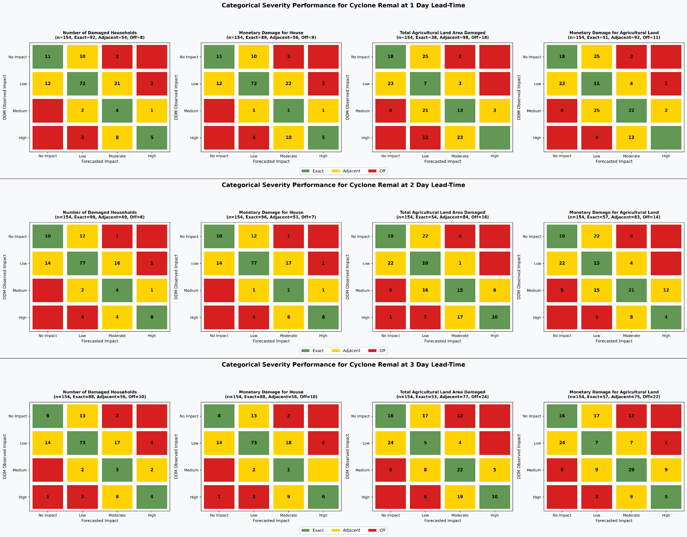
Boundary optimization yielded distinct sector-specific performance across all three forecast horizons during Cyclone Midhili. Agricultural calculations achieved substantial alignment across the three lead times, with fixed cut-points of 50 ha and 2,475 ha (P25/P83) for cropland area producing Kappa values of +0.645 at 24h, +0.560 at 48h, and +0.319 at 72h. For monetary agricultural loss, fixed boundaries of BDT 6.3M and 58.6M (P32/P89) yielded Kappa values of +0.579, +0.492, and +0.206 at 24h, 48h, and 72h respectively, with the 24-hour agricultural calculation returning the highest Kappa of any Midhili variable and keeping off-category errors at or below 2.0% across all three lead times. In contrast, built-environment housing predictions for Midhili yielded more modest agreement, with fixed cut-points of 5 and 186 damaged households (P14/P88) and BDT 0.63M and 27.3M (P25/P98) for repair loss producing Kappa values of +0.302, +0.214, and +0.160 for counts and +0.318, +0.264, and +0.185 for repair loss at 24h, 48h, and 72h respectively. Within-one-class housing agreement ranged from 33.7% to 38.8% across lead times, reflecting the limited predictive separation established in the preliminary verification for this event (Figure 9, Table 4a and 4b).
Figure 9. Four-by-four confusion matrices comparing impact forecasts against ground-truth DDM observed losses for Cyclone Midhili across four ordinal severity categories (No Impact, Low, Moderate, and High) for coastal Upazilas (n = 98). Rows display the temporal forecast horizons prior to landfall: a) 1 Day (24h, top row), b) 2 Day (48h, middle row), and c) 3 Day (72h, bottom row). Within each lead time, four matrices evaluate: (left) Number of Damaged Households, (centre-left) Monetary Damage for Houses (BDT), (centre-right) Total Agricultural Land Area Damaged (ha), and (right) Monetary Damage for Agricultural Land (BDT). Cell shading represents classification accuracy: green denotes exact category matches on the diagonal, yellow highlights single-class adjacent displacements, and red indicates severe off-category misclassifications spanning two or more severity levels. .
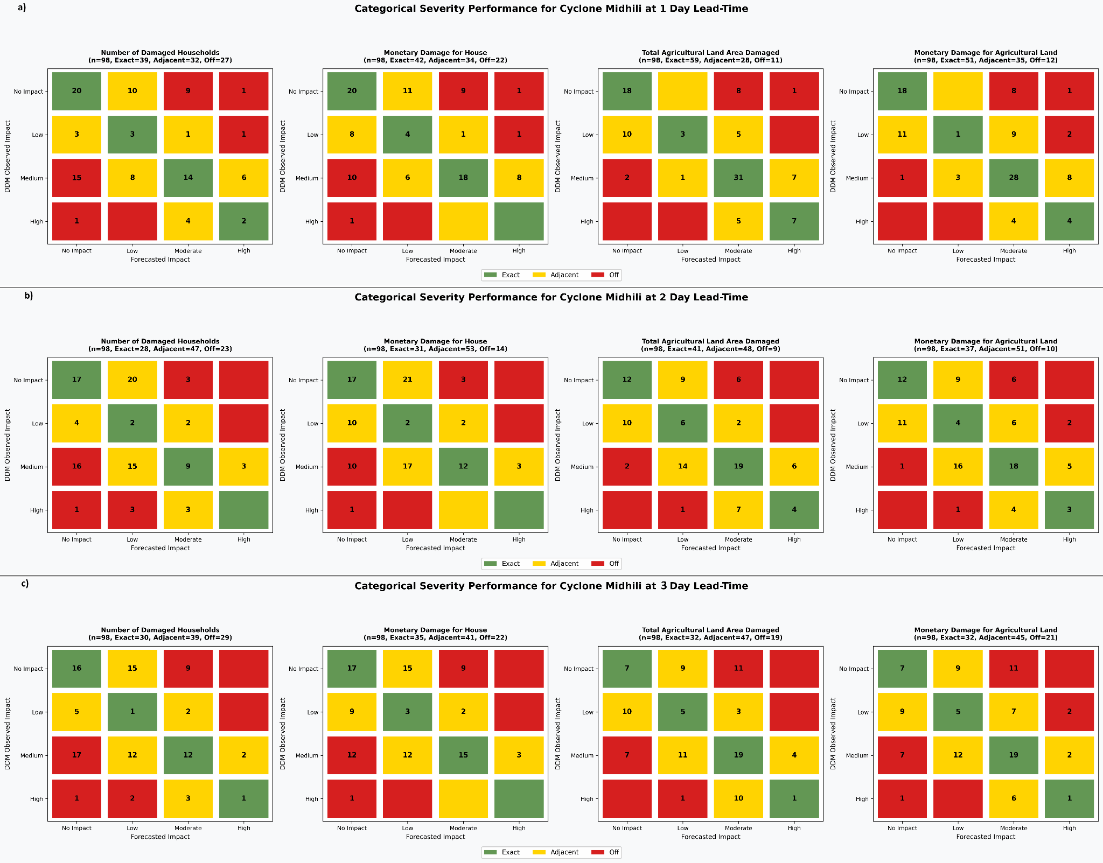
In the case of Cyclone Sitrang, the fixed DDM cut-points for housing (163 and 930 damaged households, P57/P94; BDT 35.9M and 36.5M, P87/P88) produced the lowest Kappa values of any event, ranging from +0.088 to +0.114 for counts and +0.059 to +0.101 for repair loss across lead times. Within-one-class agreement for housing nonetheless reached 58.3% to 61.5% at all three horizons, and off-category errors remained below 8.3% across all housing and agricultural variables. For the agricultural sector, fixed cut-points of 70.7 ha and 143.0 ha (P50/P62) for cropland area and BDT 8.0M and 14.1M (P72/P81) for monetary loss yielded moderate Kappa values of +0.307 and +0.325 at 24h, attenuating to +0.086 and +0.100 at 72h, with the lead-time decay consistent with the progressive loss of agricultural group-separation skill identified in the preliminary and continuous analyses (Figure 10, Table 4a and 4b).
Evaluating four-by-four confusion matrices across all administrative units showed how accurately forecasted impacts aligned with actual ground observations. In this four-class system, predictions fell into three practical outcomes: exact matches, close matches representing single-class adjacent shifts, and off-category errors spanning two or more severity classes. Overall, prediction errors across all three cyclone events were heavily concentrated in exact and close categories rather than severe off-category shifts.
During Cyclone Remal, severe off-category errors remained below 7.8% across all four evaluated variables and all three lead times. Housing predictions showed the strongest alignment at the 48-hour horizon, where 57.8% of household count predictions fell exactly on the correct class and within-one-class agreement reached 72.7% (Figure 8, Table 4a and 4b).
When examining Cyclones Midhili and Sitrang, the evaluation maintained consistent off-category bounds across pre-landfall horizons (Figures 9 and 10). For Midhili, agricultural off-category errors were held to 2.0% or below across all lead times, while housing off-category errors remained below 3.1%. For Sitrang, off-category errors for housing ranged from 4.5% to 8.3% and for agriculture from 4.5% to 9.0% across lead times, with the highest off-category rates appearing at 72h for agricultural cropland area (9.0%), consistent with the near-complete loss of agricultural AUC and regression skill at that horizon for this event.
These results demonstrate that calibrating class boundaries effectively stabilizes severity transitions without creating severe forecast blind spots. Because off-category errors remained tightly bounded across all three cyclone events and all three forecast horizons, disaster response agencies can use these pre-landfall severity estimates to guide early mobilization and allocate relief resources effectively prior to storm landfall.
Figure 10. Four-by-four confusion matrices comparing impact forecasts against ground-truth DDM observed losses for Cyclone Sitrang across four ordinal severity categories (No Impact, Low, Moderate, and High) for coastal Upazilas (n = 156). Rows display the temporal forecast horizons prior to landfall: a) 1 Day (24h, top row), b) 2 Day (48h, middle row), and c) 3 Day (72h, bottom row). Within each lead time, four matrices evaluate: (left) Number of Damaged Households, (centre-left) Monetary Damage for Houses (BDT), (centre-right) Total Agricultural Land Area Damaged (ha), and (right) Monetary Damage for Agricultural Land (BDT). Cell shading represents classification accuracy: green denotes exact category matches on the diagonal, yellow highlights single-class adjacent displacements, and red indicates severe off-category misclassifications spanning two or more severity levels.
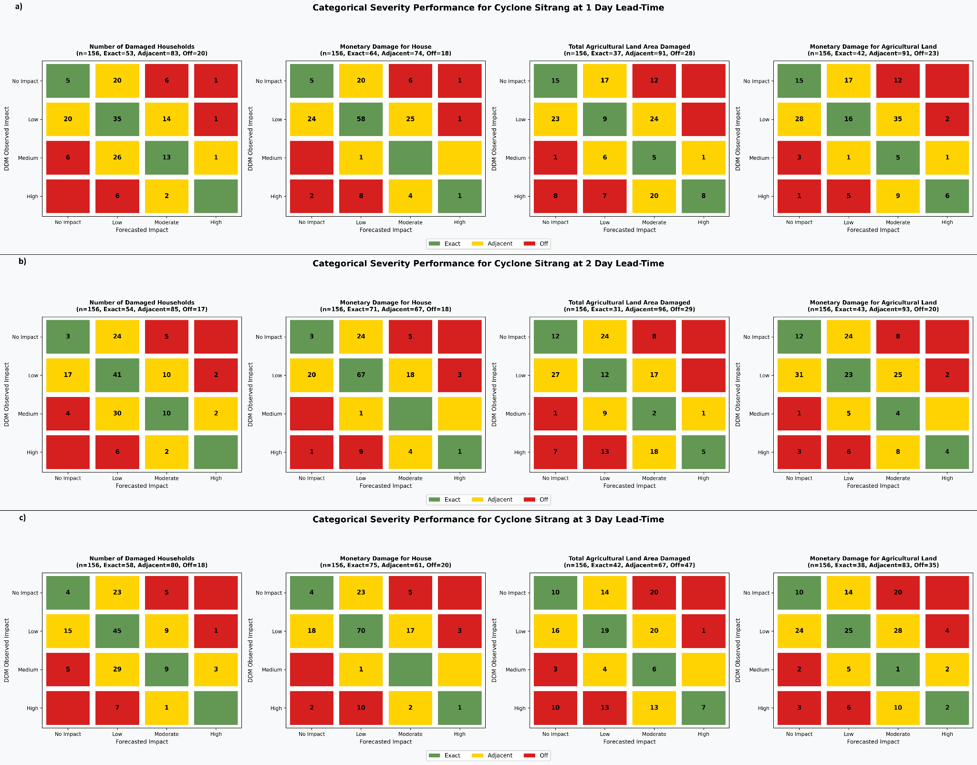
Table 4a. Multi-Class Ordinal Severity Calibration. The table contains fixed DDM Cut-Points and Quadratic-Weighted Cohen's Kappa across Lead Times. A single cyclone-wide DDM cut-point pair (Low / High) per damage variable was fixed by maximising mean Kappa across the 24h, 48h, and 72h forecasts simultaneously.
Cyclone | Variable | DDM Cut-points  (Low / High) | Low Pct /  High Pct | Kappa  24h | Kappa  48h | Kappa  72h | Mean  Kappa
Remal | House: No. Damaged Households | 3,360 / 4,277 | P82 / P88 | 0.5269 | 0.5913 | 0.4432 | 0.5205
Remal | House: Repair Amount (BDT) | 203.7M / 236.3M | P83 / P86 | 0.5132 | 0.5755 | 0.4647 | 0.5178
Remal | Agri: Land Loss (ha) | 27 / 480 | P30 / P68 | 0.4725 | 0.5669 | 0.5111 | 0.5168
Remal | Agri: Loss Amount (BDT) | 4.0M / 95.3M | P36 / P84 | 0.4827 | 0.5374 | 0.4684 | 0.4962
Midhili | House: No. Damaged Households | 5 / 186 | P14 / P88 | 0.3019 | 0.2140 | 0.1598 | 0.2252
Midhili | House: Repair Amount (BDT) | 0.63M / 27.3M | P25 / P98 | 0.3176 | 0.2641 | 0.1851 | 0.2556
Midhili | Agri: Land Loss (ha) | 50 / 2,475 | P25 / P83 | 0.6452 | 0.5596 | 0.3186 | 0.5078
Midhili | Agri: Loss Amount (BDT) | 6.27M / 58.6M | P32 / P89 | 0.5789 | 0.4923 | 0.2063 | 0.4258
Sitrang | House: No. Damaged Households | 163 / 930 | P57 / P94 | 0.0877 | 0.1144 | 0.1107 | 0.1043
Sitrang | House: Repair Amount (BDT) | 35.9M / 36.5M | P87 / P88 | 0.0592 | 0.1008 | 0.0388 | 0.0663
Sitrang | Agri: Land Loss (ha) | 70.7 / 143.0 | P50 / P62 | 0.3066 | 0.2691 | 0.0858 | 0.2205
Sitrang | Agri: Loss Amount (BDT) | 8.0M / 14.1M | P72 / P81 | 0.3255 | 0.2568 | 0.0995 | 0.2273
Table 4b. Multi-Class Ordinal Severity Confusion Matrix Breakdown which shows Exact Match, Within-1-Class Agreement, and Off-Category Errors across Cyclones and Lead Times.
Cyclone | Lead  Time | Variable | n | Exact  Match (n) | Exact  Match (%) | Adjacent  (n) | Within-1-Class (n) | Within-1-Class (%) | Off-Category  Error (%)
Remal | 24h | House: No. Damaged Households | 154 | 92 | 59.7% | 54 | 146 | 94.8% | 5.2%
Remal | 24h | House: Repair Amount (BDT) | 154 | 89 | 57.8% | 56 | 145 | 94.2% | 5.8%
Remal | 24h | Agri: Land Loss (ha) | 154 | 38 | 24.7% | 98 | 136 | 88.3% | 11.7%
Remal | 24h | Agri: Loss Amount (BDT) | 154 | 51 | 33.1% | 92 | 143 | 92.9% | 7.1%
Remal | 48h | House: No. Damaged Households | 154 | 99 | 64.3% | 49 | 148 | 96.1% | 3.9%
Remal | 48h | House: Repair Amount (BDT) | 154 | 96 | 62.3% | 51 | 147 | 95.5% | 4.5%
Remal | 48h | Agri: Land Loss (ha) | 154 | 54 | 35.1% | 84 | 138 | 89.6% | 10.4%
Remal | 48h | Agri: Loss Amount (BDT) | 154 | 57 | 37.0% | 83 | 140 | 90.9% | 9.1%
Remal | 72h | House: No. Damaged Households | 154 | 88 | 57.1% | 56 | 144 | 93.5% | 6.5%
Remal | 72h | House: Repair Amount (BDT) | 154 | 88 | 57.1% | 56 | 144 | 93.5% | 6.5%
Remal | 72h | Agri: Land Loss (ha) | 154 | 53 | 34.4% | 77 | 130 | 84.4% | 15.6%
Remal | 72h | Agri: Loss Amount (BDT) | 154 | 57 | 37.0% | 75 | 132 | 85.7% | 14.3%
Midhili | 24h | House: No. Damaged Households | 98 | 39 | 39.8% | 32 | 71 | 72.4% | 27.6%
Midhili | 24h | House: Repair Amount (BDT) | 98 | 42 | 42.9% | 34 | 76 | 77.6% | 22.4%
Midhili | 24h | Agri: Land Loss (ha) | 98 | 59 | 60.2% | 28 | 87 | 88.8% | 11.2%
Midhili | 24h | Agri: Loss Amount (BDT) | 98 | 51 | 52.0% | 35 | 86 | 87.8% | 12.2%
Midhili | 48h | House: No. Damaged Households | 98 | 28 | 28.6% | 47 | 75 | 76.5% | 23.5%
Midhili | 48h | House: Repair Amount (BDT) | 98 | 31 | 31.6% | 53 | 84 | 85.7% | 14.3%
Midhili | 48h | Agri: Land Loss (ha) | 98 | 41 | 41.8% | 48 | 89 | 90.8% | 9.2%
Midhili | 48h | Agri: Loss Amount (BDT) | 98 | 37 | 37.8% | 51 | 88 | 89.8% | 10.2%
Midhili | 72h | House: No. Damaged Households | 98 | 30 | 30.6% | 39 | 69 | 70.4% | 29.6%
Midhili | 72h | House: Repair Amount (BDT) | 98 | 35 | 35.7% | 41 | 76 | 77.6% | 22.4%
Midhili | 72h | Agri: Land Loss (ha) | 98 | 32 | 32.7% | 47 | 79 | 80.6% | 19.4%
Midhili | 72h | Agri: Loss Amount (BDT) | 98 | 32 | 32.7% | 45 | 77 | 78.6% | 21.4%
Sitrang | 24h | House: No. Damaged Households | 156 | 53 | 34.0% | 83 | 136 | 87.2% | 12.8%
Sitrang | 24h | House: Repair Amount (BDT) | 156 | 64 | 41.0% | 74 | 138 | 88.5% | 11.5%
Sitrang | 24h | Agri: Land Loss (ha) | 156 | 37 | 23.7% | 91 | 128 | 82.1% | 17.9%
Sitrang | 24h | Agri: Loss Amount (BDT) | 156 | 42 | 26.9% | 91 | 133 | 85.3% | 14.7%
Sitrang | 48h | House: No. Damaged Households | 156 | 54 | 34.6% | 85 | 139 | 89.1% | 10.9%
Sitrang | 48h | House: Repair Amount (BDT) | 156 | 71 | 45.5% | 67 | 138 | 88.5% | 11.5%
Sitrang | 48h | Agri: Land Loss (ha) | 156 | 31 | 19.9% | 96 | 127 | 81.4% | 18.6%
Sitrang | 48h | Agri: Loss Amount (BDT) | 156 | 43 | 27.6% | 93 | 136 | 87.2% | 12.8%
Sitrang | 72h | House: No. Damaged Households | 156 | 58 | 37.2% | 80 | 138 | 88.5% | 11.5%
Sitrang | 72h | House: Repair Amount (BDT) | 156 | 75 | 48.1% | 61 | 136 | 87.2% | 12.8%
Sitrang | 72h | Agri: Land Loss (ha) | 156 | 42 | 26.9% | 67 | 109 | 69.9% | 30.1%
Sitrang | 72h | Agri: Loss Amount (BDT) | 156 | 38 | 24.4% | 83 | 121 | 77.6% | 22.4%

Discussion
Translating pre-landfall forecast scores into calibrated, sector-specific damage estimates across 24-hour, 48-hour, and 72-hour decision horizons addresses a fundamental operational gap in impact-based early warning for coastal Bangladesh. The validation results across three structurally different cyclone events reveal a framework that is useful and operationally actionable, but whose reliability is uneven across sectors and event intensities in ways that carry direct implications for how it should be deployed in anticipatory action systems⁵².
The most consistent finding across all three events is that forecast skill is event-dependent rather than generalisable. Cyclone Remal, the most severe and slowest-moving of the three events, produced significant group separation for housing across all evaluable typologies and at all three lead times, strong threshold-independent AUC values of 0.827 at 24h and 48h, meaningful continuous regression skill peaking at the 48-hour horizon (r = 0.498 for total damaged households), and the highest Kappa scores of any event-sector combination (+0.591 for household counts at 48h). Cyclone Midhili, a faster-moving and lower-intensity system, produced no significant housing separation at any lead time and housing AUC values near the no-skill baseline, yet its agricultural sector performed comparably to Remal's in discrimination terms, achieving an AUC of 0.730 at 24h and the highest agricultural Kappa of the evaluation (+0.645 for cropland area). Cyclone Sitrang, a rainfall-dominated event with a wide but diffuse impact footprint, produced a consistent directional inversion for housing at all lead times and across all typologies, confirming a systematic spatial mismatch between the predicted housing impact field and observed damage distribution rather than a weak or noisy signal. Its agricultural sector retained modest but significant predictive skill at 24h and 48h before losing significance at 72h. These three profiles do not represent a single framework performing at different efficiency levels; they reflect three physically distinct cyclone regimes requiring different operational interpretations of the same output.
This event-type dependency has direct implications for how impact forecasts should enter decision chains. For severe, slow-tracking events like Remal, the 48-hour horizon emerges as the most operationally valuable window. It captures a stabilised cyclone trajectory while avoiding the spatial translation of maximum forcing that occurs during active landfall at 24 hours, when the damage centre shifts rapidly between administrative units. The 48-hour optimum was consistent across all three validation metrics for housing — group separation was broadest, OLS skill was highest, and Kappa peaked, pointing to this horizon as the preferred trigger point for pre-positioning relief supplies and issuing targeted community warnings for major events. For faster or less intense events like Midhili and Sitrang, the useful window contracts to 24 hours, with agricultural detection degrading monotonically beyond that point and housing detection absent across all horizons. This contraction of the reliable decision window for moderate events is a critical operational finding: anticipatory action protocols that assume a uniform 48-hour or 72-hour lead time will be less effective for the majority of cyclone events that do not reach Remal's intensity.
The differential performance between housing and agricultural sectors across event intensities reflects the underlying physics of each exposure indicator. The building-footprint-based housing exposure aggregates over entire Upazila administrative units, which means that when structural damage is concentrated in a small fraction of highly vulnerable structures, as is the case under moderate wind forcing, the Upazila-level signal is diluted by the majority of buildings that sustain no damage. For Midhili, this dilution was sufficient to eliminate any detectable group separation; for Sitrang, the spatial distribution of wind and surge forcing did not align with the distribution of building stock captured by the footprint indicator, producing the observed directional inversion. The fAPAR-based agricultural exposure indicator behaves differently because crop biomass is spatially continuous within a growing Upazila and uniformly vulnerable to wind damage and saline inundation. This physical continuity means that even moderate forcing generates a detectable signal, explaining why agricultural AUC values remained above the no-skill baseline for all three events while housing values did not. The practical implication is that the current framework is most reliable as an agricultural early warning tool across the full range of event intensities it was tested against, while housing predictions should be interpreted with greater caution outside the severe-event regime.
The agricultural sub-category results provide a more nuanced picture. Partially damaged cropland proved to be the most consistently significant indicator across events and lead times, while fully damaged cropland performed reliably only under Remal's severe and sustained forcing. This ordering is physically coherent: total crop loss requires the intensity of wind and inundation that only a major storm delivers, whereas partial damage tracks the broad-scale vegetation stress susceptibility that the fAPAR indicator actually measures. The total-damaged-cropland aggregate, which combines both damage classes, provided the most operationally stable single agricultural indicator across all three events, though it too lost significance at 72h for Midhili and Sitrang. For operational purposes, the aggregate indicator is the more defensible choice for trigger-based systems, as it does not depend on the event-specific balance between fully and partially damaged sub-classes.
The threshold optimisation and percentile calibration results demonstrate that uncalibrated score distributions consistently overforecast impact, with Frequency Bias values ranging from 1.181 to 1.698 when all non-zero scores are treated as impact. This over-forecasting is driven by low-amplitude background signals generated by building footprints and fAPAR values in Upazilas that are not actually exposed to damaging forcing, and it would systematically generate false alarms in any operational system using a zero-score threshold. The event-specific percentile optimisation resolved this by raising the No-Impact boundary to between the 15th and 40th percentiles depending on event and sector, bringing Frequency Bias within 0.977 to 1.028 for agricultural calibration and to exactly 1.000 for Remal housing. The notable finding that the optimal housing threshold for Sitrang varied across lead times (P20 at 24h, P25 at 48h, P15 at 72h) further reflects the spatial inconsistency of that event's impact field and argues against any fixed universal threshold in operational practice. Percentile-based calibration must be performed independently for each event-sector combination rather than transferred from previous events.
The ordinal severity calibration results confirm that, even where continuous and group-separation skill is limited, the framework maintains operationally acceptable bounds on misclassification severity. Off-category errors — errors spanning two or more severity classes, which carry the highest risk of under-resourcing a genuinely high-impact zone — remained below 7.8% for Remal across all variables and lead times, below 3.1% for Midhili housing and below 2.0% for Midhili agriculture, and below 9.0% for Sitrang across all variables and lead times. This bounded error structure means that even for Sitrang, where housing Kappa values were as low as +0.039 for repair loss at 72h, the framework is not producing classifications that would radically mislabel a severely damaged zone as unaffected. The distinction between low Kappa and bounded off-category error is operationally important: Kappa is sensitive to the full distribution of class assignments including adjacent misclassifications, while off-category error specifically measures the risk of critical operational failure. The two metrics complement rather than substitute for one another, and both are necessary to characterise a framework that will be used for resource allocation decisions.
The STEP project implementation during Cyclone Remal provides direct evidence that the framework's outputs are actionable under real operational conditions and that the gap between validated forecast skill and community-level outcomes can be substantially closed when the forecast is embedded in a co-designed anticipatory action system. Early warning reach in project areas was 58% compared to 36% in non-project areas two to three days before landfall, damage incidence was 49% in project areas against 92% in control areas, and the return on investment reached approximately 15:1. These figures represent the most important external validation of the framework: not whether the correlation coefficients meet a statistical threshold, but whether the spatial and severity information the framework provides is specific enough to enable communities to act protectively before landfall. The difference in outcomes for kutcha housing; households in project areas preserving approximately USD 795 each against USD 1.50 in control areas, which also points directly to a gap the framework's exposure disaggregation should address. The building-footprint indicator used in this study does not distinguish between kutcha, semi-pucca, and pucca structures at the spatial prediction stage; it only aggregates total building counts. Incorporating typology-weighted exposure, for example, applying higher vulnerability multipliers to the fraction of Upazila structures that are kacha, would improve both housing prediction skill and the granularity of early action guidance for the most vulnerable households.
Several limitations bound the current results and indicate directions for further development. First, the framework relies on static baseline vulnerability from the 2022 INFORM dataset, which does not capture intra-cyclone-season changes in exposure such as crop growth stage, seasonal labour migration, or recent infrastructure investment. Integrating dynamic exposure monitoring would improve the fidelity of both the housing and agricultural signals^{53,54}. Second, inherent atmospheric uncertainty in cyclone track forecasting introduces persistent spatial errors, particularly at 72 hours, as small pre-landfall deviations in translation speed or directional recurvature displace the predicted hazard swath across Upazila boundaries⁵⁵. Additionally, for Cyclones Midhili and Sitrang, the performance attenuation observed at the 72-hour lead time is partially compounded by model re-specification: the 72-hour forecast for these two events excluded storm surge due to data unavailability and redistributed weights to wind and rainfall, whereas 24-hour and 48-hour forecasts included all three hazard drivers. Thus, lead-time performance degradation for these events reflects both growing meteorological uncertainty and the omission of the storm surge predictor. The contraction of reliable decision windows from 48 hours for Remal to 24 hours for Midhili and Sitrang is partly attributable to this mechanism and will not be fully resolvable without ensemble track forecasting. Third, the DDM post-disaster survey coverage is uneven across events and damage variables, particularly for Midhili where a substantial proportion of inland Upazilas carry no ground record, limiting the geographic scope of verification and potentially biasing hit-rate estimates. Fourth, data derived from remote sensing can suffer from severe cloud obscuration during active tropical cyclones prior to landfall⁵⁶, while post-disaster ground-truth datasets compiled by agencies like the Department of Disaster Management (DDM) often exhibit spatial reporting lags and variations in survey rigor across remote administrative units. Fifth, a score that signals Low impact in a resource-constrained coastal union carries different operational consequences than the same score in a more resilient peri-urban Upazila; the current framework produces spatially consistent scores but not locally calibrated severity meanings. Co-designing severity thresholds with local disaster management committees, as the STEP project began to do operationally, would address this limitation and move the framework toward the people-centered, locally grounded early warning that its application context demands.
Scaling this approach across Bangladesh's full coastal Upazila network, and eventually to other Bay of Bengal coastal systems, requires institutionalising the event-specific calibration workflow within national meteorological and disaster management agencies rather than treating it as a research task. The results demonstrate that the calibration methodology is tractable, it requires only post-event DDM records and straightforward percentile computation and that the data inputs are globally accessible. The principal constraint on scaling is not data availability but the establishment of operational protocols that link calibrated impact outputs to predefined anticipatory action triggers in a way that is transparent, repeatable, and legitimately authoritative in the eyes of the local committees who must act on them. The STEP experience suggests that this institutional trust is achievable when communities are involved in the co-production of both the forecast interpretation and the action protocol, rather than receiving impact maps as external technical products. Advancing this co-production model across a wider range of cyclone intensities and seasonal agricultural calendars represents the most important next step for translating validated forecast skill into equitable, locally-led disaster preparedness.
To conclude, this study presents a standardised, multi-sector impact-forecasting framework that translates pre-landfall cyclone forecasts into calibrated, Upazila-level damage estimates for housing and agricultural sectors across coastal Bangladesh. Drawing exclusively on globally accessible geospatial, meteorological, and socio-economic datasets, the methodology demonstrates that granular, sector-specific risk intelligence can be generated without proprietary data streams, making it practically replicable within the resource constraints typical of national meteorological and disaster management agencies in the Bay of Bengal region. Validation across three structurally different cyclone events confirms that the framework produces operationally useful outputs, but that its reliability is governed by event intensity and sector. Ultimately, the value of an impact-based forecasting framework rests not only on its statistical performance but on whether its outputs reach the right people, at the right time, in a form that supports action. This study demonstrates that the technical foundation for that translation is achievable from open datasets and reproducible methods. Building the institutional and community partnerships needed to complete that translation represents the most important next step for advancing locally-led, equity-focused disaster preparedness across the Bay of Bengal coast and climate-vulnerable coastal regions more broadly.
Materials and Method
Data
To predict the impact of the cyclone in various upazilas, the method incorporates baseline vulnerability, forecasted hazard characteristics, and exposure variables. To establish baseline population susceptibility, vulnerability data were extracted from the INFORM Bangladesh 2022 dataset at the Administrative Level 3 (Upazila) scale to reflect the inherent structural conditions of the population. Adhering to the INFORM framework, vulnerability is operationalized through two core dimensions: socio-economic vulnerability, capturing broader demographic and economic factors dictating adaptive capacity, and vulnerable groups, representing segments with restricted access to essential resources. Indicator variables were standardized and aggregated via a hierarchical weighting approach to produce a composite vulnerability score³⁰. The assigned vulnerability score by INFORM for Bangladesh ranges between 3.2 to 7.7.
Another key component centers on hazard forecasting, which captures the predicted intensity and spatial variation of cyclonic hazards, primarily wind gusts, rainfall, and storm surge. Rainfall and wind gust forecasts were derived from the European Centre for Medium-Range Weather Forecasts (ECMWF) Integrated Forecasting System (IFS) High-Resolution (HRES) deterministic model at a 0.125° × 0.125° grid resolution, utilizing a 24 to 72 hour lead time. Total accumulated rainfall projections were processed into daily accumulated rainfall in millimeters (mm). For wind hazards, the maximum 10-meter wind gust over 3-hour intervals was processed into the daily maximum 10-meter wind gust in kilometers per hour (km/h). Storm surge projections were obtained from the Indian National Centre for Ocean Information Services (INCOIS) Storm Surge Early Warning System, providing forecasted total surge heights in meters^{31,32,33,34}. This system operates on a tightly-coupled ADCSWAN framework that sequentially executes the Advanced Circulation (ADCIRC) hydrodynamic model and the Simulating Waves Nearshore (SWAN) wave model over a single, shared unstructured mesh grid.
To identify who and what is in harm’s way during the cyclone, and to what degree, exposure elements were integrated. A two-pronged approach to exposure was conducted for this methodology: a general exposure analysis and a sector-specific analysis. In case of general Exposure (Quasi-Static Data), Building count data were derived from the Global Google–Microsoft Open Buildings Dataset, a consolidated global building footprint dataset developed by VIDA by integrating Google’s Open Buildings V3 dataset and Microsoft’s Building Footprints dataset. The dataset contains more than 2.5 billion building footprints globally and provides individual building polygons with associated attributes, including footprint area and data source. For this study, building footprint data for Administrative Level 3 of Bangladesh were accessed in cloud-native geospatial format and processed to estimate the number of buildings within the study area. Each building footprint was treated as an individual structure, and building counts were aggregated according to the required administrative units. The dataset was accessed from VIDA’s repository: Google-Microsoft Open Buildings – combined by VIDA (https://beta.source.coop/repositories/vida/google-microsoft-open-buildings)^{35,36}.
To calculate sector-specific impact, the framework incorporates an agricultural exposure component, recognizing that agriculture is central to coastal livelihoods and highly susceptible to cyclonic hazards. Pre-event vegetation conditions were evaluated using the Global Near Real-Time Filtered 500 m 10-day Fraction of Photosynthetically Active Radiation (fAPAR) dataset. This dataset synthesizes MODIS (Collection 6.1) and VIIRS (Collection 2) observations through a Whittaker smoothing-based filtering approach to deliver spatially consistent, near-real-time estimates of vegetation productivity. For this analysis, fAPAR data from the 15-day period preceding cyclone landfall were extracted to characterize baseline crop conditions. Upazilas exhibiting high fAPAR values, which indicate a substantial presence of healthy crops, were classified as highly exposed due to their elevated potential for substantial agricultural damage. All relevant values were then normalized to a 0–1 scale for all upazilas and then used as per the Impact Computation Formula^{37,38}.
Impact Computation
To estimate localized risk prior to cyclone landfall, a composite impact score is calculated by integrating spatial vulnerability, forecast hazard parameters, and local exposure characteristics. For a given sub-national administrative unit, the composite impact score (I_{m}) is defined as:
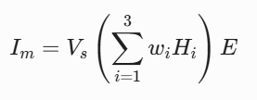
where I_{m} represents the computed impact score for the selected target area, V_{s} denotes the baseline vulnerability score, H_{i} represents the normalized values of the i-th hazard forecast indicator, W_{i} denotes the relative weighting factor for the i-th hazard component, and E represents the normalized exposure indicator.
Because tropical cyclones exhibit substantial variability in their physical drivers, applying a rigid, static weighting scheme across all hazard components can introduce significant predictive bias. A storm may be predominantly characterized by extreme inland precipitation and flooding, or conversely, by high sustained wind speeds and minimal rainfall. The real-world impact of these hazard components is further moderated by the cyclone's trajectory, landfall timing, seasonality, and local coastal geography. To capture these physical nuances, the methodology employs a dynamic weighting mechanism that adjusts W_{n,i} on a case-by-case basis based on the assessment of meteorologists. This framework synthesizes expert domain knowledge regarding dominant storm threats with scenario-specific statistical analyses to assign context-appropriate weights prior to model execution. For instance at a 72h lead time, storm surge may not be present as there is not a cyclone formation. In such a scenario the weightage for storm surge would be redistributed and prioritise the rainfall and wind gust. Similarly in case of a higher intensity of rainfall across the country the model would distribute weightage more for that parameter and redistribute the remaining two hazards accordingly.
For operational dissemination and spatial risk visualization, the continuous impact score (I_{m} ) is normalized (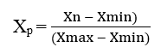) onto a bounded scale between zero and one (0, 1) and discretized into four ordinal severity classes: No Impact, Low Impact, Moderate Impact, and High Impact. Rather than relying on fixed numerical cutoffs, classification thresholds are dynamically established for each event. By evaluating empirical distribution metrics alongside meteorological expert assessments, these classification boundaries adapt to the specific physical characteristics of each cyclone, ensuring that mapped risk categories remain physically meaningful and operationally actionable for emergency planners.
In the expert assessment process, meteorologists first evaluate core system intensity using maximum sustained wind speeds and central pressure deficits, which establish the baseline storm classification. Spatial hazard boundaries are subsequently refined by incorporating three critical physical dynamics. First, radial proximity to the cyclone center and eyewall governs peak wind gust exposure, as maximum wind velocities are concentrated near the core and decay radially outward. Second, satellite-derived cloud band positions and deep convective structures dictate the spatial distribution of heavy precipitation hazards. Third, storm surge risk is evaluated by accounting for track asymmetry; in the Northern Hemisphere, onshore winds in the right-forward quadrant align with forward translation speed, producing maximum coastal surge accumulation. Integrating these empirical distribution properties with meteorologically grounded spatial dynamics ensures that the discretized impact thresholds accurately reflect localized hazard severity.
Validation
To assess operational validity, impact predictions were evaluated against post-disaster ground observations compiled by the Department of Disaster Management (DDM) across three major cyclones in Bangladesh: Remal, Sitrang, and Midhili. For each event, impact predictions were generated across variable pre-landfall lead times using hazard, exposure, and vulnerability metrics³⁹. Because disaster impact datasets inherently exhibit non-linear relationships, severe spatial skewness, and zero-inflated values, a multi-tiered validation approach was implemented combining continuous regression analyses, binary event detection, optimal thresholding, and multi-class ordinal severity assessments.
Data Preprocessing and Transformation
Initial exploratory analysis of DDM records at the sub-national administrative unit level revealed extreme right-skewness (ranging from 3.35 to 8.58, mean 5.09) and excess kurtosis (14.5 to 111.2), with maximum reported losses exceeding medians by up to 1,006-fold and Shapiro–Wilk tests strongly rejecting normality (p < 0.001). To prevent a small number of high-leverage sub-national administrative units from dominating regression modeling, four candidate transformation techniques were systematically evaluated against the natural logarithm.
Linear rescalings, including Z-score standardization and Min–Max scaling^{40,41}, were excluded because affine transformations leave skewness, kurtosis, and normality test outcomes invariant. The Box–Cox transformation was rejected because its requirement for strictly positive inputs cannot accommodate the zero-damage records present in the DDM dataset (23 sub-national administrative units for housing, 44 for agriculture). While the Yeo–Johnson transformation handles zeros and achieves minimal residual skewness (mean 0.03), its estimated transformation parameter lambda varies across variables, cyclones, and lead times (spanning -0.037 to +0.241), preventing direct comparison of regression coefficients across model runs.
Consequently, a natural logarithmic transformation was adopted for the observed damage response variable (Y):
Y' = log(Y + 1)
The predicted impact score is a normalized index already bounded on the interval [0, 1] and was retained on its original scale, consistent with regression assumptions concerning residual rather than predictor distributions. This logarithmic choice is supported by maximum-likelihood Box–Cox estimations, which yielded optimal lambda parameters close to zero across all variables and events (mean absolute lambda = 0.088). Fixing lambda at 0 provides a parameter-free, reproducible scale where regression slopes directly represent proportional changes in reported damage per unit change in predicted impact. Empirically, the transformation reduced mean skewness from 5.09 to -0.10 (with all variables brought within an absolute skewness of 0.45) and reduced mean excess kurtosis to below unity, while the additive constant preserved zero-valued observations.
Although the Yeo–Johnson and Box–Cox transformations achieve marginally better normality than the logarithm on this sample (with mean Shapiro–Wilk p-values of 0.188 and 0.205 respectively against 0.047 for the logarithm), the logarithm was nevertheless retained because this gain is small relative to the loss of a single, reproducible, and physically interpretable scale, on which a regression slope represents a proportional change in reported damage per unit change in predicted impact. Monotone rank-based statistics, including Spearman rank correlation and Kendall's tau, remain invariant to this choice. Following transformation, extreme magnitudes were controlled using top-percentile trimming of the dependent variable alongside an Interquartile Range (1.5 × IQR) filter on variable pairs, with unsurveyed sub-national administrative units handled via pairwise complete-case analysis⁴².
Continuous Statistical Validation and Regression
To determine whether higher predicted impact scores systematically correspond to greater physical damage and monetary losses, continuous linear and non-parametric evaluations were performed. For Ordinary Least Squares (OLS) regression and continuous correlation analyses, the dataset was restricted exclusively to complete pairs containing both positive predicted impact scores (X > 0) and positive observed ground losses (Y > 0). This constraint isolates locations where a measurable forecast signal and reported damages were both present, and the results therefore characterise the gradation of severity among affected upazilas rather than the ability of the forecast to separate affected from unaffected areas, which is assessed through the categorical verification described in Section X.
Simple linear regressions were fitted for each forecast–ground variable pair using two variants: one with observed damage in its raw physical or monetary units, and one using log-transformed damage. The normalized predicted impact score remained bounded on its original scale between zero and one:
Yᵢ = a + bXᵢ + εᵢ
where Xᵢ is the predicted impact score, Yᵢ is the observed loss, a is the intercept, b is the slope, and εᵢ is the residual error.
To evaluate linear strength and rank monotonicity across variables expressed in different units, several complementary measures were calculated. The Pearson correlation coefficient (r) was computed to measure the strength and direction of linear association, while the Spearman rank correlation (ρ) evaluated monotonic consistency by comparing variable ranks to minimize sensitivity to extreme tail values. The Kendall rank correlation (τ) provided a conservative measure of ordinal agreement based on concordant and discordant observation pairs^{43,44,45}. The coefficient of determination (R² = r²) quantifies the proportion of variance in observed losses explained by the fitted relationship within the analysed sample. The number of retained pairs is reported alongside each statistic, since the positivity constraint reduces the sample differently for each variable pair. Statistical significance for all continuous tests was evaluated at a threshold of p < 0.05.
Because the predicted impact score is a dimensionless index while observed losses are expressed in dwelling counts, hectares, and currency, this section characterises association and rank agreement rather than predictive error. Forecast skill is quantified separately through the categorical verification and discrimination analyses reported in Sections X and Y.

Binary Categorical Verification and No-Impact Threshold Optimization
Because continuous metrics do not capture a model's ability to discriminate affected areas from unaffected ones, zero-value observations were retained alongside positive damage cases to establish a standard 2 X 2 contingency framework. Outcomes were classified as Hits when both forecast impact and ground damage were present, Misses when ground damage occurred without a forecast impact, False Alarms when forecast impact occurred without observed damage, and Correct Negatives when neither forecast impact nor ground damage was recorded. From these counts, standard categorical skill metrics were derived, including the Probability of Detection (POD = H / (H + M)), False Alarm Ratio (FAR = FA / (H + FA)), Critical Success Index (CSI = H / (H + M + FA)), Frequency Bias ((H + FA) / (H + M)), and overall Accuracy ((H + CN) / N)⁴⁶.
Rather than applying an arbitrary cutoff, the operational threshold separating No Impact from Impact was objectively derived from the empirical score distribution across percentiles P₅ through P₅₀. For each candidate threshold T_{p} = percentile_{p} (S), binary predictions were evaluated using a custom Decision Score:
Decision Score = CSI − FAR − |Bias − 1|
This objective function balances event detection skill, penalizes false predictions, and discourages systemic over- or under-forecasting by penalizing absolute departures of bias from unity. The candidate percentile yielding the maximum Decision Score was selected as the optimal domain threshold.
This optimization was performed independently for each exposure indicator: the housing impact score and the agricultural impact score rather than applying a single, shared cutoff across both. Because these indicators respond to different physical processes (structural wind/surge damage versus vegetation stress) and exhibit different score distributions, their optimal No-Impact thresholds, and the four-class severity boundaries derived from them, were not assumed to coincide and were calibrated separately.
Threshold-Independent Detection Skill: Receiver Operating Characteristic (ROC) and Area Under the Curve (AUC)
The binary verification metrics described above POD, FAR, CSI, Bias and Accuracy are each evaluated at a single, specific decision threshold: the value of the normalized impact score above which an Upazila is classified as “Impact”. Because these metrics change with the threshold chosen, they cannot on their own distinguish a genuinely weak forecast signal from a forecast signal that is strong but poorly thresholded. To separate these two possibilities, the Receiver Operating Characteristic (ROC) curve and its associated Area Under the Curve (AUC) statistic were additionally computed as a threshold-independent measure of detection skill.

For a given exposure variable (e.g., housing or agricultural impact), the binary outcome of interest was defined as observed damage (DDM value > 0) versus no observed damage (DDM value = 0), identical to the definition used in the binary categorical verification. Every unique value of the normalized impact score was, in turn, treated as a candidate decision threshold. At each candidate threshold, the True Positive Rate (TPR, equivalent to POD) and False Positive Rate (FPR) were computed as:


where TP, FN, FP and TN denote true positives, false negatives, false positives and true negatives at that threshold, using the same contingency definitions as the binary categorical verification. Plotting TPR (y-axis) against FPR (x-axis) across the full range of candidate thresholds produces the ROC curve; a curve that bows toward the top-left corner indicates a forecast that achieves high detection rates while accumulating comparatively few false alarms, whereas a curve that tracks the diagonal indicates a forecast with no discriminative skill beyond chance.
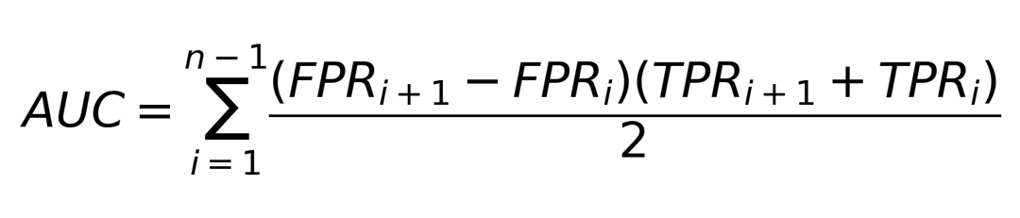
The Area Under the Curve (AUC) was computed as the trapezoidal-rule integral of the ROC curve:

where the FPR and TPR pairs are ordered by ascending FPR across the n candidate thresholds. AUC has a direct probabilistic interpretation: it is equivalent to the probability that a randomly selected damaged Upazila receives a higher forecast score than a randomly selected undamaged Upazila. AUC = 1.0 indicates perfect discrimination, AUC = 0.5 indicates performance equivalent to random guessing (the diagonal reference line), and AUC < 0.5 indicates a forecast that is systematically inverted relative to the observed outcome. Following standard conventions for discrimination statistics^{47,48}, AUC values were interpreted as: 0.5–0.6 no meaningful discrimination, 0.6–0.7 poor, 0.7–0.8 fair, 0.8–0.9 good, and 0.9–1.0 excellent.
AUC was computed independently for each exposure variable and each cyclone, using the same forecast–observed merged records employed elsewhere in the validation. Because AUC does not depend on any single threshold choice, it was used as a diagnostic complement to the No-Impact threshold optimization and the kappa-based severity calibration: a low AUC indicates that the underlying forecast score has limited capacity to separate damaged from undamaged Upazilas regardless of how the threshold is subsequently tuned, whereas a high AUC indicates that threshold and severity-class optimization are operating on a genuinely informative signal. AUC, together with the Spearman rank correlation and the quadratic-weighted kappa, was reported as one of three complementary headline statistics summarizing detection, ranking and categorical agreement, respectively.
Categorical Severity Performance and Cyclone-Specific Kappa Optimization
To evaluate how reliably the model distinguishes relative damage severity, predictions were assessed across four ordered classes: No Impact, Low, Moderate/Medium, and High. As a preliminary check, a one-sided Mann–Whitney U test was conducted to verify that predicted impact scores were significantly higher in damaged locations than in non-damaged locations, thereby assessing overall group separation without assuming normality⁴⁹.
Where a damage category recorded no positive DDM observations for a given event, the test statistic is undefined and the category is reported as not evaluable rather than as a null result. Where DDM count and repair-expenditure records implied different damaged Upazila sets for the same typology, reflecting cases in which structural damage was recorded without an accompanying repair cost entry, statistics were computed and reported separately for each variable. No correction for multiple comparisons was applied across the tested typologies and lead times, as the Mann-Whitney screen serves as a preliminary verification of predictive signal presence prior to continuous modelling rather than as a primary confirmatory inference; the false discovery risk is therefore accepted in exchange for sensitivity to weak but real signals at the screening stage.
The Department of Disaster Management (DDM) records provide continuous observed loss or damage values but do not contain predefined categorical severity classes. Because realized damage magnitude and its distribution vary substantially among cyclone events, observed severity was categorized on an event-specific basis rather than by imposing a single absolute damage threshold across all cyclones. For each cyclone and damage variable, zero-valued DDM observations were retained as No Impact, while positive records (D > 0) were divided into Low, Medium, and High using two ordered positive cut-points (C₁ < C₂). Candidate cut-point pairs were evaluated against the forecast severity classes using Quadratic-Weighted Cohen’s Kappa (κw)^{50,51}:
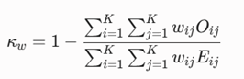
where K = 4, Oᵢⱼ represents the observed confusion matrix, Eᵢⱼ is the expected chance-agreement matrix, and quadratic disagreement weights were assigned according to the squared distance between the ordered categories:
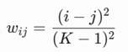
To prevent the observed severity definition from changing with forecast lead time, the cut-point optimization was performed jointly for the 24-, 48-, and 72-h forecasts of each cyclone. For every candidate pair (C₁, C₂), quadratic-weighted Kappa was calculated separately for the three lead times, and the three values were averaged. The candidate pair producing the highest mean quadratic-weighted Kappa was selected as the single cyclone-specific DDM severity partition for that damage variable.
κ̄_{w} = (κ_{w,24} + κ_{w,48} + κ_{w,72}) / 3

Once selected, the same DDM cut-points were held fixed for all three forecast lead times of that cyclone. Thus, the 24-, 48-, and 72-h forecasts were evaluated against an identical observed severity classification, allowing differences among lead times to reflect changes in forecast performance rather than changes in the observational class boundaries. Cyclone-specific cuts were retained because the DDM values represent event-specific realized impacts whose absolute magnitude depends on cyclone severity, spatial extent, exposure, vulnerability, and reported ground damage. Accordingly, these classes represent relative observed severity within each cyclone and are not intended as universal operational damage thresholds.
To reduce degenerate partitions, candidate high cut-points equal to the maximum positive DDM value were excluded so that the High category remained populated. The exhaustive search results were retained for sensitivity assessment, enabling the selected maximum-agreement partition to be interpreted relative to alternative admissible cut-point combinations rather than as an isolated threshold solution.
Using the resulting four-by-four confusion matrix, categorical performance was summarized through Exact Agreement for cases on the matrix diagonal, Adjacent Disagreement for one-level severity differences, and Off-Category Disagreement for errors spanning two or more severity classes. Quadratic-weighted Kappa was reported separately for each lead time using the cyclone-specific fixed DDM classes. This event-relative severity analysis was used to assess whether the forecast-derived categorical severity ordering corresponded to the spatial ordering of realized ground impacts recorded by DDM, complementing the continuous association and binary impact-verification components of the overall evaluation framework.
Data availability
The datasets compiled and analyzed over the course of this study are available upon reasonable request. The relevant URLs are as follows. Agricultural data: fAPAR data. (https://data.jrc.ec.europa.eu/dataset/1aac79d8-0d68-4f1c-a40f-b6e362264e50). Vulnerability Data: INFORM Risk Index for Bangladesh. (https://drmkc.jrc.ec.europa.eu/inform-index/INFORM-Subnational-Risk/Bangladesh). Housing Data: Building footprint. (https://gee-community-catalog.org/projects/global_buildings/). The Forecasted Hazard Dataset can be available upon reasonable request.
Code Availability Statement
The custom scripts and data analysis used in this study are publicly available in the GitHub repository [https://github.com/ibrahim-abdullah16/IBF-Analysis.git]
Reference
- World Meteorological Organization. The Global Climate 2011–2020: A Decade of Accelerating Climate Change. United Nations (2023).
- Willcock, S., Cooper, G. S., Addy, J. & Dearing, J. A. Earlier collapse of Anthropocene ecosystems driven by multiple faster and noisier drivers. Nat. Sustain. 6, 1331–1342 (2023).
- Saleem, A. et al. Securing a sustainable future: the climate change threat to agriculture, food security, and sustainable development goals. J. Umm Al-Qura Univ. Appl. Sci. 11, 595–611 (2024).
- Niraula, D. Impact-based risk forecasting and hydro-meteorological disasters. in Hydrometeorological Hazards (eds Ruin, I. & Anquetin, S.) 525–536. Edward Elgar Publishing (2022).
- Choudhury, M.-U.-I., Haque, C. E. & Doberstein, B. Adaptive governance and community resilience to cyclones in coastal Bangladesh: addressing the problem of fit, social learning, and institutional collaboration. Environ. Sci. Policy 124, 580–592 (2021).
- Shultz, J. M., Russell, J. & Espinel, Z. Epidemiology of tropical cyclones: the dynamics of disaster, disease, and development. Epidemiol. Rev. 27, 21–35 (2005).
- Margulis, S. et al. Economics of Adaptation to Climate Change: Synthesis Report. World Bank (2010).
- Haque, U. et al. Reduced death rates from cyclones in Bangladesh: what more needs to be done? Bull. World Health Organ. 90, 150–156 (2012).
- Zaman, T. et al. An overview of disaster risk reduction and anticipatory action in Bangladesh. Front. Clim. 4, 944736 (2022).
- ReliefWeb. Bangladesh Cyclone Amphan Joint Needs Assessment (31 May 2020). https://reliefweb.int/report/bangladesh/bangladesh-cyclone-amphan-joint-needs-assessment-31-may-2020 (2020).
- Rahman, M. M. et al. Households' vulnerability assessment: empirical evidence from cyclone-prone area of Bangladesh. Geosci. Lett. 10, 26 (2023).
- ReliefWeb. Bangladesh: Cyclone Mocha Humanitarian Response Situation Report. https://reliefweb.int/report/bangladesh/bangladesh-cyclone-mocha-humanitarian-response-situation-report-14-may-2023 (2023).
- ReliefWeb. Bangladesh: Cyclone Remal — Operation Update, Emergency Appeal No. MDRBD035. https://reliefweb.int/report/bangladesh/bangladesh-cyclone-remal-operation-update-emergency-appeal-no-mdrbd035 (2024).
- Kam, P. M. et al. Impact-based forecasting of tropical cyclone-related human displacement to support anticipatory action. Nat. Commun. 15, 8795 (2024).
- Terti, G., Anquetin, S. & Ruin, I. Social impacts: integrating dynamic social vulnerability in impact-based weather forecasting. in Hydrometeorological Hazards (eds Ruin, I. & Anquetin, S.). Elsevier (2022).
- Potter, S., Harrison, S. & Kreft, P. The benefits and challenges of implementing impact-based severe weather warning systems: perspectives of weather, flood, and emergency management personnel. Weather Clim. Soc. 13, 303–314 (2021).
- Sedhain, S., van den Homberg, M., Teklesadik, A., van Aalst, M. & Kerle, N. Evaluating impact-based forecasting models for tropical cyclone anticipatory action. Int. J. Disaster Risk Reduct. 129, 105782 (2025).
- E, G. Data-driven impact-based forecasting for tropical cyclones in the Philippines. Figshare (2025).
- Kooshki Forooshani, M. et al. Towards a global impact-based forecasting model for tropical cyclones. Nat. Hazards Earth Syst. Sci. 24, 309–329 (2024).
- Hoque, M. A.-A., Pradhan, B., Ahmed, N., Ahmed, B. & Alamri, A. Cyclone vulnerability assessment of the western coast of Bangladesh. Geomat. Nat. Hazards Risk 12, 198–221 (2021).
- Bernard, A., Long, N., Becker, M., Khan, M. J. U. & Fanchette, S. Bangladesh's vulnerability to cyclonic coastal flooding. Nat. Hazards Earth Syst. Sci. 22, 729–751 (2022).
- Islam, M. R. Tropical cyclones in Bangladesh: retrospective analysis of storm information, disaster statistics, and preparedness. Environ. Res. Commun. 7, 015003 (2025).
- Niha, F. T. et al. Integrated simulation and risk mapping of Cyclone 'Remal' (2024) over the Bangladesh coast using WRF and AHP-GIS framework. Trop. Cyclone Res. Rev. https://doi.org/10.1016/j.tcrr.2026.02.005 (2026).
- Khan, M. J. U. et al. Storm surge hazard over Bengal delta: a probabilistic–deterministic modelling approach. Nat. Hazards Earth Syst. Sci. 22, 2359–2379 (2022).
- Khan, M. J. U. et al. Towards an efficient storm surge and inundation forecasting system over the Bengal delta: chasing the Supercyclone Amphan. Nat. Hazards Earth Syst. Sci. 21, 2523–2541 (2021).
- Mamun, A. A. et al. Assessment of spatial cyclone surge susceptibility through GIS-based AHP multi-criteria analysis and frequency ratio: a case study from the Bangladesh coast. Geomat. Nat. Hazards Risk 15, 2368071 (2024).
- Lee, D., Ahmadul, H., Patz, J. A. & Block, P. Predicting social and health vulnerability to floods in Bangladesh. Nat. Hazards Earth Syst. Sci. 21, 1807–1823 (2021).
- Holle, R. L. et al. Fatalities related to lightning occurrence and agriculture in Bangladesh. Int. J. Disaster Risk Reduct. 41, 101264 (2019).
- Islam, M. S. & Schmidlin, T. W. Lightning hazard safety measures and awareness in Bangladesh. Nat. Hazards 101, 103–124 (2020).
- Marin-Ferrer, M., Vernaccini, L. & Poljansek, K. Index for Risk Management — INFORM: Concept and Methodology, Version 2017. Publications Office of the European Union (2017).
- European Centre for Medium-Range Weather Forecasts. ECMWF Integrated Forecasting System. https://www.ecmwf.int (accessed March 2025).
- Indian National Centre for Ocean Information Services. Storm Surge Early Warning System. https://incois.gov.in (accessed January 2026).
- Japan Meteorological Agency, Meteorological Research Institute. Storm Surge Forecast Model. JMA (2023).
- Bangladesh Meteorological Department. Official Website. https://live4.bmd.gov.bd (accessed March 2025).
- Sirko, W. et al. Continental-scale building detection from high resolution satellite imagery. Preprint at arXiv https://arxiv.org/abs/2107.12283 (2021).
- VIDA. Google-Microsoft Open Buildings — Combined by VIDA. https://beta.source.coop/repositories/vida/google-microsoft-open-buildings (accessed February 2026).
- Meroni, M. et al. A global near real-time filtered 500 m 10-day FPAR dataset from MODIS and VIIRS instruments, suited for operational agricultural monitoring and crop yield forecasting. Open MIND https://doi.org/10.2905/jrc.kj998w0 (2025).
- Eilers, P. H. C. A perfect smoother. Anal. Chem. 75, 3631–3636 (2003).
- Department of Disaster Management, Bangladesh. Post-Disaster Damage and Needs Assessment Data. DDM (2022–2024).
- Box, G. E. P. & Cox, D. R. An analysis of transformations. J. R. Stat. Soc. B 26, 211–252 (1964).
- Yeo, I.-K. & Johnson, R. A. A new family of power transformations to improve normality or symmetry. Biometrika 87, 954–959 (2000).
- Tukey, J. W. Exploratory Data Analysis. Addison-Wesley (1977).
- Pearson, K. Note on regression and inheritance in the case of two parents. Proc. R. Soc. Lond. 58, 240–242 (1895).
- Spearman, C. The proof and measurement of association between two things. Am. J. Psychol. 15, 72–101 (1904).
- Kendall, M. G. A new measure of rank correlation. Biometrika 30, 81–93 (1938).
- Wilks, D. S. Statistical Methods in the Atmospheric Sciences 3rd edn. Academic Press (2011).
- Hosmer, D. W. & Lemeshow, S. Applied Logistic Regression 2nd edn. Wiley (2000).
- Swets, J. A. Measuring the accuracy of diagnostic systems. Science 240, 1285–1293 (1988).
- Mann, H. B. & Whitney, D. R. On a test of whether one of two random variables is stochastically larger than the other. Ann. Math. Stat. 18, 50–60 (1947).
- Cohen, J. A coefficient of agreement for nominal scales. Educ. Psychol. Meas. 20, 37–46 (1960).
- Cohen, J. Weighted kappa: nominal scale agreement with provision for scaled disagreement or partial credit. Psychol. Bull. 70, 213–220 (1968).
- Zhang, X. et al. High-fidelity tropical cyclone prediction improves public risk communication and disaster mitigation. Preprint at EGUsphere https://doi.org/10.5194/egusphere-egu26-4651 (2026).
- Rubinyi, S. et al. High-resolution synthetic population mapping for quantifying disparities in disaster impacts: an application in the Bangladesh coastal zone. Front. Environ. Sci. 10, 1033579 (2022).
- Dimasaka, J., Geiß, C. & So, E. Global mapping of exposure and physical vulnerability dynamics in least developed countries using remote sensing and machine learning. Preprint at arXiv https://arxiv.org/abs/2404.01748 (2024).
- Nederhoff, K. et al. Accounting for uncertainties in forecasting tropical-cyclone-induced compound flooding. Geosci. Model Dev. 17, 1789–1811 (2024).
- Malmgren-Hansen, D., Sohnesen, T. P., Fisker, P. & Báez, J. E. Sentinel-1 change detection analysis for cyclone damage assessment in urban environments. Remote Sens. 12, 2409 (2020).
Acknowledgements
The team is grateful to the support provided by Muhammad Tanjilur Rahman and Ashik Uzzaman for Dataset collection and research assistance.
Author Contributions Statement
R.H.K. conceptualized and designed the project and A.U.B.N. assisted with it. R.H.K. and A.U.B.N. developed the methodology. R.B.A. and M.I.A. completed the formal analysis. R.B.A. wrote the original manuscript draft and M.I.A provided assistance. M.I.A. and R.B.A. created manuscript visualizations with feedback from A.U.B.N. All authors contributed to manuscript revision, read, and approved the submitted version.
Competing interests
The authors declare no competing interests.

Additional Information
Supplementary Materials
Table S1a. Preliminary Verification (Mann-Whitney U Test) for Cyclone Remal (24h, 48h, 72h).
Lead  Time | Variable | n  (Damaged) | n  (Undamaged) | MW U  Statistic | p-value | Sig.  (p<0.05) | r_rb
24h | Kacha Houses (count & cost) | 127 | 27 | 2,670.0 | <0.0001 | Yes | 0.557
24h | Semi-Pucca Houses (count & cost) | 73 | 81 | 4,000.0 | 0.0001 | Yes | 0.353
24h | Pucca Houses (count & cost) | 14 | 140 | 1,134.5 | 0.1666 | No | 0.158
24h | Total Houses (count & cost) | 131 | 23 | 2,492.0 | <0.0001 | Yes | 0.654
24h | Kacha Loss | 127 | 27 | 2,670.0 | <0.0001 | Yes | 0.557
24h | Semi-Pucca Loss | 73 | 81 | 4,000.0 | 0.0001 | Yes | 0.353
24h | Pucca Loss | 14 | 140 | 1,134.5 | 0.1666 | No | 0.158
24h | Total Housing Loss | 131 | 23 | 2,492.0 | <0.0001 | Yes | 0.654
24h | Fully Damaged Land (area & loss) | 67 | 87 | 3,781.5 | 0.0008 | Yes | 0.298
24h | Partially Damaged Land (area & loss) | 97 | 57 | 3,183.5 | 0.0587 | No | 0.152
24h | Total Damaged Land (area & loss) | 109 | 45 | 3,181.0 | 0.0019 | Yes | 0.297
48h | Kacha Houses (count & cost) | 127 | 27 | 2,649.0 | <0.0001 | Yes | 0.545
48h | Semi-Pucca Houses (count & cost) | 73 | 81 | 4,099.0 | <0.0001 | Yes | 0.386
48h | Pucca Houses (count & cost) | 14 | 140 | 1,284.5 | 0.0280 | Yes | 0.311
48h | Total Houses (count & cost) | 131 | 23 | 2,450.0 | <0.0001 | Yes | 0.626
48h | Kacha Loss | 127 | 27 | 2,649.0 | <0.0001 | Yes | 0.545
48h | Semi-Pucca Loss | 73 | 81 | 4,099.0 | <0.0001 | Yes | 0.386
48h | Pucca Loss | 14 | 140 | 1,284.5 | 0.0280 | Yes | 0.311
48h | Total Housing Loss | 131 | 23 | 2,450.0 | <0.0001 | Yes | 0.626
48h | Fully Damaged Land (area & loss) | 67 | 87 | 3,963.5 | 0.0001 | Yes | 0.36
48h | Partially Damaged Land (area & loss) | 97 | 57 | 3,218.5 | 0.0448 | Yes | 0.164
48h | Total Damaged Land (area & loss) | 109 | 45 | 3,351.0 | 0.0002 | Yes | 0.366
72h | Kacha Houses (count & cost) | 127 | 27 | 2,385.0 | 0.0007 | Yes | 0.391
72h | Semi-Pucca Houses (count & cost) | 73 | 81 | 3,665.5 | 0.0052 | Yes | 0.24
72h | Pucca Houses (count & cost) | 14 | 140 | 1,059.5 | 0.3098 | No | 0.081
72h | Total Houses (count & cost) | 131 | 23 | 2,237.0 | 0.0001 | Yes | 0.485
72h | Kacha Loss | 127 | 27 | 2,385.0 | 0.0007 | Yes | 0.391
72h | Semi-Pucca Loss | 73 | 81 | 3,665.5 | 0.0052 | Yes | 0.24
72h | Pucca Loss | 14 | 140 | 1,059.5 | 0.3098 | No | 0.081
72h | Total Housing Loss | 131 | 23 | 2,237.0 | 0.0001 | Yes | 0.485
72h | Fully Damaged Land (area & loss) | 67 | 87 | 3,778.5 | 0.0008 | Yes | 0.296
72h | Partially Damaged Land (area & loss) | 97 | 57 | 2,990.0 | 0.1999 | No | 0.082
72h | Total Damaged Land (area & loss) | 109 | 45 | 3,110.0 | 0.0045 | Yes | 0.268

Table S2a. Preliminary Verification (Mann-Whitney U Test) for Cyclone Midhili (24h, 48h, 72h).
Lead  Time | Variable | n  (Damaged) | n  (Undamaged) | MW U  Statistic | p-value | Sig.  (p<0.05) | r_rb
24h | Pucca Houses | NE | NE | NE | NE | NE | NE
24h | Semi-Pucca Houses (count & cost) | 21 | 77 | 846.0 | 0.3744 | No | 0.046
24h | Kacha Houses -- count | 53 | 45 | 1,388.5 | 0.0817 | No | 0.164
24h | Kacha Houses -- cost | 52 | 46 | 1,384.5 | 0.0904 | No | 0.158
24h | Total Houses -- count | 58 | 40 | 1,345.0 | 0.0912 | No | 0.159
24h | Total Houses -- cost | 57 | 41 | 1,346.0 | 0.1012 | No | 0.152
24h | Fully Damaged Land (area & loss) | 30 | 68 | 920.5 | 0.7796 | No | -0.098
24h | Partially Damaged Land (area & loss) | 54 | 44 | 1,797.0 | <0.0001 | Yes | 0.513
24h | Total Damaged Land (area & loss) | 71 | 27 | 1,399.5 | 0.0002 | Yes | 0.46
48h | Pucca Houses | NE | NE | NE | NE | NE | NE
48h | Semi-Pucca Houses (count & cost) | 21 | 77 | 835.0 | 0.4109 | No | 0.033
48h | Kacha Houses -- count | 53 | 45 | 1,420.5 | 0.0524 | No | 0.191
48h | Kacha Houses -- cost | 52 | 46 | 1,424.5 | 0.0523 | No | 0.191
48h | Total Houses -- count | 58 | 40 | 1,351.0 | 0.0843 | No | 0.165
48h | Total Houses -- cost | 57 | 41 | 1,360.0 | 0.0845 | No | 0.164
48h | Fully Damaged Land (area & loss) | 30 | 68 | 1,006.0 | 0.5445 | No | -0.014
48h | Partially Damaged Land (area & loss) | 54 | 44 | 1,743.5 | <0.0001 | Yes | 0.468
48h | Total Damaged Land (area & loss) | 71 | 27 | 1,390.0 | 0.0003 | Yes | 0.45
72h | Pucca Houses | NE | NE | NE | NE | NE | NE
72h | Semi-Pucca Houses (count & cost) | 21 | 77 | 811.0 | 0.4931 | No | 0.003
72h | Kacha Houses -- count | 53 | 45 | 1,312.0 | 0.1981 | No | 0.1
72h | Kacha Houses -- cost | 52 | 46 | 1,330.0 | 0.1710 | No | 0.112
72h | Total Houses -- count | 58 | 40 | 1,233.0 | 0.3001 | No | 0.063
72h | Total Houses -- cost | 57 | 41 | 1,256.0 | 0.2655 | No | 0.075
72h | Fully Damaged Land (area & loss) | 30 | 68 | 980.5 | 0.6211 | No | -0.039
72h | Partially Damaged Land (area & loss) | 54 | 44 | 1,485.0 | 0.0171 | Yes | 0.25
72h | Total Damaged Land (area & loss) | 71 | 27 | 1,155.5 | 0.0591 | No | 0.206
Table S3a. Preliminary Verification (Mann-Whitney U Test) for Cyclone Sitrang (24h, 48h, 72h).
Lead  Time | Variable | n  (Damaged) | n  (Undamaged) | MW U  Statistic | p-value | Sig.  (p<0.05) | r_rb
24h | Pucca Houses (count & cost) | 6 | 150 | 387.5 | 0.7192 | No | -0.139
24h | Semi-Pucca Houses (count & cost) | 36 | 120 | 1,845.5 | 0.9074 | No | -0.146
24h | Kacha Houses (count & cost) | 119 | 37 | 2,078.0 | 0.6973 | No | -0.056
24h | Total Houses (count & cost) | 124 | 32 | 1,953.0 | 0.5550 | No | -0.016
24h | Kacha Loss | 119 | 37 | 2,078.0 | 0.6973 | No | -0.056
24h | Semi-Pucca Loss | 36 | 120 | 1,845.5 | 0.9074 | No | -0.146
24h | Pucca Loss | 6 | 150 | 387.5 | 0.7192 | No | -0.139
24h | Total Housing Loss | 124 | 32 | 1,953.0 | 0.5550 | No | -0.016
24h | Fully Damaged Land (area & loss) | 50 | 106 | 2,872.0 | 0.2001 | No | 0.084
24h | Partially Damaged Land (area & loss) | 103 | 53 | 3,409.0 | 0.0055 | Yes | 0.249
24h | Total Damaged Land (area & loss) | 112 | 44 | 3,041.0 | 0.0116 | Yes | 0.234
48h | Pucca Houses (count & cost) | 6 | 150 | 364.5 | 0.7860 | No | -0.19
48h | Semi-Pucca Houses (count & cost) | 36 | 120 | 1,904.5 | 0.8592 | No | -0.118
48h | Kacha Houses (count & cost) | 119 | 37 | 2,136.0 | 0.6083 | No | -0.03
48h | Total Houses (count & cost) | 124 | 32 | 1,996.0 | 0.4799 | No | 0.006
48h | Kacha Loss | 119 | 37 | 2,136.0 | 0.6083 | No | -0.03
48h | Semi-Pucca Loss | 36 | 120 | 1,904.5 | 0.8592 | No | -0.118
48h | Pucca Loss | 6 | 150 | 364.5 | 0.7860 | No | -0.19
48h | Total Housing Loss | 124 | 32 | 1,996.0 | 0.4799 | No | 0.006
48h | Fully Damaged Land (area & loss) | 50 | 106 | 2,737.0 | 0.3713 | No | 0.033
48h | Partially Damaged Land (area & loss) | 103 | 53 | 3,275.0 | 0.0207 | Yes | 0.2
48h | Total Damaged Land (area & loss) | 112 | 44 | 2,866.0 | 0.0569 | No | 0.163
72h | Pucca Houses (count & cost) | 6 | 150 | 356.5 | 0.8068 | No | -0.208
72h | Semi-Pucca Houses (count & cost) | 36 | 120 | 1,677.5 | 0.9789 | No | -0.223
72h | Kacha Houses (count & cost) | 119 | 37 | 2,095.0 | 0.6721 | No | -0.048
72h | Total Houses (count & cost) | 124 | 32 | 1,966.0 | 0.5324 | No | -0.009
72h | Kacha Loss | 119 | 37 | 2,095.0 | 0.6721 | No | -0.048
72h | Semi-Pucca Loss | 36 | 120 | 1,677.5 | 0.9789 | No | -0.223
72h | Pucca Loss | 6 | 150 | 356.5 | 0.8068 | No | -0.208
72h | Total Housing Loss | 124 | 32 | 1,966.0 | 0.5324 | No | -0.009
72h | Fully Damaged Land (area & loss) | 50 | 106 | 2,370.0 | 0.8566 | No | -0.106
72h | Partially Damaged Land (area & loss) | 103 | 53 | 2,999.0 | 0.1571 | No | 0.099
72h | Total Damaged Land (area & loss) | 112 | 44 | 2,557.0 | 0.3578 | No | 0.038
Table S1b. Continuous Log-Transformed Regression Skill for Cyclone Remal (24h, 48h, 72h).
Lead  Time | Variable | Samples  (n) | Pearson r  (R²) | Spearman ρ  (τ) | p-value  (Pearson) | Sig.  (p<0.05)
24h | Kacha Houses | 127 | 0.397 (0.158) | 0.398 (0.270) | 3.76e-06 | Yes
24h | Semi-Pucca Houses | 73 | 0.378 (0.143) | 0.341 (0.231) | 0.000968 | Yes
24h | Pucca Houses | 14 | 0.034 (0.001) | 0.000 (-0.056) | 0.908 | No
24h | Total Houses | 131 | 0.392 (0.154) | 0.382 (0.258) | 3.61e-06 | Yes
24h | Kacha Loss | 127 | 0.361 (0.130) | 0.354 (0.243) | 3.08e-05 | Yes
24h | Semi-Pucca Loss | 73 | 0.361 (0.130) | 0.362 (0.261) | 0.00173 | Yes
24h | Pucca Loss | 14 | 0.001 (0.000) | 0.031 (-0.022) | 0.998 | No
24h | Total Housing Loss | 131 | 0.358 (0.128) | 0.347 (0.237) | 2.63e-05 | Yes
24h | Fully Damaged Land | 66 | 0.443 (0.196) | 0.530 (0.384) | 0.000198 | Yes
24h | Partially Damaged Land | 96 | 0.449 (0.202) | 0.549 (0.390) | 4.38e-06 | Yes
24h | Total Damaged Land | 108 | 0.511 (0.261) | 0.570 (0.399) | 1.59e-08 | Yes
24h | Fully Damaged Loss | 66 | 0.304 (0.092) | 0.423 (0.304) | 0.0132 | Yes
24h | Partially Damaged Loss | 96 | 0.410 (0.168) | 0.531 (0.380) | 3.3e-05 | Yes
24h | Total Agri Loss | 108 | 0.476 (0.227) | 0.574 (0.400) | 1.88e-07 | Yes
48h | Kacha Houses | 127 | 0.498 (0.248) | 0.436 (0.303) | 2.59e-09 | Yes
48h | Semi-Pucca Houses | 73 | 0.482 (0.233) | 0.400 (0.274) | 1.55e-05 | Yes
48h | Pucca Houses | 14 | 0.252 (0.064) | 0.070 (0.011) | 0.385 | No
48h | Total Houses | 131 | 0.498 (0.248) | 0.429 (0.294) | 1.46e-09 | Yes
48h | Kacha Loss | 127 | 0.475 (0.226) | 0.384 (0.263) | 1.65e-08 | Yes
48h | Semi-Pucca Loss | 73 | 0.539 (0.291) | 0.468 (0.331) | 8.47e-07 | Yes
48h | Pucca Loss | 14 | 0.260 (0.068) | 0.081 (0.044) | 0.369 | No
48h | Total Housing Loss | 131 | 0.486 (0.236) | 0.391 (0.266) | 4.03e-09 | Yes
48h | Fully Damaged Land | 66 | 0.533 (0.284) | 0.597 (0.439) | 4.03e-06 | Yes
48h | Partially Damaged Land | 96 | 0.539 (0.291) | 0.610 (0.428) | 1.42e-08 | Yes
48h | Total Damaged Land | 108 | 0.567 (0.321) | 0.615 (0.431) | 1.65e-10 | Yes
48h | Fully Damaged Loss | 66 | 0.441 (0.195) | 0.507 (0.356) | 0.000208 | Yes
48h | Partially Damaged Loss | 96 | 0.471 (0.222) | 0.548 (0.387) | 1.25e-06 | Yes
48h | Total Agri Loss | 108 | 0.539 (0.290) | 0.607 (0.421) | 1.78e-09 | Yes
72h | Kacha Houses | 127 | 0.343 (0.118) | 0.269 (0.175) | 7.86e-05 | Yes
72h | Semi-Pucca Houses | 73 | 0.377 (0.142) | 0.271 (0.193) | 0.00103 | Yes
72h | Pucca Houses | 14 | 0.162 (0.026) | 0.013 (-0.078) | 0.579 | No
72h | Total Houses | 131 | 0.340 (0.116) | 0.256 (0.165) | 7.09e-05 | Yes
72h | Kacha Loss | 127 | 0.323 (0.105) | 0.229 (0.156) | 0.00021 | Yes
72h | Semi-Pucca Loss | 73 | 0.412 (0.170) | 0.299 (0.209) | 0.000295 | Yes
72h | Pucca Loss | 14 | 0.118 (0.014) | 0.009 (-0.044) | 0.688 | No
72h | Total Housing Loss | 131 | 0.325 (0.105) | 0.224 (0.153) | 0.000154 | Yes
72h | Fully Damaged Land | 66 | 0.475 (0.226) | 0.560 (0.420) | 5.47e-05 | Yes
72h | Partially Damaged Land | 96 | 0.533 (0.284) | 0.616 (0.438) | 2.22e-08 | Yes
72h | Total Damaged Land | 108 | 0.568 (0.323) | 0.613 (0.432) | 1.43e-10 | Yes
72h | Fully Damaged Loss | 66 | 0.358 (0.128) | 0.444 (0.327) | 0.00316 | Yes
72h | Partially Damaged Loss | 96 | 0.448 (0.201) | 0.520 (0.366) | 4.59e-06 | Yes
72h | Total Agri Loss | 108 | 0.502 (0.252) | 0.562 (0.390) | 3.22e-08 | Yes
Table S2b. Continuous Log-Transformed Regression Skill for Cyclone Midhili (24h, 48h, 72h). Pucca houses excluded (insufficient positive-pair observations).
Lead  Time | Variable | Samples  (n) | Pearson r  (R²) | Spearman ρ  (τ) | p-value  (Pearson) | Sig.  (p<0.05)
24h | Semi-Pucca Houses | 21 | -0.251 (0.063) | -0.140 (-0.098) | 0.272 | No
24h | Kacha Houses | 53 | -0.053 (0.003) | -0.051 (-0.036) | 0.708 | No
24h | Kacha Loss | 52 | 0.189 (0.036) | 0.120 (0.070) | 0.180 | No
24h | Total Houses | 58 | -0.067 (0.004) | -0.061 (-0.043) | 0.620 | No
24h | Total Housing Loss | 57 | 0.181 (0.033) | 0.123 (0.092) | 0.179 | No
24h | Fully Damaged Land | 30 | 0.433 (0.188) | 0.605 (0.403) | 0.0168 | Yes
24h | Partially Damaged Land | 54 | 0.462 (0.214) | 0.407 (0.267) | 0.000433 | Yes
24h | Total Damaged Land | 71 | 0.565 (0.320) | 0.557 (0.383) | 2.81e-07 | Yes
24h | Fully Damaged Loss | 30 | 0.180 (0.032) | 0.263 (0.198) | 0.341 | No
24h | Partially Damaged Loss | 54 | 0.298 (0.089) | 0.268 (0.196) | 0.0288 | Yes
24h | Total Agri Loss | 71 | 0.322 (0.104) | 0.338 (0.242) | 0.00621 | Yes
48h | Semi-Pucca Houses | 21 | -0.230 (0.053) | -0.127 (-0.088) | 0.316 | No
48h | Kacha Houses | 53 | -0.062 (0.004) | -0.030 (-0.026) | 0.659 | No
48h | Kacha Loss | 52 | 0.123 (0.015) | 0.038 (0.020) | 0.385 | No
48h | Total Houses | 58 | -0.067 (0.004) | -0.032 (-0.030) | 0.617 | No
48h | Total Housing Loss | 57 | 0.125 (0.016) | 0.049 (0.038) | 0.355 | No
48h | Fully Damaged Land | 30 | 0.389 (0.151) | 0.623 (0.445) | 0.0336 | Yes
48h | Partially Damaged Land | 54 | 0.283 (0.080) | 0.300 (0.203) | 0.0382 | Yes
48h | Total Damaged Land | 71 | 0.411 (0.169) | 0.470 (0.331) | 0.000367 | Yes
48h | Fully Damaged Loss | 30 | 0.117 (0.014) | 0.249 (0.193) | 0.537 | No
48h | Partially Damaged Loss | 54 | 0.160 (0.026) | 0.194 (0.138) | 0.248 | No
48h | Total Agri Loss | 71 | 0.202 (0.041) | 0.277 (0.195) | 0.0904 | No
72h | Semi-Pucca Houses | 21 | -0.259 (0.067) | -0.166 (-0.132) | 0.256 | No
72h | Kacha Houses | 53 | -0.078 (0.006) | -0.033 (-0.023) | 0.578 | No
72h | Kacha Loss | 52 | 0.115 (0.013) | 0.020 (0.005) | 0.416 | No
72h | Total Houses | 58 | -0.064 (0.004) | -0.031 (-0.025) | 0.635 | No
72h | Total Housing Loss | 57 | 0.123 (0.015) | 0.043 (0.030) | 0.362 | No
72h | Fully Damaged Land | 30 | 0.458 (0.210) | 0.584 (0.410) | 0.0109 | Yes
72h | Partially Damaged Land | 54 | 0.326 (0.106) | 0.263 (0.192) | 0.0161 | Yes
72h | Total Damaged Land | 71 | 0.446 (0.199) | 0.428 (0.306) | 9.77e-05 | Yes
72h | Fully Damaged Loss | 30 | 0.236 (0.056) | 0.245 (0.186) | 0.209 | No
72h | Partially Damaged Loss | 54 | 0.189 (0.036) | 0.152 (0.122) | 0.172 | No
72h | Total Agri Loss | 71 | 0.263 (0.069) | 0.282 (0.208) | 0.0268 | Yes

Table S3b. Continuous Log-Transformed Regression Skill for Cyclone Sitrang (24h, 48h, 72h).
Lead  Time | Variable | Samples  (n) | Pearson r  (R²) | Spearman ρ  (τ) | p-value  (Pearson) | Sig.  (p<0.05)
24h | Pucca Houses | 6 | -0.031 (0.001) | 0.314 (0.200) | 0.954 | No
24h | Semi-Pucca Houses | 35 | 0.209 (0.044) | 0.198 (0.140) | 0.229 | No
24h | Kacha Houses | 118 | 0.120 (0.014) | 0.213 (0.143) | 0.197 | No
24h | Total Houses | 123 | 0.123 (0.015) | 0.209 (0.144) | 0.176 | No
24h | Kacha Loss | 118 | 0.065 (0.004) | 0.095 (0.058) | 0.483 | No
24h | Semi-Pucca Loss | 35 | -0.068 (0.005) | -0.043 (-0.049) | 0.699 | No
24h | Pucca Loss | 6 | -0.206 (0.043) | 0.200 (0.067) | 0.695 | No
24h | Total Housing Loss | 123 | 0.015 (0.000) | 0.051 (0.033) | 0.870 | No
24h | Fully Damaged Land | 49 | 0.066 (0.004) | 0.012 (0.002) | 0.654 | No
24h | Partially Damaged Land | 103 | 0.139 (0.019) | 0.182 (0.124) | 0.163 | No
24h | Total Damaged Land | 111 | 0.208 (0.043) | 0.239 (0.158) | 0.0284 | Yes
24h | Fully Damaged Loss | 49 | 0.198 (0.039) | 0.059 (0.051) | 0.172 | No
24h | Partially Damaged Loss | 103 | 0.119 (0.014) | 0.186 (0.123) | 0.233 | No
24h | Total Agri Loss | 111 | 0.216 (0.046) | 0.240 (0.166) | 0.0231 | Yes
48h | Pucca Houses | 6 | -0.086 (0.007) | 0.086 (0.067) | 0.871 | No
48h | Semi-Pucca Houses | 35 | 0.218 (0.048) | 0.206 (0.150) | 0.208 | No
48h | Kacha Houses | 118 | 0.146 (0.021) | 0.238 (0.155) | 0.114 | No
48h | Total Houses | 123 | 0.150 (0.022) | 0.240 (0.159) | 0.098 | No
48h | Kacha Loss | 118 | 0.072 (0.005) | 0.112 (0.066) | 0.441 | No
48h | Semi-Pucca Loss | 35 | -0.066 (0.004) | -0.042 (-0.042) | 0.708 | No
48h | Pucca Loss | 6 | -0.243 (0.059) | -0.143 (-0.067) | 0.643 | No
48h | Total Housing Loss | 123 | 0.025 (0.001) | 0.075 (0.043) | 0.785 | No
48h | Fully Damaged Land | 49 | 0.075 (0.006) | -0.003 (0.000) | 0.608 | No
48h | Partially Damaged Land | 103 | 0.170 (0.029) | 0.231 (0.152) | 0.0858 | No
48h | Total Damaged Land | 111 | 0.232 (0.054) | 0.269 (0.171) | 0.0143 | Yes
48h | Fully Damaged Loss | 49 | 0.204 (0.042) | 0.059 (0.031) | 0.160 | No
48h | Partially Damaged Loss | 103 | 0.166 (0.027) | 0.243 (0.156) | 0.0942 | No
48h | Total Agri Loss | 111 | 0.244 (0.059) | 0.267 (0.186) | 0.00997 | Yes
72h | Pucca Houses | 6 | 0.111 (0.012) | 0.086 (0.067) | 0.834 | No
72h | Semi-Pucca Houses | 35 | 0.264 (0.070) | 0.142 (0.127) | 0.125 | No
72h | Kacha Houses | 118 | 0.095 (0.009) | 0.114 (0.074) | 0.305 | No
72h | Total Houses | 123 | 0.119 (0.014) | 0.130 (0.085) | 0.189 | No
72h | Kacha Loss | 118 | -0.010 (0.000) | -0.007 (-0.001) | 0.917 | No
72h | Semi-Pucca Loss | 35 | 0.033 (0.001) | -0.023 (-0.022) | 0.850 | No
72h | Pucca Loss | 6 | -0.098 (0.010) | -0.029 (-0.067) | 0.854 | No
72h | Total Housing Loss | 123 | -0.024 (0.001) | -0.042 (-0.025) | 0.792 | No
72h | Fully Damaged Land | 49 | -0.066 (0.004) | -0.086 (-0.062) | 0.653 | No
72h | Partially Damaged Land | 103 | 0.049 (0.002) | 0.058 (0.041) | 0.623 | No
72h | Total Damaged Land | 111 | 0.082 (0.007) | 0.086 (0.057) | 0.394 | No
72h | Fully Damaged Loss | 49 | 0.121 (0.015) | 0.052 (0.034) | 0.408 | No
72h | Partially Damaged Loss | 103 | 0.020 (0.000) | 0.066 (0.035) | 0.842 | No
72h | Total Agri Loss | 111 | 0.059 (0.004) | 0.084 (0.055) | 0.535 | No

Figure S1. ROC-AUC Performance of Impact Forecasts for Cyclone Remal. Receiver Operating Characteristic (ROC) curves evaluating impact forecast performance for Cyclone Remal across a) 1-day, b) 2-day, and c) 3-day lead times (rows, top to bottom). The columns assess four impact indicators (left to right): Total Number of Damaged Households, Monetary Damage for Households, Total Agriculture Land Area Damaged, and Monetary Damage for Agricultural Land. The blue solid line represents model performance with calculated AUC values, and the diagonal dashed line denotes a baseline no-skill forecast (AUC = 0.50).
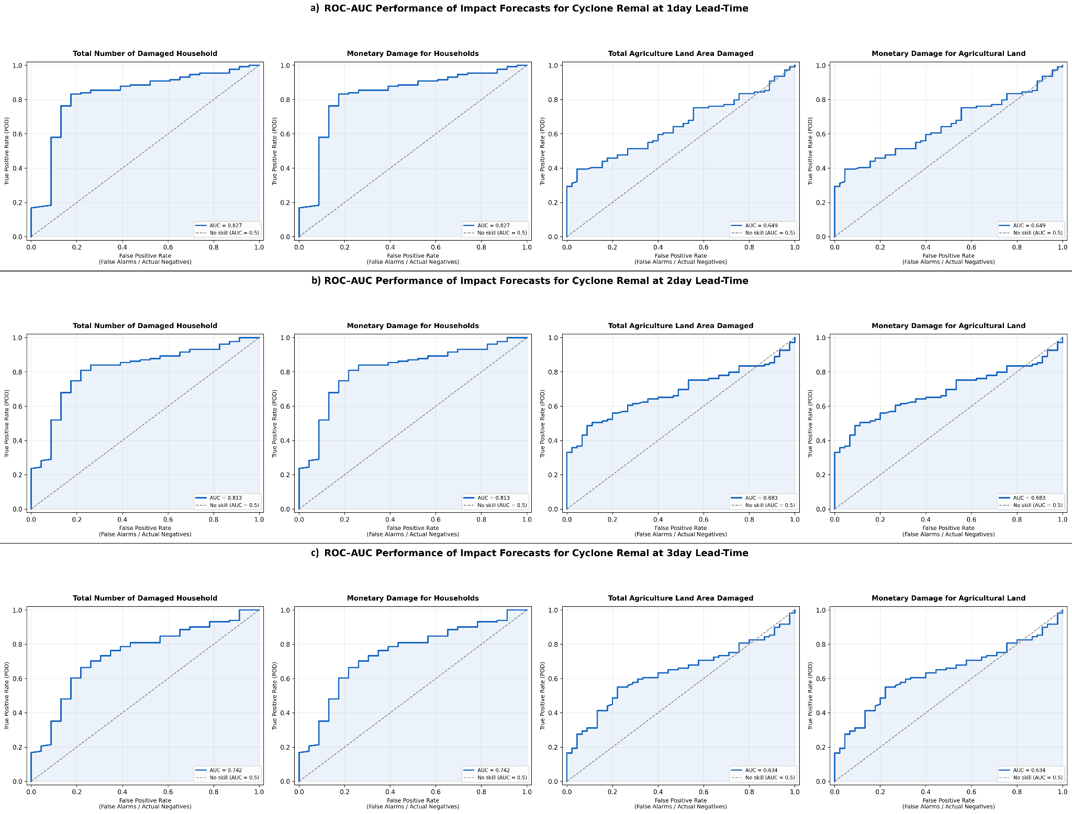

Figure S2. ROC-AUC Performance of Impact Forecasts for Cyclone Midhili. Receiver Operating Characteristic (ROC) curves evaluating impact forecast performance for Cyclone Midhili across a) 1-day, b) 2-day, and c) 3-day lead times (rows, top to bottom). The columns assess four impact indicators (left to right): Total Number of Damaged Households, Monetary Damage for Households, Total Agriculture Land Area Damaged, and Monetary Damage for Agricultural Land. The blue solid line represents model performance with calculated AUC values, and the diagonal dashed line denotes a baseline no-skill forecast (AUC = 0.50).
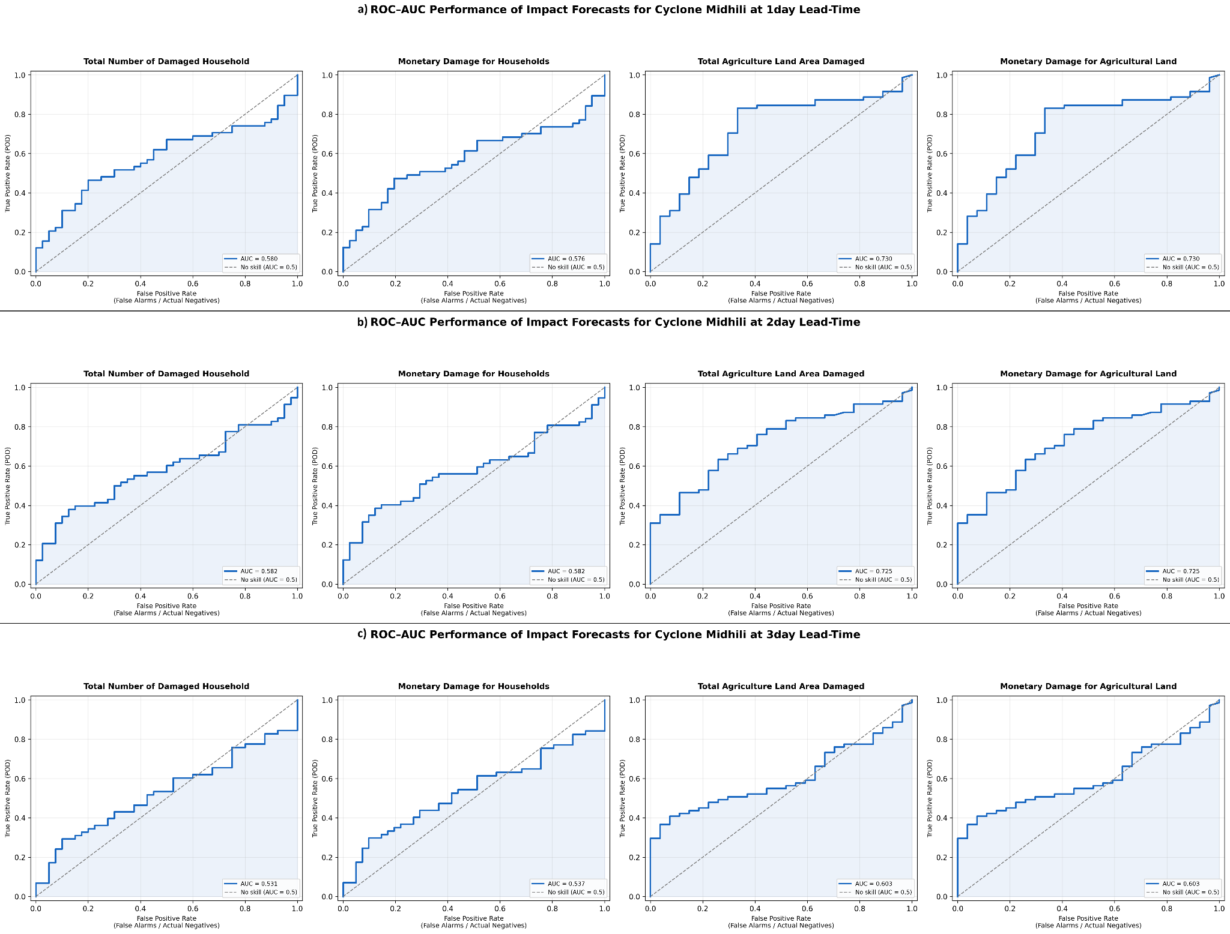
Figure S3. ROC-AUC Performance of Impact Forecasts for Cyclone Sitrang. Receiver Operating Characteristic (ROC) curves evaluating impact forecast performance for Cyclone Sitrang across 1-day, 2-day, and 3-day lead times (rows, top to bottom). The columns assess four impact indicators (left to right): Total Number of Damaged Households, Monetary Damage for Households, Total Agriculture Land Area Damaged, and Monetary Damage for Agricultural Land. The blue solid line represents model performance with calculated AUC values, and the diagonal dashed line denotes a baseline no-skill forecast (AUC = 0.50).
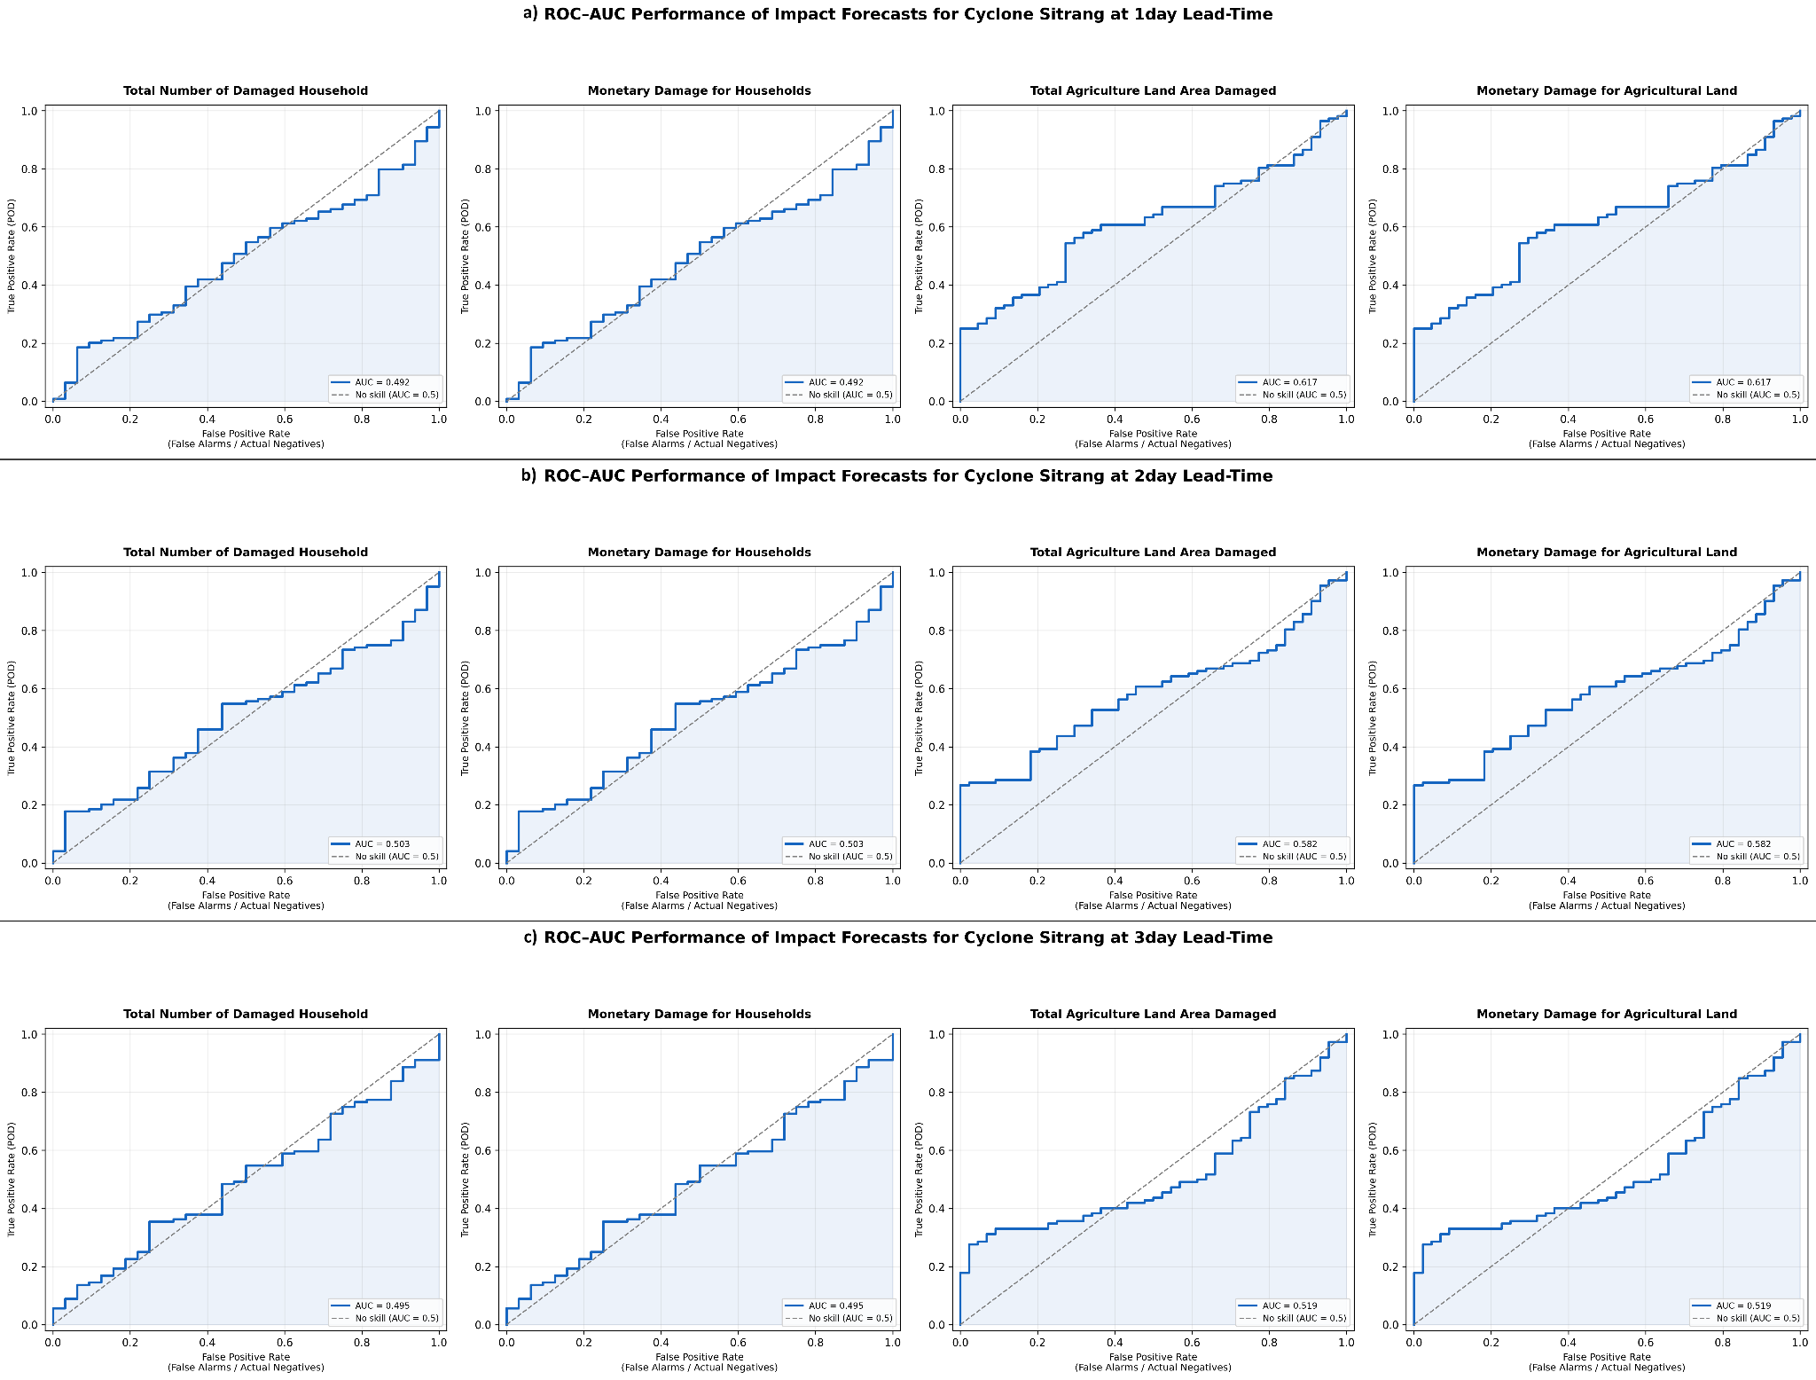
Correspondence and requests for materials should be addressed to Asif Uddin Bin Noor

