**Experiment-1: Find the signal of given sequence**

>> x=[1 5 4 -2 0 4];

stem(x)

xlabel(‘n’)

ylabel(‘x(n)’)

title(‘A sequence’)

grid on

**Output:**

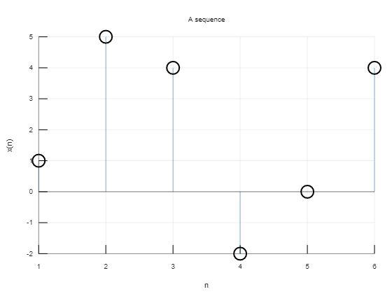

**Experiment-2: Find the signal of given sequence If array is given**

**>> x=[1 5 4 -2 0 4];**

**n=-2:1:3;**

**stem(n,x)**

**xlabel('n')**

**ylabel('x(n)')**

**title('A sequence')**

**grid on**

**Output:**

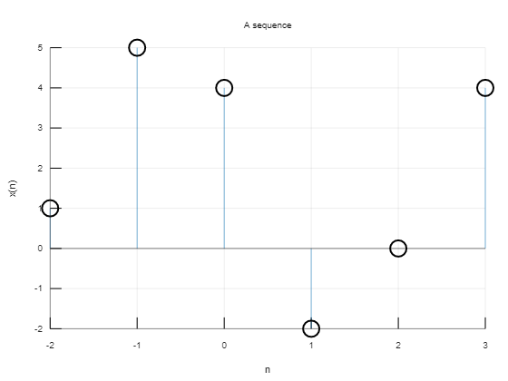

**Experiment-3:**

**>> n=0:1:120;**

**x=2*cos(0.12*pi*n+pi/6);**

**stem(n,x)**

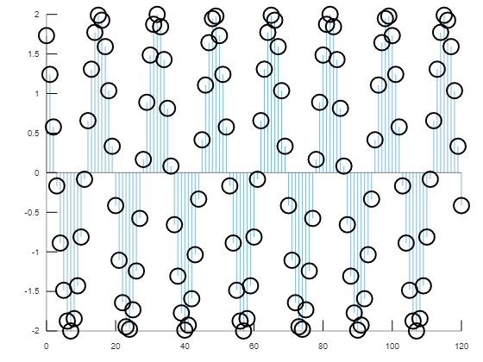

**Experiment-4:**

**>>n=0:1:20;**

**x=2*cos(sqrt(2)*pi*n+pi/6);**

**stem(n,x,'g*')**

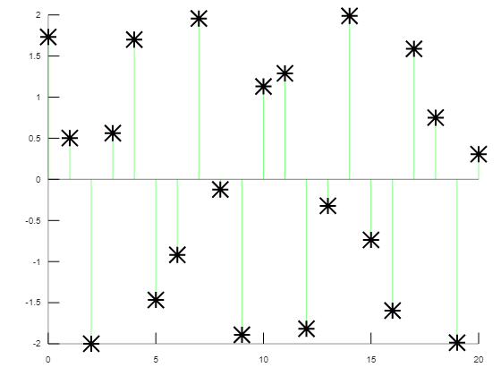

**Experiment-5:**

**>>x=[2 4 6 3 8]**

**x(1)**

**for i=1:6**

**E=E+abs(x(i))^2;**

**End**

**Output: ans = 2**

**Experiment-6:**

**x=[2 4 6 3 8]**

**E=0;**

**for i=1:6**

**E=E+abs(x(i))^2;**

**End**

**E**

**Output: E = 129**

**Experiment-7:**

**>>n=0:1:120;**

**a=.9;**

**x1=a.^n;**

**a=1.05;**

**x=a.^n;**

**stem(n,x,'rs')**

**hold on**

**stem(n,x2,'b<')**

**Output:**

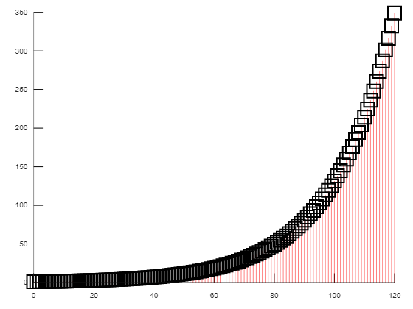

**Experiment-8:**

**>>n=0:1:120;**

**x=2*cos(sqrt(2)*pi*n+pi/6);**

**stem(n,x)**

**E=0;**

**for i=1:120;**

**E=E+abs(x(i))^2;**

**end;**

**Output:**