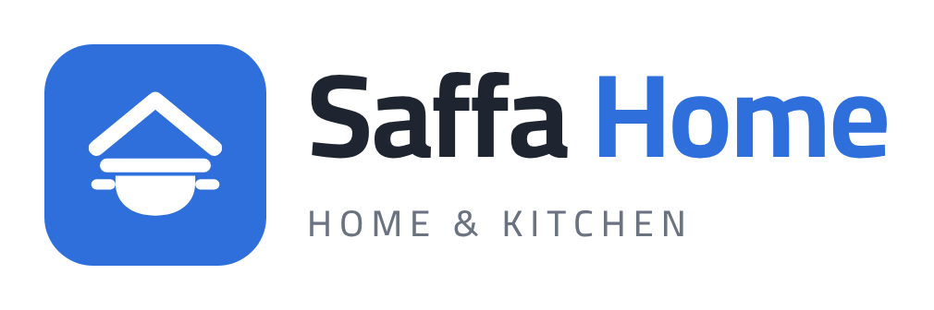

Marketing for Data Analysts
Marketing Domain Tutorial
The business process, the funnel, the definitions and the key KPIs, explained with the Saffa Home dataset
Data Analytics Course · Power BI · Sessions S27 – S29
Prepared by AbdelRahman Ashour
Saffa Home is a fictional company. The figures are generated at rates close to the Egyptian market, for teaching.

Contents
- Why a data analyst needs to understand marketing
- The business process: the customer journey
- The marketing funnel: TOFU, MOFU, BOFU and Retention
- Attribution: linking an ad to an order
- Channels and campaign objectives
- Core terms
- Key KPIs: definition, formula and value
- Reading the numbers correctly: ROAS, MER, break-even and CAC
- Egyptian seasons
- From business questions to dashboards
- The data model
- Exercises
How to use this tutorial
Read chapters 1 to 9 before you open Power BI. The goal is to understand the business first.
Every figure here is calculated on the whole dataset (January 2025 – June 2026) with no filters, so you can use it to check your own measures.

1. Why a data analyst needs to understand marketing
Your manager will not ask "is the data clean?". They will ask: how much did we spend on ads this month, and how much came back? Which channel should get more money, and which one should we stop?
An analyst who does not understand the business can produce a number that is correct as a formula and wrong in meaning. For example, calling a campaign successful because its ROAS is 2, when it is actually losing money because the gross margin is only 38%.

The story: Saffa Home
Saffa Home is a (fictional) Egyptian company that sells kitchenware, small appliances and home textiles online through its website and app, and delivers to every governorate in Egypt.
- It advertises on Facebook, Instagram, TikTok, Snapchat, Google and YouTube.
- It works with influencers, and ran a billboard campaign on the Ring Road during Ramadan.
- It uses WhatsApp, SMS and email to reach existing customers.
- 56% of orders are cash on delivery (COD), and the average order is about 2,500 EGP.
The question we answer throughout the course
The CMO said: "I want to know what every pound we spend on marketing actually does."

The data
The data covers 1 January 2025 to 30 June 2026 (18 months). The currency is the Egyptian pound (EGP).
Table | Type | Rows | Contents
FactOrders | Fact | 52,977 | One line per product per order (34,555 orders)
FactAdPerformance | Fact | 4,242 | Daily campaign performance: spend, impressions, clicks, sessions
DimDate | Dimension | 546 | Date, occasion (Ramadan, Eid…) and weekend flag
DimCampaign | Dimension | 43 | Campaigns: objective, budget, promo code
DimChannel | Dimension | 11 | Channels: Meta, TikTok, Google… plus Organic
DimProduct | Dimension | 58 | Products: category, price, cost
DimCustomer | Dimension | 21,753 | Customers: gender, age group, acquisition channel
DimGeography | Dimension | 34 | Cities, governorates and shipping zones

2. The business process: the customer journey
Marketing is not just "run an ad". It is a chain of steps. Each step has a number we can measure, and at each step some people drop out. We will follow a customer called Menna: she saw a cookware ad on Instagram during Ramadan, and came back to buy again on White Friday.
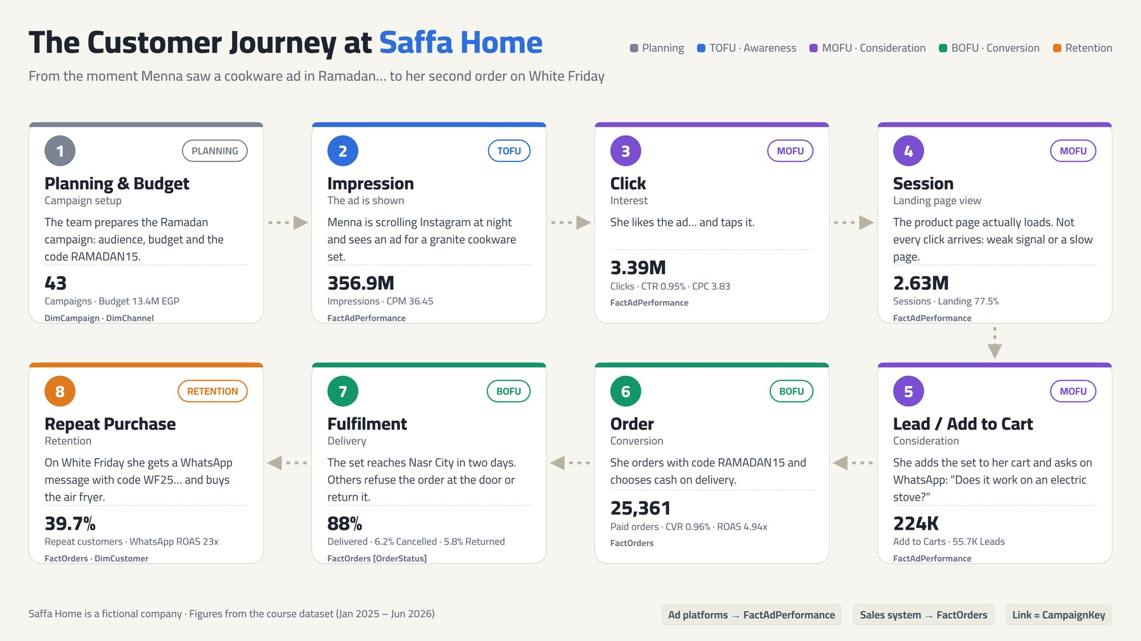
Figure 1: The customer journey at Saffa Home, from planning to repeat purchase
The journey is split across two systems
Steps 2 to 5 come from the ad platforms (FactAdPerformance).
Steps 6 to 8 come from the sales system (FactOrders).
The link between them is the campaign (CampaignKey). Chapter 4 explains how.

The 8 steps
# | Step | What happens | In the data | Table
1 | Planning & Budget | The team sets the campaign, objective, audience, channel and budget | 43 campaigns · 13.4M budget | DimCampaign
2 | Impression | The ad appears on screen. Every showing counts, even to the same person | 356.9M | FactAdPerformance
3 | Click | The customer clicks the ad | 3.39M | FactAdPerformance
4 | Session | The page actually loads. Not every click arrives (weak signal, slow page) | 2.63M | FactAdPerformance
5 | Lead / Add to Cart | Asks a question on WhatsApp (lead) or adds the product to the cart | 224K carts · 55.7K leads | FactAdPerformance
6 | Order | Places the order, often with a promo code | 25,361 from ads | FactOrders
7 | Fulfilment | The order is delivered, cancelled/refused at the door, or returned | 88% delivered | FactOrders
8 | Repeat | The customer buys again after a WhatsApp message or email | 39.7% repeat | FactOrders

3. The marketing funnel
Marketing works like a funnel: a very large number of people see the ad, some drop out at every stage, and a small number buy. At Saffa Home, out of every 1,000 clicks, only about 7 become an order.
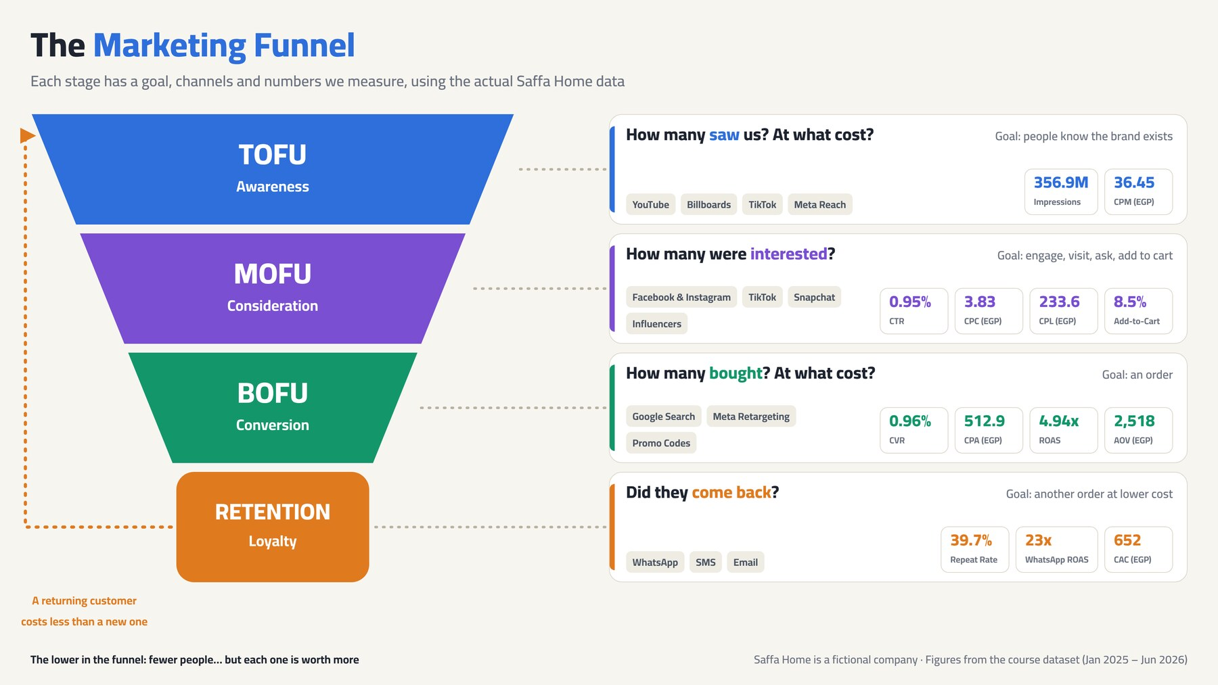
Figure 2: Funnel stages with their channels and KPIs

The stages
Stage | Goal | Typical channels | Measured by
TOFU · Awareness | People know the brand exists | YouTube, billboards, TikTok | Impressions, CPM
MOFU · Consideration | People engage and visit | Facebook & Instagram, TikTok, influencers | Clicks, CTR, CPC, sessions, leads
BOFU · Conversion | The customer buys | Google Search, Meta retargeting, promo codes | Orders, CVR, CPA, ROAS
Retention · Loyalty | The customer buys again at lower cost | WhatsApp, SMS, email | Repeat rate, CRM ROAS

The funnel in numbers
Stage | Count | % of previous | % of first
Ad clicks | 3,394,608 | — | 100%
Site sessions | 2,629,424 | 77.5% | 77.5%
Add to cart | 224,115 | 8.5% | 6.6%
Paid orders | 25,361 | 11.3% | 0.75%
The biggest drop in the funnel
91.5% of visitors leave without adding anything to the cart.
Discussion: if you were the CMO, would you fix the ad or the product page? (Answer: the ad already delivered the visit. The problem is on the page: price, photos, shipping, trust.)

4. Attribution: linking an ad to an order
Ad platforms know who saw and who clicked. The sales system knows who bought. The question is: which campaign did this order come from? The answer is called attribution.

The rules Saffa Home uses
- Last click: the order is credited to the last campaign the customer clicked before buying.
- Promo code: if the customer used a campaign code (for example RAMADAN15), the order is credited to that campaign.
- Organic & Direct: orders with no campaign go to a dedicated row in DimCampaign (CampaignKey = 43). This avoids an empty key that would show up in the report as (Blank).

The limits of last click
Last click is unfair to awareness campaigns. Someone who saw a YouTube ad might search for the brand on Google two days later and buy. The order is credited to Google Search, and YouTube gets nothing. That is why awareness ROAS looks low, and why it needs other measures (such as the lift in brand searches).
A rule for analysts
Any attribution figure is an estimate, not a fact. Always state how it was calculated.

5. Channels and campaign objectives

Channels
Each channel is paid differently (cost model) and plays a different role in the funnel. Figures cover the whole period.
Channel | Group | Cost model | Spend (EGP) | CPA | ROAS
Facebook & Instagram | Paid Social | CPM | 7,044,435 | 557.8 | 4.50
Google Search | Paid Search | CPC | 2,434,781 | 353.3 | 7.70
TikTok | Paid Social | CPM | 2,169,031 | 663.3 | 3.42
Influencers | Influencer | Flat fee | 549,239 | 435.2 | 5.90
Outdoor Billboards | Offline | Flat fee | 311,322 | 1,353.6 | 1.42
YouTube | Video | CPV | 223,839 | 2,984.5 | 1.16
Snapchat | Paid Social | CPM | 148,005 | 919.3 | 2.25
Email | CRM / Owned | Subscription | 67,344 | 140.6 | 18.67
SMS | CRM / Owned | Per message | 32,617 | 374.9 | 6.23
WhatsApp Business | CRM / Owned | Per message | 26,800 | 97.1 | 23.17
Total |  |  | 13,007,411 | 512.9 | 4.94
Red cells: channels with ROAS below break-even (2.63). On a last-click basis, they lose money.

Campaign objectives
Objective | Meaning | % of spend | ROAS
Conversion | Direct sales: retargeting, search, promo codes | 81.8% | 5.22
Traffic | Bring visits to the site | 12.2% | 3.37
Awareness | Make the brand known: YouTube, billboards | 5.0% | 1.88
Retention | Bring existing customers back: WhatsApp, email, SMS | 1.0% | 16.42
Worth discussing
Retention gets only 1% of the money and returns 16.4 EGP for every pound. Keeping a customer costs far less than finding a new one.

6. Core terms
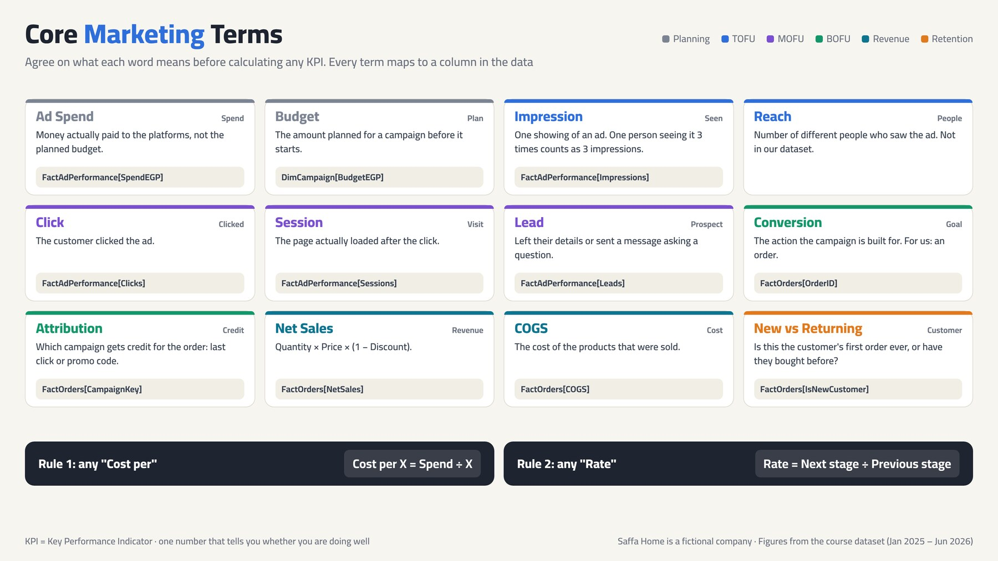
Figure 3: Core marketing terms
Term | Meaning
Ad Spend | Money actually paid to the platforms (not the planned budget).
Budget | The planned amount for a campaign: DimCampaign[BudgetEGP].
Impression | One showing of an ad. For CRM channels, one message sent. For billboards, the media owner's estimate.
Reach | The number of different people who saw the ad. Not in the data, but you must not confuse it with impressions.
Click | A tap or click on the ad.
Session | A visit to the site that actually loaded after the click.
Lead | A potential customer who left their details or sent a question.
Conversion | The action the campaign is built for. For us: an order.
Attribution | Crediting an order to a campaign (last click or promo code).
Net Sales | Quantity × price × (1 − discount).
COGS | Cost of goods sold.
New vs Returning | The customer's first order ever, or a customer who has bought before (FactOrders[IsNewCustomer]).
COD | Cash on delivery. Increases cancellations and refusals at the door.

7. Key KPIs
A KPI (Key Performance Indicator) is one number that tells you whether things are going well. Most marketing KPIs are one number divided by another, which is why DIVIDE is used so often in DAX.
Two rules that save memorising
Cost per X = Spend ÷ X. For example, CPC = Spend ÷ Clicks and CPA = Spend ÷ Orders.
Rate = next stage ÷ previous stage. For example, CTR = Clicks ÷ Impressions.
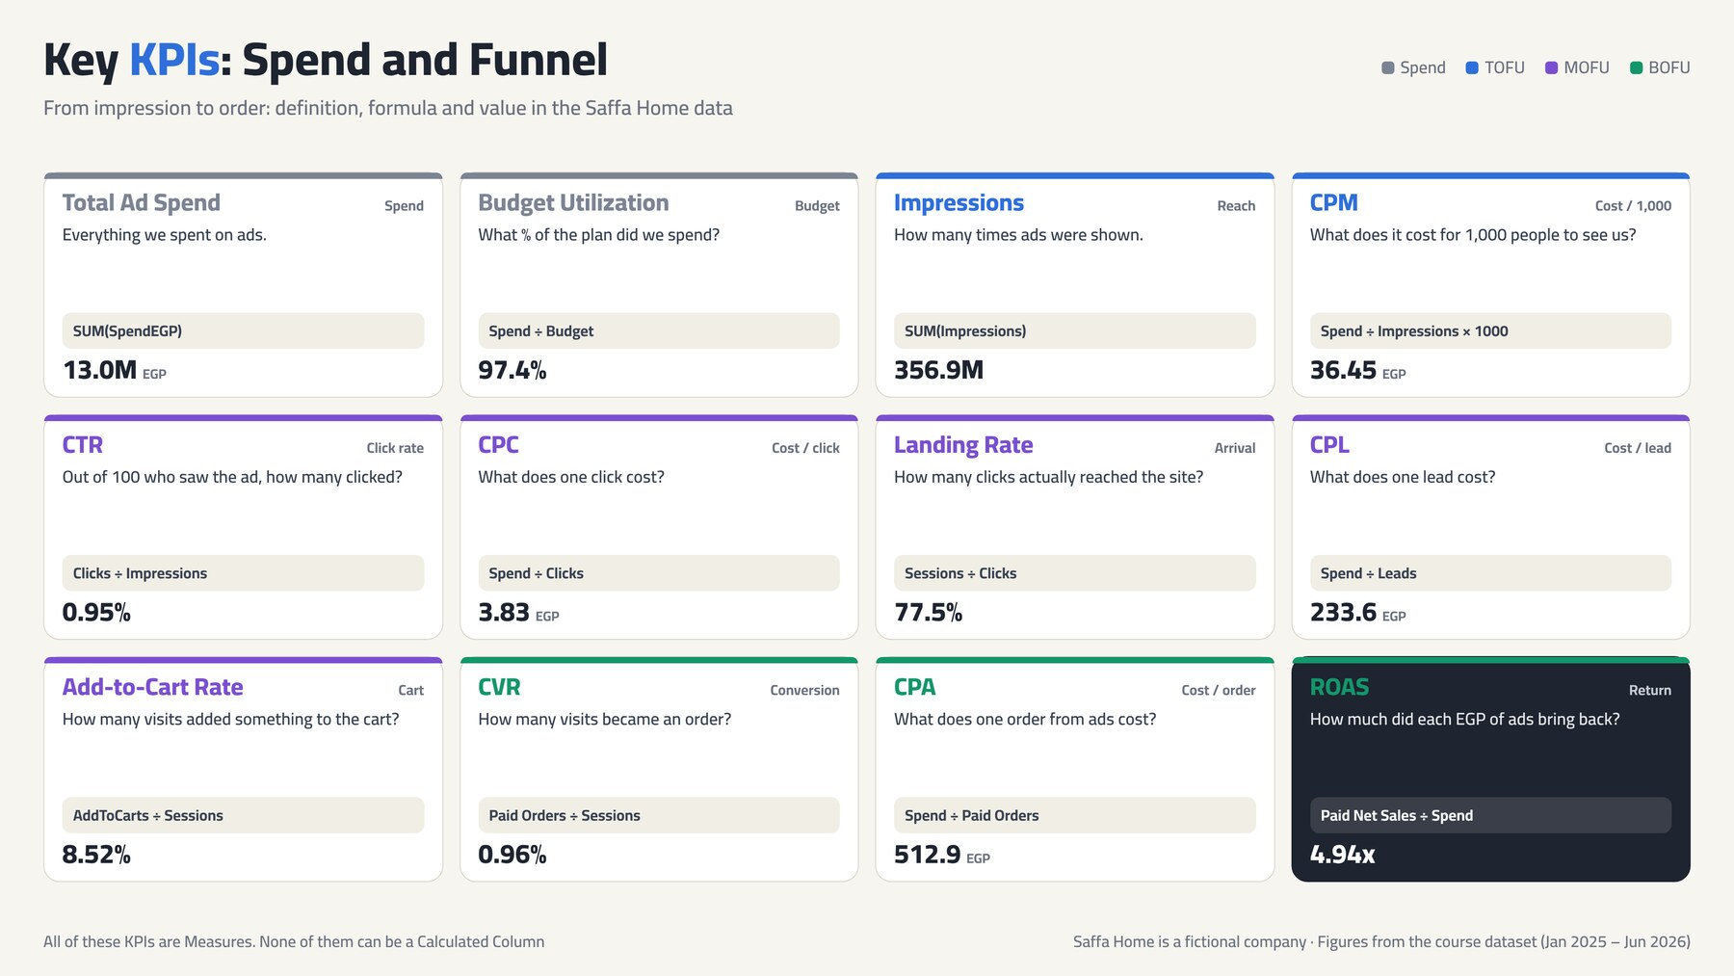
Figure 4: Spend and funnel KPIs
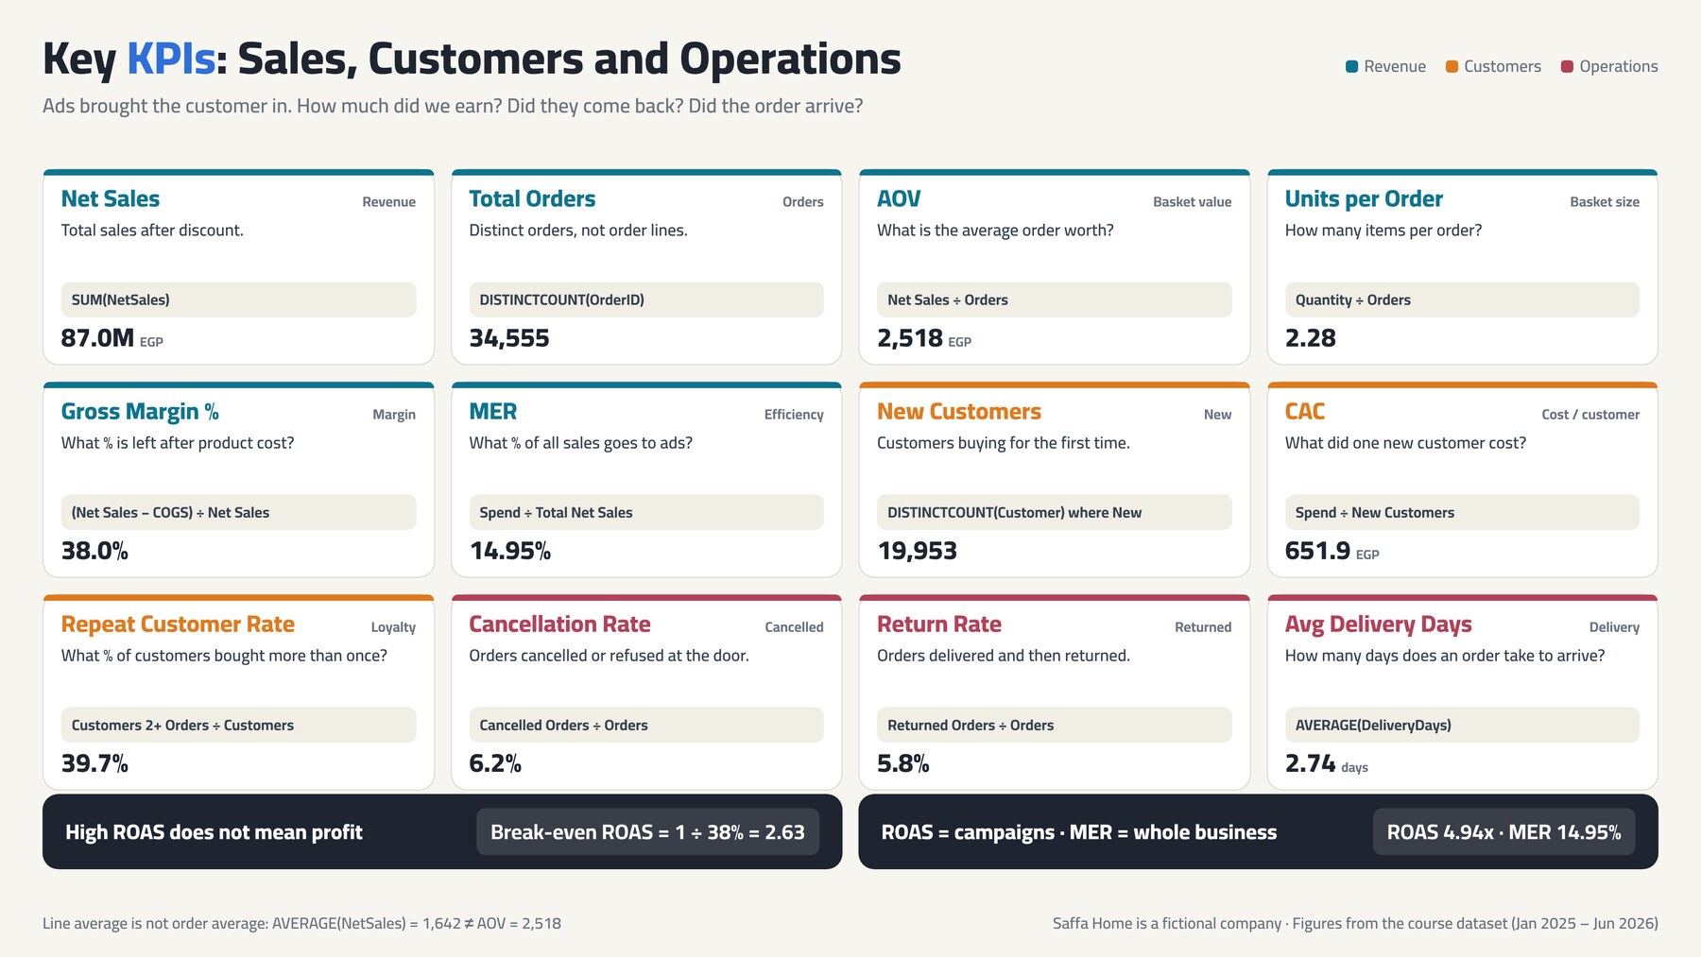
Figure 5: Sales, customer and operations KPIs

Full KPI table
KPI | Definition | Formula | Value
Total Ad Spend | Total spent on ads | SUM(SpendEGP) | 13,007,411
Budget Utilization % | Share of the budget spent | Spend ÷ Budget | 97.4%
Impressions | Times the ads were shown | SUM(Impressions) | 356,851,050
CPM | Cost per 1,000 impressions | Spend ÷ Impressions × 1,000 | 36.45
Clicks | Number of clicks | SUM(Clicks) | 3,394,608
CTR | Share of viewers who clicked | Clicks ÷ Impressions | 0.95%
CPC | Cost per click | Spend ÷ Clicks | 3.83
Landing Rate | Clicks that reached the site | Sessions ÷ Clicks | 77.5%
CPL | Cost per lead | Spend ÷ Leads | 233.6
Add-to-Cart Rate | Visits that added to cart | AddToCarts ÷ Sessions | 8.52%
CVR | Visits that became an order | Paid Orders ÷ Sessions | 0.96%
CPA | Cost per order from ads | Spend ÷ Paid Orders | 512.9
ROAS | Return on each EGP of ads | Paid Net Sales ÷ Spend | 4.94x
MER | Spend as a share of all sales | Spend ÷ Total Net Sales | 14.95%
Net Sales | Sales after discount | SUM(NetSales) | 87,020,341
Total Orders | Number of orders | DISTINCTCOUNT(OrderID) | 34,555
AOV | Average order value | Net Sales ÷ Orders | 2,518.3
Units per Order | Average items per order | Quantity ÷ Orders | 2.28
Gross Margin % | Profit after product cost | (Net Sales − COGS) ÷ Net Sales | 38.0%
New Customers | First-time buyers | DISTINCTCOUNT(CustomerKey) where IsNewCustomer = 1 | 19,953
CAC | Cost per new customer | Spend ÷ New Customers | 651.9
Cancellation Rate | Orders cancelled or refused | Cancelled Orders ÷ Orders | 6.2%
Return Rate | Orders returned | Returned Orders ÷ Orders | 5.8%
Repeat Rate | Customers who bought more than once | Customers with 2+ orders ÷ Customers | 39.7%
Avg Delivery Days | Average days to deliver | AVERAGE(DeliveryDays) | 2.74
Amounts are in Egyptian pounds (EGP).

8. Reading the numbers correctly

ROAS vs MER
- ROAS counts only the sales that came from campaigns: 64.2M ÷ 13.0M = 4.94.
- MER looks at the whole picture, including organic: 13.0M ÷ 87.0M = 14.95%.
Why both? Ads influence people who buy later without clicking an ad. If ROAS stays flat while MER falls, the brand is growing.

Break-even ROAS
A high ROAS does not mean profit. With a 38% gross margin, every pound of sales leaves 0.38 after product cost.
The formula
Break-even ROAS = 1 ÷ Gross Margin % = 1 ÷ 0.38 = 2.63
Any campaign with ROAS below 2.63 loses money, even if the number "looks good".
At Saffa Home, 8 of 42 campaigns are below this line.

CPA vs CAC
- CPA (512.9): the cost of any order from ads, whether the customer is new or returning.
- CAC (651.9): the cost of acquiring a new customer only. Always higher than CPA, because it divides by a smaller number.
A common mistake
Dividing spend by all rows of DimCustomer (21,753) gives CAC = 597.96, which is wrong. Divide by the new customers who bought in the period (19,953).

Simpson's paradox in Ramadan
Ramadan ROAS (4.39) is lower than on regular days (4.56). Yet if you look at each channel on its own, every channel does better in Ramadan. How?
Ramadan put 15.3% of its spend into awareness (YouTube and billboards), which returned only 1.39, compared with 4.2% on regular days. Remove awareness and Ramadan returns 4.93 vs 4.62. The problem is how the money was split, not Ramadan itself.

9. Egyptian seasons
Sales in Egypt follow the calendar of occasions. The column DimDate[Occasion] tags each day with its occasion, and "Regular" marks ordinary days.
Season | Days | Net Sales | Sales per day | ROAS
White Friday | 30 | 10.56M | 352K | 6.10
Eid El-Fitr | 10 | 1.75M | 175K | 5.97
Wedding Season | 112 | 20.37M | 182K | 5.86
Eid El-Adha | 12 | 2.13M | 177K | 5.74
New Year | 21 | 2.57M | 122K | 4.85
Regular days | 258 | 28.26M | 110K | 4.56
Ramadan | 59 | 16.03M | 272K | 4.39
Valentine's | 14 | 1.92M | 137K | 3.88
Back to School | 30 | 3.44M | 115K | 3.54

How to read the table
- White Friday has the highest sales per day and the highest ROAS: customers wait for the offers.
- Ramadan has the second-highest sales per day (272K, two and a half times a regular day), but a lower ROAS because of awareness spend.
- Wedding season is the longest season (112 days) with the largest total sales: newlyweds furnishing their homes.
- Back to school is the weakest season: the products are not school-related, so the money would work better elsewhere.

10. From business questions to dashboards
Each page of the report answers one question a manager asks. This is the most important design principle: start from the question, not from the visual.

0. Home
Question: The entry point
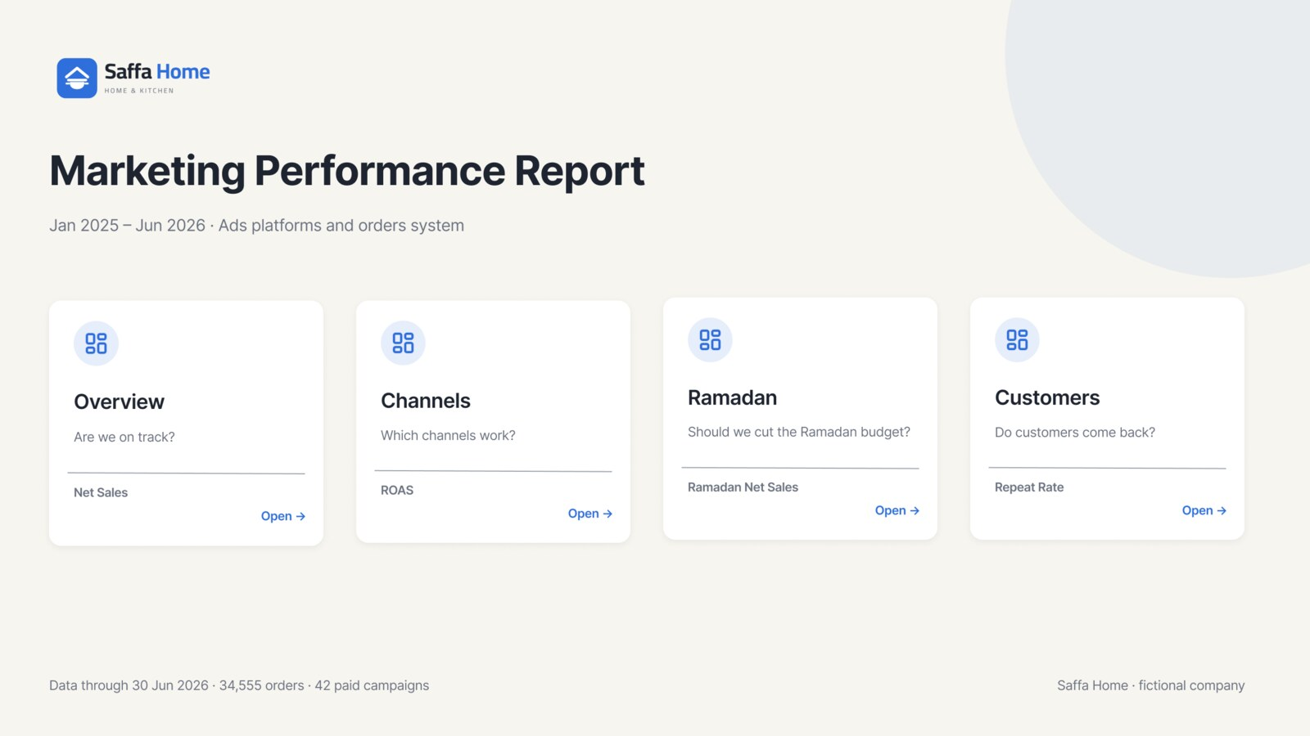
Home page design in Figma
Contents: Logo, report name and period, and four tiles. Each tile shows its page's question, one number and an Open button.

1. Executive Overview
Question: Are we on track?
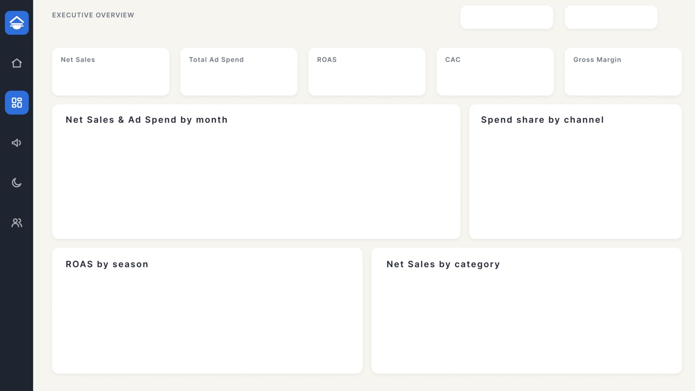
Executive Overview page design in Figma
Contents: KPIs: Net Sales 87.0M, Ad Spend 13.0M, ROAS 4.94, CAC 652, Gross Margin 38%. Below them: net sales and spend by month, spend share by channel, ROAS by season, and net sales by category.
Key message: Every EGP of ads returned 4.94, well above the 2.63 break-even.

2. Channel Performance
Question: Which channels work?
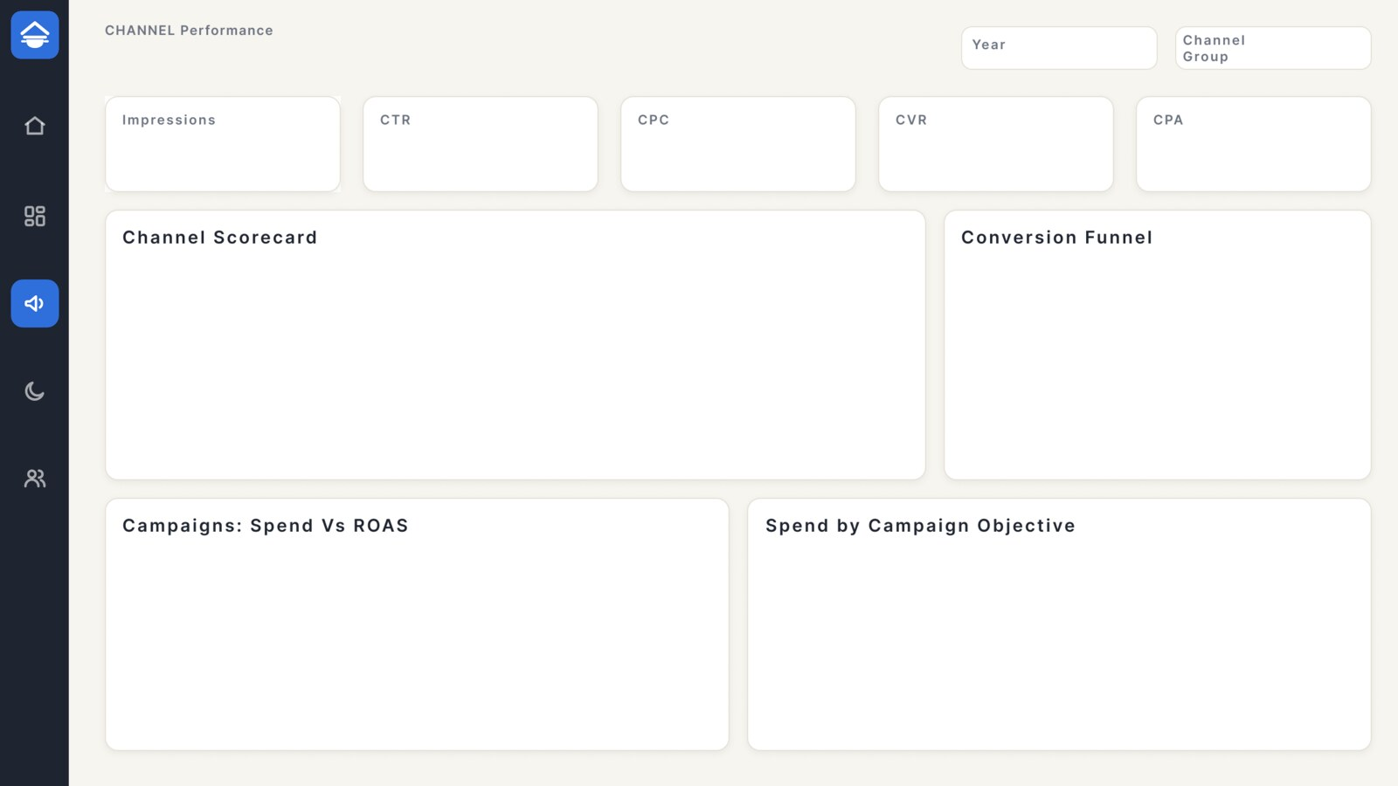
Channel Performance page design in Figma
Contents: Funnel KPIs (impressions, CTR, CPC, CVR, CPA), a channel scorecard with colour-coded ROAS, the conversion funnel, campaigns (spend vs ROAS with a break-even line), and spend by objective.
Key message: Google Search is the best channel at scale (ROAS 7.70). YouTube and billboards are below break-even.

3. Ramadan Deep Dive
Question: Should we cut the Ramadan budget?
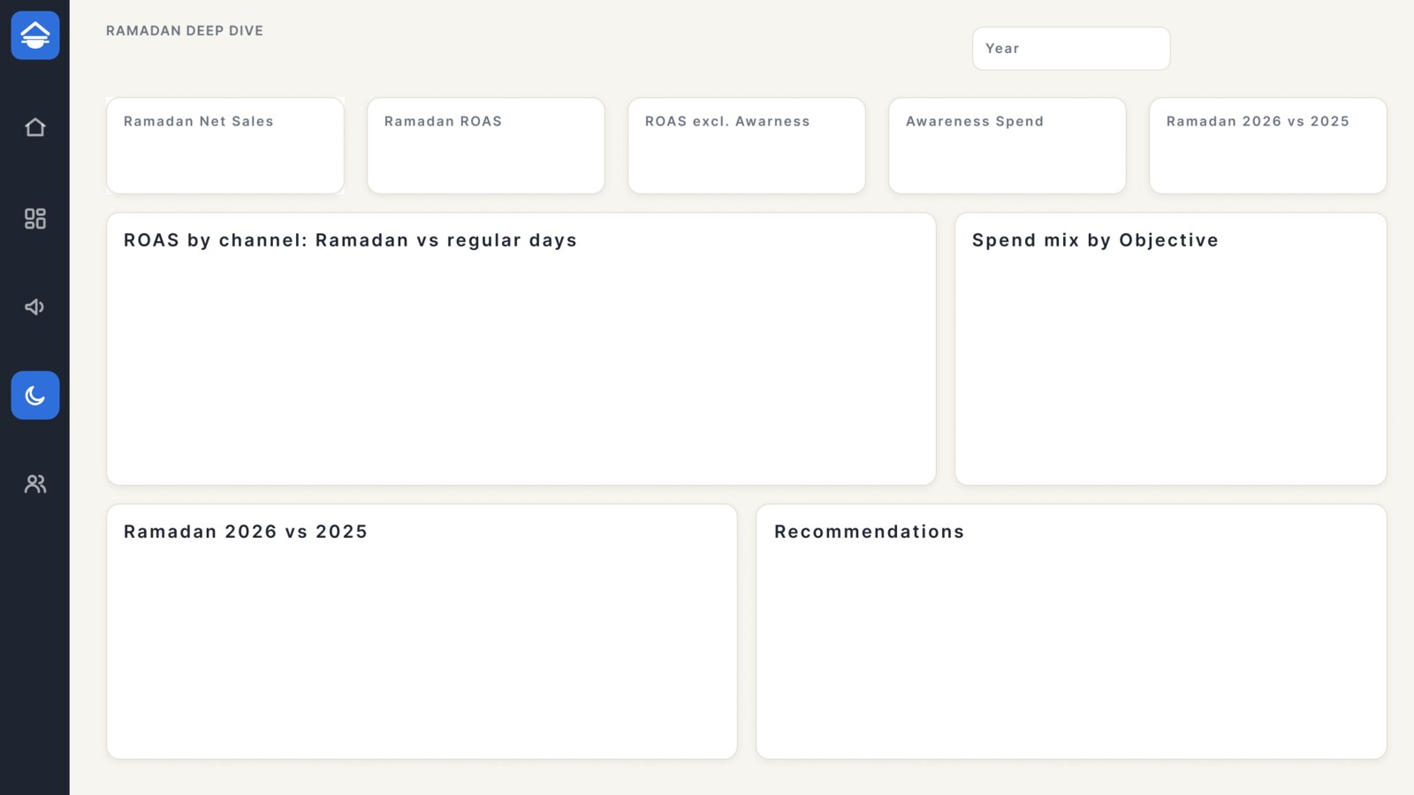
Ramadan Deep Dive page design in Figma
Contents: ROAS by channel in Ramadan vs regular days, spend mix by objective, Ramadan 2025 vs 2026, and recommendations.
Key message: No. Keep the budget and change the mix: in 2026 awareness spend fell 70% and Ramadan sales rose 21%.

4. Customers & Operations
Question: Do customers come back? Where are the operational problems?
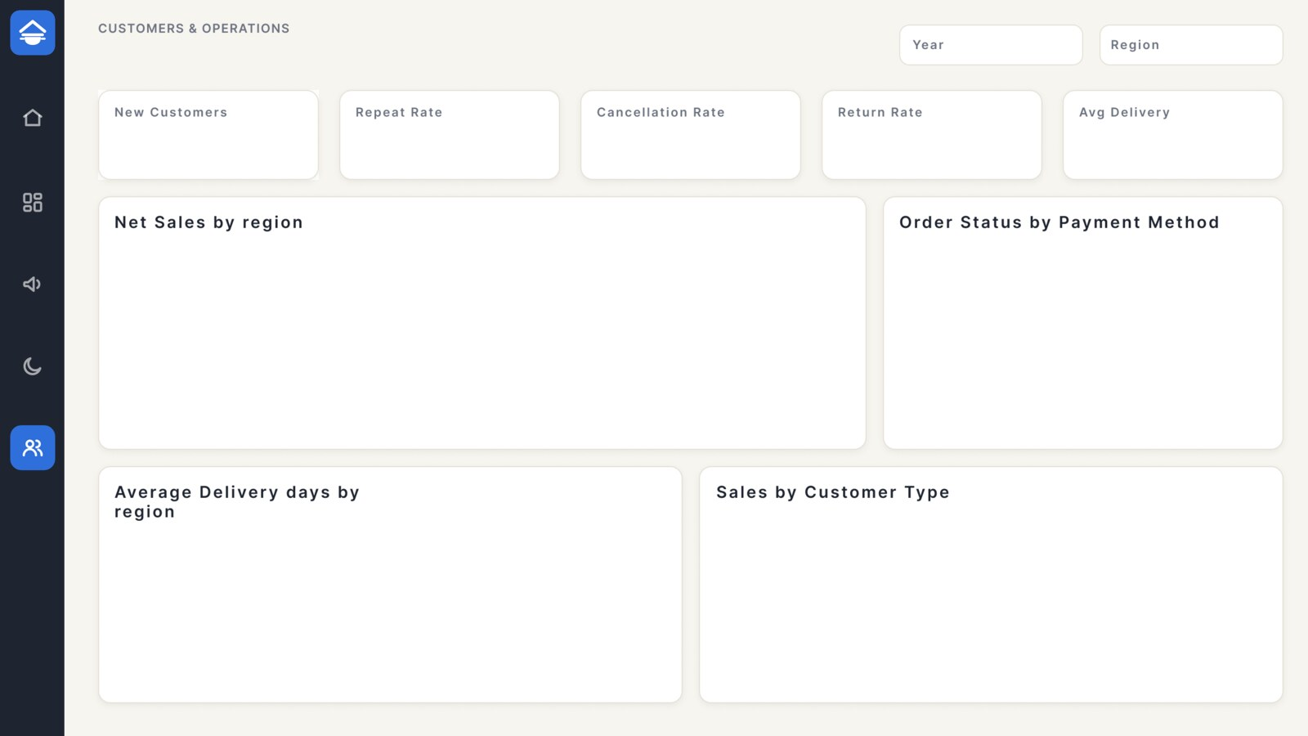
Customers & Operations page design in Figma
Contents: Customer and operations KPIs, net sales by region, order status by payment method, delivery days by region, and sales by customer type.
Key message: COD orders are cancelled 5 times as often as prepaid ones (9.6% vs 1.9%). Repeat customers (39.7% of buyers) bring 62% of sales.

Design system
Element | Value
Background | #F7F5F0
Cards | White #FFFFFF, radius 12, border #E6E1D6
Text | Ink #1E2430, muted #6B7280
Primary | Blue #2F6FDB (for what the eye should go to)
Neutral | #9AA3AF and #D5D9DF (for everything else)
Good / bad | Green #14966B / red #C0392B
Font | Inter in Figma, Segoe UI in Power BI
Canvas | 1280 × 720

11. The data model
The model has two fact tables that share DimDate and DimCampaign. DimChannel is linked to DimCampaign (a small snowflake). All relationships are one-to-many and single direction, from dimension to fact.
From (one) | To (many) | Column
DimDate | FactOrders | DateKey
DimDate | FactAdPerformance | DateKey
DimCampaign | FactOrders | CampaignKey
DimCampaign | FactAdPerformance | CampaignKey
DimChannel | DimCampaign | ChannelKey
DimProduct | FactOrders | ProductKey
DimCustomer | FactOrders | CustomerKey
DimGeography | FactOrders | GeoKey
Why doesn't a governorate filter change ad spend?
DimGeography, DimProduct and DimCustomer are linked to FactOrders only. A campaign runs across all of Egypt, not just one city.
With a governorate slicer, sales change and spend does not. That is not a bug, that is the business.

12. Exercises
Answer without looking at the answers, then check them with your measures in Power BI.
- A campaign spent 100,000 EGP and brought 220,000 in sales. What is its ROAS? Is it profitable?
- Why is CAC higher than CPA at Saffa Home?
- If CTR is very high but CVR is low, where is the problem most likely?
- WhatsApp has a ROAS of 23. Why not put the whole budget on it?
- Your manager says: "Ramadan is not profitable, cut its budget." Reply with numbers.
- Suggest a way to reduce cancellations on COD orders.

Answers
- ROAS = 220,000 ÷ 100,000 = 2.2. It is below break-even (2.63), so it is losing money even though sales exceed spend.
- CPA divides by all paid orders (25,361); CAC divides by new customers only (19,953). The same spend over a smaller number gives a higher figure.
- On the product page or site, not in the ad: the ad brought people in, but they did not buy (price, photos, shipping, trust).
- CRM channels only reach existing customers, and there are a limited number of them. They do not bring new customers, and every extra message risks annoying people.
- Every channel performs better in Ramadan. What pulled the average down was awareness spend (15.3% at ROAS 1.39). Without it, Ramadan returns 4.93 vs 4.62. The answer: same budget, better mix.
- A small discount or free shipping for prepaid orders (InstaPay / card), and a WhatsApp confirmation message before shipping COD orders.

