Question 1:

Question2:

Question 3:

Before change:

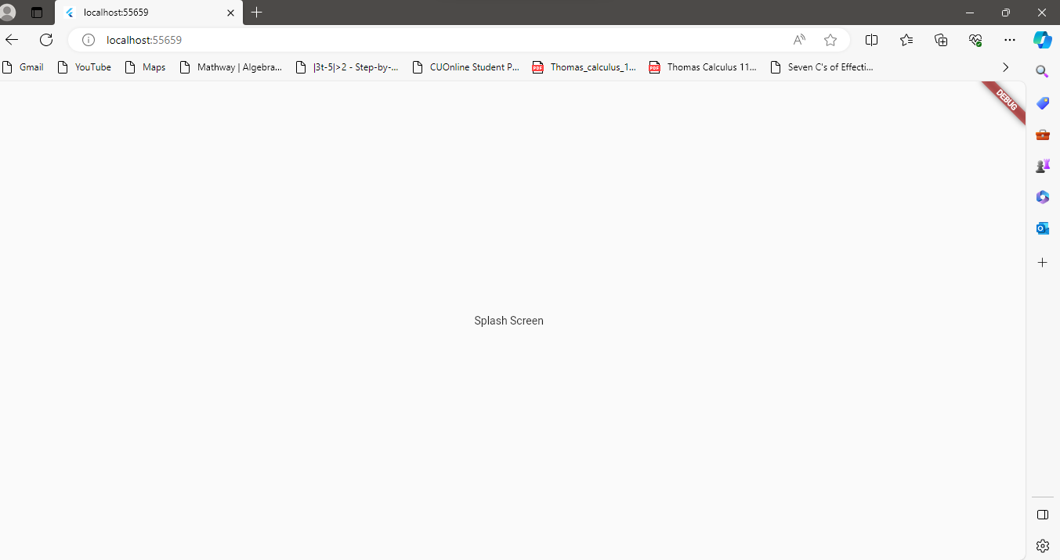

After change:

