Print Finish – Production Support Runbook

Table of Contents:
Overview: 2
Pre-requisites: 2
Engagements: 3
Application Information & Monitoring: 4
Welcome Kit: 4
Input file (from Cardify): 4
Output file (to UPC/ RPD): 4
Trigger file (to Cardify): 4
Autosys Batch Flow: 5
Linux folder structure: 6
Script functionality: 6
Letters: 7
Input file (from Control-P): 7
Output file (to UPC/ RPD): 7
Reprint Inputs (from Control-P): 8
Reprint Outputs (to UPC/ RPD): 8
Autosys Batch Flow: 8
Linux folder structure: 9
Script functionality: 10
Statements: 10
Input file (from Control-P): 10
Output file (to UPC/ RPD): 11
Reprint Inputs (from Control-P): 11
Reprint Outputs (to UPC/ RPD): 11
Autosys Batch Flow: 12
Linux folder structure: 13
Script functionality: 13

History of Revisions:
Revision Date | Version # | Revisions Requested By | Revision Description
10/3/2025 | 1 | Finishing team | Draft copy of the runbook
10/20/2025 | 1.1 | Finishing team | Included Details of Letters and Statements
11/24/2025 | 1.2 | Finishing team | Updated Pre-requisites section with new AFP finishing server access roles.
11/25/2025 | 1.3 | Finishing team | Updated for reprint and new Autosys setup for org code AFPF

Overview:
- This document outlines the prerequisites, application information & monitoring and engagements for data processing on Production environment.
- Following are the applications currently running production – Welcome Kits, Letters and Statements.
- These applications prepare COF print stream data with necessary enhancements so that it can be processed at the Utah Processing Center (UPC) running through the printer and inserter.
- ‘Cardify’ is upstream for Welcome Kits and ‘Control-P’ is upstream for Letters & Statements.
- Utah Processing Center (UPC) is downstream for these applications for printing.

Pre-requisites:
- Linux server access
  - vclp063629.rw.discoverfinancial.com - Primary
  - vclp063630.na.discoverfinancial.com - Secondary
  - IDM role: AFP : AFP Finishing Prod Server Login Access
  - - Development
  - vcld064912.rw.discoverfinancial.com
  - IDM role: AFP : AFP Finishing Linux Dev Server Login Access
- Autosys access
  - https://autosysprod.discoverfinancial.com/wcc/ui/Login.html
  - IDM role: Workload Automation : Autosys – AFPF

- UPC RPD servers
  - uplp102.up.discoverfinancial.com
  - uplp103.up.discoverfinancial.com

- Super User access
  - Super User ID: upssenrich
  - Service catalog link:
https://discover.service-now.com/now/nav/ui/classic/params/target/sp%3Fid%3Dsc_cat_item%26sys_id%3D0c9fa22b13f696008467bc122244b026

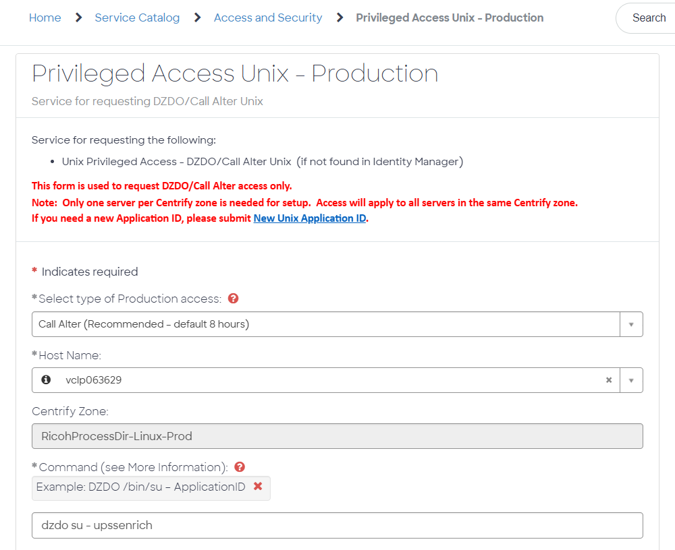

Engagements:
- ORG Code: AFPF
- ServiceNow Assignment group: AFP Print Finishing Team
- Group email address: PrintFinishingTeam@discover.com

- Support guidelines:
  - An incident will be created by ‘Moogsoft Integration’ for any failure in the batch (sample: INC22864138)
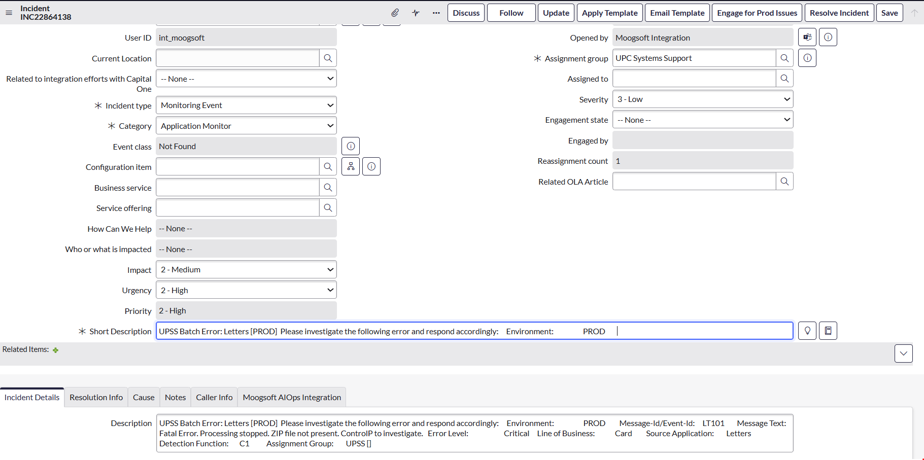

  - An email notification will also be generated for the failure
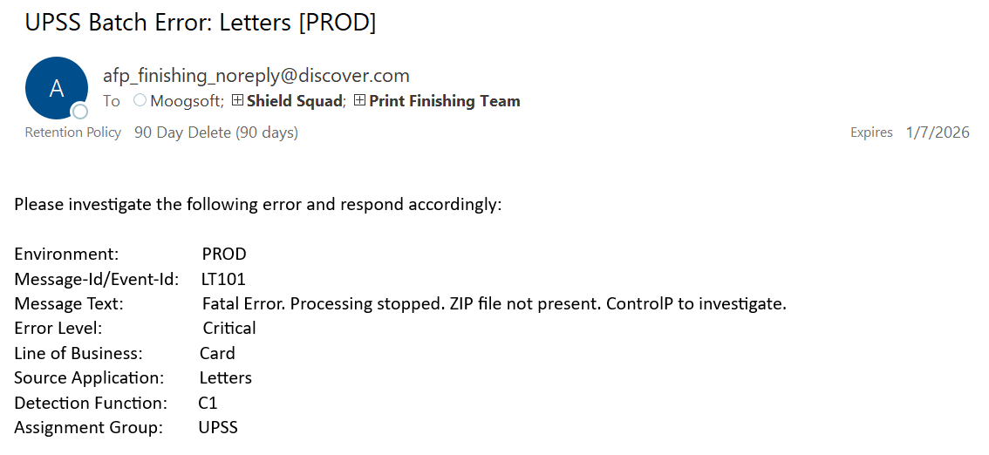
  - Verify the script log file based on the ‘Detection Function’ in the incident/ email
    - Check the Autosys job details to determine the script name
  - Error will be mentioned under ‘Message Text’ in the incident/ email
  - Refer to the individual script log in log folder for more details on the error
  - Force start/ Force complete the failed job in Autosys depending upon the resolution of the error
    - Look for red cross (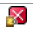) in status column in Autosys to identify the failed job

- xMatters & Escalation: TBD

Application Information & Monitoring:

Welcome Kit:

Input file (from Cardify):
- [ENV]_C_WLKKIT_[Process Type]_[Batch ID]_[Language]_[Date/time stamp].zip
  - Example: PROD_C_WLKKIT_NEW_63_ENG_202510081115.zip
- [ENV]_C_WLKKIT_[Process Type]_[Batch ID]_[Language]_[Date/time stamp].zip.SENT (trigger file)
  - Example: PROD_C_WLKKIT_NEW_63_ENG_202510081115.zip.SENT
- Lookup and AFP files will be inside the Zip file
- Lookup is pipe delimited & file name uses same naming standard as Zip file
  - Example: PROD_C_WLKKIT_NEW_63_ENG_202510081115.txt
- Input location: /apps/printfinish/prod/welcomekit/landing
- [ENV] is ‘PROD’ for production
- [Process Type] is one of the following – NEW, REISSUE, EMERGENCY
- [Language] is either ENG (English) or SPA (Spanish)

Output file (to UPC/ RPD):
- Finished AFP file: [POMS].[Date/time stamp]_[Language]_CWLKKIT.afp
  - Example: ECINAR04.202510081115_ENG_CWLKKIT.afp

Trigger file (to Cardify):
- Empty trigger file to Cardify after sending the AFP to UPC/ RPD
- Trigger file name uses same naming standard as Zip file
  - [ENV]_C_WLKKIT_[Process Type]_[Batch ID]_[Language]_[Date/time stamp].trg
    - Example: PROD_C_WLKKIT_NEW_63_ENG_202510081115.trg

Autosys Batch Flow:
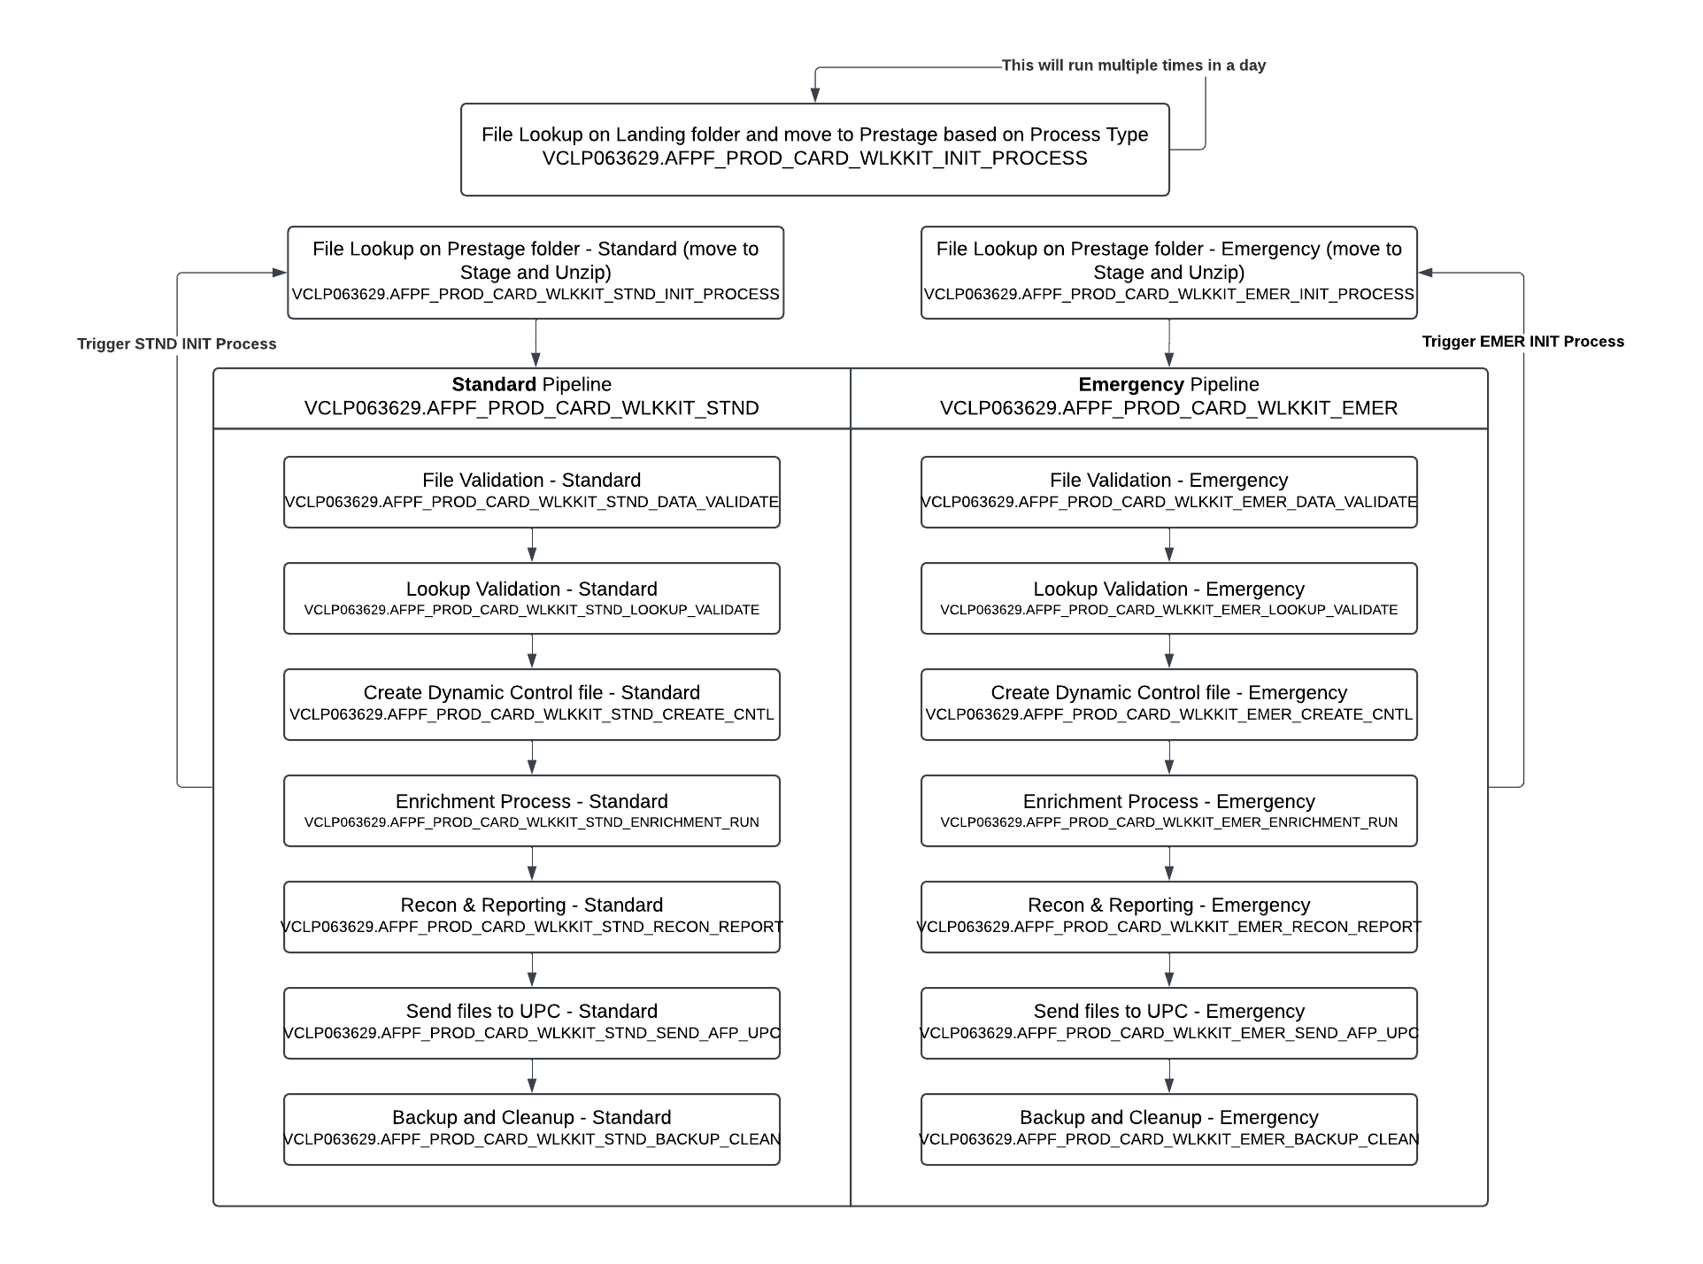
- Active Jobs in Autosys for Primary server:
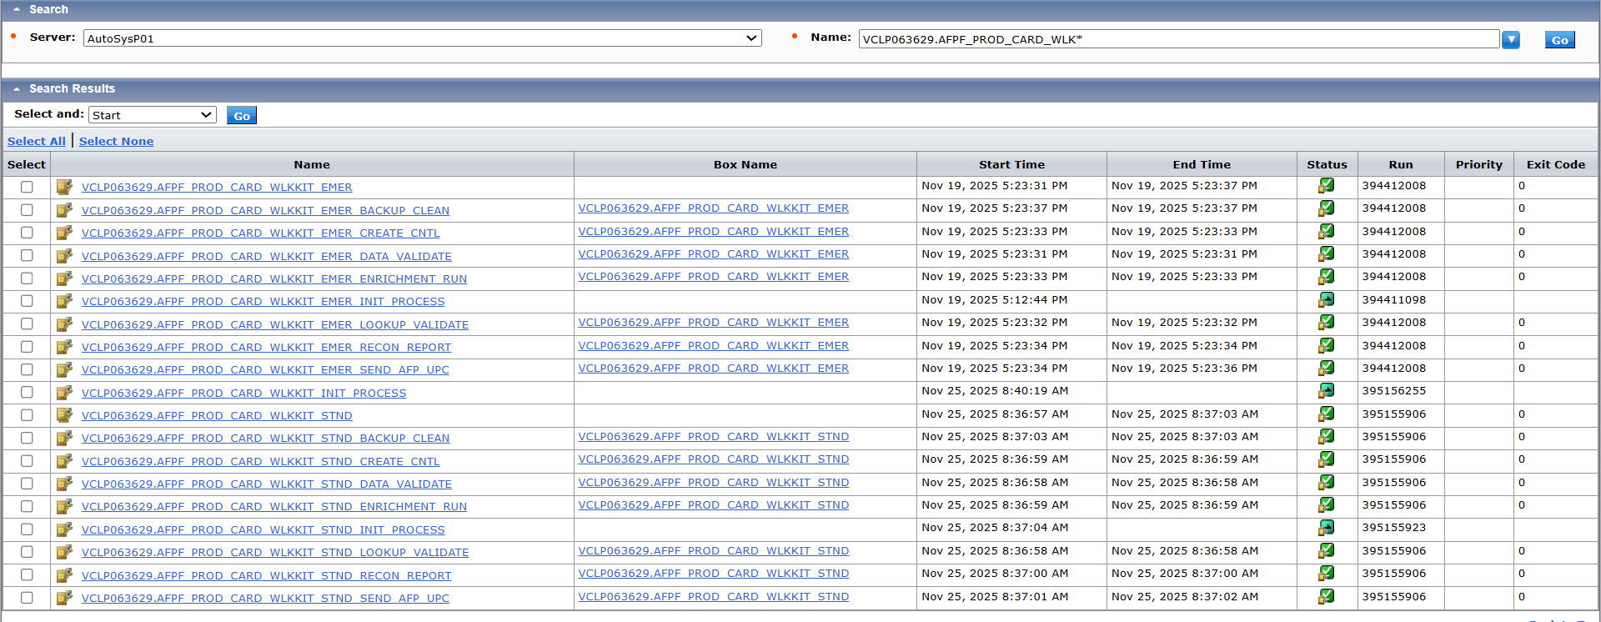
- Inactive Jobs in Autosys for Secondary server: (these jobs will remain Inactive unless primary server is unavailable and need to process data – DR scenario)
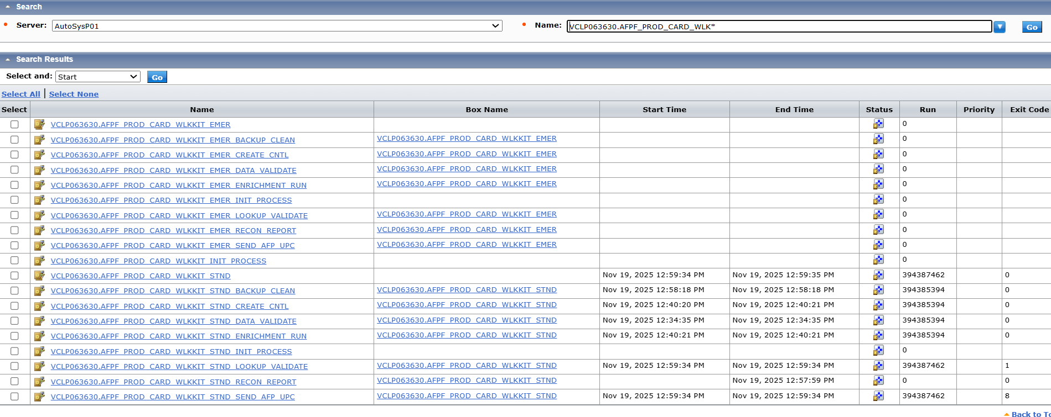

Linux folder structure:
Path Description | Welcome Kit – Standard  [Process Type: New and Reissue] | Welcome Kit – Emergency  [Process Type: Emergency]
Common Script | /apps/printfinish/prod/script | /apps/printfinish/prod/script
Base | /apps/printfinish/prod/welcomekit | /apps/printfinish/prod/welcomekit
Application Script | /apps/printfinish/prod/welcomekit/script | /apps/printfinish/prod/welcomekit/script
Landing  (input from upstream) | /apps/printfinish/prod/welcomekit/landing | /apps/printfinish/prod/welcomekit/landing
Prestage  (store files from Landing) | /apps/printfinish/prod/welcomekit/stnd/prestage | /apps/printfinish/prod/welcomekit/emer/prestage
Stage (run the Validations) | /apps/printfinish/prod/welcomekit/stnd/stage | /apps/printfinish/prod/welcomekit/emer/stage
Input (run the Enrichment) | /apps/printfinish/prod/welcomekit/stnd/input | /apps/printfinish/prod/welcomekit/emer/input
Output (AFP, Report, etc.) | /apps/printfinish/prod/welcomekit/stnd/output | /apps/printfinish/prod/welcomekit/emer/output
Log (log for each script) | /apps/printfinish/prod/welcomekit/stnd/log | /apps/printfinish/prod/welcomekit/emer/log
Backup  (archived data – each batch) | /apps/printfinish/prod/welcomekit/stnd/backup | /apps/printfinish/prod/welcomekit/emer/backup
Prestage Log | /apps/printfinish/prod/welcomekit/stnd/prestage/log | /apps/printfinish/prod/welcomekit/emer/prestage/log
Enrichment control file | /apps/printfinish/prod/welcomekit/script/cntrl/enrichment
Start log | /apps/printfinish/startlogs

Script functionality:
Script | Functionality
UPSS_PRINT_FINISH_INIT_PROCESS.ksh | - Look for .SENT file in Landing path (based on oldest time stamp)  - Validate ENV, Process Type & Language of corresponding ZIP file  - Based on ‘Process Type’ copy .SENT & .ZIP to STND/ EMER Prestage path
UPSS_PRINT_FINISH_INIT_PROCESS_PRESTAGE.ksh | - Look for .SENT file in Prestage path (based on oldest time stamp)  - Move .SENT & .ZIP to Stage folder and run Unzip process
UPSS_PRINT_FINISH_DATA_VALIDATION.ksh | - Validate ENV, Process Type & Language of ZIP file  - Validate length of AFP file name (length: 12)
UPSS_PRINT_FINISH_LOOKUP_FILE_VALIDATION.ksh | - Validate max number of fields (30) in pipe delimited Lookup file  - Validate defined length of each field (1, 2, 3, 6, 8, 4, 10, 1, 1, 1, 1, 1, 2, 28, 1, 28, 11, 11, 11, 16, 3, 12, 8, 5, 65, 8, 6, 7, 4, 4)  - Validate 23rd, 24th and 25th fields shouldn’t be blank for Non-Emergency  - Validate 26th field  - 1st char must be E/ P  - 6th char must be R/ L  - 7th char must be 0/ 2  - 8th char must be numeric and not greater than 6  - Copy all files from Stage to Input path after successful validation
UPSS_PRINT_FINISH_CNTL_FILE_CREATER.ksh | - Create Config file and list of AFP file names for Enrichment process
UPSS_PRINT_FINISH_ENRICHMENT.ksh | - Create Finished AFP file for printing based on Config file  - Generate Reconciliation report and a Side file with return code 0/ 1 based on reconciliation success/ failure
UPSS_PRINT_FINISH_RECON_AND_REPORT.ksh | - Send Reconciliation report via email  - Validate return code in Side file and stop the batch if return code is 1
UPSS_PRINT_FINISH_SEND_AFP_UPC.ksh | - Send AFP file to RPD  - Send Trigger to Cardify
UPSS_PRINT_FINISH_BACK_AND_CLEAN_UP.ksh | - Archive all input, output and log files for current run  - Zip the older backups  - Remove the backups older than 10 days

Letters:

Input file (from Control-P):
- [ENV]_CLTR_YYYYMMDDHHMMSS.zip
  - Example: PRD_CLTR_20250819163400.zip
- [ENV]_CLTR_YYYYMMDDHHMMSS.trg (Trigger file)
  - Example: PRD_CLTR_20250819163400.trg
- CTRP.YYMMDDHHMMSS.CLTR_[ENV].pdf (Control Report)
  - Example: CTRP.20250819163400.CLTR_PRD.pdf
- [ENV]_CLTR_[BID]_YYYYMMDDHHMMSS.AFP
  - Example: PRD_CLTR_gltr08152025173053_20250815173053.AFP
- MRDF files will be inside the Zip file – [ENV]_CLTR_YYMMDDHHMMSS.[JOBID].txt
  - Example: PRD_CLTR_20250819163400.L11AR231.txt
- Input location: /apps/printfinish/prod/letters/landing
- Time stamp is same for Zip, Trigger, MRDF & Control Report file names
- [ENV] is ‘PRD’ for production

Output file (to UPC/ RPD):
- Finished AFP file: [POMS].[Date/time stamp]_CLTR_[ENV].afp
  - Example: L11ARA01.20250819163400.CLTR_PROD.afp
- MRDF file (Print Finish transfers the file as is received from Control-P)
  - [JOBID].[Date/time stamp].[ENV]_CLTR.TXT
  - Example: L11AR230.20250818234000.PROD_CLTR.TXT
- Control report (Print Finish transfers the file as is received from Control-P)
  - CTRP.[Date/time stamp].CLTR_[ENV].pdf
  - Example: CTRP.20250819163400.CLTR_PROD.pdf
- [ENV] is ‘PROD’ for production

Reprint Inputs (from Control-P):
- [ENV]_CLTR_RPNT_YYYYMMDDHHMMSS.trg (Trigger file)
  - Example: PRD_CLTR_RPNT_20251124215000.trg
  - Trigger file has the information of file names of lookup mrdf, control report and select file
- [ENV]_CLTR_RPNT_YYYYMMDDHHMMSS.zip - includes below files (Lookup mrdf and Control report)
  - Example: PRD_CLTR_RPNT_20251124215000.zip
  - PRD_CLTR_RPNT_20251124215000.L31AR328.txt (Lookup MRDF)
  - CTRP.RPNT.L31ARR03.20251124110000.PROD.CLTR_PRD.pdf (Control report)
- No AFP file from Control-P for reprint – Finished AFP will be used from standard POMS_Archive based on the timestamp in select file (.SEL)
- Input location: /apps/printfinish/prod/letters/landing
- [ENV] is ‘PROD’ for production

Reprint Outputs (to UPC/ RPD):
- Finished AFP: [POMS].[Date/time from SEL file].RPNT_CLTR_[ENV].afp
  - Example: L31ARR03.20251124110000.RPNT.CLTR_PROD.afp
- CTRP.RPNT.L31ARR03.20251124110000.PROD.CLTR_PROD.pdf
- No MRDF will be sent to RPD for reprint – UPC will use the existing MRDF from original run
- [ENV] is ‘PROD’ for production

Autosys Batch Flow:
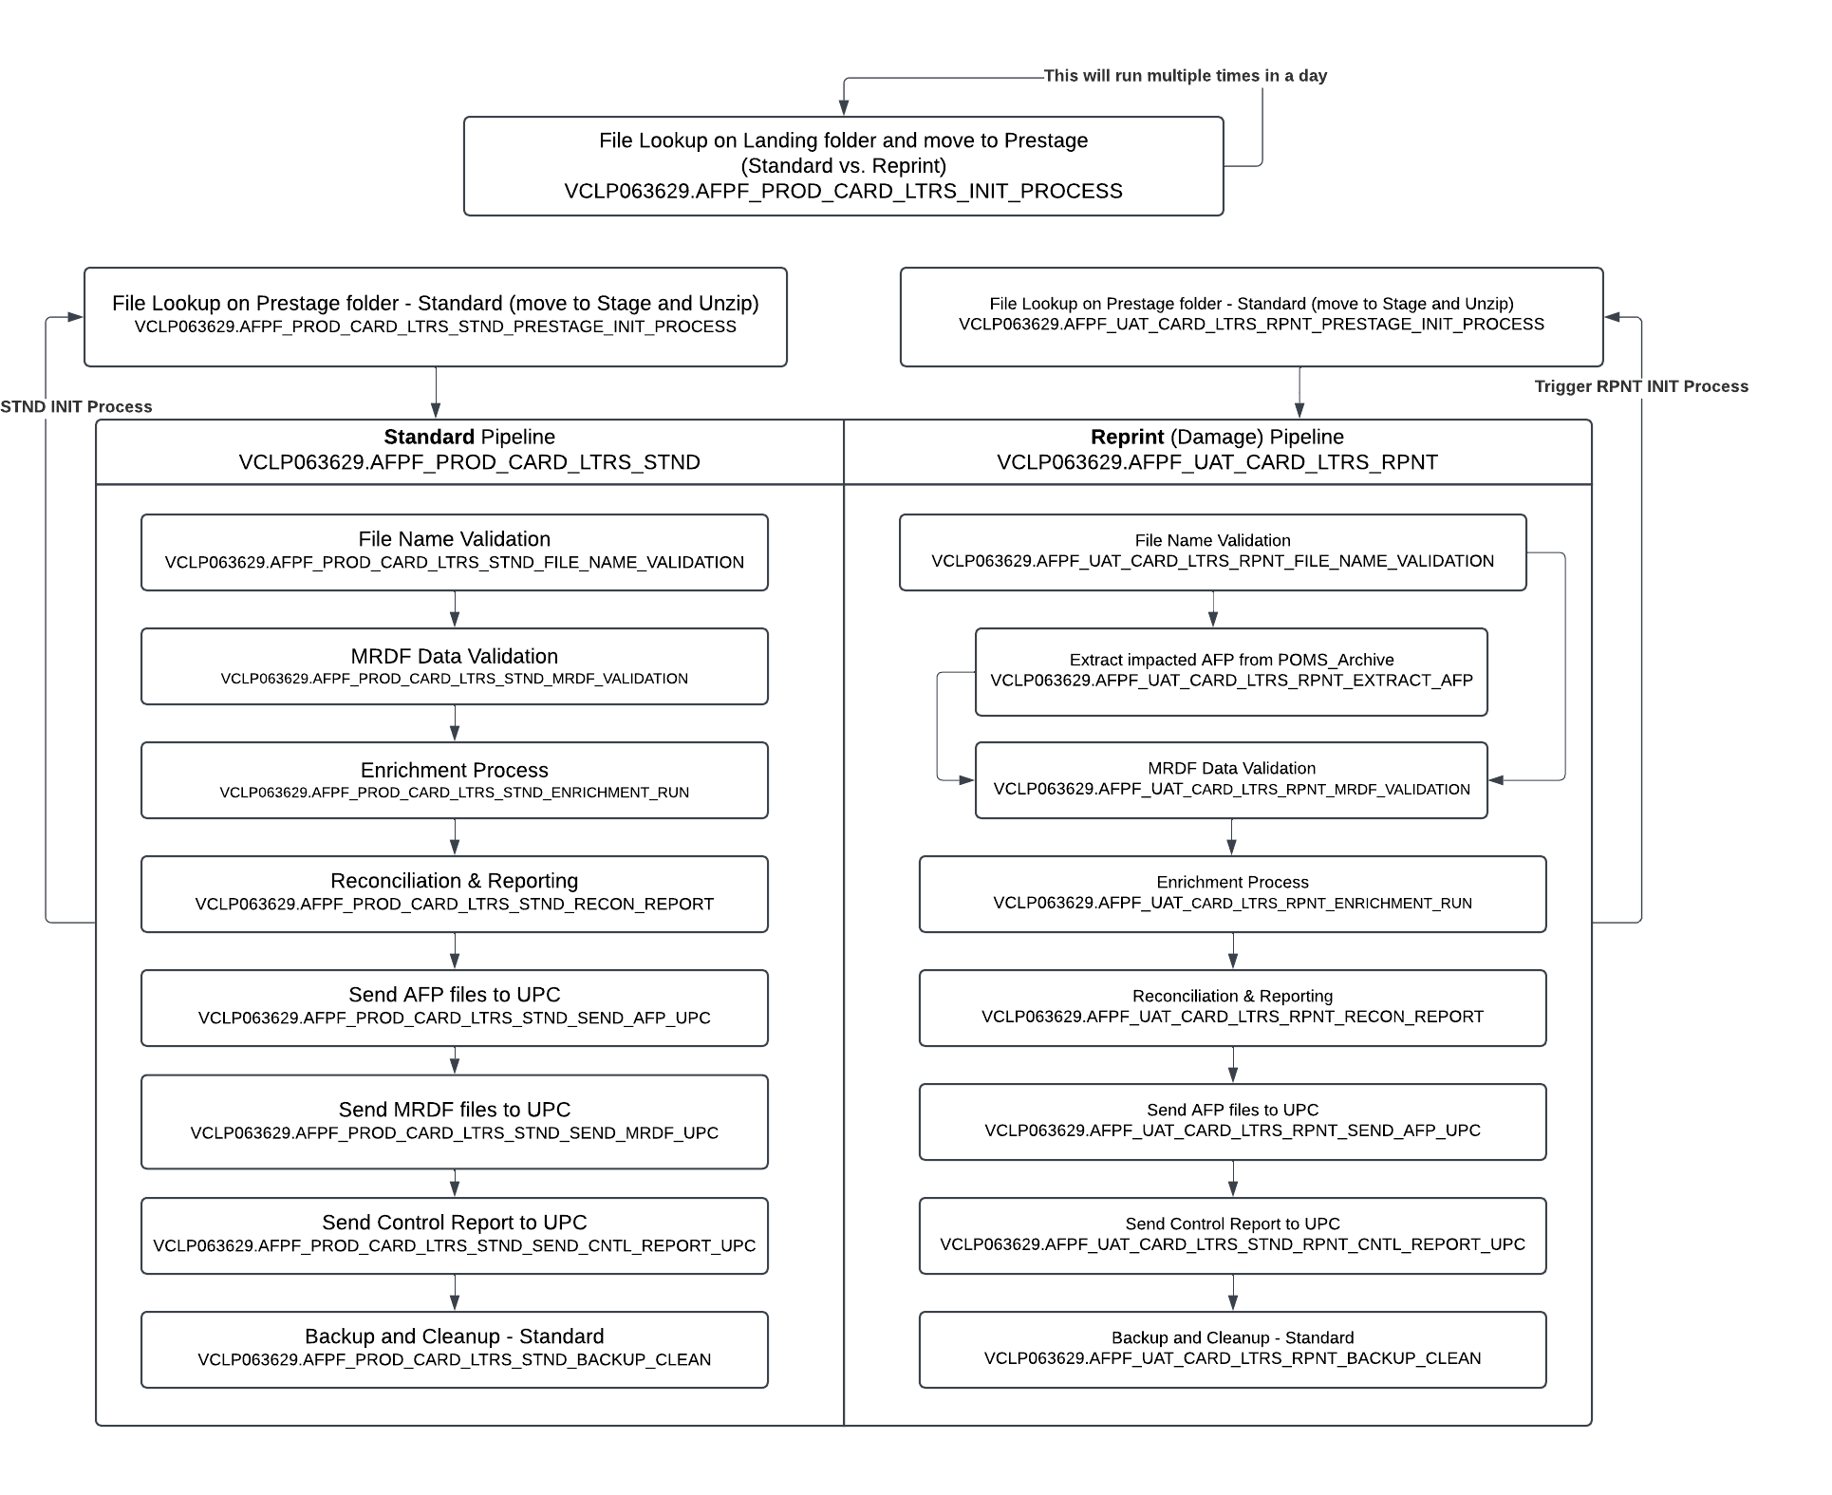
- Active Jobs in Autosys for Primary server:
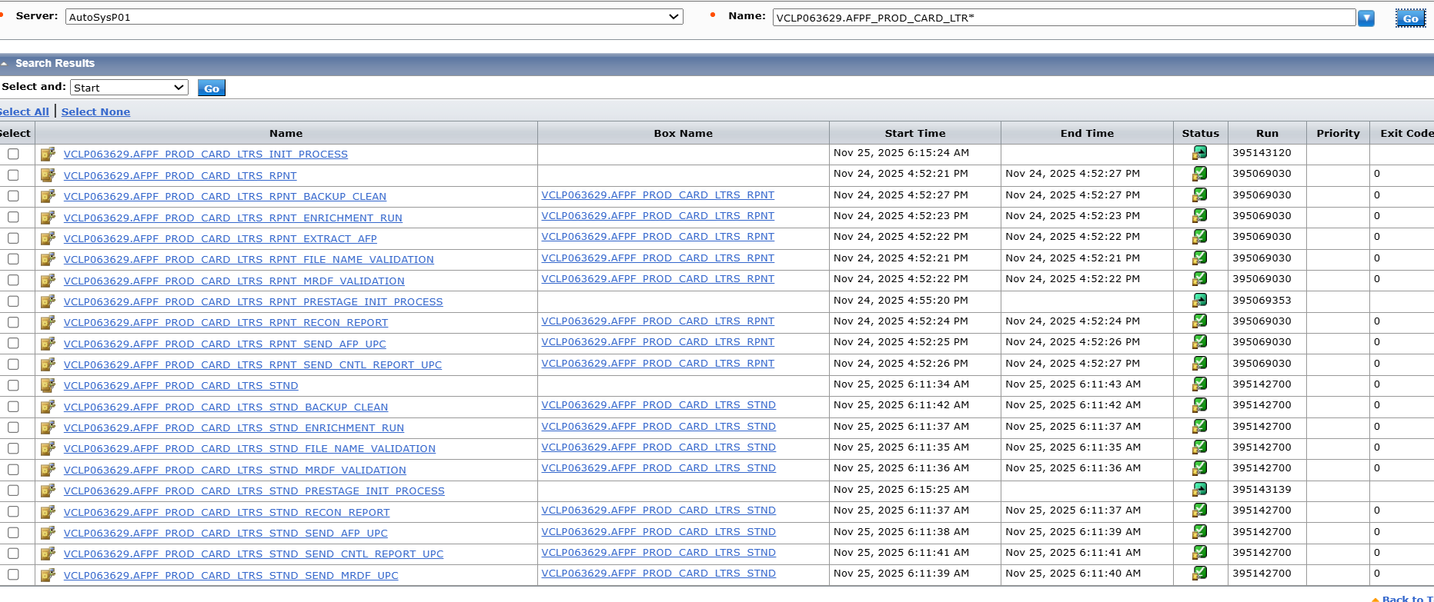
- Inactive Jobs in Autosys for Secondary server: (these jobs will remain Inactive unless primary server is unavailable and need to process data – DR scenario)
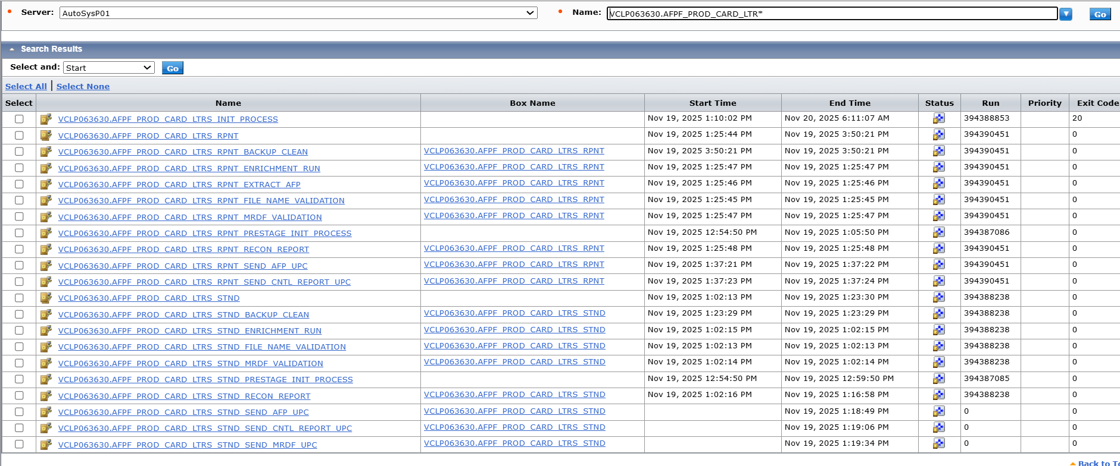

Linux folder structure:
 | Letters - Standard | Letters – Damage Reprint
Start log | /apps/printfinish/startlogs | /apps/printfinish/startlogs
Application Script | /apps/printfinish/prod/letters/script | /apps/printfinish/prod/letters/script
Landing | /apps/printfinish/prod/letters/landing | /apps/printfinish/prod/letters/landing
Prestage | /apps/printfinish/prod/letters/stnd/prestage | /apps/printfinish/prod/letters/rpnt/prestage
Stage | /apps/printfinish/prod/letters/stnd/stage | /apps/printfinish/prod/letters/rpnt/stage
Input | /apps/printfinish/prod/letters/stnd/input | /apps/printfinish/prod/letters/rpnt/input
Output | /apps/printfinish/prod/letters/stnd/output | /apps/printfinish/prod/letters/rpnt/output
Log | /apps/printfinish/prod/letters/stnd/log | /apps/printfinish/prod/letters/rpnt/log
Backup | /apps/printfinish/prod/letters/stnd/backup | /apps/printfinish/prod/letters/rpnt/backup
Prestage Log | /apps/printfinish/prod/letters/stnd/prestage/log | /apps/printfinish/prod/letters/rpnt/prestage/log
Enrichment control file | /apps/printfinish/prod/letters/Enrichment | /apps/printfinish/prod/letters/Enrichment
Resource Log | /apps/printfinish/prod/letters/stnd/output/Resource | /apps/printfinish/prod/letters/rpnt/output/Resource
POMS_Archive | /apps/printfinish/prod/letters/stnd/POMS_Archive | N/A

Script functionality:
Script | Functionality
UPSS_PRINT_FINISH_INIT_PROCESS_LTRS.ksh | - Look for “.trg” file on landing path (based on oldest time stamp)  - Read the trigger file to find out the list of AFP files  - Not applicable for Reprint  - Move all files to STND/ RPNT prestage path based on Reprint trigger
UPSS_PRINT_FINISH_INIT_PROCESS_PRESTAGE_LTRS.ksh | - Look for “.trg” file on prestage path (based on oldest time stamp)  - Read the trigger file to find out the list of AFP files  - Not applicable for Reprint  - Move all files to stage path and Unzip the zip file
UPSS_PRINT_FINISH_FILE_NAME_VALIDATION_AND_MOVE_LTRS.ksh | - Validate file name format of Zip, Trigger, MRDF, AFP and Control report  - No AFP validation for Reprint  - Move all files to input path after successful validation
UPSS_PRINT_FINISH_DETERMINE_IMPACTED_AFP_STMT_RPNT.ksh  (Only for Reprint) | - Read trigger file to capture Job Id and Timestamp from select file name  - Copy matching finished AFP file from POMS_Archive folder based on captured Job Id and Timestamp
UPSS_PRINT_FINISH_MRDF_FILE_VALIDATION_LTRS.ksh | - Halt the processing if DROP file is available  - Validate length of record 844  - JOBID (1-8 fields) & POMS (769-776 fields) are alphanumeric and shouldn’t be empty  - JOBID in file name must match with file content  - POMS should match with 1st 5 character of JOBID  - Sequence number (9-14 fields) is numeric & shouldn’t be empty  - CCID (777-800 fields) is alphanumeric & shouldn’t be empty  - Create vendor.txt for CrawfordTech
UPSS_PRINT_FINISH_ENRICHMENT_LTRS.ksh (for regular)  UPSS_PRINT_FINISH_ENRICHMENT_STMT_RPNT.ksh  (for Reprint) | - Create Finished AFP file for printing based on Config file  - Generate Reconciliation report and a Side file with return code 0/ 1 based on reconciliation success/ failure
UPSS_PRINT_FINISH_RECON_AND_REPORT_LTRS.ksh | - Send Reconciliation report via email  - Validate return code in Side file and stop the batch if return code is 1
UPSS_PRINT_FINISH_SEND_FILE_UPC_LTRS.ksh | - Send AFP files to RPD  - Send MRDF files to RPD  - Not applicable for Reprint  - Send Control Report to RPD
UPSS_PRINT_FINISH_BACK_AND_CLEAN_UP_LTRS.ksh | - Only for regular run (N/A for Reprint) –  - Copy finished AFP to POMS_Archive with the timestamp of input zip  - Cleanup 5 days older files in POMS_Archive  - Archive all input, output and log files for current run  - Zip the older backups  - Remove the backups older than 10 days

Statements:

Input file (from Control-P):
- [ENV]_CSTMT_[RID]_[CYCLE]_[Date/time stamp].zip
  - Example: PRD_CSTMT_10092025091909_09_20251010140000.zip
- [ENV]_CSTMT_[RID]_[CYCLE]_[Date/time stamp].trg (trigger file)
  - Example: PRD_CSTMT_10092025091909_09_20251010140000.trg
- CTRP.YYMMDDHHMMSS.[ENV]_CSTMT.pdf (Control Report)
  - Example: CTRP.20251010140000.PRD_CSTMT.pdf
- [ENV]_CSTMT_[RID]_[CYCLE]_YYYYMMDDHHMMSS.afp
  - Example: PRD_CSTMT_10092025091909_09_20251009131501.afp
- MRDF files will be inside the Zip file - [JOBID]YYMMDDHHMMSS.[ENV]_CSTMT.txt
  - Example: S091R28320251010140000.PRD_CSTMT.txt
- Input location: /apps/printfinish/prod/statements/landing
- Time stamp is same for Zip, Trigger, MRDF & Control Report file names
- [ENV] is ‘PRD’ for production

Output file (to UPC/ RPD):
- Finished AFP file: [POMS].[Date/time stamp].[ENV]_CSTMT.afp
  - Example: S091RA01.20251010140000.PROD_CSTMT.afp
- MRDF file (Print Finish transfers the file as is received from Control-P)
  - [JOBID][Date/time stamp].[ENV]_CSTMT.TXT
  - Example: S091R28320251010140000.PROD_CSTMT.TXT
- Control report (Print Finish transfers the file as is received from Control-P)
  - CTRP.[Date/time stamp].[ENV]_CSTMT.pdf
  - Example: CTRP.20251010140000.PROD_CSTMT.pdf
- [ENV] is ‘PROD’ for production

Reprint Inputs (from Control-P):
- [ENV]_CSTMT_RPNT_[RID]_[CYCLE]_[Date/time stamp].trg (trigger file)
  - Example: PRD_CSTMT_RPNT_11222025113522_22_20251124215000.trg
  - Trigger file has the information of file names of lookup mrdf, control report and select file
- [ENV]_CSTMT_RPNT_[RID]_[CYCLE]_[Date/time stamp].zip – includes below files (Lookup mrdf and Control report)
  - Example: PRD_CSTMT_RPNT_11222025113522_22_20251124215000.zip
  - S221R32720251124215000.PRD_CSTMT_RPNT.txt (Lookup MRDF)
  - CTRP.RPNT.S221RR03.20251123180000.PRD_CSTMT.pdf (Control report)
- No AFP file from Control-P for reprint – Finished AFP will be used from standard POMS_Archive based on the timestamp in select file (.SEL)
- Input location: /apps/printfinish/prod/statements/landing
- [ENV] is ‘PRD’ for production

Reprint Outputs (to UPC/ RPD):
- Finished AFP: [POMS].[Date/time from SEL file].RPNT.[ENV]_CSTMT.afp
  - Example: S221RR03.20251123180000.RPNT.PROD_CSTMT.afp
- Control report: CTRP.RPNT.S221RR03.20251123180000.PROD_CSTMT.pdf
- No MRDF will be sent to RPD for reprint – UPC will use the existing MRDF from original run
- [ENV] is ‘PROD’ for production

Autosys Batch Flow:
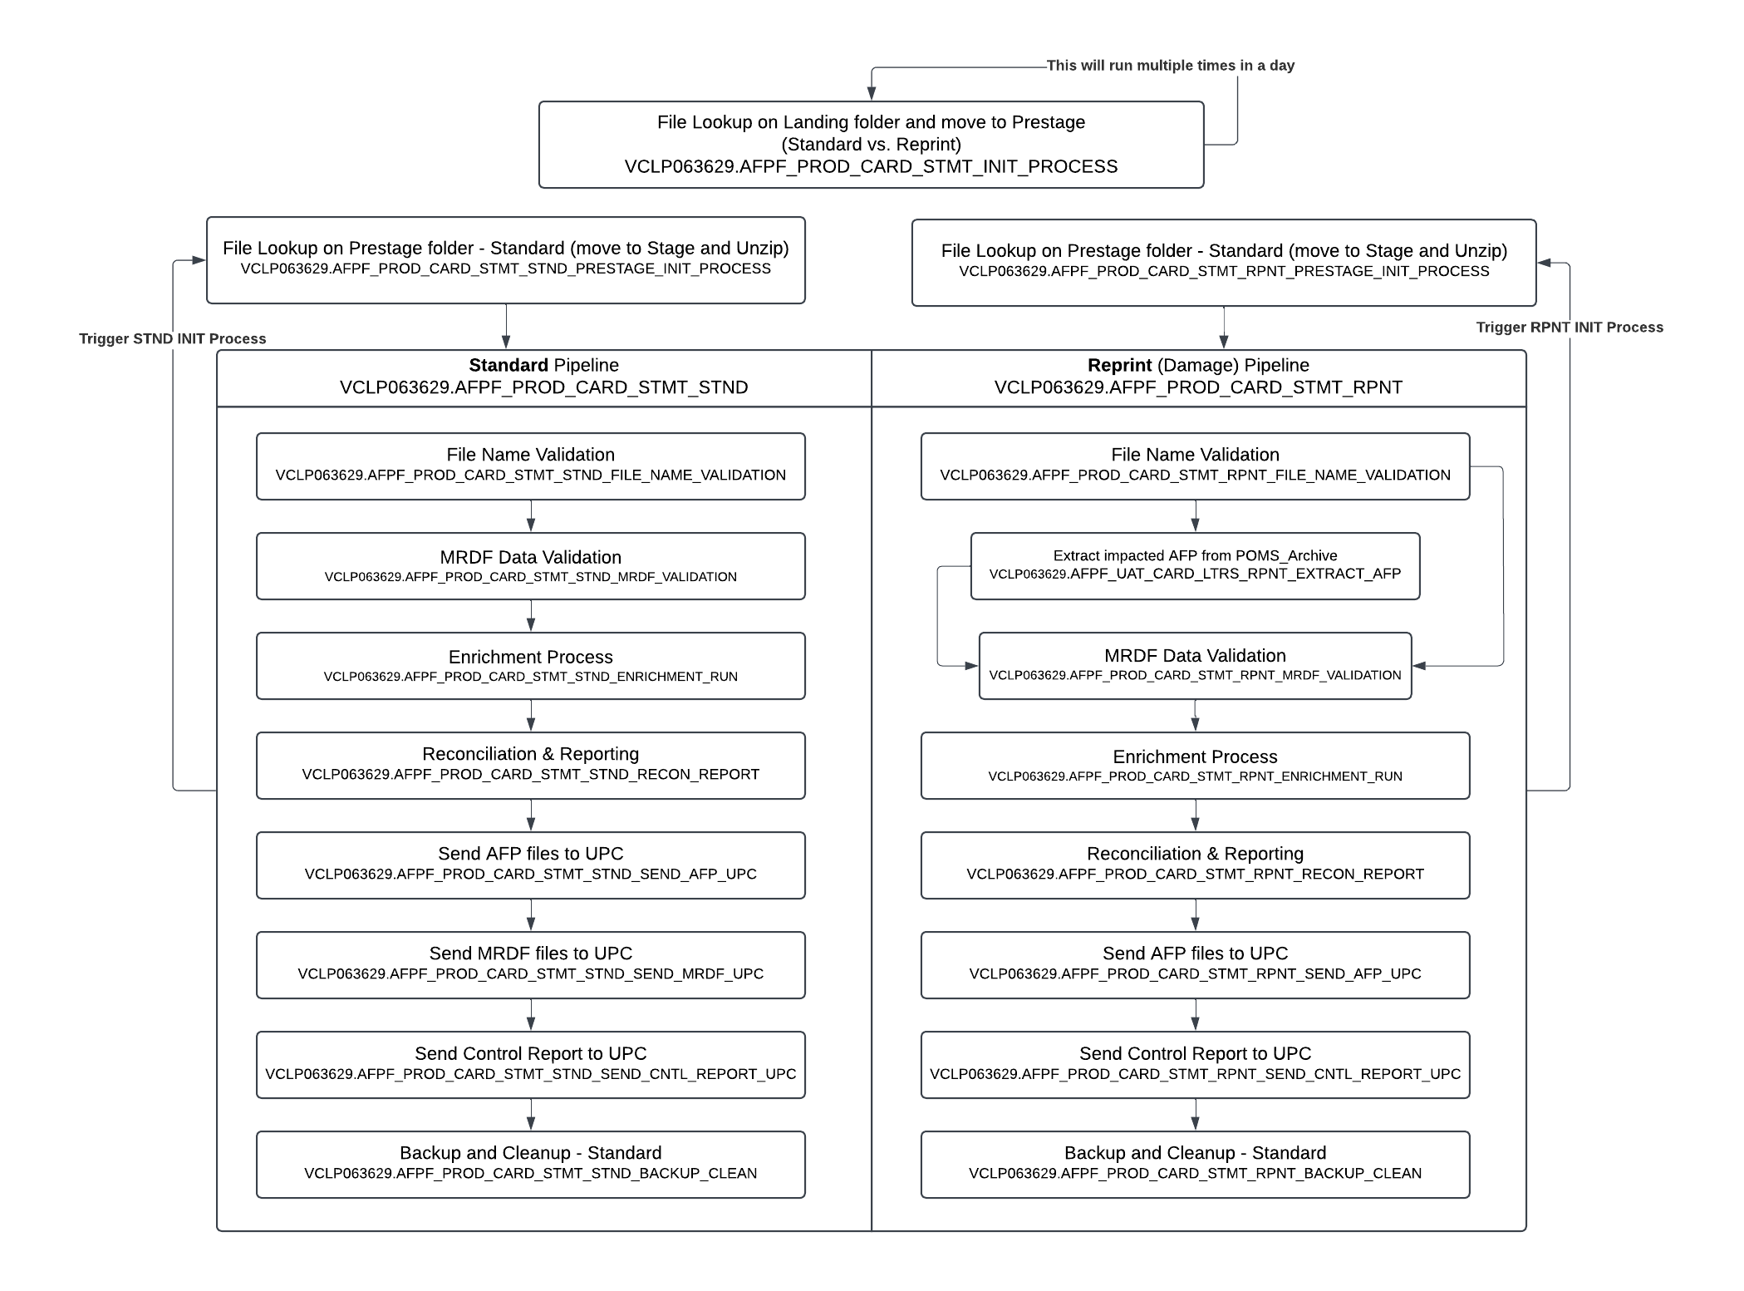
- Active Jobs in Autosys for Primary server:
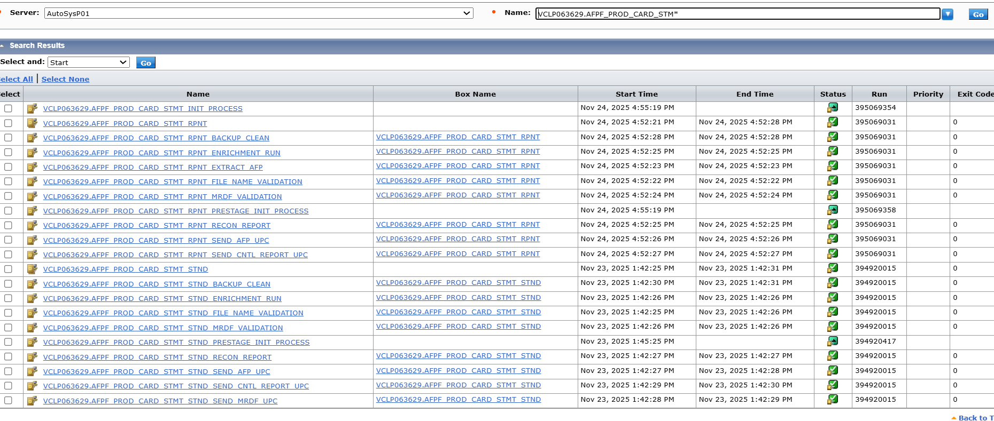
- In-active Jobs in Autosys for Secondary server: (these jobs will remain In-active unless primary server is unavailable and need to process data – DR scenario)
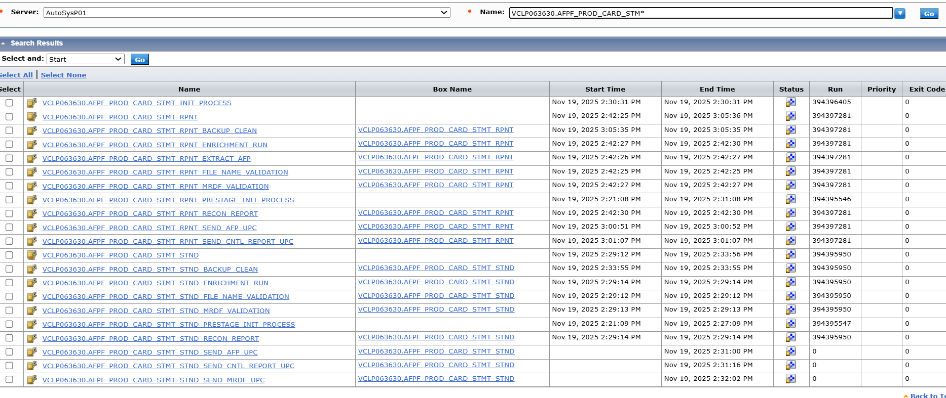

Linux folder structure:
 | Statements - Standard | Statements – Damage Reprint
Start log | /apps/printfinish/startlogs | /apps/printfinish/startlogs
Application Script | /apps/printfinish/prod/statements/script | /apps/printfinish/prod/statements/script
Landing | /apps/printfinish/prod/statements/landing | /apps/printfinish/prod/statements/landing
Prestage | /apps/printfinish/prod/statements/stnd/prestage | /apps/printfinish/prod/statements/rpnt/prestage
Stage | /apps/printfinish/prod/statements/stnd/stage | /apps/printfinish/prod/statements/rpnt/stage
Input | /apps/printfinish/prod/statements/stnd/input | /apps/printfinish/prod/statements/rpnt/input
Output | /apps/printfinish/prod/statements/stnd/output | /apps/printfinish/prod/statements/rpnt/output
Log | /apps/printfinish/prod/statements/stnd/log | /apps/printfinish/prod/statements/rpnt/log
Backup | /apps/printfinish/prod/statements/stnd/backup | /apps/printfinish/prod/statements/rpnt/backup
Prestage Log | /apps/printfinish/prod/statements/stnd/prestage/log | /apps/printfinish/prod/statements/rpnt/prestage/log
Enrichment control file | /apps/printfinish/prod/statements/Enrichment | /apps/printfinish/prod/statements/Enrichment
Resource Log | /apps/printfinish/prod/statements/stnd/output/Resource | /apps/printfinish/prod/statements/rpnt/output/Resource
POMS_Archive | /apps/printfinish/prod/statements/stnd/POMS_Archive | N/A

Script functionality:
Script | Functionality
UPSS_PRINT_FINISH_INIT_PROCESS_STMT.ksh | - Look for “.trg” file on landing path (based on oldest time stamp)  - Wait 5 mins once trigger found (short term fix for missing AFP)  - Read the trigger file to find out the list of AFP files  - Not applicable for Reprint  - Move all files to STND/ RPNT prestage path based on Reprint trigger
UPSS_PRINT_FINISH_INIT_PROCESS_PRESTAGE_STMT.ksh | - Look for “.trg” file on prestage path (based on oldest time stamp)  - Read the trigger file to find out the list of AFP files  - Not applicable for Reprint  - Move all files to stage path and Unzip the zip file
UPSS_PRINT_FINISH_FILE_NAME_VALIDATION_AND_MOVE_STMT.ksh | - RID is numeric and 14 digits  - Validate file name format of Zip, Trigger, AFP files  - No AFP validation for Reprint  - MRDF & Control report file name validation is inactive currently  - Move all files to input path after successful validation
UPSS_PRINT_FINISH_DETERMINE_IMPACTED_AFP_STMT_RPNT.ksh  (Only for Reprint) | - Read trigger file to capture Job Id and Timestamp from select file name  - Copy matching finished AFP file from POMS_Archive folder based on captured Job Id and Timestamp
UPSS_PRINT_FINISH_MRDF_FILE_VALIDATION_STMT.ksh | - Halt the processing if DROP file is available  - Validate length of record 844  - JOBID (1-8 fields) & POMS (769-776 fields) are alphanumeric and shouldn’t be empty  - JOBID in file name must match with file content  - POMS should match with 1st 5 character of JOBID  - Sequence number (9-14 fields) is numeric & shouldn’t be empty  - CCID (777-800 fields) is alphanumeric & shouldn’t be empty
UPSS_PRINT_FINISH_ENRICHMENT_STMT.ksh (for regular)  UPSS_PRINT_FINISH_ENRICHMENT_STMT_RPNT.ksh  (for Reprint) | - Create Finished AFP file for printing based on Config file  - Generate Reconciliation report and a Side file with return code 0/ 1 based on reconciliation success/ failure
UPSS_PRINT_FINISH_RECON_AND_REPORT.ksh | - Send Reconciliation report via email  - Validate return code in Side file and stop the batch if return code is 1
UPSS_PRINT_FINISH_SEND_FILE_UPC_STMT.ksh | - Send AFP files to RPD  - Send MRDF files to RPD  - Not required for Reprint  - Send Control Report to RPD
UPSS_PRINT_FINISH_BACK_AND_CLEAN_UP_STMT.ksh | - Only for regular run (N/A for Reprint) –  - Copy finished AFP to POMS_Archive with the timestamp of input zip  - Cleanup 5 days older files in POMS_Archive  - Archive all input, output and log files for current run  - Zip the older backups  - Remove the backups older than 10 days

