ADAPTIVE NETWORK SLICING IN NON-ORTHOGONAL MULTIPLE ACCESS (NOMA) LEVERAGING UNSUPERVISED LEARNING FOR TRAFFIC CLASSIFICATION AND RESOURCE MANAGEMENT.
INTRODUCTION
With the swift development of telecommunication networks, the demand for robust resource management methods capable of supporting diverse services and applications has surged. A notable solution to this challenge is network slicing, which facilitates the coexistence of multiple virtual networks on a single physical infrastructure, tailored to align with distinct service needs (Shah et-al., 2021). NOMA, or Non-Orthogonal Multiple Access, stands out as an essential innovation, permitting several users to access identical frequency resources concurrently. This advancement boosts spectral efficiency and expands the system's user capacity (DIng et-al., 2017).
As shown in figure 1.1, network systems grow more intricate, traditional methods for managing resources often struggle to respond to changing traffic patterns effectively. Unsupervised machine learning offers a robust alternative by employing algorithms that analyze unlabeled data to uncover patterns and structures. This approach significantly enhances traffic categorization and resource distribution within dynamic network slicing environments (Akbar et-al., 2021). Methods like clustering and dimensionality reduction, which fall under unsupervised learning, facilitate the examination of traffic trends and user behavior without requiring large labeled datasets. Their efficiency makes them ideal for real-time applications in constantly changing network scenarios (Rajasekaran & Yanikomeroglu, 2023).
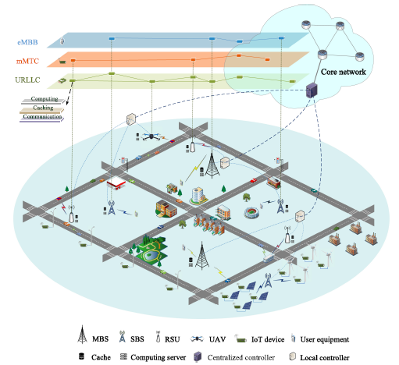
Figure: 1.1 An illustration of Network Slicing based on NGWN Architecture (Shen et-al., 2020).
The use of unsupervised learning within network slicing frameworks can substantially boost network efficiency. Clustering techniques, for instance, can classify traffic with similar characteristics, facilitating resource allocation that is better suited to the specific demands of each group (Domeke et-al., 2022). Dimensionality reduction techniques play a vital role in simplifying complex datasets, enhancing the ability to visualize and analyze traffic trends, a key factor in efficient resource management and decision-making processes (Domeke et-al., 2022).
Applying these methods helps optimize user satisfaction by maintaining quality of service (QoS) across different scenarios. As the need for fast and reliable connections grows, the ability to adjust network resources dynamically based on real-time traffic insights becomes more essential (Shu & Taleb, 2020).
MOTIVATION

Unsupervised machine learning (uML) techniques are pivotal for managing the immense volumes of unlabeled data produced by wireless communication networks in 5G and beyond. These approaches identify underlying patterns and structures without relying on predefined outcomes. Tasks such as clustering network traffic and user behavior are efficiently handled by uML, enabling better resource allocation and enhanced system performance. Furthermore, dimensionality reduction techniques simplify high-dimensional datasets, improving clarity and decision-making. By automating feature extraction, uML supports analyses where manual labeling is impractical and adapts effectively to real-time data, allowing dynamic network adjustments. This adaptability, combined with complementary machine learning methods, enables the creation of more advanced and efficient wireless communication technologies.

Aim and Objectives
Aim:
The aim of this research is to investigate the implementation of adaptive network slicing in Non-Orthogonal Multiple Access (NOMA) systems, utilizing unsupervised learning techniques for effective traffic classification and resource management to optimize network performance and user experience.

Objectives:
The above aim will be achieved through the following objectives
- To Review Existing Literature: Conduct a thorough review of current research on network slicing, NOMA, and unsupervised learning techniques to identify existing methodologies, challenges, and potential areas for improvement.
- To Analyze Traffic Patterns: Utilize unsupervised learning algorithms to analyze and classify traffic patterns in NOMA systems, aiming to identify distinct user behaviors and service requirements.
- To Develop an Adaptive Network Slicing Framework: Design and implement a framework for adaptive network slicing that can dynamically allocate resources based on traffic classification and user demands, enhancing overall network efficiency.
- To Simulate Network Scenarios: Create simulation models to evaluate the performance of the proposed adaptive network slicing framework under various traffic conditions and network topologies.
- To Evaluate Resource Management Strategies: Assess the effectiveness of different resource management strategies enabled by the adaptive slicing approach, focusing on metrics such as throughput, latency, and user satisfaction.
- To Validate the Framework with Real-World Data: Conduct experiments using real-world traffic data to validate the proposed framework's performance and its ability to adapt to changing network conditions.

