Food Storage Prediction
A project report submitted in partial fulfillment of the Academic requirements
For the award of the Degree of

BACHELOR OF ENGINEERING
IN
INFORMATION TECHNOLOGY
By
Asari Ashok Yadav 2451-17-737-019
Mohammed Ibrahim 2451-17-737-022
Shaik Vaseem 2451-17-737-023

Under the guidance of
P. Karthik
Assistant Professor, Dept. of I.T
MVSR Engineering College
Nadergul, Hyderabad.
(November 2019)


DEPARTMENT OF INFORMATION TECHNOLOGY
MVSR ENGINEERING COLLEGE (Affiliated to Osmania University, Hyderabad. Recognized by AICTE) Nadergul, Saroornagar Mandal, Hyderabad-501510
2019-2020
M.V.S.R ENGINEERING COLLEGE
(Affiliated to Osmania University, Hyderabad. Recognized by AICTE)
Nadergul, Saroornagar Mandal, Hyderabad-501510

DEPARTMENT OF INFORMATION TECHNOLOGY

Certificate

Certified that this a bonafide Mini Project work carried out by
Mr./Ms. __________________________________ Bearing H.T. No.______________________ in the course Mini Project PC ______________IT prescribed for. BE (3/4) SEM: 5 by Osmania University, in the department during the academic year 2019 - 2020

Faculty in-Charge Guide Signature

Head of the Department

ACKNOWLEDGEMENT

We with extreme jubilance and deepest gratitude, would like to thank P. Karthik, Assistant Professor, Department of Information Technology, MVSR Engineering College, for his constant encouragement and facilities provided to us to complete our project in time.

With immense pleasure, we record our deep sense of gratitude to our beloved Head of the department V.Ashwini Kumar (Associate Prof), Department of Information Technology, MVSR Engineering College, for permitting us to carry out this project.
We would like to extend our gratitude to D. Muninder (Asst prof), P.Amba Bhavani (Asst Prof), Kalyan Chakravarthi (Lab Asst) Department of Information Technology, M V S R Engineering College, for his valuable suggestions and timely help during the course of the project.
We express, from the bottom of my heart, my deepest gratitude to my parents and family for the support, dedication, comprehension and love.
Finally, we express our heartfelt thanks to each and every one who directly and indirectly helped us in successful completion of this project work.

Asari Ashok Yadav
2451-16-737-019
Mohammed Ibrahim
2451-17-737-022
Shaik Vaseem
2451-17-737-023

ABSTRACT

Food Storage Prediction is a concept which predicts the time till which the food will be edible (expiry time of the food item).
People often get to know that a food is stale after it starts smelling or after they taste it. Sometimes they don’t even get to know that a food has become stale and they eat it which causes food poisoning to them or other kinds of illness. To prevent such things from happening this project has been made. We have created a data set consisting of food items which helps us to train our model. We interpret the expiry time of the food item taking into account the different conditions encountered during the preparation and storage of the food item.
The project titled Food Storage Prediction is an application written in R programming language which allows the user to enter the main and side ingredients of the food item, time at which the food is prepared, climate during which it is prepared, the temperature at which it will be stored, the state of the food item (dry or wet). Taking all of these factors into the account our model will predict the number of days the food is going to last.

Contents page no

- Introduction 7
- System Analysis 8
  - Objectives 8
  - Problem specification 8
  - Existing Applications 8
  - Applications 10
  - Functionalities 10
  - Software and Hardware Requirements 14
- Design 15
  - System Architecture 15
- Implementation 17
- Results and Screen shots 18
  - Dataset 18
  - Preprocessing of data 20
  - Result 21
  - Summary of prediction 22
  - Plotting of dataset 23
- Conclusion 25
- Future Enhancement 26
- References 27
- Appendix 28

Screenshots

- Dataset 18
- Dataset 18
- Dataset 18
- User’s Requirement 19
- Dataset after preprocessing of the data 20
- results of Test set 21
- Results of User data 21
- Summary of the Model 22
- Plot of Dataset with respect to Expiry time 23
- Plot of the dataset without Side item 24

1. Introduction

Lot of People live in hostels or in places away from their families especially students and youngsters. People staying with their families used to have their mothers or elders to help them with knowing about the condition of food but now they don’t have this comfort with them and it’s a tedious task to call their families for each small thing and if the people live in different time zones it is not practical to call their families most of the time.

So, to solve the problem of these people we thought that this project might come in handy for them and it’ll be of great practical use for such people. This project will help them stay healthy and also help them in knowing which condition is better suited for which food item.

Today’s youth is very impatient to search for the expiry date of different food items on the internet or to even call up their elders to find out about it. Therefore, this project is aimed at making their task simpler and less time consuming thereby increasing their efficiency.

2. System Analysis
2.1. Objectives
The main objective of the project is to manage the Expiry of food. It helps in predicting the number of days the food will last based on your specifications. It allows you to know how much time will a cooked food last when kept at room temperature or in refrigerator or outside during summers or winters. Moreover, this project allows you to input different factors like storing temperature, time of preparation, season, state of food before predicting the number of days the food will last.

2.2 Problem specification
The project is made for predicting the number of days the food will last. Different factors like storing temperature, time of preparation, season, state of food is taken into account before predicting number of days the food will last.
The data set is limited to a few items so the user doesn’t have a variety of options to go with. It contains only a limited amount of ingredients.
The project isn’t available as an application as of now so it is not available to the users on their phone. They will need the code to run the project.
The project is limited only to a few factors, other factors such as preservatives can be added to predict the value.

2.3 Existing Applications

The existing system present in the internet is a very basic model developed by different sources. It offers the expiry date of mainly canned or packed products and does not take into account any significant factors.

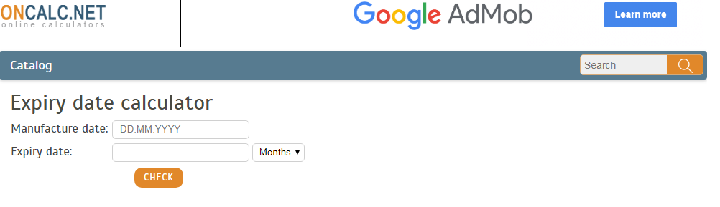Fig 1: Online expiry date calculator

The problem with the existing system is that we cannot predict the expiry date of different cooked products and they do not take into consideration the environmental factors like season, temperature, time of production, different storing temperatures and the state of food.
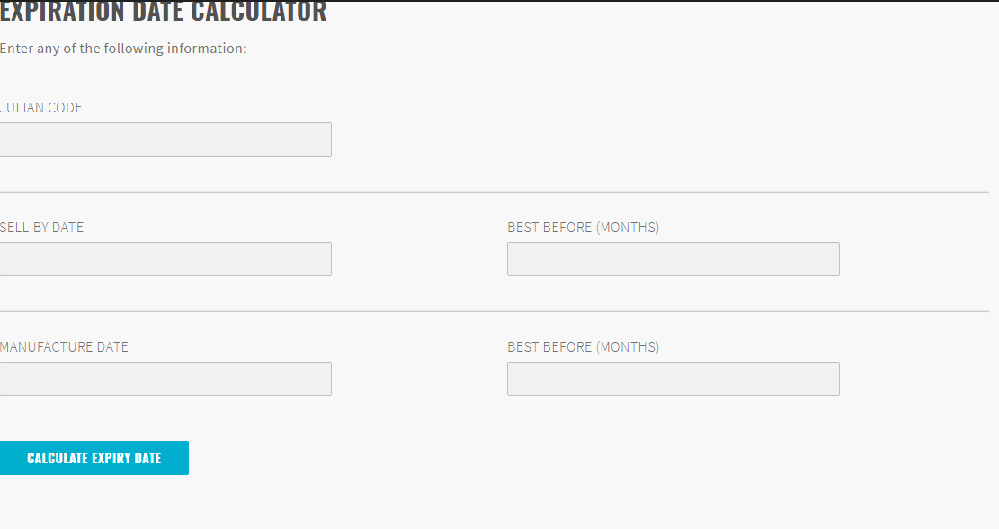

Fig 2: Online expiry date calculator

From Fig 1 and Fig 2 you can see that the expiry date is calculated by entering the manufacturing date and sell date only, there is no additional features and it is limited to sales product only.

2.4 Applications
This Project can be used by any user to know the Expiry of food Item by providing the different factors like storing temperature, time of preparation, season, state of food is taken into account before predicting number of days the food will last.
2.5 Functionalities
The project titled food storage prediction is a project in R programming language which uses the concept of machine learning. It helps in predicting the number of days the food will last based on your specifications. It allows you to know how much time will a cooked food last when kept at room temperature or in refrigerator or outside during summers or winters. Moreover, this project allows you to input different factors like storing temperature, time of preparation, season, state of food is before predicting number of days the food will last.

This project uses the concept of multiple linear regression of machine learning in which the different factors are independent variables and the expiry date is the dependent variable. The model is trained by the training set provided by a .csv file and the test set is predicted.
Multiple linear regression
- Multiple linear regression is an extension of simple linear regression used to predict an outcome variable (y) on the basis of multiple distinct predictor variables (x).
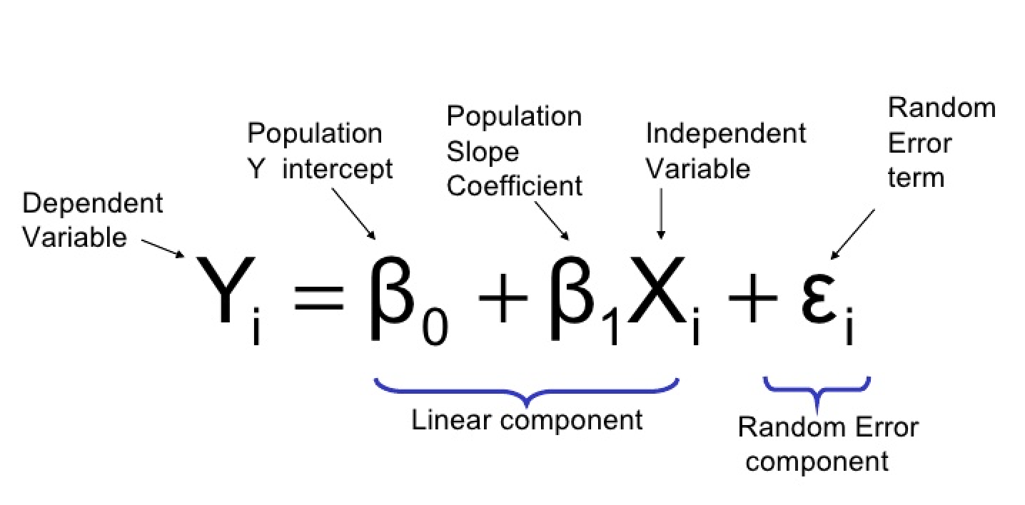
Fig 3: Multiple linear regression formula

- With three predictor variables (x), the prediction of y is expressed by the following equation:
- y = b0 + b1*x1 + b2*x2 + b3*x3

- The “b” values are called the regression weights (or beta coefficients).
- They measure the association between the predictor variable and the outcome. “b_j” can be interpreted as the average effect on y of a one unit increase in “x_j”, holding all other predictors fixed.
- Build and interpret a multiple linear regression model in R.
- Check the overall quality of the model.
- In simple linear relation we have one predictor and one response variable.
- In multiple regression we have more than one predictor variable and one response variable.

lm() Function
- This function creates the relationship model between the predictor and the response variable.

Syntax
- The basic syntax for lm() function in multiple regression is
- lm(formula~cost.,dataset)
- Following is the description of the parameters used
- formula is a symbol presenting the relation between the response variable and predictor variables.
- data is the vector on which the formula will be applied.
- It is the basic and commonly used type for predictive analysis.
- It is a statistical approach for modelling relationship between a dependent variable and a given set of independent variables.
- It is the most common form of Linear Regression. Multiple Linear Regression basically describes how a single response variable Y depends linearly on several predictor variables.
- The basic examples where Multiple Regression can be used are as follows:
- The selling price of a house can depend on the desirability of the location, the number of bedrooms, the number of bathrooms, the year the house was built, the square footage of the lot and a number of other factors.
- The height of a child can depend on the height of the mother, the height of the father, nutrition, and environmental factors.
- we will have at least three variables in our models, one response and two predictors.
- The response variable will be quantitative, but the predictor variables can be quantitative or categorical.
Plotting in R
- Line charts are created with the function lines(x, y, type=) t where x and y are numeric vectors of (x,y) points to connect.
- The lines( ) function adds information to a graph. It can not produce a graph on its own. Usually it follows a plot(x, y) command that produces a graph.
- By default, plot( ) plots the (x,y) points. Use the type="n" option in the plot( ) command, to create the graph with axes, titles, etc., but without plotting the points.
- (To practice creating line charts with this lines( ) function, try this exercise.)
- We look at some of the ways R can display information graphically.
- This is a basic introduction to some of the basic plotting commands.
- It is assumed that you know how to enter data or read data files which is covered in the first chapter, and it is assumed that you are familiar with the different data types.
- In each of the topics that follow it is assumed that two different data sets, w1.dat and trees91.csvhave been read and defined using the same variables.
- Both of these data sets come from the study discussed on the web site given in the first chapter. We assume that they are read using “read.csv” into variables w1 and tree.
The project uses a predefined package in R programming language called ggplot2 which is used for plotting the datset. The dataset is also split into the training set and test set.
2.6 Requirement specifications

Software requirements
1. Technology : R programming
2. OS : Windows 7
3. Platform : R Studio, R Console, Excel

Hardware requirements
4. Processor : Intel core i3
5. RAM : 4GB
6. ROM : 20 GB

3. Design
3.1 System Architecture

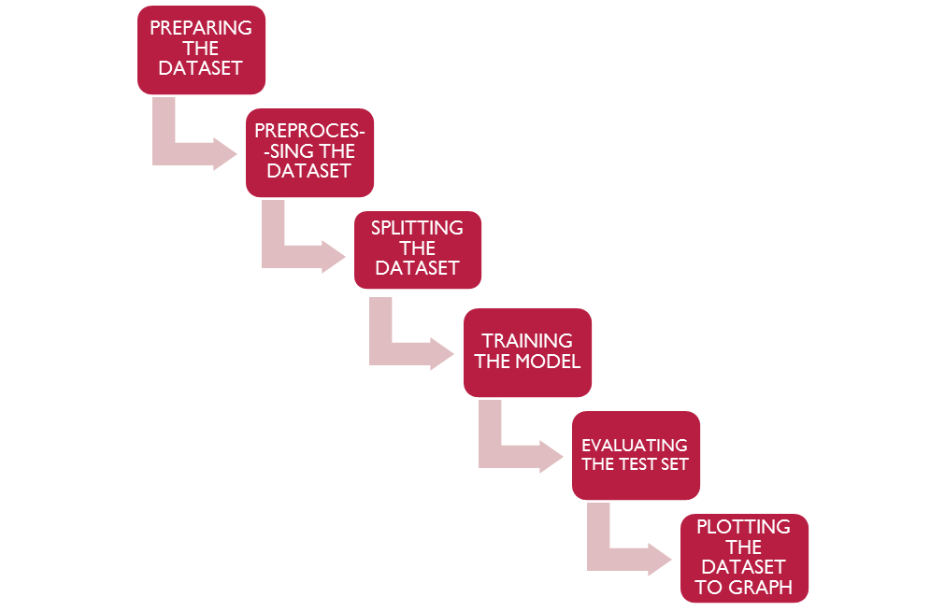
Fig 4:Flowchart

The architecture of the proposed system is as follows – the data set is created first, different combinations of food items are made and then at certain temperatures, climate, time of preparation and state of food the relevant expiry date is mentioned.

Preprocessing the dataset means converting the categorical data into labels and finding out the missing data if any through methods like mean.
The dataset is then split into the training set and test set. The training set is used to train the model and after the model is trained the model predicts the value of test set and then the expiry date is evaluated.
The dataset is then plotted using ggplot2 package which is a predefined package in R programming language.

4. Implementation

At the beginning the Data sheet of the data should be collected and should be saved as csv Extension. The data is collected with different factors like storing temperature, time of preparation, season, state of food. Data Includes two ingredients i.e., main and side ingredients.
Necessary libraries are installed such as caTools, for multiple linear regression model and ggplot2, for the graph/plot of the trained data.
All the lines in the data sheet which is saved as csv extension all allotted to train except the last line which is allotted for the prediction of the Expiry.
User can give the input in the last line with all the factors and can the Expiry of the food Item.

DDD

5. Results and Screenshots:
5.1Dataset: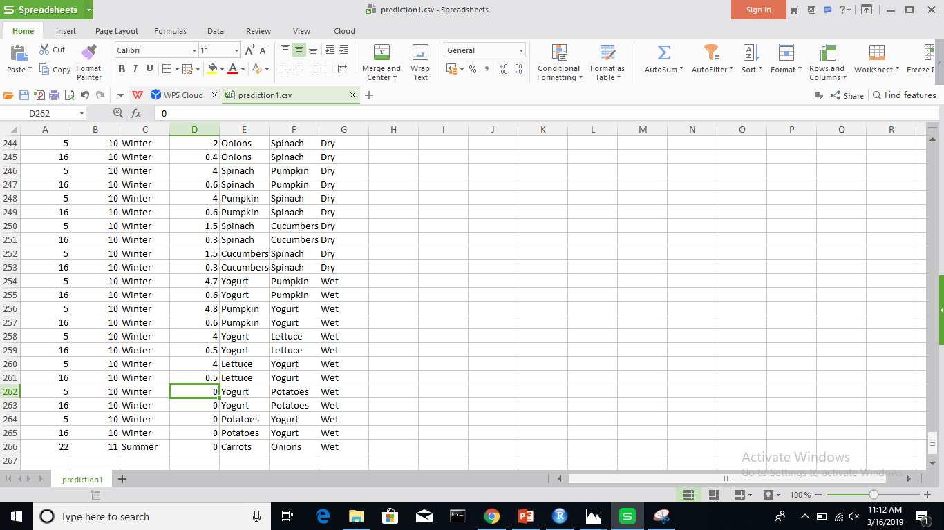Fig 5: Screenshot of the dataset.
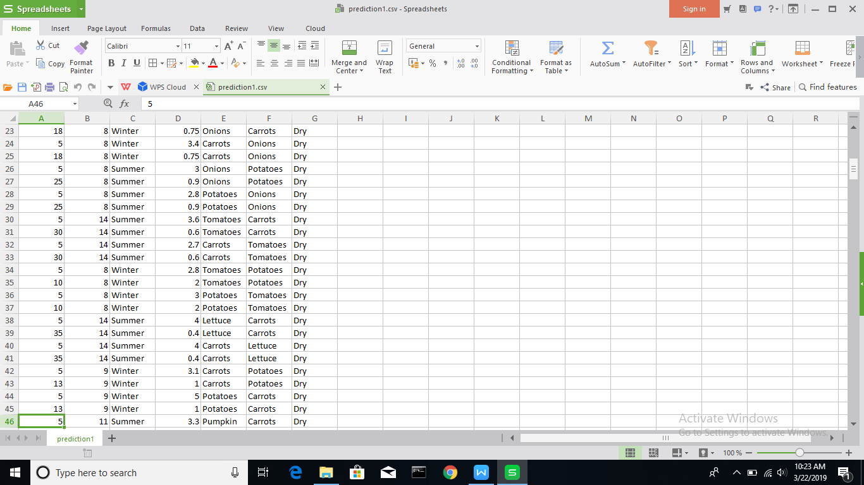Fig 6: Screenshot of the dataset
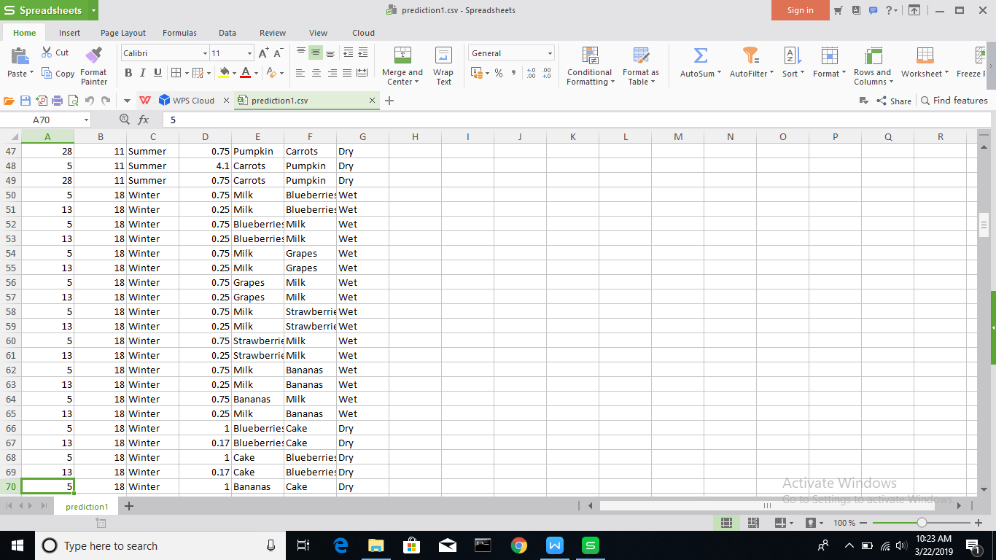
Fig 7: Screenshot of the dataset
Figure 5, Figure 6, Figure 7 are screenshots of dataset in excel which is saved as a csv file.

Fig 8: Screenshot of the user’s required dataset
Figure 8 is a screenshot of user’s input in the data set.

5.2 Preprocessing of data:
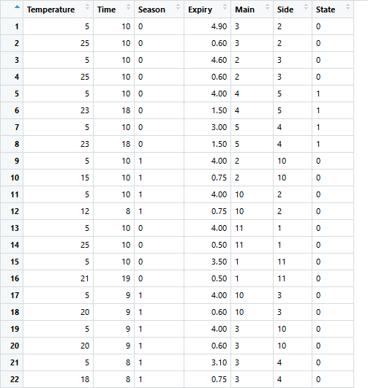
Fig 9: Screenshot of the dataset after preprocessing of the data.
Figure 9 shows the dataset after it is preprocessed i.e labels are given to the catogerical data.

5.3 Result:
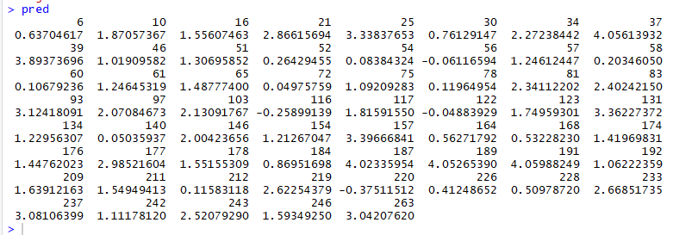
Fig 10: Screenshot of the results of Test set

Fig 11: Screenshot of the result of user’s data
Figure 10 and Figure 11 shows the result of test set which is obtained using pred keyword.

5.4 Summary of prediction:
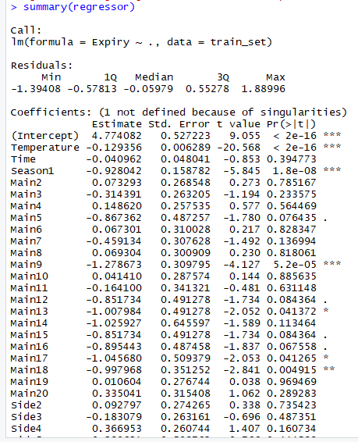

Fig 12: Screenshot of summary of the Model
Figure 12 shows the summary of the dataset using summary keyword.

5.5 Plotting of dataset:

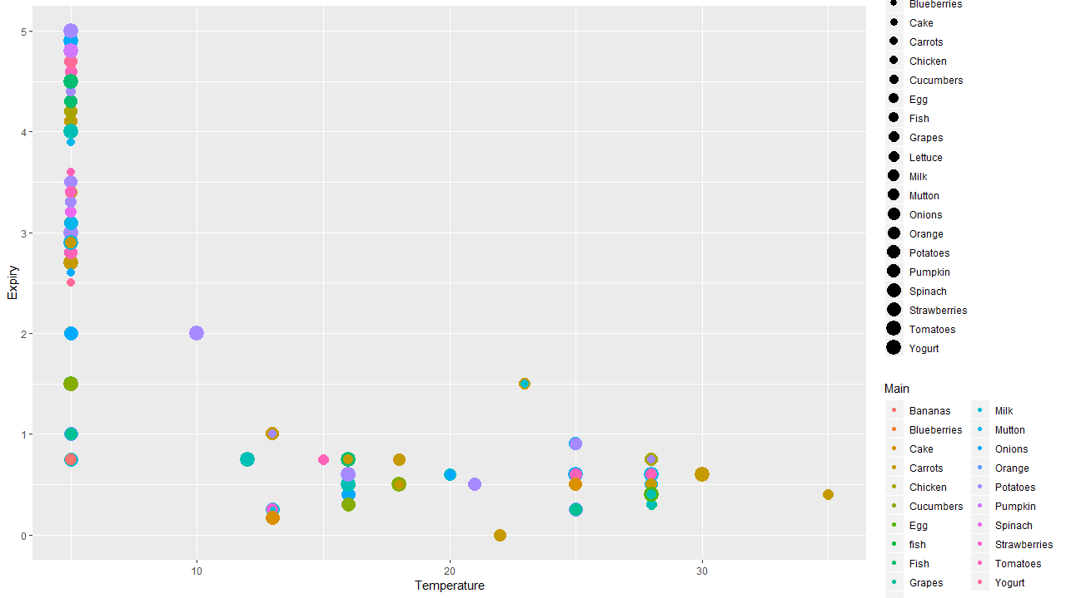

Fig 13: Plot of the dataset with respect to Expiry time
Figure 13 shows the graph plot between temperature and expiry date of the items of dataset.

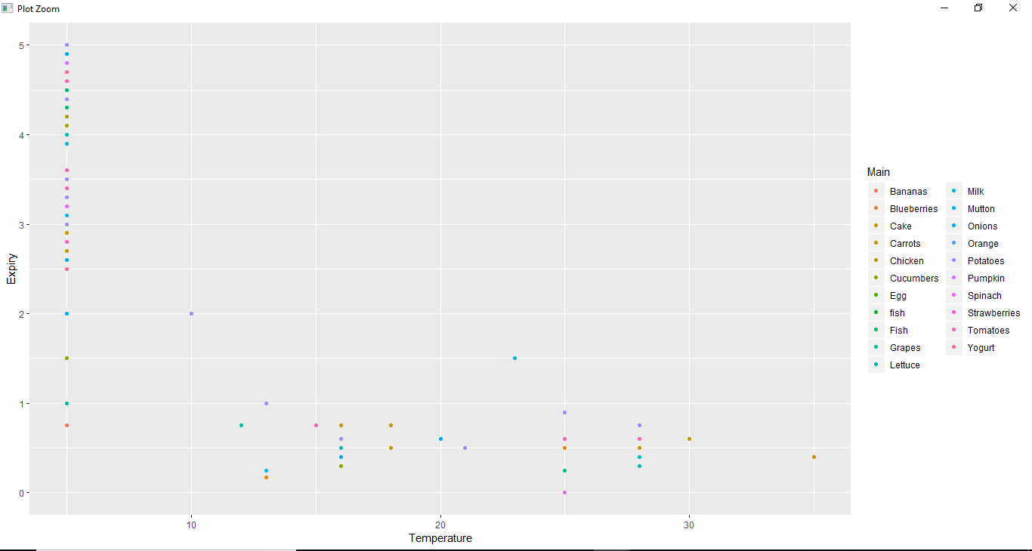
Fig 14: Plot of the dataset without Side item
Figure 14 is the graph without the side item(only between main item at a particular temperature and it’s expiry date).
Result:
Train the model using lm() with respect to the training set .Predict the result of test set using predict() . The Expiry period of the Food is obtained as number of days format .Using ggplot() plot the dataset which illustrate Expiry period with other attributes .Hence Expiry period of the Food is obtained.

6. Conclusion
This project was developed with the aim of helping people living in hostels or away from their families who don’t have knowledge about the Expiry of food Items. It will save people’s time and make their lives simpler. This project takes different factors into account and then predicts so it is more efficient. It minimizes efforts and saves time.

7. Future enhancement

The dataset can be further extended to many more ingredients like dals and spices. Now only main and side item is taken into account, a greater number of ingredients can be taken into consideration at the same time. Things like salt and other preservatives increase the life time of the food products which can also be included. The project can be converted into an Android Application so that it is more easily available to everyone.

8. References

- www.ggplot2.tidyverse.org

- www.tutorials.iq.harvard.edu/R/Rgraphics/Rgraphics.html

- www.sphweb.bumc.bu.edu/otlt/MPH-Modules/BS/BS704_Multivariable/BS704_Multivariable7.html

- www.investopedia.com/terms/m/mlr.asp

- https://www.udemy.com/machinelearning/learn/v4/t/lecture/5734728?start=90

- https://www.udemy.com/r-programming/learn/v4/overview

9. Appendix

dataset = read.csv("C:\\Users\\ibrah\\Desktop\\prediction.csv")
dataset$Main=factor(dataset$Main,
levels=c('Potatoes','Tomatoes','Onions','Carrots','Milk','Chicken','Mutton','Fish','Egg','Lettuce','Pumpkin','Grapes','Strawberries','Bananas','Blueberries','Cake','Orange','Cucumbers','Spinach','Yogurt'),
labels=c(1,2,3,4,5,6,7,8,9,10,11,12,13,14,15,16,17,18,19,20))
dataset$Side=factor(dataset$Side,
levels=c('Potatoes','Tomatoes','Onions','Carrots','Milk','Chicken','Mutton','Fish','Egg','Lettuce','Pumpkin','Grapes','Strawberries','Bananas','Blueberries','Cake','Orange','Cucumbers','Spinach','Yogurt'),
labels=c(1,2,3,4,5,6,7,8,9,10,11,12,13,14,15,16,17,18,19,20))
dataset$State=factor(dataset$State,
levels=c('Dry','Wet'),
labels=c(0,1))
dataset$Season=factor(dataset$Season,
levels=c('Summer','Winter'),
labels=c(0,1))
#install.packages('caTools')
library(caTools)
set.seed(11)
#split=sample.split(dataset$Expiry,SplitRatio=0.75)
train_set=dataset[1:263,1:7]
test_set=dataset[264,1:7]
#train_set=subset(dataset,split==TRUE)
#test_set=subset(dataset,split==FALSE)
#train_set[,1:2]=scale(train_set[,1:2])
#test_set[,1:2]=scale(test_set[,1:2])
regressor=lm(formula=Expiry~.,train_set)
pred=predict(regressor,newdata = test_set)
print(pred)
print(pred*24)
install.packages("ggplot2")
library(ggplot2)
p=ggplot(data=dataset,aes(x=Temperature,y=Expiry,colour=Main,size=Side))
p+geom_point()

