PROJECT TEAM:

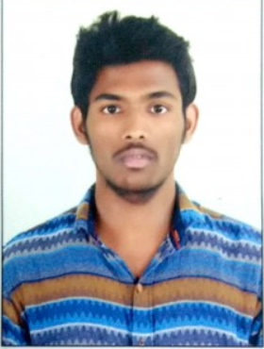 

Name:Ajay Name:Raj Vamshinath

Roll no:2451-17-737-021 Roll no:2451-17-737-024

Email ID:ajaykumarbussa1234@gmail.com Email ID:rajvamshinath16@gmail.com

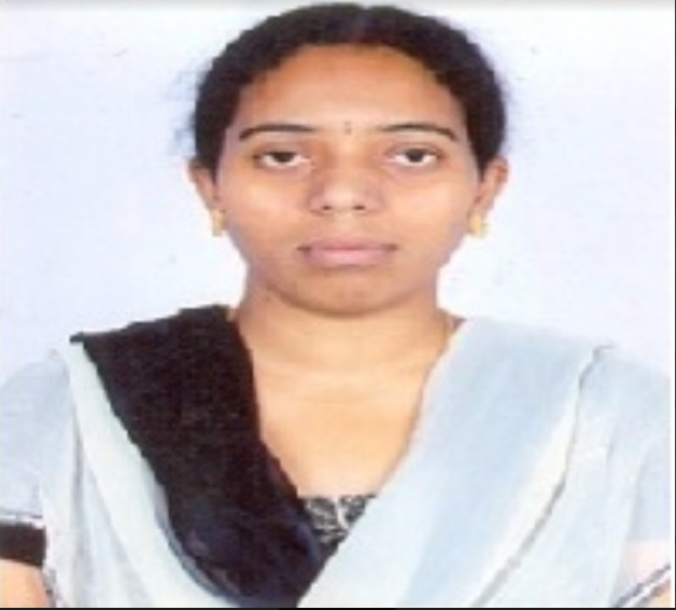

Guide:CH.Srujana

Designation:Asst.Professor