https://hub.gke.mybinder.org/user/pmonnin-datapeeler-docker-twzihxdu/tree

1-open mybinder website

mybinder.org

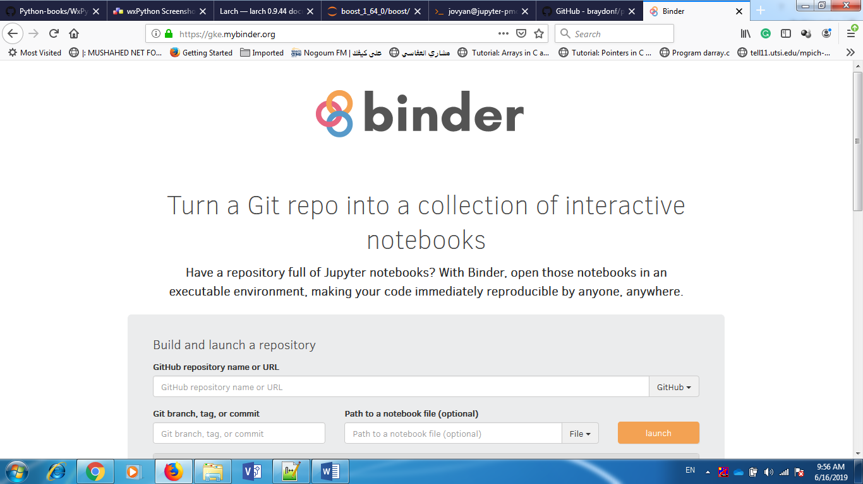

2- copy link of library

https://github.com/pmonnin/datapeeler-docker

3- paste in mybinder in the first block

- https://github.com/pmonnin/datapeeler-docker

- press lunch

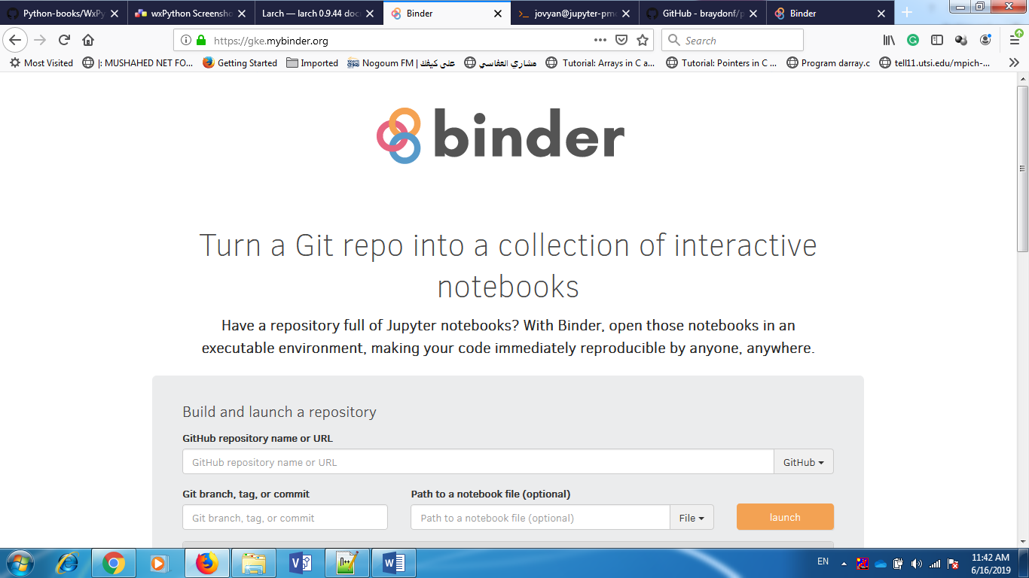

4- Install boost

open new terminal

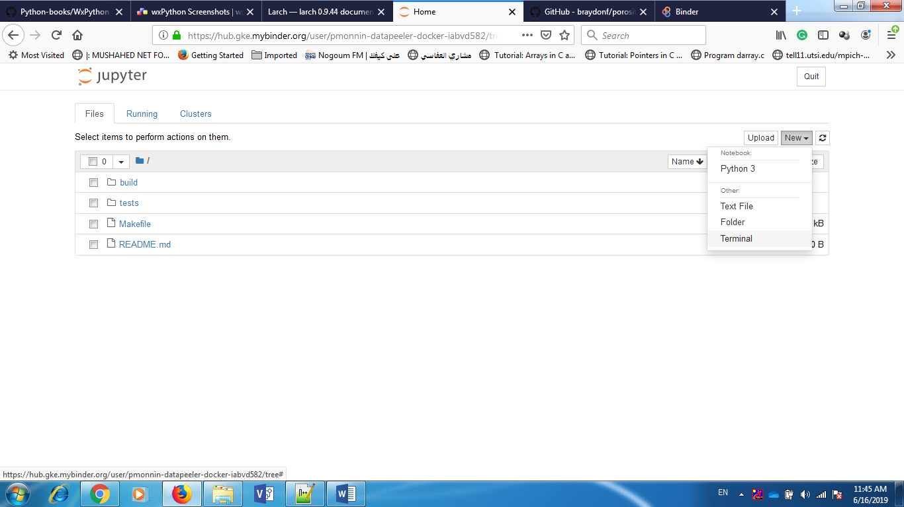

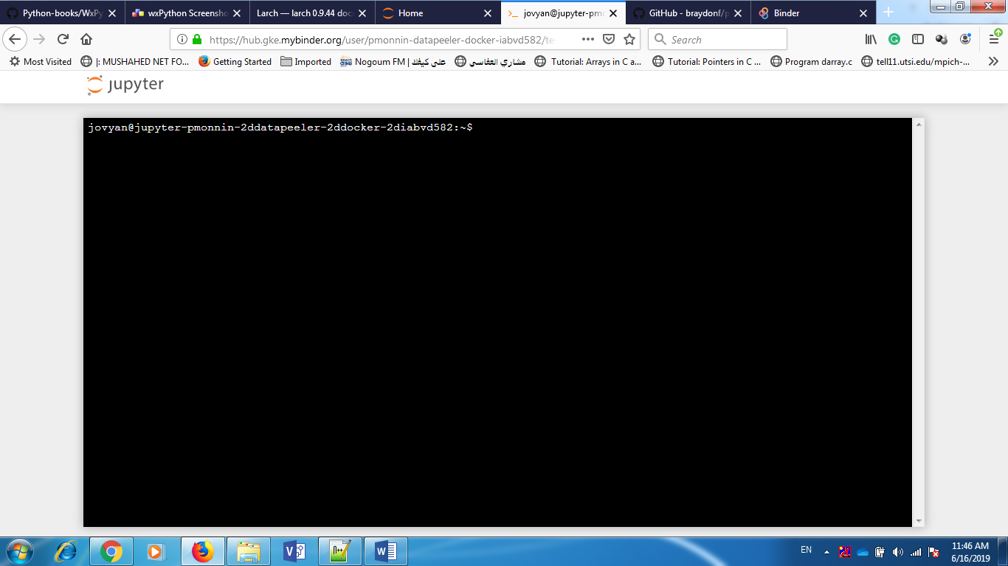

- sudo apt-get install python-dev libxml2-dev libxslt-dev libicu-dev gperf bison libjpeg-dev wget

- wget https://dl.bintray.com/boostorg/release/1.64.0/source/boost_1_64_0.tar.bz2

- tar xf boost_1_64_0.tar.bz2

- cd boost_1_64_0

- sh bootstrap.sh

- ./b2 install

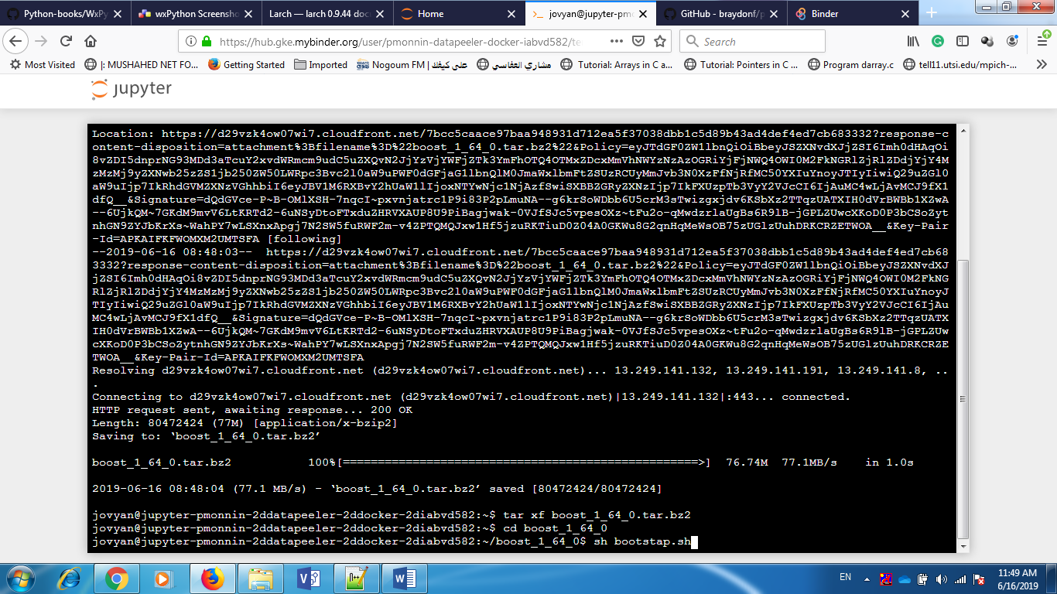

Configure and build:

./autogen.sh

./configure

make

And install with:

sudo make install

4- upload d_peeler

