**Entities**

**Employee:** “Strong entity contains 9 attributes”

* **FName** “Single/Simple”
* **Lname** “Single/Simple”
* **username** “Derived - unique”
* **Role** “Single/Simple”
* **Phone** “Multivalued - unique”
* **id** “Key - unique”
* **Email** “Single/Simple - unique”
* **Password** “Single/Simple”
* **NationalID** “Key - unique”

**Patients:** “Strong entity contains 9 attributes”

* **FName** “Single/Simple”
* **Lname** “Single/Simple”
* **History** “Single/Simple”
* **Age** “Single/Simple”
* **Phone** “Multivalued - unique”
* **id** “Key - unique”
* **Email** “Single/Simple - unique”
* **Admission Date** “Single/Simple”
* **NationalID** “Key - unique”

**Diagnosing:** “Strong entity contains 3 attributes”

* **id** “Single/Simple”
* **Date** “Single/Simple - unique”
* **Type** “Single/Simple”

**Departments:** “Strong entity contains 3 attributes”

* **id** “Key - unique”
* **Name** “Single/Simple”
* **Description** “Single/Simple”

**Relations**

**Work:**

* **Description:**

Does **Employee** work in **Department**?

* **Degree:**

**Binary** relation.

* **Ratio:**

**Many** employees can work in **One** department.

* **Participation:**

Employee **Must** be in a department.

Department **May** be empty.

**Manage:**

* **Description:**

Does **Employee** manage the **Department**?

* **Degree:**

**Binary** relation.

* **Ratio:**

**One** employees can work in **One** department.

* **Participation:**

Employee **May** be in a department.

Department **Must** be managed.

**Make:**

* **Description:**

Does **Employee** make a **Diagnosis**?

* **Degree:**

**Binary** relation.

* **Ratio:**

**Many** employees can make **Mane** diagnosis.

* **Participation:**

Employee **May** make a diagnosis.

Diagnosis **Must** be done by an employee.

**Supervise:**

* **Description:**

Does **Employee** Supervise any **Employees**?

* **Degree:**

**Unary** relation.

* **Ratio:**

**One** employee can Supervise **Many** employees.

* **Participation:**

Employee **May** Supervise.

Employee **May** Be Supervised.

**Treat:**

* **Description:**

Does **Employee** treat **Patient**?

* **Degree:**

Binary relation.

* **Ratio:**

**Many** employees can treat **Many** patients.

* **Participation:**

Employee **May** treat patients.

Patient **Must** be treated by an employee.

**Assign:**

* **Description:**

**Employee** assigns **Diagnosis** to **Patient**?

* **Degree:**

**3** Binary relations (out of ternary relation).

* **Ratio:**

**One** employee can assign **Many** diagnoses to **One** patient.

* **Participation:**

This operation **May** be done.

**Entity Relation Diagram**

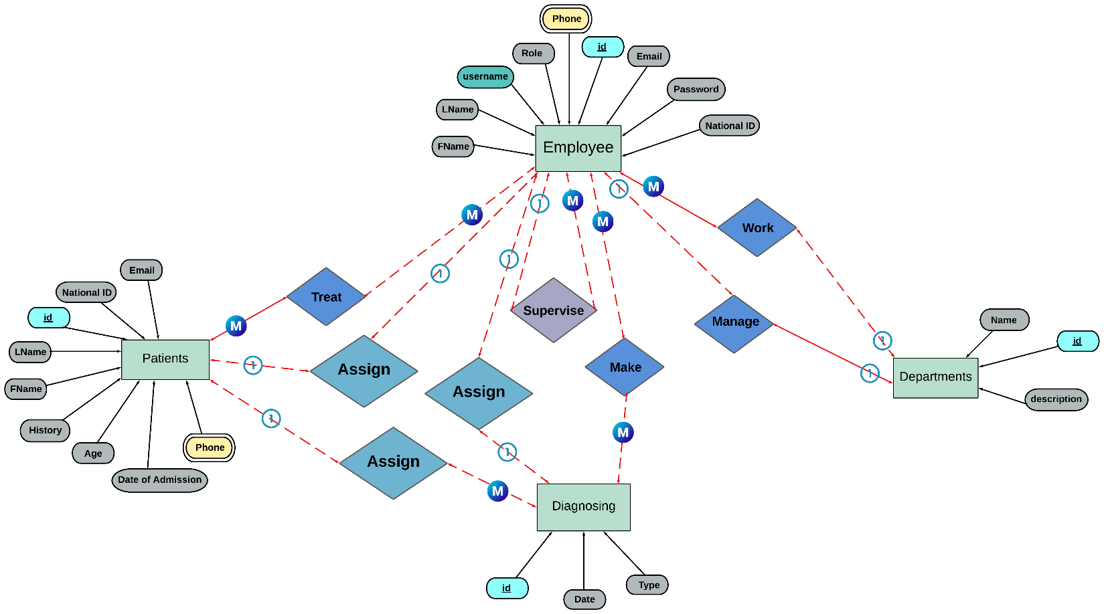

**Logical Scheme**

**Employee** (id, Fname, Lname, username, role, phone, email, password, national_id, supervisor_id, department_id);

**Department** (id, name, description, manager_id);

**Patient** (id, Fname, Lname, national_id, email, history, age, admission_date, phone);

**Diagnosis** (id, date, type);

**Assign_Diagnosis** (emp_id, patient_id, diagnosis_id);

**Treat** (emp_id, patient_id);

**Made_Diagnosis** (emp_id, diagnosis_id);