**Mega Project Summer Training**

*Problem Solving Tasks*

Name: Ibrahim Mohamed Eita

Email: ebrahimaboeita990@gmail.com

Phone: 01061468175

**Task 1 -> Fixed Password (1114)**

**Task 2 -> Type of Fuel (1134)**

**Task 3 -> Walking in Time (2235)**

**Task 4 -> Hard Choice (2702)**

**Task 5 -> Divisor1 (1157)**

**Task 6 -> Bino’s Challenge (2060)**

**Task 1:** Fixed Password

**Problem Code:** 1114

**Beecrowd Accepted:**

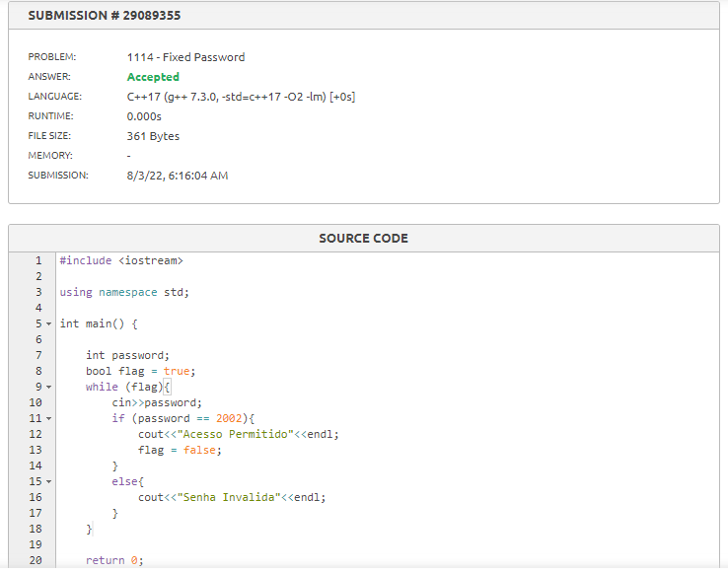

**Source Code:**

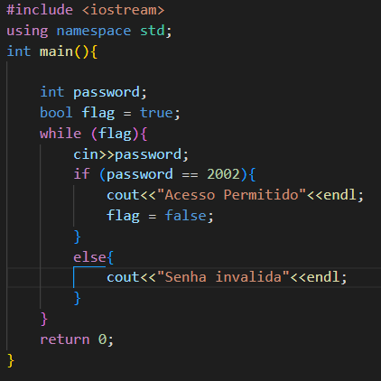

**Task 2:** Type of Fuel

**Problem Code:** 1134

**Beecrowd Accepted:**

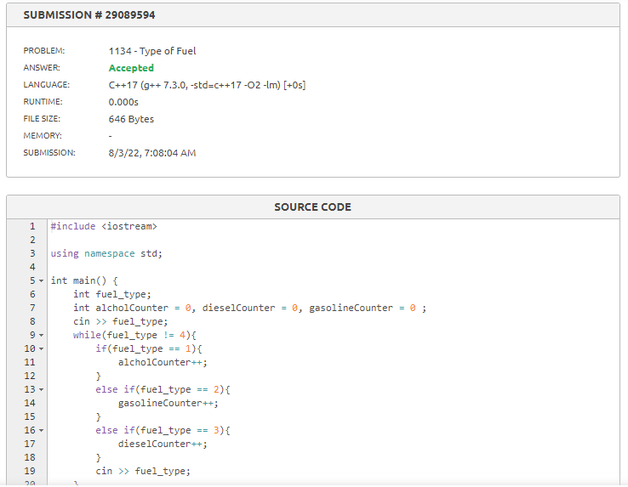

**Source Code:**

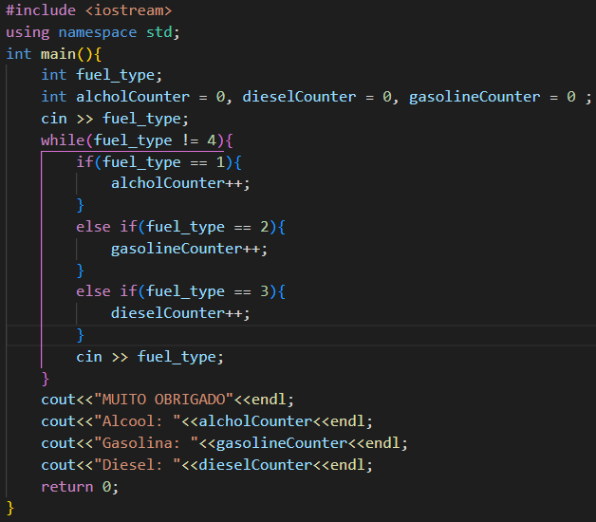

**Task 3:** Walking in Time

**Problem Code:** 2235

**Beecrowd Accepted:**

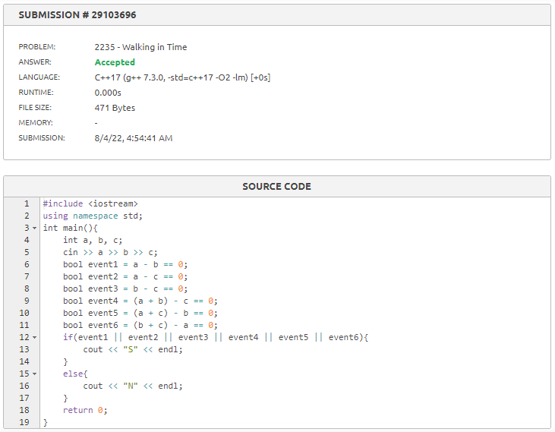

**Source Code:**

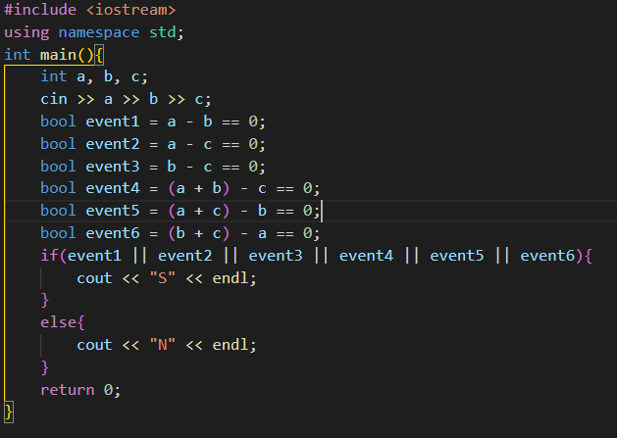

**Task 2:** Hard Choice

**Problem Code:** 2702

**Beecrowd Accepted:**

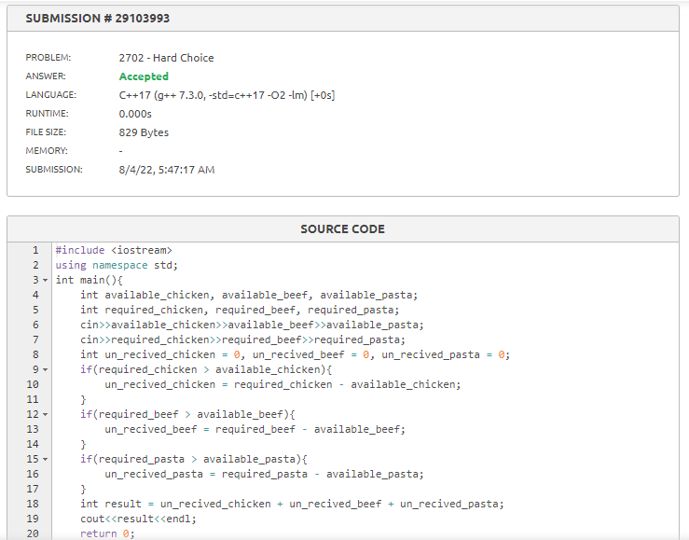

**Source Code:**

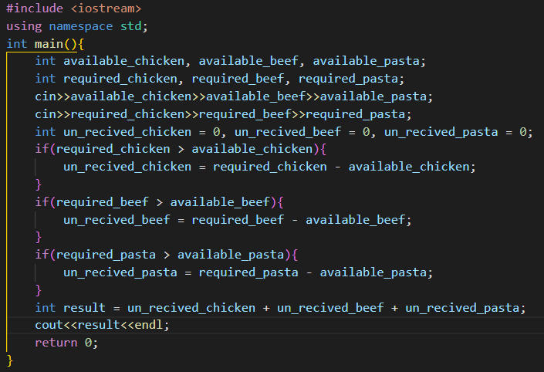

**Task 2:** Divisor1

**Problem Code:** 1157

**Beecrowd Accepted:**

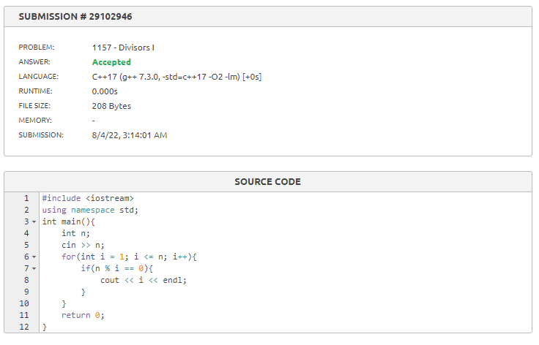

**Source Code:**

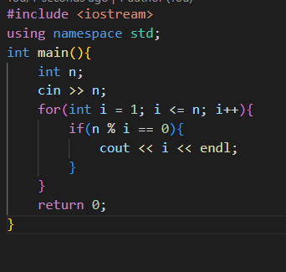

**Task 2:** Bino’s Challenge

**Problem Code:** 2060

**Beecrowd Accepted:**

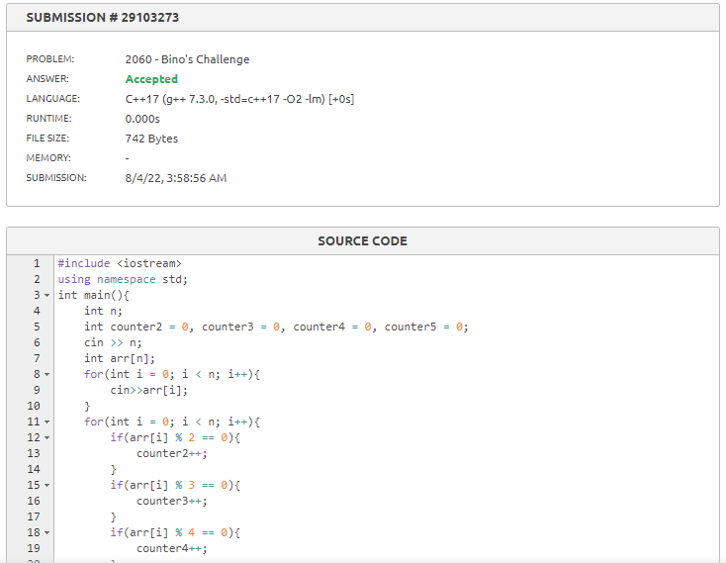

**Source Code:**

