**21378681**

IBRAHIM AHHMED KHAN

ISYS2014 DATABASE SYSTEMS

DBS USER GUIDE



Introduction

This guide provides step-by-step instructions to implement and use the Formula 1 database in MySQL. It includes the process of setting up MySQL, executing SQL scripts, and running queries to retrieve race-related data. By following these instructions, users will be able to create and interact with the database efficiently.

Version Requisites

Mysql Ver 8.0.36-0ubuntu0.22.04.1 for Linux on x86_64 ((Ubuntu))

Python 3.10.12

Setting up MySQL and creating the database

Log in to MySQL with:  
mysql -u root -p

Enter your MySQL root password when prompted.

First Flush ALL the TABLES if existed in the database before.

Run the init.sql file in sql

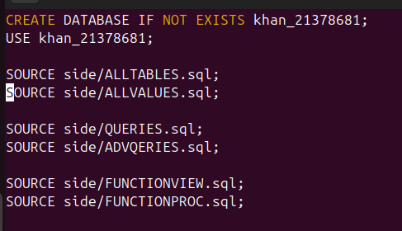

**Init.sql file**

Contains the table, the values, the queries and the advanced features.

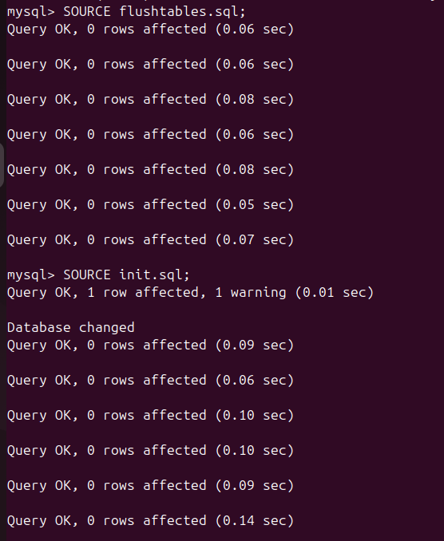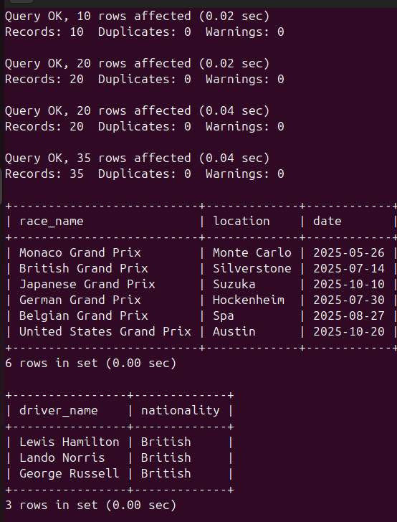

First flush all the tables then run the init code if u have some tables already created the tables in the database.

These are some query examples shown in the above screenshots:  
SELECT race_name, location, date

FROM GrandPrix

WHERE YEAR(date) = 2025;

SELECT driver_name, nationality

FROM Driver

WHERE nationality = 'British';

To individually check the queries u can copy paste each query from the 2 queries files.

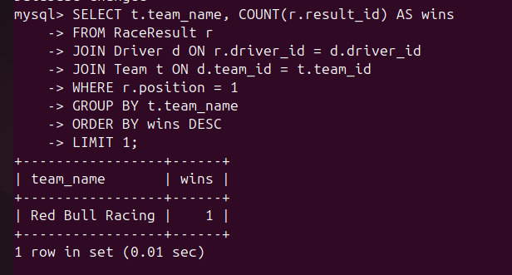

File List

**side/ALLTABLES** - Contains all the tables.

**side/ALLVALUES** - Contains all the values of the created tables

**side/QUERIES** - 5 simple queries

**side/ADVQERIES** - 5 advanced queries

**side/FUNCTIONPROC** - The 2 Stored Procedure

**side/FUNCTIONVIEW** - The 2 Views

**init.sql** - Sources all the necessary components to ensure the database order

**flushtables.sql -** for the necessary dropping of the tables.

**main.py** - GUI for the database

Troubleshooting Common Issues

**Error: Table or Column Not Found**

Run SHOW TABLES; to check if the table exists.

Use DESCRIBE table_name; to verify column names.

**Error: Foreign Key Constraint Fails**

Check if parent records exist before inserting child records.

Example: A Driver must belong to a Team before inserting.