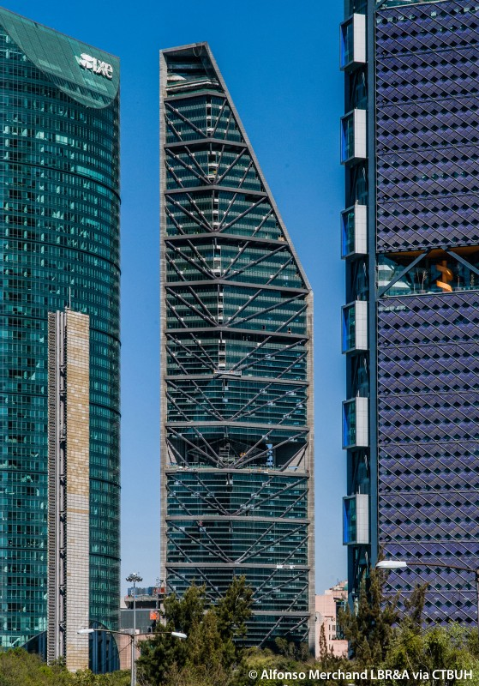



© Copyright 2018, All Rights reserved.

By:

Ibrahim Heritch

Bayan Jaber

Abdullah Barazi

**Airport**

**Database**

TM



Table of Contents

I – Airport Description and Constraints…………………………………………………………………1

II – Entity Types………………………………………………………………………………….………2

III – Relationships………..…………………………………………………………………….…………4

IV – ER to Relational Mapping Algorithm……………………………………………………………….10

Step1: Mapping of Regular Entity Types……………………………………………………………10

Step2: Mapping of Weak Entity Types…………………………………………………………...…13

Step3: Mapping of Binary 1:1 Relationship Types……………………………………………….…13

Step4: Mapping of Binary 1:N Relationship Types……………………………………………....…13

Step5: Mapping of Binary M:N Relationship Types…………………….……………………….…16

Step6: Mapping of Multi-valued Attributes……………………………………………………....…17

Step7: Mapping of N-ary Relationship Types.…………………………………………………....…18

Final Step: Final Displays………………………....……………………………………………....…19

V – Tables Structure for the Airport Database…………………………………………………………….22

VI – Tables Descriptions…………………………………………………………………………………..29

VII – Dumping Data for the Created Tables of the Airport Database……………………………………..33

VIII- Final Tables………………………………………………………………………………………….81

IX – Queries………………………………………………………………………………………………106

**Requirements for an Airport Database**

1. **Airport Description and Constraints:**

The Airport has several runways, gates, and hangars. The Airport can have many planes, either parked in gates or hangars. Those planes can be operated by either private-owners or an airline.

Once a plane arrives at the airport by landing on the runway, its owner is supposed to rent either a hangar or a gate to park the plane at. Commercial planes can pick up passengers at a gate. Each gate has a specific rent price, boarding method, and a specific size. Planes that are bigger than the gate size can’t park at that specific gate.

The two entities that can rent/own planes, gates, and hangars are the airline and the private owner. Each airline has a specific ICAO-Code given to it by the International Civil Aviation Organization that consists of the three characters. It also has a two-character code called the IATA Code given to it by the International Air Transport Association. Airlines also can operate from multiple hubs which are the home airports where the airline is based. A private owner can be any individual that owns any type of planes, gate, or hangar at the airport. Each private-owner is identified by her/his owner id which is assigned to him by the airport.

A flight is a specific instance of the plane flying from one airport to another. Flights take off and land at a runway, are either commercial or private and have a specific departure time and arrival time. Each flight also has a specific cargo capacity and passenger capacity. A flight might consist of multiple segments or stops. Flights are identified by flight numbers which are unique numbers assigned when a pilot files a flight plan. Every flight will have passengers and cargo. Passengers have a name and a ticket ID that is assigned by their airline. Every passenger has a specific luggage weight that s/he is allowed to take on the plane. Also, the airport is required to keep track of the weight of every passenger’s actual luggage weight because the net weight of cargo in the plane needs to be provided to the pilots, so they can perform some pre-flight calculations. A plane can also transport cargo, the cargo can either be the passenger’s luggage or can be independent from the passenger. Also, a passenger might have special needs that includes unaccompanied minors, people with disabilities, and the elderly. The airport needs to know the dimensions and weight of every piece of cargo so that the plane can be loaded efficiently and calculates the net weight of the plane. The airport is also responsible for providing a cargo manifest to the pilots, which is a description of all the cargo in the plane. The cargo also has a specific carrier that the airport needs to keeps track off.

Flights take off and land at runways, each runway has a specific ID and can be either closed, takeoff-only, landing-only or both. Also, the airport needs to keep track of the runway surface state and length because that information needs to be provided to the pilots.

The hangar has a specific hangar-ID and size. Multiple planes can be parked in one hangar.

Inside the airport terminal, the airport has its business spaces in the duty-free zone that it rents to specific companies, each business space has rent, size, category (as either a shop or a restaurant), and a specific ID.

The airport needs to store the name, phone numbers, and addresses of the companies that rent the business places. It also needs to know the specific field of business of the company. The airport has also a unique challenge in that it has to keep track of every employee that works in the airport for security reasons, so all employees even the ones that don’t work directly for the airport need to be kept track of in the airport database. The employee has an ID assigned to her/him by the airport, a first name and a last name, a job-description, training, and clearance. The employees can even be working for a private-owner, airline or for a business, they can also work in a flight or at a gate. Some employees also maintain the runways and hangars. An employee can either be terminal-only, runway-only, tarmac-only, or a combination of the above. This is known as the employee clearance.

1. **Entity Types:**

**1 – Private Owner:**

The PRIVATE-OWNER *owns/rents* PLANE, GATE, and HANGAR. PRIVATE-OWNER can also *operate* FLIGHT. Every PRIVATE-OWNER has an Owner ID as a key attribute, a name that is composed of a first_name and a last_name. On the other hand, EMPLOYEES work for PRIVATE-OWNERS.

**2 – Airline:**

The AIRLINE *owns/rents* PLANES, GATES, and HANGARS. The AIRLINE also *operates* FLIGHTS. In addition, EMPLOYEES *work for* AIRLINES. AIRLINES have a call_sign, ICAO code, and IATA code as key attributes. And they have a multi-valued attribute called hubs.

**3 – Plane:**

A PLANE is either *parked* at the GATE or the HANGAR. A PLANE *performs* a FLIGHT. All PLANES *are owned* by either PRIVATE-OWNERS or the AIRLINE. A PLANE has a fuel_type, registration_number as its key attribute, type (Private or commercial), model, compsite attribute of number_of_seats (First_class, business, economy) and min_gate_size.

**4 – Gate:**

A PLANE *parks at* a GATE, and a PRIVATE-OWNER/AIRLINE *rent* a GATE for a duration of time. EMPLOYEES *work on* GATES. The GATE has a rent_price, a boarding_method (bus or tunnel), number_of_seats that the gate has at the terminal, size of the gate, ID of the gate which is a key attribute, and the status of the gate as taken or available.

**5 – Cargo:**

CARGO is *transported* by the FLIGHT, and some CARGO is *owned* by the PASSENGER. CARGO has a size, weight, cargo_ID which is a key attribute, and a description.

**6 – Flight:**

AIRLINE or PRIVATE-OWNER *operate* a FLIGHT. All FLIGHTS *are performed by* PLANES. EMPLOYEES *work in* FLIGHTS, and FLIGHTS *transport* CARGO and PASSENGERS. A FLIGHT *takes off* and *lands on* a RUNWAY. FLIGHT has a PASSENGER. Passenger_capacity, cargo_capacity, departure_time, arrival_time, departure_airport, destination_airport, state, cargo capacity, segments, and the flight number which is a key attribute.

**7 – Runway:**

A RUNWAY is *maintained* by EMPLOYEES. FLIGHTS *takes-off and land_on* RUNWAYS. Each RUNWAY has a length, status, surface, and an ID attribute.

**8 – Passenger:**

A PASSENGER is a strong entity for FLIGHT. A PAS SENGER *owns* CARGO, has a ticket_ID which is its key. FLIGHT *transports* PASSENGER. Also, a PASSENGER has a name (first_name,last_name ), special needs, max luggage size and an actual luggage weight.

**9 – Business Space:**

A COMPANY *rents* a BUSINESS_SPACE for a specific date and duration. The BUSINESS_SPACE has rent, size, category, and an BusinessID as a key attribute.

**10 – Hangar:**

A PLANE *parks_in* a HANGAR. A PRIVATE-OWNER or an AIRLINE *owns/rents* a HANGAR. EMPLOYEES *maintain* the HANGAR. Also, the HANGAR consists of the hangar_ID which is a key attribute and the size.

**11 – Employee:**

EMPLOYEES *maintain* the HANGAR and RUNWAY. EMPLOYEES *work for an* AIRLINE, in a FLIGHT, COMPANY, or in a GATE. EMPLOYEES also invoke a recursive relationship that *manages* itself. EMPLOYEES consist of an EmployeeID which is a key attribute, name which is made up of the first-name and last-name, job-type, clearance, and training.

**12 – Company:**

EMPLOYEES *work for* a COMPANY. Also, COMPANIES *rent* a BUSINESS SPACE for a specific duration of time. The airport keeps track of the company’s name which is a key attribute, phone which is multivalued, address, which is also multivalued and the field that the company works in.

1. **Relationships:**

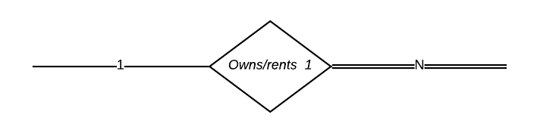

A private-owner can either buy or rent a hangar. Therefore, the Owns/rents relationship exists between the hangar entity, and the private-owner entity. One private owner can own/rent multiple hangars.

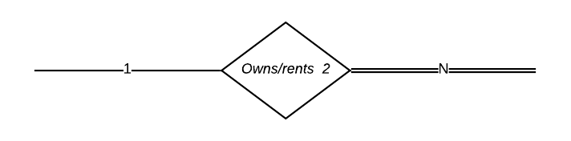

An airline can either buy or rent a hangar. Therefore, the owns/rents relationship exists between the hangar entity, and the airline entity. One airline can own/rent multiple hangars.

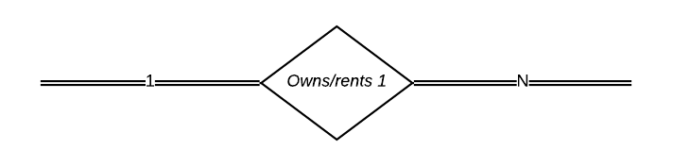

An airline can either own or rent a plane. Thus, the relationship owns/rents exists between airline and plane. The participation on the side of airline is total. One airline can own multiple planes.

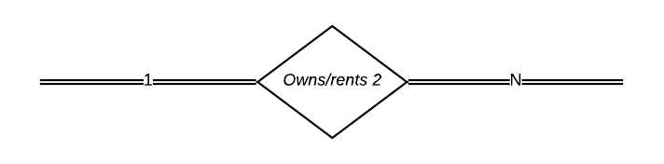

A private-owner can either own or rent a plane. Thus, the relationship owns/rents exists between private owner and plane. The participation on the side of private-owner is total. One private-owner can own multiple planes.

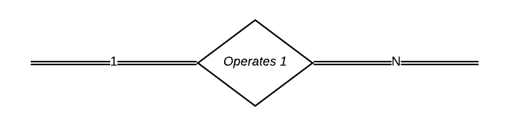

The airline operates many flights, thus, the *Operates* relation exists between airline and flight. One airline operates many flights.

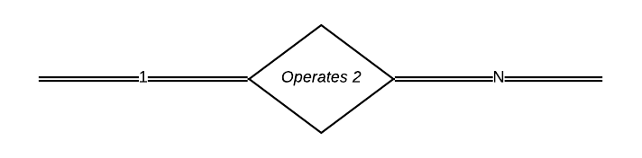

The private-owner operates many flights. Hence, the *Operates* relation exist between private-owner and flight. One private-owner operates many flights.

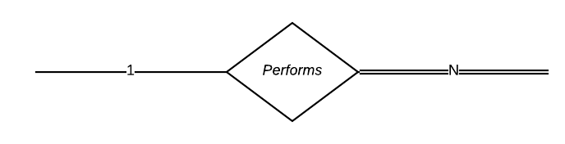

A plane performs multiple flights .Thus, the *Performs* relation exists between the plane and flight entities. The participation is total on the flights side.

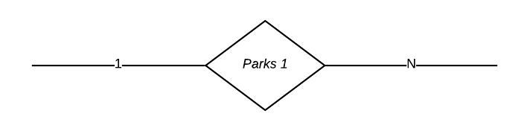

A plane parks at a gate. Thus, the *Parks* relationship exists between plane and gate. The relationship is one-to-one.

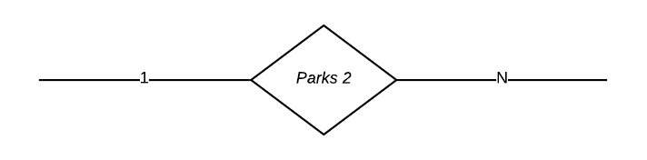

A plane can also park at a hangar. Therefore, the relation *Parks* exists between plane and hangar. Multiple planes can be parked in one hangar.

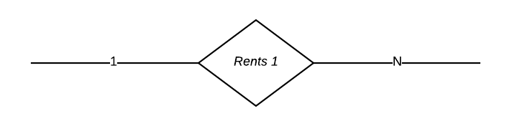

The Airline rents a gate. Therefore, the relation *Rents* exists between airline and gate. One airline can rent multiple gates. This relation has start_time and end_time as attributes, as well as a derived attribute called duration.

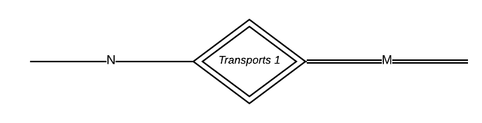

Flight transports cargo, therefore, the weak relationship *Transports* exists between flight and cargo. One flight can have several cargos.

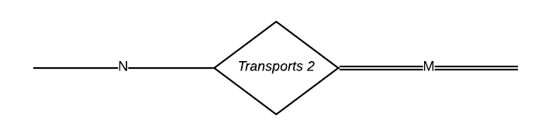

Flight transports passenger, therefore, the weak relationship *Transports* exists between flight and passenger. One flight can have several passengers.

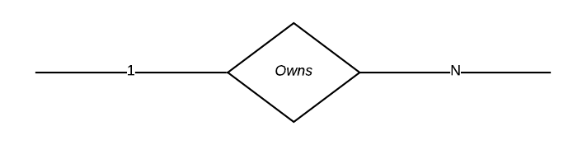

Passenger can also own cargo, therefore, the *Owns* relationship exist between passenger and cargo. One passenger can own multiple pieces of cargo.

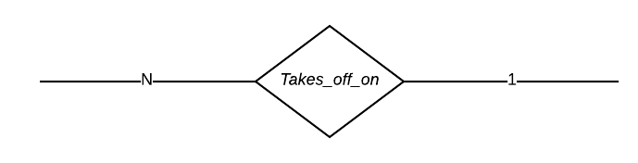

Multiple flights can take-off at a runway. Therefore, the *Takes_off*_*on* relationship exist between flight and runway.

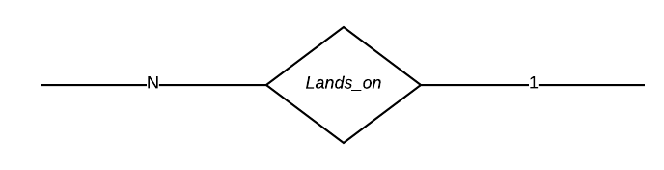

Multiple flights can lands at a runway. Therefore, the *Lands_on* relationship exist between flight and runway.

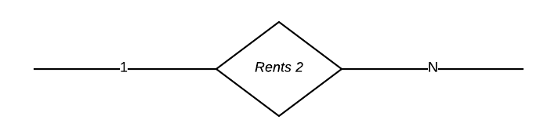

A company can rent multiple business places, therefore, the *Rents* relationship exists between company and business space.

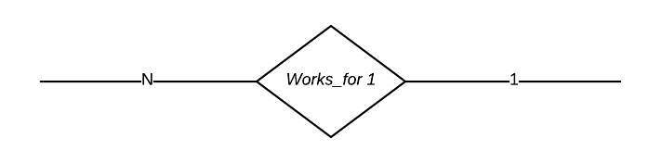

Multiple employees work for an airline. Thus, the *Works_for* relationship exists between employee and airline entities.

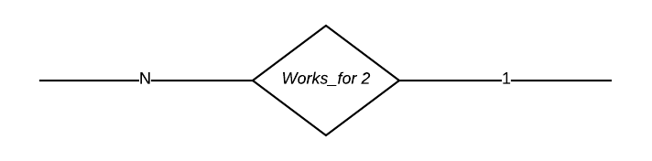

Multiple employees work for a private-owner. Thus, the *Works_for* relationship exists between

employee and private-owner entities.

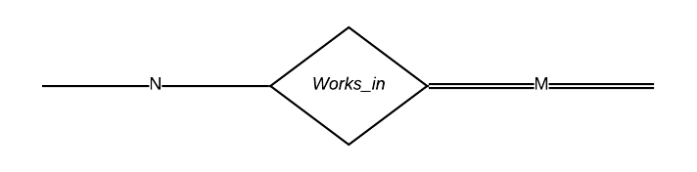

Employee works in flight. Therefore, the *Works_in* relationship exists between employee and flight. The relationship is complete participation on the side of the flight entity, and its many-to-many.

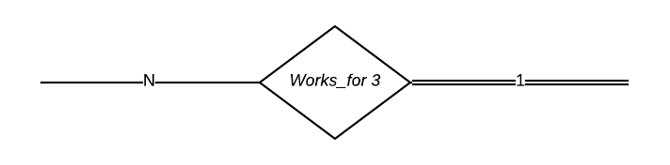

Employee *Works_for* company. It is a many-to-one relationship, and the relationship is total participation on the side of the company.

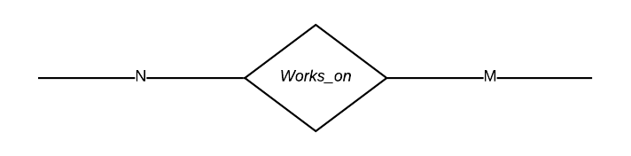

Employee works on gate. It is because of this that the relationship *Works_on* exist between employee and gate. This relationship is many-to-many.

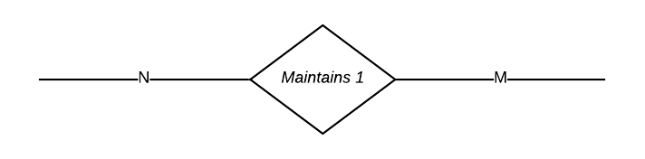

Many employees maintains many hangars. Thus the many-to-many relationship called *Maintains* exists between employee and hangar.

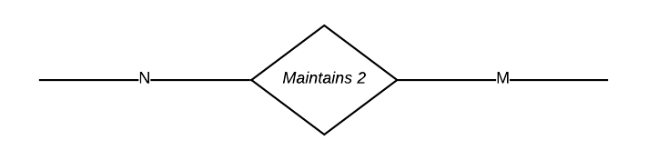

Many employees maintain many runways. Thus the many-to-many relationship called *Maintains* exists between employee and runway.

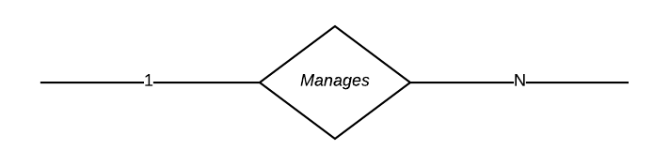

Employee manages Employee. Thus, the recursive *Manages* relationship exist between the employee that is the manager and other employees that are her/his subordinates.

1. **ER to Relational Mapping Algorithms**

In this section, we shall outline a seven-step algorithm to convert the basic ER model contructs-entity types, binary relationships, n-ary relationships, and attributes into relations.

**Step One: Mapping of Regular Entity Types:**

In this first step, we shall map all the regular entity types into relations, those relations include all simple attributes and all multi-valued attributes. The simple entities in the airport database are PRIVATE-OWNER, HANGAR, AIRLINE, PLANE, FLIGHT, EMPLOYEE, BUSINESS SPACE, COMPANY, RUNWAY, and GATE.

**PRIVATE-OWNER**

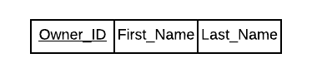

This entity has an attribute Owner_ID as a key. It also has a composite attribute called name, thus we include the simple attributes First_Name and Last_Name which compose name.

**HANGAR**

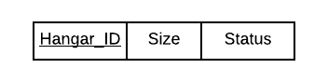

This entity has an attribute Hangar_ID as a key.It also has two simple attributes, size and status.

**AIRLINE**

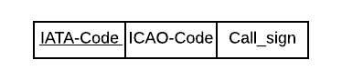

This entity has an attribute IATA-Code as a key.It also has two simple attributes, ICAO-Code and Call_sign.

**PLANE**



This entity has an attribute Reg_Num as a key.It also has three simple attributes, Fuel-Type, Type, and Min_Gate_size. The composite attribute was decomposed into Nb_Eco_Seats, Nb_Busi_Seats, and Nb_FSC_Seats.

**EMPLOYEE**

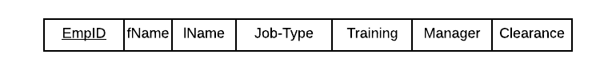

EMPLOYEE has EmpID as a key attribute. It also has four simple attributes, Job-Type, Training, Manager, and Clearance. Furthermore, it has a composite attribute called name that is made of two simple attributes fName and lName.

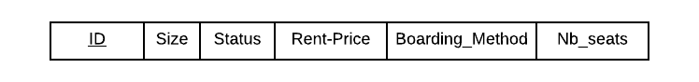**GATE**

GATE has ID as a key attribute. It also has five simple attributes, Size, Status, Rent-Price, Boarding_Method, and Nb_seats.

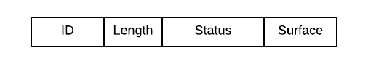**RUNWAY**

RUNWAY has ID as a key attribute. It has three simple attributes Length, Status, and Surface.

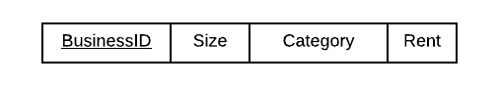**BUSINESS-SPACE**

BUSINESS-SPACE has BusinessID as a key attribute. It has three simple attributes Size, Category, and Rent.

**COMPANY**

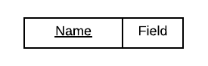

COMPANY has Name as a key attribute. It also has a single simple attribute which is Field.

**FLIGHT**



Flight has Flight_Name as a key attribute. It also has a seven simple attribute which are Passenger_Cap, Cargo_Cap, Dept_Time, Arrival_Time, Dest_Airport, Dept_Airport, and State.

**PASSENGER**



PASSENGER has Ticket_ID as a key attribute. It has three simple attributes which are Max_Lug_Weight, Special_Needs, and Actual_Lug_Weight. Furthermore, it has a composite attribute called name that is made of two simple attributes fName and lName.

**Step Two: Mapping of Weak Entity Types:**

In the second step, we shall map all weak entity-types. The only weak entity type is Cargo. In this step, we will take the primary key of the identifying-entity and add it to the weak-entity schema.

**CARGO**

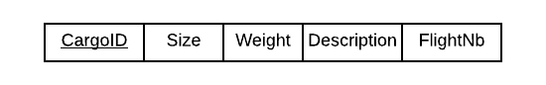

CARGO has CargoID as a partial-key attribute. It has three simple attributes which are size, weight, and description. The flight number is a foreign-key referring to the strong entity FLIGHT.

**Step Three:Mapping of Binary 1:1 Relationship Types:**

In this step, we map all one-to-one relationships. We have different approaches to follow. First approach, also known as the foreign-key approach, we choose the relation to be the entity that has a total participation on one of the sides of the relationship and its foreign-key will be the primary key of the other participating entity.The second approach, also known the merge-relation option. This option is used when both entities have total participation in the same relationship and where the entities are not needed in constructing any other relationship. The third approach is the cross-reference or relationship relation option. Since we have no one-to-one relationships, this step is not applicable.

**Step Four:Mapping of Binary 1:N Relationship Types:**

In this step, we are mapping all the one-to-many relationships. We add the primary key of the entity on the many side as a foreign-key to the other entity. We have 10 relationships that fall under this category.

**FLIGHT**



The *performs* relationship which links the PLANE to the FLIGHT implies a change in the FLIGHT relation because it is on the many side. Thus, we add the attribute Plane_RN which is a foreign-key referring to the PLANE entity.

**GATE**

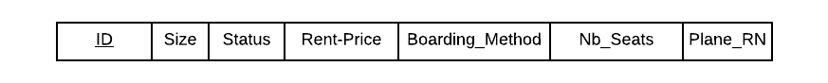

The *parks* relationship which links the PLANE to the GATE implies a change in the GATE relation because it is on the many side. Thus, we add the attribute Plane_RN which is a foreign-key referring to the PLANE entity.

**CARGO**

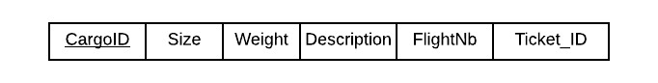

The *Owns* relationship which links the PASSENGER to the CARGO implies a change in the CARGO relation because it is on the many side. Thus, we add the attribute Ticket_ID which is a foreign-key referring to the PASSENGER.

**FLIGHT**



The *Takes_Off_on* relationship which links the FLIGHT to the RUNWAY implies a change in the FLIGHT relation because it is on the many side. Thus, we add the attribute RunwayID which is a foreign-key referring to the RUNWAY.

**FLIGHT**

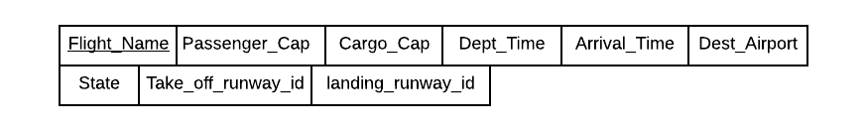

The *lands_on* relationship which links the FLIGHT to the RUNWAY implies a change in the FLIGHT relation because it is on the many side. Thus, we add the attribute landing_runway_id which is a foreign-key referring to the RUNWAY.

**BUSINESS SPACE**

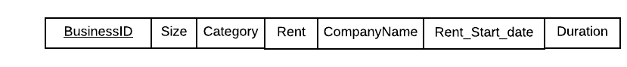

The *Rents* relationship which links the COMPANY to the BUSINESS SPACE implies a change in the BUSINESS SPACE relation because it is on the many side. Thus, we add the attribute CompanyName which is a foreign-key referring to the COMPANY, also the attributes Rent_Start_date and Duration have been added because those are attributes of the relationship *rents*.

**EMPLOYEE**



The *Works_for* relationship which links the PRIVATE-OWNER to the EMPLOYEE implies a change in the EMPLOYEE relation because it is on the many side. Thus, we add the attribute OwnerID which is a foreign-key referring to the PRIVATE-OWNER.

**EMPLOYEE**



The *Works_for* relationship which links the AIRLINE to the EMPLOYEE implies a change in the EMPLOYEE relation because it is on the many side. Thus, we add the attribute IATA which is a foreign-key referring to the AIRLINE.

**EMPLOYEE**

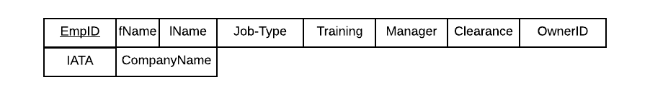

The *Works_for* relationship which links the COMPANY to the EMPLOYEE implies a change in the EMPLOYEE relation because it is on the many side. Thus, we add the attribute CompanyName which is a foreign-key referring to the COMPANY.

**EMPLOYEE**

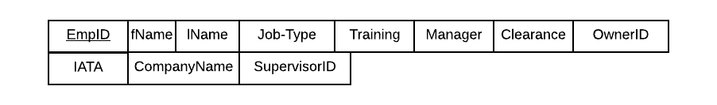

The *Manages* relationship which links the EMPLOYEE to EMPLOYEE implies a change in the EMPLOYEE relation because it is on the many side. Thus, we add the attribute SupervisorID which is a foreign-key referring to the EMPLOYEE.

**Step Five:Mapping of Binary M:N Relationship Types:**

In this step, we shall be mapping the many-to-many relationship types. As a result, the relationship relation approach is used. For each relationship there exists a relation whose primary key is the combination of the two primary keys of the entity linked by this relation.

**TRANSPORTS PASSENGER**

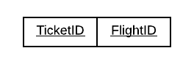

The *transports PASSENGER* relationship connects the PASSENGER to the FLIGHT. To represent this relationship, we create the *transports passenger* relation.

**WORKS-IN**

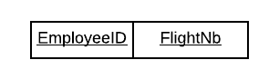

The *works-in* relationship connects the EMPLOYEE to the FLIGHT. To represent this relationship, we create the *works-in* relation.

**WORKS-ON**

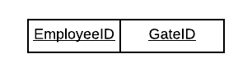

The *works-on* relationship connects the EMPLOYEE to the GATE. To represent this relationship, we create the *works-on* relation.

**Step Six:Mapping of Multi-valued Attributes:**

In this step, we represent all the multi-valued attributes, which are not mentioned in the steps before. We create a new relation for each one of them, the primary key of each of these relations will be composite of the primary key of the entity, and the attribute related to it.

**AIRLINE HUBS**

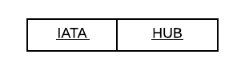

The hubs multivalued attribute is part of the AIRLINE entity-type. To represent this attribute, we create the *Airline-hubs* relation.

**COMPANY-PHONE**

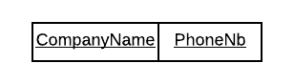

The phone multivalued attribute is part of the COMPANY entity-type. To represent this attribute, we create the *Company-phone* relation.

**COMPANY-ADDRESS**

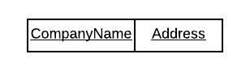

The address multivalued attribute is part of the COMPANY entity-type. To represent this attribute, we create the *Company-address* relation.

**FLIGHT-SEGMENT**

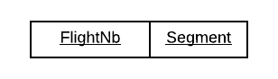

The segment multivalued attribute is part of the FLIGHT entity-type. To represent this attribute, we create the *flight-segment* relation.

**Step Seven:Mapping of N-ary Relationship types:**

In this step, we are mapping the N-ary relationship types, for each one of those relationships we create a new relation to represent it. We include as foreign-key attributes the primary keys of the relation that represent the participating entities.

**OWNS-RENTS HANGAR**

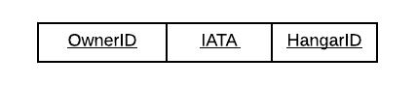The *owns/rents* relationship exists between PRIVATE-OWNER, AIRLINE, and HANGAR. Thus, we created the *owns/rents* HANGAR relation to represent this relationship.

**OWNS-RENTS PLANE**

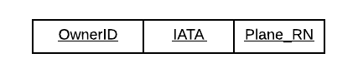The *owns/rents* relationship exists between PRIVATE-OWNER, AIRLINE, and PLANE. Thus, we created the *owns/rents* PLANE relation to represent this relationship.

**OPERATES**

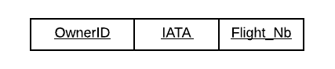The *operates* relationship exists between PRIVATE-OWNER, AIRLINE, and PLANE. Thus, we created the *operates* relation to represent this relationship.

**MAINTAINS**

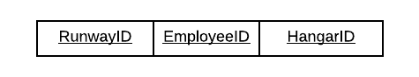The *maintains* relationship exists between EMPLOYEE, RUNWAY, and HANGAR. Thus, we created the *maintains* relation to represent this relationship.

**Final Step:**

**TRANSPORTS PASSENGER**



**WORKS-IN**



**WORKS-ON**



**AIRLINE HUBS**



**COMPANY-PHONE**



**COMPANY-ADDRESS**



**OWNS-RENTS HANGAR**



**OWNS-RENTS PLANE**



**OPERATES**



**MAINTAINS**



**EMPLOYEE**

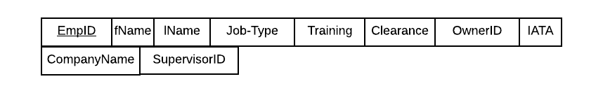

**BUSINESS SPACE**



**FLIGHT**

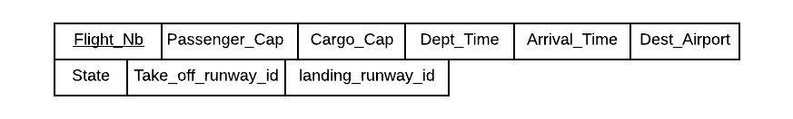

**GATE**



**CARGO**



**RUNWAY**

**HANGAR**



**PRIVATE-OWNER**



**AIRLINE**



**PLANE**



**PASSENGER**



**COMPANY**



1. **Tables Structure for Airport Database**
2. **Table Structure for “AIRLINE”**

CREATE TABLE AIRLINE

(

IATA_CODE CHAR(5 BYTE) NOT NULL

, ICAO_CODE CHAR(3 BYTE) NOT NULL

, CALL_SIGN VARCHAR2(20 BYTE) NOT NULL

, CONSTRAINT AIRLINE_PK PRIMARY KEY

(

IATA_CODE );

1. **Table Structure for “AIRLINE_RENTS_GATE”**

CREATE TABLE AIRLINE_RENTS_GATE

(

IATA CHAR(5 BYTE) NOT NULL

, GATE_ID NUMBER(*, 0) NOT NULL

, CONSTRAINT AIRLINE_RENTS_GATE_PK PRIMARY KEY

(

IATA

, GATE_ID );

1. **Table Structure for “AIRLINE_RENTS_HANGAR”**

CREATE TABLE AIRLINE_RENTS_HANGAR

(

HANGAR_ID NUMBER(*, 0) NOT NULL

, IATA CHAR(5 BYTE) NOT NULL

, CONSTRAINT AIRLINE_RENTS_HANGAR_PK PRIMARY KEY

(

HANGAR_ID

, IATA );

1. **Table Structure for “AIRLINEHUBS”**

CREATE TABLE AIRLINESHUBS

(

IATA CHAR(5 BYTE) NOT NULL

, HUB CHAR(3 BYTE) NOT NULL

, CONSTRAINT AIRLINESHUBS_PK PRIMARY KEY

(

IATA

, HUB );

1. **Table Structure for “BUSINESSSPACE”**

CREATE TABLE BUSINESSSPACE

(

BUSINESSID NUMBER(*, 0) NOT NULL

, BSIZE NUMBER(*, 0) NOT NULL

, BCATEGORY VARCHAR2(20 BYTE) NOT NULL

, RENT NUMBER(*, 0)

, COMPANYNAME VARCHAR2(20 BYTE)

, RENT_START_DATE DATE NOT NULL

, DURATION NUMBER(*, 0)

, CONSTRAINT BUSINESSSPACE_PK PRIMARY KEY

(

BUSINESSID );

1. **Table Structure for “CARGO”**

CREATE TABLE CARGO

(

CARGOID NUMBER(*, 0) NOT NULL

, CSIZE NUMBER(*, 0) NOT NULL

, WEIGHT NUMBER(*, 0) NOT NULL

, DESCRIPTION VARCHAR2(126 BYTE) NOT NULL

, FLIGHT_NB NUMBER(*, 0) NOT NULL

, TICKET_ID NUMBER(*, 0) NOT NULL

, CONSTRAINT CARGO_PK PRIMARY KEY

(

CARGOID

, FLIGHT_NB );

1. **Table Structure for “COMPANY”**

CREATE TABLE COMPANY

(

CNAME VARCHAR2(20 BYTE) NOT NULL

, FIELD VARCHAR2(20 BYTE) NOT NULL

, CONSTRAINT TABLE1_PK PRIMARY KEY

(

CNAME );

1. **Table Structure for “COMPANY_ADDRESS”**

CREATE TABLE COMPANY_ADDRESS

(

COMPANYNAME VARCHAR2(25 BYTE) NOT NULL

, ADDRESS VARCHAR2(50 BYTE) NOT NULL

, CONSTRAINT SYS_C0019095 PRIMARY KEY

(

COMPANYNAME

, ADDRESS

);

1. **Table Structure for “COMPANY_PHONE”**

CREATE TABLE COMPANY_PHONE

(

COMPANYNAME VARCHAR2(25 BYTE) NOT NULL

, PHONE CHAR(13 BYTE) NOT NULL

, CONSTRAINT SYS_C0019091 PRIMARY KEY

(

COMPANYNAME

, PHONE

);

1. **Table Structure for “EMPLOYEE”**

CREATE TABLE EMPLOYEE

(

EMPID NUMBER(*, 0) NOT NULL

, FNAME VARCHAR2(20 BYTE) NOT NULL

, LNAME VARCHAR2(20 BYTE) NOT NULL

, JOB_TYPE VARCHAR2(20 BYTE) NOT NULL

, TRAINING VARCHAR2(20 BYTE) NOT NULL

, CLEARENCE VARCHAR2(20 BYTE) NOT NULL

, OWNERID NUMBER(*, 0)

, IATA CHAR(5 BYTE)

, COMPANYNAME VARCHAR2(20 BYTE)

, SUPERVISORID NUMBER(*, 0) NOT NULL

, CONSTRAINT EMPLOYEE_PK PRIMARY KEY

(

EMPID

);

1. **Table Structure for “FLIGHT”**

CREATE TABLE FLIGHT

(

FLIGHT_NB NUMBER(*, 0) NOT NULL

, PARSSENGER_CAP NUMBER(*, 0)

, CARGO_CAP NUMBER(*, 0)

, DEPT_TIME TIMESTAMP(6) NOT NULL

, ARRIVAL_TIME TIMESTAMP(6)

, DEST_AIRPORT CHAR(3 BYTE) NOT NULL

, STATE VARCHAR2(26 BYTE) NOT NULL

, TAKE_OFF_RUNWAY_ID NUMBER(*, 0) NOT NULL

, LANDING_RUNWAY_ID NUMBER(*, 0)

, CONSTRAINT FLIGHT_PK PRIMARY KEY

(

FLIGHT_NB );

1. **Table Structure for “GATE”**

CREATE TABLE GATE

(

GID NUMBER(*, 0) NOT NULL

, GSIZE NUMBER(*, 0) NOT NULL

, STATUS VARCHAR2(20 BYTE) NOT NULL

, RENTPRICE NUMBER(*, 0) NOT NULL

, BOARDING_METHOD VARCHAR2(20 BYTE) NOT NULL

, NB_SEATS NUMBER(*, 0) NOT NULL

, PLANE_RN VARCHAR2(20 BYTE)

, CONSTRAINT GATE_PK PRIMARY KEY

(

GID

);

1. **Table Structure for “HANGAR”**

CREATE TABLE HANGAR

(

HANGAR_ID NUMBER(*, 0) NOT NULL

, HSIZE NUMBER(*, 0) NOT NULL

, STATUD VARCHAR2(8 BYTE) NOT NULL

, CONSTRAINT HANGAR_PK PRIMARY KEY

(

HANGAR_ID );

1. **Table Structure for “PO_OPERATES_FLIGHT”**

CREATE TABLE PO_OPERATES_FLIGHT

(

OWNER_ID NUMBER(*, 0) NOT NULL

, FLIGHT_NB NUMBER(*, 0) NOT NULL

, CONSTRAINT PO_OPERATES_FLIGHT_PK PRIMARY KEY

(

OWNER_ID

, FLIGHT_NB

);

1. **Table Structure for “PASSENGER”**

CREATE TABLE PASSENGER

(

TICKET_ID NUMBER(*, 0) NOT NULL

, FNAME VARCHAR2(20 BYTE) NOT NULL

, LNAME VARCHAR2(20 BYTE) NOT NULL

, MAX_LUG_WEIGHT NUMBER(*, 0) NOT NULL

, SPECIAL_NEEDS VARCHAR2(20 BYTE)

, ACTUAL_LUG_WEIGHT NUMBER(*, 0) NOT NULL

, CONSTRAINT PASSENGER_PK PRIMARY KEY

(

TICKET_ID

);

1. **Table Structure for “PLANE”**

CREATE TABLE PLANE

(

REG_NUM VARCHAR2(20 BYTE) NOT NULL

, NB_ECO_SEATS NUMBER(*, 0)

, NB_BUSI_SEATS NUMBER(*, 0)

, NB_FSC_SEATS NUMBER(*, 0)

, FUEL_TYPE VARCHAR2(10 BYTE) NOT NULL

, PTYPE VARCHAR2(10 BYTE) NOT NULL

, MIN_GATE_SIZE NUMBER(*, 0) NOT NULL

, CONSTRAINT PLANE_PK PRIMARY KEY

(

REG_NUM

);

1. **Table Structure for “PO_RENTS_HANGAR”**

CREATE TABLE PO_RENTS_HANGAR

(

HANGAR_ID NUMBER(*, 0) NOT NULL

, OWNER_ID NUMBER(*, 0) NOT NULL

, CONSTRAINT PO_RENTS_HANGAR_PK PRIMARY KEY

(

HANGAR_ID

, OWNER_ID

);

1. **Table Structure for “PRIVATE_OWNER”**

CREATE TABLE PRIVATE_OWNER

(

OWNER_ID NUMBER(*, 0) NOT NULL

, FIRSTNAME VARCHAR2(20 BYTE) NOT NULL

, LASTNAME VARCHAR2(20 BYTE) NOT NULL

, CONSTRAINT PRIVATE_OWNER_PK PRIMARY KEY

(

OWNER_ID

);

1. **Table Structure for “PRIVATEOWNER_RENTS_GATE”**

CREATE TABLE PRIVATEOWNER_RENTS_GATE

(

OWNER_ID NUMBER(*, 0) NOT NULL

, GATE_ID NUMBER(*, 0) NOT NULL

, CONSTRAINT PRIVATEOWNER_RENTS_GATE_PK PRIMARY KEY

(

OWNER_ID

, GATE_ID

);

1. **Table Structure for “RUNWAY”**

CREATE TABLE RUNWAY

(

RID NUMBER(*, 0) NOT NULL

, RLENGTH NUMBER(*, 0) NOT NULL

, STATUS VARCHAR2(20 BYTE) NOT NULL

, SURFACE VARCHAR2(20 BYTE) NOT NULL

, CONSTRAINT RUNWAY_PK PRIMARY KEY

(

RID

);

1. **Table Structure for “TRANSPORT_PASSENGER”**

CREATE TABLE TRANSPORT_PASSENGER

(

FLIGHT_NB NUMBER(*, 0) NOT NULL

, TICKET_ID NUMBER(*, 0) NOT NULL

, CONSTRAINT TRANSPORT_PASSENGER_PK PRIMARY KEY

(

FLIGHT_NB

, TICKET_ID

);

1. **Table Structure for “WORKSIN”**

CREATE TABLE WORKSIN

(

EMPLOYEEID NUMBER(*, 0) NOT NULL

, FLIGHT_NB NUMBER(*, 0) NOT NULL

, CONSTRAINT WORKSIN_PK PRIMARY KEY

(

EMPLOYEEID

, FLIGHT_NB

);

1. **Table Structure for “WORKSON”**

CREATE TABLE WORKSON

(

EMPLOYEEID NUMBER(*, 0) NOT NULL

, GATEID NUMBER(*, 0) NOT NULL

, CONSTRAINT WORKSON_PK PRIMARY KEY

(

EMPLOYEEID

, GATEID

);

1. **Table Structure for “AIRLINE_RENTSPLANE”**

CREATE TABLE AIRLINE_RENTSPLANE

(

IATA CHAR(5 BYTE) NOT NULL

, REGNUM VARCHAR2(5 BYTE) NOT NULL

, CONSTRAINT AIRLINE_RENTSPLANE_PK PRIMARY KEY

(

IATA

, REGNUM

);

1. **Table Structure for “AIRLINE_OPERATESFLIGHT”**

CREATE TABLE AIRLINE_OPERATESFLIGHT

(

IATA CHAR(5 BYTE) NOT NULL

, FLIGHT_NB NUMBER(*, 0) NOT NULL

, CONSTRAINT AIRLINE_OPERATESFLIGHT_PK PRIMARY KEY

(

IATA

, FLIGHT_NB

);

1. **Table Structure for “MAINTAINS_HANGAR”**

CREATE TABLE MAINTAINS_HANGAR

(

HANGAR_ID NUMBER(*, 0) NOT NULL

, EMP_ID NUMBER(*, 0) NOT NULL

, CONSTRAINT MAINTAINS_HANGAR_PK PRIMARY KEY

(

HANGAR_ID

, EMP_ID

);

1. **Table Structure for “MAINTAINS_RUNWAY”**

CREATE TABLE MAINTAINS_RUNWAY

(

RUNWAY_ID NUMBER(*, 0) NOT NULL

, EMP_ID NUMBER(*, 0) NOT NULL

, CONSTRAINT MAINTAINS_RUNWAY_PK PRIMARY KEY

(

RUNWAY_ID

, EMP_ID

);

1. **Table Structure for “PO_OWNS_RENTSPLANE”**

CREATE TABLE PO_OWNS_RENTSPLANE

(

REGNUM VARCHAR2(5 BYTE) NOT NULL

, OWNER_ID NUMBER(*, 0) NOT NULL

, CONSTRAINT PO_OWNS_RENTSPLANE_PK PRIMARY KEY

(

REGNUM

, OWNER_ID

);

**VI - Tables Descriptions**

1. **Table Description for “AIRLINE”**

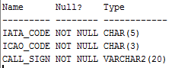

1. **Table Description for “AIRLINE_RENTS_GATE”**

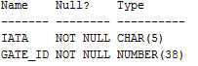

1. **Table Description for “AIRLINE_RENTS_HANGAR”**

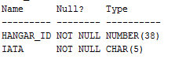

1. **Table Description for “AIRLINEHUBS”**

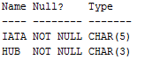

1. **Table Description for “BUSINESSSPACE”**

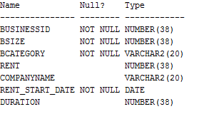

1. **Table Description for “CARGO”**

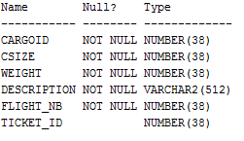

1. **Table Description for “COMPANY”**

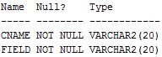

1. **Table Description for “COMPANY_ADDRESS”**

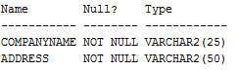

1. **Table Description for “COMPANY_PHONE”**

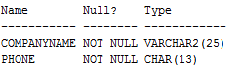

1. **Table Description for “EMPLOYEE”**

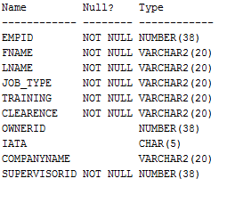

1. **Table Description for “FLIGHT”**

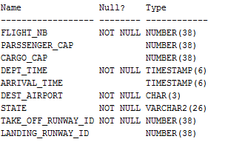

1. **Table Description for “GATE”**

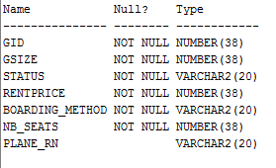

1. **Table Description for “HANGAR”**

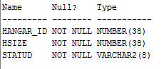

1. **Table Description for “PASSENGER”**

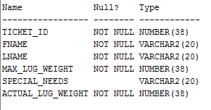

1. **Table Description for “PLANE”**

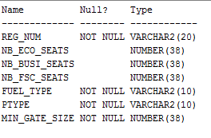

1. **Table Description for “PO_RENTS_HANGAR”**

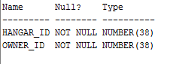

1. **Table Description for “PRIVATE_OWNER”**

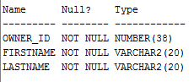

1. **Table Description for “PRIVATEOWNER_RENTS_GATE”**

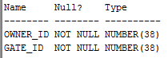

1. **Table Description for “RUNWAY”**

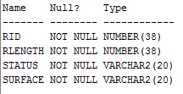

1. **Table Description for “TRANSPORT_PASSENGER”**

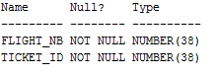

1. **Table Description for “WORKSIN”**

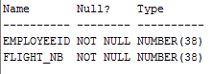

1. **Table Description for “WORKSON”**

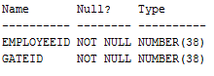

1. **Table Description for “AIRLINE_OPERATESFLIGHT”**

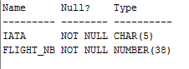

1. **Table Description for “AIRLINE_RENTSPLANE”**

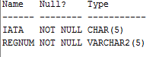

1. **Table Description for “MAINTAINS_HANGAR”**

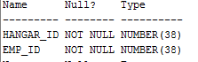

1. **Table Description for “MAINTAINS_RUNWAY”**

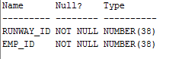

1. **Table Description for “PO_OPERATES_FLIGHT”**

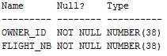

1. **Table Description for “PO_OWNS_RENTSPLANE”**

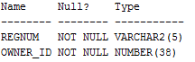

**VII – Dumping Data for the Created Tables of the Airport Database**

1. **Dumping Data for “AIRLINE”**

INSERT INTO AIRLINE VALUES('JP165','ADR','Adria Airways');

INSERT INTO AIRLINE VALUES('A3390','AEE','Aegean Airlines');

INSERT INTO AIRLINE VALUES('EI053','EIN','Aer Lingus');

INSERT INTO AIRLINE VALUES('DL006','DAL','Delta Air Lines');

INSERT INTO AIRLINE VALUES('JF169','JEF','Jeffrey Int Airline');

INSERT INTO AIRLINE VALUES('LA094','LAA','LAA');

INSERT INTO AIRLINE VALUES('TF091','TFA','Takkoush Flowers');

INSERT INTO AIRLINE VALUES('CC194','CCL','City Cafe Lines');

INSERT INTO AIRLINE VALUES('AA077','AAL','Apple Airline');

INSERT INTO AIRLINE VALUES('SA078','SAW','Skip Airways');

INSERT INTO AIRLINE VALUES('CA079','CAW','Charlotte Airways');

INSERT INTO AIRLINE VALUES('SU080','SMA','Sumaiyah Mccoy');

INSERT INTO AIRLINE VALUES('MI081','MML','Mimi Hansen Lines');

INSERT INTO AIRLINE VALUES('OM082','OMA','Orlaith May');

INSERT INTO AIRLINE VALUES('AS083','ADL','Ashraf Dowling Lines');

INSERT INTO AIRLINE VALUES('KI084','KAL','Kiki Airlines');

INSERT INTO AIRLINE VALUES('AL085','ALI','Ali Airlines');

INSERT INTO AIRLINE VALUES('JP086','PSA','Proba Air');

INSERT INTO AIRLINE VALUES('JP087','ALA','3ashika al wardi');

INSERT INTO AIRLINE VALUES('JT088','AAR','Airline Airways');

1. **Dumping Data for “AIRLINE_RENTS_GATE”**

INSERT INTO AIRLINE_RENTS_GATE VALUES ('JP165',53);

INSERT INTO AIRLINE_RENTS_GATE VALUES ('A3390',87);

INSERT INTO AIRLINE_RENTS_GATE VALUES ('EI053',0);

INSERT INTO AIRLINE_RENTS_GATE VALUES ('DL006',5);

INSERT INTO AIRLINE_RENTS_GATE VALUES ('JF169',84);

INSERT INTO AIRLINE_RENTS_GATE VALUES ('LA094',61);

INSERT INTO AIRLINE_RENTS_GATE VALUES ('TF091',75);

INSERT INTO AIRLINE_RENTS_GATE VALUES ('CC194',36);

INSERT INTO AIRLINE_RENTS_GATE VALUES ('AA077',22);

INSERT INTO AIRLINE_RENTS_GATE VALUES ('SA078',20);

INSERT INTO AIRLINE_RENTS_GATE VALUES ('CA079',40);

INSERT INTO AIRLINE_RENTS_GATE VALUES ('SU080',78);

INSERT INTO AIRLINE_RENTS_GATE VALUES ('MI081',33);

INSERT INTO AIRLINE_RENTS_GATE VALUES ('OM082',86);

INSERT INTO AIRLINE_RENTS_GATE VALUES ('AS083',83);

INSERT INTO AIRLINE_RENTS_GATE VALUES ('KI084',18);

INSERT INTO AIRLINE_RENTS_GATE VALUES ('AL085',27);

INSERT INTO AIRLINE_RENTS_GATE VALUES ('JP086',14);

INSERT INTO AIRLINE_RENTS_GATE VALUES ('JP087',74);

INSERT INTO AIRLINE_RENTS_GATE VALUES ('JT088',48);

1. **Dumping Data for “AIRLINE_RENTS_HANGAR”**

1 INSERT INTO AIRLINE_RENTS_HANGAR VALUES (1,'JP165');

INSERT INTO AIRLINE_RENTS_HANGAR VALUES (3,'A3390');

INSERT INTO AIRLINE_RENTS_HANGAR VALUES(5,'EI053');

INSERT INTO AIRLINE_RENTS_HANGAR VALUES(7,'DL006');

INSERT INTO AIRLINE_RENTS_HANGAR VALUES(9,'JF169');

INSERT INTO AIRLINE_RENTS_HANGAR VALUES(11,'TF091');

INSERT INTO AIRLINE_RENTS_HANGAR VALUES(13,'CC194');

INSERT INTO AIRLINE_RENTS_HANGAR VALUES(15,'AA077');

1. **Dumping Data for “AIRLINEHUBS”**

INSERT INTO AIRLINESHUBS VALUES ('DL006','DEN');

INSERT INTO AIRLINESHUBS VALUES ('CC194','LHR');

INSERT INTO AIRLINESHUBS VALUES ('SA078','ORD');

INSERT INTO AIRLINESHUBS VALUES ('TF091','PVG');

INSERT INTO AIRLINESHUBS VALUES ('SA078','SIN');

INSERT INTO AIRLINESHUBS VALUES ('JT088','IST');

INSERT INTO AIRLINESHUBS VALUES ('AL085','CGK');

INSERT INTO AIRLINESHUBS VALUES ('TF091','HND');

INSERT INTO AIRLINESHUBS VALUES ('SU080','DXB');

INSERT INTO AIRLINESHUBS VALUES ('KI084','SIN');

INSERT INTO AIRLINESHUBS VALUES ('EI053','JFK' );

INSERT INTO AIRLINESHUBS VALUES ('JP165','SIN');

INSERT INTO AIRLINESHUBS VALUES ('A3390','DEL');

INSERT INTO AIRLINESHUBS VALUES ('LA094','DXB');

INSERT INTO AIRLINESHUBS VALUES ('AA077','CAM');

INSERT INTO AIRLINESHUBS VALUES ('OM082','JFK' );

INSERT INTO AIRLINESHUBS VALUES ('JT088','DEN');

INSERT INTO AIRLINESHUBS VALUES ('KI084','PEK');

INSERT INTO AIRLINESHUBS VALUES ('LA094','DFW');

INSERT INTO AIRLINESHUBS VALUES ('DL006','LHR');

INSERT INTO AIRLINESHUBS VALUES ('JP165','CDG');

INSERT INTO AIRLINESHUBS VALUES ('A3390','BKK');

INSERT INTO AIRLINESHUBS VALUES ('JF169','DXB');

INSERT INTO AIRLINESHUBS VALUES ('MI081','HKG');

INSERT INTO AIRLINESHUBS VALUES ('SA078','CAM');

INSERT INTO AIRLINESHUBS VALUES ('DL006','PVG');

INSERT INTO AIRLINESHUBS VALUES ('AA077','PEK');

INSERT INTO AIRLINESHUBS VALUES ('JT088','CDG');

INSERT INTO AIRLINESHUBS VALUES ('JP165','PEK');

INSERT INTO AIRLINESHUBS VALUES ('EI053','FRA');

1. **Dumping Data for “BUSINESSSPACE”**

INSERT INTO BUSINESSSPACE VALUES (6216,63,'Bakery',810,'BAYAN HATES SKIP',TO_DATE('18/04/2018','DD/MM/YYYY'),651);

INSERT INTO BUSINESSSPACE VALUES (4187,49,'Drug Dealer' ,737,'MYNAMEJEFF',TO_DATE('18/04/2018','DD/MM/YYYY'),962);

INSERT INTO BUSINESSSPACE VALUES (7889,54,'softwaresol',848,'ALPHA DATA',TO_DATE('18/04/2018','DD/MM/YYYY'),560);

INSERT INTO BUSINESSSPACE VALUES (4892,96,'PerfumeShop',702,'LETHAL ORANGE',TO_DATE('18/04/2018','DD/MM/YYYY'),618);

INSERT INTO BUSINESSSPACE VALUES (5035,94,'ExoticBakery',741,'NADALOVESCUPCAKES',TO_DATE('18/04/2018','DD/MM/YYYY'),331);

INSERT INTO BUSINESSSPACE VALUES (8712,90,'WebSol',824,'ALPHA DATA',TO_DATE('18/04/2018','DD/MM/YYYY'),435);

INSERT INTO BUSINESSSPACE VALUES (8645,96,'HomemadeSweets',441,'CHOCOBITS',TO_DATE('18/04/2018','DD/MM/YYYY'),758);

INSERT INTO BUSINESSSPACE VALUES (2343,52,'MarijuanaStore',333,'MYNAMEJEFF',TO_DATE('18/04/2018','DD/MM/YYYY'),394);

INSERT INTO BUSINESSSPACE VALUES (5344,93, 'TobaccoShop' ,622,'DEADLY PINEAPPLE',TO_DATE('18/04/2018','DD/MM/YYYY'),986);

INSERT INTO BUSINESSSPACE VALUES (3531,45,'Bakery',768,'MISCELLANEOUSPEPPERS',TO_DATE('18/04/2018','DD/MM/YYYY'),583);

INSERT INTO BUSINESSSPACE VALUES (3960,83, 'Perfumes',877,'LETHAL ORANGE',TO_DATE('18/04/2018','DD/MM/YYYY'),399);

INSERT INTO BUSINESSSPACE VALUES (4648,90,'Perfume' ,644,'PROBA AND JEFFERSONS',TO_DATE('18/04/2018','DD/MM/YYYY'),530);

INSERT INTO BUSINESSSPACE VALUES (5093,43,'Sweets',601,'MISCELLANEOUSPEPPERS',TO_DATE('18/04/2018','DD/MM/YYYY'),567);

INSERT INTO BUSINESSSPACE VALUES (6514,44,'hardwarestore',340,'TECH CO.',TO_DATE('18/04/2018','DD/MM/YYYY'),767);

INSERT INTO BUSINESSSPACE VALUES (6665,71,'perfumes',473,'AHWE CHARLOTTE',TO_DATE('18/04/2018','DD/MM/YYYY'),422);

INSERT INTO BUSINESSSPACE VALUES (2375,88,'perfumesShop',800,'PERFUMES INC',TO_DATE('18/04/2018','DD/MM/YYYY'),537);

INSERT INTO BUSINESSSPACE VALUES (6806,71,'techstore',468,'ALPHA DATA',TO_DATE('18/04/2018','DD/MM/YYYY'),348);

INSERT INTO BUSINESSSPACE VALUES (1687,78,'LegalCupcakes',982,'BAYAN HATES SKIP',TO_DATE('18/04/2018','DD/MM/YYYY'),674);

INSERT INTO BUSINESSSPACE VALUES (4358,87,'bakery',900,'MISCELLANEOUSPEPPERS',TO_DATE('18/04/2018','DD/MM/YYYY'),999);

INSERT INTO BUSINESSSPACE VALUES (7507,83,'bakeries ',370,'MISCELLANEOUSPEPPERS',TO_DATE('18/04/2018','DD/MM/YYYY'),863);

INSERT INTO BUSINESSSPACE VALUES (4881,70, 'perfumes',616,'AHWE CHARLOTTE',TO_DATE('18/04/2018','DD/MM/YYYY'),557);

INSERT INTO BUSINESSSPACE VALUES (5745,91,'weed',627,'CHARLOTTETA3A',TO_DATE('18/04/2018','DD/MM/YYYY'),563);

INSERT INTO BUSINESSSPACE VALUES (6378,75,'electronicupcakes',785,'CUPCAKES CO.',TO_DATE('18/04/2018','DD/MM/YYYY'),412);

INSERT INTO BUSINESSSPACE VALUES (7995,86,'illegalcupcakes',437,'BAYAN HATES SKIP',TO_DATE('18/04/2018','DD/MM/YYYY'),810);

INSERT INTO BUSINESSSPACE VALUES (3617,88, 'hardwareshop' ,576,'CUPCAKES CO.',TO_DATE('18/04/2018','DD/MM/YYYY'),356);

INSERT INTO BUSINESSSPACE VALUES (2244,40,'weedperfume',615,'RECREATIONALMAR',TO_DATE('18/04/2018','DD/MM/YYYY'),932);

INSERT INTO BUSINESSSPACE VALUES (9070,73, 'miscalcohol',523,'ALCHOHOL CO.',TO_DATE('18/04/2018','DD/MM/YYYY'),461);

INSERT INTO BUSINESSSPACE VALUES (3370,62, 'perfumes',387,'PERFUMES INC',TO_DATE('18/04/2018','DD/MM/YYYY'),914);

INSERT INTO BUSINESSSPACE VALUES (2641,54, 'softwaredev',926,'CUPCAKES CO.',TO_DATE('18/04/2018','DD/MM/YYYY'),864);

INSERT INTO BUSINESSSPACE VALUES (4572,72,'tobaccoshop',507,'DEADLY PINEAPPLE',TO_DATE('18/04/2018','DD/MM/YYYY'),449);

INSERT INTO BUSINESSSPACE VALUES (1699,69,'cupcakesforlife',705,'BAYAN HATES SKIP',TO_DATE('18/04/2018','DD/MM/YYYY'),372);

INSERT INTO BUSINESSSPACE VALUES (1120,78, 'techshit',394,'TECH CO.',TO_DATE('18/04/2018','DD/MM/YYYY'),716);

INSERT INTO BUSINESSSPACE VALUES (4902,98, 'techlab',549,'CUPCAKES CO.',TO_DATE('18/04/2018','DD/MM/YYYY'),620);

INSERT INTO BUSINESSSPACE VALUES (1993,48,'juice bar',581,'JUICEENTERTAINMENT',TO_DATE('18/04/2018','DD/MM/YYYY'),853);

INSERT INTO BUSINESSSPACE VALUES (4655,43, 'tobaccostore',823,'HELLO WORLD',TO_DATE('18/04/2018','DD/MM/YYYY'),537);

INSERT INTO BUSINESSSPACE VALUES (4056,53,'peppercupcakes',971,'MISCELLANEOUSPEPPERS',TO_DATE('18/04/2018','DD/MM/YYYY'),678);

INSERT INTO BUSINESSSPACE VALUES (8484,64,'alcoholbuyer',545,'ALCHOHOL CO.',TO_DATE('18/04/2018','DD/MM/YYYY'),629);

INSERT INTO BUSINESSSPACE VALUES (5892,94,'techdealer',748,'TECH CO.',TO_DATE('18/04/2018','DD/MM/YYYY'),353);

INSERT INTO BUSINESSSPACE VALUES (7317,82,'alcoholdealer',224,'ALCHOHOL CO.',TO_DATE('18/04/2018','DD/MM/YYYY'),400);

INSERT INTO BUSINESSSPACE VALUES (2409,59,'perfumestore',864,'RECREATIONALMAR',TO_DATE('18/04/2018','DD/MM/YYYY'),944);

INSERT INTO BUSINESSSPACE VALUES (1633,70,'techsoftware',778,'ALPHA DATA',TO_DATE('18/04/2018','DD/MM/YYYY'),349);

INSERT INTO BUSINESSSPACE VALUES (5168,71,'softwaredev',683,'ALPHA DATA',TO_DATE('18/04/2018','DD/MM/YYYY'),738);

INSERT INTO BUSINESSSPACE VALUES (1151,68,'tobaccoshop',404,'HELLO WORLD',TO_DATE('18/04/2018','DD/MM/YYYY'),653);

INSERT INTO BUSINESSSPACE VALUES (2944,89,'winetasting',512,'ALCHOHOL CO.',TO_DATE('18/04/2018','DD/MM/YYYY'),768);

INSERT INTO BUSINESSSPACE VALUES (2767,60,'perfumelounge',307,'LETHAL ORANGE',TO_DATE('18/04/2018','DD/MM/YYYY'),458);

INSERT INTO BUSINESSSPACE VALUES (5517,50,'legalcupcakes',650,'NADALOVESCUPCAKES',TO_DATE('18/04/2018','DD/MM/YYYY'),495);

INSERT INTO BUSINESSSPACE VALUES (2680,75,'weedcupcakes',240,'NADALOVESCUPCAKES',TO_DATE('18/04/2018','DD/MM/YYYY'),828);

INSERT INTO BUSINESSSPACE VALUES (7953,84,'cigarlounge',274,'HELLO WORLD',TO_DATE('18/04/2018','DD/MM/YYYY'),979);

INSERT INTO BUSINESSSPACE VALUES (3374,62,'techlounge',848,'TECH CO.',TO_DATE('18/04/2018','DD/MM/YYYY'),410);

INSERT INTO BUSINESSSPACE VALUES (3542,82,'chococupcakes',988,'CHOCOBITS',TO_DATE('18/04/2018','DD/MM/YYYY'),723);

1. **Dumping Data for “CARGO”**

INSERT INTO CARGO VALUES (3248,20,33,'This cargo is managed by Zookeepers. It is used to transport specific animals such as Dogs, Cats, Scorpions, Tarantula, Hedgehog, Fennec Fox, Burmese Python, Sugar Glider, and more. It is highly monitored. It is of medium weight.'

,4710,NULL);

INSERT INTO CARGO VALUES (5594,31,48,'This cargo is managed by the ministry of health. It is HIGHLY monitored by the ministry too. It contains medicines from trusted sources to be delievered to the Lebanese lands. The ministry takes precautions for the public safety and has a zero tolerance policy for outdated/damaged medicine. It is of medium weight.',6243,NULL);

INSERT INTO CARGO VALUES (7208,24,13,'This cargo is managed by the ministry of education. It is usually funded by the Lebanese government and provides educational improvements for all public schools in lebanon such as updated tables for students, boards, etc.. It is of light weight.',9088,NULL);

INSERT INTO CARGO VALUES (5893,82,40,'This cargo is managed by Zookeepers. It is used to transport specific animals such as Dogs, Cats, Scorpions, Tarantula, Hedgehog, Fennec Fox, Burmese Python, Sugar Glider, and more. It is highly monitored. It is of medium weight.',4895,1417);

INSERT INTO CARGO VALUES (7970,16,42,'This cargo contains Apple inc. Products. They are a mixture of iPhones,iPads, and Macs. They are stored inside the iBox, and secured by an iSensor, and monitored by an iMonitor, and Shipped by an iPlane. And finally guarded by an iGuard. It is of Medium Weight.'

,7744,NULL);

INSERT INTO CARGO VALUES (7128,65,37,'This cargo is owned and monitored by the Lebanese American University. It is used to exchange LAU-owned products between the New York Campus, and Beirut and Byblos. Contains physical-exams for accreditation purposes. And is highly monitored so no tampering can be done. It is of medium weight.',7923,5274);

INSERT INTO CARGO VALUES (8011,39,6,'This cargo is managed by the ministry of telecommuncations. It is usually to used to transport high-tech signal towers, and other equipment to the Lebanese field and allows for higher internet connections and lower latencies. Currently managed by Touch and Alfa exclusively.',4790,3511);

INSERT INTO CARGO VALUES (5632,26,46,'This cargo is managed by the ministry of education. It is usually funded by the Lebanese government and provides educational improvements for all public schools in lebanon such as updated tables for students, boards, etc.. It is of light weight.',5470,5852);

INSERT INTO CARGO VALUES (6367,98,33,'This cargo is managed by airports. It is used for transporting exclusively airport-owned machines. Usually used when the airport assigns renovations and decides to improve its security measures. It is of medium weight.',4573,1558);

INSERT INTO CARGO VALUES (8842,64,4,'This cargo is managed by the ministry of telecommuncations. It is usually to used to transport high-tech signal towers, and other equipment to the Lebanese field and allows for higher internet connections and lower latencies. Currently managed by Touch and Alfa exclusively.',7025,NULL);

INSERT INTO CARGO VALUES (5930,85,34,'This cargo contains Takkoush International flowers. They are well known to be durable, cheap (except on holidays), and are expressive. For instance, if you want to ask someone out and you are LAU, takkoush flowers have you covered with a 10% discount. This cargo is always in high demand, as they are the best in the region. It is of light weight.',5410,NULL);

INSERT INTO CARGO VALUES (3756,25,50,'This cargo is managed by the ministry of telecommuncations. It is usually to used to transport high-tech signal towers, and other equipment to the Lebanese field and allows for higher internet connections and lower latencies. Currently managed by Touch and Alfa exclusively.',4101,NULL);

INSERT INTO CARGO VALUES (8406,60,45,'This cargo contains Apple inc. Products. They are a mixture of iPhones,iPads, and Macs. They are stored inside the iBox, and secured by an iSensor, and monitored by an iMonitor, and Shipped by an iPlane. And finally guarded by an iGuard. It is of Medium Weight.',7025,4869);

INSERT INTO CARGO VALUES (8322,82,32,'This cargo is used by private companies such as H&M, Eldorado, Zara, Moustache..etc. It is simply used to transport clothes between Lebanon and its source companies. It is of medium demand depending on the season. Also, it is of medium size.',7025,NULL);

INSERT INTO CARGO VALUES (2557,62,42,'This cargo is managed by the ministry of education. It is usually funded by the Lebanese government and provides educational improvements for all public schools in lebanon such as updated tables for students, boards, etc.. It is of light weight.',7830,NULL);

INSERT INTO CARGO VALUES (3446,0,11,'This cargo is managed by the Chinese government. Most of its contents are orders from AliExpress including 1$ chargers and is used by resellers as a source. It is barely monitored. And is of high demand. It is of high weight.',7208,NULL);

INSERT INTO CARGO VALUES (4062,25,58,'This cargo is used to transport corpses between countries. There is nothing more to add. It is of low weight.',6170,NULL);

INSERT INTO CARGO VALUES (7074,20,46,'This cargo contains Apple inc. Products. They are a mixture of iPhones,iPads, and Macs. They are stored inside the iBox, and secured by an iSensor, and monitored by an iMonitor, and Shipped by an iPlane. And finally guarded by an iGuard. It is of Medium Weight.',5867,NULL);

INSERT INTO CARGO VALUES (5269,97,52,'This cargo is managed by the Chinese government. Most of its contents are orders from AliExpress including 1$ chargers and is used by resellers as a source. It is barely monitored. And is of high demand. It is of high weight.',1671,5428);

INSERT INTO CARGO VALUES (5164,8,48,'This cargo is managed the Lebanese Military. It has its very own unique cargo plane. Usually contains mini-battle tanks, armored combat support vehicles, mine-protected, artillery,and light utility vehicles. It should be confidential, but the budget doesnt allow encryption. Usually used to receive gifts from nearby allies. It is of EXTREMELY HIGH WEIGHT.',2040,NULL);

INSERT INTO CARGO VALUES (6718,93,39,'This cargo is used by private companies such as H&M, Eldorado, ara, Moustache..etc. It is simply used to transport clothes between Lebanon and its source companies. It is of medium demand depending on the season. Also, it is of medium size.',7830,4869);

INSERT INTO CARGO VALUES (2508,93,55,'This cargo is managed by the Chinese government. Most of its contents are orders from AliExpress including 1$ chargers and is used by resellers as a source. It is barely monitored. And is of high demand. It is of high weight.',4972,NULL);

INSERT INTO CARGO VALUES (4834,74,34,'This cargo is managed by various Tires Companies. This cargo is usually used to move Tires across countries such as Michelin,Pirelli, and Dunlop Tires. It is of medium weight.',3545,NULL);

INSERT INTO CARGO VALUES (4842,56,31,'This cargo is managed the Lebanese Military. It has its very own unique cargo plane. Usually contains mini-battle tanks, armored combat support vehicles, mine-protected, artillery,and light utility vehicles. It should be confidential, but the budget doesnt allow encryption. Usually used to receive gifts from nearby allies. It is of EXTREMELY HIGH WEIGHT.',9775,NULL);

INSERT INTO CARGO VALUES (4089,79,2,'This cargo is managed by the ministry of health. It is HIGHLY monitored by the ministry too. It contains medicines from trusted sources to be delievered to the Lebanese lands. The ministry takes precautions for the public safety and has a zero tolerance policy for outdated/damaged medicine. It is of medium weight.'

,5615,NULL);

INSERT INTO CARGO VALUES (4730,85,30,'This cargo contains Takkoush International flowers. They are well known to be durable, cheap (except on holidays), and are expressive. For instance, if you want to ask someone out and you are LAU, takkoush flowers have you covered with a 10% discount. This cargo is always in high demand, as they are the best in the region. It is of light weight.',4895,3152);

INSERT INTO CARGO VALUES (8963,63,39,'This cargo is managed the Lebanese Military. It has its very own unique cargo plane. Usually contains mini-battle tanks, armored combat support vehicles, mine-protected, artillery,and light utility vehicles. It should be confidential, but the budget doesnt allow encryption. Usually used to receive gifts from nearby allies. It is of EXTREMELY HIGH WEIGHT.',5396,NULL);

INSERT INTO CARGO VALUES (3182,90,39,'This cargo is managed by Lenovo. It is used to transport PCs of many form factors across countries. It is usually monitored as Lenovo takes its product seriously. It is of medium weight',7830,NULL);

INSERT INTO CARGO VALUES (4223,38,51,'This cargo is managed by Zookeepers. It is used to transport specific animals such as Dogs, Cats, Scorpions, Tarantula, Hedgehog, Fennec Fox, Burmese Python, Sugar Glider, and more. It is highly monitored. It is of medium weight.',4028,NULL);

INSERT INTO CARGO VALUES (6094,58,40,'This cargo contains vegetables imported from the mystical land of narnia, they are well known to be healthy for humans, orcs, mystical elves, and any other creature. It has a 30% chance of curing cancer. scientists all over the world recommend this. It is of Medium Weight.',4490,3511);

INSERT INTO CARGO VALUES (7053,90,48,'This cargo is managed by the ministry of health. It is HIGHLY monitored by the ministry too. It contains medicines from trusted sources to be delievered to the Lebanese lands. The ministry takes precautions for the public safety and has a zero tolerance policy for outdated/damaged medicine. It is of medium weight.',9520,4119);

INSERT INTO CARGO VALUES (7640,36,13,'This cargo includes cars. It includes cars imported from nearby countries. Cars created by BMW, Honda, Ford, Hyndai, Nissan,Volkswagon, GMC, and Finally Toyota. It is of high demand due to the fact that Lebanon is well known to have lots of cars. It is of fair demand, and of Extremely high weight.',9555,NULL);

INSERT INTO CARGO VALUES (3561,87,10,'This cargo is a exclusively owned by SpaceX and NASA, it is usually used as a Space Shutter, and transports high tech space parts. It is highly unique and is NEVER used on public planes for obvious reasons. It is of HIGH weight.',7902,1450);

INSERT INTO CARGO VALUES (6162,48,35,'This cargo is managed by the Chinese government. Most of its contents are orders from AliExpress including 1$ chargers and is used by resellers as a source. It is barely monitored. And is of high demand. It is of high weight.

',1671,NULL);

INSERT INTO CARGO VALUES (7829,85,51,'This cargo includes cars. It includes cars imported from nearby countries. Cars created by BMW, Honda, Ford, Hyndai, Nissan,Volkswagon, GMC, and Finally Toyota. It is of high demand due to the fact that Lebanon is well known to have lots of cars. It is of fair demand, and of Extremely high weight.',5396,5625);

INSERT INTO CARGO VALUES (6483,76,58,'This cargo is managed the Lebanese Military. It has its very own unique cargo plane. Usually contains mini-battle tanks, armored combat support vehicles, mine-protected, artillery,and light utility vehicles. It should be confidential, but the budget doesnt allow encryption. Usually used to receive gifts from nearby allies. It is of EXTREMELY HIGH WEIGHT.',1131,NULL);

INSERT INTO CARGO VALUES (8626,71,27,'This cargo contains Apple inc. Products. They are a mixture of iPhones,iPads, and Macs. They are stored inside the iBox, and secured by an iSensor, and monitored by an iMonitor, and Shipped by an iPlane. And finally guarded by an iGuard. It is of Medium Weight.',4822,4353);

INSERT INTO CARGO VALUES (6697,51,22,'This cargo is owned by the Lebanese government. It is used to transport special-material used for creating the Lebanese Pounds.It is highly monitored and protected for obvious reasons. It is of medium weight.',5470,5852);

INSERT INTO CARGO VALUES (2935,84,21,'This cargo is a exclusively owned by SpaceX and NASA, it is usually used as a Space Shuttle, and transports high tech space parts. It is highly unique and is NEVER used on public planes for obvious reasons. It is of HIGH weight.',3830,NULL);

INSERT INTO CARGO VALUES (2702,61,20,'This cargo is managed by Zookeepers. It is used to transport specific animals such as Dogs, Cats, Scorpions, Tarantula, Hedgehog, Fennec Fox, Burmese Python, Sugar Glider, and more. It is highly monitored. It is of medium weight.',7763,5325);

INSERT INTO CARGO VALUES (2598,99,51,'This cargo is under the name of "Johns Bananas"managed and owned by John Smith the actor.However, many accusations have struck the American government claiming that is a property of the government itself. Reports have shown that Area51 Parts are being imported and exported using this method. Smith have yet to declare a position. Many people have dropepd the case due to the fact that reporters are disappearing after their first incident with the case. It is of high weight.',9689,2057);

INSERT INTO CARGO VALUES (4060,78,47,'This cargo is managed by airports. It is used for transporting exclusively airport-owned machines. Usually used when the airport assigns renovations and decides to improve its security measures. It is of medium weight.',8576,5041);

INSERT INTO CARGO VALUES (4405,18,41,'This cargo is managed by the ministry of education. It is usually funded by the Lebanese government and provides educational improvements for all public schools in lebanon such as updated tables for students, boards, etc.. It is of light weight.',8689,1769);

INSERT INTO CARGO VALUES (8065,88,17,'This cargo is managed by Lenovo. It is used to transport PCs of many form factors across countries. It is usually monitored as Lenovo takes its product seriously. It is of medium weight.',5759,4355);

INSERT INTO CARGO VALUES (8366,86,10,'This cargo is managed by various Tires Companies. This cargo is usually used to move Tires across countries such as Michelin,Pirelli, and Dunlop Tires. It is of medium weight.',7744,NULL);

INSERT INTO CARGO VALUES (6751,21,52,'This cargo is used to transport corpses between countries. There is nothing more to add. It is of low weight.',9087,NULL);

INSERT INTO CARGO VALUES (3889,35,20,'This cargo is owned and monitored by the Lebanese American University. It is used to exchange LAU-owned products between the New York Campus, and Beirut and Byblos. Contains physical-exams for accreditation purposes. And is highly monitored so no tampering can be done. It is of medium weight.',3534,2912);

INSERT INTO CARGO VALUES (9018,98,16,'This cargo includes cars. It includes cars imported from nearby countries. Cars created by BMW, Honda, Ford, Hyndai, Nissan,Volkswagon, GMC, and Finally Toyota. It is of high demand due to the fact that Lebanon is well known to have lots of cars. It is of fair demand, and of Extremely high weight.',9741,NULL);

INSERT INTO CARGO VALUES (2925,9,45,'This cargo is a exclusively owned by SpaceX and NASA, it is usually used as a Space Shutter, and transports high tech space parts. It is highly unique and is NEVER used on public planes for obvious reasons. It is of HIGH weight.',5276,3276);

INSERT INTO CARGO VALUES (4688,32,5,'This cargo is a exclusively owned by SpaceX and NASA, it is usually used as a Space Shutter, and transports high tech space parts. It is highly unique and is NEVER used on public planes for obvious reasons. It is of HIGH weight.',9084,NULL);

INSERT INTO CARGO VALUES (4426,0,24,'This cargo is a exclusively owned by SpaceX and NASA, it is usually used as a Space Shutter, and transports high tech space parts. It is highly unique and is NEVER used on public planes for obvious reasons. It is of HIGH weight.',6957,NULL);

INSERT INTO CARGO VALUES (2231,67,45,'This cargo contains Apple inc. Products. They are a mixture of iPhones,iPads, and Macs. They are stored inside the iBox, and secured by an iSensor, and monitored by an iMonitor, and Shipped by an iPlane. And finally guarded by an iGuard. It is of Medium Weight.',4573,NULL);

INSERT INTO CARGO VALUES (5031,97,46,'This cargo is owned by the Lebanese government. It is used to transport special-material used for creating the Lebanese Pounds.It is highly monitored and protected for obvious reasons. It is of medium weight.',9775,3164);

INSERT INTO CARGO VALUES (6999,69,59,'This cargo is used to transport corpses between countries. There is nothing more to add. It is of low weight.',3245,NULL);

INSERT INTO CARGO VALUES (2905,52,37,'This cargo is managed by various Tires Companies. This cargo is usually used to move Tires across countries such as Michelin,Pirelli, and Dunlop Tires. It is of medium weight.',5386,NULL);

INSERT INTO CARGO VALUES (2878,2,35,'This cargo is managed by the ministry of health. It is HIGHLY monitored by the ministry too. It contains medicines from trusted sources to be delievered to the Lebanese lands. The ministry takes precautions for the public safety and has a zero tolerance policy for outdated/damaged medicine. It is of medium weight.',5625,NULL);

INSERT INTO CARGO VALUES (2479,80,58,'This cargo is managed by the Chinese government. Most of its contents are orders from AliExpress including 1$ chargers and is used by resellers as a source. It is barely monitored. And is of high demand. It is of high weight.',7827,5795);

INSERT INTO CARGO VALUES (6812,69,54,'This cargo is a exclusively owned by SpaceX and NASA, it is usually used as a Space Shutter, and transports high tech space parts. It is highly unique and is NEVER used on public planes for obvious reasons. It is of HIGH weight.',7923,NULL);

INSERT INTO CARGO VALUES (7564,99,19,'This cargo is managed by the ministry of health. It is HIGHLY monitored by the ministry too. It contains medicines from trusted sources to be delievered to the Lebanese lands. The ministry takes precautions for the public safety and has a zero tolerance policy for outdated/damaged medicine. It is of medium weight.',2277,3844);

INSERT INTO CARGO VALUES (6723,22,29,'This cargo is a exclusively owned by SpaceX and NASA, it is usually used as a Space Shutter, and transports high tech space parts. It is highly unique and is NEVER used on public planes for obvious reasons. It is of HIGH weight.',9087,NULL);

INSERT INTO CARGO VALUES (6698,94,35,'This cargo is managed by the ministry of telecommuncations. It is usually to used to transport high-tech signal towers, and other equipment to the Lebanese field and allows for higher internet connections and lower latencies. Currently managed by Touch and Alfa exclusively.',2277,NULL);

INSERT INTO CARGO VALUES (7985,51,54,'This cargo is managed by the Chinese government. Most of its contents are orders from AliExpress including 1$ chargers and is used by resellers as a source. It is barely monitored. And is of high demand. It is of high weight.',4482,NULL);

INSERT INTO CARGO VALUES (5435,27,33,'This cargo is under the name of "Johns Bananas"managed and owned by John Smith the actor.However, many accusations have struck the American government claiming that is a property of the government itself. Reports have shown that Area51 Parts are being imported and exported using this method. Smith have yet to declare a position. Many people have dropepd the case due to the fact that reporters are disappearing after their first incident with the case. It is of high weight.',7923,NULL);

INSERT INTO CARGO VALUES (7144,93,58,'This cargo is owned and monitored by the Lebanese American University. It is used to exchange LAU-owned products between the New York Campus, and Beirut and Byblos. Contains physical-exams for accreditation purposes. And is highly monitored so no tampering can be done. It is of medium weight.',7827,NULL);

INSERT INTO CARGO VALUES (3784,55,30,'This cargo contains vegetables imported from the mystical land of narnia, they are well known to be healthy for humans, orcs, mystical elves, and any other creature. It has a 30% chance of curing cancer. scientists all over the world recommend this. It is of Medium Weight.',7025,NULL);

INSERT INTO CARGO VALUES (2719,89,54,'This cargo is owned and monitored by the Lebanese American University. It is used to exchange LAU-owned products between the New York Campus, and Beirut and Byblos. Contains physical-exams for accreditation purposes. And is highly monitored so no tampering can be done. It is of medium weight.',7816,5662);

INSERT INTO CARGO VALUES (6172,88,4,'This cargo is managed by airports. It is used for transporting exclusively airport-owned machines. Usually used when the airport assigns renovations and decides to improve its security measures. It is of medium weight.',7902,5662);

INSERT INTO CARGO VALUES (3472,77,18,'This cargo contains vegetables imported from the mystical land of narnia, they are well known to be healthy for humans, orcs, mystical elves, and any other creature. It has a 30% chance of curing cancer. scientists all over the world recommend this. It is of Medium Weight.',7208,NULL);

INSERT INTO CARGO VALUES (8282,79,43,'This cargo contains vegetables imported from the mystical land of narnia, they are well known to be healthy for humans, orcs, mystical elves, and any other creature. It has a 30% chance of curing cancer. scientists all over the world recommend this. It is of Medium Weight.',6424,NULL);

INSERT INTO CARGO VALUES (4028,95,12,'This cargo is managed by the Chinese government. Most of its contents are orders from AliExpress including 1$ chargers and is used by resellers as a source. It is barely monitored. And is of high demand. It is of high weight.',1131,3929);

INSERT INTO CARGO VALUES (5830,12,57,'This cargo is owned by the Lebanese government. It is used to transport special-material used for creating the Lebanese Pounds.It is highly monitored and protected for obvious reasons. It is of medium weight.',6243,4566);

INSERT INTO CARGO VALUES (6933,16,18,'This cargo is owned by the Lebanese government. It is used to transport special-material used for creating the Lebanese Pounds.It is highly monitored and protected for obvious reasons. It is of medium weight.',8650,4383);

INSERT INTO CARGO VALUES (5954,52,24,'This cargo is managed by various Tires Companies. This cargo is usually used to move Tires across countries such as Michelin,Pirelli, and Dunlop Tires. It is of medium weight.',7827,NULL);

INSERT INTO CARGO VALUES (8709,13,3,'This cargo is used by private companies such as H&M, Eldorado, Zara, Moustache..etc. It is simply used to transport clothes between Lebanon and its source companies. It is of medium demand depending on the season. Also, it is of medium size.

',6546,5837);

INSERT INTO CARGO VALUES (3263,46,53,'This cargo is managed the Lebanese Military. It has its very own unique cargo plane. Usually contains mini-battle tanks, armored combat support vehicles, mine-protected, artillery,and light utility vehicles. It should be confidential, but the budget doesnt allow encryption. Usually used to receive gifts from nearby allies. It is of EXTREMELY HIGH WEIGHT.',7938,NULL);

INSERT INTO CARGO VALUES (4667,13,20,'This cargo is used to transport corpses between countries. There is nothing more to add. It is of low weight.',7126,3999);

INSERT INTO CARGO VALUES (2290,47,8,'This cargo is managed the Lebanese Military. It has its very own unique cargo plane. Usually contains mini-battle tanks, armored combat support vehicles, mine-protected, artillery,and light utility vehicles. It should be confidential, but the budget doesnt allow encryption. Usually used to receive gifts from nearby allies. It is of EXTREMELY HIGH WEIGHT.',4488,NULL);

INSERT INTO CARGO VALUES (4067,12,58,'This cargo is managed by airports. It is used for transporting exclusively airport-owned machines. Usually used when the airport assigns renovations and decides to improve its security measures. It is of medium weight.',5016,NULL);

INSERT INTO CARGO VALUES (2420,49,6,'This cargo contains vegetables imported from the mystical land of narnia, they are well known to be healthy for humans, orcs, mystical elves, and any other creature. It has a 30% chance of curing cancer. scientists all over the world recommend this. It is of Medium Weight.',8695,3812);

INSERT INTO CARGO VALUES (8804,25,57,'This cargo is managed by the Chinese government. Most of its contents are orders from AliExpress including 1$ chargers and is used by resellers as a source. It is barely monitored. And is of high demand. It is of high weight.',4710,NULL);

INSERT INTO CARGO VALUES (8316,38,33,'This cargo is managed by Zookeepers. It is used to transport specific animals such as Dogs, Cats, Scorpions, Tarantula, Hedgehog, Fennec Fox, Burmese Python, Sugar Glider, and more. It is highly monitored. It is of medium weight.',9536,5041);

INSERT INTO CARGO VALUES (4208,44,32,'This cargo is managed by airports. It is used for transporting exclusively airport-owned machines. Usually used when the airport assigns renovations and decides to improve its security measures. It is of medium weight.',9267,4132);

INSERT INTO CARGO VALUES (5061,28,59,'This cargo contains vegetables imported from the mystical land of narnia, they are well known to be healthy for humans, orcs, mystical elves, and any other creature. It has a 30% chance of curing cancer. scientists all over the world recommend this. It is of Medium Weight.',9775,NULL);

INSERT INTO CARGO VALUES (3016,47,14,'This cargo is managed by Lenovo. It is used to transport PCs of many form factors across countries. It is usually monitored as Lenovo takes its product seriously. It is of medium weight.',5410,NULL);

INSERT INTO CARGO VALUES (8795,14,16,'This cargo is managed by the Chinese government. Most of its contents are orders from AliExpress including 1$ chargers and is used by resellers as a source. It is barely monitored. And is of high demand. It is of high weight.

',9727,1417);

INSERT INTO CARGO VALUES (6002,66,22,'This cargo is used by private companies such as H&M, Eldorado, Zara, Moustache..etc. It is simply used to transport clothes between Lebanon and its source companies. It is of medium demand depending on the season. Also, it is of medium size.

',6243,NULL);

INSERT INTO CARGO VALUES (3617,27,47,'This cargo is managed by the ministry of education. It is usually funded by the Lebanese government and provides educational improvements for all public schools in lebanon such as updated tables for students, boards, etc.. It is of light weight.',5470,NULL);

INSERT INTO CARGO VALUES (6589,19,29,'This cargo contains Apple inc. Products. They are a mixture of iPhones,iPads, and Macs. They are stored inside the iBox, and secured by an iSensor, and monitored by an iMonitor, and Shipped by an iPlane. And finally guarded by an iGuard. It is of Medium Weight.',7827,NULL);

INSERT INTO CARGO VALUES (5070,60,42,'This cargo is owned and monitored by the Lebanese American University. It is used to exchange LAU-owned products between the New York Campus, and Beirut and Byblos. Contains physical-exams for accreditation purposes. And is highly monitored so no tampering can be done. It is of medium weight.',1542,1100);

INSERT INTO CARGO VALUES (3118,90,41,'This cargo contains Takkoush International flowers. They are well known to be durable, cheap (except on holidays), and are expressive. For instance, if you want to ask someone out and you are LAU, takkoush flowers have you covered with a 10% discount. This cargo is always in high demand, as they are the best in the region. It is of light weight.',4482,NULL);

INSERT INTO CARGO VALUES (2377,35,48,'This cargo is used to transport corpses between countries. There is nothing more to add. It is of low weight.',7238,NULL);

INSERT INTO CARGO VALUES (3619,35,4,'This cargo is managed by various Tires Companies. This cargo is usually used to move Tires across countries such as Michelin,Pirelli, and Dunlop Tires. It is of medium weight.',4488,4295);

INSERT INTO CARGO VALUES (7520,99,21,'This cargo is used by private companies such as H&M, Eldorado, Zara, Moustache..etc. It is simply used to transport clothes between Lebanon and its source companies. It is of medium demand depending on the season. Also, it is of medium size.

',7923,NULL);

INSERT INTO CARGO VALUES (2222,83,49,'This cargo is managed by the ministry of education. It is usually funded by the Lebanese government and provides educational improvements for all public schools in lebanon such as updated tables for students, boards, etc.. It is of light weight.',2040,3812);

INSERT INTO CARGO VALUES (3112,62,59,'This cargo contains confidential products HIGHLY restricted by the government.You will or never will acknowledge the contents of this cargo ,if you can read this description, then you have successfully decrypted the description and should contact the closest Lebanese American Intelligence Center. Weight is obviously unknown.

',9088,NULL);

INSERT INTO CARGO VALUES (2495,34,40,'This cargo contains Takkoush International flowers. They are well known to be durable, cheap (except on holidays), and are expressive. For instance, if you want to ask someone out and you are LAU, takkoush flowers have you covered with a 10% discount. This cargo is always in high demand, as they are the best in the region. It is of light weight.

',3184,NULL);

INSERT INTO CARGO VALUES (5469,50,59,'This cargo includes cars. It includes cars imported from nearby countries. Cars created by BMW, Honda, Ford, Hyndai, Nissan,Volkswagon, GMC, and Finally Toyota. It is of high demand due to the fact that Lebanon is well known to have lots of cars. It is of fair demand, and of Extremely high weight.',9689,NULL);

INSERT INTO CARGO VALUES (4565,14,31,'This cargo is managed by Zookeepers. It is used to transport specific animals such as Dogs, Cats, Scorpions, Tarantula, Hedgehog, Fennec Fox, Burmese Python, Sugar Glider, and more. It is highly monitored. It is of medium weight.',9969,NULL);

INSERT INTO CARGO VALUES (3508,12,3,'This cargo is managed by the ministry of education. It is usually funded by the Lebanese government and provides educational improvements for all public schools in lebanon such as updated tables for students, boards, etc.. It is of light weight.

',9707,1244);

INSERT INTO CARGO VALUES (8257,4,35,'This cargo is managed by the ministry of health. It is HIGHLY monitored by the ministry too. It contains medicines from trusted sources to be delievered to the Lebanese lands. The ministry takes precautions for the public safety and has a zero tolerance policy for outdated/damaged medicine. It is of medium weight.',7769,5166);

1. **Dumping Data for “COMPANY_ADDRESS”**

INSERT INTO COMPANY_ADDRESS VALUES('PROBA AND JEFFERSONS','Beirut,Ras Al Nabe3');

INSERT INTO COMPANY_ADDRESS VALUES('TABACCO LLT','Beirut,Gemmayze');

INSERT INTO COMPANY_ADDRESS VALUES('TABACCO LLT','Jounieh,Kaslik');

INSERT INTO COMPANY_ADDRESS VALUES('CUPCAKES CO.','Jbeil,Edde');

INSERT INTO COMPANY_ADDRESS VALUES('PERFUMES INC','Tripoli,Malaab');

INSERT INTO COMPANY_ADDRESS VALUES('CHOCOBITS','Hermel,Bdita');

INSERT INTO COMPANY_ADDRESS VALUES('LETHAL ORANGE','Baalbak, Nabi Rachad');

INSERT INTO COMPANY_ADDRESS VALUES('TECH CO.','Bekaa,Hammana');

INSERT INTO COMPANY_ADDRESS VALUES('RECREATIONALMAR','Tripoli,Zgharta');

INSERT INTO COMPANY_ADDRESS VALUES('HELLO WORLD','Saida, Ain Ed Delb');

INSERT INTO COMPANY_ADDRESS VALUES('ALPHA DATA','Tyre, Bazouriye');

INSERT INTO COMPANY_ADDRESS VALUES('JEFFERSONENTERT ','Nabatiye,Maifadoun');

INSERT INTO COMPANY_ADDRESS VALUES('CHARLOTTETA3A','Tyre, El-Buss');

INSERT INTO COMPANY_ADDRESS VALUES('MYNAMEJEFF','Beirut,Hamra');

INSERT INTO COMPANY_ADDRESS VALUES('JUICEENTERTAINMENT','Tyre,Naqoura');

INSERT INTO COMPANY_ADDRESS VALUES('NADALOVESCUPCAKES','Beirut,Sodeco');

INSERT INTO COMPANY_ADDRESS VALUES('DEADLY PINEAPPLE','Saida,Ghaziye');

INSERT INTO COMPANY_ADDRESS VALUES('DEADLY PINEAPPLE','Ghobeiry,Al Chiyah');

INSERT INTO COMPANY_ADDRESS VALUES('BAYAN HATES SKIP','Mount Liban,Aramoon');

INSERT INTO COMPANY_ADDRESS VALUES('ALCHOHOL CO.','Beirut,Tariq l Jdide');

INSERT INTO COMPANY_ADDRESS VALUES('ALCHOHOL CO.','Beirut,Jnah');

INSERT INTO COMPANY_ADDRESS VALUES('MYNAMEJEFF','Mount Liban,Bshamoun');

INSERT INTO COMPANY_ADDRESS VALUES('JUICEENTERTAINMENT','Beqaa, Chtora');

INSERT INTO COMPANY_ADDRESS VALUES('ALPHA DATA','Baabda,Louaizeh');

INSERT INTO COMPANY_ADDRESS VALUES('HELLO WORLD','Beqaa, Taanayel');

INSERT INTO COMPANY_ADDRESS VALUES('LETHAL ORANGE','Chouaifet,Yinnar');

INSERT INTO COMPANY_ADDRESS VALUES('LETHAL ORANGE','Baalbak, Ras El Ein');

INSERT INTO COMPANY_ADDRESS VALUES('HELLO WORLD','Zahle, Kamel');

INSERT INTO COMPANY_ADDRESS VALUES('PROBA AND JEFFERSONS','Beirut, Araytem');

1. **Dumping Data for “COMPANY_PHONE”**

INSERT INTO COMPANY_PHONE VALUES ('PROBA AND JEFFERSONS','(357)649-5170');

INSERT INTO COMPANY_PHONE VALUES ('LETHAL ORANGE','(570)411-2683');

INSERT INTO COMPANY_PHONE VALUES ('DEADLY PINEAPPLE','(211)257-0047');

INSERT INTO COMPANY_PHONE VALUES ('ALCHOHOL CO.','(211)243-5744');

INSERT INTO COMPANY_PHONE VALUES ('TECH CO.','(254)987-0023');

INSERT INTO COMPANY_PHONE VALUES ('BAYAN HATES SKIP','(087)543-0347');

INSERT INTO COMPANY_PHONE VALUES ('TABACCO LLT','(275)257-6547');

INSERT INTO COMPANY_PHONE VALUES ('PERFUMES INC','(976)897-5675');

INSERT INTO COMPANY_PHONE VALUES ('AHWE CHARLOTTE','(546)265-0447');

INSERT INTO COMPANY_PHONE VALUES ('NADALOVESCUPCAKES','(967)543-0347');

INSERT INTO COMPANY_PHONE VALUES ('MISCELLANEOUSPEPPERS','(648)275-0765');

INSERT INTO COMPANY_PHONE VALUES ('JUICEENTERTAINMENT','(251)120-0876');

INSERT INTO COMPANY_PHONE VALUES ('MYNAMEJEFF','(768)276-0089');

INSERT INTO COMPANY_PHONE VALUES ('CHOCOBITS','(955)546-4578');

INSERT INTO COMPANY_PHONE VALUES ('CUPCAKES CO.','(468)857-4567');

INSERT INTO COMPANY_PHONE VALUES ('CHARLOTTETA3A','(696)569-6566');

INSERT INTO COMPANY_PHONE VALUES ('JEFFERSONENTERT ','(696)969-6969');

INSERT INTO COMPANY_PHONE VALUES ('HELLO WORLD','(677)546-8688');

INSERT INTO COMPANY_PHONE VALUES ('ALPHA DATA','(101)111-0101');

INSERT INTO COMPANY_PHONE VALUES ('RECREATIONALMAR','(463)896-0547');

INSERT INTO COMPANY_PHONE VALUES ('TECH CO.','(978)754-7547');

INSERT INTO COMPANY_PHONE VALUES ('TECH CO.','(754)856-7864');

INSERT INTO COMPANY_PHONE VALUES ('LETHAL ORANGE','(681)736-2314');

INSERT INTO COMPANY_PHONE VALUES ('CHOCOBITS','(756)978-8978');

INSERT INTO COMPANY_PHONE VALUES ('PERFUMES INC','(544)257-2351');

INSERT INTO COMPANY_PHONE VALUES ('CUPCAKES CO.','(890)257-0067');

INSERT INTO COMPANY_PHONE VALUES ('TABACCO LLT','(211)257-5655');

1. **Dumping Data for “EMPLOYEE”**

INSERT INTO EMPLOYEE VALUES (1146,'Adaline','Elle','PILOT','INPROCCESS','BOTH',NULL,'JP165',NULL,1162);

INSERT INTO EMPLOYEE VALUES (1062,'Daniela','Loretta','GROUND_CREW','COMPLETE','TARMAC',NULL,NULL,NULL,1107);

INSERT INTO EMPLOYEE VALUES (1167,'Ericha','Teresina','PILOT','INPROCCESS','BOTH',0,NULL,NULL,1163);

INSERT INTO EMPLOYEE VALUES (1009,'Felisha','Selinda','STUARDRESS','COMPLETE','TERMINAL',NULL,'A3390',NULL,1046);

INSERT INTO EMPLOYEE VALUES (1186,'Hayley','Friederike','PILOT','COMPLETE','BOTH',NULL,'EI053',NULL,1123);

INSERT INTO EMPLOYEE VALUES (1065,'Melba','Raychel','GROUND_CREW','COMPLETE','TARMAC',NULL,NULL,NULL,1156);

INSERT INTO EMPLOYEE VALUES (1036,'Sally','Mella','STUARDRESS','COMPLETE','BOTH',NULL,NULL,'DL006',1086);

INSERT INTO EMPLOYEE VALUES (1034,'Lida','Gabbie','GROUND_CREW','INPROCCESS','TARMAC',NULL,NULL,NULL,1192);

INSERT INTO EMPLOYEE VALUES (1093,'Marisa','Cele','STUARDRESS','COMPLETE','TERMINAL',NULL,'JP165',NULL,1072);

INSERT INTO EMPLOYEE VALUES (1123,'Jojo','Gilemette','STUARDRESS','COMPLETE','TERMINAL',NULL,'DL006',NULL,1177);

INSERT INTO EMPLOYEE VALUES (1102,'Elka','Judy','TERMINAL_CREW','COMPLETE','TERMINAL',NULL,NULL,'TECH CO.',1099);

INSERT INTO EMPLOYEE VALUES (1055,'Flora','Antonietta','GROUND_CREW','COMPLETE','TARMAC',1,NULL,NULL,1129);

INSERT INTO EMPLOYEE VALUES (1041,'Florry','Vyky','STUARDRESS','COMPLETE','TERMINAL',NULL,'EI053',NULL,1008);

INSERT INTO EMPLOYEE VALUES (1047,'Camel','Charlotte','GROUND_CREW','COMPLETE','TARMAC',NULL,NULL,NULL,1039);

INSERT INTO EMPLOYEE VALUES (1074,'Tasha','Emmalynn','STUARDRESS','COMPLETE','TERIMNAL',NULL,'A3390',NULL,1105);

INSERT INTO EMPLOYEE VALUES (1155,'Adrianna','Adrienne','STUARDRESS','COMPLETE','TERMINAL',3,NULL,NULL,1018);

INSERT INTO EMPLOYEE VALUES (1109,'Janot','Xaviera','PILOT','COMPLETE','BOTH',5,NULL,NULL,1030);

INSERT INTO EMPLOYEE VALUES (1006,'Olia','Linnie','PILOT','COMPLETE','BOTH',3,NULL,NULL,1185);

INSERT INTO EMPLOYEE VALUES (1173,'Nessi','Lyssa','TERMINAL_CREW','COMPLETE','TERMINAL',NULL,NULL,'TABACCO LLT',1099);

INSERT INTO EMPLOYEE VALUES (1158,'Moina','Sharai','SECURITY','COMPLETE','BOTH',NULL,NULL,NULL,1139);

INSERT INTO EMPLOYEE VALUES (1101,'Marthena','Jacqueline','PILOT','COMPLETE','BOTH',NULL,'SA078',NULL,1141);

INSERT INTO EMPLOYEE VALUES (1178,'Claudia','Dorolisa','SECURITY','COMPLETE','BOTH',NULL,NULL,NULL,1011);

INSERT INTO EMPLOYEE VALUES (1067,'Remy','Etheline','SECURITY','COMPLETE','BOTH',NULL,NULL,NULL,1068);

INSERT INTO EMPLOYEE VALUES (1106,'Winne','Mabel','SECURITY','COMPLETE','BOTH',NULL,NULL,NULL,1192);

INSERT INTO EMPLOYEE VALUES (1076,'Feodora','Barbara','STUARDRESS','INPROCCESS','TERMINAL',NULL,'SA078',NULL,1077);

INSERT INTO EMPLOYEE VALUES (1180,'Milena','Zelda','TERMINAL_CREW','COMPLETE','TERMINAL',NULL,NULL,'PROBA AND JEFFERSONS',1112);

INSERT INTO EMPLOYEE VALUES (1125,'Wanda','Nedda','GROUND_CREW','COMPLETE','BOTH',NULL,NULL,NULL,1005);

INSERT INTO EMPLOYEE VALUES (1040,'Oriana','Ethyl','SECURITY','COMPLETE','BOTH',NULL,NULL,NULL,1108);

INSERT INTO EMPLOYEE VALUES (1001,'Ariella','Hailee','SECURITY','COMPLETE','BOTH',NULL,NULL,NULL,1073);

INSERT INTO EMPLOYEE VALUES (1128,'Jorey','Merrielle','PILOT','INPROCCESS','BOTH',6,NULL,NULL,1000);

INSERT INTO EMPLOYEE VALUES (1046,'Courtenay','Tabbatha','TERMINAL_CREW','COMPLETE','TERMINAL',NULL,NULL,NULL,1030);

INSERT INTO EMPLOYEE VALUES (1111,'Myrta','Nettie','TERMINAL_CREW','COMPLETE','TERMINAL',NULL,NULL,'PERFUMES INC',1198);

INSERT INTO EMPLOYEE VALUES (1118,'Lana','Eleanore','PILOT','COMPLETE','BOTH',NULL,'SA078',NULL,1097);

INSERT INTO EMPLOYEE VALUES (1061,'Klara','Maegan','TERMINAL_CREW','COMPLETE','TERMINAL',NULL,NULL,'JUICEENTERTAINMENT',1034);

INSERT INTO EMPLOYEE VALUES (1198,'Zelda','Claudelle','GROUND_CREW','COMPLETE','BOTH',NULL,NULL,NULL,1117);

INSERT INTO EMPLOYEE VALUES (1169,'Lexine','Margit','GROUND_CREW','COMPLETE','BOTH',NULL,NULL,NULL,1147);

INSERT INTO EMPLOYEE VALUES (1115,'Valentina','Patty','SECURITY','COMPLETE','BOTH',NULL,NULL,NULL,1135);

INSERT INTO EMPLOYEE VALUES (1114,'Carlita','Jemie','GROUND_CREW','COMPLETE','BOTH',NULL,NULL,NULL,1021);

INSERT INTO EMPLOYEE VALUES (1140,'Jeanelle','Dori','SECURITY','COMPLETE','BOTH',NULL,NULL,NULL,1064);

INSERT INTO EMPLOYEE VALUES (1112,'Heidie','Chickie','STUARDRESS','COMPLETE','TERMINAL',NULL,'AL085',NULL,1045);

INSERT INTO EMPLOYEE VALUES (1024,'Audrye','Lenka','SECURITY','COMPLETE','BOTH',NULL,NULL,NULL,1140);

INSERT INTO EMPLOYEE VALUES (1059,'Gwenny','Leora','PILOT','COMPLETE','BOTH',41,NULL,NULL,1032);

INSERT INTO EMPLOYEE VALUES (1081,'Aurelie','Junette','TERMINAL_CREW','COMPLETE','TERMINAL',NULL,NULL,'AHWE CHARLOTTE',1097);

INSERT INTO EMPLOYEE VALUES (1082,'Mel','Karlotta','TERMINAL_CREW','INPROCCESS','TERMINAL',NULL,NULL,'DEADLY PINEAPPLE',1001);

INSERT INTO EMPLOYEE VALUES (1168,'Athene','Rahel','GROUND_CREW','COMPLETE','BOTH',NULL,NULL,NULL,1023);

INSERT INTO EMPLOYEE VALUES (1166,'Sisile','Rosemarie','STUARDRESS','COMPLETE','TERMINAL',NULL,'CC194',NULL,1097);

INSERT INTO EMPLOYEE VALUES (1147,'Sallie','Tildie','PILOT','COMPLETE','BOTH',NULL,'CC194',NULL,1011);

INSERT INTO EMPLOYEE VALUES (1085,'Hildegarde','Caroline','SECURITY','COMPLETE','BOTH',NULL,NULL,NULL,1047);

INSERT INTO EMPLOYEE VALUES (1161,'Robinet','Camile','PILOT','COMPLETE','BOTH',NULL,'CC194',NULL,1127);

INSERT INTO EMPLOYEE VALUES (1005,'Trudy','Emmalyn','STUARDRESS','COMPLETE','BOTH',27,NULL,NULL,1086);

INSERT INTO EMPLOYEE VALUES (1145,'Liuka','Magdalene','SECURITY','COMPLETE','BOTH',NULL,NULL,NULL,1061);

INSERT INTO EMPLOYEE VALUES (1028,'Karoline','Ana','GROUND_CREW','COMPLETE','BOTH',NULL,NULL,NULL,1139);

INSERT INTO EMPLOYEE VALUES (1015,'Valaree','Carena','TERMINAL_CREW','COMPLETE','TERMINAL',NULL,NULL,'MYNAMEJEFF',1157);

INSERT INTO EMPLOYEE VALUES (1157,'Shandee','Beulah','PILOT','COMPLETE','BOTH',NULL,'SU080',NULL,1066);

INSERT INTO EMPLOYEE VALUES (1103,'Junette','Isabel','PILOT','COMPLETE','BOTH',NULL,'AL085',NULL,1066);

INSERT INTO EMPLOYEE VALUES (1190,'Thelma','Gustie','PILOT','COMPLETE','BOTH',NULL,'KI084',NULL,1078);

INSERT INTO EMPLOYEE VALUES (1044,'Micheline','Josi','SECURITY','INPROCCESS','BOTH',NULL,NULL,NULL,1118);

INSERT INTO EMPLOYEE VALUES (1083,'Sharleen','Phillis','GROUND_CREW','COMPLETE','BOTH',NULL,NULL,NULL,1036);

INSERT INTO EMPLOYEE VALUES (1108,'Delinda','Karole','SECURITY','COMPLETE','BOTH',NULL,NULL,NULL,1097);

INSERT INTO EMPLOYEE VALUES (1031,'Sandra','Kora','PILOT','INPROCCESS','BOTH',NULL,'CC194',NULL,1055);

INSERT INTO EMPLOYEE VALUES (1137,'Jesselyn','Geralda','STUARDRESS','INPROCCESS','BOTH',NULL,'CC194',NULL,1098);

INSERT INTO EMPLOYEE VALUES (1191,'Jada','Minnnie','PILOT','INPROCCESS','BOTH',NULL,'MI081',NULL,1106);

INSERT INTO EMPLOYEE VALUES (1171,'Danyette','Eolanda','SECURITY','INPROCCESS','BOTH',NULL,NULL,NULL,1149);

INSERT INTO EMPLOYEE VALUES (1002,'Bliss','Sela','GROUND_CREW','COMPLETE','BOTH',NULL,NULL,NULL,1141);

INSERT INTO EMPLOYEE VALUES (1010,'Yettie','Maxi','TERMINAL_CREW','COMPLETE','TERMINAL',NULL,NULL,'BAYAN HATES SKIP',1084);

INSERT INTO EMPLOYEE VALUES (1019,'Ali','Liv','GROUND_CREW','INPROCCESS','BOTH',NULL,NULL,NULL,1143);

INSERT INTO EMPLOYEE VALUES (1195,'Reena','Inez','STUARDRESS','COMPLETE','TERMINAL',NULL,'CC194',NULL,1046);

INSERT INTO EMPLOYEE VALUES (1086,'Simone','Kip','PILOT','COMPLETE','BOTH',15,NULL,NULL,1124);

INSERT INTO EMPLOYEE VALUES (1131,'Madelon','Laraine','STUARDRESS','COMPLETE','BOTH',15,NULL,NULL,1175);

INSERT INTO EMPLOYEE VALUES (1075,'Silvana','Colleen','GROUND_CREW','INPROCCESS','BOTH',NULL,NULL,NULL,1154);

INSERT INTO EMPLOYEE VALUES (1124,'Filide','Elset','STUARDRESS','COMPLETE','BOTH',11,NULL,NULL,1109);

INSERT INTO EMPLOYEE VALUES (1151,'Tamma','Isabella','PILOT','COMPLETE','BOTH',9,NULL,NULL,1030);

INSERT INTO EMPLOYEE VALUES (1004,'Chlo','Stephenie','TERMINAL_CREW','COMPLETE','TERMINAL',NULL,NULL,'CHARLOTTETA3A',1178);

INSERT INTO EMPLOYEE VALUES (1183,'Aloise','Maddi','SECURITY','COMPLETE','BOTH',NULL,NULL,NULL,1072);

INSERT INTO EMPLOYEE VALUES (1051,'Nike','Alidia','SECURITY','COMPLETE','BOTH',NULL,NULL,NULL,1164);

INSERT INTO EMPLOYEE VALUES (1023,'Sheelah','Stepha','PILOT','COMPLETE','BOTH',3,NULL,NULL,1117);

INSERT INTO EMPLOYEE VALUES (1107,'Shoshana','Venus','PILOT','INPROCCESS','BOTH',NULL,'AS083',NULL,1023);

INSERT INTO EMPLOYEE VALUES (1068,'Chryste','Karee','PILOT','COMPLETE','BOTH',NULL,'OM082',NULL,1029);

INSERT INTO EMPLOYEE VALUES (1175,'Edee','Yvonne','SECURITY','COMPLETE','BOTH',NULL,NULL,NULL,1125);

INSERT INTO EMPLOYEE VALUES (1099,'Odette','Brinn','GROUND_CREW','INPROCCESS','BOTH',NULL,NULL,NULL,1184);

1. **Dumping Data for “FLIGHT”**

INSERT INTO FLIGHT VALUES (3245,244,726,'01-NOV-2018 03:12:27','02-NOV-2018 06:12:27','LHR','delayed',1,1);

INSERT INTO FLIGHT VALUES (4155,998,573,'02-JAN-2018 06:12:27','03-JAN-2018 01:25:27','AMS','delayed',4,3);

INSERT INTO FLIGHT VALUES (4895,262,348,'03-JUN-2018 03:15:27',NULL,'CDG','CRASHED',3,NULL);

INSERT INTO FLIGHT VALUES (7294,234,110,'04-JUL-2018 06:15:27','05-JUL-2018 08:15:27','IST','early',1,3);

INSERT INTO FLIGHT VALUES (4594,177,785,'05-AUG-2018 03:45:27','06-AUG-2018 02:05:27','CGK','early',4,4);

INSERT INTO FLIGHT VALUES (9520,184,385,'06-SEP-2018 06:45:27','07-SEP-2018 07:45:27','CDG','early',4,1);

INSERT INTO FLIGHT VALUES (4267,984,268,'07-DEC-2018 05:30:27','08-DEC-2018 06:20:27','DFW','early',4,0);

INSERT INTO FLIGHT VALUES (5189,786,605,'08-FEB-2018 03:21:27','09-FEB-2018 04:12:27','LHR','early',4,0);

INSERT INTO FLIGHT VALUES (6728,20,789,'09-APR-2018 04:16:27','10-APR-2018 06:12:27','JFK' ,'early',3,3);

INSERT INTO FLIGHT VALUES (7923,810,663,'10-MAR-2018 07:59:27','11-MAR-2018 11:59:27','PVG','early',0,3);

INSERT INTO FLIGHT VALUES (7669,380,787,'11-MAY-2018 06:09:27','12-MAY-2018 10:12:27','CDG','early',0,3);

INSERT INTO FLIGHT VALUES (1671,816,893,'11-DEC-2018 09:06:27','12-DEC-2018 09:12:27','AMS','scheduled',3,4);

INSERT INTO FLIGHT VALUES (7920,211,0,'12-DEC-2018 02:03:27','02-NOV-2018 06:12:27','FRA','scheduled',3,2);

INSERT INTO FLIGHT VALUES (3482,875,547,'13-DEC-2018 11:12:27','14-DEC-2018 12:20:27','HKG','scheduled',1,4);

INSERT INTO FLIGHT VALUES (4183,588,752,'14-DEC-2018 10:12:27','15-DEC-2018 12:45:27','HKG','scheduled',0,4);

INSERT INTO FLIGHT VALUES (9689,454,273,'15-NOV-2018 12:01:27','16-NOV-2018 05:25:27','LAX','scheduled',3,3);

INSERT INTO FLIGHT VALUES (3830,456,867,'16-JUL-2018 03:30:27','17-JUL-2018 08:20:27','AMS','early',4,3);

INSERT INTO FLIGHT VALUES (4071,149,644,'17-NOV-2018 10:12:27','18-NOV-2018 03:30:27','AMS','departed',3,3);

INSERT INTO FLIGHT VALUES (9536,793,734,'18-FEB-2018 12:12:27','19-FEB-2018 11:15:27','PEK','departed',1,2);

INSERT INTO FLIGHT VALUES (9087,837,414,'19-MAY-2018 11:11:27','20-MAY-2018 03:15:27','LAX','departed',3,2);

INSERT INTO FLIGHT VALUES (5396,918,237,'06-FEB-2018 05:45:27','06-FEB-2018 08:45:27','FRA','departed',2,4);

INSERT INTO FLIGHT VALUES (2040,767,459,'24-FEB-2018 04:12:27','25-FEB-2018 09:30:27','PVG','departed',4,4);

INSERT INTO FLIGHT VALUES (9555,603,850,'26-MAY-2018 11:25:27','27-MAY-2018 02:52:27','CAM','departed',1,0);

INSERT INTO FLIGHT VALUES (7855,68,601,'27-FEB-2018 02:14:27','28-FEB-2018 06:56:27','LAX','departed',2,1);

INSERT INTO FLIGHT VALUES (7238,88,936,'20-JUL-2018 03:09:27','21-JUL-2018 03:06:27','PVG','cancelled',1,1);

INSERT INTO FLIGHT VALUES (1762,707,378,'12-FEB-2018 08:45:27','12-FEB-2018 12:12:27','DXB','scheduled',1,3);

INSERT INTO FLIGHT VALUES (5867,859,779,'30-JAN-2018 03:20:27','31-JAN-2018 05:22:27','ORD','early',0,3);

INSERT INTO FLIGHT VALUES (2400,942,178,'31-JUL-2018 04:35:27','01-AUG-2018 06:12:27','DEN','scheduled',4,4);

INSERT INTO FLIGHT VALUES (4710,839,282,'26-FEB-2018 03:09:27','26-FEB-2018 06:15:27','SIN','scheduled',2,0);

INSERT INTO FLIGHT VALUES (8828,647,99,'27-JAN-2018 04:20:27','27-JAN-2018 07:32:27','CDG','delayed',0,2);

INSERT INTO FLIGHT VALUES (5615,185,334,'30-JAN-2018 03:05:27','31-JAN-2018 03:02:27','CGK','delayed',1,0);

INSERT INTO FLIGHT VALUES (5299,288,222,'30-JUN-2018 06:16:27','01-JUL-2018 01:50:27','AMS','departed',1,2);

INSERT INTO FLIGHT VALUES (5507,555,509,'16-JAN-2018 07:42:27','16-JAN-2018 12:58:27','LAX','departed',3,3);

INSERT INTO FLIGHT VALUES (7208,620,825,'13-APR-2018 07:45:27','13-APR-2018 10:59:27','IST','delayed',0,1);

INSERT INTO FLIGHT VALUES (4490,824,804,'19-JAN-2018 07:37:27','19-JAN-2018 08:32:27','BKK','early',4,0);

INSERT INTO FLIGHT VALUES (4033,947,595,'14-APR-2018 08:36:27','15-APR-2018 12:45:27','DXB','early',3,2);

INSERT INTO FLIGHT VALUES (7827,739,938,'13-JAN-2018 06:35:27','14-JAN-2018 01:00:27','DFW','departed',2,3);

INSERT INTO FLIGHT VALUES (4611,337,25,'21-JAN-2018 09:34:27','22-JAN-2018 12:16:27','DEL','departed',0,2);

INSERT INTO FLIGHT VALUES (6957,714,151,'25-AUG-2018 12:32:27','26-AUG-2018 04:50:27','CDG','arrived',3,4);

INSERT INTO FLIGHT VALUES (9610,59,828,'05-JAN-2018 01:20:27','05-JAN-2018 05:21:27','SIN','arrived',2,4);

INSERT INTO FLIGHT VALUES (6532,476,176,'06-AUG-2018 08:21:27','06-AUG-2018 12:35:27','FRA','cancelled',3,1);

INSERT INTO FLIGHT VALUES (5410,702,543,'28-JUL-2018 07:22:27','29-JUL-2018 06:02:27','ORD','delayed',2,3);

INSERT INTO FLIGHT VALUES (4573,152,429,'26-JAN-2018 09:23:27','27-JAN-2018 03:22:27','CDG','delayed',3,3);

INSERT INTO FLIGHT VALUES (3545,548,91,'27-AUG-2018 06:24:27','27-AUG-2018 12:45:27','ATL','departed',1,2);

INSERT INTO FLIGHT VALUES (9079,842,116,'30-JAN-2018 09:25:27','31-JAN-2018 01:01:27','PVG','scheduled',4,4);

INSERT INTO FLIGHT VALUES (9969,260,858,'04-JUL-2018 11:26:27','05-JUL-2018 03:29:27','HKG','delayed',3,0);

INSERT INTO FLIGHT VALUES (4822,830,991,'12-JUL-2018 12:27:27','13-JUL-2018 05:30:27','DEN','delayed',3,1);

INSERT INTO FLIGHT VALUES (7830,577,353,'15-JAN-2018 09:23:27','16-JAN-2018 02:29:27','CGK','delayed',0,3);

INSERT INTO FLIGHT VALUES (5386,19,244,'07-MAY-2018 03:20:27','07-MAY-2018 06:45:27','JFK','delayed',3,3);

INSERT INTO FLIGHT VALUES (7025,932,670,'09-JAN-2018 12:21:27','10-JAN-2018 03:12:27','DEN','arrived',0,3);

INSERT INTO FLIGHT VALUES (5276,399,209,'12-FEB-2018 03:22:27','12-FEB-2018 09:38:27','LHR','arrived',4,3);

INSERT INTO FLIGHT VALUES (9355,948,384,'18-JAN-2018 09:23:27','18-JAN-2018 11:45:27','IST','arrived',3,0);

INSERT INTO FLIGHT VALUES (1542,587,269,'21-JUL-2018 07:24:27','21-JUL-2018 10:32:27','CDG','arrived',3,4);

INSERT INTO FLIGHT VALUES (7131,350,899,'08-JAN-2018 01:25:27','08-JAN-2018 09:30:27','CAM','arrived',4,3);

INSERT INTO FLIGHT VALUES (9223,387,963,'09-FEB-2018 01:26:27','09-FEB-2018 05:34:27','IST','arrived',3,3);

INSERT INTO FLIGHT VALUES (6243,660,117,'05-JAN-2018 04:27:27','06-JAN-2018 08:45:27','LHR','scheduled',4,0);

INSERT INTO FLIGHT VALUES (5470,914,220,'16-FEB-2018 04:28:27','16-FEB-2018 11:59:27','HND','scheduled',2,3);

INSERT INTO FLIGHT VALUES (7769,575,473,'18-NOV-2018 12:29:27','19-NOV-2018 07:32:27','PVG','scheduled',4,2);

INSERT INTO FLIGHT VALUES (6546,240,790,'19-JAN-2018 06:29:27','20-JAN-2018 06:12:27','JFK' ,'scheduled',1,2);

INSERT INTO FLIGHT VALUES (6149,940,307,'30-JUL-2018 10:29:27','31-JUL-2018 03:52:27','DEN','delayed',4,1);

INSERT INTO FLIGHT VALUES (8689,389,621,'29-JAN-2018 05:28:27','29-JAN-2018 09:25:27','PVG','delayed',0,4);

INSERT INTO FLIGHT VALUES (9775,672,996,'13-MAY-2018 02:27:27','13-MAY-2018 06:00:27','DEL','cancelled',3,4);

INSERT INTO FLIGHT VALUES (6424,964,919,'14-AUG-2018 09:26:27','15-AUG-2018 01:56:27','IST','cancelled',2,3);

INSERT INTO FLIGHT VALUES (4028,857,109,'19-JAN-2018 04:25:27','19-JAN-2018 09:06:27','BKK','cancelled',3,3);

INSERT INTO FLIGHT VALUES (1078,591,477,'22-JUL-2018 02:24:27','22-JUL-2018 07:31:27','BKK','cancelled',3,0);

INSERT INTO FLIGHT VALUES (9084,232,575,'23-JAN-2018 04:23:27','23-JAN-2018 07:31:27','HKG','cancelled',0,1);

INSERT INTO FLIGHT VALUES (8695,559,837,'24-FEB-2018 10:23:27','25-FEB-2018 12:22:27','CAM','cancelled',3,2);

INSERT INTO FLIGHT VALUES (4488,46,101 , '25-NOV-2018 12:07:27','26-NOV-2018 03:12:27','SIN','departed',4,1);

INSERT INTO FLIGHT VALUES (5458,258,739,'21-JAN-2018 05:04:27','21-JAN-2018 07:42:27','ATL','departed',2,1);

INSERT INTO FLIGHT VALUES (5016,955,854,'13-MAY-2018 01:03:27','13-MAY-2018 04:15:27','ICN','departed',2,1);

INSERT INTO FLIGHT VALUES (8576,889,957,'14-JAN-2018 12:02:27','16-JAN-2018 06:12:27','ICN','departed',0,2);

INSERT INTO FLIGHT VALUES (7744,40,622,'15-NOV-2018 01:02:27','15-NOV-2018 06:12:27','FRA','departed',1,1);

INSERT INTO FLIGHT VALUES (7816,175,566,'28-JAN-2018 04:01:27','29-JAN-2018 06:12:27','JFK' ,'arrived',1,0);

INSERT INTO FLIGHT VALUES (7938,694,972,'07-FEB-2018 12:10:27','08-FEB-2018 12:12:27','CDG','arrived',1,1);

INSERT INTO FLIGHT VALUES (7126,850,601,'05-JAN-2018 10:00:27','06-JAN-2018 04:12:27','HND','arrived',4,0);

INSERT INTO FLIGHT VALUES (5625,396,698,'23-JUL-2018 09:20:27','24-JUL-2018 09:12:27','HKG','arrived',3,0);

INSERT INTO FLIGHT VALUES (7387,633,320,'16-JAN-2018 04:25:27','17-JAN-2018 01:12:27','HND','arrived',4,3);

INSERT INTO FLIGHT VALUES (4686,952,718,'15-NOV-2018 03:34:27','16-NOV-2018 12:12:27','CDG','arrived',3,2);

INSERT INTO FLIGHT VALUES (8650,314,705,'12-JAN-2018 10:59:27','22-JAN-2018 04:22:27','DXB','arrived',1,2);

INSERT INTO FLIGHT VALUES (9727,914,861,'10-FEB-2018 09:56:27','12-FEB-2018 06:12:27','CDG','arrived',3,0);

INSERT INTO FLIGHT VALUES (3184,933,953,'25-NOV-2018 07:45:27','26-NOV-2018 11:12:27','JFK','arrived',0,2);

INSERT INTO FLIGHT VALUES (7657,382,124,'26-JUL-2018 06:43:27','27-JUL-2018 06:22:27','FRA','arrived',1,2);

INSERT INTO FLIGHT VALUES (7980,833,788,'22-JAN-2018 12:34:27','23-JAN-2018 07:17:27','DXB','arrived',4,0);

INSERT INTO FLIGHT VALUES (9703,816,184,'23-MAY-2018 06:23:27','24-MAY-2018 06:02:27','CAM','arrived',2,4);

INSERT INTO FLIGHT VALUES (9088,436,455,'21-AUG-2018 08:34:27','22-AUG-2018 10:12:27','SIN','arrived',1,2);

INSERT INTO FLIGHT VALUES (6170,69,653,'02-JAN-2018 11:34:27','02-JAN-2018 12:12:27','DXB','arrived',4,1);

INSERT INTO FLIGHT VALUES (9707,886,844,'03-MAY-2018 03:54:27','04-MAY-2018 06:42:27','FRA','delayed',3,4);

INSERT INTO FLIGHT VALUES (4101,562,211,'02-FEB-2018 09:34:27','03-FEB-2018 06:12:27','ATL','delayed',1,1);

INSERT INTO FLIGHT VALUES (4972,461,264,'01-JAN-2018 11:54:27','02-JAN-2018 06:12:27','DFW','delayed',4,0);

INSERT INTO FLIGHT VALUES (9741,946,602,'20-FEB-2018 03:43:27','21-FEB-2018 06:12:27','CAM','delayed',4,1);

INSERT INTO FLIGHT VALUES (2277,786,494,'27-APR-2018 08:18:27','28-APR-2018 06:12:27','AMS','delayed',0,0);

INSERT INTO FLIGHT VALUES (4790,374,221,'22-NOV-2018 01:17:27','23-NOV-2018 06:12:27','HND','delayed',2,0);

INSERT INTO FLIGHT VALUES (7763,949,478,'19-OCT-2018 02:15:27','19-OCT-2018 06:12:27','JFK' ,'delayed',3,4);

INSERT INTO FLIGHT VALUES (9267,380,918,'31-DEC-2018 11:14:27','01-JAN-2019 01:30:27','DFW','delayed',0,0);

INSERT INTO FLIGHT VALUES (4482,374,554,'11-AUG-2018 12:11:27','12-AUG-2018 05:23:27','DEL','delayed',4,0);

INSERT INTO FLIGHT VALUES (7902,110,125,'09-JUL-2018 08:12:27','10-JUL-2018 03:49:27','JFK' ,'delayed',4,3);

INSERT INTO FLIGHT VALUES (5759,487,186,'07-JUN-2018 08:23:27','08-JUN-2018 01:12:27','DXB','delayed',0,3);

INSERT INTO FLIGHT VALUES (1131,140,536,'04-MAR-2018 09:45:27','05-MAR-2018 01:59:27','DEL','delayed',3,3);

INSERT INTO FLIGHT VALUES (5862,248,545,'03-FEB-2018 10:32:27','04-FEB-2018 01:56:27','ICN','delayed',0,3);

INSERT INTO FLIGHT VALUES (3534,447,342,'12-APR-2018 11:55:27','13-APR-2018 01:49:27','HND','delayed',2,1);

1. **Dumping Data for “GATE”**

INSERT INTO GATE VALUES (47,1,'TAKEN',550,'STAIRS',0,'N276');

INSERT INTO GATE VALUES (6,1,'TAKEN',659,'TUNNEL',200,'N216');

INSERT INTO GATE VALUES (69,1,'TAKEN',584,'STAIRS',0,'N1016');

INSERT INTO GATE VALUES (43,4,'TAKEN',973,'TUNNEL',0,'N466');

INSERT INTO GATE VALUES (26,3,'TAKEN',302,'TUNNEL',100,'N878');

INSERT INTO GATE VALUES (25,2,'TAKEN',591,'TUNNEL',400,'N367');

INSERT INTO GATE VALUES (63,1,'TAKEN',256,'TUNNEL',0,'N333');

INSERT INTO GATE VALUES (42,2,'NOT_TAKEN',546,'STAIRS',100,NULL);

INSERT INTO GATE VALUES (67,1,'NOT_TAKEN',422,'TUNNEL',400,NULL);

INSERT INTO GATE VALUES (83,2,'NOT_TAKEN',615,'TUNNEL',1000,NULL);

INSERT INTO GATE VALUES (16,3,'NOT_TAKEN',737,'TUNNEL',100,NULL);

INSERT INTO GATE VALUES (39,3,'TAKEN',311,'TUNNEL',200,'N103');

INSERT INTO GATE VALUES (60,3,'TAKEN',599,'STAIRS',100,'N762');

INSERT INTO GATE VALUES (52,3,'NOT_TAKEN',233,'TUNNEL',1000,NULL);

INSERT INTO GATE VALUES (12,2,'NOT_TAKEN',985,'TUNNEL',100,NULL);

INSERT INTO GATE VALUES (58,4,'TAKEN',672,'TUNNEL',0,'N171');

INSERT INTO GATE VALUES (70,4,'NOT_TAKEN',751,'STAIRS',100,NULL);

INSERT INTO GATE VALUES (17,1,'NOT_TAKEN',737,'TUNNEL',100,NULL);

INSERT INTO GATE VALUES (15,4,'TAKEN',925,'TUNNEL',100,'N417');

INSERT INTO GATE VALUES (45,4,'NOT_TAKEN',865,'TUNNEL',400,NULL);

INSERT INTO GATE VALUES (50,2,'TAKEN',728,'TUNNEL',100,'N175');

INSERT INTO GATE VALUES (81,4,'NOT_TAKEN',743,'TUNNEL',100,NULL);

INSERT INTO GATE VALUES (10,2,'TAKEN',532,'STAIRS',100,'N783');

INSERT INTO GATE VALUES (73,4,'NOT_TAKEN',917,'TUNNEL',400,NULL);

INSERT INTO GATE VALUES (44,1,'TAKEN',396,'STAIRS',1000,'N198');

INSERT INTO GATE VALUES (85,3,'TAKEN',849,'TUNNEL',100,'N288');

INSERT INTO GATE VALUES (71,1,'TAKEN',487,'STAIRS',1000,'N905');

INSERT INTO GATE VALUES (56,1,'NOT_TAKEN',490,'TUNNEL',1000,NULL);

INSERT INTO GATE VALUES (49,3,'NOT_TAKEN',919,'STAIRS',200,NULL);

INSERT INTO GATE VALUES (65,3,'TAKEN',707,'STAIRS',0,'N364');

INSERT INTO GATE VALUES (68,4,'TAKEN',247,'TUNNEL',400,'N260');

INSERT INTO GATE VALUES (4,4,'NOT_TAKEN',589,'STAIRS',100,NULL);

INSERT INTO GATE VALUES (23,3,'NOT_TAKEN',952,'STAIRS',1000,NULL);

INSERT INTO GATE VALUES (9,4,'TAKEN',481,'TUNNEL',0,'N828');

INSERT INTO GATE VALUES (80,3,'NOT_TAKEN',361,'STAIRS',1000,NULL);

INSERT INTO GATE VALUES (28,3,'TAKEN',790,'TUNNEL',0,'N418');

INSERT INTO GATE VALUES (46,4,'TAKEN',221,'STAIRS',200,'N875');

INSERT INTO GATE VALUES (72,1,'NOT_TAKEN',308,'TUNNEL',100,NULL);

INSERT INTO GATE VALUES (34,4,'TAKEN',724,'STAIRS',200,'N755');

INSERT INTO GATE VALUES (62,2,'TAKEN',332,'TUNNEL',200,'N919');

INSERT INTO GATE VALUES (53,4,'TAKEN',911,'TUNNEL',400,'N806');

INSERT INTO GATE VALUES (32,3,'NOT_TAKEN',858,'STAIRS',1000,NULL);

INSERT INTO GATE VALUES (55,1,'NOT_TAKEN',953,'TUNNEL',0,NULL);

INSERT INTO GATE VALUES (87,2,'TAKEN',800,'TUNNEL',1000,'N928');

INSERT INTO GATE VALUES (0,1,'TAKEN',346,'STAIRS',200,'N771');

INSERT INTO GATE VALUES (79,4,'NOT_TAKEN',207,'STAIRS',200,NULL);

INSERT INTO GATE VALUES (54,2,'NOT_TAKEN',783,'TUNNEL',200,NULL);

INSERT INTO GATE VALUES (82,2,'NOT_TAKEN',817,'STAIRS',0,NULL);

INSERT INTO GATE VALUES (64,4,'NOT_TAKEN',348,'TUNNEL',200,NULL);

INSERT INTO GATE VALUES (89,1,'NOT_TAKEN',575,'STAIRS',100,NULL);

INSERT INTO GATE VALUES (1,3,'NOT_TAKEN',364,'STAIRS',0,NULL);

INSERT INTO GATE VALUES (5,4,'TAKEN',916,'STAIRS',100,'N1002');

INSERT INTO GATE VALUES (84,4,'TAKEN',700,'TUNNEL',200,'N1013');

INSERT INTO GATE VALUES (61,1,'TAKEN',622,'STAIRS',200,'N658');

INSERT INTO GATE VALUES (75,1,'TAKEN',340,'TUNNEL',0,'N516');

INSERT INTO GATE VALUES (3,2,'NOT_TAKEN',713,'STAIRS',400,NULL);

INSERT INTO GATE VALUES (30,2,'NOT_TAKEN',764,'TUNNEL',100,NULL);

INSERT INTO GATE VALUES (77,1,'NOT_TAKEN',667,'TUNNEL',100,NULL);

INSERT INTO GATE VALUES (36,4,'TAKEN',633,'TUNNEL',200,'N112');

INSERT INTO GATE VALUES (22,1,'TAKEN',885,'TUNNEL',1000,'N392');

INSERT INTO GATE VALUES (20,2,'TAKEN',801,'TUNNEL',1000,'N116');

INSERT INTO GATE VALUES (40,4,'TAKEN',305,'STAIRS',100,'N314');

INSERT INTO GATE VALUES (2,4,'NOT_TAKEN',752,'STAIRS',200,NULL);

INSERT INTO GATE VALUES (57,4,'NOT_TAKEN',294,'TUNNEL',200,NULL);

INSERT INTO GATE VALUES (78,2,'TAKEN',611,'STAIRS',200,'N675');

INSERT INTO GATE VALUES (33,2,'TAKEN',468,'TUNNEL',0,'N565');

INSERT INTO GATE VALUES (86,4,'TAKEN',927,'STAIRS',100,'N719');

INSERT INTO GATE VALUES (38,2,'TAKEN',605,'STAIRS',1000,'N74');

INSERT INTO GATE VALUES (13,3,'NOT_TAKEN',460,'TUNNEL',400,NULL);

INSERT INTO GATE VALUES (76,3,'NOT_TAKEN',454,'TUNNEL',1000,NULL);

INSERT INTO GATE VALUES (18,4,'TAKEN',811,'STAIRS',0,'N855');

INSERT INTO GATE VALUES (11,2,'NOT_TAKEN',638,'TUNNEL',400,NULL);

INSERT INTO GATE VALUES (27,4,'TAKEN',306,'STAIRS',0,'N83');

INSERT INTO GATE VALUES (8,3,'NOT_TAKEN',641,'TUNNEL',100,NULL);

INSERT INTO GATE VALUES (14,3,'TAKEN',828,'TUNNEL',400,'N849');

INSERT INTO GATE VALUES (35,4,'NOT_TAKEN',317,'STAIRS',200,NULL);

INSERT INTO GATE VALUES (19,4,'NOT_TAKEN',337,'STAIRS',0,NULL);

INSERT INTO GATE VALUES (51,3,'NOT_TAKEN',687,'TUNNEL',400,NULL);

INSERT INTO GATE VALUES (74,2,'TAKEN',387,'TUNNEL',400,'N737');

INSERT INTO GATE VALUES (48,3,'TAKEN',809,'TUNNEL',100,'N513');

1. **Dumping Data for “HANGAR”**

INSERT INTO HANGAR VALUES (4,17,'EMPTY');

INSERT INTO HANGAR VALUES (3, 45,'EMPTY');

INSERT INTO HANGAR VALUES (11,79,'EMPTY');

INSERT INTO HANGAR VALUES (0,29,'EMPTY');

INSERT INTO HANGAR VALUES (2,24, 'OCCUPIED');

INSERT INTO HANGAR VALUES (8,48, 'OCCUPIED');

INSERT INTO HANGAR VALUES (7,9, 'EMPTY');

INSERT INTO HANGAR VALUES (6,83, 'EMPTY');

INSERT INTO HANGAR VALUES (1,72, 'OCCUPIED');

INSERT INTO HANGAR VALUES (14,33, 'OCCUPIED');

INSERT INTO HANGAR VALUES (10,78, 'EMPTY');

INSERT INTO HANGAR VALUES (12,29, 'EMPTY');

INSERT INTO HANGAR VALUES (9,45, 'OCCUPIED');

INSERT INTO HANGAR VALUES (5,35, 'EMPTY');

INSERT INTO HANGAR VALUES (15,91, 'OCCUPIED');

INSERT INTO HANGAR VALUES (13,12, 'OCCUPIED');

1. **Dumping Data for “PO_OPERATES_FLIGHT”**

INSERT INTO PO_OPERATES_FLIGHT VALUES(1,3482);

INSERT INTO PO_OPERATES_FLIGHT VALUES(2,3534);

INSERT INTO PO_OPERATES_FLIGHT VALUES(3,3545);

INSERT INTO PO_OPERATES_FLIGHT VALUES(4,3830);

INSERT INTO PO_OPERATES_FLIGHT VALUES(5,4028);

INSERT INTO PO_OPERATES_FLIGHT VALUES(6,4033);

INSERT INTO PO_OPERATES_FLIGHT VALUES(7,4071);

INSERT INTO PO_OPERATES_FLIGHT VALUES(8,4101);

INSERT INTO PO_OPERATES_FLIGHT VALUES(9,4155);

INSERT INTO PO_OPERATES_FLIGHT VALUES(10,4183);

1. **Dumping Data for “PASSENGER”**

INSERT INTO PASSENGER VALUES (2472,'Eran','Melisandra',95,'NULL',3);

INSERT INTO PASSENGER VALUES (3121,'Frannie','Farrand',79,'NULL',17);

INSERT INTO PASSENGER VALUES (2729,'Chanda','Ciel',95,'NULL',11);

INSERT INTO PASSENGER VALUES (3152,'Elisa','Lexy',96,'UNACCOMPANIED_CHILD',29);

INSERT INTO PASSENGER VALUES (1417,'Enrica','Opalina',90,'NULL',0);

INSERT INTO PASSENGER VALUES (2371,'Elbertine','Valina',71,'UNACCOMPANIED_CHILD',48);

INSERT INTO PASSENGER VALUES (3940,'Maris','Drucie',92,'NULL',27);

INSERT INTO PASSENGER VALUES (5808,'Clarine','Clovis',78,'ELDERLY',56);

INSERT INTO PASSENGER VALUES (4463,'Luciana','Rahal',91,'NULL',13);

INSERT INTO PASSENGER VALUES (2461,'Melony','Melba',73,'ELDERLY',52);

INSERT INTO PASSENGER VALUES (4419,'Katlin','Bessy',70,'HANDYCAPED',10);

INSERT INTO PASSENGER VALUES (4295,'Saraann','Jobina',62,'NULL',4);

INSERT INTO PASSENGER VALUES (4653,'Sherie','Drucill',63,'UNACCOMPANIED_CHILD',15);

INSERT INTO PASSENGER VALUES (2465,'Glynda','Lisabeth',96,'NULL',46);

INSERT INTO PASSENGER VALUES (5274,'Daffy','Margarita',85,'NULL',35);

INSERT INTO PASSENGER VALUES (3844,'Valentine','Tonya',75,'NULL',57);

INSERT INTO PASSENGER VALUES (3544,'Brina','Vally',72,'NULL',56);

INSERT INTO PASSENGER VALUES (2134,'Beilul','Renelle',91,'UNACCOMPANIED_CHILD',37);

INSERT INTO PASSENGER VALUES (4687,'Leticia','Shane',84,'UNACCOMPANIED_CHILD',16);

INSERT INTO PASSENGER VALUES (4069,'Katuscha','Anastasia',80,'NULL',38);

INSERT INTO PASSENGER VALUES (5483,'Brandie','Laureen',88,'NULL',2);

INSERT INTO PASSENGER VALUES (3283,'Drusie','Junie',78,'NULL',57);

INSERT INTO PASSENGER VALUES (3423,'Isabella','Daisi',97,'ELDERLY',28);

INSERT INTO PASSENGER VALUES (3511,'Amity','Esther',79,'NULL',57);

INSERT INTO PASSENGER VALUES (2080,'Ardyce','Viviyan',76,'ELDERLY',49);

INSERT INTO PASSENGER VALUES (4839,'Daveta','Veriee',72,'NULL',49);

INSERT INTO PASSENGER VALUES (1756,'Beatriz','Amabel',75,'UNACCOMPANIED_CHILD',43);

INSERT INTO PASSENGER VALUES (4945,'Gabriell','Harri',71,'ELDERLY',9);

INSERT INTO PASSENGER VALUES (1119,'Monique','Mariele',63,'NULL',14);

INSERT INTO PASSENGER VALUES (1769,'Kitti','Emiline',75,'UNACCOMPANIED_CHILD',9);

INSERT INTO PASSENGER VALUES (4383,'Aurilia','Anissa',61,'NULL',53);

INSERT INTO PASSENGER VALUES (5662,'Jannelle','Willyt',95,'NULL',27);

INSERT INTO PASSENGER VALUES (4253,'Vina','Fran',64,'NULL',38);

INSERT INTO PASSENGER VALUES (5325,'Alvira','Taffy',97,'NULL',26);

INSERT INTO PASSENGER VALUES (3999,'Bea','Babb',76,'UNACCOMPANIED_CHILD',54);

INSERT INTO PASSENGER VALUES (1150,'Albertine','Ninetta',79,'ELDERLY',52);

INSERT INTO PASSENGER VALUES (3570,'Shirley','Violante',74,'NULL',10);

INSERT INTO PASSENGER VALUES (5041,'Jody','Michaella',95,'NULL',32);

INSERT INTO PASSENGER VALUES (3646,'Brynna','Alikee',62,'UNACCOMPANIED_CHILD',58);

INSERT INTO PASSENGER VALUES (5625,'Desdemona','Amity',98,'NULL',0);

INSERT INTO PASSENGER VALUES (3812,'Dalila','Winna',99,'NULL',18);

INSERT INTO PASSENGER VALUES (3895,'Gratiana','Rona',76,'NULL',2);

INSERT INTO PASSENGER VALUES (1752,'Mady','Petunia',65,'NULL',39);

INSERT INTO PASSENGER VALUES (2007,'Bliss','Elena',68,'NULL',41);

INSERT INTO PASSENGER VALUES (2861,'Dominique','Orelia',74,'NULL',38);

INSERT INTO PASSENGER VALUES (5300,'Glad','Joeann',89,'NULL',46);

INSERT INTO PASSENGER VALUES (1257,'Liesa','Trina',98,'NULL',38);

INSERT INTO PASSENGER VALUES (3519,'Fulvia','Daffi',94,'NULL',54);

INSERT INTO PASSENGER VALUES (5795,'Happy','Korrie',65,'UNACCOMPANIED_CHILD',8);

INSERT INTO PASSENGER VALUES (2955,'Emera','Ruth',71,'ELDERLY',47);

INSERT INTO PASSENGER VALUES (2038,'Penelopa','Louise',78,'UNACCOMPANIED_CHILD',19);

INSERT INTO PASSENGER VALUES (2939,'Peggi','Jen',84,'ELDERLY',43);

INSERT INTO PASSENGER VALUES (1978,'Shirline','Carlee',91,'NULL',38);

INSERT INTO PASSENGER VALUES (2631,'Toni','Kandace',72,'NULL',7);

INSERT INTO PASSENGER VALUES (5344,'Beatrisa','Patsy',91,'NULL',23);

INSERT INTO PASSENGER VALUES (1558,'Maye','Livvyy',71,'NULL',6);

INSERT INTO PASSENGER VALUES (4282,'Elbertine','Tamqrah',67,'NULL',54);

INSERT INTO PASSENGER VALUES (4353,'Magdalene','Jordanna',64,'NULL',6);

INSERT INTO PASSENGER VALUES (4869,'Julianna','Charleen',84,'NULL',59);

INSERT INTO PASSENGER VALUES (1560,'Natalia','Larisa',98,'UNACCOMPANIED_CHILD',52);

INSERT INTO PASSENGER VALUES (5550,'Arlette','Lorilyn',68,'NULL',8);

INSERT INTO PASSENGER VALUES (3276,'Laurel','Minni',73,'NULL',11);

INSERT INTO PASSENGER VALUES (2240,'Helsa','Ania',93,'NULL',46);

INSERT INTO PASSENGER VALUES (2979,'Lilas','Pauli',99,'NULL',33);

INSERT INTO PASSENGER VALUES (1100,'Cathryn','Daloris',72,'ELDERLY',34);

INSERT INTO PASSENGER VALUES (2753,'Netty','Saraann',68,'NULL',2);

INSERT INTO PASSENGER VALUES (3911,'Amity','Britteny',96,'UNACCOMPANIED_CHILD',57);

INSERT INTO PASSENGER VALUES (1244,'Tracie','Cristine',69,'NULL',50);

INSERT INTO PASSENGER VALUES (1233,'Inesita','Kerrill',72,'UNACCOMPANIED_CHILD',18);

INSERT INTO PASSENGER VALUES (2581,'George','Leola',98,'NULL',44);

INSERT INTO PASSENGER VALUES (4195,'Velvet','Giovanna',88,'ELDERLY',7);

INSERT INTO PASSENGER VALUES (4188,'Tandy','Leesa',94,'NULL',10);

INSERT INTO PASSENGER VALUES (4132,'Pierette','Grete',72,'ELDERLY',45);

INSERT INTO PASSENGER VALUES (1450,'Deena','Benny',89,'NULL',28);

INSERT INTO PASSENGER VALUES (2980,'Deidre','Mab',85,'UNACCOMPANIED_CHILD',30);

INSERT INTO PASSENGER VALUES (2912,'Cherey','Carolann',95,'NULL',59);

INSERT INTO PASSENGER VALUES (4355,'Cassandry','Phoebe',72,'NULL',8);

INSERT INTO PASSENGER VALUES (3929,'Rosana','Caresse',88,'UNACCOMPANIED_CHILD',39);

INSERT INTO PASSENGER VALUES (5428,'Sydelle','Kai',75,'NULL',41);

INSERT INTO PASSENGER VALUES (3325,'Minnnie','Cherry',93,'ELDERLY',45);

INSERT INTO PASSENGER VALUES (2116,'Petronille','Nanon',95,'NULL',11);

INSERT INTO PASSENGER VALUES (3386,'Robenia','Bobina',67,'NULL',31);

INSERT INTO PASSENGER VALUES (2057,'Cyndi','Corabella',65,'UNACCOMPANIED_CHILD',2);

INSERT INTO PASSENGER VALUES (4078,'Mufi','Kelcey',86,'NULL',46);

INSERT INTO PASSENGER VALUES (5790,'Merry','Corina',66,'UNACCOMPANIED_CHILD',50);

INSERT INTO PASSENGER VALUES (2981,'Kare','Vina',66,'UNACCOMPANIED_CHILD',0);

INSERT INTO PASSENGER VALUES (1251,'Freddy','Rosalinde',75,'UNACCOMPANIED_CHILD',25);

INSERT INTO PASSENGER VALUES (5252,'Sheri','Caria',84,'NULL',43);

INSERT INTO PASSENGER VALUES (3693,'Yetta','Lorette',62,'NULL',40);

INSERT INTO PASSENGER VALUES (1531,'Livia','Iona',75,'UNACCOMPANIED_CHILD',40);

INSERT INTO PASSENGER VALUES (4566,'Eadith','Angela',79,'UNACCOMPANIED_CHILD',30);

INSERT INTO PASSENGER VALUES (1402,'Loree','Judi',96,'NULL',34);

INSERT INTO PASSENGER VALUES (5852,'Cristine','Stormie',71,'NULL',50);

INSERT INTO PASSENGER VALUES (5166,'Adele','Lib',78,'NULL',27);

INSERT INTO PASSENGER VALUES (5837,'Mirelle','Thomasine',95,'NULL',19);

INSERT INTO PASSENGER VALUES (3164,'Rina','Suzette',67,'NULL',46);

INSERT INTO PASSENGER VALUES (1502,'Lottie','Keelia',74,'HANDYCAPED',17);

INSERT INTO PASSENGER VALUES (4778,'Sal','Evania',73,'NULL',47);

INSERT INTO PASSENGER VALUES (1393,'Kalindi','Felecia',87,'UNACCOMPANIED_CHILD',20);

INSERT INTO PASSENGER VALUES (5845,'Constantia','Eartha',74,'UNACCOMPANIED_CHILD',16);

1. **Dumping Data for “PLANE”**

INSERT INTO PLANE VALUES ('N818',334,51,89,'Jet A-1','jet',4);

INSERT INTO PLANE VALUES ('N417',105,149,69,'Angas','prop',1);

INSERT INTO PLANE VALUES ('N276',574,17,89,'Angas','prop',1);

INSERT INTO PLANE VALUES ('N314',163,151,90,'Jet A-1','jet',1);

INSERT INTO PLANE VALUES ('N968',135,88,5,'Jet B','prop',1);

INSERT INTO PLANE VALUES ('N658',465,133,64,'Jet B','jet',4);

INSERT INTO PLANE VALUES ('N836',157,27,83,'Jet A-1','turbo prop',1);

INSERT INTO PLANE VALUES ('N195',639,192,42,'Jet B','prop',1);

INSERT INTO PLANE VALUES ('N477',431,140,89,'Angas','turbo prop',1);

INSERT INTO PLANE VALUES ('N260',145,61,11,'Jet A-1','prop',3);

INSERT INTO PLANE VALUES ('N755',152,17,32,'Jet B','prop',3);

INSERT INTO PLANE VALUES ('N438',351,119,79,'Jet A-1','turbo prop',3);

INSERT INTO PLANE VALUES ('N241',394,118,17,'Jet A-1','jet',1);

INSERT INTO PLANE VALUES ('N392',162,31,29,'Jet B','jet',3);

INSERT INTO PLANE VALUES ('N466',18,11,50,'Angas','prop',1);

INSERT INTO PLANE VALUES ('N112',635,108,71,'Jet B','prop',2);

INSERT INTO PLANE VALUES ('N83',446,7,85,'Jet A-1','prop',2);

INSERT INTO PLANE VALUES ('N432',586,142,97,'Jet A-1','turbo prop',4);

INSERT INTO PLANE VALUES ('N737',323,193,86,'Jet A-1','jet',1);

INSERT INTO PLANE VALUES ('N1016',641,45,11,'Jet A-1','turbo prop',4);

INSERT INTO PLANE VALUES ('N928',499,154,34,'Angas','jet',2);

INSERT INTO PLANE VALUES ('N364',130,147,74,'Jet B','jet',4);

INSERT INTO PLANE VALUES ('N593',654,196,9,'Jet B','turbo prop',1);

INSERT INTO PLANE VALUES ('N333',106,23,35,'Angas','prop',4);

INSERT INTO PLANE VALUES ('N367',100,97,5,'Jet B','prop',1);

INSERT INTO PLANE VALUES ('N116',204,34,37,'Jet A-1','turbo prop',1);

INSERT INTO PLANE VALUES ('N675',572,96,26,'Angas','turbo prop',4);

INSERT INTO PLANE VALUES ('N527',472,59,69,'Jet A-1','turbo prop',2);

INSERT INTO PLANE VALUES ('N905',556,179,6,'Jet A-1','prop',1);

INSERT INTO PLANE VALUES ('N771',571,177,92,'Jet A-1','turbo prop',1);

INSERT INTO PLANE VALUES ('N171',200,160,44,'Angas','prop',1);

INSERT INTO PLANE VALUES ('N783',618,76,50,'Jet B','jet',4);

INSERT INTO PLANE VALUES ('N277',380,8,84,'Jet A-1','prop',3);

INSERT INTO PLANE VALUES ('N1046',311,114,63,'Jet A-1','jet',4);

INSERT INTO PLANE VALUES ('N765',525,119,21,'Angas','turbo prop',2);

INSERT INTO PLANE VALUES ('N216',253,50,58,'Jet A-1','jet',4);

INSERT INTO PLANE VALUES ('N285',611,168,65,'Jet B','prop',3);

INSERT INTO PLANE VALUES ('N418',35,85,62,'Jet A-1','prop',4);

INSERT INTO PLANE VALUES ('N999',544,68,69,'Jet A-1','prop',1);

INSERT INTO PLANE VALUES ('N719',350,2,24,'Jet B','prop',4);

INSERT INTO PLANE VALUES ('N288',29,4,39,'Angas','turbo prop',2);

INSERT INTO PLANE VALUES ('N849',210,131,19,'Angas','turbo prop',1);

INSERT INTO PLANE VALUES ('N699',412,87,27,'Jet A-1','prop',1);

INSERT INTO PLANE VALUES ('N319',382,180,35,'Jet A-1','jet',4);

INSERT INTO PLANE VALUES ('N875',674,18,2,'Angas','turbo prop',4);

INSERT INTO PLANE VALUES ('N74',341,32,13,'Jet A-1','prop',1);

INSERT INTO PLANE VALUES ('N198',52,92,89,'Angas','turbo prop',3);

INSERT INTO PLANE VALUES ('N565',21,6,29,'Jet B','prop',2);

INSERT INTO PLANE VALUES ('N516',198,96,99,'Jet A-1','turbo prop',3);

INSERT INTO PLANE VALUES ('N513',481,94,7,'Jet B','prop',1);

INSERT INTO PLANE VALUES ('N878',217,46,7,'Jet A-1','turbo prop',3);

INSERT INTO PLANE VALUES ('N806',547,98,85,'Jet A-1','turbo prop',3);

INSERT INTO PLANE VALUES ('N97',465,11,82,'Jet A-1','prop',1);

INSERT INTO PLANE VALUES ('N389',551,184,95,'Jet A-1','prop',2);

INSERT INTO PLANE VALUES ('N788',365,130,96,'Jet A-1','jet',1);

INSERT INTO PLANE VALUES ('N554',266,132,92,'Jet B','prop',4);

INSERT INTO PLANE VALUES ('N663',347,90,52,'Jet B','jet',1);

INSERT INTO PLANE VALUES ('N107',499,67,99,'Jet A-1','turbo prop',2);

INSERT INTO PLANE VALUES ('N278',502,92,82,'Angas','prop',3);

INSERT INTO PLANE VALUES ('N103',209,44,22,'Angas','turbo prop',3);

INSERT INTO PLANE VALUES ('N175',97,160,16,'Angas','turbo prop',3);

INSERT INTO PLANE VALUES ('N810',251,79,52,'Angas','jet',4);

INSERT INTO PLANE VALUES ('N98',554,190,1,'Angas','turbo prop',3);

INSERT INTO PLANE VALUES ('N762',153,191,69,'Jet B','prop',4);

INSERT INTO PLANE VALUES ('N1013',570,129,39,'Jet A-1','prop',4);

INSERT INTO PLANE VALUES ('N919',167,135,33,'Angas','jet',2);

INSERT INTO PLANE VALUES ('N1002',90,115,97,'Angas','jet',4);

INSERT INTO PLANE VALUES ('N855',466,69,91,'Angas','prop',4);

INSERT INTO PLANE VALUES ('N828',647,120,26,'Jet A-1','jet',3);

INSERT INTO PLANE VALUES ('N446',604,51,57,'Jet B','jet',3);

1. **Dumping Data for “PO_RENTS_HANGAR”**

INSERT INTO PO_RENTS_HANGAR VALUES (2,1);

INSERT INTO PO_RENTS_HANGAR VALUES (4,2);

INSERT INTO PO_RENTS_HANGAR VALUES(6,3);

INSERT INTO PO_RENTS_HANGAR VALUES(8,4);

INSERT INTO PO_RENTS_HANGAR VALUES(10,5);

INSERT INTO PO_RENTS_HANGAR VALUES(12,6);

INSERT INTO PO_RENTS_HANGAR VALUES(14,7);

INSERT INTO PO_RENTS_HANGAR VALUES(0,8);

1. **Dumping Data for “PRIVATE_OWNER”**

INSERT INTO PRIVATE_OWNER VALUES (21,'Kaye','Rosalie');

INSERT INTO PRIVATE_OWNER VALUES (32,'Kit','Nonie');

INSERT INTO PRIVATE_OWNER VALUES (22,'Mada','Mahala');

INSERT INTO PRIVATE_OWNER VALUES (38,'Trenna','Othilia');

INSERT INTO PRIVATE_OWNER VALUES (44,'Mirabelle','Delly');

INSERT INTO PRIVATE_OWNER VALUES (39,'Elnora','Perrine');

INSERT INTO PRIVATE_OWNER VALUES (8,'Matelda','Lorelei');

INSERT INTO PRIVATE_OWNER VALUES (10,'Kamillah','Honey');

INSERT INTO PRIVATE_OWNER VALUES (37,'Dehlia','Joice');

INSERT INTO PRIVATE_OWNER VALUES (12,'Aloise','Lauryn');

INSERT INTO PRIVATE_OWNER VALUES (34,'Seana','Auria');

INSERT INTO PRIVATE_OWNER VALUES (24,'Jerrie','Zulema');

INSERT INTO PRIVATE_OWNER VALUES (9,'Olympe','Dasie');

INSERT INTO PRIVATE_OWNER VALUES (30,'Zola','Cally');

INSERT INTO PRIVATE_OWNER VALUES (47,'Livia','Jeana');

INSERT INTO PRIVATE_OWNER VALUES (23,'Hesther','Tabbitha');

INSERT INTO PRIVATE_OWNER VALUES (49,'Kelci','Cristionna');

INSERT INTO PRIVATE_OWNER VALUES (48,'Joellen','Maitilde');

INSERT INTO PRIVATE_OWNER VALUES (27,'Lian','Randa');

INSERT INTO PRIVATE_OWNER VALUES (2,'Alis','Cassandra');

INSERT INTO PRIVATE_OWNER VALUES (36,'Ariela','Fredia');

INSERT INTO PRIVATE_OWNER VALUES (29,'Fancy','Miguela');

INSERT INTO PRIVATE_OWNER VALUES (42,'Pauly','Ddene');

INSERT INTO PRIVATE_OWNER VALUES (5,'Pooh','Lonni');

INSERT INTO PRIVATE_OWNER VALUES (15,'Korie','Starlene');

INSERT INTO PRIVATE_OWNER VALUES (14,'Caitrin','Olympe');

INSERT INTO PRIVATE_OWNER VALUES (6,'Arlana','Shaylyn');

INSERT INTO PRIVATE_OWNER VALUES (4,'Delia','Jilli');

INSERT INTO PRIVATE_OWNER VALUES (11,'Jourdan','Cari');

INSERT INTO PRIVATE_OWNER VALUES (0,'Imelda','Mathilda');

INSERT INTO PRIVATE_OWNER VALUES (43,'Bibbie','Asia');

INSERT INTO PRIVATE_OWNER VALUES (28,'Lynna','Suzanne');

INSERT INTO PRIVATE_OWNER VALUES (17,'Buffay','Phoebe');

INSERT INTO PRIVATE_OWNER VALUES (26,'Cally','Rubetta');

INSERT INTO PRIVATE_OWNER VALUES (7,'Abra','Gaelle');

INSERT INTO PRIVATE_OWNER VALUES (19,'Myrilla','Roxana');

INSERT INTO PRIVATE_OWNER VALUES (13,'Rochette','Petronella');

INSERT INTO PRIVATE_OWNER VALUES (16,'Joletta','Rycca');

INSERT INTO PRIVATE_OWNER VALUES (20,'Kelli','Hester');

INSERT INTO PRIVATE_OWNER VALUES (18,'Nessi','Sophronia');

INSERT INTO PRIVATE_OWNER VALUES (1,'Lorianne','Jordanna');

INSERT INTO PRIVATE_OWNER VALUES (35,'Ilka','Nola');

INSERT INTO PRIVATE_OWNER VALUES (45,'Sapphire','Nerta');

INSERT INTO PRIVATE_OWNER VALUES (33,'Rebeca','Ulrika');

INSERT INTO PRIVATE_OWNER VALUES (46,'Georgine','Imojean');

INSERT INTO PRIVATE_OWNER VALUES (40,'Alicea','Helene');

INSERT INTO PRIVATE_OWNER VALUES (3,'Dorrie','Fara');

INSERT INTO PRIVATE_OWNER VALUES (41,'Reine','Joline');

INSERT INTO PRIVATE_OWNER VALUES (25,'Claudette','Kipp');

INSERT INTO PRIVATE_OWNER VALUES (31,'Amalea','Imogen');

1. **Dumping Data for “PRIVATEOWNER_RENTS_GATE”**

INSERT INTO PRIVATEOWNER_RENTS_GATE VALUES (1,47);

INSERT INTO PRIVATEOWNER_RENTS_GATE VALUES (2,6);

INSERT INTO PRIVATEOWNER_RENTS_GATE VALUES (3,69);

INSERT INTO PRIVATEOWNER_RENTS_GATE VALUES (4,43);

INSERT INTO PRIVATEOWNER_RENTS_GATE VALUES (5,26);

INSERT INTO PRIVATEOWNER_RENTS_GATE VALUES (6,25);

INSERT INTO PRIVATEOWNER_RENTS_GATE VALUES (7,63);

INSERT INTO PRIVATEOWNER_RENTS_GATE VALUES (8,39);

INSERT INTO PRIVATEOWNER_RENTS_GATE VALUES (9,60);

INSERT INTO PRIVATEOWNER_RENTS_GATE VALUES (10,58);

INSERT INTO PRIVATEOWNER_RENTS_GATE VALUES (11,15);

INSERT INTO PRIVATEOWNER_RENTS_GATE VALUES (12,50);

INSERT INTO PRIVATEOWNER_RENTS_GATE VALUES (13,10);

INSERT INTO PRIVATEOWNER_RENTS_GATE VALUES (14,44);

INSERT INTO PRIVATEOWNER_RENTS_GATE VALUES (15,85);

INSERT INTO PRIVATEOWNER_RENTS_GATE VALUES (16,71);

INSERT INTO PRIVATEOWNER_RENTS_GATE VALUES (17,65);

INSERT INTO PRIVATEOWNER_RENTS_GATE VALUES (18,68);

INSERT INTO PRIVATEOWNER_RENTS_GATE VALUES (19,9);

INSERT INTO PRIVATEOWNER_RENTS_GATE VALUES (20,28);

INSERT INTO PRIVATEOWNER_RENTS_GATE VALUES (21,46);

INSERT INTO PRIVATEOWNER_RENTS_GATE VALUES (22,34);

INSERT INTO PRIVATEOWNER_RENTS_GATE VALUES (23,32);

1. **Dumping Data for “RUNWAY”**

INSERT INTO RUNWAY VALUES (0,7200,'LANDING_ONLY','ASPHALT');

INSERT INTO RUNWAY VALUES (4,7500,'CLOSED','ASPHALT');

INSERT INTO RUNWAY VALUES (3,7500,'LANDING_ONLY','ASPHALT');

INSERT INTO RUNWAY VALUES (2,7200,'CLOSED','CONCRETE');

INSERT INTO RUNWAY VALUES (1,6000,'FULLY_OPEN','CONCRETE');

1. **Dumping Data for “TRANSPORT_PASSENGER”**

INSERT INTO TRANSPORT_PASSENGER VALUES (3245,2472);

INSERT INTO TRANSPORT_PASSENGER VALUES (3245,3121);

INSERT INTO TRANSPORT_PASSENGER VALUES (3245,2729);

INSERT INTO TRANSPORT_PASSENGER VALUES (4895,3152);

INSERT INTO TRANSPORT_PASSENGER VALUES (4895,1417);

INSERT INTO TRANSPORT_PASSENGER VALUES (7294,2371);

INSERT INTO TRANSPORT_PASSENGER VALUES (4594,3940);

INSERT INTO TRANSPORT_PASSENGER VALUES (4594,5808);

INSERT INTO TRANSPORT_PASSENGER VALUES (4594,4463);

INSERT INTO TRANSPORT_PASSENGER VALUES (4594,2461);

INSERT INTO TRANSPORT_PASSENGER VALUES (9520,4419);

INSERT INTO TRANSPORT_PASSENGER VALUES (4267,4295);

INSERT INTO TRANSPORT_PASSENGER VALUES (5189,4653);

INSERT INTO TRANSPORT_PASSENGER VALUES (6728,2465);

INSERT INTO TRANSPORT_PASSENGER VALUES (7923,5274);

INSERT INTO TRANSPORT_PASSENGER VALUES (7669,3844);

INSERT INTO TRANSPORT_PASSENGER VALUES (7855,3844);

INSERT INTO TRANSPORT_PASSENGER VALUES (5867,3544);

INSERT INTO TRANSPORT_PASSENGER VALUES (5867,2134);

INSERT INTO TRANSPORT_PASSENGER VALUES (8828,4687);

INSERT INTO TRANSPORT_PASSENGER VALUES (5299,4069);

INSERT INTO TRANSPORT_PASSENGER VALUES (5507,5483);

INSERT INTO TRANSPORT_PASSENGER VALUES (7208,3283);

INSERT INTO TRANSPORT_PASSENGER VALUES (7208,3423);

INSERT INTO TRANSPORT_PASSENGER VALUES (4490,3511);

INSERT INTO TRANSPORT_PASSENGER VALUES (4033,2080);

INSERT INTO TRANSPORT_PASSENGER VALUES (9610,4839);

INSERT INTO TRANSPORT_PASSENGER VALUES (3545,4839);

INSERT INTO TRANSPORT_PASSENGER VALUES (5386,1756);

INSERT INTO TRANSPORT_PASSENGER VALUES (9223,4945);

INSERT INTO TRANSPORT_PASSENGER VALUES (9223,1119);

INSERT INTO TRANSPORT_PASSENGER VALUES (8689,1769);

INSERT INTO TRANSPORT_PASSENGER VALUES (7744,1769);

INSERT INTO TRANSPORT_PASSENGER VALUES (7744,4383);

INSERT INTO TRANSPORT_PASSENGER VALUES (7816,5662);

INSERT INTO TRANSPORT_PASSENGER VALUES (7938,5662);

INSERT INTO TRANSPORT_PASSENGER VALUES (5625,4253);

INSERT INTO TRANSPORT_PASSENGER VALUES (5625,3121);

INSERT INTO TRANSPORT_PASSENGER VALUES (4686,2729);

INSERT INTO TRANSPORT_PASSENGER VALUES (4686,2472);

INSERT INTO TRANSPORT_PASSENGER VALUES (9727,1417);

INSERT INTO TRANSPORT_PASSENGER VALUES (7980,2371);

INSERT INTO TRANSPORT_PASSENGER VALUES (6170,3940);

INSERT INTO TRANSPORT_PASSENGER VALUES (6170,4295);

INSERT INTO TRANSPORT_PASSENGER VALUES (2277,3844);

INSERT INTO TRANSPORT_PASSENGER VALUES (2277,2134);

INSERT INTO TRANSPORT_PASSENGER VALUES (4790,3511);

INSERT INTO TRANSPORT_PASSENGER VALUES (7763,5325);

INSERT INTO TRANSPORT_PASSENGER VALUES (4155,5325);

INSERT INTO TRANSPORT_PASSENGER VALUES (3830,3999);

INSERT INTO TRANSPORT_PASSENGER VALUES (4071,1150);

INSERT INTO TRANSPORT_PASSENGER VALUES (4071,3570);

INSERT INTO TRANSPORT_PASSENGER VALUES (9536,5041);

INSERT INTO TRANSPORT_PASSENGER VALUES (9087,3646);

INSERT INTO TRANSPORT_PASSENGER VALUES (5396,5625);

INSERT INTO TRANSPORT_PASSENGER VALUES (2040,3812);

INSERT INTO TRANSPORT_PASSENGER VALUES (2040,3895);

INSERT INTO TRANSPORT_PASSENGER VALUES (2040,1752);

INSERT INTO TRANSPORT_PASSENGER VALUES (2040,2007);

INSERT INTO TRANSPORT_PASSENGER VALUES (9555,2861);

INSERT INTO TRANSPORT_PASSENGER VALUES (9555,5300);

INSERT INTO TRANSPORT_PASSENGER VALUES (5615,1257);

INSERT INTO TRANSPORT_PASSENGER VALUES (5615,3519);

INSERT INTO TRANSPORT_PASSENGER VALUES (7827,5795);

INSERT INTO TRANSPORT_PASSENGER VALUES (4611,2955);

INSERT INTO TRANSPORT_PASSENGER VALUES (4611,2038);

INSERT INTO TRANSPORT_PASSENGER VALUES (6957,2939);

INSERT INTO TRANSPORT_PASSENGER VALUES (5410,1978);

INSERT INTO TRANSPORT_PASSENGER VALUES (4573,2631);

INSERT INTO TRANSPORT_PASSENGER VALUES (4573,5344);

INSERT INTO TRANSPORT_PASSENGER VALUES (4573,1558);

INSERT INTO TRANSPORT_PASSENGER VALUES (9969,4282);

INSERT INTO TRANSPORT_PASSENGER VALUES (4822,4353);

INSERT INTO TRANSPORT_PASSENGER VALUES (7830,4869);

INSERT INTO TRANSPORT_PASSENGER VALUES (7025,4869);

INSERT INTO TRANSPORT_PASSENGER VALUES (5276,1560);

INSERT INTO TRANSPORT_PASSENGER VALUES (5276,5550);

INSERT INTO TRANSPORT_PASSENGER VALUES (5276,3276);

INSERT INTO TRANSPORT_PASSENGER VALUES (9355,2240);

INSERT INTO TRANSPORT_PASSENGER VALUES (9355,2979);

INSERT INTO TRANSPORT_PASSENGER VALUES (1542,1100);

INSERT INTO TRANSPORT_PASSENGER VALUES (7131,2753);

INSERT INTO TRANSPORT_PASSENGER VALUES (6149,3911);

INSERT INTO TRANSPORT_PASSENGER VALUES (6149,5662);

INSERT INTO TRANSPORT_PASSENGER VALUES (6149,4253);

INSERT INTO TRANSPORT_PASSENGER VALUES (6149,3121);

INSERT INTO TRANSPORT_PASSENGER VALUES (6149,2729);

INSERT INTO TRANSPORT_PASSENGER VALUES (6149,2472);

INSERT INTO TRANSPORT_PASSENGER VALUES (6149,1417);

INSERT INTO TRANSPORT_PASSENGER VALUES (4488,2371);

INSERT INTO TRANSPORT_PASSENGER VALUES (4488,3940);

INSERT INTO TRANSPORT_PASSENGER VALUES (4488,4295);

INSERT INTO TRANSPORT_PASSENGER VALUES (4488,3844);

INSERT INTO TRANSPORT_PASSENGER VALUES (5458,2134);

INSERT INTO TRANSPORT_PASSENGER VALUES (5016,3812);

INSERT INTO TRANSPORT_PASSENGER VALUES (8576,3895);

INSERT INTO TRANSPORT_PASSENGER VALUES (8576,5041);

INSERT INTO TRANSPORT_PASSENGER VALUES (7126,1150);

INSERT INTO TRANSPORT_PASSENGER VALUES (7126,3999);

INSERT INTO TRANSPORT_PASSENGER VALUES (7387,3283);

INSERT INTO TRANSPORT_PASSENGER VALUES (7387,1756);

INSERT INTO TRANSPORT_PASSENGER VALUES (8650,4383);

INSERT INTO TRANSPORT_PASSENGER VALUES (3184,3276);

INSERT INTO TRANSPORT_PASSENGER VALUES (7657,2240);

INSERT INTO TRANSPORT_PASSENGER VALUES (9703,2979);

INSERT INTO TRANSPORT_PASSENGER VALUES (9703,1100);

INSERT INTO TRANSPORT_PASSENGER VALUES (9703,3911);

INSERT INTO TRANSPORT_PASSENGER VALUES (9088,1244);

INSERT INTO TRANSPORT_PASSENGER VALUES (9707,1244);

INSERT INTO TRANSPORT_PASSENGER VALUES (4101,1233);

INSERT INTO TRANSPORT_PASSENGER VALUES (4972,1233);

INSERT INTO TRANSPORT_PASSENGER VALUES (9741,2581);

INSERT INTO TRANSPORT_PASSENGER VALUES (9741,4195);

INSERT INTO TRANSPORT_PASSENGER VALUES (9741,4188);

INSERT INTO TRANSPORT_PASSENGER VALUES (9267,4132);

INSERT INTO TRANSPORT_PASSENGER VALUES (4482,4132);

INSERT INTO TRANSPORT_PASSENGER VALUES (7902,1450);

INSERT INTO TRANSPORT_PASSENGER VALUES (5862,2980);

INSERT INTO TRANSPORT_PASSENGER VALUES (3534,2912);

INSERT INTO TRANSPORT_PASSENGER VALUES (5759,4355);

INSERT INTO TRANSPORT_PASSENGER VALUES (1131,3929);

INSERT INTO TRANSPORT_PASSENGER VALUES (1671,5428);

INSERT INTO TRANSPORT_PASSENGER VALUES (7920,3325);

INSERT INTO TRANSPORT_PASSENGER VALUES (3482,2116);

INSERT INTO TRANSPORT_PASSENGER VALUES (4183,3386);

INSERT INTO TRANSPORT_PASSENGER VALUES (9689,2057);

INSERT INTO TRANSPORT_PASSENGER VALUES (7238,4078);

INSERT INTO TRANSPORT_PASSENGER VALUES (1762,5790);

INSERT INTO TRANSPORT_PASSENGER VALUES (2400,2981);

INSERT INTO TRANSPORT_PASSENGER VALUES (4710,1251);

INSERT INTO TRANSPORT_PASSENGER VALUES (6532,5252);

INSERT INTO TRANSPORT_PASSENGER VALUES (9079,3693);

INSERT INTO TRANSPORT_PASSENGER VALUES (6243,1531);

INSERT INTO TRANSPORT_PASSENGER VALUES (6243,4566);

INSERT INTO TRANSPORT_PASSENGER VALUES (6243,1402);

INSERT INTO TRANSPORT_PASSENGER VALUES (5470,5852);

INSERT INTO TRANSPORT_PASSENGER VALUES (7769,5166);

INSERT INTO TRANSPORT_PASSENGER VALUES (6546,5837);

INSERT INTO TRANSPORT_PASSENGER VALUES (9775,3164);

INSERT INTO TRANSPORT_PASSENGER VALUES (6424,1502);

INSERT INTO TRANSPORT_PASSENGER VALUES (4028,4778);

INSERT INTO TRANSPORT_PASSENGER VALUES (1078,1393);

INSERT INTO TRANSPORT_PASSENGER VALUES (9084,5845);

INSERT INTO TRANSPORT_PASSENGER VALUES (8695,3812);

1. **Dumping Data for “WORKSIN”**

INSERT INTO WORKSIN VALUES(1146,4033);

INSERT INTO WORKSIN VALUES(1167,4071);

INSERT INTO WORKSIN VALUES(1009,4101);

INSERT INTO WORKSIN VALUES(1065,4155);

INSERT INTO WORKSIN VALUES(1055,2400);

INSERT INTO WORKSIN VALUES(1074,1078);

INSERT INTO WORKSIN VALUES(1093,1542);

INSERT INTO WORKSIN VALUES(1109,1671);

INSERT INTO WORKSIN VALUES(1006,1762);

INSERT INTO WORKSIN VALUES(1123,2040);

1. **Dumping Data for “WORKSON”**

INSERT INTO WORKSON VALUES(1075,47);

INSERT INTO WORKSON VALUES(1010,6);

INSERT INTO WORKSON VALUES(1041,69);

INSERT INTO WORKSON VALUES(1186,43);

INSERT INTO WORKSON VALUES(1099,26);

INSERT INTO WORKSON VALUES(1075,25);

INSERT INTO WORKSON VALUES(1068,63);

INSERT INTO WORKSON VALUES(1107,39);

INSERT INTO WORKSON VALUES(1023,60);

INSERT INTO WORKSON VALUES(1051,58);

1. **Dumping Data for “AIRLINE_RENTSPLANE”**

INSERT INTO AIRLINE_RENTSPLANE VALUES('JP165',N755);

INSERT INTO AIRLINE_RENTSPLANE VALUES('A3390',N438);

INSERT INTO AIRLINE_RENTSPLANE VALUES('EI053',N241);

INSERT INTO AIRLINE_RENTSPLANE VALUES('JF169',N392);

INSERT INTO AIRLINE_RENTSPLANE VALUES('DL006',N466);

INSERT INTO AIRLINE_RENTSPLANE VALUES('TF091',N112);

INSERT INTO AIRLINE_RENTSPLANE VALUES('CC194',N83);

INSERT INTO AIRLINE_RENTSPLANE VALUES('JT088',N432);

INSERT INTO AIRLINE_RENTSPLANE VALUES('AA077',N737);

INSERT INTO AIRLINE_RENTSPLANE VALUES('JP165',N1016);

1. **Dumping Data for “AIRLINE_OPERATESFLIGHT”**

INSERT INTO AIRLINE_OPERATESFLIGHT VALUES('JP165',1078);

INSERT INTO AIRLINE_OPERATESFLIGHT VALUES('A3390',1131);

INSERT INTO AIRLINE_OPERATESFLIGHT VALUES('EI053',1542);

INSERT INTO AIRLINE_OPERATESFLIGHT VALUES('JF169',1671);

INSERT INTO AIRLINE_OPERATESFLIGHT VALUES('DL006',1762);

INSERT INTO AIRLINE_OPERATESFLIGHT VALUES('TF091',2040);

INSERT INTO AIRLINE_OPERATESFLIGHT VALUES('CC194',2277);

INSERT INTO AIRLINE_OPERATESFLIGHT VALUES('JT088',2400);

INSERT INTO AIRLINE_OPERATESFLIGHT VALUES('AA077',3184);

INSERT INTO AIRLINE_OPERATESFLIGHT VALUES('JP165',3245);

1. **Dumping Data for “COMPANY”**

INSERT INTO COMPANY VALUES ('PROBA AND JEFFERSONS','PERFUMES');

INSERT INTO COMPANY VALUES ('LETHAL ORANGE','PERFUMES');

INSERT INTO COMPANY VALUES ('DEADLY PINEAPPLE','TABACCO');

INSERT INTO COMPANY VALUES ('ALCHOHOL CO.','MISCELLANEOUS');

INSERT INTO COMPANY VALUES ('TECH CO.','MISCELLANEOUS');

INSERT INTO COMPANY VALUES ('BAYAN HATES SKIP','CUPCAKES');

INSERT INTO COMPANY VALUES ('TABACCO LLT','TECH');

INSERT INTO COMPANY VALUES ('PERFUMES INC','PERFUMES');

INSERT INTO COMPANY VALUES ('AHWE CHARLOTTE','PERFUMES');

INSERT INTO COMPANY VALUES ('NADALOVESCUPCAKES','MISCELLANEOUS');

INSERT INTO COMPANY VALUES ('MISCELLANEOUSPEPPERS','CUPCAKES'));

INSERT INTO COMPANY VALUES ('JUICEENTERTAINMENT','MISCELLANEOUS');

INSERT INTO COMPANY VALUES ('MYNAMEJEFF','RECREATIONALWEED');

INSERT INTO COMPANY VALUES ('CHOCOBITS','CUPCAKES');

INSERT INTO COMPANY VALUES ('CUPCAKES CO.','TECH');

INSERT INTO COMPANY VALUES ('CHARLOTTETA3A','RECREATIONALWEED');

INSERT INTO COMPANY VALUES ('JEFFERSONENTERT ','MISCELLANEOUS');

INSERT INTO COMPANY VALUES ('HELLO WORLD','TABACCO');

INSERT INTO COMPANY VALUES ('ALPHA DATA','TECH');

INSERT INTO COMPANY VALUES ('RECREATIONALMAR','PERFUMES');

1. **Dumping Data for “MAINTAINS_HANGAR”**

INSERT INTO MAINTAINS_HANGAR VALUES(2,1055);

INSERT INTO MAINTAINS_HANGAR VALUES(6,1155);

INSERT INTO MAINTAINS_HANGAR VALUES(10,1109);

INSERT INTO MAINTAINS_HANGAR VALUES(12,1128);

INSERT INTO MAINTAINS_HANGAR VALUES(1,1093);

INSERT INTO MAINTAINS_HANGAR VALUES(3,1009);

INSERT INTO MAINTAINS_HANGAR VALUES(5,1041);

INSERT INTO MAINTAINS_HANGAR VALUES(7,1123);

INSERT INTO MAINTAINS_HANGAR VALUES(13,1031);

INSERT INTO MAINTAINS_HANGAR VALUES(13,1166);

1. **Dumping Data for “MAINTAINS_RUNWAY”**

INSERT INTO MAINTAINS_RUNWAY VALUES(0,1047);

INSERT INTO MAINTAINS_RUNWAY VALUES(1,1047);

INSERT INTO MAINTAINS_RUNWAY VALUES(2,1047);

INSERT INTO MAINTAINS_RUNWAY VALUES(3,1125);

INSERT INTO MAINTAINS_RUNWAY VALUES(4,1169);

1. **Dumping Data for “PO_OWNS_RENTSPLANE”**

INSERT INTO PO_OWNS_RENTSPLANE VALUES('N818',1);

INSERT INTO PO_OWNS_RENTSPLANE VALUES('N417',2);

INSERT INTO PO_OWNS_RENTSPLANE VALUES('N276',3);

INSERT INTO PO_OWNS_RENTSPLANE VALUES('N314',4);

INSERT INTO PO_OWNS_RENTSPLANE VALUES('N968',5);

INSERT INTO PO_OWNS_RENTSPLANE VALUES('N658',6);

INSERT INTO PO_OWNS_RENTSPLANE VALUES('N195',7);

INSERT INTO PO_OWNS_RENTSPLANE VALUES('N836',8);

INSERT INTO PO_OWNS_RENTSPLANE VALUES('N477',9);

INSERT INTO PO_OWNS_RENTSPLANE VALUES('N260',10);

**VIII – Final Tables**

1. **Table “AIRLINE”**

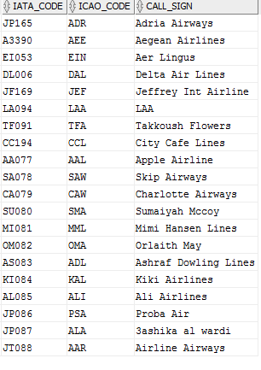

1. **Table “AIRLINE_RENTS_GATE”**

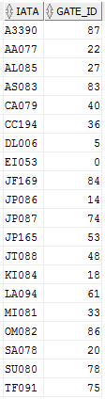

1. **Table “AIRLINE_RENTS_HANGAR”**

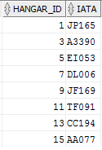

1. **Table “AIRLINEHUBS”**

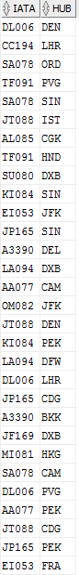

1. **Table “BUSINESSSPACE”**

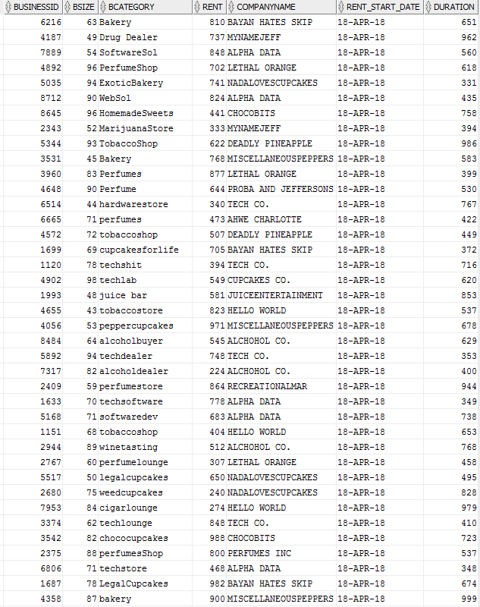

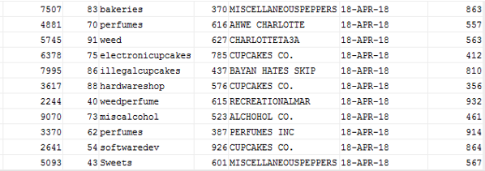

1. **Table “CARGO”**

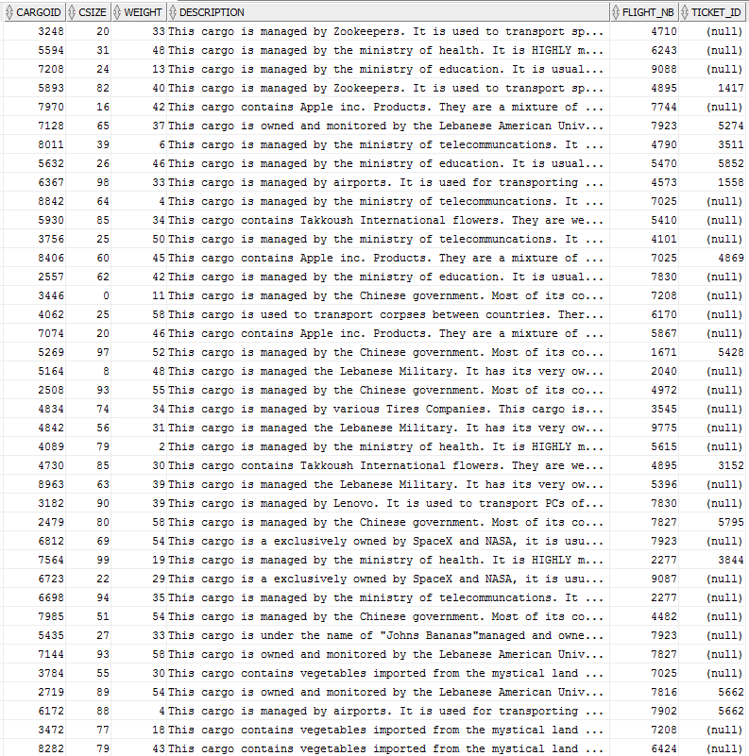

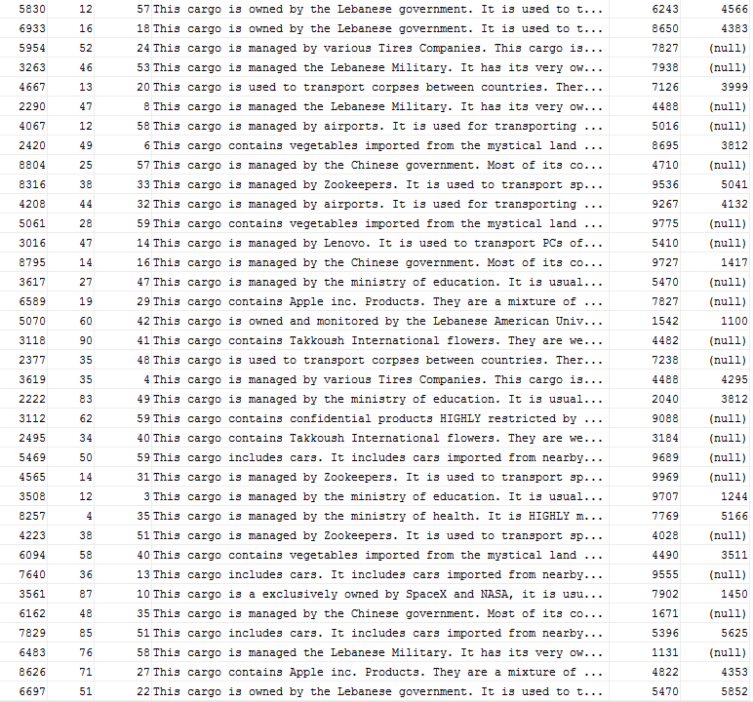

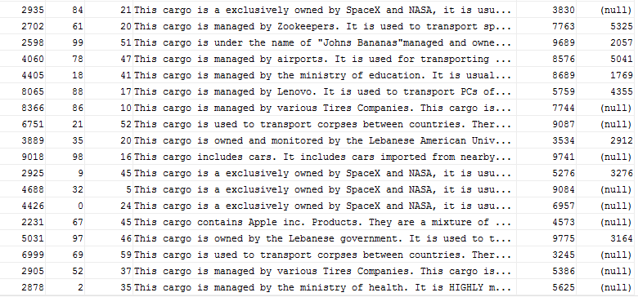

1. **Table “COMPANY”**

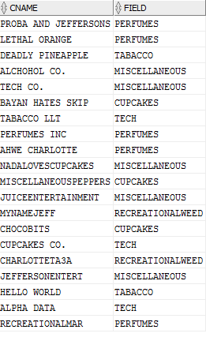

1. **Table “COMPANY_ADDRESS”**

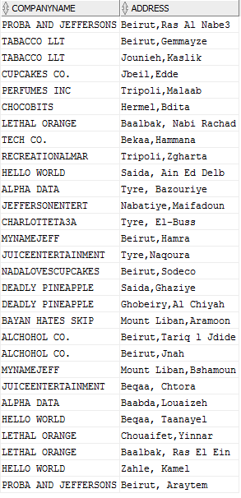

1. **Table “COMPANY_PHONE”**

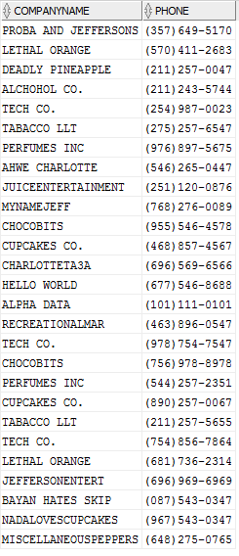

1. **Table “EMPLOYEE”**

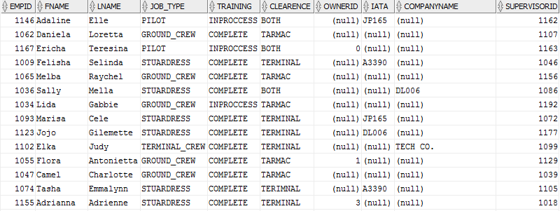

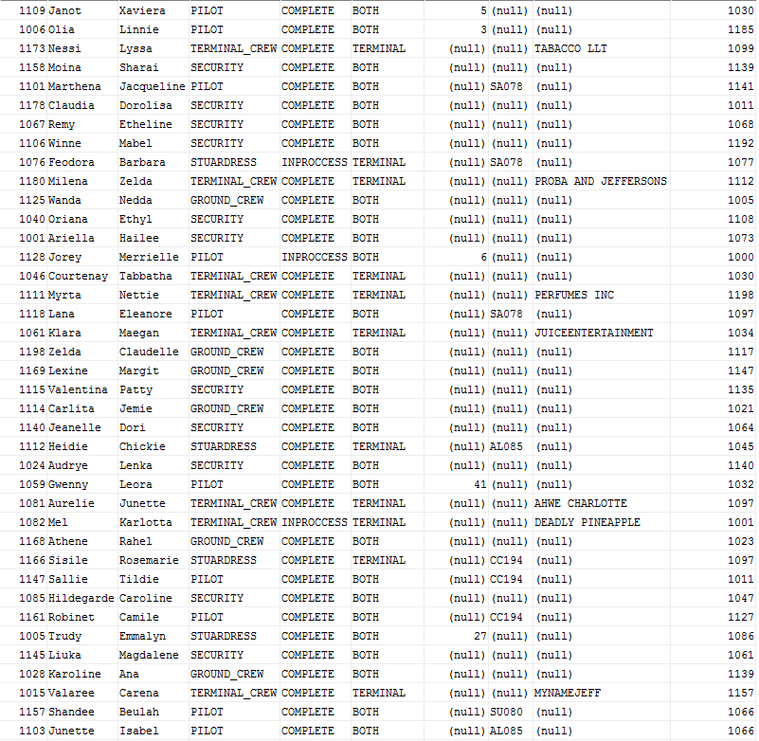

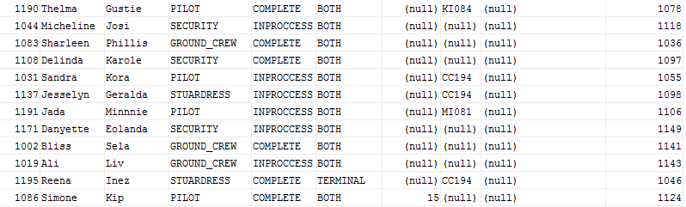

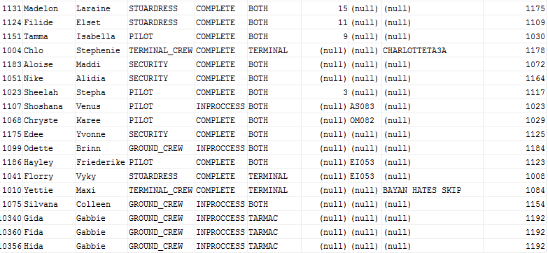

1. **Table “FLIGHT”**

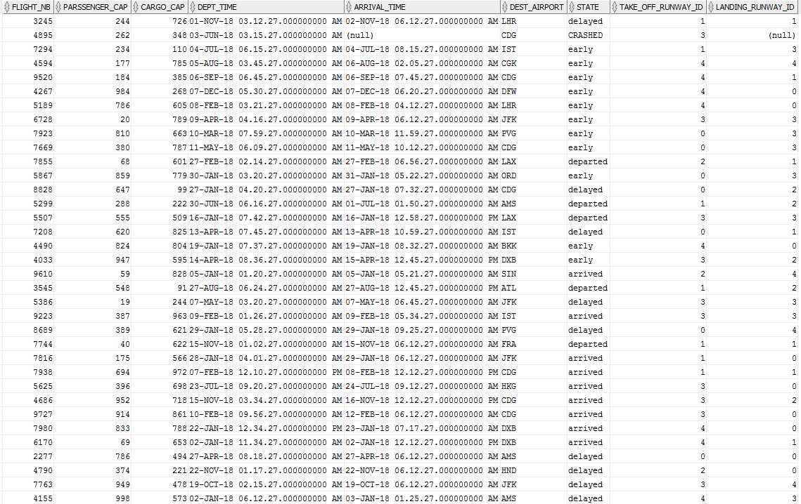

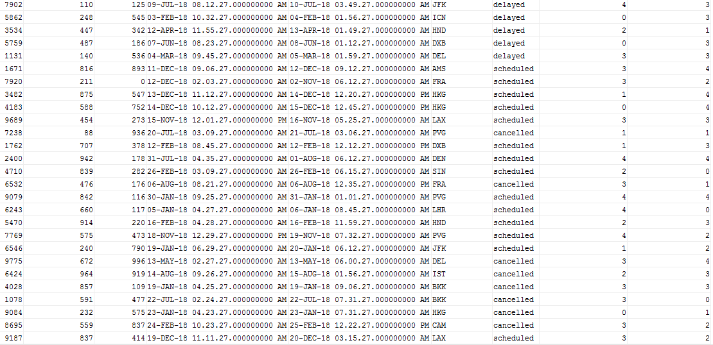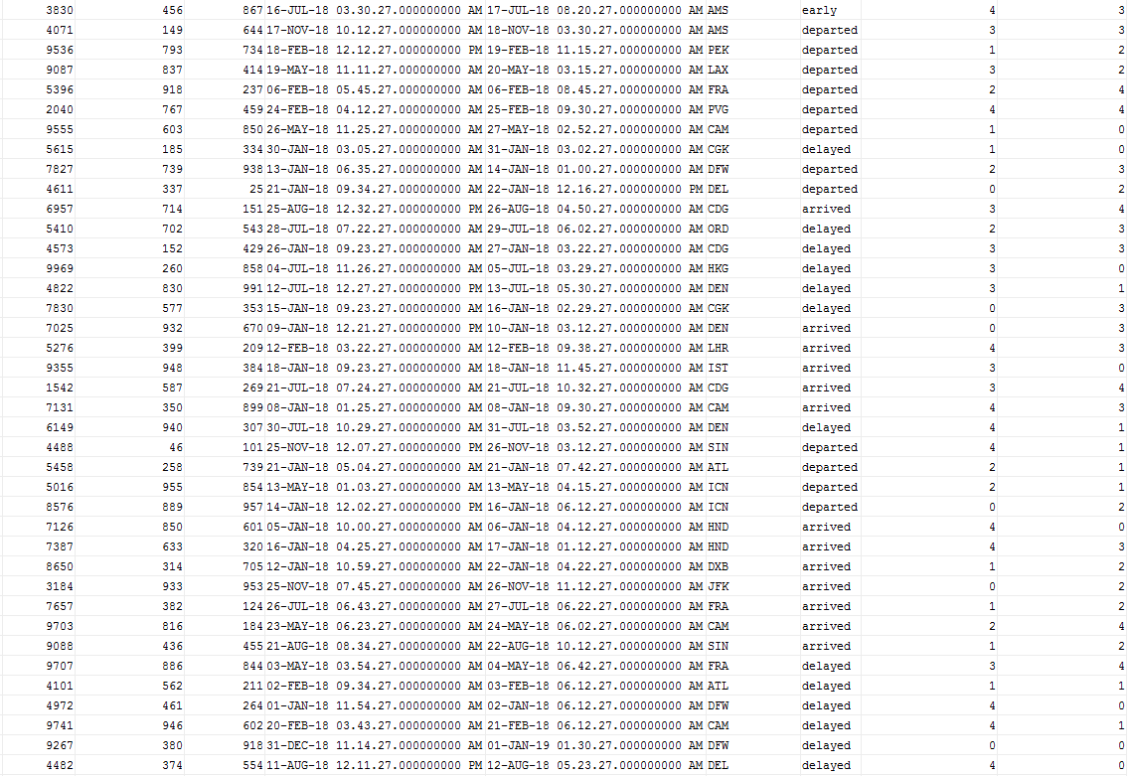

1. **Table “GATE”**

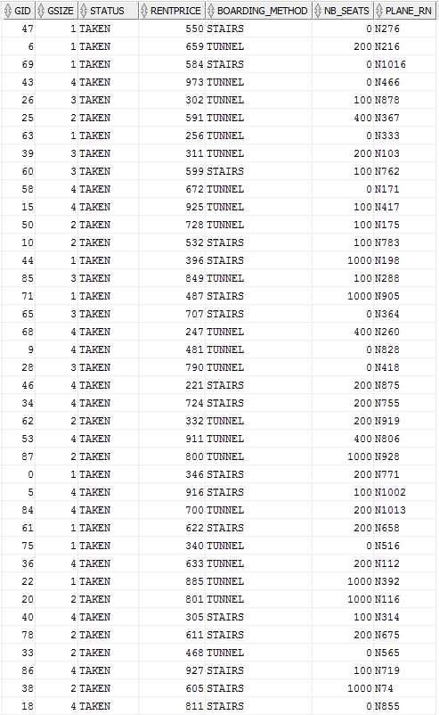

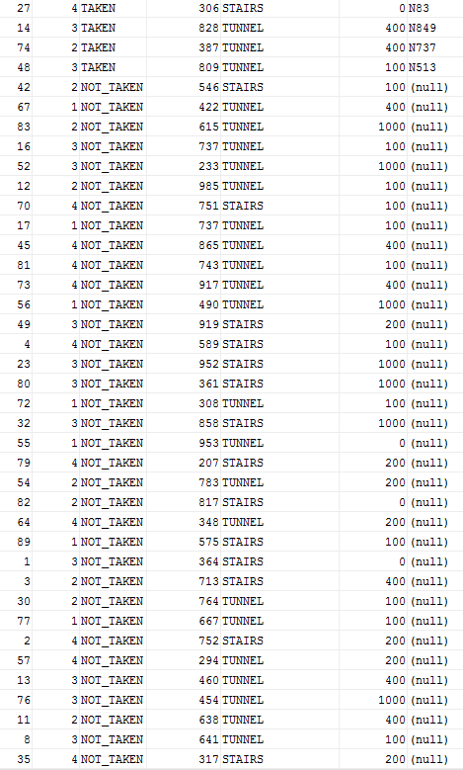



1. **Table “HANGAR”**

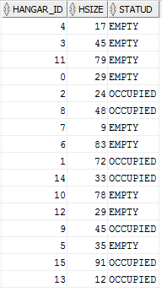

1. **Table “PO_OPERATES_FLIGHT”**

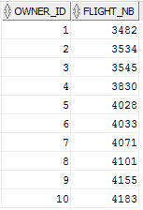

1. **Table “AIRLINE_OPERATES_FLIGHT”**

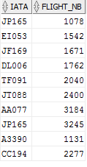

1. **Table “PASSENGER”**

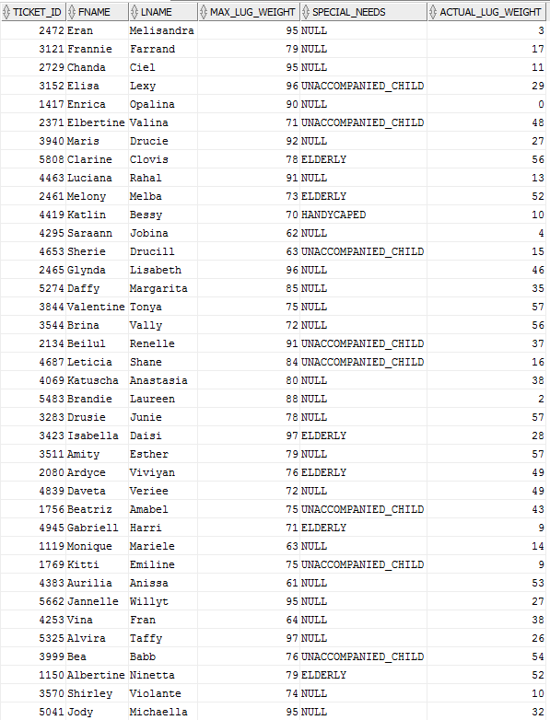

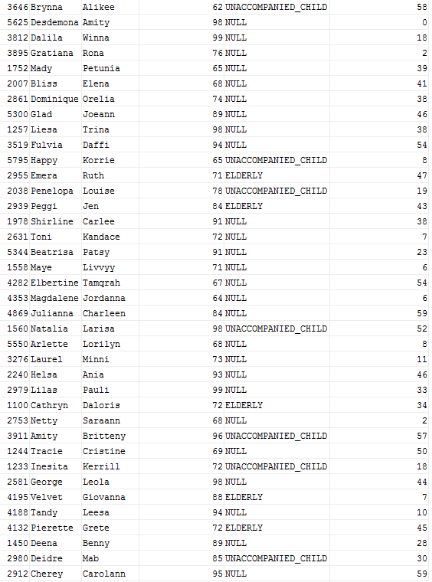

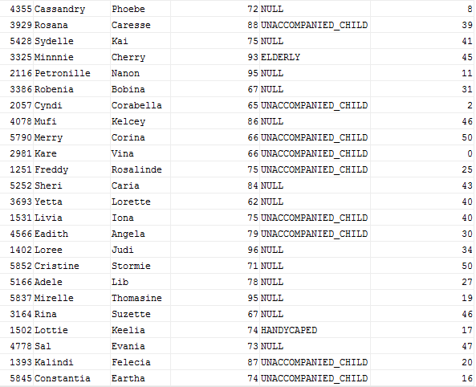

1. **Table “PLANE”**

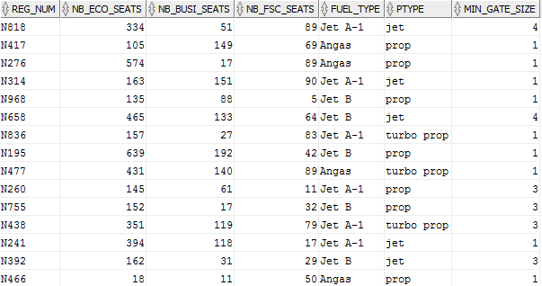

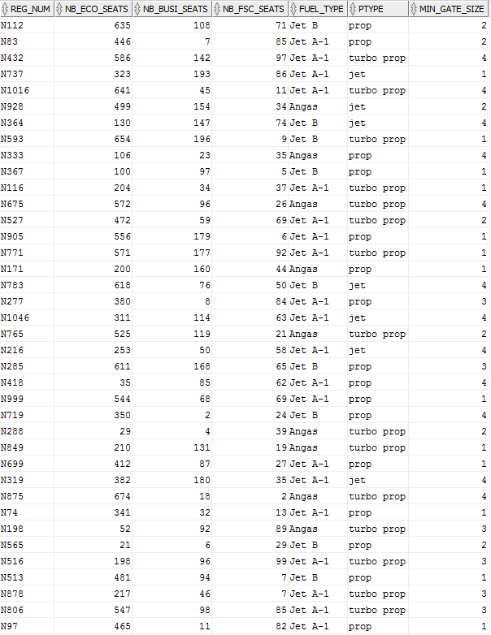

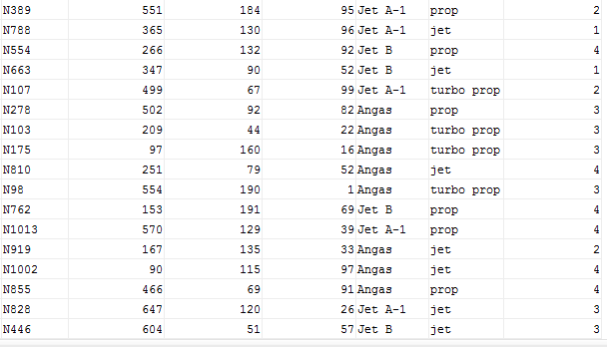

1. **Table “PO_RENTS_HANGAR”**

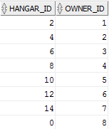

1. **Table “PRIVATE_OWNER”**

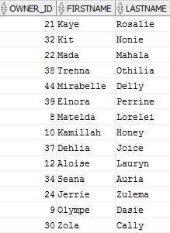

1. **Table “PRIVATEOWNER_RENTS_GATE”**

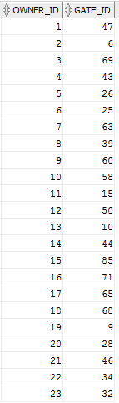

1. **Table “RUNWAY”**

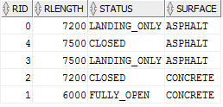

1. **Table “TRANSPORT_PASSENGER”**

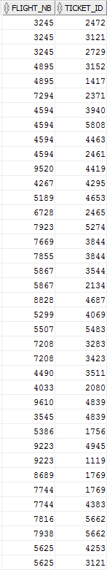

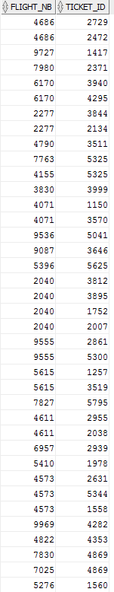

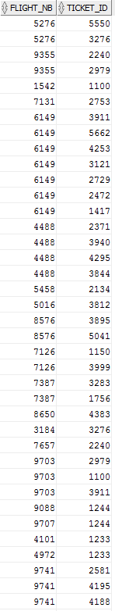

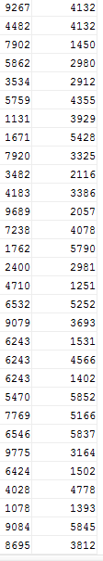

1. **Table “WORKSIN”**

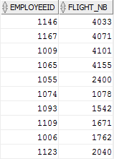

1. **Table “WORKSON”**

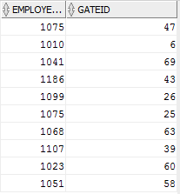

1. **Table “AIRLINE_RENTSPLANE”**

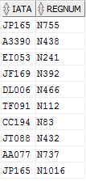

1. **Table “MAINTAINS_HANGAR”**

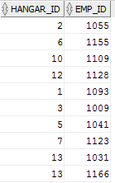

1. **Table “MAINTAINS_RUNWAY”**

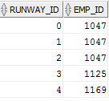

1. **Table “PO_OWNS_RENTSPLANE”**

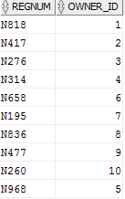

**IX – Queries**

**Question-1-** Ayman is now a plane owner, last night he won a plane while playing cards. But, unfortunately Ayman didn’t ask the previous owner at what gate the plane is parked, nor what is its registration number, in fact Ayman doesn’t even know the previous owners name.  All Ayman knows is that his plane is a turbo prop and uses Jet A-1 fuel, he also remembers that his plane has more than 10 first class seats. Can we execute a query to find all the gates that have planes that fit the description?

**Answer-1-**

SELECT GID

From GATE,

(SELECT *

FROM PLANE

WHERE PTYPE='turbo prop' AND FUEL_TYPE='Jet A-1' AND NB_FSC_SEATS>10)  X

WHERE PLANE_RN=X.REG_NUM;

**SQL Output-1-:**



**Question-2-** Some of the airports passengers are quite superstitious they refuse to board any plane that has a registration number ending with 13, so the airport must find all such planes to change their numbers.

**Answer-2-**

SELECT * FROM PLANE WHERE REG_NUM LIKE '%13';

**SQL Output-2-:**

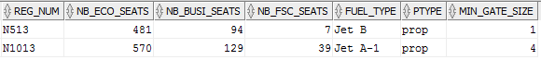

**Question-3-** A plane has crashed!!!! According to the airport emergency procedure the airport must the list of passengers that were on the crashed plane to their lawyers so that the lawyers can contact their loved ones and insure that they don’t sue the airport. So, the airport needs to find all passengers that were on the flight with status=’crashed’

**Answer-3-**

 SELECT p.Ticket_ID, p.FNAME, p.LNAME

From (PASSENGER) p, (SELECT FLIGHT_NB from FLIGHT Where state='CRASHED ') f , (TRANSPORT_PASSENGER) t

where t.FLIGHT_NB=f.FLIGHT_NB and t.ticket_id=p.ticket_id;

**SQL Output-3-:**



**Question-4-** The government suspects that the director of the Lebanese American Airport is biased when hiring employees to the airport. They believe that he has hired his family members into positions at the airport. We shall execute a query to determine how many people of Last name 'Gabbie' work at the airport.

**Answer-4-**

S SELECT * FROM employee WHERE LNAME='Gabbie';

**SQL Output-4-:**

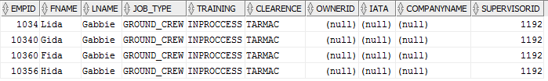

**Question-5-** Dr. Haraty wants to travel to Los Angelos for an academic conference, and that would require him to miss 2 Database sessions.   But, since his students greatly enjoy his class and would really miss him if he traveled, they hacked into the database and cancelled dr. Haraty’s reservation. The airport needs to execute a query to get the next flights to lax airport to help dr. Haraty ordered by departure time.

**Answer-5-**

SELECT * FROM FLIGHTS WHERE DEST_AIRPORT=’LAX’ order by DEPT_TIME;

**SQL Output-5-:**



**Question-6-** The airport wants to reward its most loyal customers. Thus, the airport wants to find the company that has the longest rent contract so they can offer them a discount.

**Answer-6-**

SELECT *

FROM (BUSINESSSPACE) a

ORDER BY a.DURATION DESC

FETCH FIRST 1 ROWS ONLY;

**SQL Output-6-:**



**Question-7-** There has been confusion at the baggage pick up station passengers are fighting over which bag belongs to them. We need to help the security personnel determine which bag belongs to which passenger.

**Answer-7-**

SELECT Passenger.TICKET_ID, Passenger.FNAME,Passenger.LNAME, Cargo.cargoID

FROM Passenger

INNER JOIN Cargo ON Passenger.TICKET_ID=Cargo.ticket_ID;

**SQL Output-7-:**

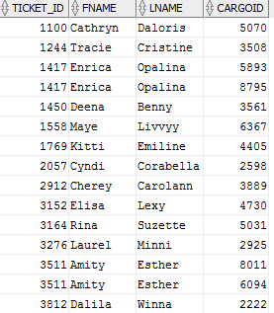

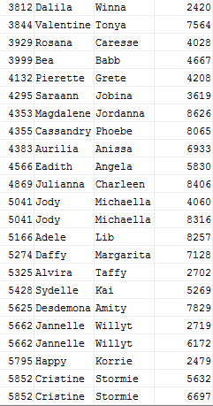

**Question-8-** The airport has bought new equipment, all gate and terminal workers need to be trained on this new equipment. Thus, the Airport needs to fetch all employees that work either in maintaining a hangar or work on a gate.

**Answer-8-**

SELECT  DISTINCT EMPLOYEE.EMPID

FROM EMPLOYEE, MAINTAINS_HANGAR, WORKSON

WHERE EMPLOYEE.EMPID IN (Select MAINTAINS_HANGAR.EMP_ID from MAINTAINS_HANGAR ) OR EMPLOYEE.EMPID IN (Select WORKSON.EMPLOYEEID from WORKSON);

**SQL Output-8-:**



**Question-9-** The airport what’s to know how many elder passengers pass through the airport so they can deduce how many elderly helpers they need to hire.

**Answer-9-**

Select count(*)

from Passenger

where special_needs='ELDERLY';

**SQL Output-9-:**



**Question-10-** Airport officials have noticed an inconsistency in the airport database, the actual_lauguage_size reported in the passenger entity doesn’t reflect the real language weights. They suspect corruption. The airport employees are accepting payments from passengers in exchange for faking their luggage weight. The officials know that the cargo weights that are part of the cargo entity are accurate (since they are measured letter by an automated machine). So to help the officials with their investigation they’d like a list of passengers whose sum of cargo weights are different than their reported actual weights.

**Answer-10-**

SELECT Ticket_ID, FNAME, LNAME

From PASSENGER

Where NOT Actual_Lug_Weight=(Select SUM(Weight)

From (CARGO) c

Where c.Ticket_ID=Ticket_ID);

**SQL Output-10-:**

