ER-Diagram for E-commerce Website

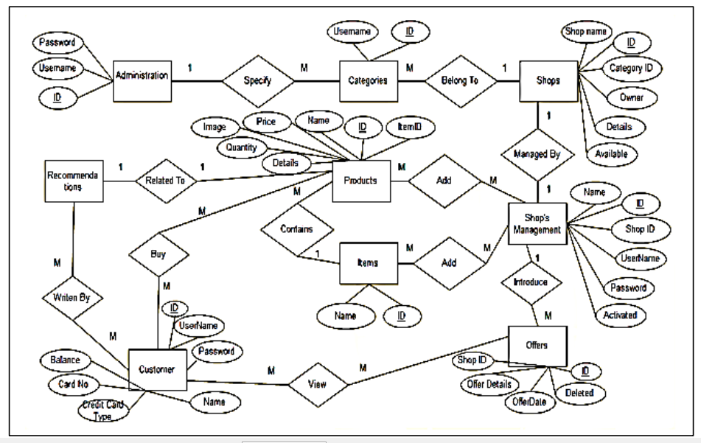

Mapping

1. administration(id, username, password)
2. categories(id, username, **admin_id, shop_id**)
3. shops(id, username, owner, details, available)
4. Shop_shop’sManagement(shop_id, **shop_managment_id**)
5. shop_managment(id, name, username, password, active)
6. offers(id, start_date, offer_details, deleted, **shop_management_id**)
7. products(id, name, price, image, quantity, details, **item_id**)
8. items(id, name)
9. customers(id, name, username, password, credit_card_type, card_no, balance)
10. recommendation(id, description)
11. Shop_mangement_product(**shop_management_id, product_id**)
12. Shop_management_item(**shop_management_id, item_id**)
13. Customer_product(**customer_id, product_id**)
14. Customer_offer(**cutomer_id, offer_id**)
15. Customer_recommendation(**recommendation_id, customer_id**)
16. Recommendation_product(**recommendation_id**, **product_id**)