Final Report
AI Crop Disease Detector for Bangladeshi Farmers
Student: ibrahimSumon47
Repository: https://github.com/ibrahimSumon47/AI-Crop-Disease-Detector-for-Bangladeshi-Farmers
Live application: https://ai-crop-disease-detector-for-bangla-three.vercel.app
All metrics in this report come from the evaluation runs stored in ml/reports/ (plant_classifier_metrics.json, gate_e2e_report.json, metrics.md, history.json, threshold.json).

1. Problem Solved
Smallholder farmers in Bangladesh usually discover that a rice, potato, tomato or other crop is diseased only after visible damage. Getting expert advice means reaching an agriculture officer, who may be far away, and by then the disease may have spread. Most available plant-disease tools are English-only, so their output is hard to act on in the field.
This project delivers a deployed system. A farmer photographs a leaf and, within seconds on a low-end phone, receives:
- the crop and the most likely disease, with the Bangla name;
- a confidence score and the top-3 alternative diagnoses;
- treatment advice written in simple Bangla (symptoms, treatment, organic option, prevention, and when to call an officer);
- an honest "নিশ্চিত বলা যাচ্ছে না" (not certain) screen when the model is not confident. This screen still shows the most-probable disease's advice, clearly labelled low-confidence;
- a clear message instead of a diagnosis when the photo does not show a plant leaf; blurred or very dark photos still get a diagnosis, with a quality warning.

2. Design Decisions

2.1 One deployment instead of split hosting
The original plan was a separate backend host plus Vercel for the frontend. Because the ONNX model is small, the whole system now runs as one Vercel project: a Next.js service and a Python serverless function (api/index.py) that mounts the FastAPI backend under /api/*. This gives one account, one URL and no CORS configuration. Trade-offs: scan history lives in SQLite under /tmp and resets on redeploy, uploads are capped at 4 MB on that deployment, because Vercel limits request bodies to about 4.5 MB, and a cold start after idle adds a few seconds.

2.2 Honest uncertainty as a core principle
A wrong pesticide recommendation can ruin a season, so the calibrated confidence threshold decides between answering and deferring. Refusing with no guidance made the app feel useless in testing, so the uncertain screen still gives the most-probable disease's advice, flagged as low-confidence.

2.3 Advice from a curated file, not from a language model
Treatment advice is stored in backend/app/data/guidelines_bn.json, written in Bangla and reviewed for glyph correctness. An optional LLM layer may only rephrase this file. It is temperature 0.2, falls back to the static text on any error, and is off by default in the deployed app.

2.4 A plant gate in front of the classifier
A separate binary model (plant_guard) first decides whether the photo shows a leaf. Non-leaf photos get clear Bangla guidance before any disease inference runs. Section 4.3 measures its effect.

2.5 Cross-crop family note
Potato and tomato share pathogens (early blight, late blight). When the top-1 disease and a top-3 alternative are the same disease across that boundary, the response carries a Bangla note saying the model is torn between the two hosts, that the advice applies to both, and that the useful information is the disease family rather than the host.

3. AI Workflow

3.1 Data
The classifier covers 61 classes across potato, tomato, rice, maize, grape, mango, chilli, cucumber, cauliflower, okra and papaya, including healthy classes. Sources and licences are recorded in ml/DATASETS.md. ml/src/prepare_data.py merges sources with folder-name alias matching and writes a stratified 70/15/15 train/validation/test split with seed 42. The test split has 14,641 images.
Known data gap: the training photos are mostly lab or close-up images, while farmers photograph leaves in fields. This is the main reason for the accuracy ceiling in Section 4.

3.2 Classifier training
MobileNetV2 with ImageNet weights and a new classification head, trained on a free Colab GPU through the notebook in ml/notebooks/train_kaggle.ipynb. Stage 1 trains only the head for 5 epochs at learning rate 1e-3. Stage 2 fine-tunes for up to 20 epochs at learning rate 1e-5, with class-weighted loss, early stopping and checkpointing. Stage 1 ran 5 epochs and stage 2 ran 11 before early stopping. Preprocessing is 224x224 with inputs scaled to [-1, +1], the same at training and serving time.

3.3 Plant gate
A small binary classifier (plant_guard, 19 features) separates leaves from non-leaf photos. It was trained on synthetic photo-junk, leaf-free background crops and partial-leaf edge windows from the real dataset (30% camera-degraded), and one user-submitted non-leaf photo. Its held-out validation results are: leaf recall 95.7%, non-leaf detection 95.2%, accuracy 95.5%. Its stated limitation is that complex real non-plant scenes such as people or landscapes are not in the negative set.

3.4 Calibration and the deployment threshold
The validation sweep (ml/reports/threshold.json) shows that a high threshold of 0.97 keeps precision above 93%, but it answers only about 4% of images. The deployed threshold is 0.30. At this value the sweep covers about 68% of validation images at roughly 53% precision, and the UI labels lower-confidence answers honestly. The value is set in backend/app/config.py, so the deployed default does not depend on environment variables.

3.5 Serving and export
The model is exported to ONNX. The parity check against onnxruntime gives a maximum absolute difference of 8.3e-8 for the plant gate. Labels are read from backend/app/data/labels.json, which is ordered to match the model output. A serving fix removed a double softmax: the exported graph already outputs probabilities, so applying softmax again flattened the confidence scores. The fix is in commit 13f6010.

4. Results

4.1 Classifier on the test split (14,641 unseen images)
Metric | Value
Top-1 accuracy | 42.80%
Macro F1 | 0.299
Classes | 61

A 61-way problem on mostly lab-style photos is much harder than the 11-class earlier model (61.34% on 5,220 images). The numbers are not directly comparable, because the class set, the test set and the data mix all changed. The earlier model is not the shipped model.

4.2 Per-class highlights
- Strongest: chilli_curl_virus F1 0.68, maize_streak_virus F1 0.67, maize_common_rust F1 0.76, mango_cutting_weevil F1 0.76.
- Weakest: cucumber_anthracnose and cucumber_downy_mildew (F1 0.00), grape_bacterial_leaf_spot (F1 0.00), okra_leaf_curl_virus (F1 0.00), and several classes with 24 to 35 test images.
- Potato early blight F1 0.43, late blight F1 0.34; tomato late blight F1 0.48.
Small test counts make per-class F1 noisy. Per-class results are a guide to where the data is thin, not a precise ranking.

4.3 Effect of the plant gate (end-to-end, full test split)
Metric | Before gate retrain | After gate retrain
Gate leaf pass rate | 98.91% | 98.58%
Leaf refusals | 159 / 14,641 | 208 / 14,641
Junk photos passed into the diagnosis | 28.33% | 14.67%
Top-1 accuracy, all leaves | 44.07% | 43.83%
Top-1 accuracy, gate-passed leaves | 44.56% | 44.46%

Retraining the gate on harder negatives roughly halved the junk that reached diagnosis, for a cost of about 0.3 percentage points more false refusals on real leaves and about 0.2 points of top-1 accuracy. This is a trade-off the project accepts, because a wrong diagnosis of a non-leaf photo is worse than a refusal.
The two runs above use the same test split and seed (4242). The earlier small-sample run (244 leaves, 300 junk) shows the same direction: junk passed fell from 30.7% to 14.7%.

4.4 Uncertainty and the family note in practice
Below the 0.30 threshold, the app shows the honest uncertain screen with the best-guess advice labelled low-confidence. When the potato/tomato family note applies, it appears alongside the result. Both are covered by backend tests (test_family_note.py and test_api.py).

4.5 Engineering verification
- Backend test suite: 39 pytest tests, run in GitHub Actions on every push to main.
- Deployed application: Vercel, with /health reporting model_loaded: true.
- Git: main is in sync with origin/main on GitHub. The repository history shows the incremental changes described in this report.

5. Limitations
- Accuracy is limited: 42.8% top-1 on the 61-class test split. Many classes have few test images, and several have F1 near zero.
- Training data is mostly lab-style photos. Field photos are the main gap, and collecting them is the highest-impact next step.
- The plant gate was not tested on complex real non-plant scenes such as people or landscapes.
- Scan history is stored in SQLite under /tmp on Vercel and resets on redeploy.
- Uploads are limited to 5 MB by the app, and 4 MB on the Vercel deployment because the platform caps request bodies at about 4.5 MB. The LLM advice layer is off by default.

6. Conclusions
- The system is deployed and working end to end: frontend, backend, a trained computer-vision classifier, a plant gate, Bangla advice, scan history and a PWA, with a public URL.
- Honesty is the central design choice. The app says when it is not sure, and it still gives usable guidance in those cases.
- The measured accuracy is modest and is reported as measured. The main limit is data, not the architecture. Field-photo collection and a retrain are the documented next steps.
- Measurement changed decisions: the threshold was set from validation data, the gate was retrained after the before/after study showed junk leaking through, and a double-softmax bug was found and fixed.

7. System Architecture
A farmer's photo goes through these steps:
- Upload and validation: the file must be JPG or PNG, at most 5 MB, and at least 64x64 pixels.
- Plant gate: a trained classifier decides whether the photo shows a plant leaf. Non-leaf photos get a clear Bangla message and no diagnosis.
- Photo-quality check: blurry or very dark photos still get a diagnosis, with a Bangla tip to retake the photo.
- Preprocessing: resize to 224x224, apply EXIF rotation, and scale to [-1, +1], matching training.
- ONNX inference on the CPU, producing class probabilities.
- Calibrated threshold (0.30): above it, the app returns the diagnosis with Bangla advice. Below it, the app shows the uncertain screen with the best-guess advice labelled low-confidence and a note to consult the agriculture officer.
- Response: the scan is saved to history, and the JSON response returns.
The frontend is a Next.js app and the backend is a FastAPI app, both deployed on one Vercel project under the same origin.

8. Data Sources
The training data comes from 11 public datasets, merged into canonical class folders with a stratified 70/15/15 split (seed 42): PlantVillage (potato, tomato, maize, grape), a rice leaf disease dataset including tungro, RiceLeafBD (field photos from Bangladesh), a chilli leaf disease dataset from Bangladesh, a Tanzanian maize dataset, the NGLD grape dataset, a Bangladeshi cauliflower dataset, a cucumber disease dataset, BDPapayaLeaf, MangoLeafBD and an Okra disease dataset. Each source's licence is recorded in ml/DATASETS.md. Some licences are non-commercial only, so this project is suitable for research and education, and a commercial product would need permission or different data.

9. Advice Review
The Bangla treatment advice is stored in backend/app/data/guidelines_bn.json. Of the 61 entries, 11 were reviewed by an agriculture officer. The other 50 were written carefully but are still marked as drafts in the data file, until a Bangla agriculture officer verifies them. Pesticide names and doses must be checked against local regulations before commercial use.

10. Future Work
- Collect 50 to 100 real field photos per class, retrain with --merge-sources, and check the 50 draft advice entries with an agriculture officer.
- Add eggplant (brinjal), the first unsupported crop, using the dataset candidates in ml/src/download_data.md.
- Consider an opt-in feature to store anonymised upload thumbnails, to build a real Bangladeshi field dataset over time.
- Move scan history to a persistent database, since the current /tmp store resets on redeploy.

11. User Interface
Screenshots of the deployed app (ai-crop-disease-detector-for-bangla-three.vercel.app), taken in a browser at phone-friendly width.
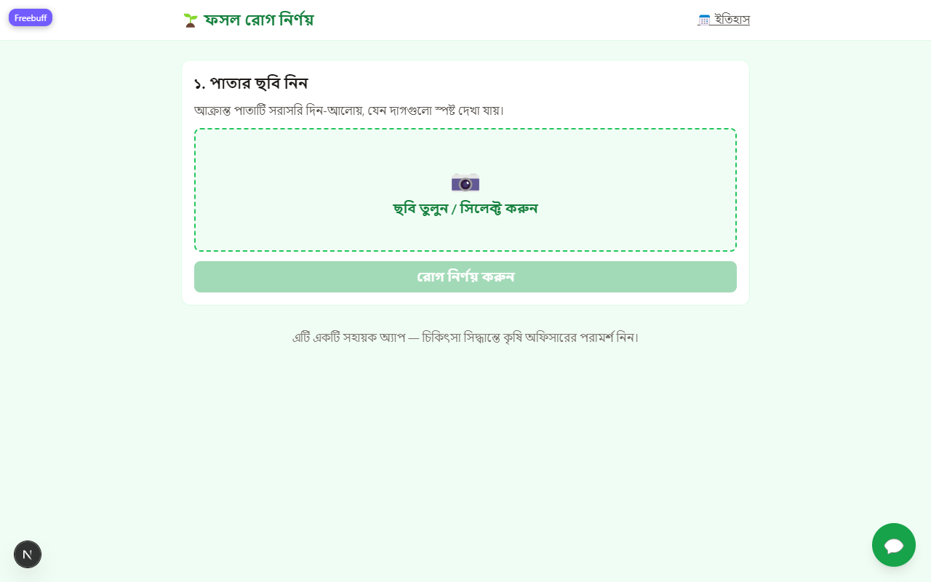
Figure 1 — Home screen: the farmer takes or selects a leaf photo, then presses 'রোগ নির্ণয় করুন' (diagnose).
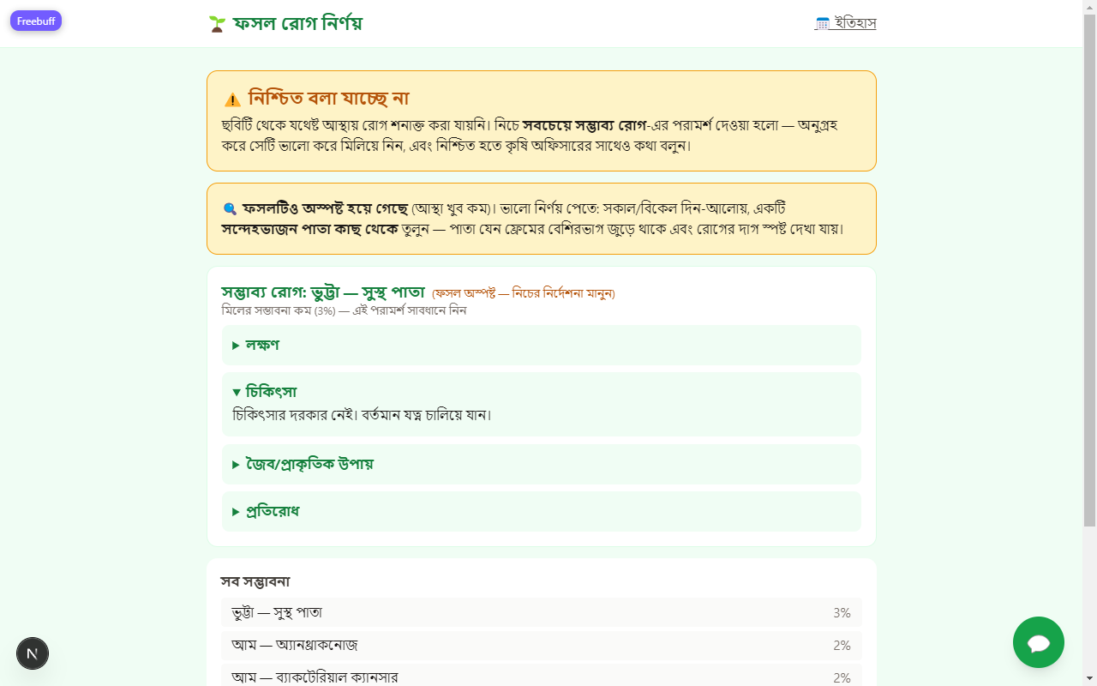
Figure 2 — Honest uncertainty: below the confidence threshold the app shows 'নিশ্চিত বলা যাচ্ছে না' (cannot confirm), still offers the most probable condition's Bangla advice labelled low-confidence, and asks the farmer to consult an agriculture officer.

