NovaStore
System Analysis & Database Design
Based on the supplied ASP.NET Core MVC / .NET 10 project. The current implementation stores products and orders in JSON files and keeps the cart in the user session. The relational schema in Sections 3–6 is a proposed SQL Server migration design, not an existing database.

1. Project Planning

1.1 Project overview
NovaStore is a modern, responsive online retail demonstration. Customers can browse, search and sort products, inspect product details, manage a session cart, and place cash-on-delivery demo orders. A password-protected demo administrator can maintain products, stock and order status.

1.2 Objectives
- Provide intuitive product discovery and a responsive shopping experience.
- Validate checkout input and record order totals and product snapshots.
- Allow basic inventory and order administration.
- Propose a normalized SQL Server design for future persistence and maintainability.

1.3 Scope
In scope (implemented) | Out of scope / future enhancement
Product catalogue; categories stored as text; search and sorting | Real payment gateway and refunds
Session cart and checkout; cash-on-delivery (COD) demo | Registered customer accounts / ASP.NET Identity
JSON persistence for products and orders; stock deduction | SQL Server / EF Core migration and transactional inventory
Demo admin password; product CRUD; order status updates | Multi-admin roles; shipping integrations; tax and email

1.4 Work breakdown and indicative schedule
Phase | Deliverables | Duration
1. Requirements | Features, actors, scope and acceptance criteria | Week 1
2. Design | Wireframes, ERD, mapping, UI and architecture | Week 2
3. Development | Catalogue, cart, checkout, admin | Weeks 3–4
4. Testing | Validation, stock, order, UI and responsive tests | Week 5
5. Deployment and documentation | Demo deployment, README, handover | Week 6
This is a proposed six-week academic plan, not a record of actual development history.

1.5 Risks and mitigations
Risk | Mitigation
JSON write and concurrency limitations | Migrate to SQL Server with transactions and stock checks
Demo admin authentication | Use ASP.NET Core Identity and secrets management
Remote images unavailable | Provide locally hosted images and a fallback
Stock race conditions | Atomic stock updates inside order transactions
No live payment | Clearly label cash-on-delivery as a demo

2. Stakeholder Analysis
Stakeholder | Interest / responsibility | Influence
Customer / visitor | Find products; cart; checkout; order confirmation | High
Store administrator | Maintain catalogue, inventory and order status | High
Store owner / sponsor | Revenue visibility; usable storefront; business rules | High
Developer / maintainer | Implement MVC; test, secure and maintain the system | High
Hosting provider | Application availability and runtime environment | Medium
Delivery / payment partners (future) | Fulfilment and payment integration; not implemented | Low (current)

2.1 Stakeholder needs
- Customer: responsive UI, clear prices, product availability, simple checkout and confirmation.
- Administrator: reliable product CRUD, stock visibility, order listing and status updates.
- Owner: accurate totals and an understandable operational summary.
- Developer: clean models, testable services, and documented persistence and security constraints.

3. Database Design

3.1 Current data model vs proposed model
Current state: Product records are persisted in products.json. Order records, including embedded CheckoutInput and OrderItem snapshots, are persisted in orders.json. CartLine is held in session. Category is a string property on Product. There is no persistent Customer, Category or Cart table, and OrderItem has no ProductId in the current C# model.
Proposed SQL Server schema: Category, Product, Customer, Orders and OrderItem. A Customer record is created or resolved at checkout; this does not imply user authentication. OrderItem stores product snapshots so historical orders remain accurate after catalogue changes. ProductId is nullable so order history is retained when a product is removed. A persistent Cart table is intentionally omitted because the current cart is session-based.

3.2 Business rules
- One category has many products; each product belongs to exactly one category.
- One customer may place many orders; each order belongs to exactly one customer.
- One order has one or more order items; each item refers optionally to one current product.
- Each order item preserves name, price and image at purchase time.
- Quantity must be greater than zero; prices and stock cannot be negative.
- Order total = Subtotal + Shipping. In the demo, shipping is free when the subtotal is 200 USD or more; otherwise it is 15 USD.

4. Entity Relationship Diagram (ERD)
The ERD uses Crow's Foot notation: each box is an entity with its attributes listed below its name; relationships are lines, with the symbol at each end showing cardinality (a bar means exactly one, a crow's foot means many, and a circle means zero, i.e. optional). Primary keys are underlined and marked PK; foreign keys are marked FK.
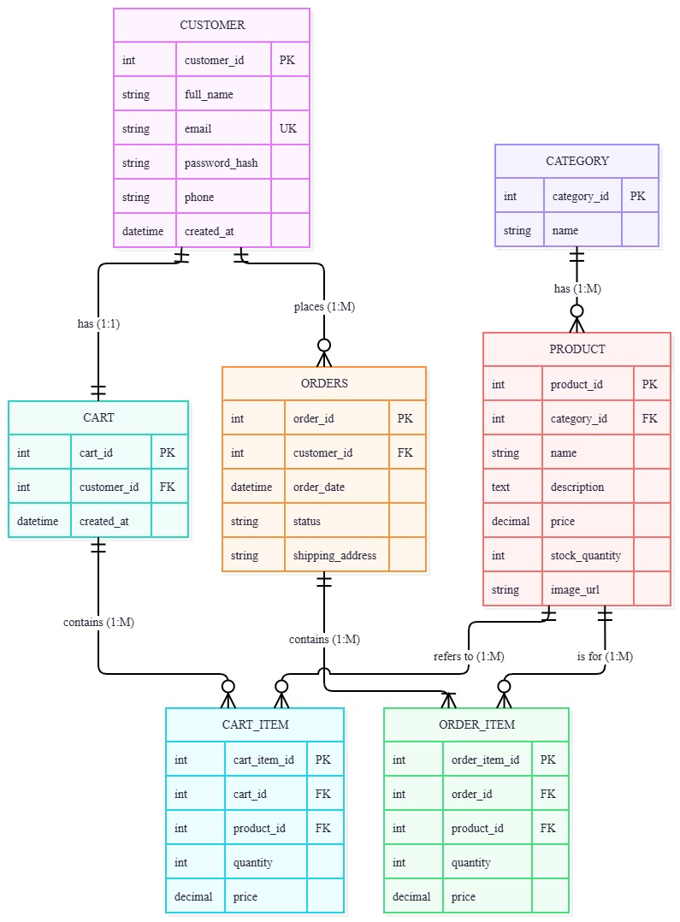
The Product–OrderItem association is conceptually one-to-many. In the proposed physical database, ProductId is nullable so historical order lines remain after a product is deleted. A customer may place multiple orders without a login account.
The entity names in the diagram match the table names in Section 5.

5. ERD-to-Relational Mapping
Mapping rules: each strong entity becomes a table; each 1:N relationship places the primary key of the 1-side as a foreign key on the N-side. OrderItem is a separate line-item table that resolves the many-to-many business relationship between Orders and Products. Historical snapshots preserve checkout prices and names.
Table | Attributes and constraints
CATEGORY | CategoryId INT PK; Name NVARCHAR(80) NOT NULL UNIQUE
PRODUCT | ProductId INT PK; CategoryId INT NOT NULL FK → CATEGORY.CategoryId; Name NVARCHAR(100) NOT NULL; Description NVARCHAR(MAX); Price DECIMAL(12,2) NOT NULL; OldPrice DECIMAL(12,2) NULL; ImageUrl NVARCHAR(500); Stock INT NOT NULL; Featured BIT NOT NULL; Badge NVARCHAR(40); Rating DECIMAL(3,2)
CUSTOMER | CustomerId INT PK; FullName NVARCHAR(120) NOT NULL; Email NVARCHAR(254) NOT NULL; Phone NVARCHAR(30) NOT NULL
ORDERS | OrderId VARCHAR(30) PK; CustomerId INT NOT NULL FK → CUSTOMER.CustomerId; CreatedAt DATETIME2 NOT NULL; ShippingAddress NVARCHAR(300) NOT NULL; City NVARCHAR(100) NOT NULL; Notes NVARCHAR(MAX) NULL; Subtotal DECIMAL(12,2) NOT NULL; Shipping DECIMAL(12,2) NOT NULL; Status NVARCHAR(30) NOT NULL
ORDER_ITEM | OrderItemId INT PK; OrderId VARCHAR(30) NOT NULL FK → ORDERS.OrderId; ProductId INT NULL FK → PRODUCT.ProductId ON DELETE SET NULL; ProductNameSnapshot NVARCHAR(100) NOT NULL; UnitPriceSnapshot DECIMAL(12,2) NOT NULL; ImageUrlSnapshot NVARCHAR(500); Quantity INT NOT NULL

Relationships
- Category → Product: CATEGORY.CategoryId (PK) → PRODUCT.CategoryId (FK), 1:N
- Customer → Orders: CUSTOMER.CustomerId (PK) → ORDERS.CustomerId (FK), 1:N
- Orders → OrderItem: ORDERS.OrderId (PK) → ORDER_ITEM.OrderId (FK), 1:N
- Product → OrderItem: PRODUCT.ProductId (PK) → ORDER_ITEM.ProductId (nullable FK), 1:N

5.1 Normalization and integrity
The proposed schema is designed toward Third Normal Form (3NF): category names are stored once, customer details are separated from orders, and repeating order lines reside in ORDER_ITEM. The snapshot columns in ORDER_ITEM are deliberate: they record historical transaction facts and are an intentional exception to strict 3NF. The order total is computed as Subtotal + Shipping rather than stored as an independently editable column.
Recommended constraints: CHECK Price >= 0, Stock >= 0, Quantity > 0, Shipping >= 0 and UnitPriceSnapshot >= 0. Index all foreign keys.

5.2 Scope and implementation note
This is a proposed SQL Server relational design. It does not claim that the current .NET 10 demo already implements these tables. The supplied source currently uses Product.Category as text, stores order and customer information embedded in JSON, and keeps cart lines in session. The mapping normalizes these concepts for a future migration. No persistent cart, payment transaction or registered-user table is assumed.

6. MVC-to-Data Mapping
- Shop / Home → CATEGORY, PRODUCT: product listing, search, category filters and product details.
- Cart → session CartLine (ProductId, Quantity); products are read from PRODUCT. No persisted cart table is required.
- Checkout → CUSTOMER, ORDERS, ORDER_ITEM: validate input, save the order and line snapshots, and reduce PRODUCT.Stock.
- Admin → PRODUCT and ORDERS: catalogue CRUD, stock monitoring and order status management.

7. Acceptance Criteria
- The ERD shows five entities, their attributes, and four cardinality-labelled relationships.
- Every entity has a primary key; all one-to-many relationships are mapped with explicit foreign keys.
- An order contains one or more order items; line-item snapshots preserve historical purchase values.
- The proposed schema supports product administration, customer checkout and order history without claiming unimplemented features.

Source: NovaStore .NET 10 MVC project — Models/Product.cs, Services/StoreService.cs and the controllers.

