DSAI-22 (2022-2024)

**Project Work:** Project Management & Communication

**Professor:** Mahmoud Golabi

**Students:** Ibrahim Aliyev, Oktay Rasulzade, Majid Rahmanov

**Topic:** Usage of Gravitational Search Algorithm (GSA) to optimize well-known mathematical functions



**Abstract**

This report is designed to cover the topics “Gravitational Search Algorithm”, “Well-known mathematical functions” and “Usage of Gravitational Search Algorithm to optimize well-known mathematical functions”. Gravitational Search Algorithm (GSA) is one of the population search algorithms that discovered in 2009 by Esmat Rashedi who inspired from nature. This algorithm is mainly based on Newton’s rule of gravity, motion, mass interactions and their mathematically modelization.

First of all, we’ll look at some basic concepts of Physics, including velocity and acceleration, Newton’s laws and Gravitational force. The content Newton’s rule of gravity forms the base of this chapter.

Second part, which is on the GSA itself, provides formulation and properties of given optimization problem. In addition details of some well-known mathematical functions are also described.

In the last part, there are given optimization results of 4 mathematical functions and explanation of Python GSA code.

**Definition of the problem**

Understanding the Gravitational Search Algorithm, making research about it and its applications

Understanding given Matlab code and converting the formulas into python code

Optimizing one-dimensional (has only one argument - *x*) Ackley, Rastrigin, Rosenbrock and Schwefel functions using Gravitational Search Algorithm

Comparing the results of each function optimization

**Basic concepts of Physics used in formulation of GSA**

A push or pull that an object experiences as a result of interacting with another item is known as a **force** and marked with the letter ***F***. In other words, force is a vectorial physical quantity that sets an object in motion and has the effect of accelerating it.

**Acceleration** is a physical quantity equal to the ratio of the change in speed to the time at which this change occurs. Acceleration of a body occurs at the expense of the compensator of the forces acting on the body, as shown in Newton's second law. In the International System of Units (IS), the unit of acceleration is meters divided by seconds squared ( $\frac{m}{s^{2}}$ or $\frac{m}{\sec^{2}}$). Acceleration is a vector quantity (that is, defined by both magnitude and direction) and sums according to the parallelogram law. Calculated as a vector, the displacement force is equal to the product of the object's mass (a scalar quantity) and its momentum.

For example, when a car accelerates along a straight line from a stationary state (initial velocity is 0), the direction of momentum is in the direction of motion. If the car turns, the momentum changes direction and takes a new direction. In this example, the force observed by the passengers in the car pushing or pressing them towards the seat is called the instantaneous or linear acceleration of the car. When the car changes its direction, the passengers in the car will notice the forces that push them to the side, such acceleration is called non-linear acceleration. If the car slows down, then the momentum is directed against the direction of the car's movement, and this is sometimes called deceleration. During deceleration, passengers notice that a force is created that pushes them forward. Mathematically, deceleration does not have a separate formula, it is a change of speed in both. Each of these accelerations (linear, non-linear decelerating, accelerating) is felt by passengers until their velocities (value and direction of velocity) are the same as the velocity of the car.

The average acceleration of an object is equal to the ratio of the change in velocity to the time interval during which that change occurs:

$$\overline{a}=\frac{∆v}{∆t}$$

where *a* is average acceleration, *v* is velocity and *t* is time.

The instantaneous acceleration is equal to the limit of the infinitesimal time interval of the average acceleration. In the calculations, the instantaneous acceleration vector is taken as the first derivative of the vector with respect to time:

$$a=\lim_{∆t→0}{\frac{∆v}{∆t}}=\frac{dv}{dt}$$

Instantaneous force - $F=ma$ where *F* is force, *m* is mass and *a* is acceleration.

Force is a quantitative measure of the interaction between objects and particles. The unit of measurement is 1 *N* (Newton) in International System of Units. Newton is the force that accelerates an object with a mass of 1 *kg* by 1 $\frac{m}{s^{2}}$. Force is needed to change the speed of an object, that is, to gain momentum. The movement of the object is directly proportional to the substitute of the forces immediately acting on it, and inversely proportional to its mass, directed in the direction of this force: $a=\frac{F}{m}$. From there we get that $F=ma$. Force is a vector quantity.

Newton's laws are the laws of classical mechanics that allow us to write the equation of motion of a given mechanical system. In 1687, Isaac Newton's famous work "The Mathematical Beginning of Natural Philosophy" was published. Here Newton describes the three laws of mechanics. These laws are popularly known as "Newton's axioms" or "Newton's laws".

**Newton's first law** refers to the principle of inertia. It exists only in inertial systems and was first formulated by Galileo Galilei in 1638: If no force acts on an object, it either remains at rest or maintains its momentum. Newton's first law is expressed as follows: There are such calculation systems that when a body is not affected by other bodies or when the effects on it balance each other, it maintains a state of rest if it is at rest, and a state of rectilinear constant speed motion if it is moving in a straight line. Such calculation systems are called inertial calculation systems. That is, for the object to move at a constant speed, it does not need an external force. If the exponent of the forces acting on the body is different from zero, it will change its speed, that is, it will gain momentum. Velocity keeps its value and direction constant only under given conditions. An external force must act to change the state of motion. In many cases, this is the gravity of the place. In classical mechanics, this corresponds to the equilibrium conditions.

**Newton's second law** - the differential law of motion shows the relationship between the force exerted on a material point and its acceleration. According to this law, the acceleration of a material point in the inertial calculation system is directly proportional to the compensating force and inversely proportional to its mass. Newton's second law is expressed as follows:

$$a=\frac{F}{m}$$

where *a* is acceleration of object, *F* is force acting on that object and *m* is mass of given object.

**Newton's third principle** is based on interaction: The forces of interaction between arbitrary two bodies are equal in magnitude and opposite in direction. Forces arise in pairs. However, since they are applied to different objects, they do not balance each other. If object A exerts a force on another object B, then object A will also be exerted by object B with the same amount of force but directed in the opposite direction. That is, force creates an opposite force:

$$F_{A→B}=F_{B→A}$$

**Gravity** is a natural phenomenon that refers to the attraction of material objects with mass and is one of the four fundamental forces of nature in physics.

How do the planets revolve around the Sun without being tied to any chains?.. – What is the interaction that keeps the planets around the Sun without touching?.. – How does the Sun stand in the sky without any support? The answer to all these questions is gravitational force.

As a result of the Earth's gravity, objects are attracted by the Earth. This force also determines the trajectory of the Earth and other planets, thus playing a major role in astronomy.

It was Isaac Newton who first tried to mathematically describe the gravitational force of the earth. Newton's theory of gravitation, which he described, was the first theory that could be applied to astronomy.

According to Newton's law of gravitation, two bodies with masses *m* and *M* attract each other with a force $F(r)$ that is directly proportional to their masses and inversely proportional to the square of the distance between them. The force of gravity is calculated in this case as follows:

$$F\left(r\right)=-\frac{GMm}{r^{2}}$$

where $G=6,673*{10}^{-11}\frac{m^{3}}{kg*s^{2}}$ is a gravitational constant and the value of this constant is calculated using gravity scale.

Force that acting on the particle surface is expressed as follows:

$$F=mg$$

where *m* is mass and *g* is gravitational force.

**Formulation of Gravitational Search Algorithm**

Gravitational search algorithm is one of the very few algorithms that were inspired by one of the main rules of Physics which is the Newtonian law of gravity and the law of motion. It has been proved that this algorithm is used to solve various problems like load power dispatch, routing , classification and etc.

Gravitational search algorithm works by applying the Newtonian law. We can think of the search agents that apply force to each other. In this way it is done by the formula of F = m * g which is a Newtonian Law formula. Gravitational force causes movement of objects towards Heavier masses. When all the agents gather at the same point, the gravitational search algorithm will stop its function.

Generation initial population:

In this algorithm agents are considered as objects. Let us consider a system with *N* agents:

$$X_{i}=\left(x_{i}^{1},…,x_{i}^{d},…,x_{i}^{d}\right) for i=\overline{1,N}$$

where $x_{i}^{d}$ is a position of *i*-th agent in the *d*-th dimension.

After this, our equation about gravitational force acting on mass *i* from mass *j* will take the form at a specific time *t*:

$$F_{ij}^{d}(t)=G(t)\frac{M_{pi}\left(t\right) *{ M}_{aj}\left(t\right)}{R_{ij}\left(t\right) + ε}(x_{j}^{d}\left(t\right)-x_{i}^{d}(t))$$

where ${ M}_{aj}$ is active and $M_{pi}$ is passive mass on given agents *j* and *i*.

$R_{ij}\left(t\right)=|\left|X_{i}\left(t\right),X_{j}\left(t\right)\right||$ is the Euclidian distance between these agents. Then,

$$F_{i}^{d}\left(t\right)=\sum_{j=1,j≠i}^{N}{{rand}_{j}F_{ij}^{d}(t)}$$

where ${rand}_{j}∈[0,1]$ is a random number and $F_{i}^{d}\left(t\right)$ is the total force which is acting on *i* on dimension *d*.

Calculation of *M* and *a* for each agent:

As we know from the Newton’s second rule, acceleration will be like below, in that case:

$$a_{i}^{d}\left(t\right)=\frac{F_{i}^{d}\left(t\right)}{M_{ii}^{ }\left(t\right)}$$

Here, $M_{ii}^{ }\left(t\right)$ is the inertial mass of *i-*th agent.

Updating velocity and position:

$$v_{i}^{d}\left(t+1\right)={rand}_{i}*v_{i}^{d}\left(t\right)+a_{i}^{d}\left(t\right)$$

$$x_{i}^{d}\left(t+1\right)=x_{i}^{d}\left(t\right)+v_{i}^{d}\left(t+1\right)$$

Update the *G*, *best* and *worst* of the population:

$$G\left(t\right)=G(G_{0},t)$$

Updating the gravitational and inertial masses:

$$m_{i}\left(t\right)=\frac{{fit}_{i}\left(t\right)-worst\left(t\right)}{best\left(t\right)-worst\left(t\right)}$$

where

$best\left(t\right)=\min_{j∈\overline{1,N}}{{fit}_{j}(t)}$ and $worst\left(t\right)=\max_{j∈\overline{1,N}}{{fit}_{j}(t)}$ for a minimization problem and

$best\left(t\right)=\max_{j∈\overline{1,N}}{{fit}_{j}(t)}$ and $worst\left(t\right)=\min_{j∈\overline{1,N}}{{fit}_{j}(t)}$ for a maximization problem.

In the end, we check if it meets criteria, or not. If yes, it will return the best solution. If no, then we continue our iteration from the stratch.

Fitness function evaluation is done for best and worst fitness values of search agents in each generation.

All GSA steps are listed below:

1. Initialization phase
2. Randomly generate search space of size N
3. Evaluate the fitness value for each individual agent (object)
4. Set iteration counter to zero: t = 0
5. Update best and worst value in the population
6. Calculate G, mass, acceleration, force for current population
7. Update position and velocity for each agent (object)
8. Evaluate the fitness values
9. Repeat until stopping criteria met
10. Return best solution
11. En0064

**Well-known mathematical functions**

In below, given formulas and ranges for 4 well-known mathematical functions (but one dimensional versions):

1. Ackley function:
$$F\left(x\right)=-20e^{-0.2\sqrt{\frac{1}{n}\sum_{i=1}^{n}{x_{i}^{2}}}}-e^{\frac{1}{n}\sqrt{\sum_{i=1}^{n}{\cos{2πx_{i}}}}}+20+e$$

$$-5≤x_{i}≤5$$

2. Rastrigin function:
$$F\left(x\right)=\sum_{i=1}^{n}{x_{i}^{2}-10\cos{2πx_{i}}}+10$$

$$-5.12≤x_{i}≤5.12$$

3. Rosenbrock function:
$$F\left(x\right)=\sum_{i=1}^{n-1}{100{(x_{i+1}-x_{i}^{2})}^{2}+{(x_{i}-1)}^{2}}$$

$$-∞≤x_{i}≤+∞$$

4. Schwefel function:

$$F\left(x\right)=\sum_{i=1}^{n}{-x_{i}\sin{(\sqrt{|x_{i}|})}}$$

$$-500≤x_{i}≤500$$

**Applications of Gravitational Search Algorithm**

As it is one of the metaheuristic algorithms, it is applied in several problems, listed below:

1. Economic load dispatch problem
2. Economic and emission dispatch problem
3. Optimal power flow problem
4. Reactive power dispatch problem
5. Energy management systems
6. Clustering problem
7. Classification problem
8. Feature subset selection
9. Parameter identification
10. Training neural networks
11. Travelling salesman problem
12. Filter design and communication systems
13. Unit commitment problem in power systems
14. Multi-objective optimisation

**Conclusion & Result**

We have downloaded MATLAB software to see the result (graph and best fitnesses for each four function) of given code. And all results given below:

1 – Ackley function (Fbest = 3.8951e-09):

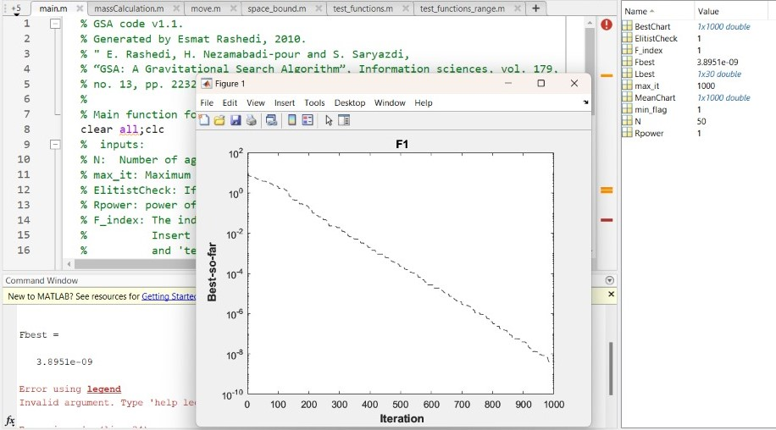

2 – Rastrigin function (Fbest = 14.9244):

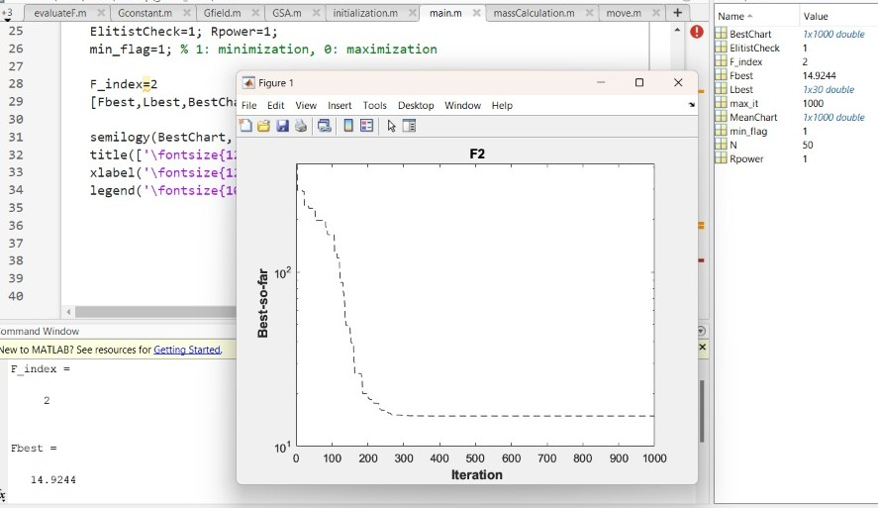

3 – Rosenbrock function (Fbest = 26.1419):

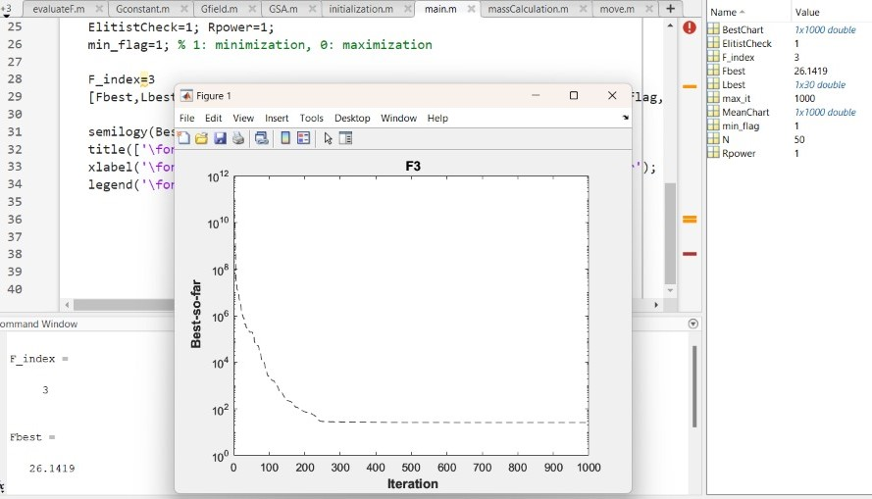

4 – Schwefel function (Fbest = -2.5328e+03):

Now, let us discuss about python codes. We rewrote the given MATLAB code in Python, Google Colab and compared results. All Jupyter Notebook files are included in the given zip folder and attached to the email.

But, we also created graphs for best fitness of each function after optimization using GSA algorithm. To get .csv files that includes best fitness iterations of given function, we have used free and open source repository in GitHub. And then, we created plots, execution time for 2 million iterations for each plots:

1 – Ackley function:

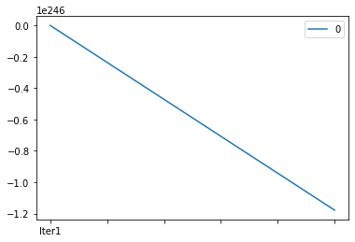

2 - Rastrigin function:

3 – Rosenbrock function:

4 – Schwefel function:

|  |  |  |  |  |
| --- | --- | --- | --- | --- |
|  | Ackley | Rastrigin | Rosenbrock | Schwefel |
| Execution time: | 50,687.73 | 65,141.06 | 58,380.53 | 62,147 |
| Standart deviation: | NaN | 62.218913030734875 | 4834042519.995008 | 23.350254826634075 |
| Mean: | $$-∞$$ | -23.822253453477504 | 4130406541.670403 | -1713.753881111497 |

**Literature**

1. <https://www.sciencedirect.com/science/article/abs/pii/S0020025509001200>
2. <https://www.mathworks.com/products/matlab.html>
3. <https://www.youtube.com/watch?v=OtWWOFmtwgQ>
4. <https://www.youtube.com/watch?v=K1FvdHb7mek&t>
5. <https://en.wikipedia.org/wiki/Test_functions_for_optimization>
6. <https://www.mathworks.com/help/matlab/matlab_prog/matlab-operators-and-special-characters.html>
7. <https://www.researchgate.net/publication/310837749_Applications_of_gravitational_search_algorithm_in_engineering>
8. <https://github.com/7ossam81/EvoloPy>
9. <https://github.com/7ossam81/EvoloPy/wiki/List-of-optimizers>
10. <https://github.com/himanshuRepo/Gravitational-Search-Algorithm>