ALANYA ALAADDİN KEYKUBAT ÜNİVERSİTESİ

RAFET KAYIŞ MÜHENDİSLİK FAKÜLTESİ

LİSANS TEZİ

SMART CLASSROOM ATTENDANCE

AND MANAGEMENT SYSTEM

İbrahim ARDIÇ

Batuhan YILDIZHAN

ALANYA, ANTALYA

**2024**

Her hakkı saklıdır

**TEZ ONAYI**

İbrahim Ardıç ve Batuhan Yıldızhan tarafından hazırlanan " Smart Classroom Attendance and Management System " adlı tez çalışması 13/04/2024 tarihinde aşağıdaki jüri tarafından oy birliği/oy çokluğu ile Alanya Alaaddin Keykubat Üniversitesi Rafet Kayış Mühendislik Fakültesi Bilgisayar Mühendisliği Bölümünde LİSANS TEZİ olarak kabul edilmiştir.

**Danışman:** Dr. Öğr. Üyesi Kübra UYAR

**Jüri Üyeleri:**

**Üye:** Doç. Dr. Alper Kürşat UYSAL

**Üye:** Dr. Öğr. Üyesi İbrahim Rıza HALLAÇ

**Üye:** Dr. Öğr. Üyesi Yılmaz Kemal YÜCE

**Üye:** Dr. Öğr. Üyesi Özge ÖZTİMUR KARADAĞ

# ETİK

Alanya Alaaddin Keykubat Üniversitesi Rafet Kayış Mühendislik Fakültesi tez yazım kurallarına uygun olarak hazırladığım bu tez içindeki bütün bilgilerin doğru ve tam olduğunu, bilgilerin üretilmesi aşamasında bilimsel etiğe uygun davranıldığı, yararlandığım bütün kaynakları atıf yaparak belirttiğimi beyan ederim.

|  |
| --- |
| **13/04/2024** |
| İbrahim ARDIÇ  Batuhan YILDIZHAN |

# TEŞEKKÜR

Bu tezin hazırlanmasında değerli katkıları olan, her zaman yanımda olan ve bana destek olan danışman hocam Sayın Dr. Öğr. Üyesi Kübra UYAR'a sonsuz teşekkürlerimi sunarım. Danışman hocamın değerli rehberliği ve yönlendirmeleri olmadan bu çalışmanın tamamlanması mümkün olmazdı.

Tez çalışmamın her aşamasında bilgi ve deneyimleriyle bana destek olan, değerli hocalarım Sayın Dr. Öğr. Üyesi İbrahim Rıza HALLAÇ, Sayın Dr. Öğr. Üyesi Yılmaz Kemal YÜCE, Sayın Dr. Öğr. Üyesi Özge ÖZTİMUR KARADAĞ ve Sayın Doç. Dr. Alper Kürşat UYSAL'a da teşekkürlerimi sunarım.

Bu çalışmanın, alanındaki araştırmacılara ve ilgililere faydalı olmasını dilerim.

İbrahim Ardıç, Batuhan Yıldızhan

Alanya Aladdin Keykubat Üniversitesi

# ÖZET

Lisans Tezi

AKILLI SINIF YOKLAMA VE YÖNETİM SİSTEMİ

İbrahim ARDIÇ

Batuhan Yıldızhan

Alanya Alaaddin Keykubat Üniversitesi

Rafet Kayış Mühendislik Fakültesi

Bilgisayar Mühendisliği

Danışman: Kübra UYAR

Geleneksel eğitim metodlarının evrimi, teknolojik gelişmelere uyum sağlama ihtiyacını doğurmuştur. Bu proje, eğitim sektöründeki yoklama alma süreçlerini otomasyon ile kolaylaştırmayı amaçlamaktadır. Kağıt tabanlı yoklama sistemlerinin zaman kaybı, doğruluk sorunları ve ders sürelerinin bölünmesi gibi zorluklarını ele alarak, Smart Classroom Attendance and Management System'i tanıtmaktayız.Projemiz, yüz tanıma teknolojisi kullanarak her öğrencinin yüz hatlarını tarar ve benzersiz bir biyometrik tanımlama sağlayarak öğrencileri otomatik olarak sınıfa kaydeder. Bu, öğrencilerin sınıfa girişlerini otomatik olarak kaydetmelerine imkan tanır ve kağıt tabanlı yoklamaların gereksizliğini ortadan kaldırır.Ayrıca, projemiz mobil bir uygulama ile desteklenerek öğretmenlere ve öğrencilere iki ayrı panel sunmaktadır. Bu sayede, insan hataları en aza indirgenir. Öğrenciler, dersin sonunda uygulama aracılığıyla yoklama bilgilerini görüntüleyebilir ve doğrulayabilirken, öğretmenler de alınan yoklamaları onaylayarak sistemin güvenilirliğini artırırlar. Sonuç olarak, Smart Classroom Attendance and Management System, geleneksel yöntemlerin zorluklarını aşmak ve eğitim süreçlerini daha verimli hale getirmek için yenilikçi bir yaklaşım sunmaktadır. Bu proje, eğitim sektöründe otomasyon dönüşümünü temsil eder ve öğrenciler ile öğretmenlerin daha etkili bir ders deneyimi yaşamasına katkı sağlamayı hedeflemektedir.

**2024, 4 sayfa**

**Anahtar Kelimeler**: *Otomasyon, Yüz Tanıma, Panel, Biyometrik Tarama, Mobil Uygulama, Kağıt Tabanlı Yoklama.*

# ABSTRACT

Undergraduate Thesis

SMART CLASSROOM ATTENDANCE AND MANAGEMENT SYSTEM

İbrahim ARDIÇ

Batuhan YILDIZHAN

Alanya Alaaddin Keykubat University

The Faculty of Engineering

Department of Computer Engineering

Supervisor: Kübra UYAR

The evolution of traditional educational methods highlights the necessity to adapt to new technologies. This project aims to facilitate the attendance-taking processes in the education sector through automation. Addressing challenges such as time loss, accuracy issues, and the fragmentation of class periods associated with paper-based attendance methods, we introduce the Smart Classroom Attendance and Management System. Our project utilizes facial recognition technology to scan the facial features of each student, providing a unique biometric identification and automatically enrolling students in the class. This allows students to be automatically recorded upon entering the classroom, eliminating the need for paper-based attendance. Additionally,it’s supported by a mobile application, our project provides two different panels for teachers and students, minimizing human errors. Students can view and verify attendance information through the application at the end of the class, while teachers can approve the recorded attendance, thereby enhancing the reliability of the system. In conclusion, the Smart Classroom Attendance and Management System offers an innovative approach to overcome the challenges posed by traditional methods and make educational processes more efficient. Representing the transformation of automation in the education sector, this project aims to contribute to a more effective learning experience for both students and teachers.

**2024, 4 sayfa**

**Keywords**: *Automation, Facial Recognition Technology, Panels, Biometric idendification, Mobile application, paper-based attendance.*

# İÇİNDEKİLER

ETİK i

TEŞEKKÜR ii

ÖZET iii

ABSTRACT iv

İÇİNDEKİLER v

1. INTRODUCTION 1-2

2. LITERATURE REVIEW 3-8

3 MATERIAL METHOD. 8

3.1 Database and Integration. 8

3.1.1 Firebase and Database. 9

3.1.2 Database Requirements. 9-10

3.1.3 Integration Requirements 10-11

4 FUNCTIONAL REQUIREMENTS. 12

5 NON-FUNCTIONAL REQUIREMENTS. 13

6. SYSTEM EFFICIENCY.. 13

7. LEGISLATIVE REGULATIONS. 14

8.DIAGRAMS. 14-16

9.SYSTEM FUNCIONALITIES AND SUBSTANCES. 17-20

KAYNAKÇA 21-22

# Table of fıgures

**Figure 2.1** Conceptual Model of RFID roll call system 4

**Figure 2.2** Android-based Smart Student Attendance System Login Page. 5

**Figure 2.3** Fingerprint Attendance System for classroom needs portable fingerprint attendance system 5

**Figure 2.4** QR Code and Barcode 6

**Figure 2.5** Block Diagram of Location Based Smart Attendance System Using GPS 7

**Figure 2.6** Bluetooth Technology 8

**Figure 8.1** Use-Case Diagram 14

**Figure 8.2** Flowchart Diagram 15

**Figure 8.3** Block Diagram of Location Based Smart Attendance System Using GPS 16

**Figure 8.4** Class Diagram 16

**Figure 9.1** 'findEncodings()' function. 17

**Figure 9.2** **‘**data’ dictionary in addDataToDatabase.py 18

**Figure 9.3** Different modes in ‘main.py’ class 19

**Figure 9.4** ‘Student_info’ mode in ‘main.py’ class 20

# 

1. ıntroductıon

Education is a fundamental factor for the progress of societies and the personal development of individuals. Good education plays a critical role in the development of each individual and the preparation of new generations. Efficient and effective management of education processes is one of the key elements that reinforce this success. Traditional educational methods, with their time-consuming and paper-based processes, susceptibility to manipulation of information, and tendency to disrupt class periods, have brought about challenges. In light of these challenges, our project aims to overcome them in the education sector. It has emerged with the goal of automating and improving student attendance processes.

The ‘Smart Classroom Attendance and Management System’ project, developed to address challenges such as time loss, accuracy issues, and class period disruptions associated with paper-based attendance methods, presents an integrated approach with new-generation technologies. The main objective of the project is to automatically enroll each student in the class by creating a unique biometric identity through facial recognition technology. This allows the automatic recording of students’ entry into the classroom, eliminating the need for paper-based attendance. Additionally, through a designed mobile application with two separate panels for teachers and students, a user-friendly experience is provided, minimizing human errors and enhancing the efficiency of the education process. This project is considered to represent an automation transformation in the way attendance is taken in the education sector, aiming to provide students and teachers with a more reliable, fast, and effective learning experience. The report symbolizes a significant transformation in the method of taking attendance by explaining the key features of the Smart Classroom Attendance Management System and the overall objectives of the project.

In the Smart Classroom Attendance and Management System, the attendance process begins with teachers manually adding students to the appropriate course through the mobile app. Before class, teachers activate the classroom camera and attendance system by connecting to the system. Upon entering the classroom, students present their faces to the camera. The system then utilizes facial recognition technology to match each student's face against the teacher's record. If a match is successful, the student is marked as present in the attendance log. Before confirming the attendance, teacher can count the students in class and compare with the number of students in the system. This process will increase accuracy. At the end of class, the teacher confirms the camera shutdown via the mobile app, triggering a notification to all students informing them of their class attendance record. By implementing this system, we aim to achieve two goals: Students who are physically present in class but marked absent due to a system error can notify their teacher through the notification received, and the attendance system can provide feedback to students regarding their attendance status.This automated process streamlines the attendance process, saving time and minimizing human error.

Our project stands out in terms of originality compared to previous applications in the field. Unlike past implementations that solely relied on mobile applications or facial recognition systems, our project combines both technologies for a more robust solution. Specifically, while facial recognition technology ensures accurate attendance records, the integration of a dedicated mobile application adds an extra layer of sophistication. Unlike the existing projects, our mobile application boasts two distinct panels tailored for students and teachers, a feature designed to minimize potential errors in the attendance tracking process. This dual-system integration not only enhances accuracy but also plays a pivotal role in the overall automation system, setting our project apart with its innovative approach.

1. Lıterature revıew

There are several projects aimed at addressing challenges in attendance systems have been identified. Previous works focused on developing smart attendance systems utilizing card reading, RFID systems, fingerprint scanning, IoT systems, and facial recognition technologies, emerging as notable examples in our research. Among these exemplary projects in the field: Smart Classroom Roll Caller System with IoT Architecture[1], College Smart Classroom Attendance Management System Based on Internet of Things[2], A Smart Classroom Application, Monitoring and Reporting Attendance Automatically Using Smart Devices[3], Automated Attendance System[4], Automated Attendance Marking and Management System by Facial Recognition Using Histogram[5], Classroom Attendance Systems Based on Bluetooth Low Energy Indoor Positioning Technology for Smart Campus[6], Free & Generic Facial Attendance System Using Android[7], Android-based Smart Student Attendance System[8] , Fingerprint Attendance System for Classroom Needs[9], IoT Based Cloud Integrated Smart Classroom for Smart and a Sustainable Campus[10], Developing a NFC-Equipped Smart Classroom: Effects on Attitudes Toward Computer Science[11], Face Recognition based Attendance Management System[12], A Smart Phone Integrated Smart Classroom[13], Automation Attendance Systems Approaches: A Practical Review[14], Android-Based Attendance Management System[15], Location Based Smart Attendance System Using GPS[16], Mobile Based Attendance System: Face Recognition and Location Detection using Machine Learning[17], Automatic Attendance Management System using Face Detection[18].

Under the category of RFID ,which indicated as an older version of the currently used NFC technology, Souza et al. [5] have examined institutions that facilitate participation from various environments and suggest the need for a different participation project for these institutions. The Android-Based RFID project includes a mobile application and RFID components. The RFID component documents student participation in the database, but when it cannot be used due to resource constraints, the mobile application is used as an alternative. Chang [1] , using a different RFID technology, also implements a system where RFID tags can be attached to student ID cards or clothing. The tags have a lifespan of 5 to 10 years and the read range is 10 to 100 centimeters. The server can be cloud-based or local. Another project by Zhao [2] uses 2 different RFID readers (one at the entrance and one at the exit of the classroom) to also detect whether students are present in the classroom during the entire class period and generate an automatic attendance report. This makes it easier to track absenteeism and take appropriate measures.

metin, ekran görüntüsü, tasarım içeren bir resim

Açıklama otomatik olarak oluşturuldu

**Figure 2.1** Conceptual Model of RFID roll call system [1].

In terms of Android Based Identity Authentication, a system Developed by the Android operating system is designed to expedite and simplify routine registration or login processes for users. However, this widely used system today can pose a security threat for users using weak login credentials. Hameed [8] offers three separate management profiles using Android-based identity authentication in his developed application. These profiles include an administrator account that can modify the database, a teacher account that can mark students, and a reporter account that can verify attendance records. Teachers can easily take attendance with their Android or iOS devices and comfortably record it for presentations.

metin, ekran görüntüsü, yazı tipi, logo içeren bir resim

Açıklama otomatik olarak oluşturuldu

**Figure 2.2** Android-based Smart Student Attendance System[8] Login Page.

Some studies above, show the usability of Fingerprint Based Attendance systems. Mohamed and Raghu [9] allow students to verify their attendance by scanning their fingerprints on the device's sensor in the defined fingerprint attendance system. However, since fingerprint readers are generally sensitive devices, this process may require multiple repetitions and extend the attendance process.

bilgisayar, metin, diyagram, ekran görüntüsü içeren bir resim

Açıklama otomatik olarak oluşturuldu

**Figure 2.3** Fingerprint Attendance System for classroom needs[9] Portable fingerprint attendance system

The Face Recognition Based relies on comparing faces detected from photo or video sources with recognized/unrecognized face data in the database. The system developed by Smitha [12] consists of two main sections: face recognition and detection. It applies face recognition to data obtained with the help of a camera, and if the recognized face is detected in the recognized face database, it records the student's attendance in the attendance system. Another aspect addressed by Varadharajan et al. [18] is the capturing of the classroom photo through a camera placed in the classroom, checkin for recognized faces in the photo against the database, and entering attendance information. Families of students not present in the class are informed. Hava and her coworkers research [7] identities by detecting their faces using a facial recognition algorithm from the cameras of their Android phones.

QR codes and Barcodes are graphical representations of data that can be read by machines. Barcodes are typically used to store information associated with a product. QR codes, on the other hand, are similar to barcodes but can store more information because they are two-dimensional. QR code technology and is based on research by Sutar et al. [4], is a smart attendance system that would speed the attendance process by creating and scanning QR codes. The system runs as an application on mobile devices and is built on QR Technology.

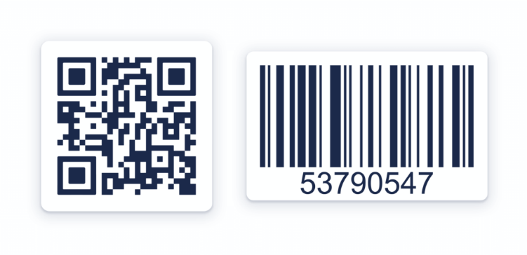

**Figure 2.4** QR Code and Barcode

Another system called GPS Based Attendance Systems uses location of students in order to define their attendance. GPS technology allows us to determine the current location of a user on the Earth. This technology is now being utilized in attendance systems in classrooms. For instance, Kumar and his colleagues [16] presented a location-based attendance monitoring system in their work using Android mobile applications. The GPS system in the mobile application used by students monitors their current location. In this scenario, if the student is present at the specified location during class hours, the attendance information is recorded in the database. However, there is a possibility of misleading the teacher during attendance with less accurate GPS devices.

metin, bilgisayar, küçük alet, multimedya içeren bir resim

Açıklama otomatik olarak oluşturuldu

**Figure 2.5** Block Diagram of Location Based Smart Attendance System Using GPS[16]

In the Bluetooth Technology , researchers developed a system that utilizes Bluetooth Low Energy (BLE) technology for attendance management. Şengül [3] utilizes a BLE beacon placed within the classroom. When students enter the classroom, their smartphones automatically detect the beacon's signal, triggering their presence to be logged in the system. This data is then transmitted to a central server where attendance reports are generated and

accessible to instructors. Puckdeevongs [6], also uses BLE technology for automated attendance, but it also utilize dedicated beacons for enhanced accuracy and scalability.

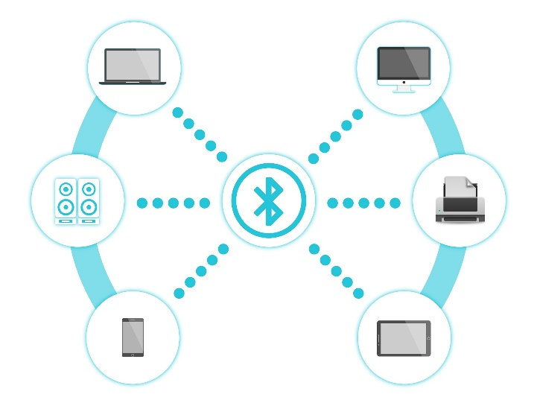

**Figure 2.6** Bluetooth Technology

1. materıal method

In this section, the focus will be on the technologies used in the Smart Classroom Attendance and Management System project and the integration of these technologies.

**3.1 Database And Integration**

A project's database is an important component for storing and managing information. In the "Smart Classroom Attendance and Management System" project, we need a database because we need to store and access this data as needed. The project should store a variety of data, such as student information, teacher information, course information, and more. This data will make it possible to track and manage student attendance.

In order for students and teachers to interact with the system, we need to provide access to this data in the database. The database supports secure and structured access to this data.

In addition, the data in the system, such as attendance status, may need to be updated in real time. The database makes real-time data synchronization possible. Student attendance and absenteeism statistics can also be analyzed using this dataset.

**3.1.1 Firebase and Database**

We plan to use Google Firebase to meet our database needs for the project. Firebase is a cloud-based platform that provides the service that meets our project requirements. One of the reasons we are using Firebase is to provide real-time synchronization of student attendance records. Firebase makes it easy to synchronize data in real time. It also provides tools to track and analyze application performance through its website. This will help us better track project data in a more convenient way. Also, Firebase can be seamlessly and easily integrated into Android and iOS mobile applications. This makes it easier for students and teachers to access the right data.

Firebase uses end-to-end encryption to protect user data. This is a very difficult cryptography method to solve. This prevents unauthorized access to data and keeps student and teacher information safe and secure. In our project, different access levels will also be defined for different user types (Student and Teacher). Firebase also provides this definition and management. This also increases data security.

**3.1.2 Database Requirements**

Our project’s database needs a robust structure to store and manage various types of data. This includes:

Student information: This encompasses essential details like student names, surnames, unique student numbers, and any other relevant student data.

Student face recognition data: To enable the system's core functionality of facial recognition attendance, we need to store unique biometric identifiers for each student.

Teacher information: Similar to student data, we'll store personal details of teachers like names, surnames, and unique teacher numbers for system identification and access control purposes.

Course details: Each course offered in the system requires a dedicated data record. This record will likely include information like course name, instructor, schedule, syllabus, and potentially student enrollment details.

User information: To manage user sessions and track authentication processes, the system needs to securely store user login credentials. This may include usernames, passwords, or any other secure user identification methods implemented.

**3.1.3 Integration Requirements**

Our project must be integrated with face recognition libraries such as OpenCV, dlib, face_recognition, TensorFlow in order to be able to recognize students by their facial features. The face recognition part of the project will be done using Python.

The system will be integrated with Google Firebase for user authentication, real-time data management and synchronization, and secure data storage. Firebase Realtime Database and Firestore will store student and course data.

The UI designs on the mobile side will be carried out separately for teachers and students. The teacher UI will provide the ability to view and change the data from the database. The student UI will only provide the ability to read.

The mobile application will serve as an interface for students and teachers to interact with the system. Developed using the Flutter framework for both iOS and Android platforms, the mobile application integrated with Firebase will provide the following features:

* Students' ability to view and verify attendance information.
* Teachers' ability to approve and edit taken attendance through the mobile interface.
* Real-time data synchronization with Firebase.

These technologies will be seamlessly integrated to ensure that the Smart Classroom Attendance and Management System delivers a reliable, effective, and user-friendly experience.

**3.2 Scenario**

The teacher manually adds students under the class title through the mobile application.

Before the lesson, the teacher connects to the system and activates the camera and attendance system in the classroom. When the camera is activated, students enter the classroom and present their faces. When the facial recognition system matches the student's face with the students recorded by the teacher, the attendance record is written as "Student present". The approval icon appears on the screen and the system goes into standby mode for other students to present their faces. At the end of the lesson, the teacher approves the camera shutdown process through the mobile application. After approval, a notification of the class attendance information is sent to the students through the mobile application.

As long as the camera is active, another teacher cannot access the same camera. Another teacher can activate the system using a different camera for a different lesson. For troubleshooting, If there is a problem with a student's attendance information, the student can notice it thanks to the notification that comes to their phone and contact the teacher. The teacher manually resolves the issue through the application and updates the information.

The camera will only be active with student interaction, in accordance with the Law on Unauthorised Surveillance of Persons. If there is no interaction for a long time or after the students' entry is approved, the camera will be automatically deactivated.Student consent will be obtained in accordance with the KVKK law for the processing of student facial data.

Google Firebase will be used for data security, the database will be created with Flutter. The mobile application will be developed on Flutter.Python software will be used for the facial recognition system. OpenCV and Face Recognition libraries will be used in the project.

**4. FUNCTIONAL REQUIREMENTS**

**Student Requirements:** The system should provide a user-friendly interface for students to view and verify their current attendance information through the mobile application.

**Lecturer Requirements:** Lecturers should be able to initiate attendance before the start of the class and approve attendance records at the end of the class. A user-friendly interface should be provided for lecturers to view and, if necessary, edit current attendance information through the mobile application or web interface.

**Face Recognition and Student Attendance:** The integrated system within the classroom should be capable of creating a unique biometric identity by recognizing student faces through the camera. The facial recognition data generated for each student should be securely stored in the database.

**Automated Attendance System:** The system should be able to automatically record the entries of students entering the classroom through the camera. When the facial recognition system identifies a student, they should be added to the attendance list as "present."

**Integration of Mobile Application:** Students should be able to view and verify attendance information through the mobile application. Lecturers should be able to ensure the reliability of the system by approving the attendance records received through the mobile application.

**5. NON-FUNCTIONAL REQUIREMENTS**

**Data Security:** User data should be securely stored using end-to-end encryption on Firebase. Access levels specific to user types (students and lecturers) should be defined, and only authorized users should be able to access the data.

**Real-Time Data Synchronization:** Using Firebase, student attendance records should be synchronized in real-time. The system should be able to quickly respond to manual changes made by the lecturer when necessary.

**Performance of Mobile Application:** The mobile application should operate smoothly and quickly on iOS and Android platforms. The performance of the mobile application should be monitored and analyzed using tools like Firebase Analytics.

**6. SYSTEM EFFICIENCY**

**Camera Control:** The system should not activate classroom cameras without the approval of the lecturer. Another lecturer should not be able to activate an already active system. The attendance process should be usable only once for the same class simultaneously.

**Troubleshooting and Data Update:** Students should be able to communicate with lecturers and address issues with attendance information through the mobile application. Lecturers should be able to manually resolve issues and update information through the application.

**Technology Use:**For the facial recognition system, Python and necessary libraries (OpenCV, dlib, face_recognition, TensorFlow) should be integrated into the system. The system should perform user authentication, real-time data management, and secure data storage through Firebase integration.

**7. LEGISLATIVE REGULATIONS**

**Allowance and Confirmation:** Necessary permissions for processing student facial data should be obtained in compliance with the Personal Data Protection Law (KVKK) and other legal regulations. The camera should only be active during student interactions for attendance purposes and must comply with the Unauthorized Surveillance of Persons Law.

**8. DIAGRAMS**

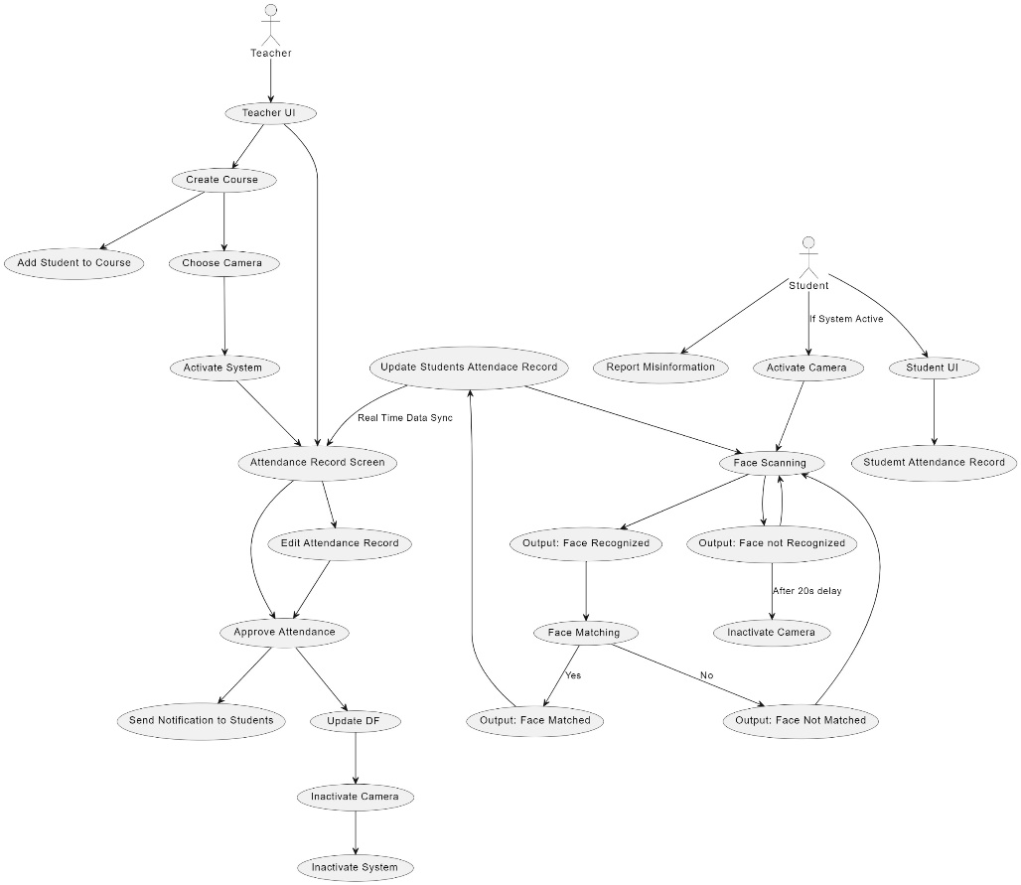

**Figure 8.1:** Usecase Diagram

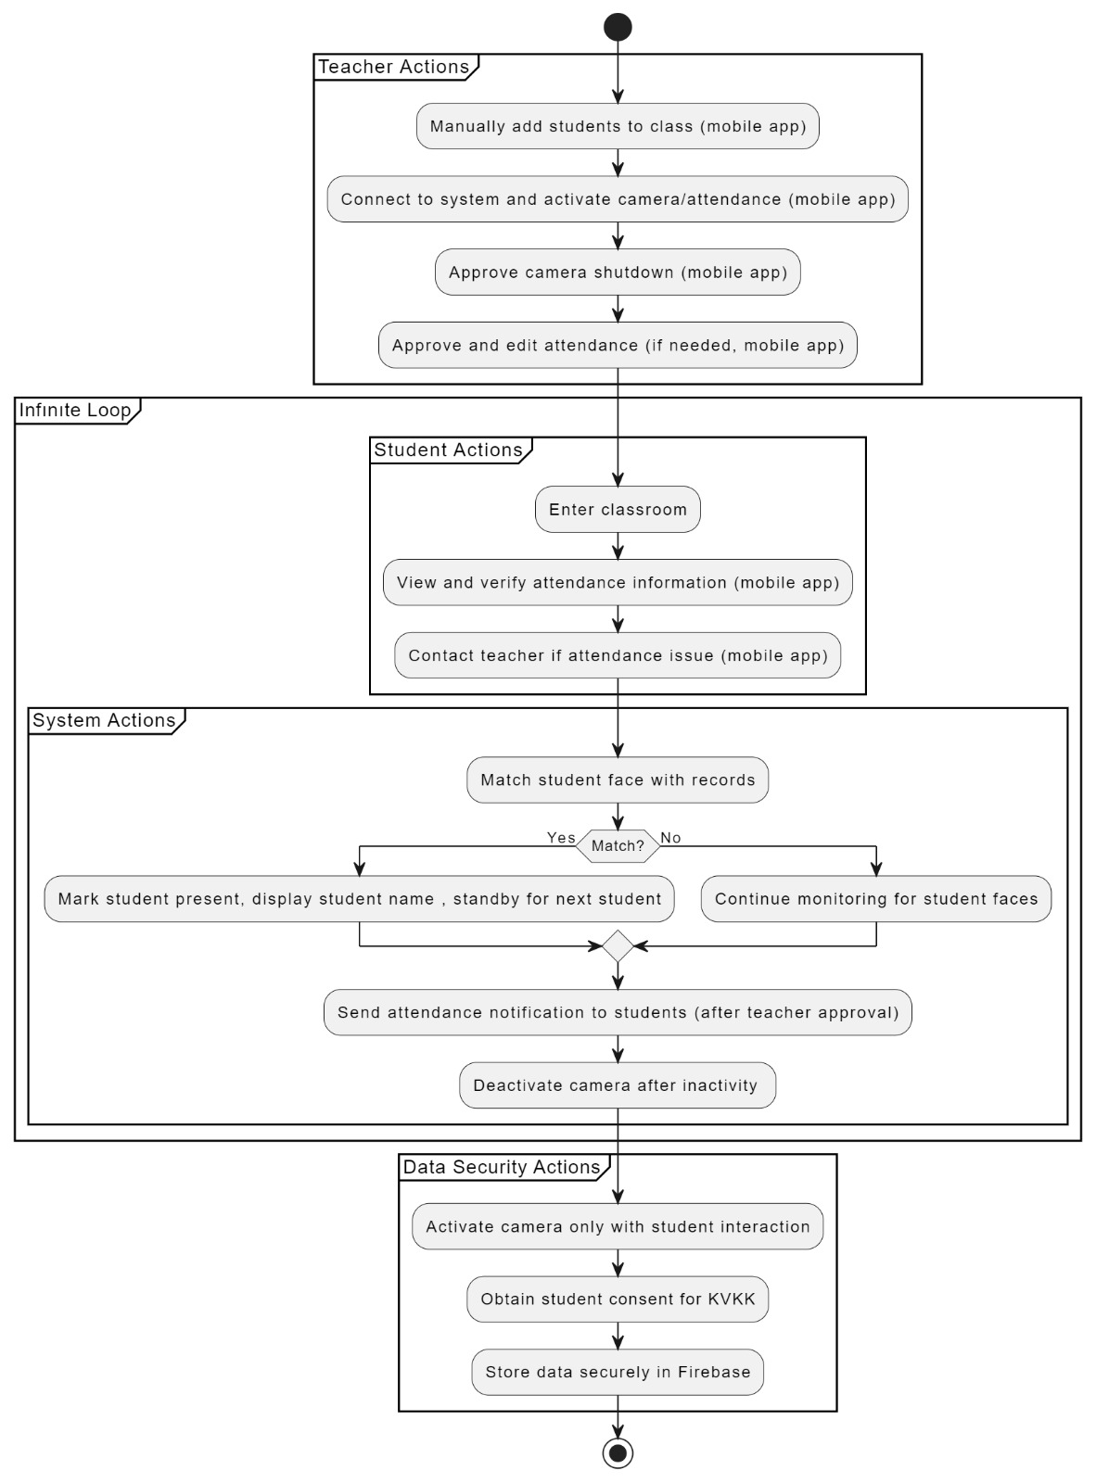

**Figure 8.2:** Flowchart Diagram

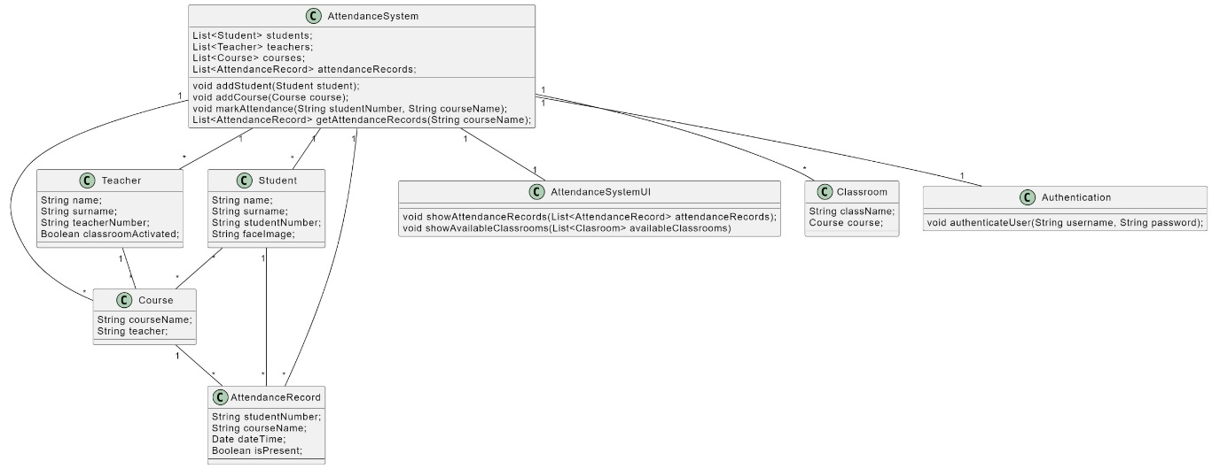**Figure 8.3:** Class Diagram

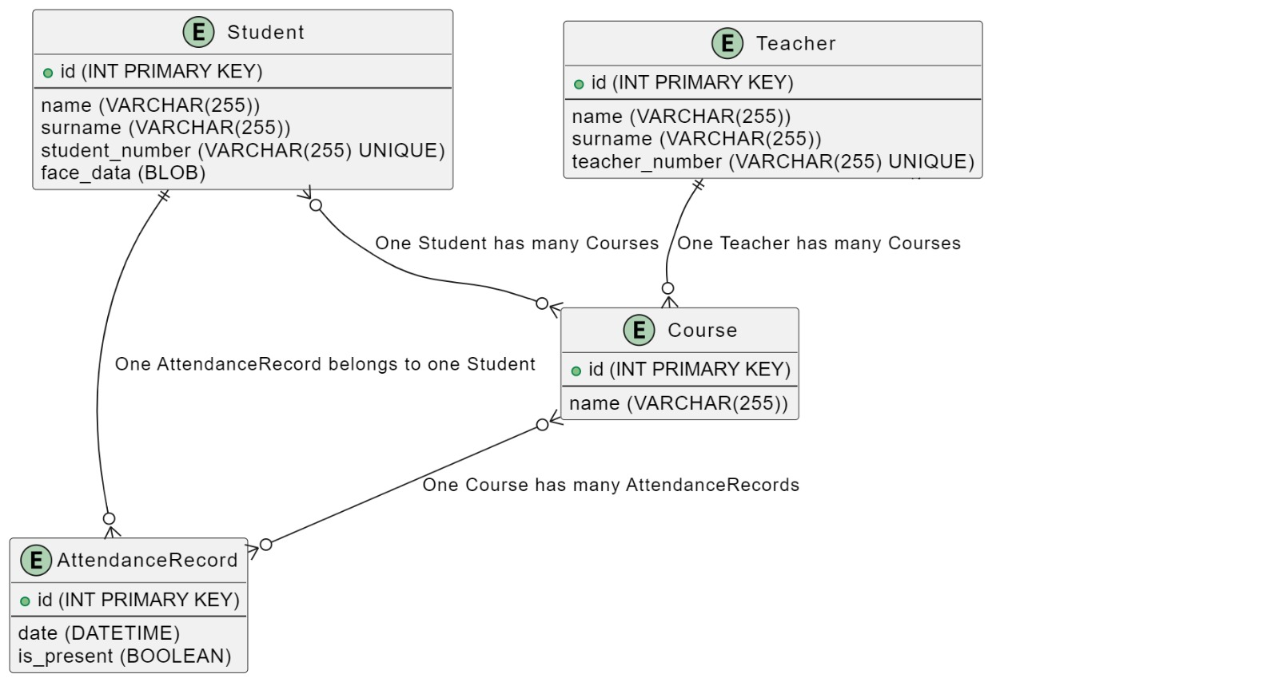

**Figure 8.4:** Database Diagram

# 9. SYSTEM functıonalıtıes and substances

This project consists of four main Python Scripts: ‘EncodeGenerator.py’, ‘addDataToDatabase.py’, ‘main.py’, and ‘EncodeFile.p’. Also it has a backround images and 4 different modes depends on the situation of the system.

**EncodeGenerator.py:** This script is responsible for generating encodings for known faces and storing them in a pickle file. findEncodings(imagesList) function in itself, takes a list of images as input and returns a list of encoding for each face detected in the images using [face-recognition library](https://medium.com/@ageitgey/machine-learning-is-fun-part-4-modern-face-recognition-with-deep-learning-c3cffc121d78).

**metin, ekran görüntüsü, yazı tipi içeren bir resim

Açıklama otomatik olarak oluşturuldu**

**Figure 9.1:** findEncodings() function.

**addDataToDatabase.py:** This class is responsible for adding data to a Firebase Realtime Database using ‘**serviceAccountKey.json**’ file provided by the Google Firebase System. Data is added manually to this script for trying the system. In the code below, we see there are 2 different students names (Elon Musk, Ibrahim Ardic) with different features. ‘last_attendance_time’ is automatically updated whenever a student takes the attendance.

metin, ekran görüntüsü, yazı tipi içeren bir resim

Açıklama otomatik olarak oluşturuldu

**Figure 9.2: ‘**data’ dictionary in addDataToDatabase.py.

**Main.py:** This class is the main application that uses face recognition to mark attendance of the students and displaying information to students. ‘findEncodings(imagesList)’ function is the same as the one in ‘EncodeGenerator.py’ and is used to generate encodings for known faces. ‘markAttendance(encodeFace, faceLoc)’ function marks attendance for a detected face and updates the Firebase Realtime Database accordingly. Modes of the application is also defined in this class. There are 4 different modes in the application. ‘Active’ mode is showing that system is available to take the attendance and students can show their faces to the camera. ‘Student_info’ mode shows the details of the student (name, department, last attendance time, etc.) if face is known and waits for few seconds.’Marked’ mode is says the students their attendance is taken and marked. Lastly, ‘Already_Marked’ is showed on the screen if student tries to take attendance more than once in a limited time period.

metin, ekran görüntüsü, yazı tipi içeren bir resim

Açıklama otomatik olarak oluşturuldu

**Figure 9.3:** Different modes in ‘main.py’ class.

**EncodeFile.p:** It is a pickle file that stores the encodings of known faces and their corresponding student Ids. The ‘EncodeGenerator.py’ class generates this file by processing the images in the ‘Images’ folder and extracting the facial encodings using ‘face_recognition’ library. The resulting encodings are then stored in this file along with the student IDs.

metin, ekran görüntüsü, yazı tipi, tasarım içeren bir resim

Açıklama otomatik olarak oluşturuldu

**Figure 9.4:** ‘Student_info’ mode in ‘main.py’ class.

# references

**[1] Ching Hisang Chang,** “Smart Classroom Roll Caller System with IOT Architecture” *2011 Second International Conference on Innovations in Bio-inspired Computing and Applications* *16-18-2011, Shenzen, China. IEEE 02 January 2012.* https://ieeexplore.ieee.org/abstract/document/6118772

**[2] Mingtao Zhao, Gang Zhao, Meihong Qu,** “College Smart Classroom Attendance Management System Based on Internet of Things”. Volume 2022 | Article ID 4953721 , https://doi.org/10.1155/2022/4953721

**[3] Gökhan Şengül, Murat Karakaya, Atilla Bostan, “**A Smart Classroom Application, Monitoring and Reporting Attendance Automatically Using Smart Devices” *International Journal of Scientific Research in Information Systems and Engineering* Volume 3, issue 1,April – 2017. ISSN 2380-8128

**[4] Harshad Sutar, Suyash Chaudhari, Pritam Bhopi, and Dipashri Sonavale,** “Automated Attendance System,” *Int. Res. J. Mod. Eng. Technol. Sci.,* vol. 04, 2022*.*

**[5]Jenif W. S. D’Souza, S. Jothi, A. Chandrasekar,** “Automated Attendance Marking and Management System by Facial Recognition Using Histogram” *in 2019 5th International Conference on Advanced Computing and Communication Systems*, ICACCS 2019, doi: 10.1109/ICACCS.2019.8728399.

**[6] Aipruk** **Puckdeevongs, N. K. Tripathi, Apichon Witayangkurn, Poompat Saengudomlert, “**Classroom Attendance Systems Based on Bluetooth Low Energy Indoor Positioning Technology for Smart Campus”, *Remote Sensing and Geographic Information* *Systems Field of Study, School of Engineering and Technology, Asian Institute of Technology*

*Telecommunications Field of Study, School of Engineering and Technology, Asian Institute of Technology*  vol.11 No.329 ,2020

**[7]** **Vaishnavi Hava, Seema Kale, Arun Bairagi, Chandan Prasad, Sagar Chatterjee, Anish Varghese,** “Free & Generic Facial Attendance System using Android” *Int. Res. J. Eng. Technol.*, vol. 06, no. 09, p. 6, 2019.

**[8]M. A. J. Hameed,** “Android-based Smart Student Attendance System” *Int. Res. J. Eng. Technol., vol. 12, pp. 2356–2395, 2017. Detection,” in 2016 Online international conference on green engineering and technologies, 2016.*

**[9] Basheer K. P. Mohamed, C.V. Raghu**, “Fingerprint Attendance System for Classroom Needs,” *2012 Annual IEEE India Conference*, INDICON 2012, 2012, doi: 10.1109/INDCON.2012.6420657. https://ieeexplore.ieee.org/abstract/document/6420657

**[10] Chien-wen Shen, Yen-Chun Jim Wu, Tsung-Che Lee,** “Developing a NFC-Equipped Smart Classroom: Effects on Attitudes Toward Computer Science” *Computers in Human Behavior* Volume 30 January 2014, Pages 731-738

**[11]** **P. S. H. Smitha,** “Face Recognition based Attendance Management System” *Int. J. Eng. Res. & Technol*., vol. 9, no. 05, 2020.

**[12] Atanu Shuvam Roy, Hong Lan, Mehdi Gheisari, Aqif AfzaalAbbasi, Ata Jahangir Moshayedi, Liefa liao, Seyed Mojtaba Hosseini Bamakan,** “Automation Attendance Systems Approaches: A Practical Review,” *BOHR Int. J. Internet Things Res.*, vol. 1, no. 1, pp. 7–15, 2022.

**[13]** **Siti Aisah Mohd Noor, Norliza Zaini, Mohd Fuad Abdul Latip,Nabilah Hamzah,** “Android-Based Attendance Management System,” in 2015 *IEEE Conference on Systems, Process and Control (ICSPC*), 2015, pp. 118–122.

**[14]** **Yoganathan N. S., Raviteja S., Sathyanarayanan R., Anup Kumar, Nithish Kumar R. ,**“Location Based Smart Attendance System Using GPS” *Ann. Rom. Soc. Cell Biol*., vol. 25, no. 2, pp. 4510–4516, 2021, [Online]. Available: http://annalsofrscb.ro

**[15] Mubarak Salem Mubarak Alburaiki, Gapar Md Johar, Rabap Alayam Abbas Helmi, Mohammed Hazim Alkawaz,** “Mobile Based Attendance System: Face Recognition and Location Detection using Machine Learning” *in 2021 IEEE 12th Control and System Graduate Research Colloquium,* , 07 July 2021, doi: 10.1109/ICSGRC53186.2021.9515221.

**[16] E. Varadharajan, R. Dharani, S. Jeevitha, B. Kavinmathi, and S. Hemalatha,** “Automatic Attendance Management System using Face Detection” *in 2016 Online international conference on green engineering and technologies*, 2016.