PRODUCT INVENTORY
MANAGEMENT SYSTEM

Table of Contents
No. | Section | Page
1 | Introduction | 5
2 | Project Objectives and Scope | 6
3 | Technology Stack | 7
4 | System Architecture | 8
5 | Database Design | 9
6 | SQL Schema | 10
7 | Backend Design | 11
8 | Frontend Design | 12
9 | Dashboard Module | 13
10 | Product Module | 14
11 | Product Detail and Image Module | 15
12 | Sell Workflow and Quick Sell | 16
13 | Sales History and Reporting | 17
14 | Testing and Validation | 18
15 | Setup and User Guide | 19
16 | Conclusion and Future Enhancements | 20

List of Figures
- Figure 1: Inventory dashboard with KPI cards and latest products.
- Figure 2: Quick Sell grid on the dashboard.
- Figure 3: Products list with filtering and action buttons.
- Figure 4: Product detail page with image, stock badge, and description.

1. Introduction
Inventory management is an important requirement for shops, laboratories, stores, and small businesses. A manual inventory process can create mistakes such as duplicate product codes, wrong stock quantity, missing low-stock alerts, and unclear sales history. This project solves those issues using a simple but complete web application built with Jakarta EE and MySQL.
The system allows users to create product categories, add products with image URLs, update inventory information, delete records, view product details, sell products, and track sales. The dashboard shows key inventory indicators such as total products, total categories, total stock, low-stock items, and total inventory value.

1.1 Problem Statement
Small inventory systems often lack a clean workflow for product management and stock reduction after sales. Without automation, the user must manually update stock after every sale, which increases the risk of overselling. The project implements a controlled selling workflow where the stock quantity is reduced only when enough stock is available.

1.2 Project Motivation
The motivation of the project is to demonstrate a practical enterprise Java application that is simple enough for academic learning but complete enough to show real business value. It focuses on raw JDBC and servlet-based MVC so that the data flow is visible and easy to understand.
- Reduce manual inventory errors through database-driven stock tracking.
- Provide a clean product list, product detail page, and sell interface.
- Display all currency values in Indian Rupees for local usage.
- Maintain sales records for revenue and history analysis.

2. Project Objectives and Scope
The main objective of this project is to build and enhance a Jakarta EE inventory management web application with product images, product detail page, sell workflow, sales history, dashboard quick-sell grid, Indian Rupee currency display, and complete project documentation.

2.1 Functional Objectives
- Create, update, delete, view, search, and filter products.
- Create, update, delete, and list categories.
- Attach an image URL to every product and display thumbnails in lists.
- Show a product detail page with a larger image, description, category, price, and stock badge.
- Process sales using a confirmation dialog before stock is reduced.
- Protect against overselling by checking stock quantity at SQL update level.
- Record each sale with product id, name, code, quantity, unit price, total price, and timestamp.
- Show dashboard cards and a quick-sell grid for fast stock movement.

2.2 Scope of the System
The project scope focuses on inventory operations for a single-user or small-team environment. It does not include authentication, multi-branch inventory, barcode scanning, supplier management, or payment integration. However, the current architecture allows these features to be added later.
In Scope | Out of Scope
Products, categories, stock, sales, dashboard | Authentication and role-based access
JSP pages, servlets, raw JDBC DAOs | Online payment gateway
MySQL relational database | Multi-warehouse logistics
CSV export and sales history | Advanced ERP integration

3. Technology Stack
The project uses a traditional enterprise Java web stack. The stack is suitable for learning servlet and JSP fundamentals while still supporting a complete database-backed application.
Layer | Technology | Purpose
Programming Language | Java 17 | Core server-side programming language.
Web Platform | Jakarta EE | Servlets, request handling, and web application structure.
View Layer | JSP and JSTL | Dynamic web pages, forms, lists, and formatting.
Database | MySQL 8 | Relational storage for categories, products, and sales.
Data Access | Raw JDBC | Prepared statements, result mapping, and SQL execution.
Server | Apache Tomcat 11 | Deployment runtime for Jakarta Servlet web app.
IDE | Eclipse WTP | Development and deployment workflow.
UI Framework | Bootstrap and Bootstrap Icons | Responsive layout, buttons, badges, tables, and cards.

3.1 Development Constraints
- No ORM framework is used; all database operations are implemented using raw JDBC inside DAO classes.
- Flash messages use session-scoped attributes to survive redirect-based actions.
- Product code is unique, so clone operations append a suffix to avoid duplicate product_code values.
- All price and revenue displays use Indian Rupees instead of dollars.
- Sell operations must ask confirmation before processing.
- When redirect=dashboard is present, the sell action returns the user to the dashboard.

4. System Architecture
The application follows the Model-View-Controller pattern. The model classes represent database entities, DAO classes execute SQL queries, servlets act as controllers, and JSP pages render the interface. This structure keeps responsibilities separated and makes the code easier to maintain.

4.1 MVC Flow
Step | Component | Responsibility
1 | User / Browser | Sends request such as view products, add product, sell product, or open dashboard.
2 | Servlet Controller | Reads request parameters, validates action, and calls the correct DAO method.
3 | DAO Layer | Executes prepared SQL statements and maps database rows into model objects.
4 | MySQL Database | Stores categories, products, stock quantities, and sales records.
5 | JSP View | Displays tables, cards, forms, badges, images, flash messages, and links.

4.2 Request Routing Overview
Browser Request
-> ProductServlet / CategoryServlet / DashboardServlet
-> DAO Method: insert, update, delete, getById, searchProducts, sellProduct
-> MySQL Query Execution
-> Request/Session Attributes
-> JSP Page Rendering
-> HTML Response

4.3 Package Organization
Package / Folder | Description
com.inventory.model | Contains Product, Category, and Sale model classes.
com.inventory.dao | Contains ProductDAO, CategoryDAO, and SaleDAO.
com.inventory.servlet | Contains controller servlets for dashboard, product, category, and sales flows.
webapp / JSP pages | Contains dashboard.jsp, product-list.jsp, product-form.jsp, product-detail.jsp, product-sell.jsp, sales-history.jsp.

5. Database Design
The database is named inventory_db and contains three main tables: categories, products, and sales. The design is normalized so that product category names are stored in the categories table, while products reference categories using category_id. Sales records store product snapshot details so that old sales remain meaningful even if a product name or price changes later.

5.1 Entity Description
Entity | Main Fields | Description
Category | id, name, description | Stores product grouping information such as samsung, Tecno, and Itel.
Product | id, product_code, name, description, price, stock_quantity, minimum_stock_level, category_id, image_url | Stores complete product inventory records.
Sale | id, product_id, product_name, product_code, quantity, unit_price, total_price, sold_at | Stores every sell operation and timestamp.

5.2 Relationship Design
- One category can have many products.
- Each product belongs to one category.
- One product can appear in many sale records.
- Sales keep product_name and product_code as a snapshot to preserve historical reporting.
categories (1) ------------------ (many) products
products (1) ------------------ (many) sales
categories.id -> products.category_id
products.id -> sales.product_id

6. SQL Schema
The following schema represents the current database structure used by the project. It includes drop statements ordered by foreign-key dependencies, table creation, constraints, and seed data for demonstration.
CREATE DATABASE IF NOT EXISTS inventory_db;
USE inventory_db;
DROP TABLE IF EXISTS sales;
DROP TABLE IF EXISTS products;
DROP TABLE IF EXISTS categories;
CREATE TABLE categories (
id INT AUTO_INCREMENT PRIMARY KEY,
name VARCHAR(100) NOT NULL UNIQUE,
description TEXT
);
CREATE TABLE products (
id INT AUTO_INCREMENT PRIMARY KEY,
product_code VARCHAR(50) NOT NULL UNIQUE,
name VARCHAR(150) NOT NULL,
description TEXT,
price DECIMAL(10,2) NOT NULL,
stock_quantity INT NOT NULL DEFAULT 0,
minimum_stock_level INT NOT NULL DEFAULT 5,
category_id INT NOT NULL,
image_url VARCHAR(500),
CONSTRAINT fk_products_category
FOREIGN KEY (category_id) REFERENCES categories(id)
ON DELETE RESTRICT ON UPDATE CASCADE
);
CREATE TABLE sales (
id INT AUTO_INCREMENT PRIMARY KEY,
product_id INT NOT NULL,
product_name VARCHAR(150) NOT NULL,
product_code VARCHAR(50) NOT NULL,
quantity INT NOT NULL,
unit_price DECIMAL(10,2) NOT NULL,
total_price DECIMAL(10,2) NOT NULL,
sold_at TIMESTAMP DEFAULT CURRENT_TIMESTAMP,
CONSTRAINT fk_sales_product
FOREIGN KEY (product_id) REFERENCES products(id)
ON DELETE RESTRICT ON UPDATE CASCADE
);

6.1 Important SQL Safety Rule
UPDATE products
SET stock_quantity = stock_quantity - ?
WHERE id = ? AND stock_quantity >= ?;
This update protects the database against overselling because stock is reduced only when available quantity is greater than or equal to the requested sale quantity.

7. Backend Design
The backend is divided into model classes, DAO classes, and servlet controllers. This makes the code clear and testable. Model classes only store data, DAO classes contain SQL logic, and servlets manage web requests.

7.1 Model Classes
Model | Important Fields | Key Method / Purpose
Category | id, name, description | Represents the category table.
Product | id, productCode, name, description, price, stockQuantity, minimumStockLevel, categoryId, categoryName, imageUrl | getStockStatus() returns OUT OF STOCK, LOW STOCK, or IN STOCK.
Sale | id, productId, productName, productCode, quantity, unitPrice, totalPrice, soldAt | Represents one completed sell transaction.

7.2 DAO Methods
DAO | Main Methods
ProductDAO | insert, update, delete, getById, getAll, searchProducts, getLatest, getLatestFive, sellProduct, mapProduct
CategoryDAO | insert, update, delete, getById, getAll
SaleDAO | recordSale, getAllSales ordered by sold_at DESC

7.3 Controller Servlets
ProductServlet controls product actions such as list, new, insert, edit, update, delete, clone, view, sell, and sell submission. DashboardServlet prepares KPI statistics and quick-sell products for dashboard.jsp. CategoryServlet manages category actions, while SalesServlet displays sales history and reporting summaries.

8. Frontend and UI Design
The frontend is built using JSP pages with Bootstrap styling. The UI uses a simple navigation bar, responsive containers, table layouts, cards, badges, buttons, and image thumbnails. The interface is designed to be understandable for both technical evaluators and normal users.

8.1 JSP Pages
JSP Page | Purpose
dashboard.jsp | Displays KPI cards, total inventory value, latest products, and quick-sell grid.
product-list.jsp | Displays searchable products table with image, code, category, price, stock, status, and actions.
product-form.jsp | Used for adding and editing products, including image URL input.
product-detail.jsp | Displays product image, details, description, stock badge, and action buttons.
product-sell.jsp | Displays searchable sell table and quantity input with confirmation.
sales-history.jsp | Displays sales records and summary cards.

8.2 UI Design Decisions
- Bootstrap cards are used for dashboard statistics and quick-sell products.
- Bootstrap badges show stock status using color-coded labels.
- Product image thumbnails use a compact 50x50 px display in product tables.
- Product names are clickable and open the product detail page.
- Confirmation dialogs use native confirm() to keep the workflow simple.
- Navigation links are available on all JSP pages for a consistent user experience.

9. Dashboard Module
The dashboard is the landing page of the application. It gives a quick overview of inventory health and recent products. It displays total products, total categories, total stock, low-stock items, total inventory value, and quick navigation buttons.
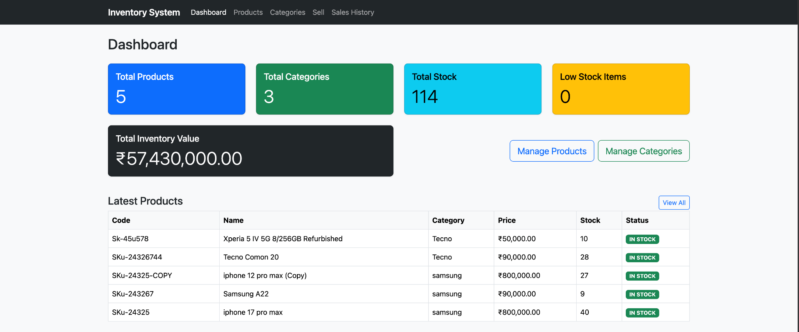
Figure 1: Dashboard KPI cards and latest products.

9.1 Dashboard Metrics
Metric | Description
Total Products | Number of products available in the products table.
Total Categories | Number of product categories stored in the system.
Total Stock | Sum of stock_quantity across all products.
Low Stock Items | Count of products where stock_quantity is less than or equal to minimum_stock_level.
Total Inventory Value | Sum of product price multiplied by stock quantity, displayed in Indian Rupees.

10. Product Module
The product module is the main operational module of the system. It allows users to list, search, filter, add, edit, view, clone, and delete products. The product table includes image preview, product code, product name, category, price, stock, minimum stock, status, and action buttons.
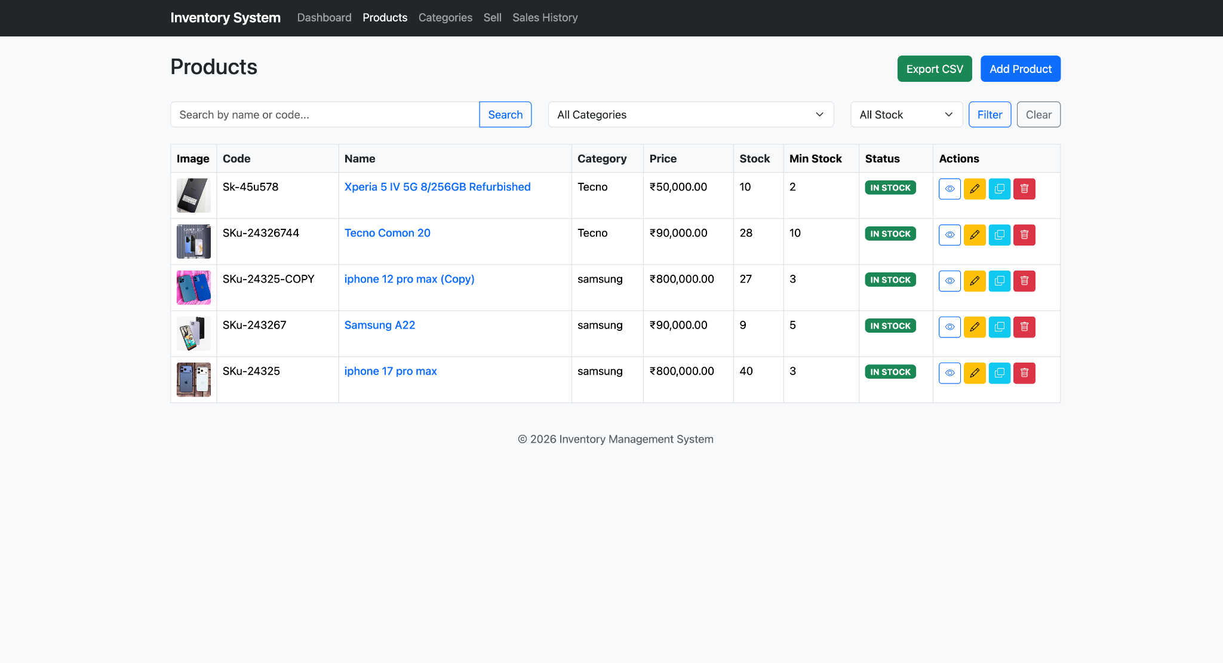
Figure 2: Product list with image thumbnails, filters, and action buttons.

10.1 Product Code Constraint
The product_code column has a UNIQUE constraint. This prevents duplicate product identification. During cloning, the project appends a suffix such as -COPY plus the current time to create a new unique product code.

10.2 Search and Filter
The system uses a single parameterized searchProducts(keyword, categoryId, lowStock, sortBy, sortOrder) method instead of many separate search methods. This design makes filtering easier to maintain and reduces duplicate DAO code.

11. Product Detail and Image Module
The product detail page gives a complete view of a selected product. It displays the product image on the left side and product information on the right side. The design includes a breadcrumb, stock badge, category badge, price in INR, stock quantity, minimum stock level, category id, and a scrollable description box.
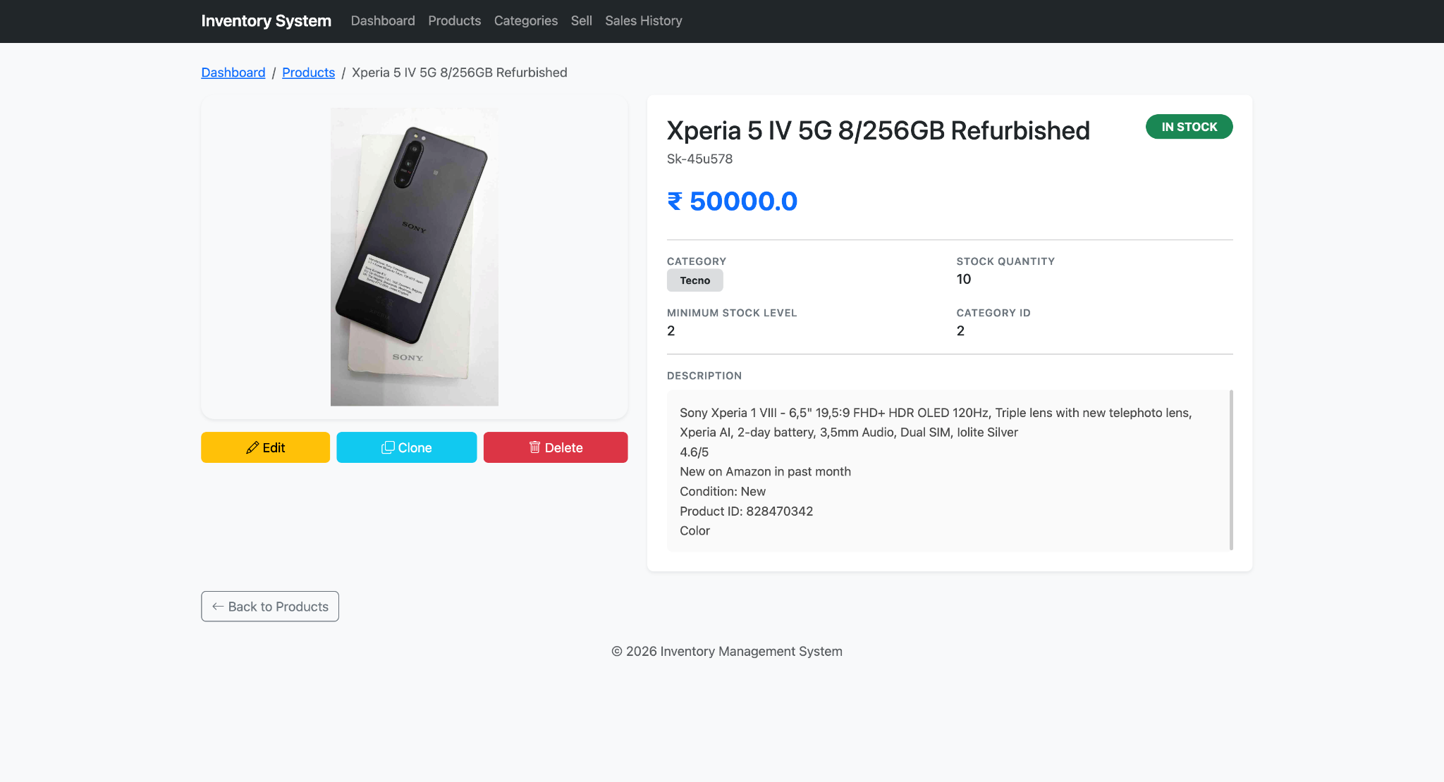
Figure 3: Product detail page with image, stock status, and action buttons.

11.1 Image Support
The product table was enhanced with an image_url VARCHAR(500) column. The Product model includes an imageUrl field with getter and setter. ProductDAO insert, update, and mapProduct methods include image_url so the image can be saved and displayed on multiple pages.

11.2 Description Handling
The database description column was changed from VARCHAR(500) to TEXT. On the detail page, the description is shown inside a scrollable box with a maximum height to keep the card compact even when the product description is long.

12. Sell Workflow and Quick Sell
The sell workflow reduces product stock and records a sale. The workflow is designed to be safe and user-friendly. A confirmation dialog appears before processing so the user can verify product name, quantity, and total amount in Indian Rupees.
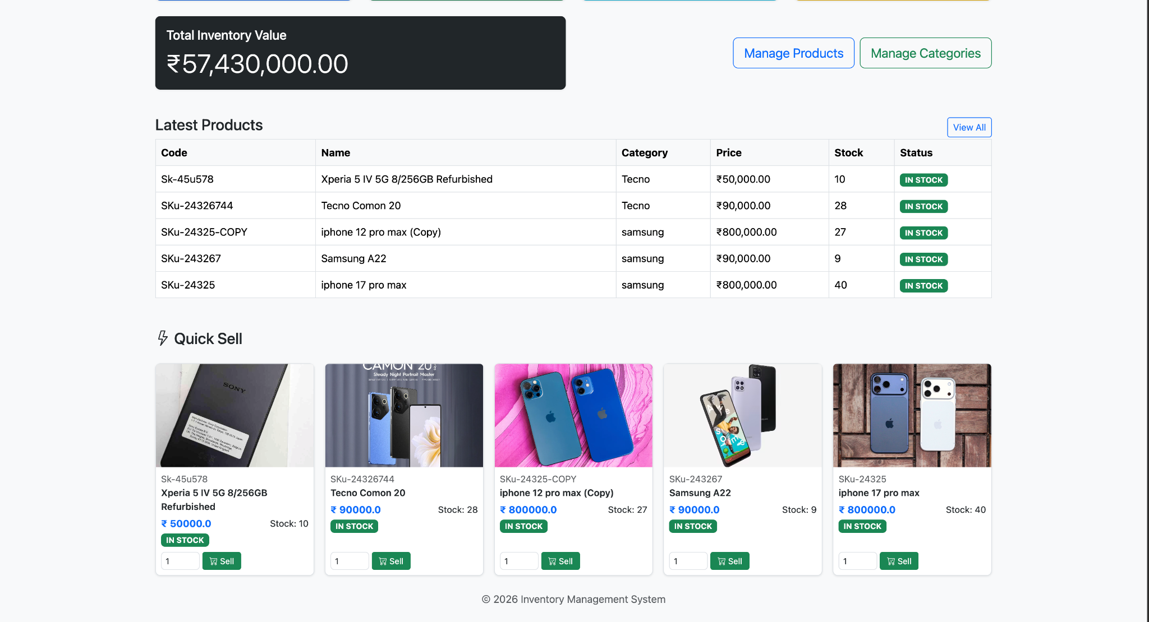
Figure 4: Dashboard quick-sell grid with product cards and quantity input.

12.1 Sell Flow
Step | Action
1 | User opens Sell page or sells directly from dashboard quick-sell grid.
2 | User enters quantity for the selected product.
3 | Browser shows confirmation dialog with product name, quantity, and total price.
4 | ProductServlet receives action=sell request.
5 | ProductDAO.sellProduct(id, quantity) updates stock with stock safety condition.
6 | SaleDAO.recordSale(sale) stores the sale history record.
7 | Servlet redirects back to sell page or dashboard depending on redirect=dashboard parameter.

12.2 Overselling Protection
The SQL update includes WHERE stock_quantity >= ? so that the application cannot sell more units than are available, even if two users try to process stock at the same time.

13. Sales History and Reporting
The sales history module records completed sale transactions and displays them in descending order by sold_at. The page includes summary cards for total sales count and total revenue in Indian Rupees, followed by a table of all sales.

13.1 Sales Table Fields
Column | Purpose
id | Unique identifier for the sale.
product_id | Reference to the product sold.
product_name | Product name snapshot stored at time of sale.
product_code | Product code snapshot stored at time of sale.
quantity | Number of units sold.
unit_price | Price per unit at time of sale.
total_price | unit_price multiplied by quantity.
sold_at | Timestamp when the sale was recorded.

13.2 Reporting Benefits
- Helps track what products were sold and when they were sold.
- Provides total revenue calculation for the inventory owner.
- Makes stock movement transparent and auditable.
- Supports future expansion to daily, weekly, monthly, and category-based reports.

13.3 Currency Formatting
The project changed all hardcoded dollar symbols to Indian Rupees. JSP pages use currencySymbol="Rs." or INR-related display, and DashboardServlet uses the Indian locale for currency instance formatting.

14. Testing and Validation
Testing was performed module by module to ensure that the application behaves correctly. The main focus was on database operations, product code uniqueness, stock validation, image display, navigation, and sales recording.

14.1 Test Cases
Test Case | Input / Action | Expected Result | Status
Add Category | Submit category form with name and description. | Category is inserted and appears in category list. | Pass
Add Product | Submit product form with code, name, price, stock, category, and image URL. | Product is inserted and appears in products page. | Pass
Duplicate Product Code | Try to add same product_code twice. | Database prevents duplicate record. | Pass
Product Detail | Click product name or view icon. | Detail page opens with image and full details. | Pass
Low Stock Status | Set stock <= minimum stock level. | Status changes to LOW STOCK. | Pass
Out of Stock Status | Set stock to 0. | Status changes to OUT OF STOCK. | Pass
Sell Product | Sell valid quantity. | Stock reduces and sale is recorded. | Pass
Oversell Product | Sell quantity greater than available stock. | Sale is rejected by SQL safety check. | Pass
Dashboard Redirect | Sell using redirect=dashboard. | User returns to dashboard after sale. | Pass

14.2 Validation Rules
- Product code must be unique and not empty.
- Product name is required.
- Price must be a positive number.
- Stock quantity cannot be negative.
- Minimum stock level should be zero or positive.
- Category id must reference an existing category.
- Sell quantity must be greater than zero and less than or equal to available stock.

15. Setup and User Guide
This section describes how to run the project locally using MySQL 8 and Apache Tomcat 11. The application can be deployed from Eclipse WTP or manually by exporting a WAR file and placing it in the Tomcat webapps directory.

15.1 Database Connection
JDBC URL : jdbc:mysql://localhost:3306/inventory_db
User : root
Password : rootroot
Driver : com.mysql.cj.jdbc.Driver

15.2 Setup Steps
- Install Java 17 and configure JAVA_HOME.
- Install Apache Tomcat 11 and configure it in Eclipse WTP.
- Install MySQL 8 and start the MySQL server.
- Create the inventory_db database and run database.sql.
- Import the Jakarta EE project into Eclipse.
- Add MySQL Connector/J to the project build path or Maven dependencies.
- Deploy the project to Tomcat 11 and start the server.
- Open the application in the browser and test dashboard, products, categories, sell, and sales history pages.

15.3 Basic User Workflow
Action | User Step
Manage Categories | Open Categories, add category names such as samsung, Tecno, and Itel.
Add Product | Open Products, click Add Product, enter product details and image URL.
View Product | Click product name or eye icon to open the detail page.
Sell Product | Open Sell page or dashboard quick-sell grid, enter quantity, confirm sale.
Check Sales | Open Sales History to view revenue and transaction records.

16. Conclusion and Future Enhancements
The Product Inventory Management System successfully demonstrates a complete Jakarta EE web application with MySQL database integration, raw JDBC data access, servlet-based MVC routing, JSP views, image-enabled product records, stock status logic, safe selling workflow, sales history, and dashboard analytics.
The project is useful as both an academic mini project and a practical learning application. It shows how enterprise Java concepts can be combined into a clean working system without using heavy frameworks or ORM tools. The use of prepared statements, normalized tables, MVC separation, session flash messages, and database-level stock validation makes the system reliable and easy to extend.

16.1 Future Enhancements
- Add login and role-based access for admin, manager, and cashier users.
- Add barcode or QR code support for faster product search and selling.
- Add supplier and purchase management for complete inventory lifecycle.
- Add PDF invoice generation after each sale.
- Add sales analytics with charts for daily, weekly, and monthly reports.
- Add image upload instead of image URL only.
- Add REST API endpoints for integration with mobile or frontend frameworks.
- Add backup and restore options for the MySQL database.

16.2 Bibliography / References
- Jakarta EE Servlet and JSP documentation.
- MySQL 8 documentation for relational schema design and constraints.
- Apache Tomcat documentation for web application deployment.
- Bootstrap documentation for responsive cards, buttons, badges, and tables.
- Java JDBC documentation for PreparedStatement and ResultSet usage.

