Directives:

* The exam is on 30 points and has 15 questions
* The weighting for the session is 30%.
* Submit your evaluation in the dovecote "Exam 1 DB AV"
* The duration of the exam is 180 minutes.
* For each question you have to put a screenshot of the command and its result in the word file.

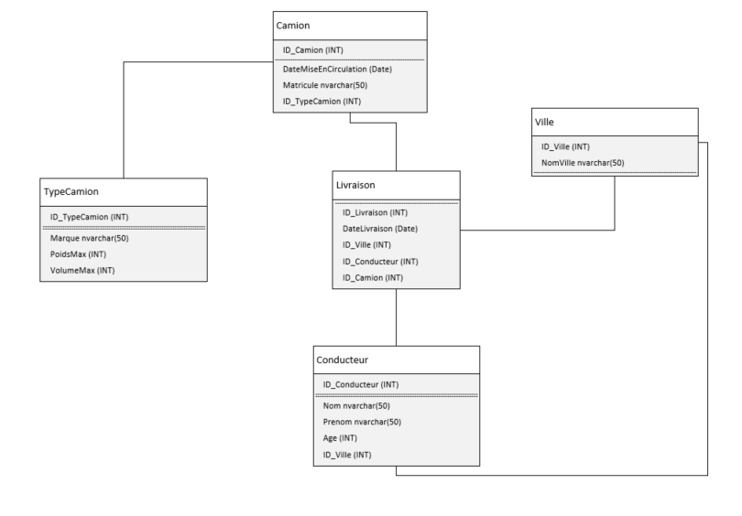

1. Create the database script from the schema, **(3 points)**
2. Create the data insertion script based on the tables below **(3 points)**

|  |  |  |  |
| --- | --- | --- | --- |
| Truck | | | |
| ID_Camion | DateMiseEnCirculation | ID_TypeCamion | Register |
| 1 | 2020-01-01 | 1 | CK09 |
| 2 | 2021-01-02 | 1 | CK20 |
| 3 | 2020-11-03 | 2 | CK60 |
| 4 | 2020-07-04 | 3 | CK25 |
| 5 | 2021-09-05 | 4 | CK13 |

|  |  |  |  |
| --- | --- | --- | --- |
| TypeCamion | | | |
| ID_TypeCamion (INT) | Brand nvarchar(50) | Max Weight (INT) | VolumeMax (INT) |
| 1 | Mercedes | 26 000 | 80 |
| 2 | Scania | 25 000 | 90 |
| 3 | Volvo | 21 000 | 100 |
| 4 | DAF | 25 000 | 80 |
| 5 | Man | 28 000 | 90 |

|  |  |  |  |  |
| --- | --- | --- | --- | --- |
| Driver | | | | |
| ID_Conducteur (INT) | Name nvarchar(50) | Prenom nvarchar(50) | Age (INT) | ID_Ville (INT) |
| 1 | Alexi | Borno | 45 | 1 |
| 2 | Fred | Mexi | 50 | 2 |
| 3 | Ali | Darki | 35 | 4 |
| 4 | Sofia | Bernard | 30 | 5 |
| 5 | Slim | Weld haj | 40 | 5 |

|  |  |  |  |  |
| --- | --- | --- | --- | --- |
| Delivery | | | | |
| ID_Livraison (INT) | DateDelivery (Date) | ID_Ville (INT) | ID_Conducteur (INT) | ID_Camion (INT) |
| 1 | 2022-02-10 | 1 | 1 | 1 |
| 2 | 2022-02-11 | 2 | 3 | 2 |
| 3 | 2022-02-12 | 3 | 4 | 3 |
| 4 | 2022-02-13 | 4 | 5 | 3 |
| 5 | 2021-02-14 | 4 | 1 | 5 |
| 6 | 2021-03-14 | 5 | 2 | 1 |
| 7 | 2021-05-14 | 5 | 1 | 2 |
| 8 | 2021-09-14 | 2 | 5 | 4 |
| 9 | 2021-11-14 | 2 | 2 | 5 |
| 10 | 2021-12-14 | 1 | 3 | 2 |

|  |  |
| --- | --- |
| Town | |
| ID_Ville (INT) | CityName nvarchar(50) |
| 1 | Ottawa |
| 2 | Toronto |
| 3 | Montreal |
| 4 | Quebec |
| 5 | Vancouver |
|  |  |

3- Formulate in SQL the following queries:

1. List Trucks with a start date greater than 2021 **(1 points)**
2. List deliveries with id-truck equal to 5 **(1 points)**
3. List drivers who live in the city of Vancouver **(1 points)**
4. List drivers who have made deliveries **(2 points)**
5. List deliveries with the name of the driver, date of entry into service and brand of the truck **(2 points)**
6. List the number of deliveries made by city **(2 points)**
7. List the number of deliveries made by truck brand **(2 points)**
8. List the number of deliveries made per driver **(2 points)**
9. List the trucks with the number that ends with 0 **(2 points)**
10. List trucks with max brand and weight greater than 25000 **(2 points)**
11. List deliveries from the city "Québec" **(2 points)**
12. List the deliveries of the driver "Slim" **(2 points)**
13. List the surname, first name and age of the drivers who made deliveries with the "Mercedes" truck  **(3 points)**