**Monday, March 14, 2022**

**Directives:**

**For each question you must put a screenshot of the command and its result in the Word file of the evaluation.**

==================================================================================================

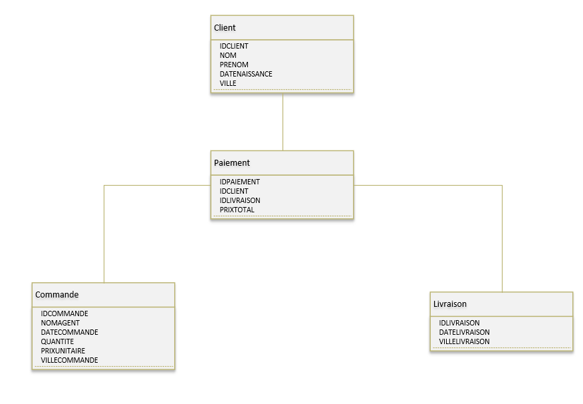

**\**

**attached** script  **in the dovecote to create the tables and load the data**

Formulate the following queries in SQL:

1. List customers (Last name, first name, date of birth and city) of the City of Ottawa **(3 points)**

Customers = Client

Last name = PRENOM

first name = NOM

date of birth = DATENAISSANCE

city = VILLE

1. List customers (Last name, first name, date of birth, age and city) with the age over 30 years **(3 points)**

Customers= Client

Last name = PRENOM

first name = NOM

date of birth = DATENAISSANCE

age= âge

city = VILLE

1. List the CUSTOMER ID, ORDER ID AND DELIVERY ID such that the customer, the order and the delivery are in the same city (without the customer necessarily having an order) (**4 points)**

CUSTOMER ID = IDCLIENT

ORDER ID= IDCOMMANDE

DELIVERY ID= IDLIVRAISON

City= VILLE

Customer= client

1. List the CUSTOMER ID, ORDER ID AND DELIVERY ID such that the customer, order and delivery are in the same city and they have made at least one payment (**4 points)**

CUSTOMER ID = IDCLIENT

Customer= Client

Order = Commande

ORDER ID= IDCOMMANDE

DELIVERY ID= IDLIVRAISON

Delivery= Livraison

City= VILLE

Payment= Paiement

1. Calculate the number of orders per year of order date **(3 points)**

Orders= commandes

order date = DATECOMMANDE

1. Calculate order turnover per agent (**3 points)**

Order= commandes

1. List payments (PAYMENT ID, NAME, FIRST NAME, DELIVERY DATE, ORDER CITY AND AGENT NAME) of orders for the month of March 2022 **(3 points)**

Payments= paiements

PAYMENT ID= ID PAIEMENT

NAME= NOM

Last Name = PRENOM

DELIVERY DATE = DATE LIVRAISON

ORDER CITY= VILLE COMMANDE

AGENT NAME= NOM AGENT

1. Increase the quantity +2 of agent Sophie's orders

Quantity = quantité

Orders= commandes

1. Update the column total price (Quantity * Unit Price) of payments **(3 points)**

Quantity= Quantité

Unit Price = Prix Unitaire

total price= prix total

1. Calculate customer turnover by city (propose two solutions) **(6 points)**

Customer = Client

City = Ville