

MARMARA UNIVERSITY
FACULTY OF ENGINEERING
COMPUTER ENGINEERING DEPARTMENT

3033 – OPERATING SYSTEMS
3. PROJECT REPORT

150114075 - İbrahim Aycan
150117829 - Serra Nur Sarı

Introduction:
In this project our aim is using multithreads to generate a nxn square matrix. To do this we used mutexes, multithreads, queues and random number generator. We used four kinds of threads which are generate, mod, add and log. Generate thread creates 5x5 matrix and fills this matrix with random numbers. After created the matrix , puts it in the queue1. Then mod matrix reads the queue and gets the mod of each element according to the element of [0,0] of that matrix and creates new matrix. Then puts that matrix to queue2. Add thread reads queue2 and gets element of matrix and adds each element of that matrix. This summation is the local sum. After that, add matrix adds local sum to global sum. Log matrix is also reads queue1 and generate a new square matrix nxn. It writes the elements that created by generate matrix to this big matrix. After that we write the output to the text file. To do so all threads are working together in parallel. In other words when generate matrix created first 5x5 matrix it puts them into queue and mod matrix takes the generated matrix and makes it’s operations and puts it into another queue. Then add thread takes from that queue and makes its operations in parallel.
Explanation of the source code :
First we defined 4 thread array which are which are :
pthread_t generate_thread_id[gen_thread_size];
pthread_t mod_thread_id[mod_thread_size];
pthread_t add_thread_id[add_thread_size];
pthread_t log_thread_id[log_thread_size];
Thread size will be taken as an argument of the program. If big matrix includes elements more than thread number then threads will be used more than once.
Using mutex part:
We used mutexes when we changing the global values.
-Generate_thread_mutex:
First we give an id to the generated matrix. We have a global counter to give matrix an id. ID’s starts from zero to number of matrix that will generated .
-Inserting_queue_mutex:
While we inserting to queue, we used mutex. Because only one thread can enqueue at the same time.

-Mode_thread_mutex:
First we give an id to the mod matrix. We have a global counter to give matrix an id. ID’s starts from zero to number of matrix that will generated .
-Inserting_queue2_mutex:
When we inserted to queue2, we used mutex. Because only one thread can enqueue at the same time.
-Mode_readqueue_mutex:
Only one mod_thread should read queue1.To synchronize that, we used mutex.
-log_readqueue_mutex:
Only one log_thread should read queue1.To synchronize this, we used mutex.
add_readqueue2_mutex:
Only one add_thread should read queue1.To synchronize this, we used mutex.
print_mutex:
We locked all print operations using one mutex. Only one mutex can print at the same time.

:
Testing Of The Code:When we run the program threads are working parallel. You can see that in our output.
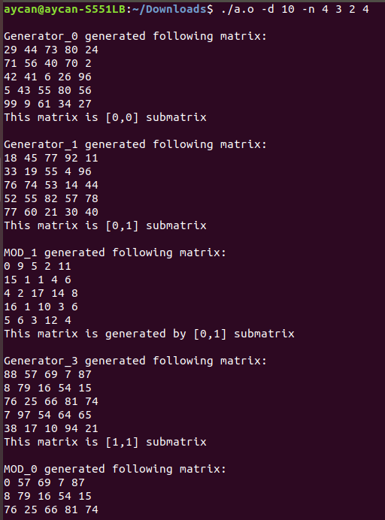

As you can after [0,0] submatrix and [0,1] submatrix generated, mod thread gets mode of [0,1] matrix then [1,1] matrix has generated.

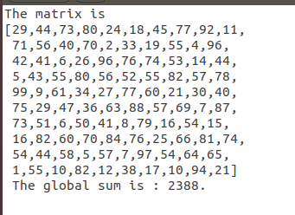
You can see that after all these operations, [15,15] matrix has generated and write into text file with its global sum.

