Assignment 2
Assignment Syntax Validation of a programming language by writing the Context Free Grammar. (PLY Tools)

Batch No. | 2025 | Date:11/11/2025
Name 1: Ibrahim khaleel | SRN 1: PES2UG25CS809
Name 2:Dheeraj | SRN 2: PES2UG25CS806
Programming Language:

List of constructs:

Programming Language:
C++

List of constructs:
- Do-While Loop
- Nested If-Else
- For Loop
- Switch-Case
- Function Definition

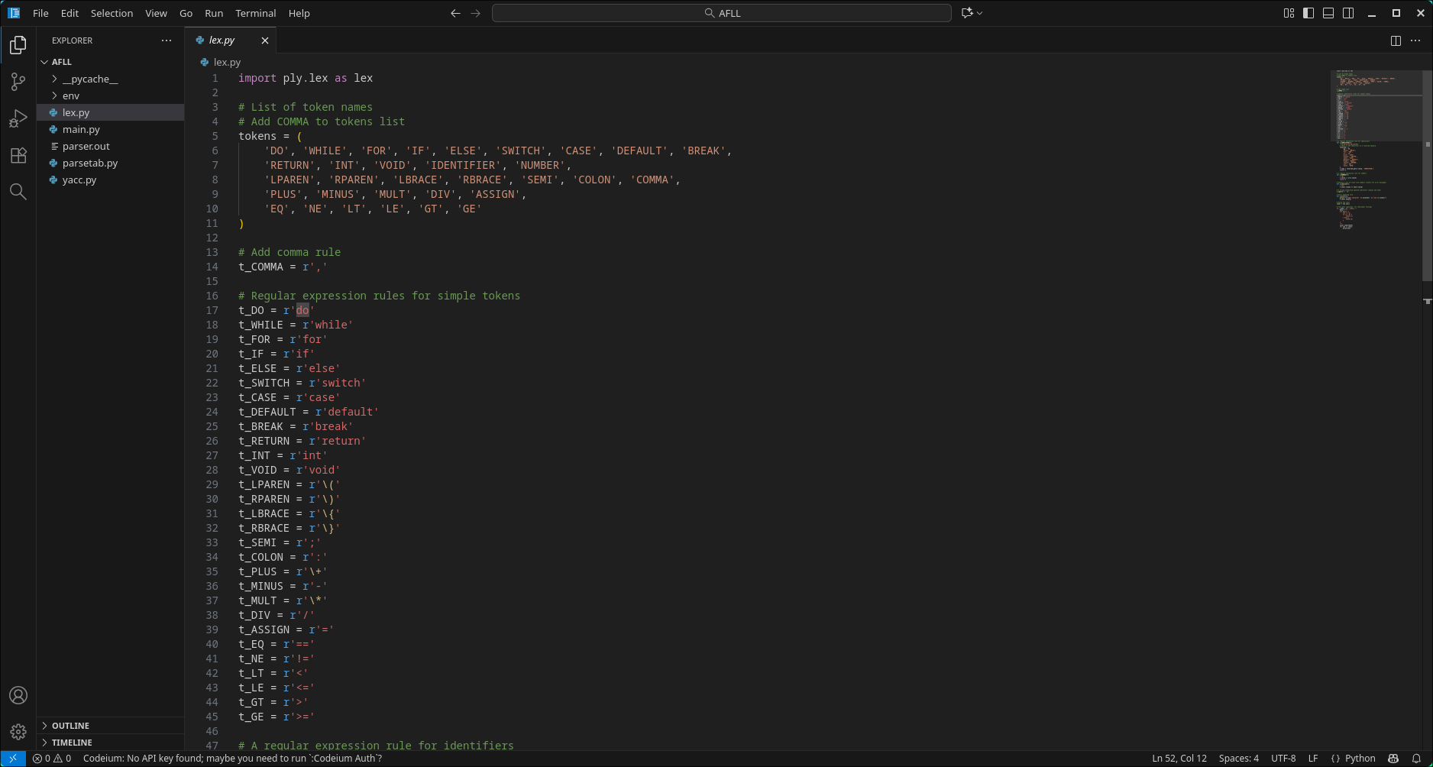
Lex Program:

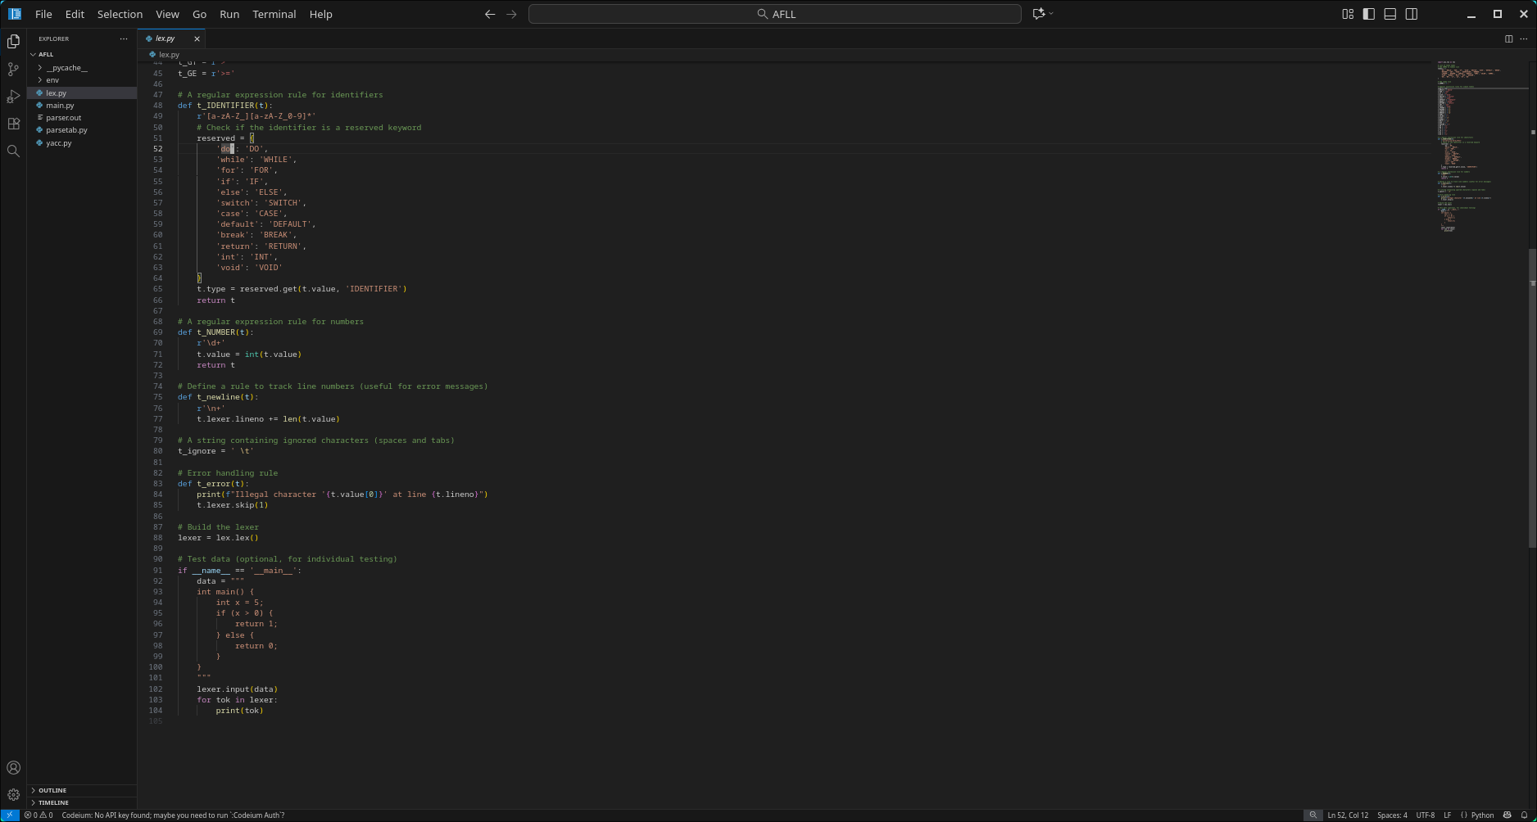

Yacc Program:

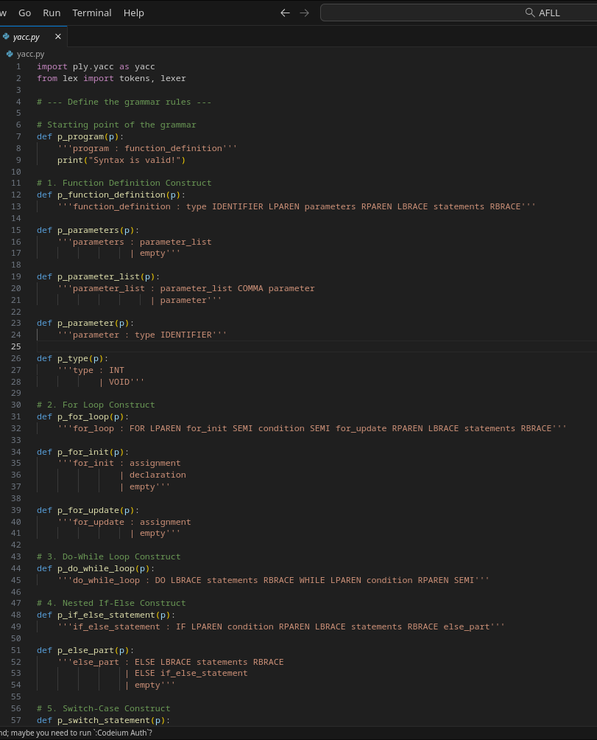

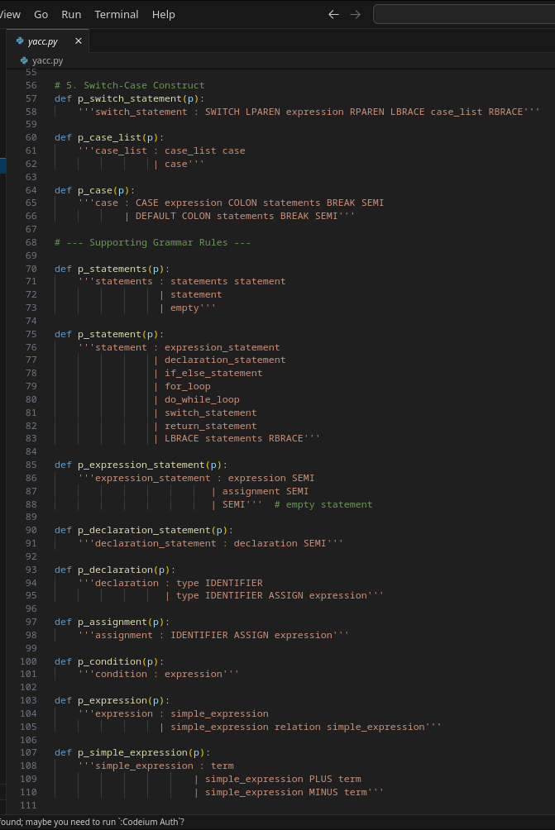

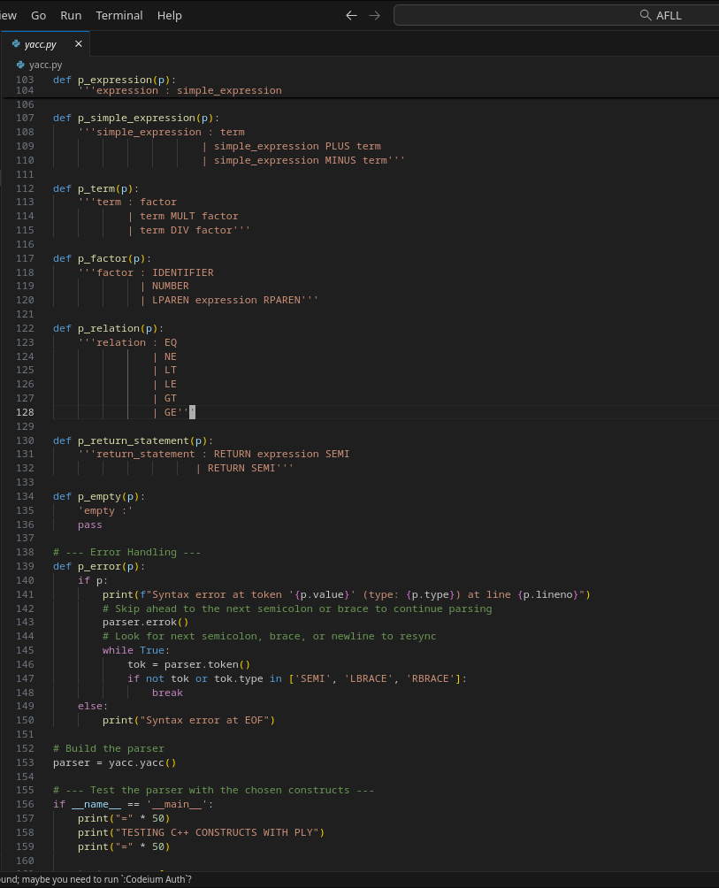

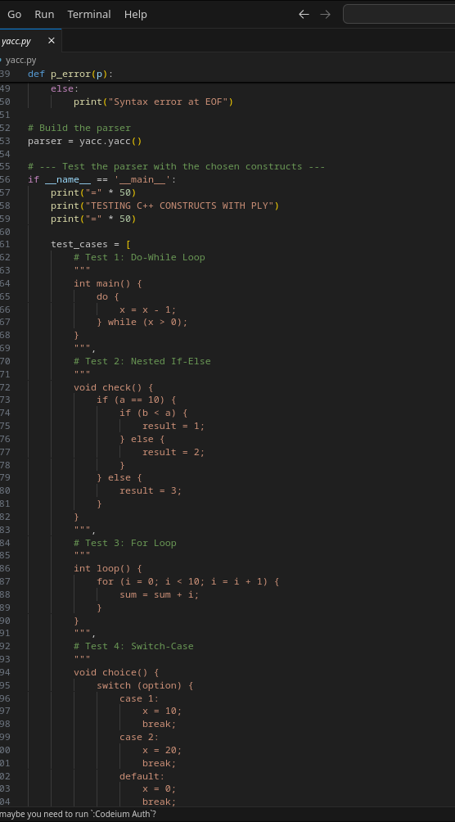

Screen Shot of Output

