Digital Design and Computer Organisation Laboratory
3rd Semester, Academic Year 2025

NAME | SRN
IBRAHIM KHALEEL | PES2UG25CS809
DEERAJ S | PES2UG25CS806
L A GOKUL | PES2UG24CS246

TITLE: Stop Watch(Start, Reset, Stop)
Deliverables
I. Verilog Code Screenshot
II. Verilog VVP Output Screen Shot
III. GTKWAVE Screenshot
IV. Output Table to be completed and included

State Diagram

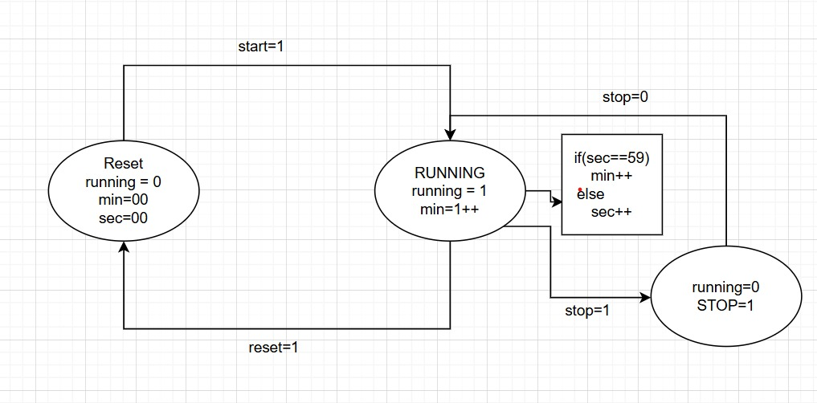

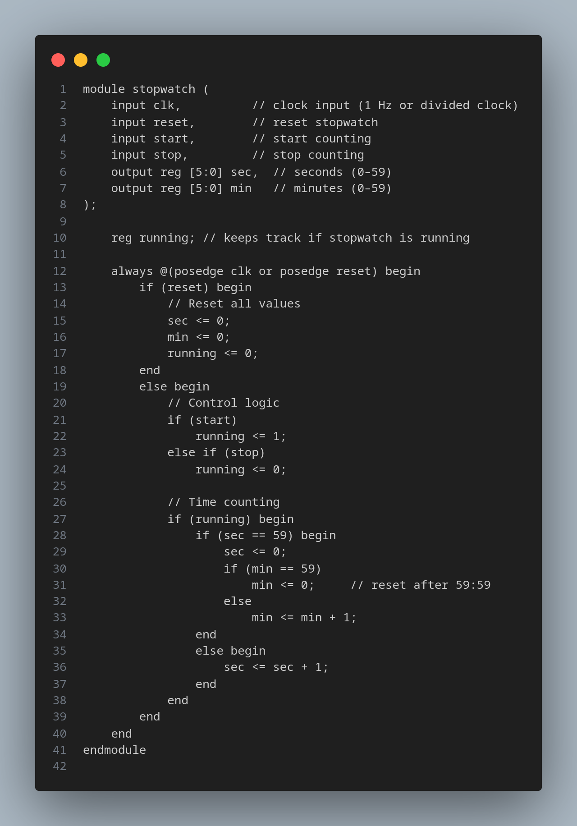
IVERLOG CODE

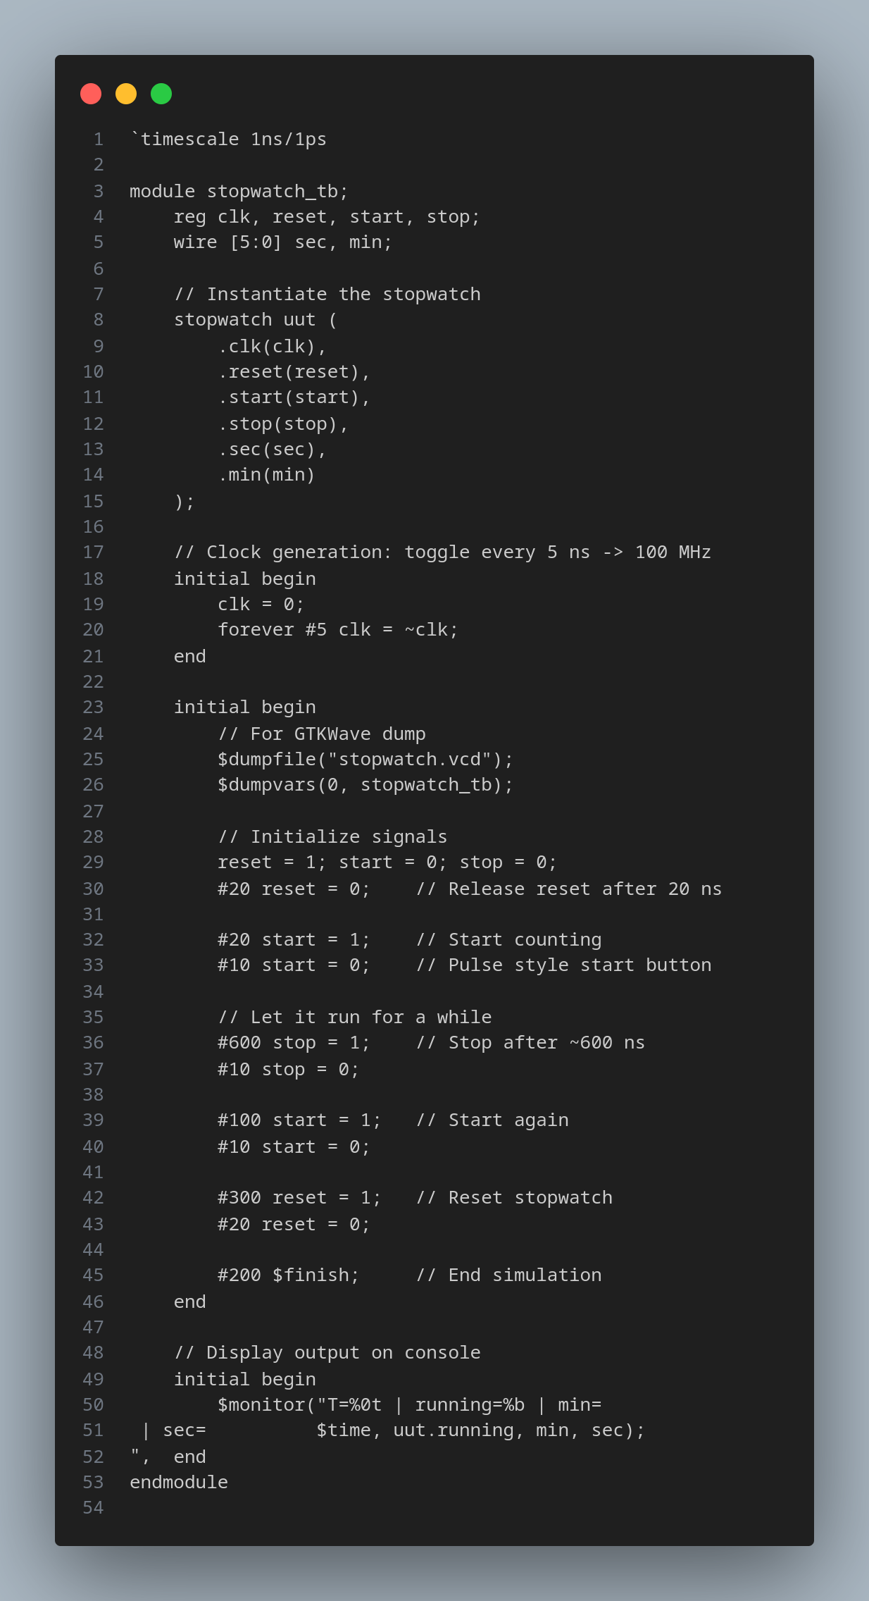
TEST BENCH

VVP OUTPUT

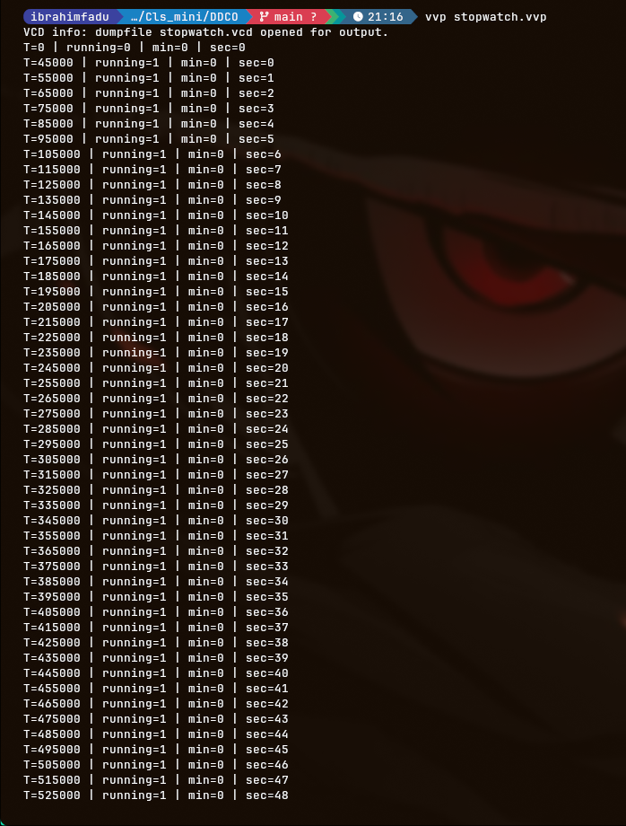
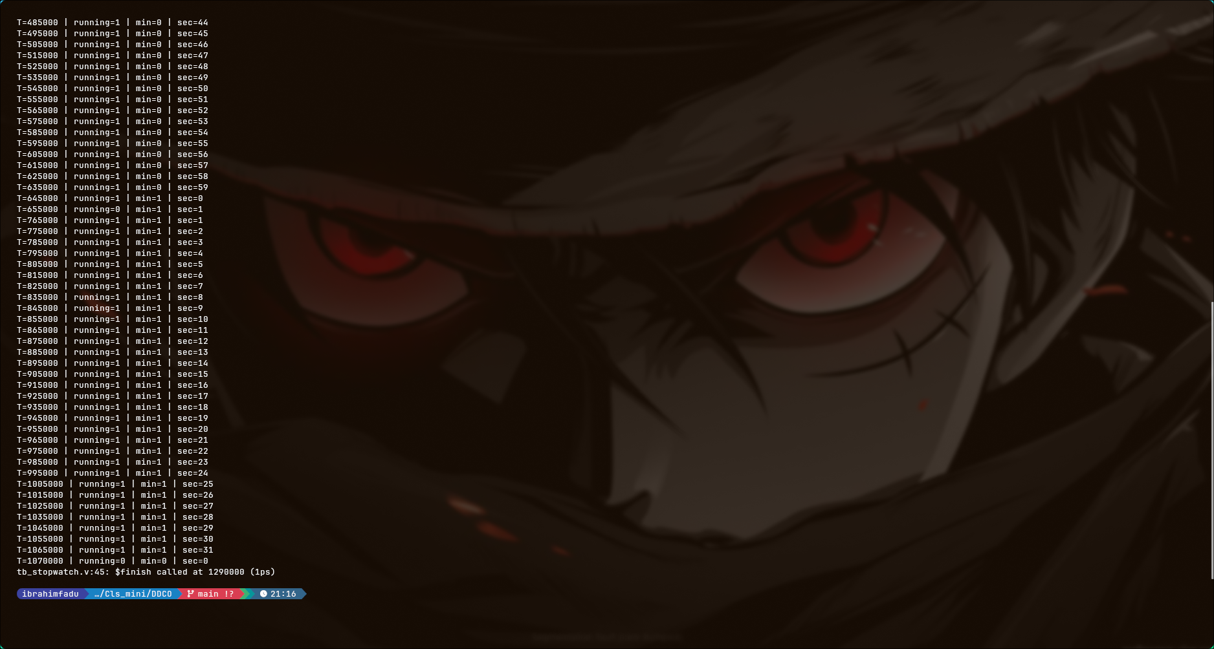

GTKWAVE

