LAB 7: FUZZ TESTING FOR INPUT VALIDATION BUGS
Software Engineering Lab Report — Automated Property-Based Testing with Hypothesis
Student Name: Ibrahim Khaleel | Course: Software Engineering Lab (SE)
SRN: PES2UG25CS809 | Topic: Property-Based Fuzz Testing (Hypothesis)
Section: D | Module Assigned: L6_L7_58 (Restaurant Bill Parser)

1. Objective & Learning Outcomes
Lab Objective: To explore fuzz testing as an automated security and quality assurance technique by discovering, analyzing, and resolving input validation vulnerabilities in a Python application module using the Hypothesis property-based testing framework.
- Understand Fuzzing Methodology: Comprehend how feeding pseudo-random, malformed, and non-canonical data uncovers unforeseen edge cases and crash conditions.
- Property-Based Testing with Hypothesis: Formulate behavioral invariants and domain constraints using @given decorators and strategy generators (st.text(), st.integers(), st.one_of()).
- Test-Case Shrinking Analysis: Leverage Hypothesis's automated shrinking engine to isolate minimal reproducible counterexamples for each failure.
- Defensive Programming: Implement defensive guards (type validation, boundaries, sanitization, zero-division guards) ensuring the module never experiences unhandled exceptions.

2. Laboratory Execution Screenshots
Step 2 (SS1): Initial Execution of Buggy Module (restaurant_bill_parser.py)
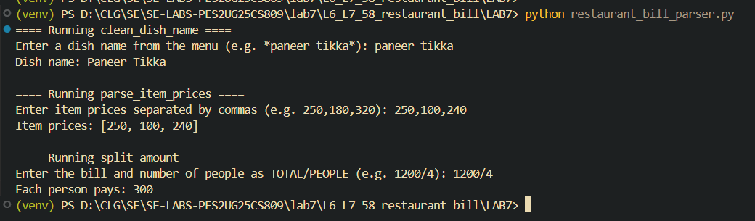
Figure 1 (SS1): Baseline run of buggy restaurant_bill_parser.py on typical inputs.
Step 3 & 4 (SS2): Hypothesis Fuzz Testing Exposing Application Bugs (7 Failed)
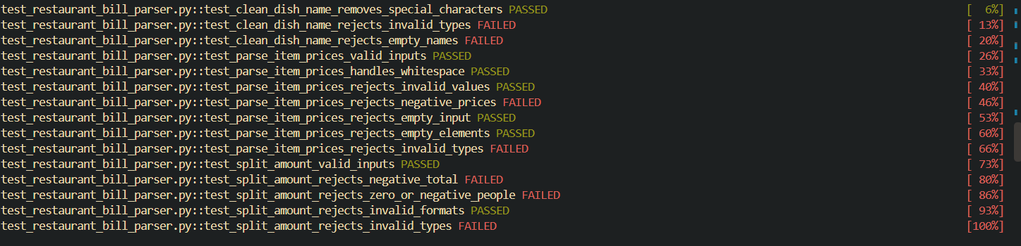
Figure 2 (SS2 - Part A): Verbose pytest output showing 7 failing tests on the unhardened module.
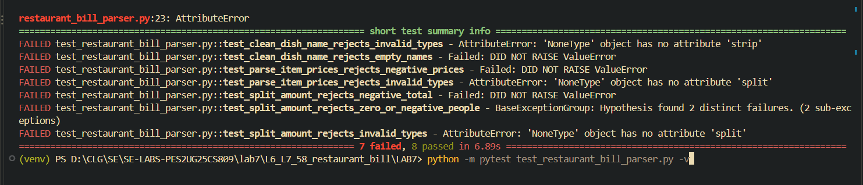
Figure 3 (SS2 - Part B): Short summary of unhandled exceptions (AttributeError, ZeroDivisionError).

Step 5 (SS3): Execution of Fixed & Hardened Module
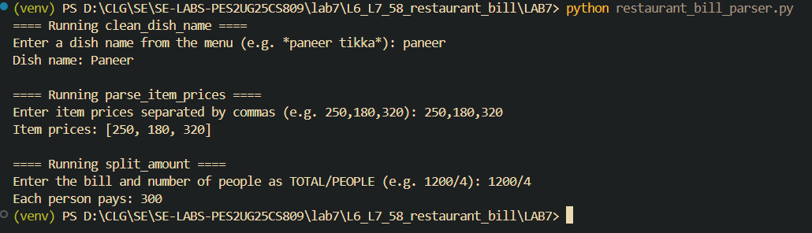
Figure 4 (SS3): Interactive run of the hardened restaurant_bill_parser.py.
Step 6 (SS4): Re-Running Hypothesis Fuzz Suite on Fixed Module (15 Passed)
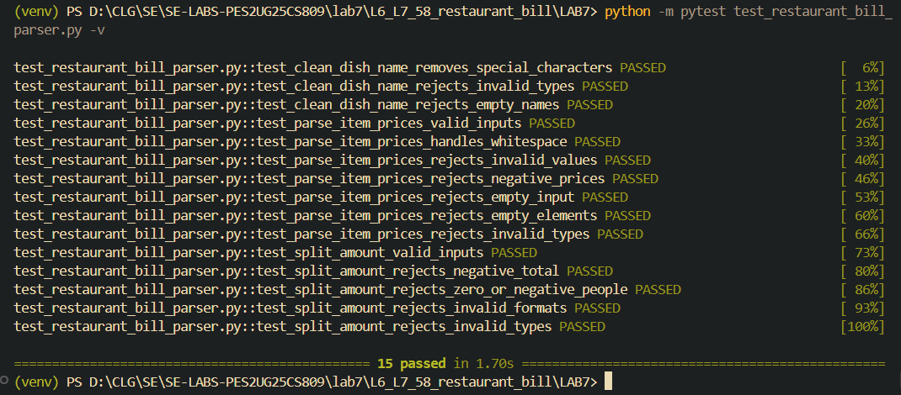
Figure 5 (SS4): Pytest execution report confirming all 15 property-based fuzz tests PASSED on the fixed module.

3. Vulnerability & Edge Case Analysis
Target Function | Vulnerability Uncovered | Shrunk Counterexample | Defensive Fix Implemented
clean_dish_name | Unhandled NoneType or non-string object caused AttributeError: 'NoneType' object has no attribute 'strip'. | name=None | Added if not isinstance(name, str): raise TypeError(...)
clean_dish_name | Empty string or strings containing only marker characters (*, #, ~) returned empty string instead of rejecting. | name=''  name='*#~' | Checked if not name: raise ValueError('Dish name cannot be empty') after sanitization.
parse_item_prices | Missing type check crashed on non-string input. Negative numbers were parsed without raising errors. | text=None  text='-1' | Enforced string type check; verified if value < 0: raise ValueError(...).
parse_item_prices | Malformed lists with adjacent commas or trailing commas caused ValueError: invalid literal for int() with base 10: ''. | text='100,,200' | Trimmed whitespace and explicitly checked if not price: raise ValueError(...).
split_amount | Zero diners caused unhandled ZeroDivisionError; negative diners or bill totals resulted in mathematically nonsensical splits. | text='1200/0'  text='-500/2' | Validated total >= 0 and strictly required people > 0; raised ValueError.
split_amount | Missing or multiple slash delimiters caused ValueError: not enough values to unpack. | text='1200/4/2'  text='1200' | Verified len(parts) == 2 before attempting integer conversion.

4. Answers to Lab Reflection Questions
Q1: What are the primary differences between traditional example-based unit testing and property-based fuzz testing?
Answer: Traditional unit testing relies on specific hardcoded input/output pairs designed according to the engineer's assumptions. It verifies that known cases work as expected. In contrast, property-based fuzz testing specifies general invariants (e.g., 'the function must never crash regardless of input', 'the output list must have non-negative integers') and generates hundreds of pseudo-random, edge-case, and boundary inputs. It excels at discovering 'unknown unknowns' that human test authors rarely consider, such as empty delimiters, extreme numeric boundaries, and non-ASCII character inputs.
Q2: How does Hypothesis test-case minimization (shrinking) assist developers in debugging?
Answer: When a randomized test fails on an unwieldy input (e.g., an 80-character string with complex Unicode characters), finding the root cause manually is difficult. Hypothesis automatically executes a shrinking algorithm, systematically reducing the input complexity (removing characters, zeroing numbers) while re-evaluating the test until it identifies the minimal reproducible counterexample (e.g., shrinking to None, '', or 0). This directly isolates the exact boundary condition causing the crash.
Q3: Why is defensive programming essential for software security and system reliability?
Answer: In production systems, unexpected or malformed user inputs can lead to uncaught exceptions, Denial of Service (DoS) crashes, or security exploits (such as buffer corruption or injection attacks). By adopting defensive programming—explicitly checking input data types, stripping and validating strings, bounding numeric ranges, and handling exceptional cases gracefully—the application establishes robust failure boundaries and prevents application downtime.

5. Source Code
Appendix A: Fixed Application Script (restaurant_bill_parser.py / processor.py)
def clean_dish_name(name):
"""
Removes chef's-special markers and title-cases the dish name.
Rejects invalid types and empty dish names.
"""
if not isinstance(name, str):
raise TypeError("Dish name must be a string")
name = name.strip()
for ch in ['*', '#', '~']:
name = name.replace(ch, '')
name = name.strip()
if not name:
raise ValueError("Dish name cannot be empty")
return name.title()
def parse_item_prices(text):
"""
Parses comma-separated prices into a list of non-negative integers.
"""
if not isinstance(text, str):
raise TypeError("Prices must be provided as a string")
if not text.strip():
raise ValueError("Price list cannot be empty")
prices = []
for price in text.split(','):
price = price.strip()
if not price:
raise ValueError("Price cannot be empty")
try:
value = int(price)
except ValueError:
raise ValueError("Prices must be valid whole numbers")
if value < 0:
raise ValueError("Prices cannot be negative")
prices.append(value)
return prices
def split_amount(text):
"""
Splits TOTAL/PEOPLE and calculates each person's share.
"""
if not isinstance(text, str):
raise TypeError("Bill details must be a string")
parts = text.split('/')
if len(parts) != 2:
raise ValueError("Format must be TOTAL/PEOPLE")
try:
total = int(parts[0].strip())
people = int(parts[1].strip())
except ValueError:
raise ValueError("Total and people must be whole numbers")
if total < 0:
raise ValueError("Total cannot be negative")
if people <= 0:
raise ValueError("Number of people must be positive")
return total // people
def main():
print("==== Running clean_dish_name ====")
value = input("Enter a dish name from the menu (e.g. *paneer tikka*): ")
print("Dish name:", clean_dish_name(value))
print("\n==== Running parse_item_prices ====")
value = input("Enter item prices separated by commas (e.g. 250,180,320): ")
print("Item prices:", parse_item_prices(value))
print("\n==== Running split_amount ====")
value = input("Enter the bill and number of people as TOTAL/PEOPLE (e.g. 1200/4): ")
print("Each person pays:", split_amount(value))
if __name__ == "__main__":
main()

Appendix B: Updated Hypothesis Test Suite (test_restaurant_bill_parser.py / test_processor.py)
import pytest
from hypothesis import given, strategies as st
from restaurant_bill_parser import (
clean_dish_name,
parse_item_prices,
split_amount
)
# ==========================================
# TEST 1: clean_dish_name()
# ==========================================
@given(
st.text(min_size=1).filter(
lambda s: bool(
s.strip()
.replace('*', '')
.replace('#', '')
.replace('~', '')
.strip()
)
)
)
def test_clean_dish_name_removes_special_characters(name):
result = clean_dish_name(name)
expected = name.strip()
for ch in ['*', '#', '~']:
expected = expected.replace(ch, '')
assert result == expected.title()
@given(st.one_of(
st.none(),
st.integers(),
st.floats(),
st.lists(st.integers())
))
def test_clean_dish_name_rejects_invalid_types(name):
with pytest.raises(TypeError):
clean_dish_name(name)
@given(st.sampled_from(["", " ", "*", "#", "~", "*#~"]))
def test_clean_dish_name_rejects_empty_names(name):
with pytest.raises(ValueError):
clean_dish_name(name)
# ==========================================
# TEST 2: parse_item_prices()
# ==========================================
@given(st.lists(
st.integers(min_value=0, max_value=100000),
min_size=1,
max_size=20
))
def test_parse_item_prices_valid_inputs(prices):
text = ",".join(map(str, prices))
result = parse_item_prices(text)
assert result == prices
@given(st.lists(
st.integers(min_value=0, max_value=100000),
min_size=1,
max_size=10
))
def test_parse_item_prices_handles_whitespace(prices):
text = ", ".join(map(str, prices))
result = parse_item_prices(text)
assert result == prices
@given(st.text().filter(lambda s: not s.strip().isdigit()))
def test_parse_item_prices_rejects_invalid_values(value):
with pytest.raises(ValueError):
parse_item_prices("100," + value)
@given(st.integers(max_value=-1))
def test_parse_item_prices_rejects_negative_prices(price):
with pytest.raises(ValueError):
parse_item_prices(str(price))
def test_parse_item_prices_rejects_empty_input():
with pytest.raises(ValueError):
parse_item_prices("")
def test_parse_item_prices_rejects_empty_elements():
with pytest.raises(ValueError):
parse_item_prices("100,,200")
def test_parse_item_prices_rejects_invalid_types():
with pytest.raises(TypeError):
parse_item_prices(None)
# ==========================================
# TEST 3: split_amount()
# ==========================================
@given(
st.integers(min_value=0, max_value=1000000),
st.integers(min_value=1, max_value=10000)
)
def test_split_amount_valid_inputs(total, people):
text = f"{total}/{people}"
result = split_amount(text)
assert result == total // people
@given(st.integers(max_value=-1))
def test_split_amount_rejects_negative_total(total):
with pytest.raises(ValueError):
split_amount(f"{total}/4")
@given(st.integers(max_value=0))
def test_split_amount_rejects_zero_or_negative_people(people):
with pytest.raises(ValueError):
split_amount(f"1200/{people}")
@given(st.sampled_from([
"",
"1200",
"/4",
"1200/",
"1200/4/2",
"abc/4",
"1200/abc"
]))
def test_split_amount_rejects_invalid_formats(text):
with pytest.raises(ValueError):
split_amount(text)
def test_split_amount_rejects_invalid_types():
with pytest.raises(TypeError):
split_amount(None)

